Tailoring Porous Silicon Micro-nanostructures via Alloy Precursor Engineering for High-Performance Lithium-Ion Battery Anodes
Liang Liu¹, Jialin Zhang¹, Chunlong Li¹, Zhenchao Xu¹, Qidi Wang¹, Limei Wang^{1*}, Yun Wang²
- Automotive Engineering Research Institute, Jiangsu University, Zhenjiang 212013, China
- Jiangsu Autoparts New Energy Technology Co., Ltd, Zhenjiang 212132, China
*Corresponding author: wanglimei@ujs.edu.cn
Table. S1 Measurement results of the crystalline size of Si of PSi particles.
Sample | Crystalline size of Si (nm)
PSi₁₂ | 16 nm
PSi₂₀ | 28 nm
PSi₃₀ | 30 nm
PSi₄₀ | 48 nm
PSi₅₀ | >100 nm

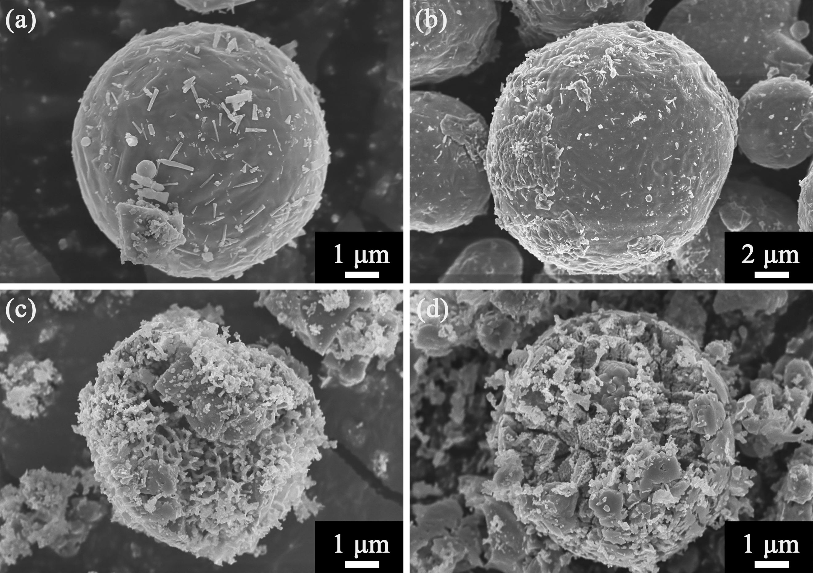
Fig. S1 SEM images of porous silicon samples before etching (a, b) and after etching (c, d): PSi₃₀ (a, c) and PSi₄₀ (b, d).
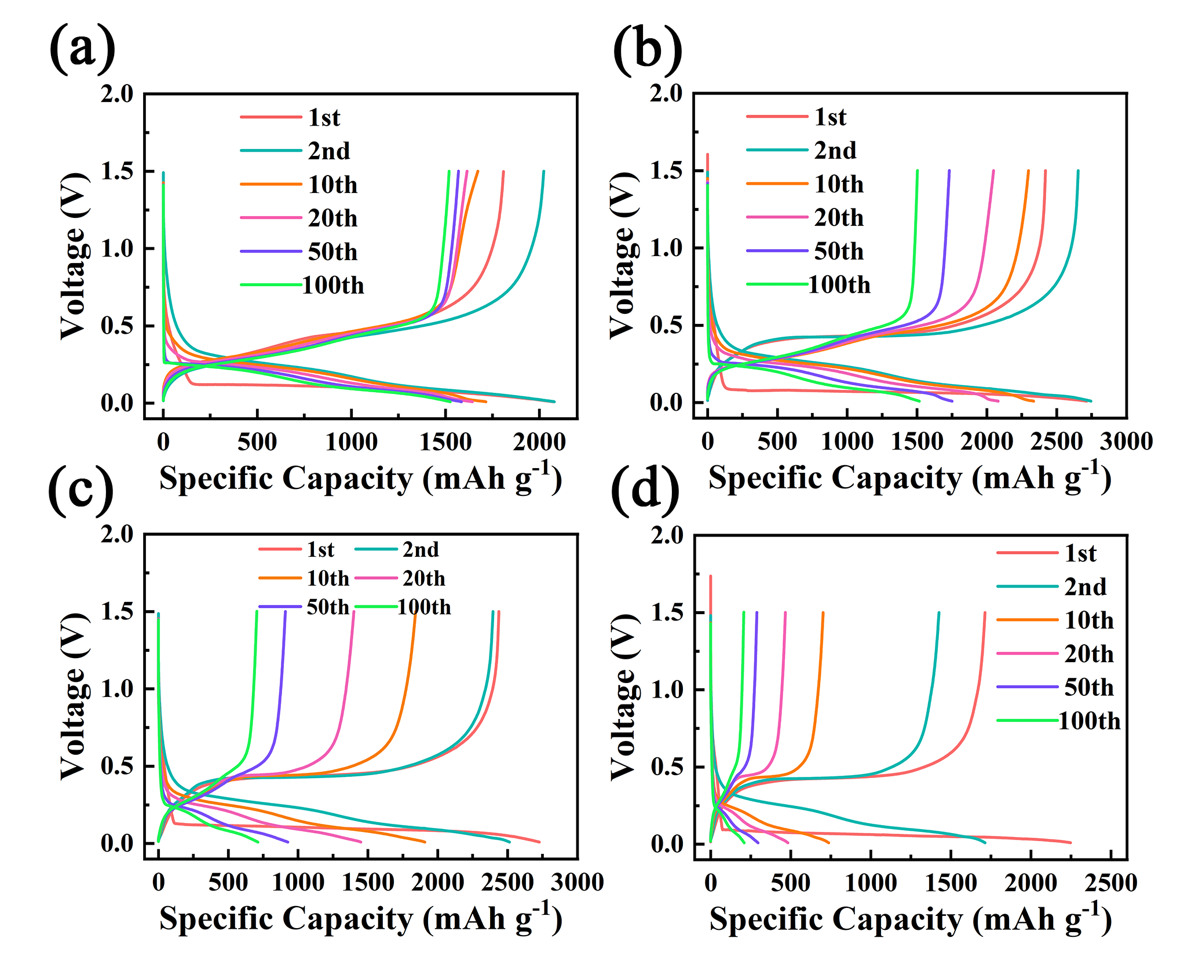
Fig. S2 Galvanostatic charge-discharge voltage profiles at 500 mA g⁻¹ for the 1st, 2nd, 10th, 20th, 50th, and 100th cycles: (a) PSi₁₂, (b) PSi₃₀, (c) PSi₄₀, and (d) PSi₅₀.
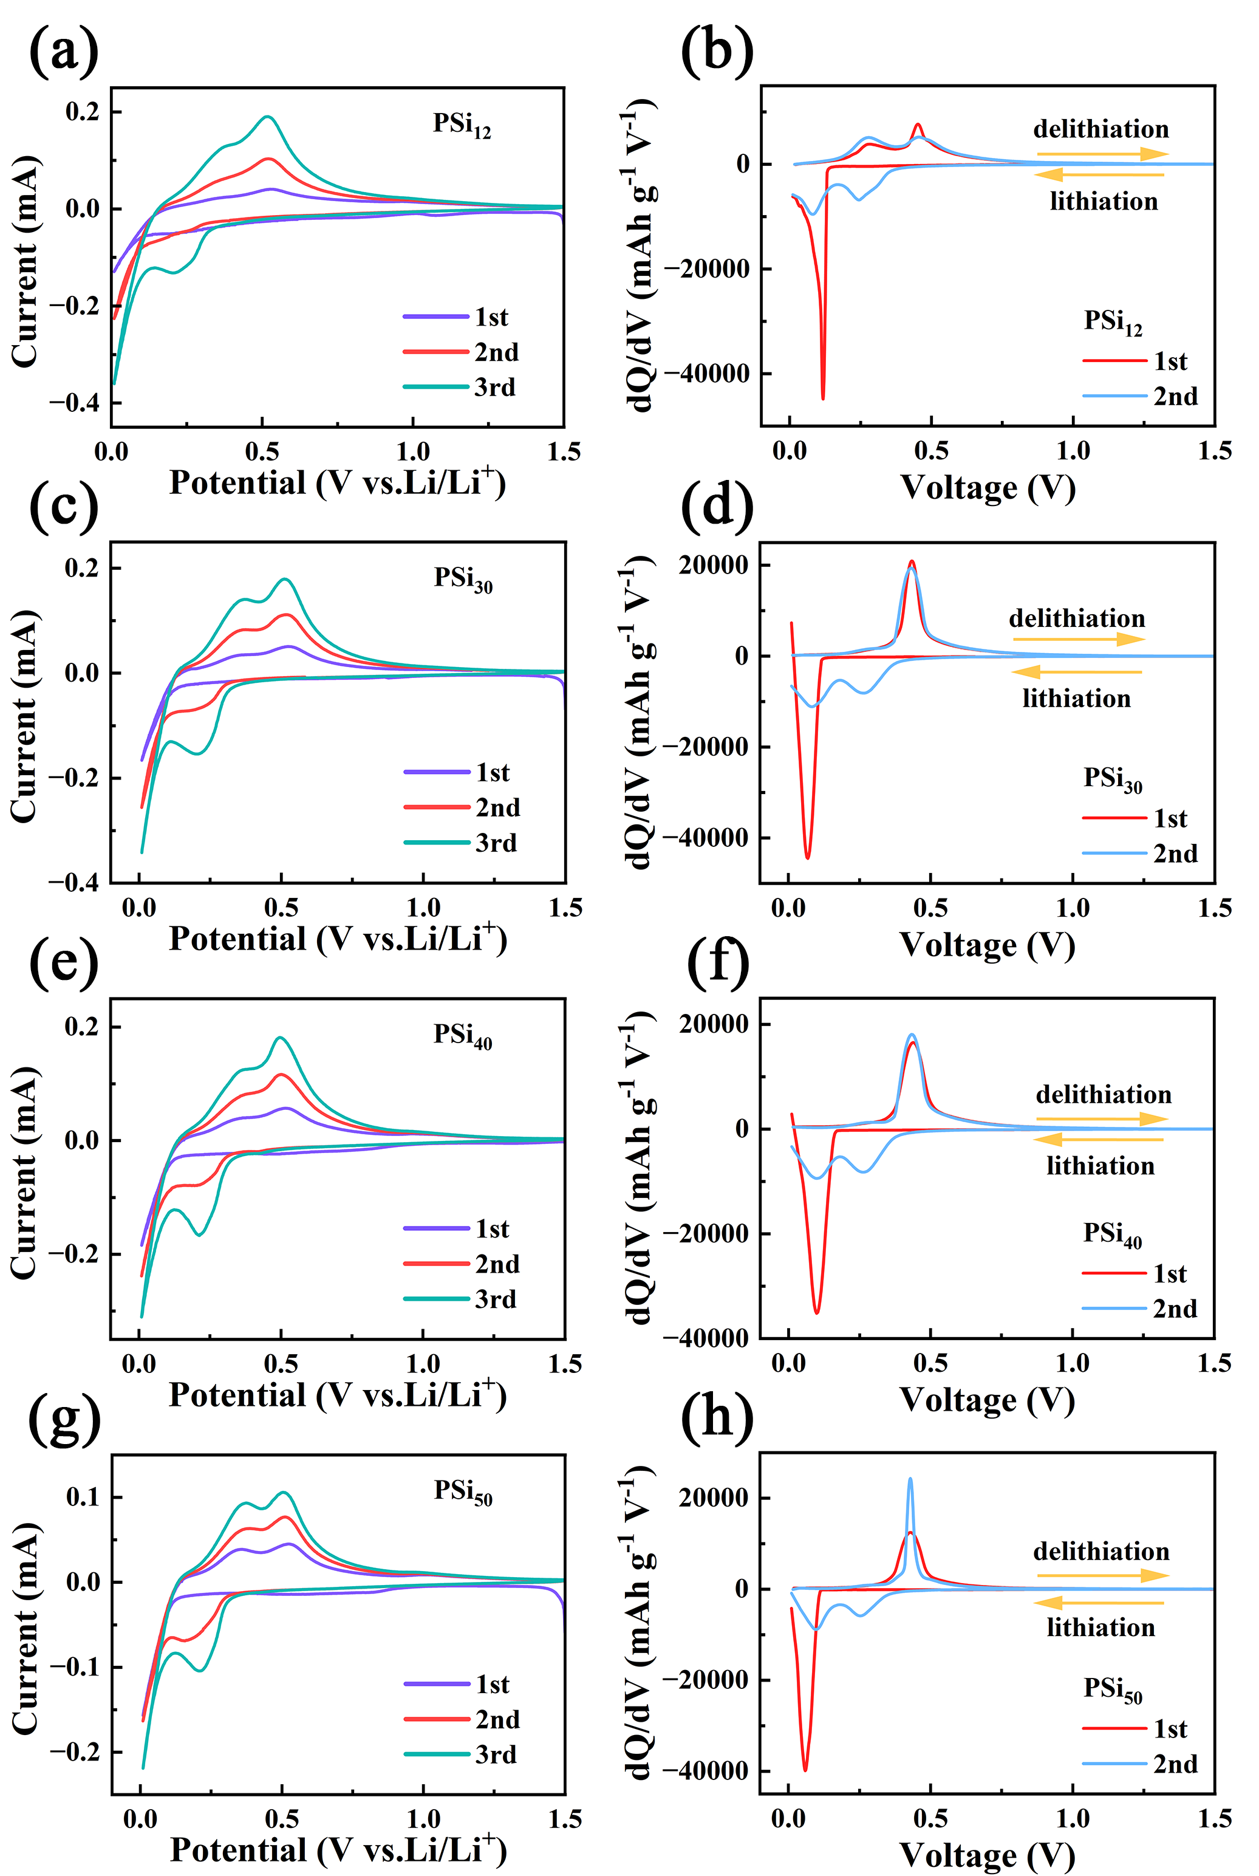
Fig. S3 Cyclic voltammetry (CV) curves for the first three cycles at 0.1 mV s⁻¹ between 0.01 and 1.5 V (a, c, e, g) and dQ/dV curves for the first two cycles (b, d, f, h): PSi₁₂ (a, b), PSi₃₀ (c, d), PSi₄₀ (e, f), and PSi₅₀ (g, h).

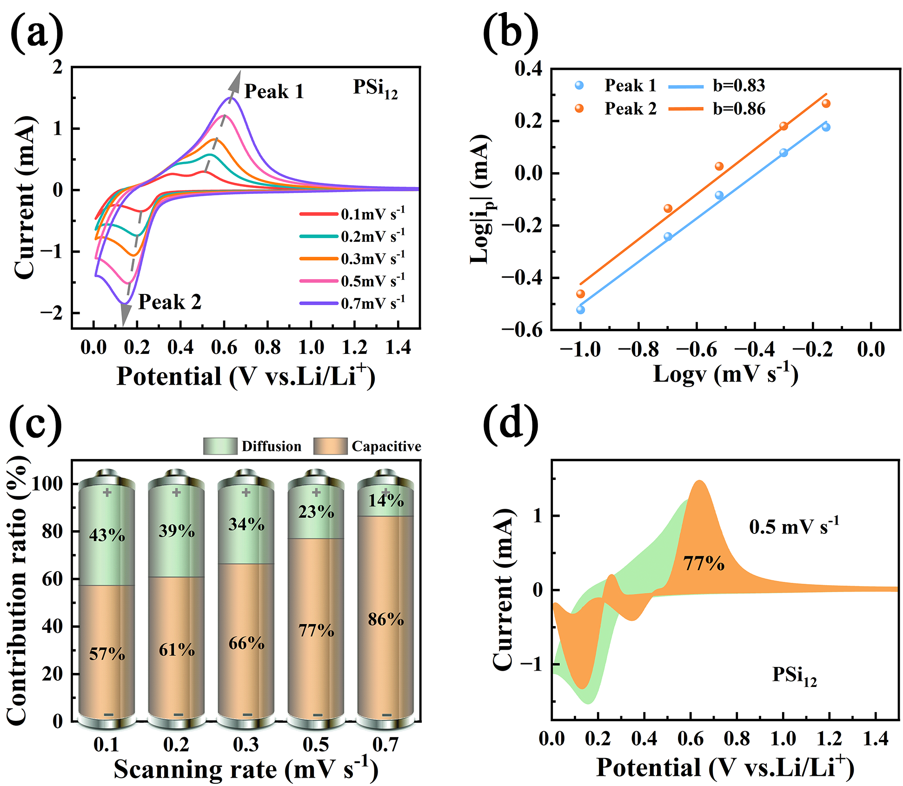
Fig. S4 (a) CV curves at scan rates of 0.1, 0.2, 0.3, 0.5 and 0.7 mV s⁻¹, (b) $\log{{|i}_{p}|}$ against $\log{v}$ at marked peaks, (c) the percentages of pseudocapacitive contribution at different scan rates and (d) the detailed pseudocapacitive contribution at 0.5 mV s⁻¹ of PSi₁₂.
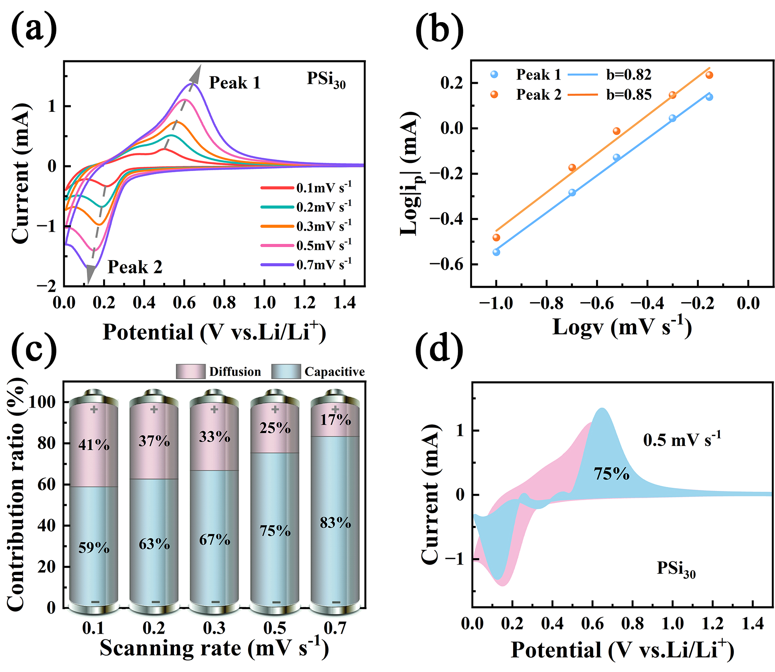
Fig. S5 (a) CV curves at scan rates of 0.1, 0.2, 0.3, 0.5 and 0.7 mV s⁻¹, (b) $\log{{|i}_{p}|}$ against $\log{v}$ at marked peaks, (c) the percentages of pseudocapacitive contribution at different scan rates and (d) the detailed pseudocapacitive contribution at 0.5 mV s⁻¹ of PSi₃₀.
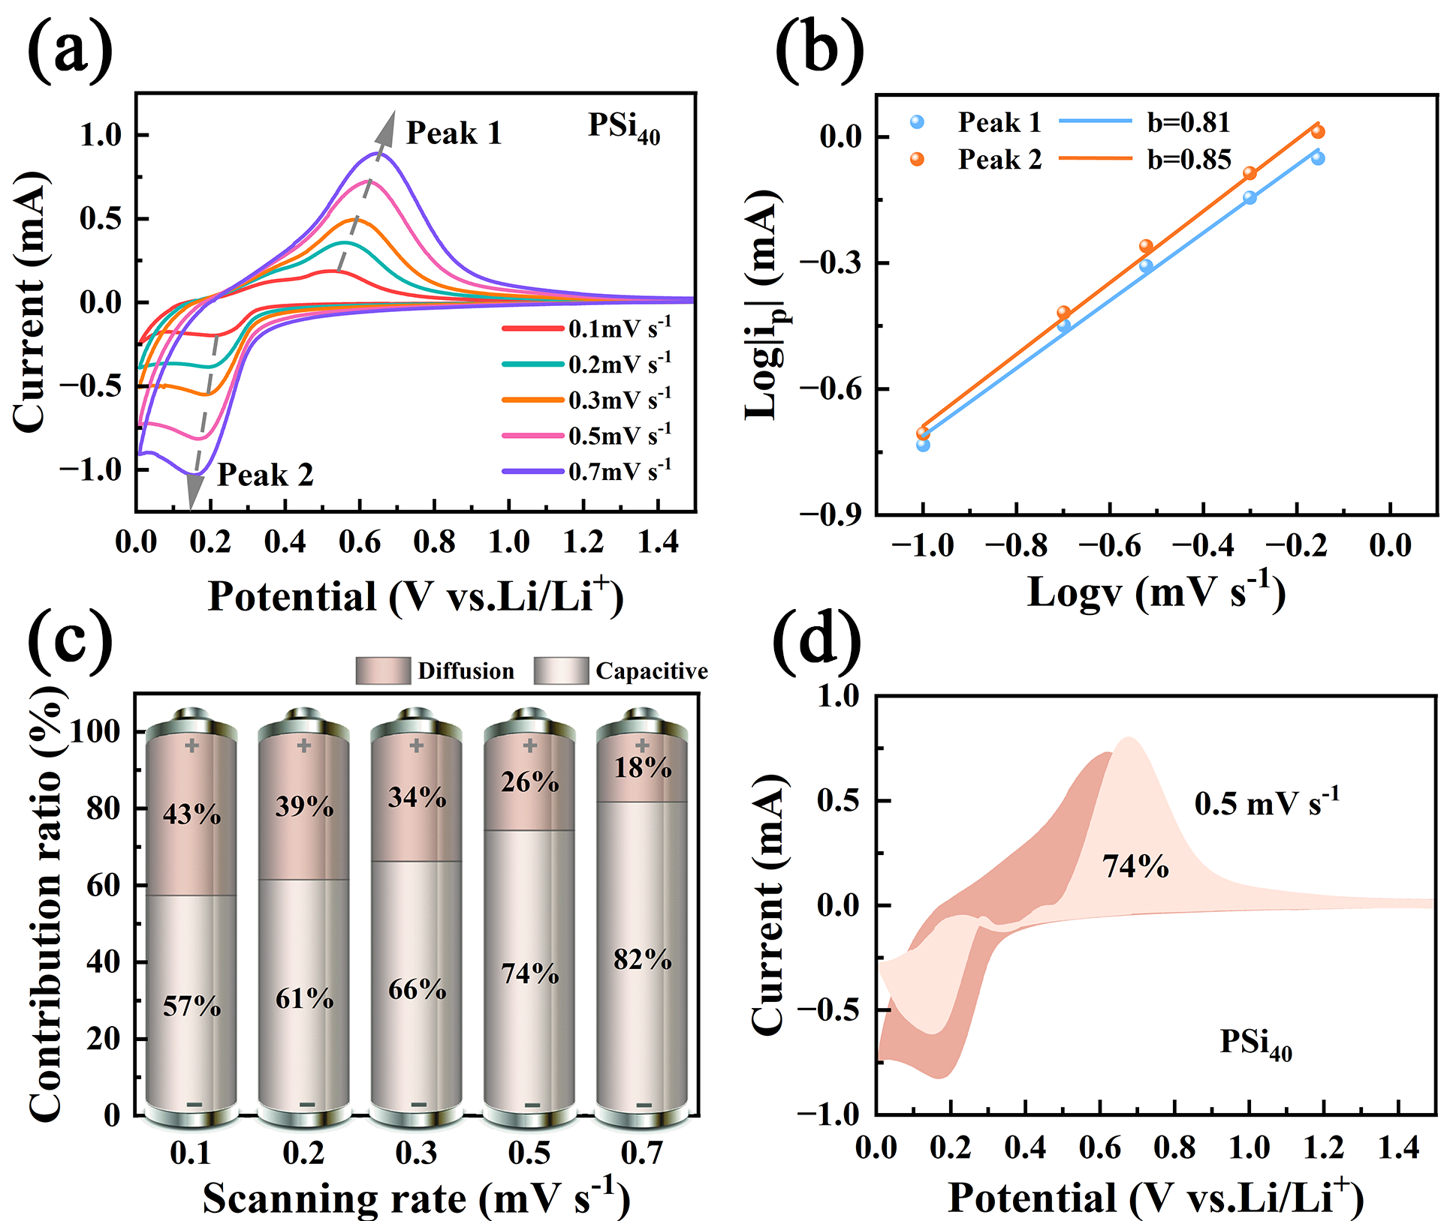
Fig. S6 (a) CV curves at scan rates of 0.1, 0.2, 0.3, 0.5 and 0.7 mV s⁻¹, (b) $\log{{|i}_{p}|}$ against $\log{v}$ at marked peaks, (c) the percentages of pseudocapacitive contribution at different scan rates and (d) the detailed pseudocapacitive contribution at 0.5 mV s⁻¹ of PSi₄₀.
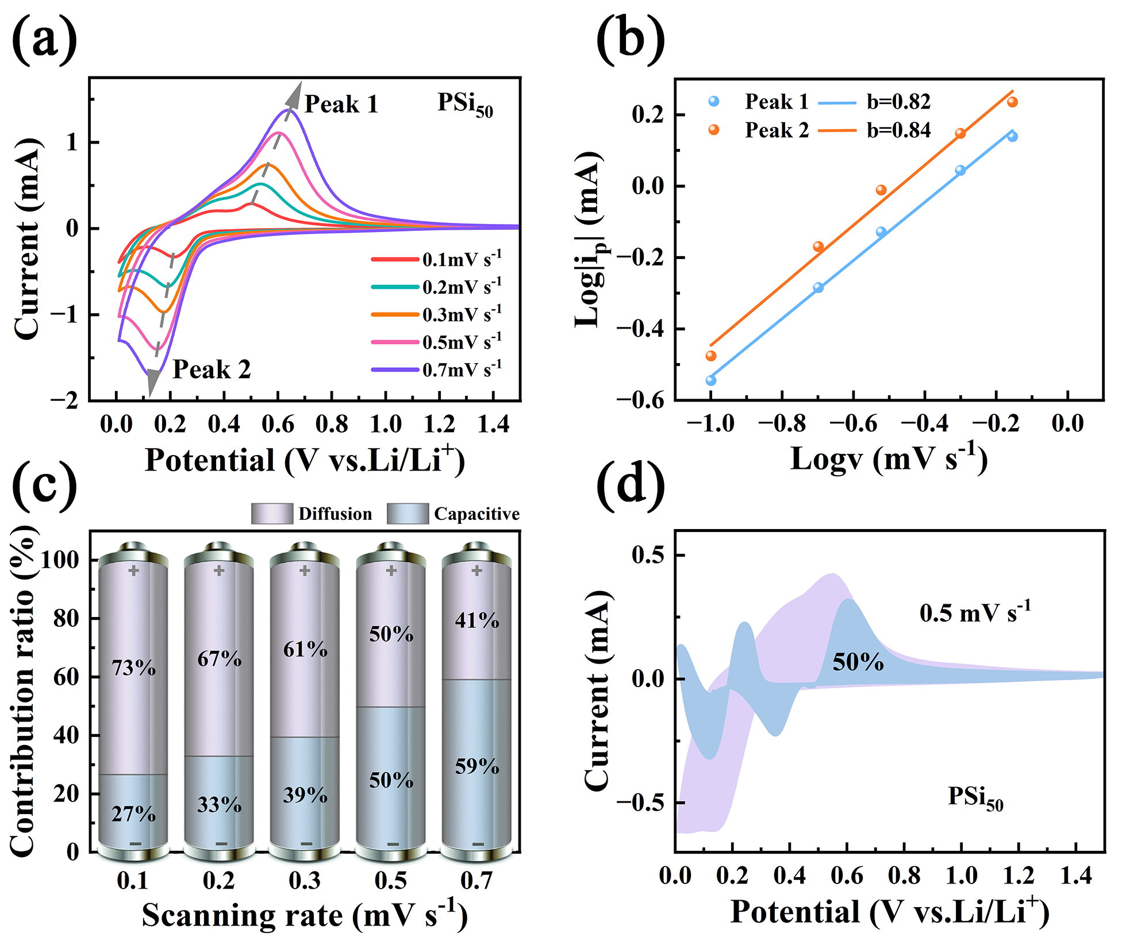
Fig. S7 (a) CV curves at scan rates of 0.1, 0.2, 0.3, 0.5 and 0.7 mV s⁻¹, (b) $\log{{|i}_{p}|}$ against $\log{v}$ at marked peaks, (c) the percentages of pseudocapacitive contribution at different scan rates and (d) the detailed pseudocapacitive contribution at 0.5 mV s⁻¹ of PSi₅₀.
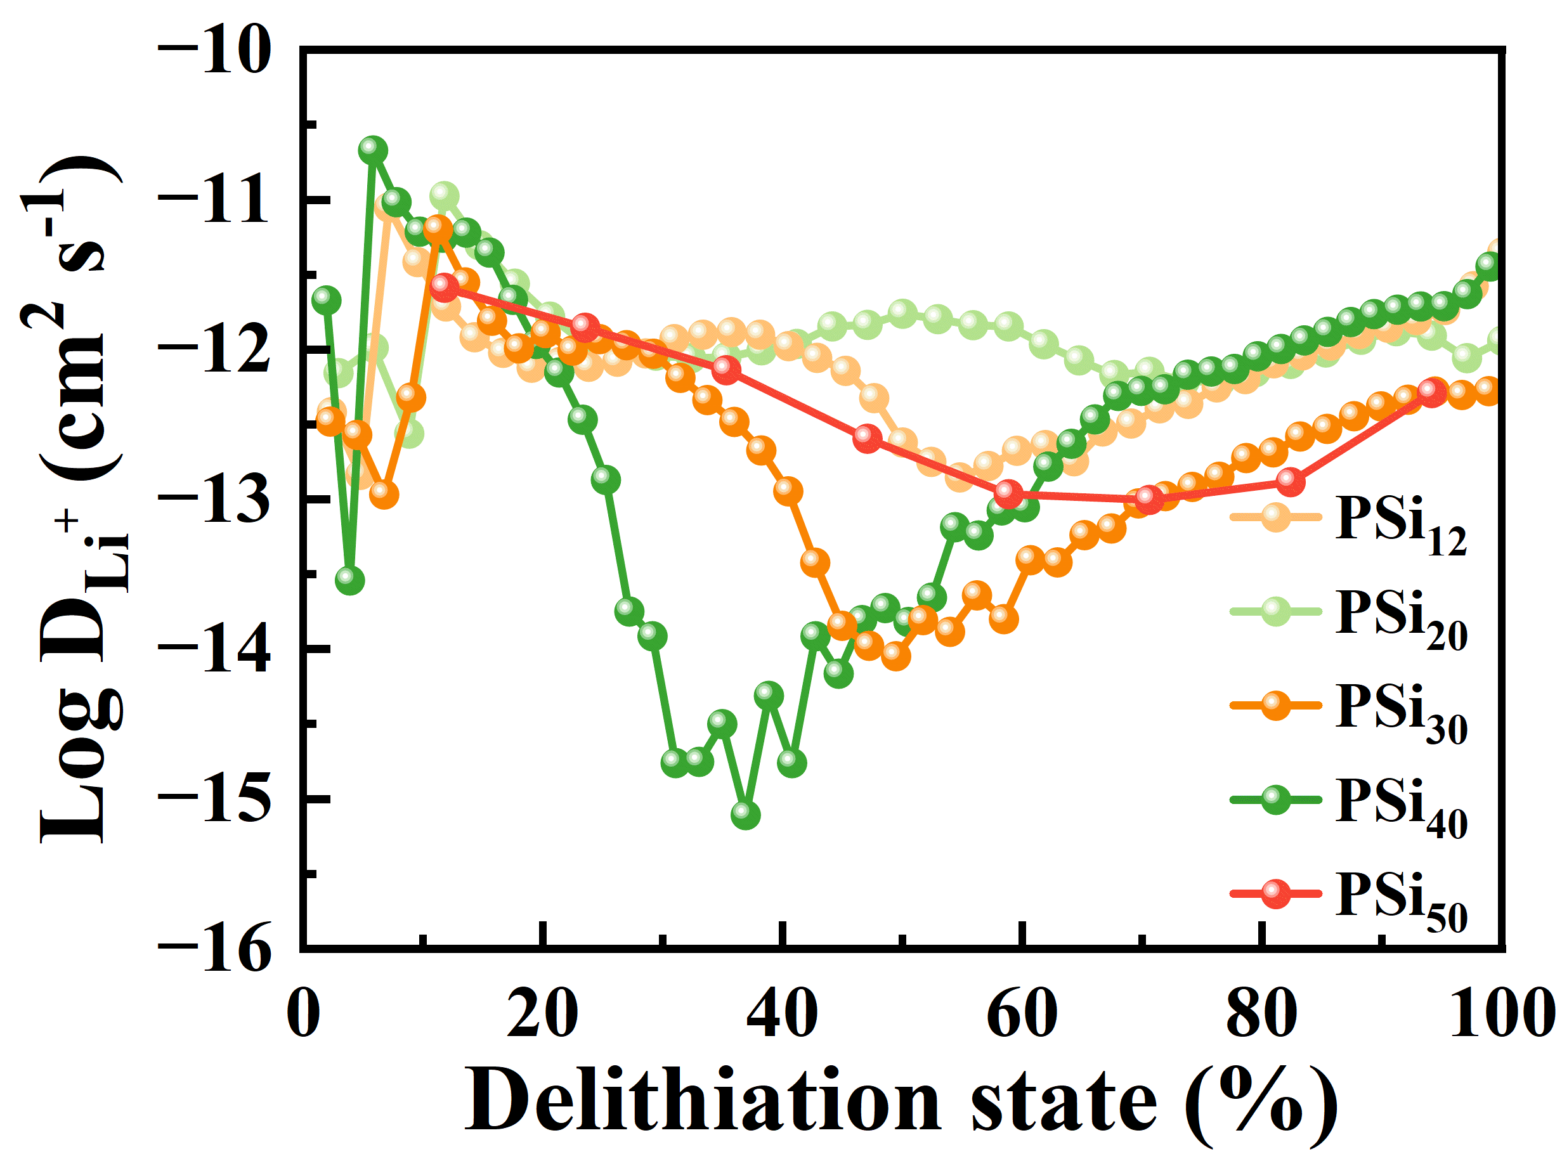
Fig. S8 Diffusion coefficients at different states of delithiation.

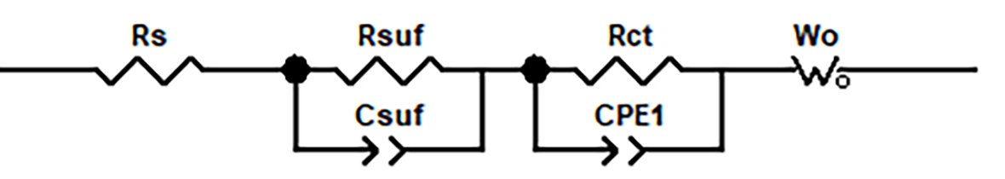
Fig. S9 Equivalent circuits.
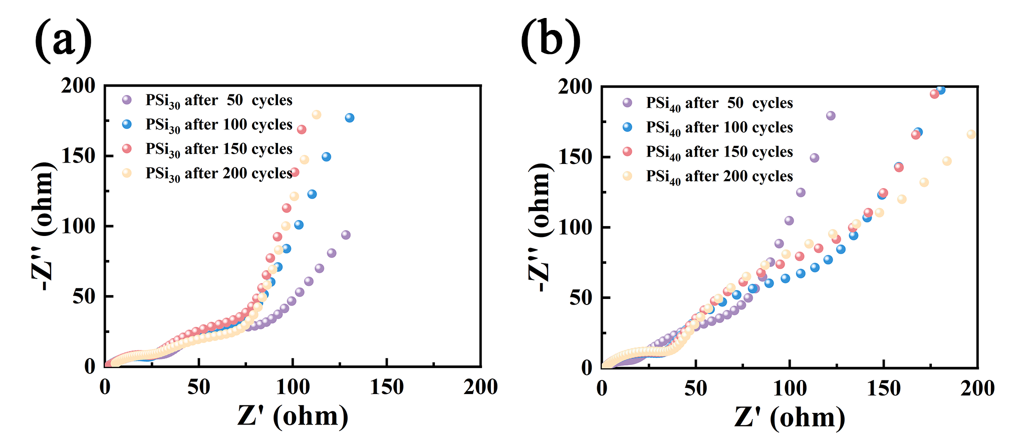
Fig. S10 Nyquist plots of porous silicon electrodes at 0.5 A g⁻¹ over 0.01-10⁵ Hz for the 50th, 100th, 150th, and 200th cycles: (a) PSi₃₀ and (b) PSi₅₀.

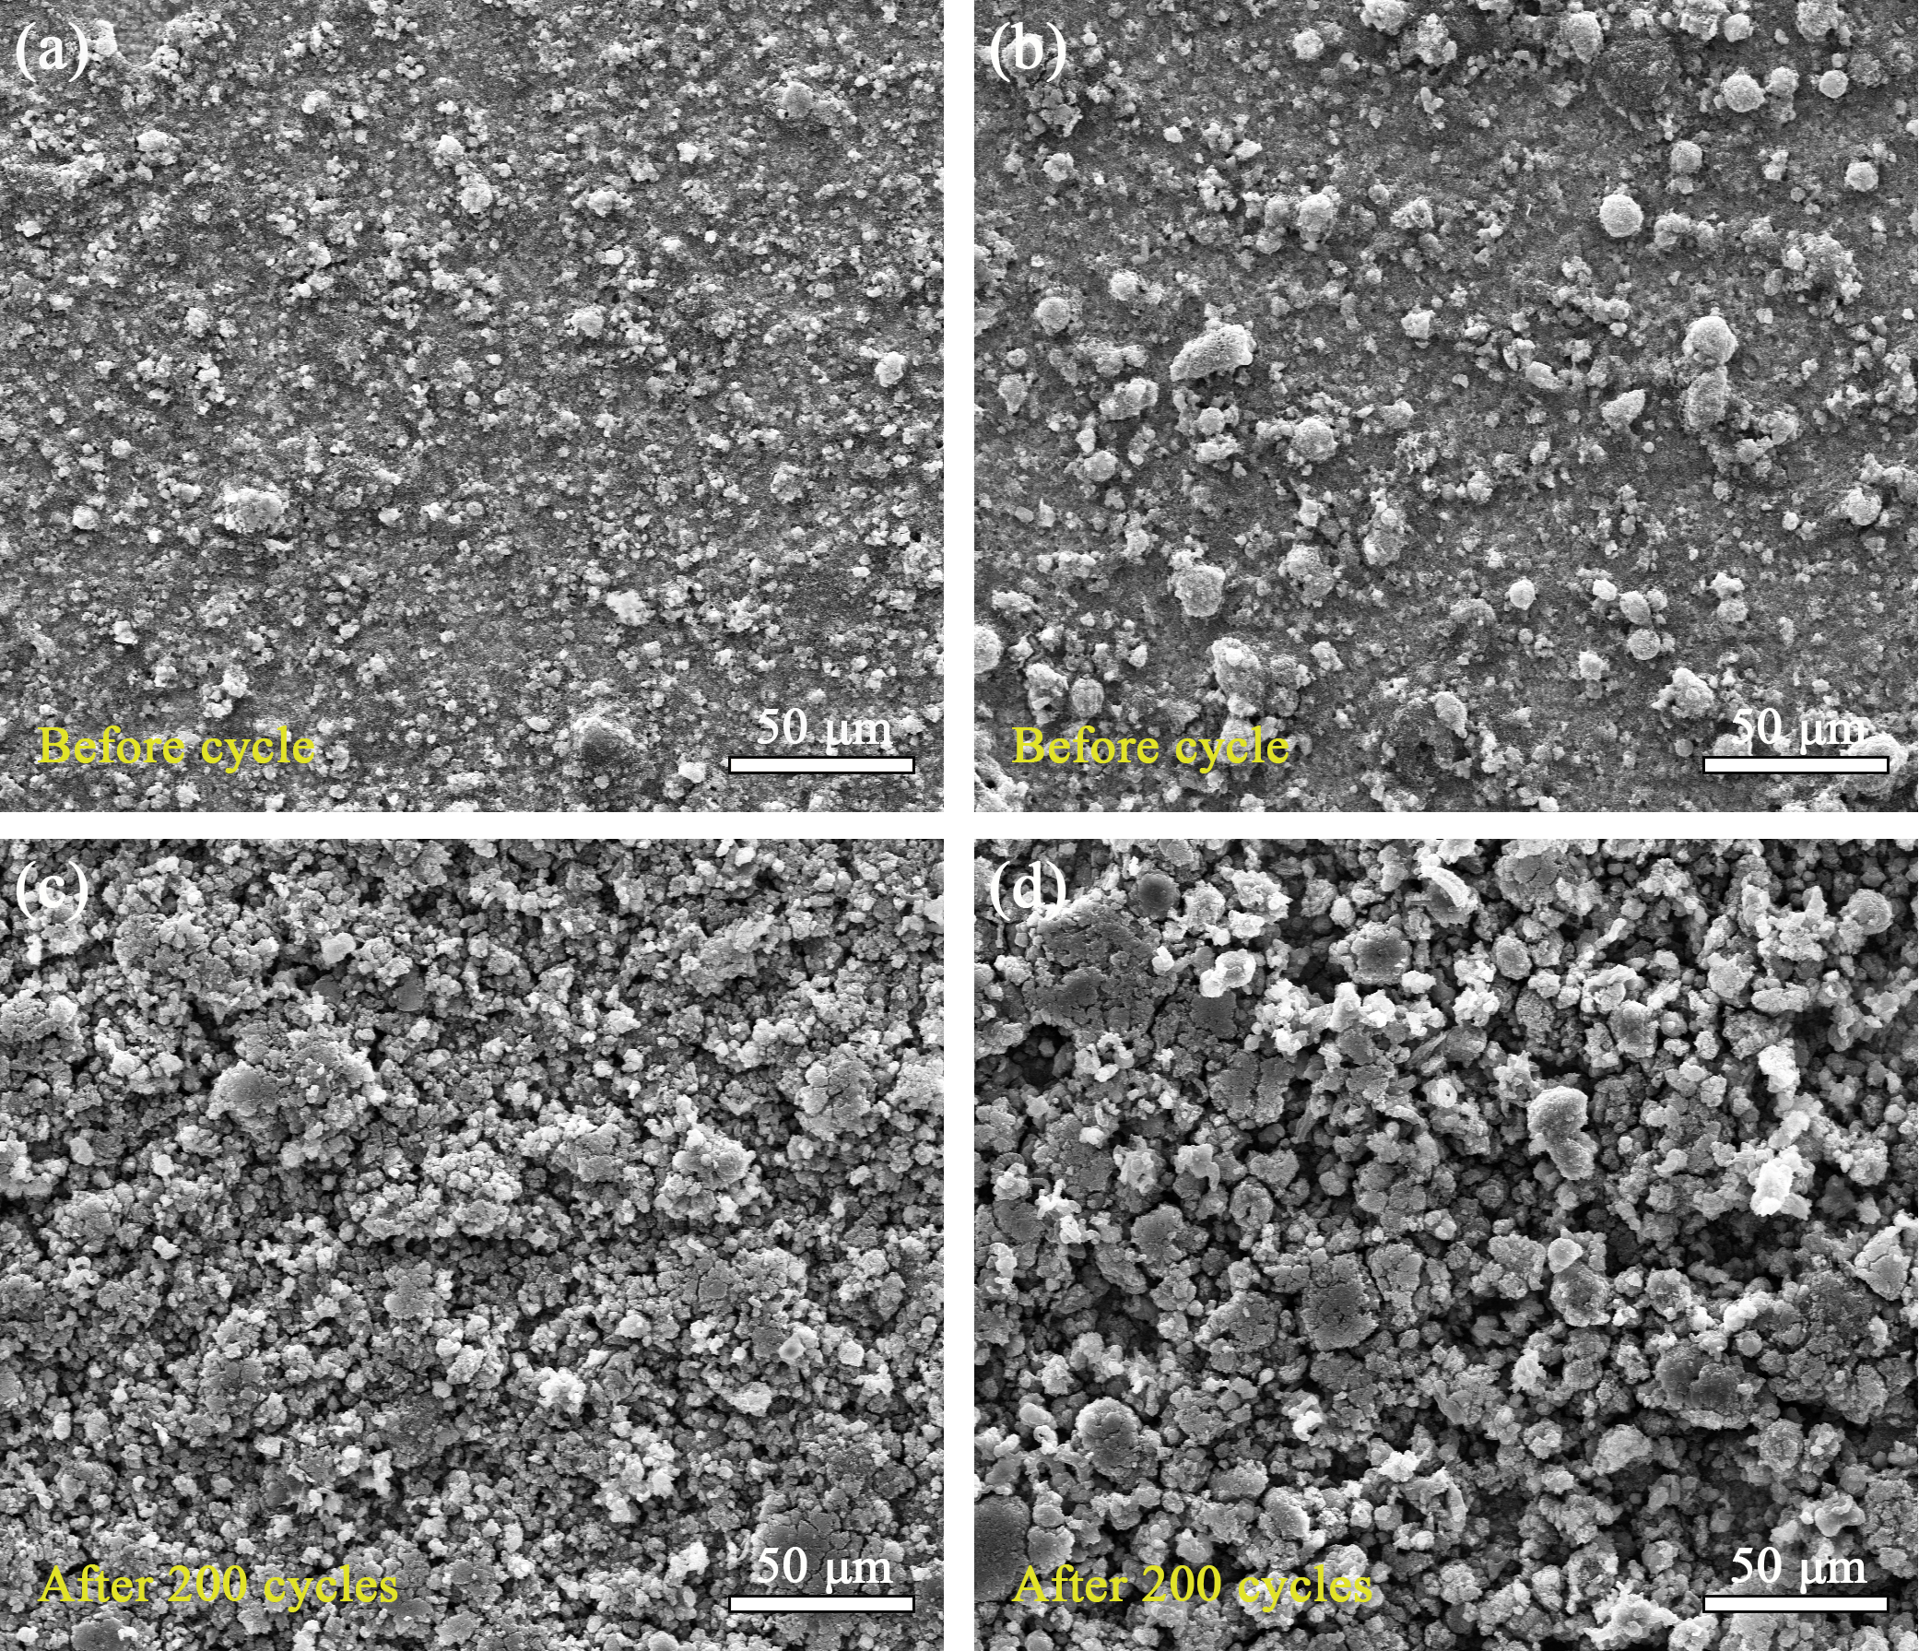
Fig. S11 SEM images of PSi₃₀ and PSi₄₀ electrodes before cycling (a, b) and after 200 cycles at 0.5 A g⁻¹ (c, d): PSi₃₀ (a, c) and PSi₄₀ (b, d).

