Table S1 The primers used in this work.
Gene |  | 5’- to 3’- sequences
PzDNT2-F | ATGGGTCGCGGATCCGAATTCAATAAATATGAATGTACTAAAACTAAAACTAGACC
PzDNT2-R | GTGGTGGTGGTGGTGCTCGAGATTATTTTTCAAATCATTTTCTGTAATTACG
PzDNT3-F | ATGGGTCGCGGATCCGAATTCAATAAAGAAAATTGTAATAAGTATAAAATGCG
PzDNT3-R | GTGGTGGTGGTGGTGCTCGAGTTTTAAATTTTTTTGACGAACTATGCA
PzDNT8-F | ATGGGTCGCGGATCCGAATTCATGACCAATACAATAAATGAAGTAAAACA
PzDNT8-R | GTGGTGGTGGTGGTGCTCGAGTTGATTTCTTTTTTGTTGTAAATCATTT

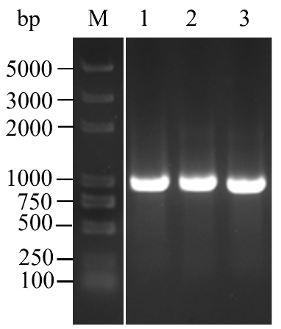
Fig.S1 Electrophoresis detection of dermonecrotic toxin genes in P. zhonghuajia. M, DL2000 Plus Marke; 1, PzDNT2; 2, PzDNT3; 3, PzDNT8

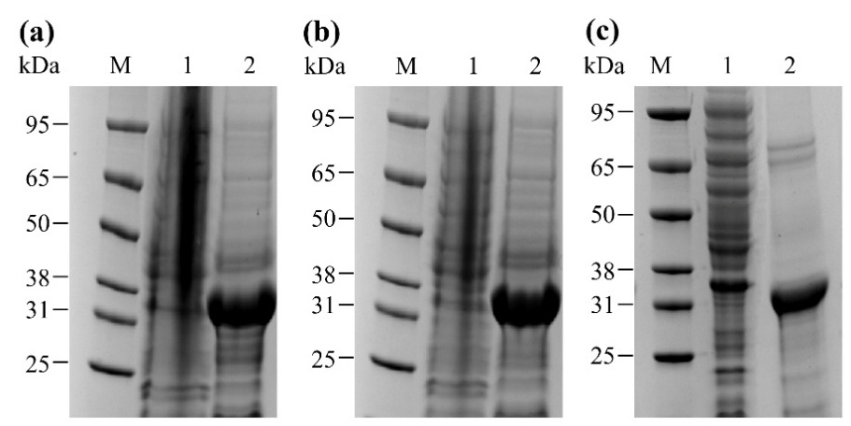
Fig.S2 Identification of the recombinant proteins. (a) PzDNT2; (b) PzDNT3; (c) PzDNT8; M, Molecular weight marker; Lane 1: the soluble supernatant; Lane 2: inclusion bodies

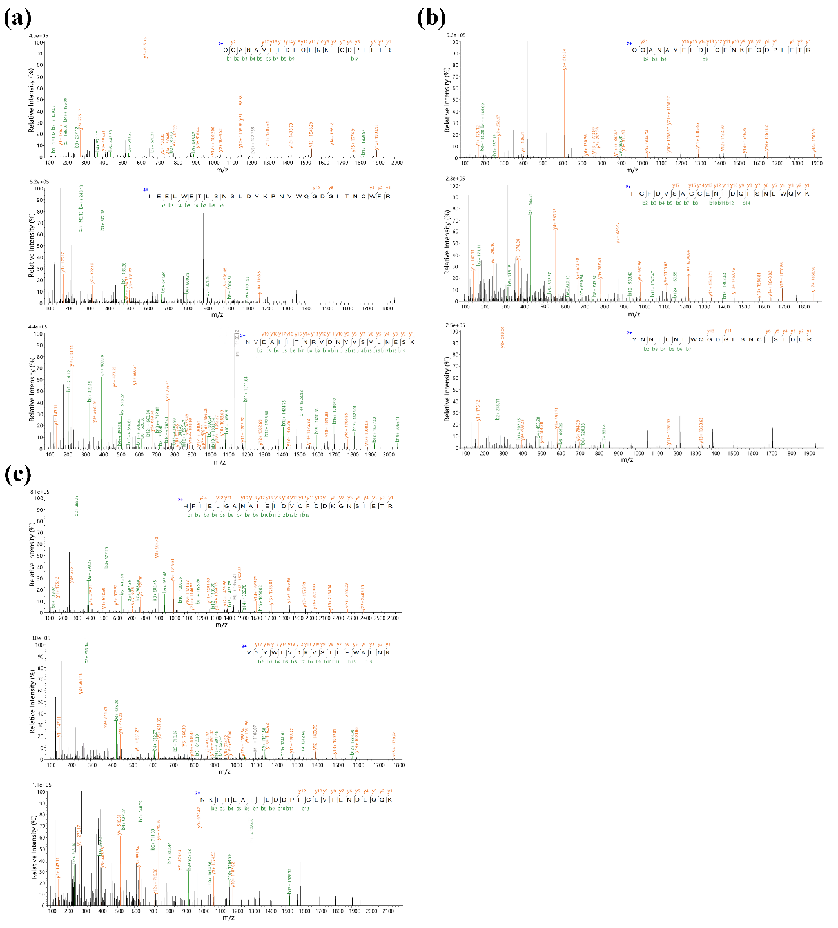
Fig.S3 Mass spectrum, representative MS/MS spectra of three unique peptides (with well-matched b/y ion series). (a) PzDNT2; (b) PzDNT3; (c) PzDNT8. m/z, mass-to-charge ratio

