Appendix 1

Table A1 Summary of the environmental impacts of the solar power system without heatsink
Impact Category | Without heatsink
Impact Category | Unit | Solar panels | Battery tubular 220ah | Inverter | Total impact | Total improvement (%)
Global Warming Potential (GWP) | kg CO₂ eq | 5352.00 | 1980 | 490.86 | 7822.86 | 0
Stratospheric Ozone Depletion (ODP) | kg CFC-11 eq | 0.0013728 | 0 | 0.00 | 0.0013728 | 0
Photochemical Oxidant Formation (POFP) | kg C₂H₄ eq | 0.11496 | 1.5 | 0.55 | 2.16496 | 0
Acidification (AP) | kg SO₂ eq | 31.92 | 1.25 | 7.98 | 41.15 | 0
Eutrophication (EP) | kg PO₄ eq | 3.60 | 0.275 | 3.56 | 7.435 | 0

Table A2 Summary of the environmental impacts of the solar power system with heatsink using virgin aluminium
Impact Category | With a heatsink (virgin Al)
Impact Category | Unit | Solar panels | Battery tubular 220ah | Inverter | Heatsink production (virgin Al) | Heatsink operation | Total impact | Total improvement (%)
Global Warming Potential (GWP) | kg CO₂ eq | 4281.60 | 1584 | 392.69 | 880.60 | -386.10 | 6752.79 | 13.68
Stratospheric Ozone Depletion (ODP) | kg CFC-11 eq | 0.00 | 0 | 0.00 | 0.00 | 0.00 | 0 | -
Photochemical Oxidant Formation (POFP) | kg C₂H₄ eq | 0.09 | 1.2 | 0.44 | 0.45 | -0.10 | 2.08 | 3.92
Acidification (AP) | kg SO₂ eq | 25.54 | 1 | 6.39 | 7.34 | -2.22 | 38.05 | 7.53
Eutrophication (EP) | kg PO₄ eq | 2.88 | 0.22 | 2.85 | 2.25 | -2.39 | 5.81 | 21.86

Table A3 Summary of the environmental impacts of the solar power system with heatsink using recycled aluminium
Impact category | With a heatsink (recycled Al)
Impact category | Unit | Solar panels | Battery tubular 220ah | Inverter | Heatsink production (recycle Al) | Heatsink operation | Total impact | Total improvement (%)
Global Warming Potential (GWP) | kg CO₂ eq | 4281.60 | 1584 | 392.69 | 48.87 | -386.10 | 5921.06 | 24.31
Stratospheric Ozone Depletion (ODP) | kg CFC-11 eq | 0.00109824 | 0 | 0.00 | 0.00 | 0.00 | 0.00109824 | -
Photochemical Oxidant Formation (POFP) | kg C₂H₄ eq | 0.09 | 1.2 | 0.44 | 0.06 | -0.10 | 1.69 | 21.94
Acidification (AP) | kg SO₂ eq | 25.54 | 1 | 6.39 | 0.92 | -2.22 | 31.63 | 23.13
Eutrophication (EP) | kg PO₄ eq | 2.88 | 0.22 | 2.85 | 0.37 | -2.39 | 3.93 | 47.14

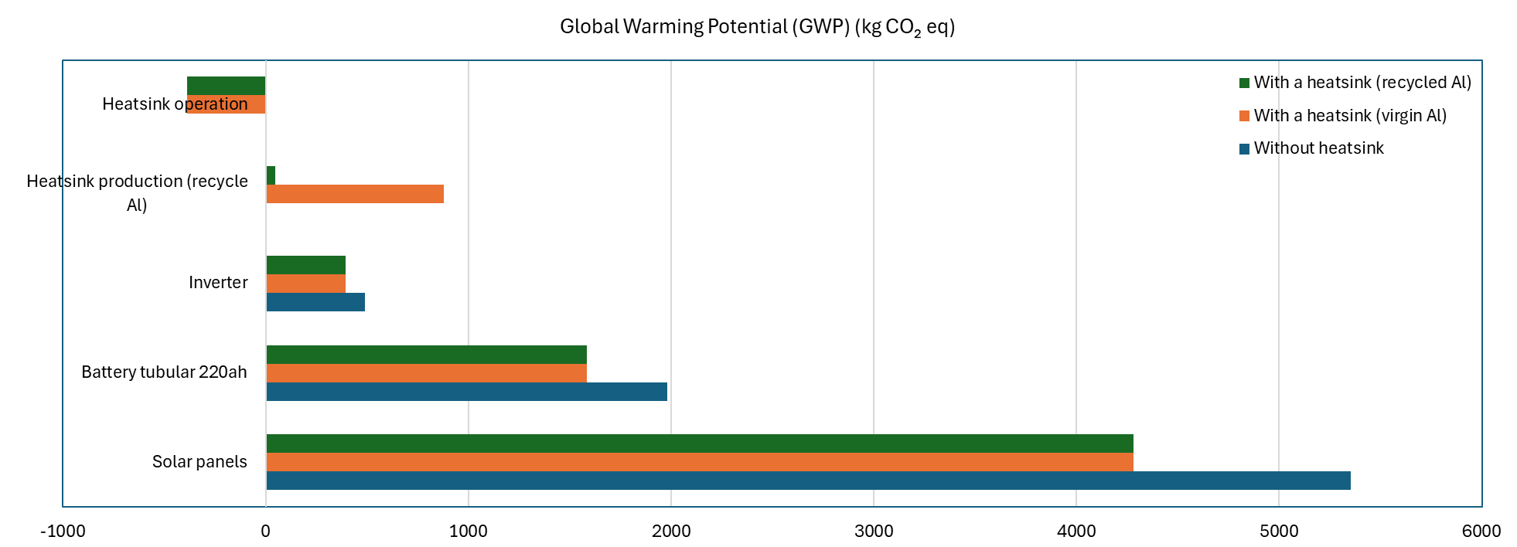
Figure A1 Global Warming Potential (GWP) of the solar power system

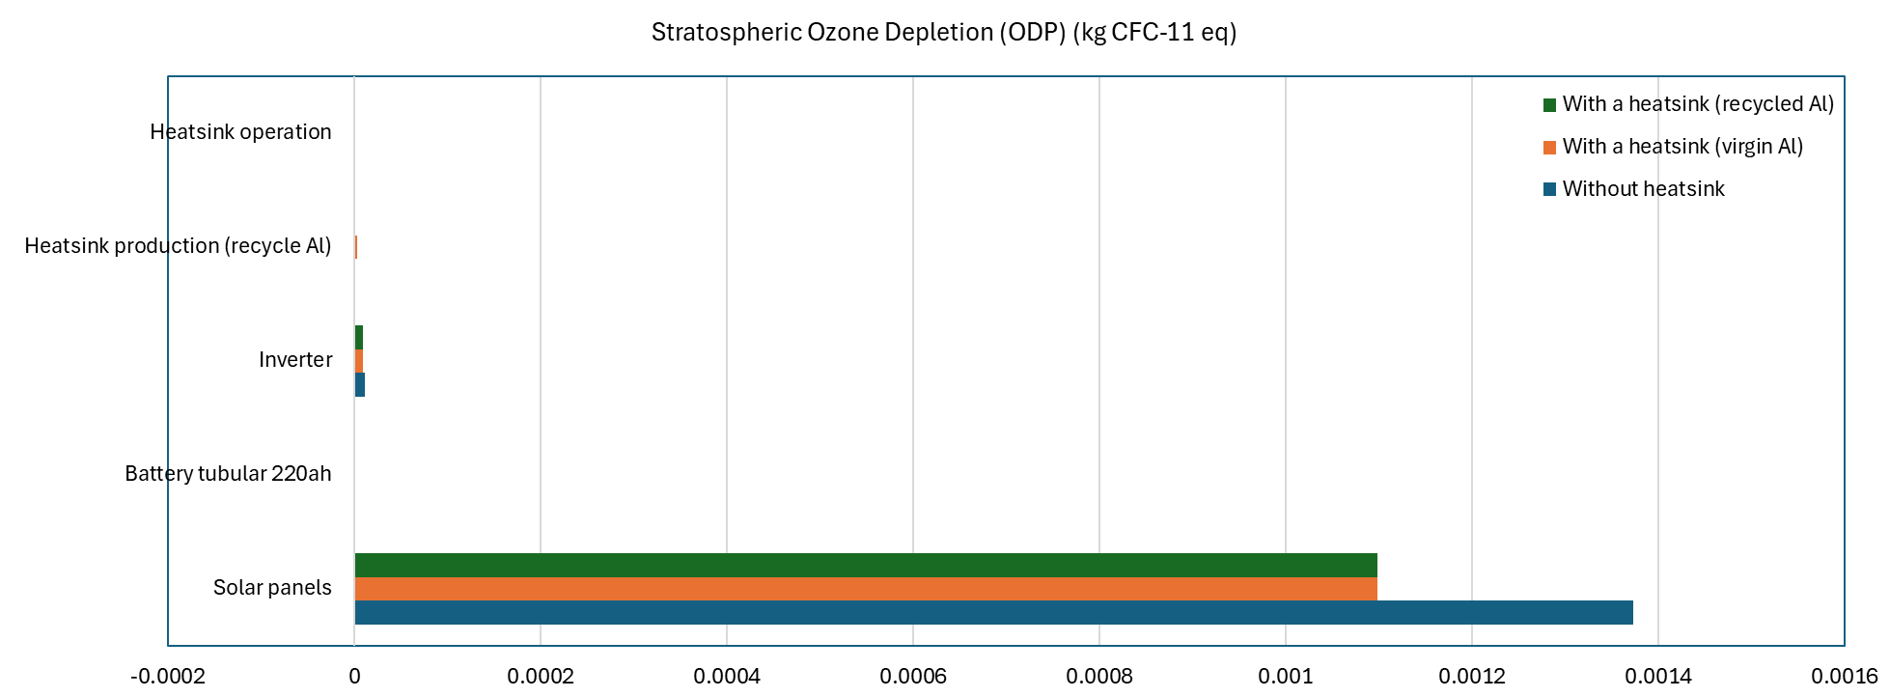
Figure A2 Stratospheric Ozone Depletion (ODP) of the solar power system

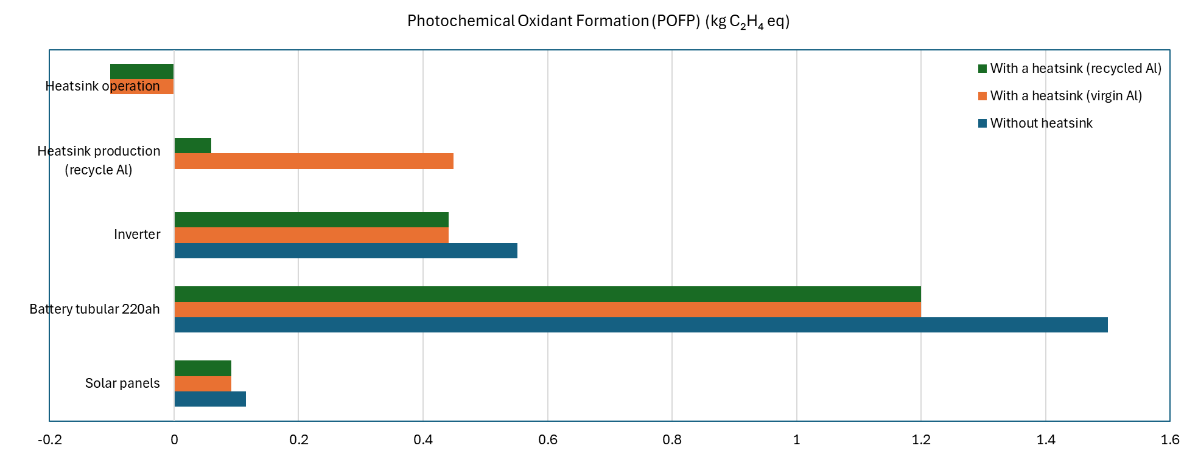
Figure A3 Photochemical Oxidant Formation (POFP) of the solar power system

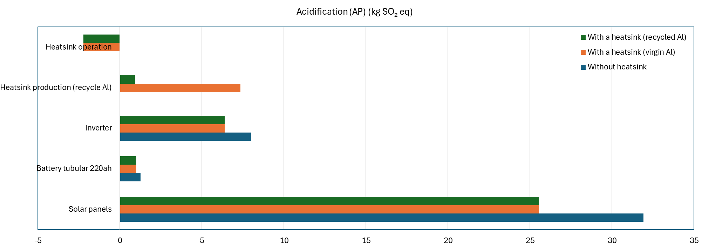
Figure A4 Acidification (AP) of the solar power system

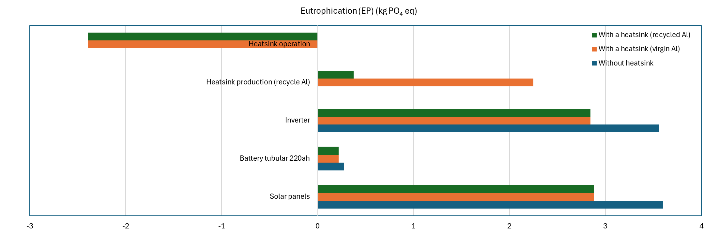
Figure A5 Eutrophication (EP) of the solar power system

