Appendix
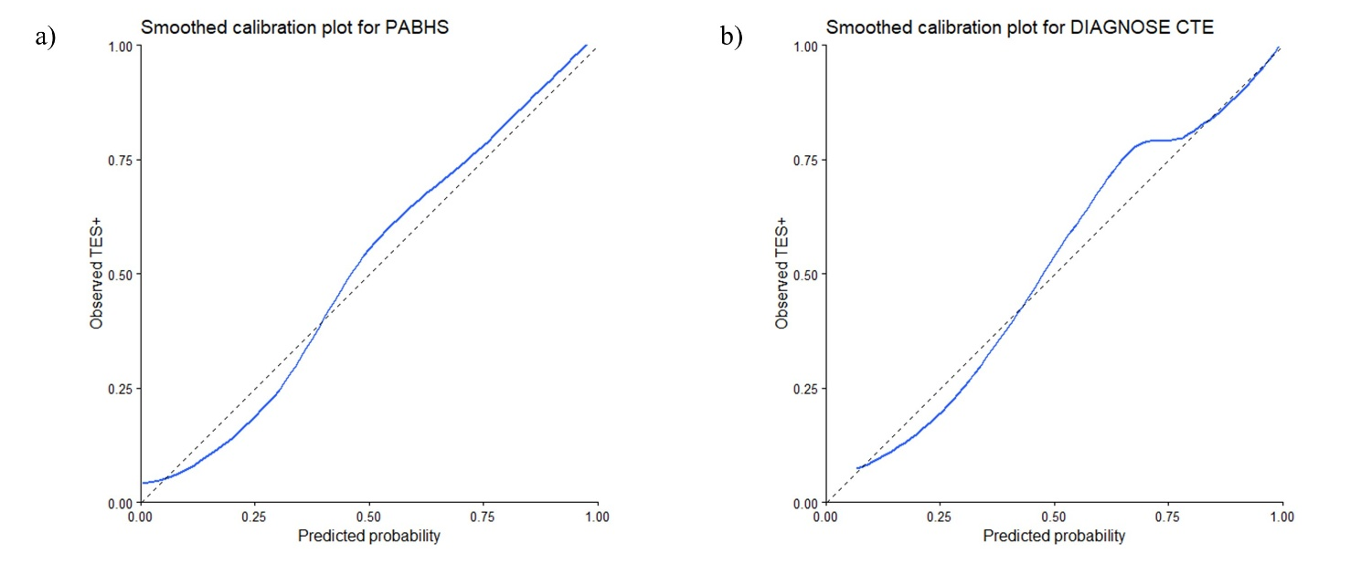
Figure A1. Smoothed Calibration Plots for a) PABHS and b) DIAGNOSE CTE.
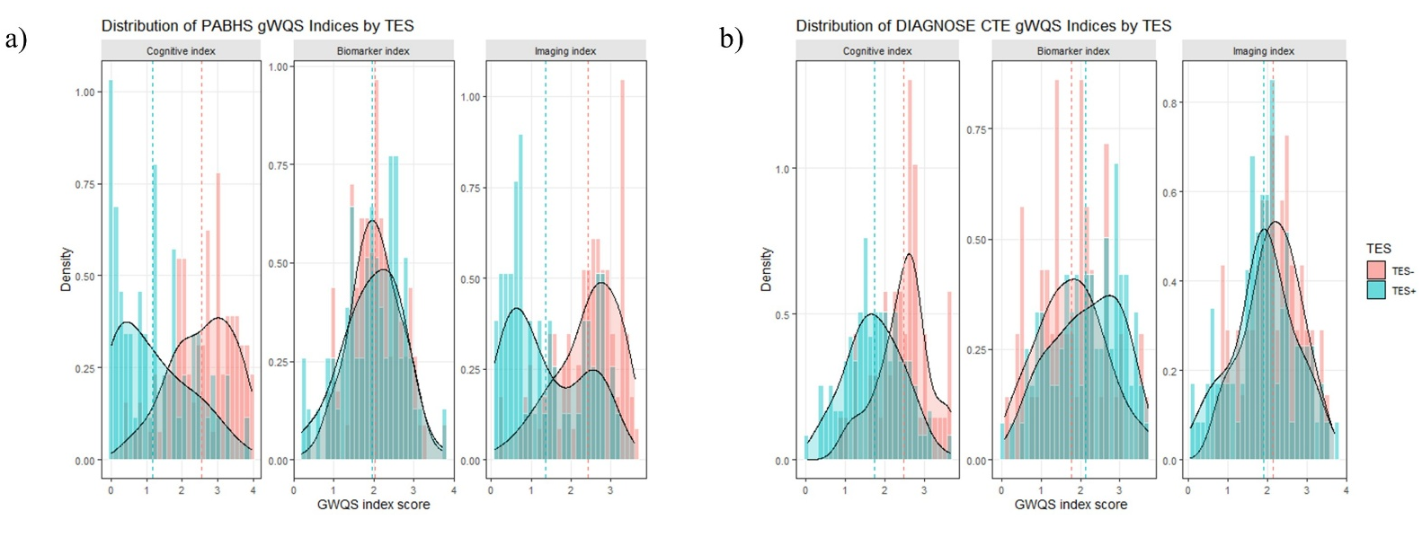
Figure A2. Histograms of the computed indices by TES status in the adjusted multi-index model for a) PABHS and b) DIAGNOSE CTE
Table A3. Summary statistics of weighted indices included in the adjusted models
TES Status | Mean | SD | Min | Q1 | Median | Q3 | Max
PABHS
Positive
Cognitive Index | 1.18 | 1.03 | 0.00 | 0.26 | 0.95 | 1.85 | 3.79
Biomarker Index | 1.95 | 0.74 | 0.20 | 1.45 | 1.99 | 2.50 | 3.72
Imaging Index | 1.37 | 0.97 | 0.08 | 0.56 | 1.05 | 2.32 | 3.15
Negative
Cognitive Index | 2.56 | 0.88 | 0.41 | 1.92 | 2.71 | 3.24 | 3.95
Biomarker Index | 2.03 | 0.62 | 0.36 | 1.63 | 2.03 | 2.46 | 3.72
Imaging Index | 2.43 | 0.80 | 0.24 | 1.93 | 2.56 | 3.02 | 3.62
DIAGNOSE CTE
Positive
Cognitive Index | 1.73 | 0.72 | 0.03 | 1.24 | 1.74 | 2.24 | 3.67
Biomarker Index | 2.14 | 0.89 | 0.06 | 1.49 | 2.19 | 2.90 | 3.73
Imaging Index | 1.91 | 0.82 | 0.07 | 1.47 | 1.94 | 2.45 | 3.70
Negative
Cognitive Index | 2.47 | 0.65 | 0.90 | 2.09 | 2.58 | 2.78 | 3.68
Biomarker Index | 1.77 | 0.86 | 0.14 | 1.15 | 1.81 | 2.24 | 3.74
Imaging Index | 2.15 | 0.67 | 0.67 | 1.68 | 2.22 | 2.53 | 3.50

