Supplementary Information for
Single-Scan Three-Dimensional Atomic Imaging via Electron Ptychographic Interferometry
Ang Li^{1#}, Shuoyuan Huang^{1#}, Yinhang Ma^{1#,†}, Tong Liu¹, Zhaoqing Wang¹, Jingbo Pang¹, Stephen J. Pennycook¹, Hong-Jun Gao^{1,2}, Wu Zhou¹*
¹School of Physical Sciences, University of Chinese Academy of Sciences, Beijing 100049, China
²Institute of Physics, Chinese Academy of Sciences, Beijing, China
†Present address: School of Materials and Energy, University of Electronic Science and Technology of China, 611731, Chengdu, China

# These authors contributed equally: Ang Li, Shuoyuan Huang, Yinhang Ma.
* Corresponding author: wuzhou@ucas.ac.cn

Contents:
Supplementary Notes 1-3
Supplementary Figures 1-14
Supplementary Table 1

Supplementary Note 1: Simulation of electron probe propagation
Numerical simulations using a probe and pure-phase atoms were conducted to study various probe-atom interactions during probe propagation. A 60-kV electron probe can be written as $P\left(r\right)=F\{A\left(k\right)\}$, where $F\{∙\}$ is the Fourier transform and $A\left(k\right)$is the aperture function with a 32 mrad cut-off angle, which is a typical setting in experiments. A pure-phase atom can be written as $O\left(r\right)=e^{iϕ(r)}$, where the phase $ϕ$(r) is a Gaussian function with a peak value of 0.4 rad and a full width of half maximum (FWHM) of 0.4 Å, chosen in reference to the experimental results of ptychographic reconstruction (typically a single atom has a phase <1 rad, and FWHM <0.6 Å).

For electron probe propagation simulations, the probe interacts with an atom placed at the focal plane and produce an exit wave based on the multiplication assumption, $ψ_{exit}\left(r\right)= P\left(r\right)∙O\left(r\right)$. The exit wave then propagates to different planes ($Δz$’s) using Fresnel propagation: $ψ'\left(r\right)|_{z=Δz}= P\{ψ\left(r\right),Δz\}=F^{-1}\{F\left\{ψ\left(r\right)\}∙\exp\left(iπλΔz | k|^{2}\right)\right\}$, where $P\{∙\}$ denotes the Fresnel propagator, $Δz$ is the propagation distance and $λ$ is the wavelength of the electron beam. Because Fresnel propagation obey the principle of reversibility, the backward propagation ($Δz<0)$ is essentially the reversal condition of forward propagation. To isolate the atom induced modulation in the exit wave, probe propagation in vacuum was also simulated by $ψ_{vac}\left(r\right)|_{z=Δz}= P\{P\left(r\right),Δz\}$. The atom-induced amplitude change is defined as the $\frac{\left|ψ_{exit}\left(r\right)\right|}{\left|ψ_{vac}\left(r\right)\right|}-1$. Since the amplitude is also influenced by the atomic potential, we normalize the amplitude change by the atom-induced phase shift, which also encodes atomic potential but not axial information. The normalized amplitude is found near-proportional to the propagation distance (Supplementary Fig. 3).

To simulate probe interaction with an atom placed away from reference plane $(z=0)$ at atomic z-coordinates $z_{a}$ ($z_{a}>0$ means above the reference plane), the probe can be propagated from the reference plane to the atom plane, written as $P'\left(r\right)=P\{P\left(r\right),-z_{a}\}$, where it then interacts with the atom to produce the exit wave $ψ_{exit}\left(r\right)= P'\left(r\right)∙O\left(r\right)$. Then it is propagated back to the reference plane, written as ${ψ'}_{exit}\left(r\right)=P\left\{ψ_{exit}\left(r\right),z_{a}\right\}=P\left\{P\{P\left(r\right),-z_{a}\}∙O\left(r\right),z_{a}\right\}$. Due to the inversion symmetry, this is equivalent to the case where the atom is at $z=0$ and the wave propagates to reference plane placed at$-z_{a}$, a situation discussed earlier. Again, the atom-induced amplitude change here is calculated as $\frac{\left|{ψ'}_{exit}\left(r\right)\right|}{\left|P\left(r\right)∙O\left(r\right)\right|}-1$ to study the atom-induced modulation of the wave function measured at the reference plane. The normalized amplitude change defined as the amplitude change divided by the phase shift of ${ψ'}_{exit}\left(r\right)$ is also near-proportional to the atomic z-coordinate (Fig. 1d).

In the case of a probe interacting with two atoms with different z-coordinates $z_{1}$ and $z_{2}$ (without loss of generality, assume that $z_{1}>z_{2}$), the probe first propagates from the reference plane to the upper atom plane and interacts with the upper atom. Then, it propagates to the lower atom plane, interacts with the lower atom and propagates back to the reference plane. The exit wave detected at the reference plane is then: $ψ_{exit}\left(r\right)|_{z=0}=P\left\{P\left\{P\left\{P\left(r\right),-z_{1}\right\}∙o_{1}\left(r \right)|_{z=z_{1}},z_{1}-z_{2}\right\}∙o_{2}\left(r \right)|_{z=z_{2}},z_{2}\right\}$.

Supplementary Note 2: 3D-coordinates fitting with Gaussian functions
From the ptychography phase image, the coordinates of Mo atoms are first fitted using Gaussian functions. Double-Gaussian functions are then used to fit the lateral coordinates and the phase peak value ($ϕ$) of each S atom pair. Their coordinates are set to be centrosymmetric around the center every three Mo atoms, while their maxima and widths are freely adjustable. The S atom sites with fitted phase values smaller than a threshold (0.12 rad) are identified as vacancies. From the EPI image, the EPI peak value (EPI) of each S atom is also fitted using double-Gaussian function, with lateral coordinates fixed as the phase image fitting results. The normalized amplitude of each S atom is then calculated using $EPI/ϕ^{2}$.

To obtain the z-axis atomic coordinates, we need to estimate the linear relationship between the normalized amplitude and z-coordinates. This is realized by the reconstructed probe function interacting with a Gaussian pure phase atom at different z values using the workflow described in Supplementary Note 1. The pure phase atoms have FWHM of 0.48 Å, chosen as the mean value from Mo atom fitting. Then, the linear slope $k$ can be extracted from the normalized amplitude with respect to the z-axis atom position: $\frac{A-1}{ϕ}=kz$ (Supplementary Fig. 11a). $k$ is then utilized to retrieve the z coordinates of S atoms from the EPI images: $EPI=\left(A-1\right)ϕ=kzϕ^{2}$. Within each S atom pair, S-S distance is calculated using their 3D coordinates (Supplementary Fig. 11b).

Supplementary Note 3: 3D-coordinate fitting with propagation model
A numerical wave propagation model was utilized to obtain the 3D coordinates of atoms from the ptychographic object functions based on the discussion in Supplementary Note 1. When the electron probe $P\left(r\right)$ interacts with an atom $o\left(r,r_{1}\right)$ with an in-plane coordinate of $r_{1}$ and out-of-plane coordinate of $z_{1}$, the exit wave at the reference plane can be written as $ψ\left(r\right)=P\left\{P\left\{P\left(r\right),-z_{1}\right\}×o_{1}\left(r \right)|_{z=z_{1}},z_{1}\right\}$. In this case, the probe is propagated from the reference plane $z=0$ to the atom plane $z=z_{1}$ and then propagated back to the reference plane. If two atoms are located very close in lateral space their modulation upon the wave amplitude would need to be considered together. In this case, the exit wave can then be written as $ψ\left(r\right)=P\left\{P\left\{P\left\{P\left(r\right),-z_{1}\right\}∙o_{1}\left(r \right)|_{z=z_{1}},z_{1}-z_{2}\right\}∙o_{2}\left(r \right)|_{z=z_{2}},z_{2}\right\}$, where $z_{2}<z_{1}$ is the out-of-plane coordinate of the second atom. Finally, the output object function is calculated by $O'\left(r\right)=ψ\left(r\right)/P\left(r\right)$. This would be fitted with the ptychographically reconstructed object function $O\left(r\right)$ to obtain the atomic coordinates.

The fitting is realized through a least-square minimization process: the complex object function $O\left(r\right)$ is broken down to its amplitude $A\left(r\right)$ and phase $ϕ\left(r\right)$, then a total residual function $L=\left|A'\left(r\right)ϕ'\left(r\right)-A\left(r\right)ϕ\left(r\right)\right|+γ\left|ϕ'\left(r\right)-ϕ\left(r\right)\right|$ is minimized with adjustable parameters $\left\{r_{i},z_{i},a,σ,c\right\}$. The two terms in $L$ represent the EPI loss and phase loss, respectively. $r_{i}$ and $z_{i}$ are the lateral and axial atomic coordinates. $a$, $σ$ and $c$ are the amplitude, width and offset of the Gaussian approximated atom object function $o\left(r,r_{i}\right)$. A mixing strength parameter $γ$ is introduced to balance the contribution between object amplitude and phase. Given the relative values of $A$ and $ϕ$ in this dataset, $γ=0.01$ is chosen.

According to the ptychographic reconstruction formalism, at each spatial pixel $R_{j}$, the aforementioned numerical model needs to be applied to obtain $ψ\left(r=0,R_{j}\right)=P\left(r\right)O\left(r-R_{j} \right)$. This means even for a small 16×16 patch of object function, the probe would be propagated 256 times to generate one exit wave function $ψ\left(r\right)$. To save computational time, the exit wave inside a small area centered around an atom $r_{i}$ can be approximated by propagating a probe centered at that atom: $ψ\left(R_{j}\right)≈ψ\left(r-r_{i}\right)$. Now the probe would be propagated once for each atom, resulting in hundreds-fold reduction in computational time.

Here summarizes the workflow of determining the 3D coordinates of all atoms. First, an initial guess of the in-plane coordinates of all atoms is generated by applying the peak finding algorithm to the EPI images. Then for each atom, a 16×16 patch of object function centered around the initial guess coordinate $r_{1}$ is cropped out. The atom in the other layer closest in projection is selected as a paired atom. Let its coordinate be$r_{2}$, and the out-of-plane coordinates for both at $z_{1}$ and $z_{2}$. The total residual function $L\left\{r_{1},z_{1},r_{2},r_{2},a,σ,c\right\}$ is then minimized using the aforementioned method to obtain the fitted positions. If $\left|r_{2}-r_{1}\right|>0.75 Å$, the position of $r_{2}$ is fixed, simulating the situation of an isolated atom; otherwise, all coordinates are adjustable. In both cases, only $\left(r_{1},z_{1}\right)$ is updated as fitted positions. After all atoms in one layer are iterated, this process is repeated for the other layer. The as-fitted coordinates are then iteratively refined by averaging the positions of individual atoms and their three nearest neighbors. The in-plane coordinates are refined for 5 iterations, while the out-of-plane coordinates are refined only once to prevent over averaging.

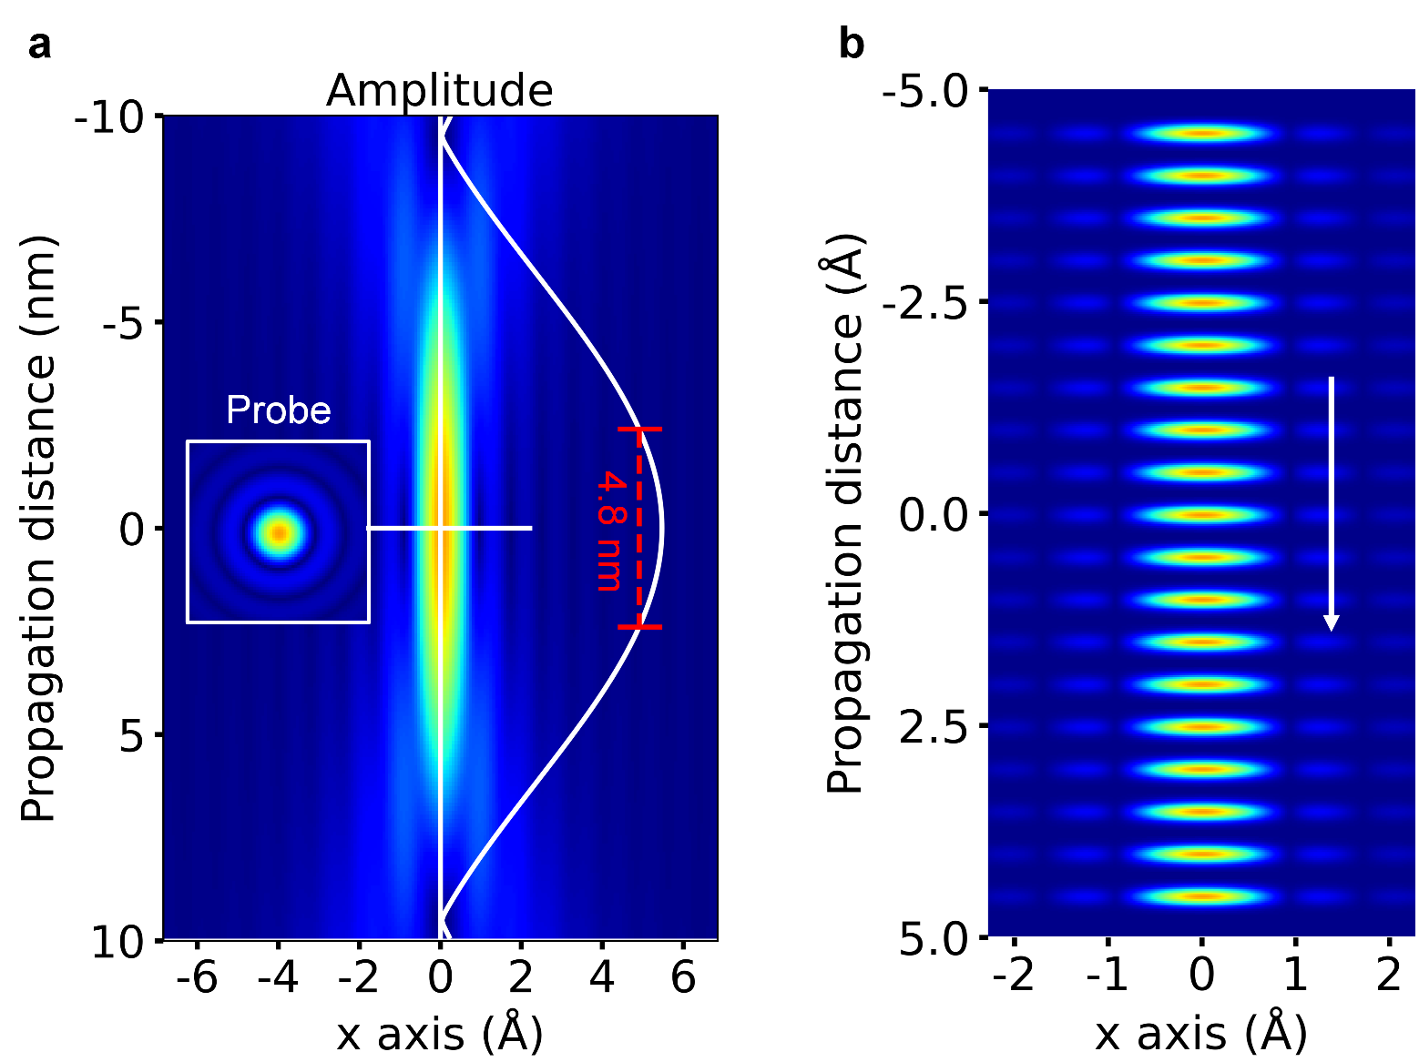
Supplementary Figure 1. Simulation of electron probe propagation in vacuum. a, Amplitude distribution of the electron probe during propagation in vacuum. The inset shows the probe amplitude at the focal plane. The solid white line shows the axial amplitude profile. b, Wavefront evolution of the electron probe propagating in vacuum along the axial direction. Because of the flat wavefront, the axial variation in the electron probe amplitude is minimal, displaying only ~ 10% decay over a 2.4-nm propagation distance.

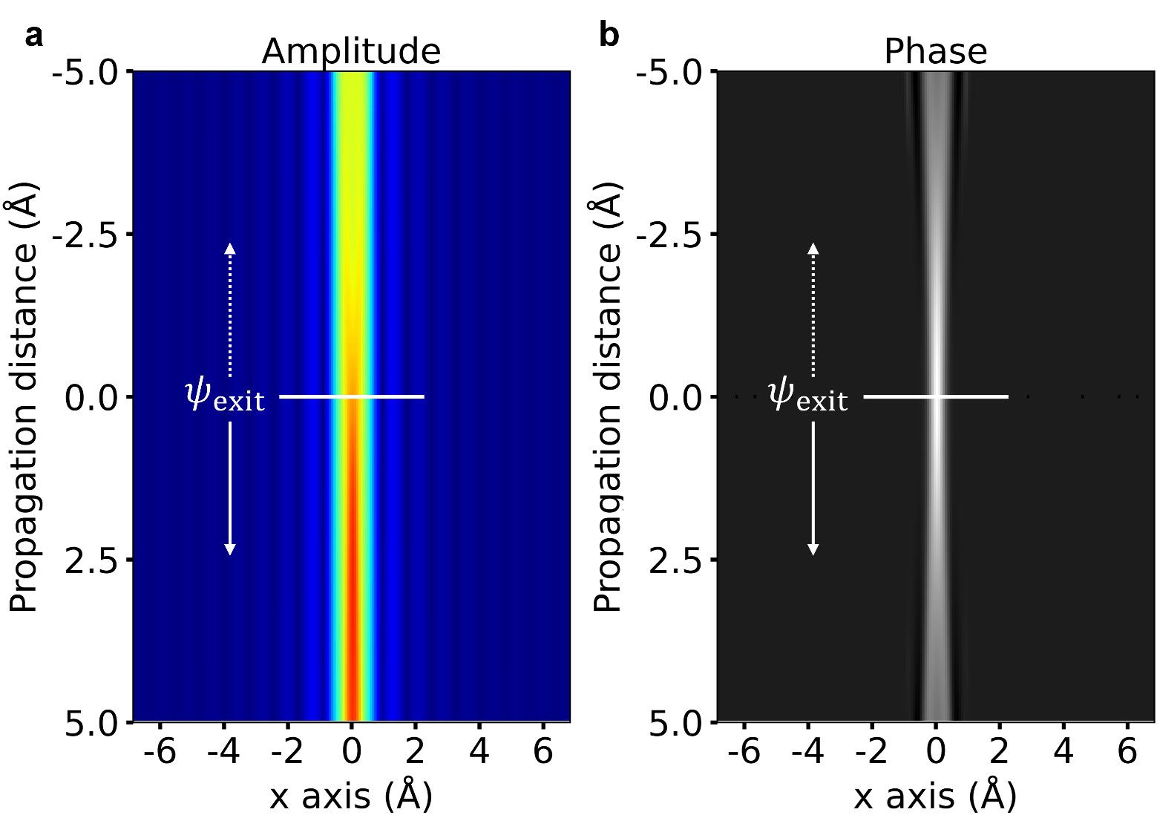
Supplementary Figure 2. Simulation of the atom induced modulation during electron wave propagation. (a) Amplitude and (b) phase evolution of the exit wave. The amplitude modulation increases nearly monotonically with propagation distance, while the corresponding phase shift decreases along the optical axis.

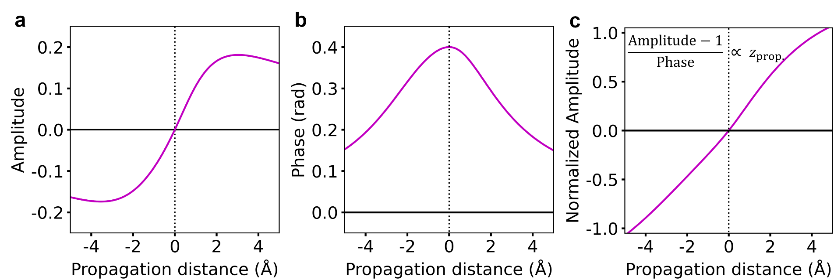
Supplementary Figure 3. Quantitative analysis of atom-induced modulation in the exit wave propagation along the axial position. Axial profiles of the amplitude change (a), phase shift (b) and normalized amplitude change (c) of the exit-wave propagation. The normalized amplitude change is nearly proportional to propagation distance.

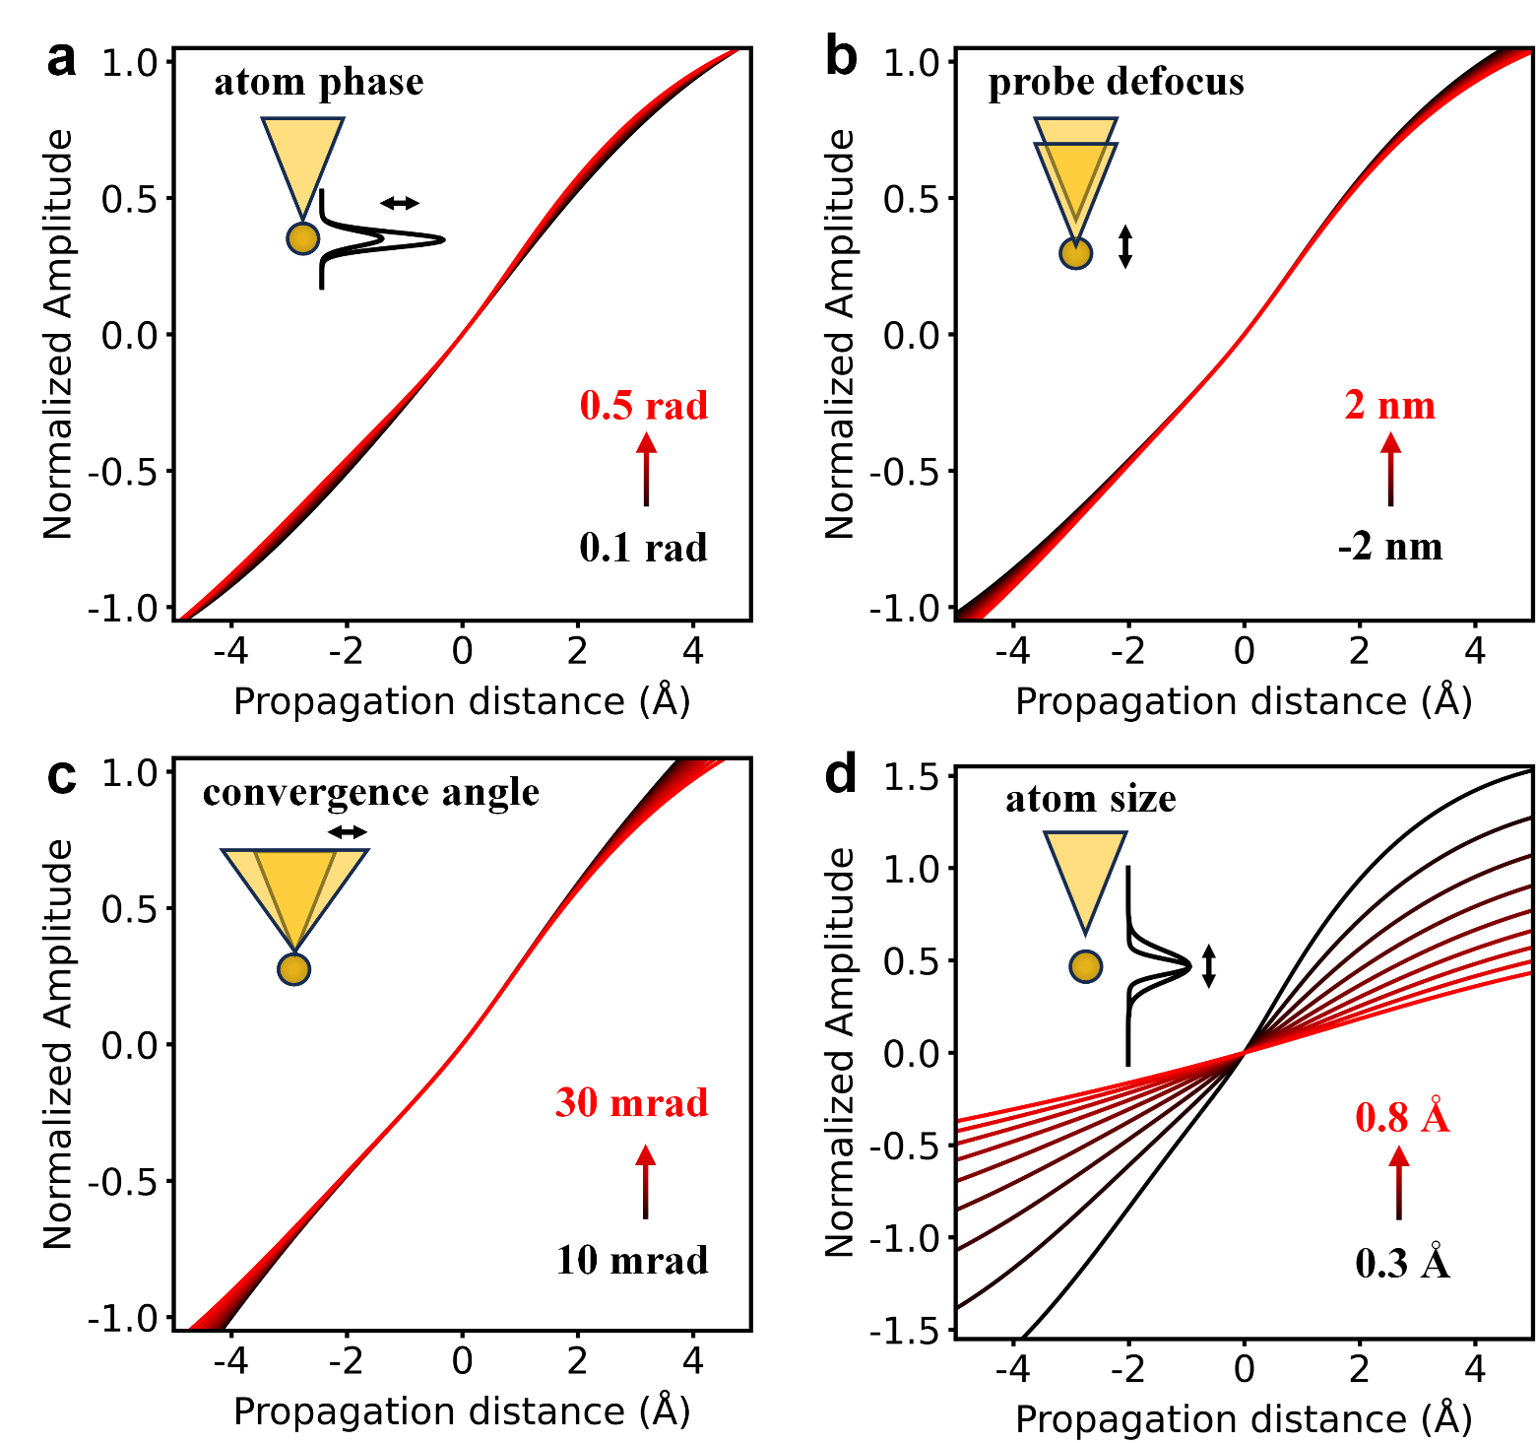
Supplementary Figure 4. Influencing factors on the relationship between the normalized amplitude and propagation distance. a, Effect of atom phase. The linear relationship between normalized amplitude and propagation distance is preserved over a wide range of atom phase. b-c, Effect of probe defocus (b) and convergence angle (c). As these parameters do not change the flat wavefront of the incident electron probe or the curvature of the exit wave, the linear relationship between normalized amplitude and propagation distance is preserved. d, Effect of atom size, quantified by the full width at half maximum (FWHM) of the Gaussian function. As atom size directly affects the exit wave curvature, the slope of the linear relationship decreases significantly with increasing atomic size. Nevertheless, the linearity is maintained under all conditions.

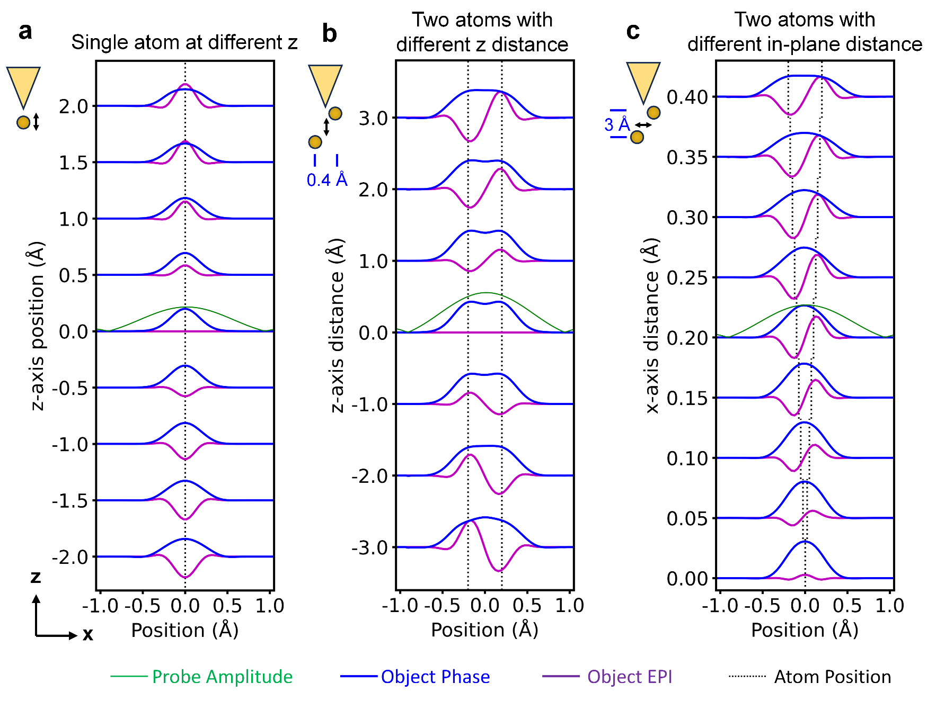
Supplementary Figure 5. Origin of the improved lateral spatial resolution in EPI. a, Simulated phase and EPI line profiles of a single atom at different axial positions. The EPI images exhibit better lateral spatial resolution than conventional ptychographic phase images, as evident by the smaller FWHM of the peaks. The atomic contrast in EPI image is directly correlated with the atom’s axial position. b, Simulated phase and EPI line profiles of two atoms separated laterally by 0.4 Å but positioned at different axial distance. While the atoms are not resolved in object phase, they can be clearly resolved in EPI as long as they are separated along the z-axis. c, Simulated phase and EPI line profiles of two atoms with varying lateral distances and a fixed axial distance of 3 Å. The atoms remain resolvable in EPI even at a lateral separation as small as 5 pm.

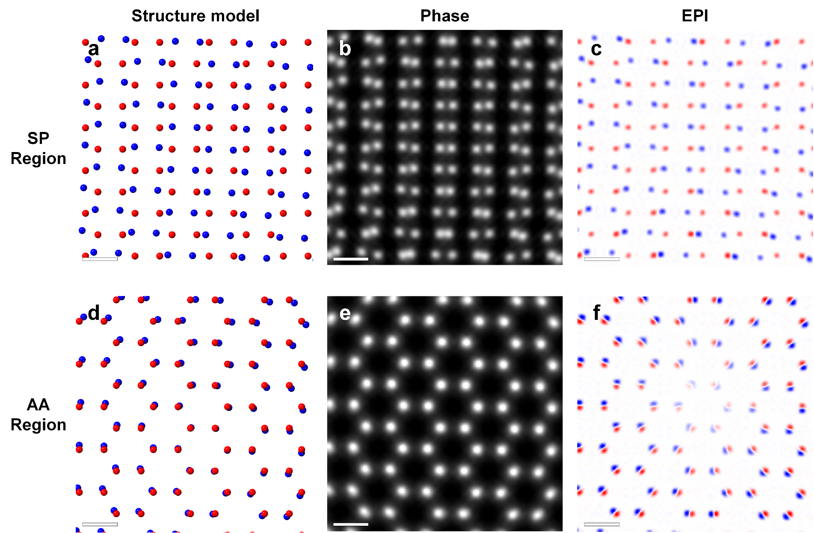
Supplementary Figure 6. EPI results from simulated 4D-STEM dataset of tBLG. a, Structure model of the SP stacked region of tBLG, with carbon atoms in the upper and lower layers shown in red and blue, respectively. b-c, Ptychography reconstructed phase (b) and EPI (c) images of the SP stacked region. d, Structure model of the AA-stacked region, with carbon atoms in the upper and lower layers colored red and blue, respectively. e-f, Ptychography reconstructed phase (b) and EPI (c) images of the AA-stacked region. Scale bars: 0.2 nm (a-f).

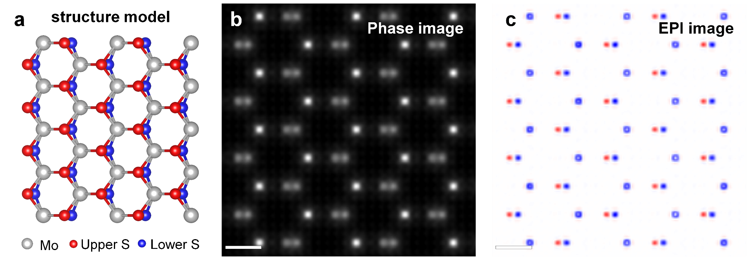
Supplementary Figure 7. EPI results from simulated 4D-STEM dataset of tilted monolayer MoS₂. a, Structure model of monolayer MoS₂ with a 10° tilt. b-c, Ptychography reconstructed phase (b) and EPI (c) images of the tilted MoS₂. S atoms in different sublayers show opposite EPI contrast. Scale bars: 0.2 nm (b, c).

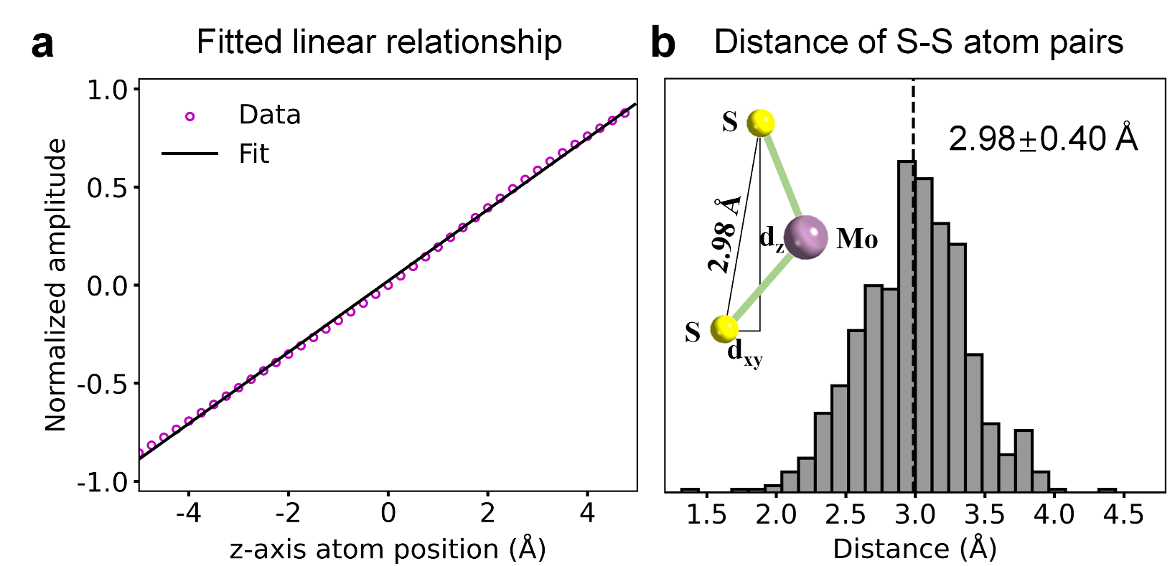
Supplementary Figure 8. EPI analysis of monolayer MoS₂ using Gaussian fitting. a, Linear relationship between the normalized amplitude and the z-axis atomic coordinates, obtained from the reconstructed probe function interacting with a Gaussian pure-phase atom with a FWHM of 0.48 Å. The calculated data points and the fitted line are shown with pink circles and a black line, respectively. b, Histogram of the S-S atom pair distances, with an average value of 2.98 Å and a standard deviation of 0.40 Å. Inset illustrates the structural model with the theoretical S-S distance value indicated.

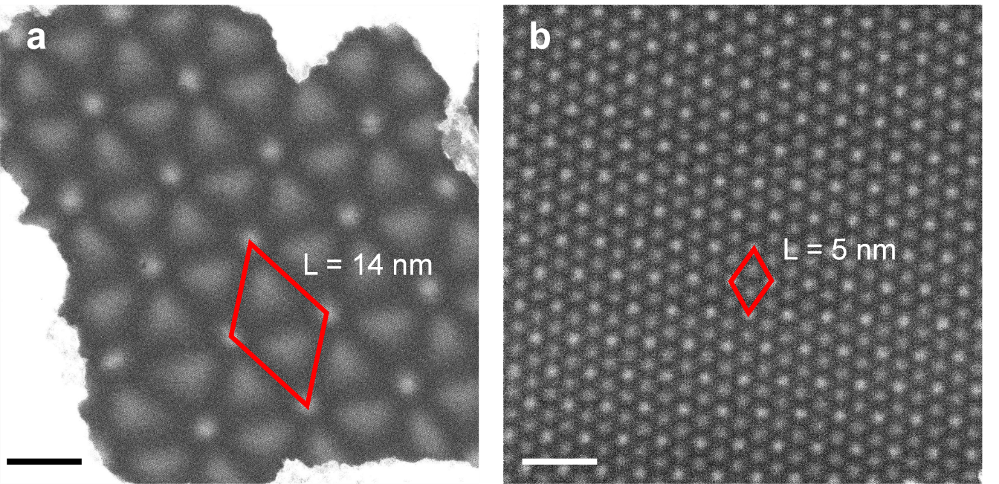
Supplementary Figure 9. STEM-ADF images of tBLG samples. a, STEM-ADF image of a tBLG sample showing a moiré lattice parameter of 14 nm, corresponding to a twist angle of 1°. b, STEM-ADF image of a tBLG sample with a moiré lattice parameter of 5 nm, corresponding to a twist angle of 2.8°. The twist angle $θ$ is calculated from the moiré lattice constant L using $L= \frac{a_{0}}{2sin⁡(θ/2)}$, where $a_{0}=0.246 nm$ is the lattice constant of graphene. Scale bars: 10 nm (a, b).

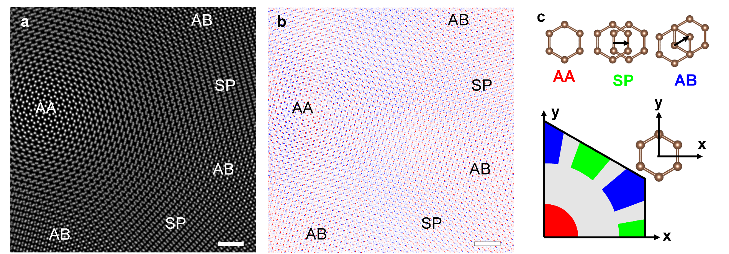
Supplementary Figure 10. Phase and EPI contrast of tBLG with a twist angle of 1°. a-b, Ptychography reconstructed phase (a) and EPI (b) images of tBLG with a twist angle of 1°. c, Identification of different stackings in tBLG based on the displacement vector of each carbon hexagon ring relative to its nearest neighbor in the other layer (marked with arrows). Scale bars: 1 nm (a-b).

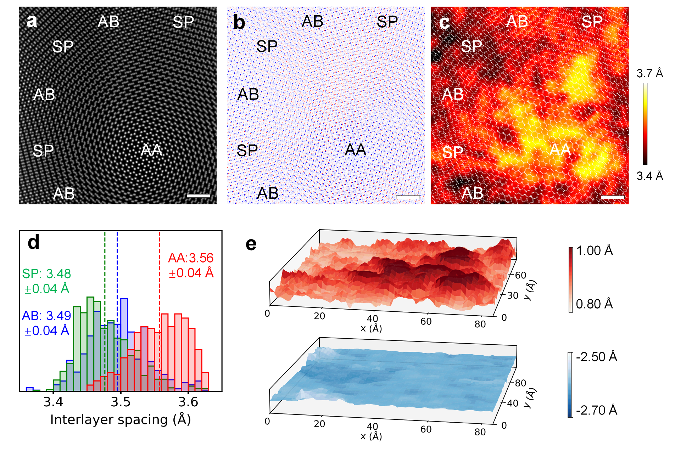
Supplementary Figure 11. Additional results for tBLG with a twist angle of 1°. a-c, Ptychography reconstructed phase image (a), EPI image (b) and interlayer spacing map (c) of tBLG with a twist angle of 1°, showing an increased interlayer spacing in the AA-stacked region. d, Histograms of the interlayer spacing in the AA, AB and SP stacked regions. The AA-stacked region shows a larger interlayer spacing value due to out-of-plane structural relaxation. e, The z-coordinate mapping of the upper (top) and lower (bottom) graphene layers. Scale bars: 1 nm (a-c).

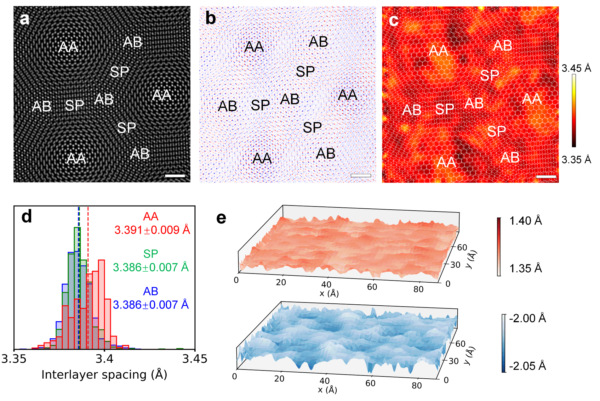
Supplementary Figure 12. Structural relaxation in tBLG with a twist angle of 2.8°. a-c, Ptychography reconstructed phase image (a), EPI image (b) and interlayer spacing map (c) of tBLG with a twist angle of 2.8°, showing slightly increased interlayer spacing in the AA-stacked regions. d, Histograms of the interlayer spacing in the AA, AB and SP stacked regions. The AA-stacked regions show a slightly larger mean interlayer spacing. e, The z-coordinate mapping of the upper (top) and lower (bottom) graphene layers. Scale bars: 1 nm (a-c).

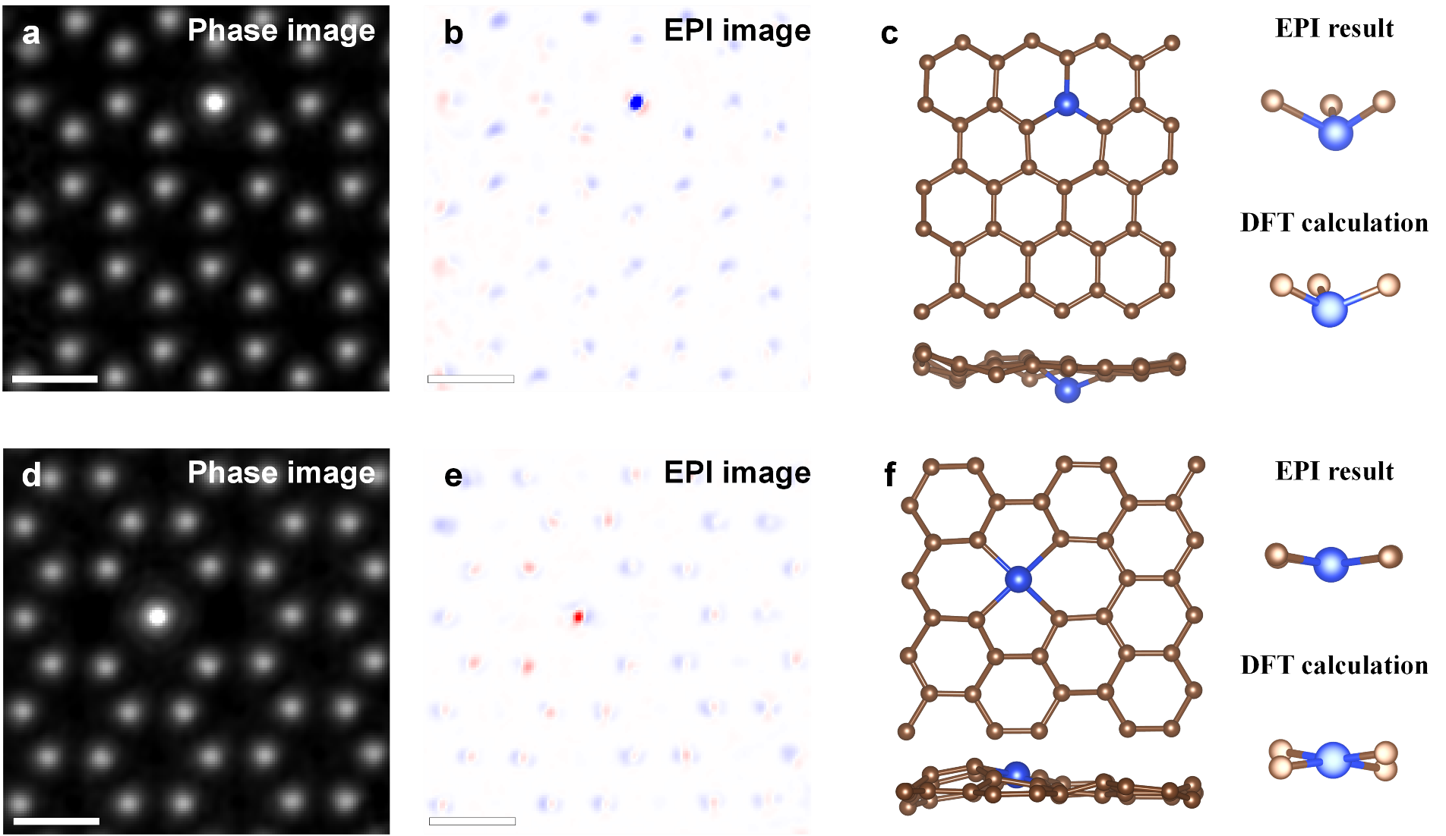
Supplementary Figure 13. Three-dimensional imaging of single Si dopants in monolayer graphene by EPI. a-b, Ptychography reconstructed phase (a) and EPI (b) images of monolayer graphene containing threefold-coordinated Si dopants (Si-C₃). c, 3D atomic structure model derived from EPI using Gaussian fitting approach, showing the Si-C₃ dopants buckled significantly below the graphene plane. The right panel shows the comparison of the buckled Si-C₃ configuration between experiment and DFT calculation. d-e, Ptychography reconstructed phase (d) and EPI (e) images of monolayer graphene containing fourfold-coordinated Si dopant (Si-C₄). f, 3D atomic structure model derived from EPI using Gaussian fitting approach, confirming the Si-C₄ dopant resides nearly within the graphene monolayer. The right panel shows the comparison of the planar Si-C₄ configuration between experiment and DFT calculation. The DFT calculation are taken from reference²¹. Scale bars: 0.2 nm.

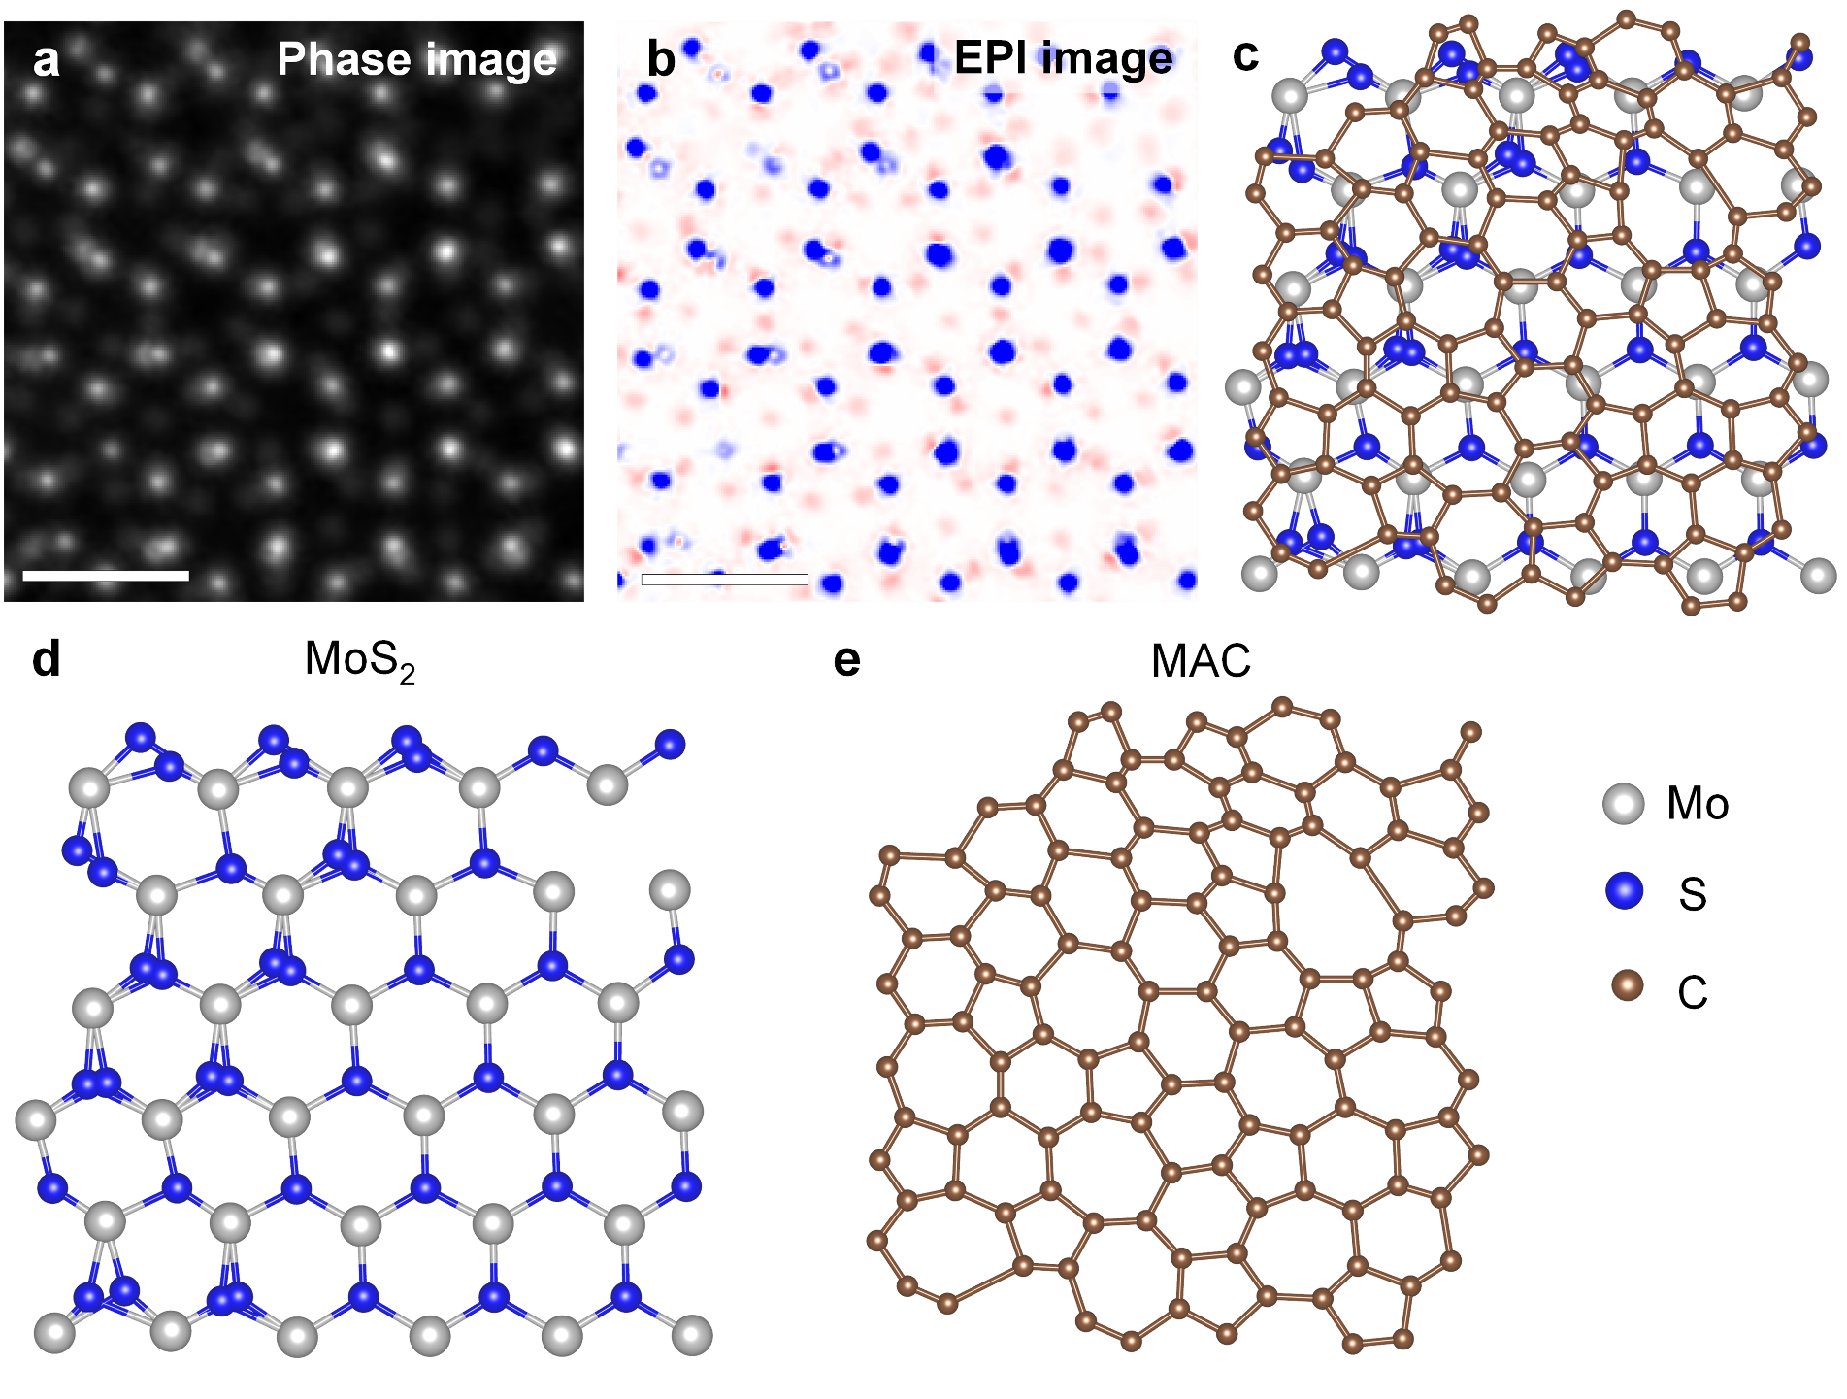
Supplementary Figure 14. Additional results from monolayer MoS₂ with carbon deposition. a-b, Ptychography reconstructed phase (a) and EPI (b) images of monolayer MoS₂ with carbon deposition. The weak positive contrast in EPI image shows the atomic structure of monolayer amorphous carbon (MAC) deposition on the top surface of MoS₂. c-e, Structure model of monolayer MoS₂ with MAC deposition (c), which is deviated from b. Layer separated structure models of MoS₂ and MAC are shown in d and e, respectively. Scale bars: 0.5 nm.

Materials | Voltage | Electron wavelength (λ) | Lateral spatial resolution (R) | R/λ | Methods | Reference
MoS₂ | 80 kV | 0.042 Å | 0.39 Å | 9.34 | Single-slice | 24
PrScO₃ | 300 kV | 0.020 Å | 0.23 Å | 11.7 | Multi-slice | 25
DyScO₃ | 300 kV | 0.020 Å | 0.14 Å | 7.11 | Multi-slice + LOP | 26
SrTiO₃ | 300 kV | 0.020Å | 0.31 Å | 15.7 | Multi-slice + APP | 27
WSe₂ | 200kV  80kV | 0.025 Å  0.042 Å | 0.44 Å  0.41 Å | 17.5  9.82 | Single-slice | 28
tBLG | 60 kV | 0.049 Å | 0.46 Å  0.31Å | 9.45  6.37 | Single-slice  Single-slice + EPI | This work
Supplementary Table 1. Comparison of the lateral spatial resolution achieved in this work with previously reported records from ptychography literature.

