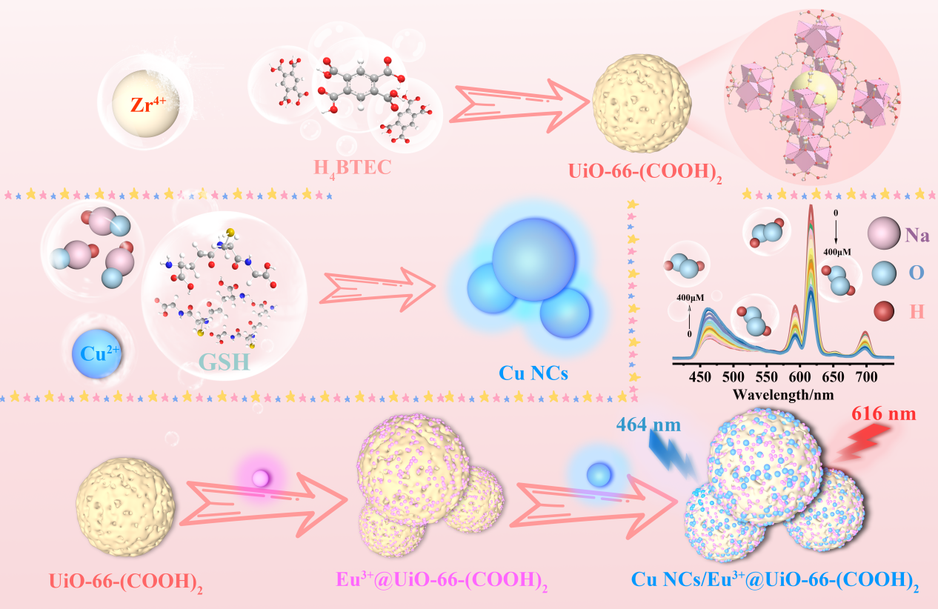
Scheme 1. Synthesis of Cu NCs/Eu³⁺@UiO-66-(COOH)₂.

