Supplementary Materials
Supplemental Table 1. Subgroup analyses of the association between headache and CircS by sex.
Supplemental Table 2. Subgroup analyses of the association between headache and CircS by age.
Supplemental Table 3. Multivariate logistic regression analysis between CircS components and headache.
Supplementary figure 1. Simple diagram of the cross-lagged path analysis model; 2011 represents the baseline period and 2015 represents the follow-up period. Note: Circs, circadian syndrome.

Supplemental Table 1. Subgroup analyses of the association between headache and CircS by sex.
Cohort | Subgroup | Group | Model | OR | 95% CI | P
Headache → CircS | Gender | Male | Model 1 | 1.93 | 1.24-3.00 | 0.0034
Headache → CircS | Gender | Male | Model 2 | 1.94 | 1.25-3.01 | 0.0031
Headache → CircS | Gender | Male | Model 3 | 2.36 | 1.43-3.89 | 0.0007
Headache → CircS | Gender | Female | Model 1 | 0.96 | 0.73-1.27 | 0.7864
Headache → CircS | Gender | Female | Model 2 | 0.96 | 0.73-1.27 | 0.7857
Headache → CircS | Gender | Female | Model 3 | 1.03 | 0.75-1.42 | 0.835
CircS → Headache | Gender | Male | Model 1 | 1.49 | 1.12-1.98 | 0.0055
CircS → Headache | Gender | Male | Model 2 | 1.48 | 1.12-1.96 | 0.0064
CircS → Headache | Gender | Male | Model 3 | 1.65 | 1.20-2.27 | 0.0019
CircS → Headache | Gender | Female | Model 1 | 1.52 | 1.27-1.83 | < 0.001
CircS → Headache | Gender | Female | Model 2 | 1.51 | 1.25-1.82 | < 0.001
CircS → Headache | Gender | Female | Model 3 | 1.54 | 1.26-1.88 | < 0.001

Model 1 was the unadjusted model; Model 2 was adjusted for sex and age; Model 3 was additionally adjusted for education, marital status, residence, BMI, annual household income, smoking, drinking, physical activity, cancer, stroke, and heart disease. CircS: circadian syndrome; OR: odds ratio; 95% CI: 95% confidence interval.

Supplemental Table 2. Subgroup analyses of the association between headache and CircS by age.
Cohort | Subgroup | Group | Model | OR | 95% CI | P
Headache → CircS | Age | <60 | Model 1 | 1.49 | 1.11-1.98 | 0.0073
Headache → CircS | Age | <60 | Model 2 | 1.26 | 0.94-1.68 | 0.1289
Headache → CircS | Age | <60 | Model 3 | 1.52 | 1.09-2.12 | 0.0132
Headache → CircS | Age | ≥60 | Model 1 | 1.18 | 0.79-1.78 | 0.419
Headache → CircS | Age | ≥60 | Model 2 | 0.96 | 0.63-1.46 | 0.8541
Headache → CircS | Age | ≥60 | Model 3 | 0.94 | 0.58-1.51 | 0.7841
CircS → Headache | Age | <60 | Model 1 | 1.7 | 1.38-2.09 | < 0.001
CircS → Headache | Age | <60 | Model 2 | 1.5 | 1.21-1.85 | 0.0002
CircS → Headache | Age | <60 | Model 3 | 1.53 | 1.22-1.93 | 0.0003
CircS → Headache | Age | ≥60 | Model 1 | 1.7 | 1.37-2.13 | < 0.001
CircS → Headache | Age | ≥60 | Model 2 | 1.51 | 1.20-1.90 | 0.0004
CircS → Headache | Age | ≥60 | Model 3 | 1.6 | 1.24-2.06 | 0.0003

Model 1 was the unadjusted model; Model 2 was adjusted for sex and age; Model 3 was additionally adjusted for education, marital status, residence, BMI, annual household income, smoking, drinking, physical activity, cancer, stroke, and heart disease. CircS: circadian syndrome; OR: odds ratio; 95% CI: 95% confidence interval.

Supplemental Table 3. Multivariate logistic regression analysis between CircS components and headache.
Model | Component | OR | 95% CI | P
Model 1 | Abdominal obesity | 0.932 | 0.800-1.086 | 0.368
Model 1 | Hypertriglyceridemia | 1.043 | 0.870-1.250 | 0.649
Model 1 | Low HDL-C | 1.112 | 0.936-1.321 | 0.227
Model 1 | Hypertension | 1.34 | 1.133-1.584 | <0.001
Model 1 | Hyperglycemia | 1.109 | 0.954-1.288 | 0.178
Model 1 | Short sleep | 1.278 | 1.087-1.502 | 0.003
Model 1 | Depression | 2.952 | 2.550-3.417 | <0.001
Model 2 | Abdominal obesity | 0.803 | 0.685-0.940 | 0.006
Model 2 | Hypertriglyceridemia | 1.066 | 0.888-1.279 | 0.496
Model 2 | Low HDL-C | 0.998 | 0.838-1.189 | 0.985
Model 2 | Hypertension | 1.345 | 1.134-1.596 | <0.001
Model 2 | Hyperglycemia | 1.133 | 0.973-1.319 | 0.108
Model 2 | Short sleep | 1.238 | 1.051-1.458 | 0.01
Model 2 | Depression | 2.748 | 2.371-3.185 | <0.001
Model 3 | Abdominal obesity | 0.9 | 0.744-1.089 | 0.28
Model 3 | Hypertriglyceridemia | 1.083 | 0.898-1.305 | 0.404
Model 3 | Low HDL-C | 0.987 | 0.826-1.179 | 0.885
Model 3 | Hypertension | 1.312 | 1.096-1.570 | 0.003
Model 3 | Hyperglycemia | 1.141 | 0.979-1.329 | 0.092
Model 3 | Short sleep | 1.187 | 1.006-1.399 | 0.042
Model 3 | Depression | 2.491 | 2.142-2.896 | <0.001

Model 1 was the unadjusted model; Model 2 was adjusted for sex and age; Model 3 was additionally adjusted for education, marital status, residence, BMI, annual household income, smoking, drinking, physical activity, cancer, stroke, and heart disease. CircS: circadian syndrome; OR: odds ratio; 95% CI: 95% confidence interval; HDL-C: high-density lipoprotein cholesterol.

Supplemental Table 4. Longitudinal association between headache and CircS
Model | Headache(N = 8294) |  | CircS(N = 10201)
 | OR (95% CI) | p | OR (95% CI) | p
Model 1 | 1.39 (1.12-1.72) | 0.003 | 1.74 (1.52-1.99) | <0.001
Model 2 | 1.18 (0.94-1.46) | 0.142 | 1.50 (1.31-1.72) | <0.001
Model 3 | 1.13 (0.73-1.71) | 0.571 | 1.58 (1.23-2.01) | <0.001
Data are presented as odds ratio (95% confidence interval). Model 1 was the unadjusted model; Model 2 was adjusted for sex and age; Model 3 was additionally adjusted for education, marital status, residence, BMI, annual household income, smoking, drinking, physical activity, cancer, stroke, and heart disease. CircS: circadian syndrome; OR: odds ratio; 95% CI: 95% confidence interval.

Headache
(2011)

rl

CircS
(2011)

αl

β1

β2

α2

Headache
(2015)

CircS
(2015)

Supplementary figure 1. A simple schematic diagram of the cross-lagged path analysis model; 2011 represents the baseline period and 2015 represents the follow-up period. Note: Circs, circadian syndrome.

ALL
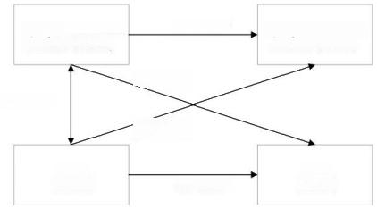
Symptomatic knee arthritis(2011)

r1=0.104*

CireS
(2011)
Symptomatic knee arthritis(2015)

CircS
(2015)
αl=0.321*

βl=0.047*

B2=0.066*

α2=0.439*
B MALE C FEMALE
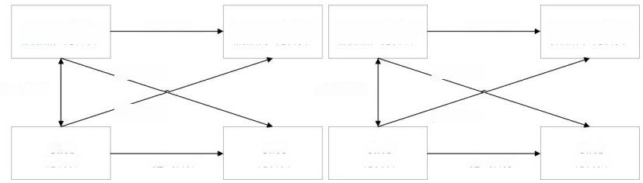
Symptomatic knee arthritis(2011)

βl=0.042*
r1=0.092*
B2=0.043*
CireS
(2011)
CircS CireS
(2015) (2011) α2=0.415*
β1=0.035*

β2=0.054*
Symptomatic knee arthritis(2011)
Symptomatic knee arthritis(2015)
Symptomatic knee arthritis(2015)
CireS
(2015)
α2=0.417*
α1=0.328*
αl=0.292*
rl=0.116*
Supplemental Figure 2.Cross-lagged path with statistical significance;*,P<0.01;

2011 represents baseline and 2015 represents follow-up.Notes,CircS,circadian

syndrome.

