Supporting Information
Time-Resolved Investigation of the Priming Effect of Biodegradable Plastics on Soil Organic Matter Using Radiocarbon Analysis
Sungbin Ju ^{1,†}, Lam Tan Hao ^{1,†}, Semin Kim ¹, Minkyung Lee ², Hyo Jeong Kim ^{1,3}, Hyeonyeol Jeon ^{1,3*}, Jeyoung Park ^{4*}, Dongyeop X. Oh ^{5,*}
¹ Research Center for Bio-based Chemistry, Korea Research Institute of Chemical Technology (KRICT), Ulsan 44429, Republic of Korea
² Technical Support Center for Chemical Industry, Korea Research Institute of Chemical Technology (KRICT), Ulsan 44429, Republic of Korea
³ Advanced Materials & Chemical Engineering, Korea National University of Science and Technology (UST), Daejeon 34113, Republic of Korea
⁴ Department of Chemical and Biomolecular Engineering, Sogang University, Seoul 04107, Republic of Korea
⁵ Department of Materials Science and Engineering, Korea University, Seoul 02841, Republic of Korea
†These authors equally contributed to this work.

*Corresponding authors

E-mail: hyjeon@krict.re.kr; jeypark@sogang.ac.kr; dongyeopoh@korea.ac.kr

Supplementary Data

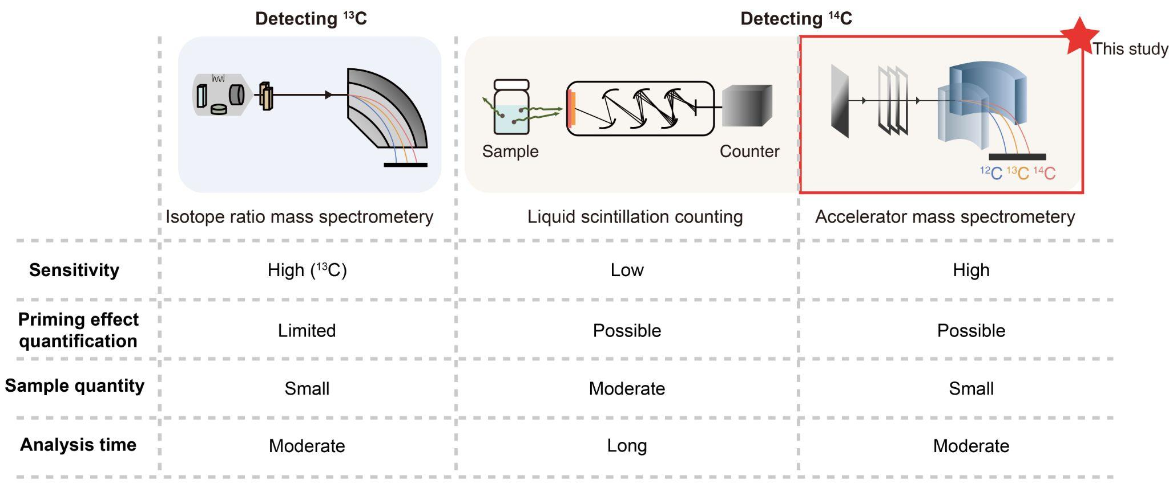
Figure S1. Comparison of carbon-tracing techniques with their analytical advantages and disadvantages. Accelerator mass spectroscopy offers precision over other carbon-tracing techniques, including stable isotope ratio mass spectrometry and liquid scintillation counting for carbon source partitioning.
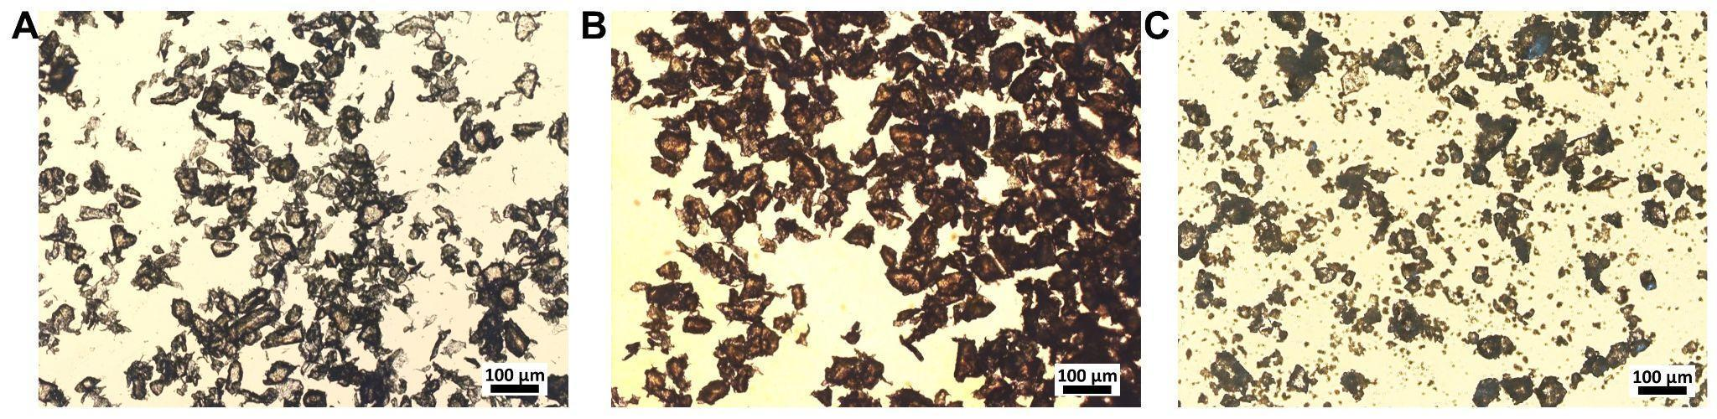
Figure S2. Optical microscope images of microplastics used in this study: (A) poly(ε-caprolactone) (PCL), (B) poly(butylene adipate-co-terephthalate) (PBAT), and (C) polystyrene (PS).
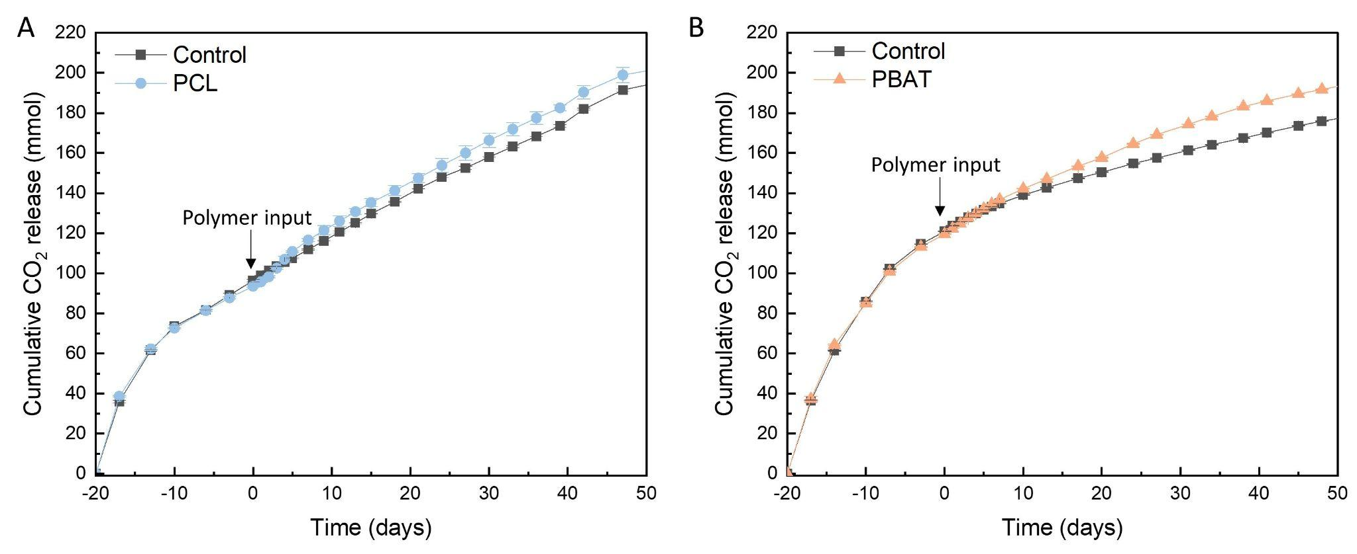
Figure S3. Cumulative CO₂ release from soil (control) and soil amended with (A) PCL and (B) PBAT microplastics (MPs), showing the period of initial activation by glucose addition (prior to day 0), followed by MP addition at day 0.

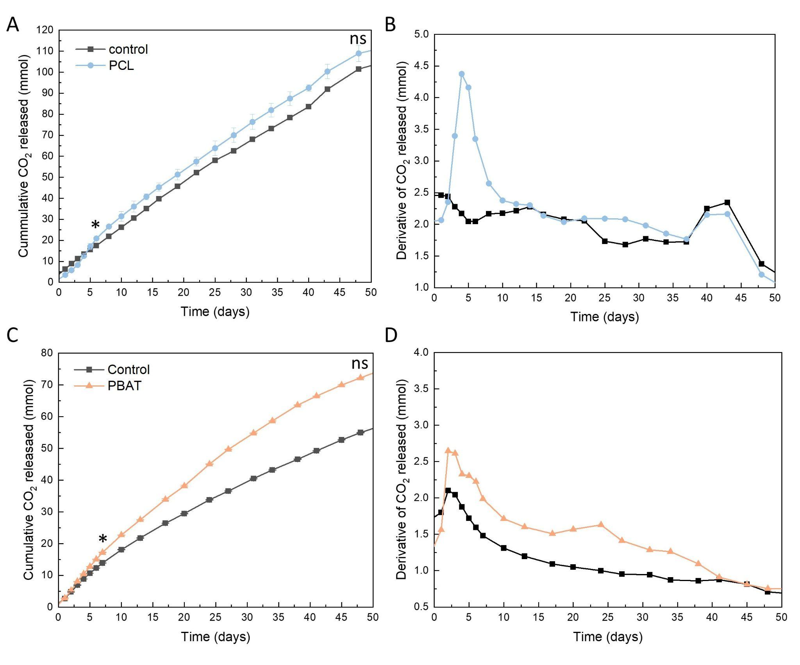
Figure S4. Biodegradation of fossil-based biodegradable microplastics assessed through CO₂ evolution. (Left) Cumulative CO₂ release and (right) its derivative, indicating the rate of CO₂ release, for (A, B) PCL and (C, D) PBAT incubated in soil. Soil without plastic input serves as the blank control. * denotes statistical significance (p < 0.05) between treatment and control at the corresponding sampling time point with two-tailed Student’s t-test; ns: non-significance.
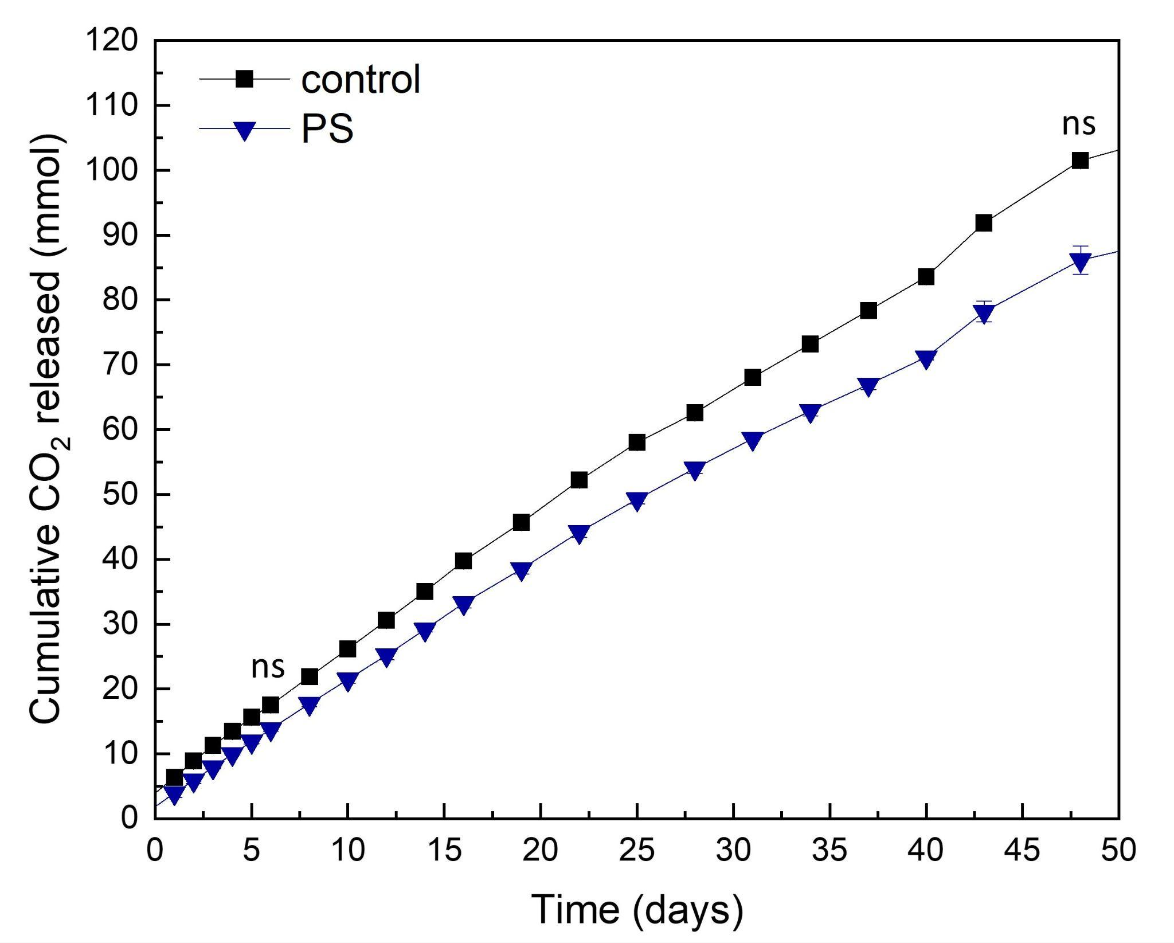
Figure S5. Cumulative CO₂ release from soil and soil with PS input. ns: non-significance (p > 0.05) treatment and control at the corresponding sampling time point using two-tailed Student’s t-test.

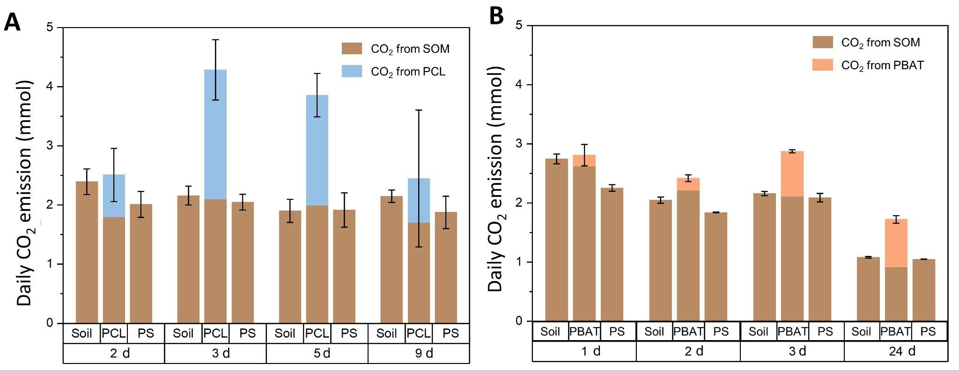
Figure S6. Daily CO₂ emission from soil and soil amended with (A) PCL, and (B) PBAT showing the partitioning between SOM-derived and plastic-derived CO₂.

Table S1. Characterization of the soil before and after incubation
 | Before | Control ª | PCL ª | PBAT ª | PS ª
N(%) | 1.41 | 1.17 | 1.26 | 1.18 | 1.13
P(%) | 1.62 | 1.76 | 1.66 | 1.72 | 1.79
K(%) | 1.15 | 1.30 | 1.38 | 1.31 | 1.39
Organic matter ^{b} (%) | 17.63 | 17.13 | 17.19 | 17.80 | 17.88
C/N ratio | 12.50 | 14.64 | 13.64 | 15.08 | 15.82
Moisture (%) | 28.03 | 20.84 | 24.11 | 24.10 | 20.83

ª Soil samples collected after incubating for 56 d.
^{b} Calculated through combusted weight under 600 °C for 4 h.
Table S2. Percent of modern carbon in BaCO₃ samples obtained from soil amended with microplastics of polycaprolactone (PCL) and poly(butylene adipate-co-terephthalate) (PBAT) at certain time points after plastic input
PCL |  | PBAT
Day | pMC (%) ª | Day | pMC (%) ª
2 | 71.88 (± 0.05) | 1 | 93.42 (± 0.33)
3 | 49.09 (± 0.01) | 2 | 91.44 (± 0.33)
5 | 51.80 (± 0.02) | 3 | 73.57 (± 0.29)
9 | 69.57 (± 0.01) | 24 | 53.39 (± 0.20)
ª Calculated using the atmospheric correction factor of 99.4 (ASTM D6866)

Table S3. AMS-based isotopic analysis of soil, PCL, PBAT, and PS plastic samples

 | ¹⁴C/¹²C (10^{–12}) | pMC (%) ª | δ¹³C (‰)
Phthalic anhydride ^{b} | 0.006 (± 0.00013) | 0.511 (± 0.0001) | −29.0 (± 0.152)
Soil | 1.1061 (± 0.0042) | 98.94 (± 0.003) | −25.7 (± 2.08)
PCL | 0.002 (± 0.00018) | BDL ^{c} | −27.4 (± 0.58)
PBAT | 0.006 (± 0.00005) | 0.005 (± 0.004) | −28.5 (± 1.54)
PS | 0.004 (± 0.00003) | BDL | −28.8 (± 0.92)
ª Calculated by the atmospheric correction factor of 99.4 (ASTM D6866)
^{b} Used for background correction or as a fossil-derived reference
^{c} BDL: Below detection limit

