Supplementary Appendix

Predictive Modeling of Post-Allogeneic Transplant Outcomes Using Machine Learning and Integrated Clinical and Immunogenetic Data: a Study from the SFGM-TC and a Multicenter US Consortium

Stratified Modeling of Allogeneic Results using Transformative data integration-SMART

Simona Pagliuca¹,² Vincent Alcazer³, Mélanie Gaudfrin², Nicole Raus⁴, Anne Huynh^{4,5},
Raynier Devillier^{4,6}, Arda Dumaz⁷, Ashwin Kishtagari⁸, Lukasz Gondek⁹, Mark Juckett¹⁰, Suresh Kumar Balasubramanian¹¹, Marie Robin¹², Ibrahim Yakoub-Agha¹³, Edouard Forcade¹⁴, Claude Eric Bulabois¹⁵, Jean-Baptiste Méar¹⁶, Patrice Chevallier¹⁷, Cristina Castilla Llorente¹⁸, Xavier Poiré¹⁹, Michaël Loschi²⁰, Johan Maertens²¹, Stéphanie Nguyen²², Frédéric Baron²³, Etienne Daguindau²⁴, Natacha Maillard²⁵, Florent Malard²⁶, Alice Aarnink^{27,2}, Maud D’Aveni-Piney^{1,2}, Marie Thérèse Rubio^{1,2}, Francesca Ferraro²⁸, Valeria Visconte⁷, Tobias Lenz²⁹, Carmelo Gurnari^{6,30}, Jaroslaw Maciejewski⁶

1 Department of Hematology, CHRU de Nancy, Vandœuvre-lès-Nancy, France
2 UMR7365-CNRS, IMOPA, University of Lorraine, Vandœuvre-lès-Nancy, France
3 Service d’Hématologie Clinique, Centre Hospitalier Lyon Sud, Hospices Civils de Lyon, Pierre Bénite, France / Université Claude Bernard Lyon 1, CIRI INSERM U1111 - CNRS UMR5308
4 Société Francophone de Greffe de Moelle et de Thérapie Cellulaire (SFGM-TC) Centre Hospitalier Lyon Sud Pierre-Bénite France.
5 Hematology unit, Institut Universitaire de Cancerologie de Toulouse, Oncopole, Toulouse, France.
6 Programme de Transplantation & Therapie Cellulaire, Marseille, France.
7 Department of Translational Hematology and Oncology Research, Cleveland Clinic, Cleveland, OH, USA.
8 Division of Hematology Oncology, Department of Medicine, Vanderbilt University Medical Center, Nashville, Tennessee.
9 Sidney Kimmel Comprehensive Cancer Center, Johns Hopkins University School of Medicine, Baltimore, MD
10 Department of Hematology, University of Minnesota, Minneapolis,
11 Department of Oncology, Karmanos Cancer Institute/ Wayne State University, Detroit, MI
12 Hematology and Transplantation Unit, Saint Louis Hospital, Paris, France.
13 CHU de Lille, Univ Lille, INSERM U1286, Infinite, 59000, Lille, France.
14 Service d'Hématologie Clinique et Thérapie Cellulaire, CHU Bordeaux, F-33000, Bordeaux, France.
15 CHU Grenoble Alpes-Université Grenoble Alpes, Grenoble, France.
16 Centre Hospitalier Universitaire de Rennes, Rennes, France.
17 Hematology Department, CHU Hotel-Dieu, Nantes, France.
18 Gustave Roussy Cancer Campus Grand Paris, Hematology Department, Villejuif, France
19 Department of Hematology, Institut Roi Albert II, Cliniques Universitaires St-Luc, Brussels, Belgium.
20 Department of Hematology, Hôpital L'Archet, Centre Hospitalier Universitaire de Nice, Nice, France.
21 Department of Haematology, University Hospitals Leuven, Leuven, Belgium.
22 Department of Hematology, Centre Hospitalier Universitaire Pitié-Salpêtrière, Assistance Publique-Hôpitaux de Paris, Paris, France.
23 Department of Hematology, CHU Sart-Tilman University of Liege, Liege, Belgium.
24 Department of Hematology, Jean Minjoz University Hospital, Besancon, France.
25 Hematology unit, Poitiers university hospital, Poitiers, France.
26 Department of Clinical Hematology and Cellular Therapy, Saint-Antoine Hospital, AP-HP, Sorbonne University, INSERM UMR 938, Centre de Recherche Saint-Antoine, Paris, France.
27 HLA and Histocompatibility Laboratory, CHRU de Nancy, Vandœuvre-lès-Nancy, France.
28 Division of Oncology, Department of Medicine, Washington University School of Medicine (WUSM), St. Louis, Missouri.
29 Research Unit for Evolutionary Immunogenomics, Department of Biology, Universität Hamburg, Hamburg, Germany.
30 Department of Biomedicine and Prevention, University of Rome Tor Vergata, Rome, Italy.

Corrisponding author : Simona Pagliuca, s.pagliuca@chru-nancy.fr, simona.pagliuca@univ-lorraine.fr

Supplementary Methods

Study design and patient population

This multicenter, international retrospective cohort study included 16,028 adult patients who underwent first allo-HCT for hematological malignancies between 2010 and 2022. The training and internal validation cohort was derived from the Societe Francophone de Greffe de Moelle et de Therapie Cellulaire (SFGM-TC) registry, comprising 13,979 patients transplanted at French centers. This cohort was randomly split (70:30) into a training set (N=9,840) and a hold-out test set (N=4,139), with stratification to ensure balance across clinical and immunogenetic variables. A multi-variable stratification approach was employed to ensure balanced representation of key prognostic factors in both training and test sets. The stratification was based on variables known to influence transplant outcomes in hematologic malignancies :
- Donor Type: MSD, MUD, MMUD, Haploidentical, Cord Blood
- Disease: 10 disease categories (AML, MDS, ALL, MPN, B-NHL, T-NHL, HL, CLL/PLL, MM/PCL, MDS/MPN)
- Age Categories: <50, 50-64, 65+ years
- Conditioning Intensity: Myeloablative (MAC) vs Reduced Intensity (RIC)
The stratified split was performed using scikit-learn's train_test_split function with stratification on combined categorical variables. Random seed 123 was used for reproducibility.
After excluding patients with missing outcome data or covariates, the analysis included 9,196 patients in the training set and 3,826 patients in the test set with complete data for all model variables.
The external validation cohort comprised 1,931 patients from five US transplant centers: Cleveland Clinic Foundation (CCF, n=344), Johns Hopkins (JH, n=354), Karmanos Cancer Institute (KARM, n=404), University Hospitals (UH, n=253), and Vanderbilt University Medical Center (VAND, n=576). After applying eligibility criteria (valid GRFS outcome), 1,700 patients were available for analysis. A total of 616 patients with complete data for all model variables were included in the final external validation.

Inclusion criteria were: (1) age >= 18 years at transplant; (2) first allo-HCT; (3) hematological malignancy as primary indication; (4) complete recipient and donor HLA typing at high resolution for loci A, B, C, DRB1, and DQB1; and (5) available outcome data. Patients receiving second transplants, those with non-malignant indications, or those with incomplete HLA typing were excluded.

HLA typing and HLA evolutionary divergence calculation

High-resolution HLA typing (minimum 4-digit/2-field resolution) was performed using sequence-based typing or next-generation sequencing at accredited histocompatibility laboratories. HED was calculated for each HLA locus, as previously shown, using the Grantham distance-based algorithm, which quantifies the physicochemical divergence between the antigen binding sites of two alleles carried by an individual at each locus. For each HLA molecule, the Grantham distance between amino acid sequences of the peptide-binding domain was computed. HED values were calculated separately for loci A, B, C, DRB1, DQB1, and DPB1 (when available). Total HED was defined as the sum of locus-specific HED values for A, B, C, DRB1, and DQB1. Class I HED comprised the sum of A, B, and C, while Class II HED included DRB1 and DQB1. HED values were computed independently for recipients and donors. Delta HED was defined as the difference between donor and recipient total HED (donor minus recipient).

Clinical variables and outcomes

Clinical and demographic variables were extracted from registry databases, including recipient age at transplantation (years), recipient sex, underlying diagnosis (acute myeloid leukemia [AML], acute lymphoblastic leukemia [ALL], myelodysplastic syndromes [MDS], myeloproliferative neoplasms [MPN], MDS/MPN overlap, B-cell non-Hodgkin lymphoma [B-NHL], T-cell non-Hodgkin lymphoma [T-NHL], Hodgkin lymphoma [HL], chronic lymphocytic leukemia/prolymphocytic leukemia [CLL/PLL], or multiple myeloma/plasma cell leukemia [MM/PCL]), disease status at transplantation (complete remission [CR] vs active disease [AD]), donor type (matched sibling donor [MSD], matched unrelated donor [MUD], mismatched unrelated donor [MMUD], haploidentical donor [Haplo], or cord blood [CB]), donor age (years), stem cell source (peripheral blood stem cells [PBSC], bone marrow [BM], or cord blood [CB]), conditioning intensity (myeloablative conditioning [MAC] vs reduced-intensity conditioning [RIC]), graft-versus-host disease prophylaxis (calcineurin inhibitor [CNI] alone, CNI plus mycophenolate mofetil [MMF], CNI plus methotrexate [MTX], or other), and in vivo T-cell depletion (anti-thymocyte globulin [ATG], post-transplant cyclophosphamide [PTCy], ATG+PTCy, or other).
The primary endpoint was GRFS defined as survival without grade III-IV acute GvHD, extensive chronic GvHD, disease relapse, or death from any cause. Time to GRFS event was calculated from date of transplant to first occurrence of any component event. Patients without events were censored at the date of last follow-up. Secondary endpoints included overall survival (OS), defined as time from transplantation to death from any cause. Relapse was defined as recurrence of the underlying malignancy after transplantation and was analyzed with death as a competing event; non-relapse mortality (NRM) was defined as death occurring in the absence of prior relapse and was analyzed with relapse as the competing event.
Acute and chronic GvHD were also evaluated using cumulative incidence methods: for acute GvHD, death before day 100 was treated as a competing event, and for chronic GvHD, death at any time was treated as a competing event. Acute GvHD was graded according to the maximum clinical grade (with a focus on grade III–IV), and chronic GvHD was categorized by severity, emphasizing extensive forms requiring systemic therapy.

Machine learning model development

Three complementary survival modeling approaches were implemented to assess the contribution of immunogenetic information:

1. An ensemble method based on survival trees (Random survival forest, RSF), trained with 1,500 trees, minimum node size of 15, and 10 random splits per node. RSF handles non-linear relationships and variable interactions without requiring explicit specification.

2. XGBoost Survival: A gradient-boosted survival model using the Cox partial likelihood objective, with hyperparameters optimized via 5-fold cross-validation (learning rate 0.01-0.1, max depth 3-6, subsample 0.7-0.9).

3. Cox Proportional Hazards with Elastic Net: Penalized Cox proportional hazards regression combining L1 (lasso) and L2 (ridge) penalties. The mixing parameter (alpha) and regularization strength (lambda) were optimized via cross-validation.

For each approach, two models were trained: (1) a clinical model using 9 standard pre-transplant variables (patient age, patient sex, disease, disease status, donor type, donor age, stem cell source, conditioning intensity, GvHD prophylaxis); and (2) a full model adding 10 HED variables (locus-specific HED at A, B, C, DRB1, DQB1 for both recipient and donor). Models were trained on the training set (N=9,196 with complete data) and evaluated on the internal test set (N=3,826 with complete data).

Model evaluation and validation

Discriminatory performance was assessed using Harrell's concordance index (c-index) with 95% confidence intervals derived from 1,000 bootstrap resamples. Time-dependent AUC was calculated at 1, 2, and 5 years. Calibration was assessed by comparing predicted and observed event rates across risk deciles. Internal validation used the held-out test set, while external validation applied the trained RSF model to the US multicenter cohort without recalibration.
For risk stratification, patients were categorized into low, intermediate, and high-risk groups using tertiles of the predicted cumulative hazard score derived from the trained RSF model. Cutpoints (score <103 for low, 103-143 for intermediate, >143 for high) were established in the training set and applied unchanged to validation cohorts. Kaplan-Meier survival curves were generated for each risk category and compared using log-rank tests.

Simulation Studies

To characterize the relationship between HED and predicted GRFS risk across clinically relevant scenarios, we performed simulation studies using the trained RSF model. A reference clinical profile was defined (56-year-old male with AML in complete remission, receiving peripheral blood stem cells with reduced-intensity conditioning and CNI/MMF prophylaxis). HED values were varied systematically across their observed range while holding clinical variables constant.
For matched donor transplants, total HED was varied from 0 to the 95th percentile for both recipient and donor to generate risk surfaces. For haploidentical transplants, a 7x7 matrix of recipient-donor HED combinations (P5, P10, P25, P50, P75, P90, P95) was generated to identify optimal donor selection strategies. For 9/10 mismatched unrelated donor transplants (N=1,326), simulations were stratified by mismatched locus (A, B, C, DRB1, or DQB1) to quantify locus-specific HED effects.

Statistical Analysis

Continuous variables were summarized as median with interquartile range (IQR) and compared using Wilcoxon rank-sum tests. Categorical variables were presented as frequencies with percentages and compared using chi-squared or Fisher's exact tests. Survival outcomes were estimated using the Kaplan-Meier method and compared with log-rank tests. Multivariable Cox proportional hazards models were used to assess associations between HED and time-to-event outcomes, adjusted for relevant clinical covariates. Competing risks for relapse and NRM were handled using Fine-Gray subdistribution hazards models.
Missing data patterns were assessed across all variables. After complete-case analysis for model training (requiring complete data for all 19 predictors), 9,196 patients remained in training and 3,826 in test sets. Missing data were not imputed.
All analyses were performed using R version 4.2.0 with packages survival, randomForestSRC, xgboost, glmnet, survminer, and ggplot2. A two-sided P-value <0.05 was considered statistically significant.

SMART Tool development
Given the well-documented non-linear relationship between recipient age and non-relapse mortality (NRM) and to avoid bias related to the absence in both French and US cohorts of elderly patients receiving myeloablative conditioning (MAC) procedures, a post-hoc calibration was applied to the RSF model predictions. This calibration accounts for: (1) the exponential increase in NRM observed in patients aged >60 years, and (2) the interaction between advanced age and myeloablative conditioning intensity.
The calibration formula is:
- Base age adjustment = (age − 60)^1.5 × 1.5 for patients >60 years
- MAC interaction = (age − 55) × 2 + (age − 65) × 3 for patients receiving MAC aged >55/65 years
This calibration reflects findings from EBMT and CIBMTR registries demonstrating age-dependent increases in transplant-related complications, particularly in elderly patients receiving intensive conditioning regimens The final calibrated risk score was used for patient stratification into Low (<103.09), Intermediate (103.09–143.13), and High (>143.13) risk groups. For mismatched donor transplantation, the tool displays the patient's position on the U-shaped HED-risk curve, highlighting whether HED optimization through alternative donor selection could improve predicted outcomes.
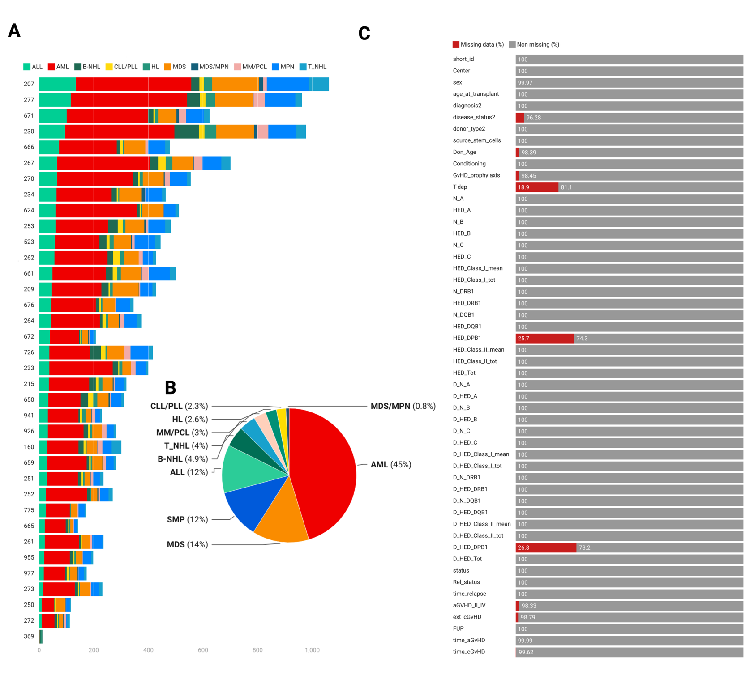
Figure S1. Cohort composition and data completeness in the model development dataset.
(A) Center-level contribution to the study population. Horizontal stacked bars show the number of transplanted patients contributed by each participating center (y-axis labels), with colors indicating underlying disease categories.
(B) Overall distribution of malignant diagnoses in the full cohort, displayed as proportions of the total population.
(C) Missingness profile across study variables. For each clinical, outcome, and immunogenetic feature, bars indicate the percentage of missing (red) and non-missing (grey) observations. Overall completeness was high for most variables, with the most notable missingness observed for T-cell depletion status and HLA-DPB1–related fields (recipient and donor), consistent with registry reporting patterns.

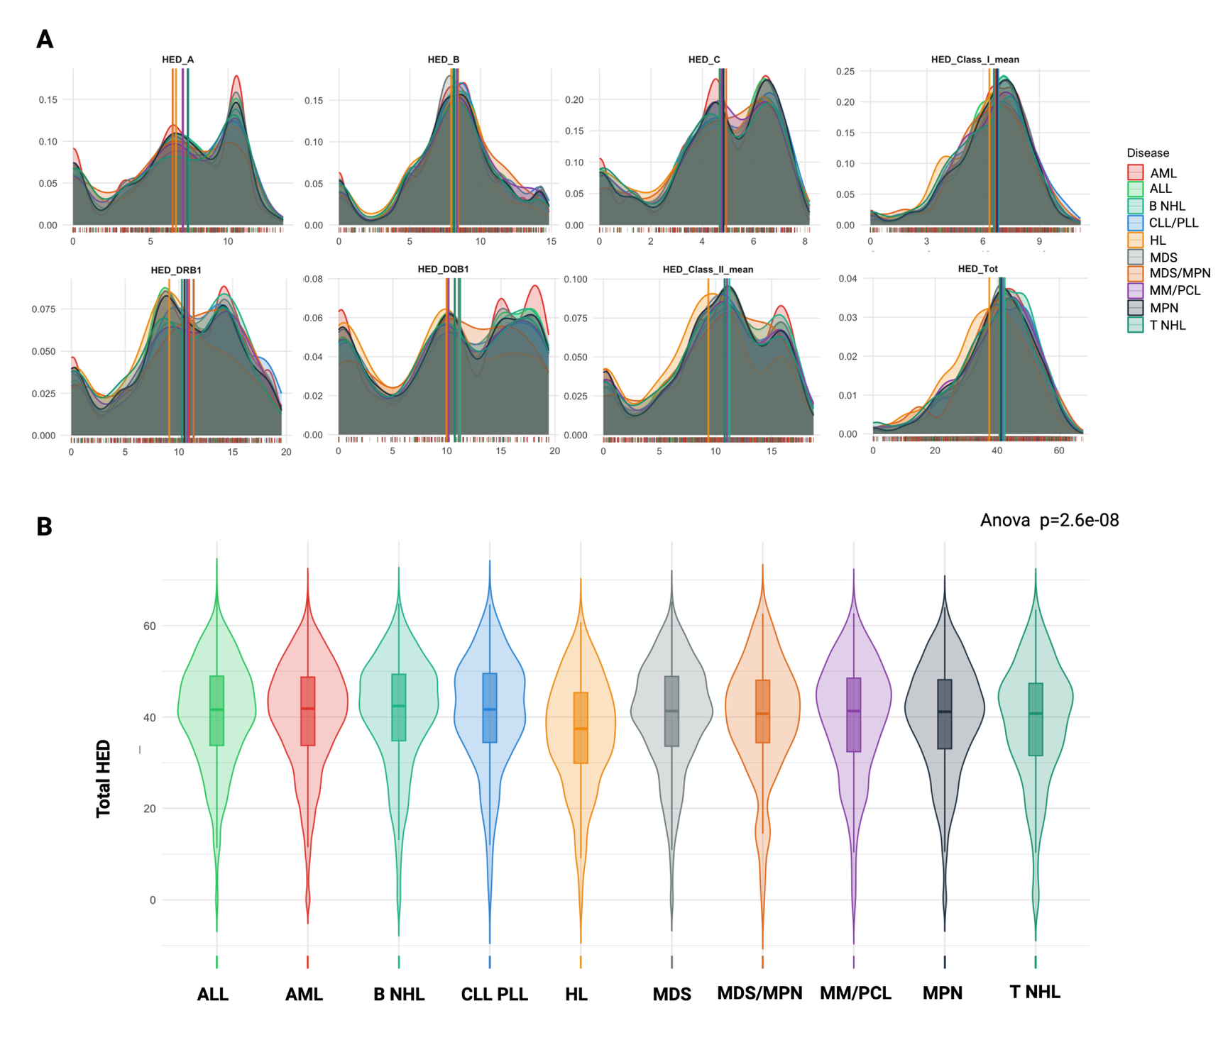

Figure S2. Distribution of HLA evolutionary divergence (HED) according to underlying disease.
(A) Kernel density plots of locus-specific (A, B, C, DRB1, DQB1), class I, class II and total HED in the overall cohort, stratified by disease category (AML, ALL, B-cell NHL, CLL/PLL, HL, MDS, MDS/MPN, MM/PCL, MPN, T-cell NHL). Colored curves and vertical lines indicate, respectively, the smoothed distribution and median HED for each disease group; rugs on the x-axis represent individual patients.
(B) Violin and embedded boxplots showing the distribution of total HED across disease categories, with the p value from one-way ANOVA (p = 2.6×10⁻⁸) indicating overall differences in total HED between disease groups. Notably, the Hodgkin lymphoma (HL) group showed the lowest total HED scores among all disease categories.

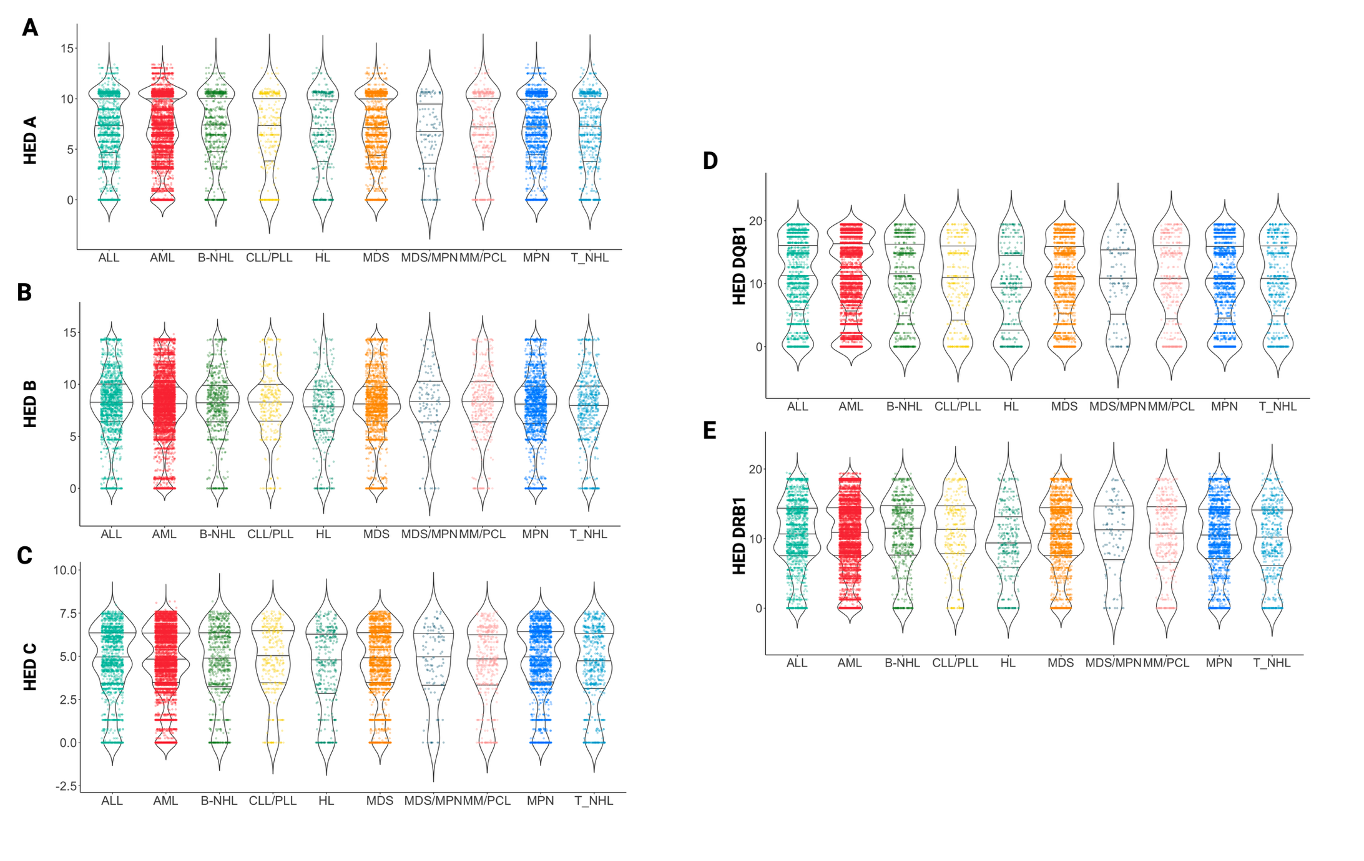
Figure S3. Locus-specific HED by disease category.
(A–E) Violin plots with overlaid jittered points showing the distribution of locus-specific HED values for HLA-A (A), HLA-B (B), HLA-C (C), HLA-DQB1 (D) and HLA-DRB1 (E) according to underlying disease. For each disease group, the violin outlines represent the kernel density of HED values, and the internal boxplots indicate the median and interquartile range. Notably HL group showed the lowest total HED scores especially across class II loci (HED DQB1 and DRB1)
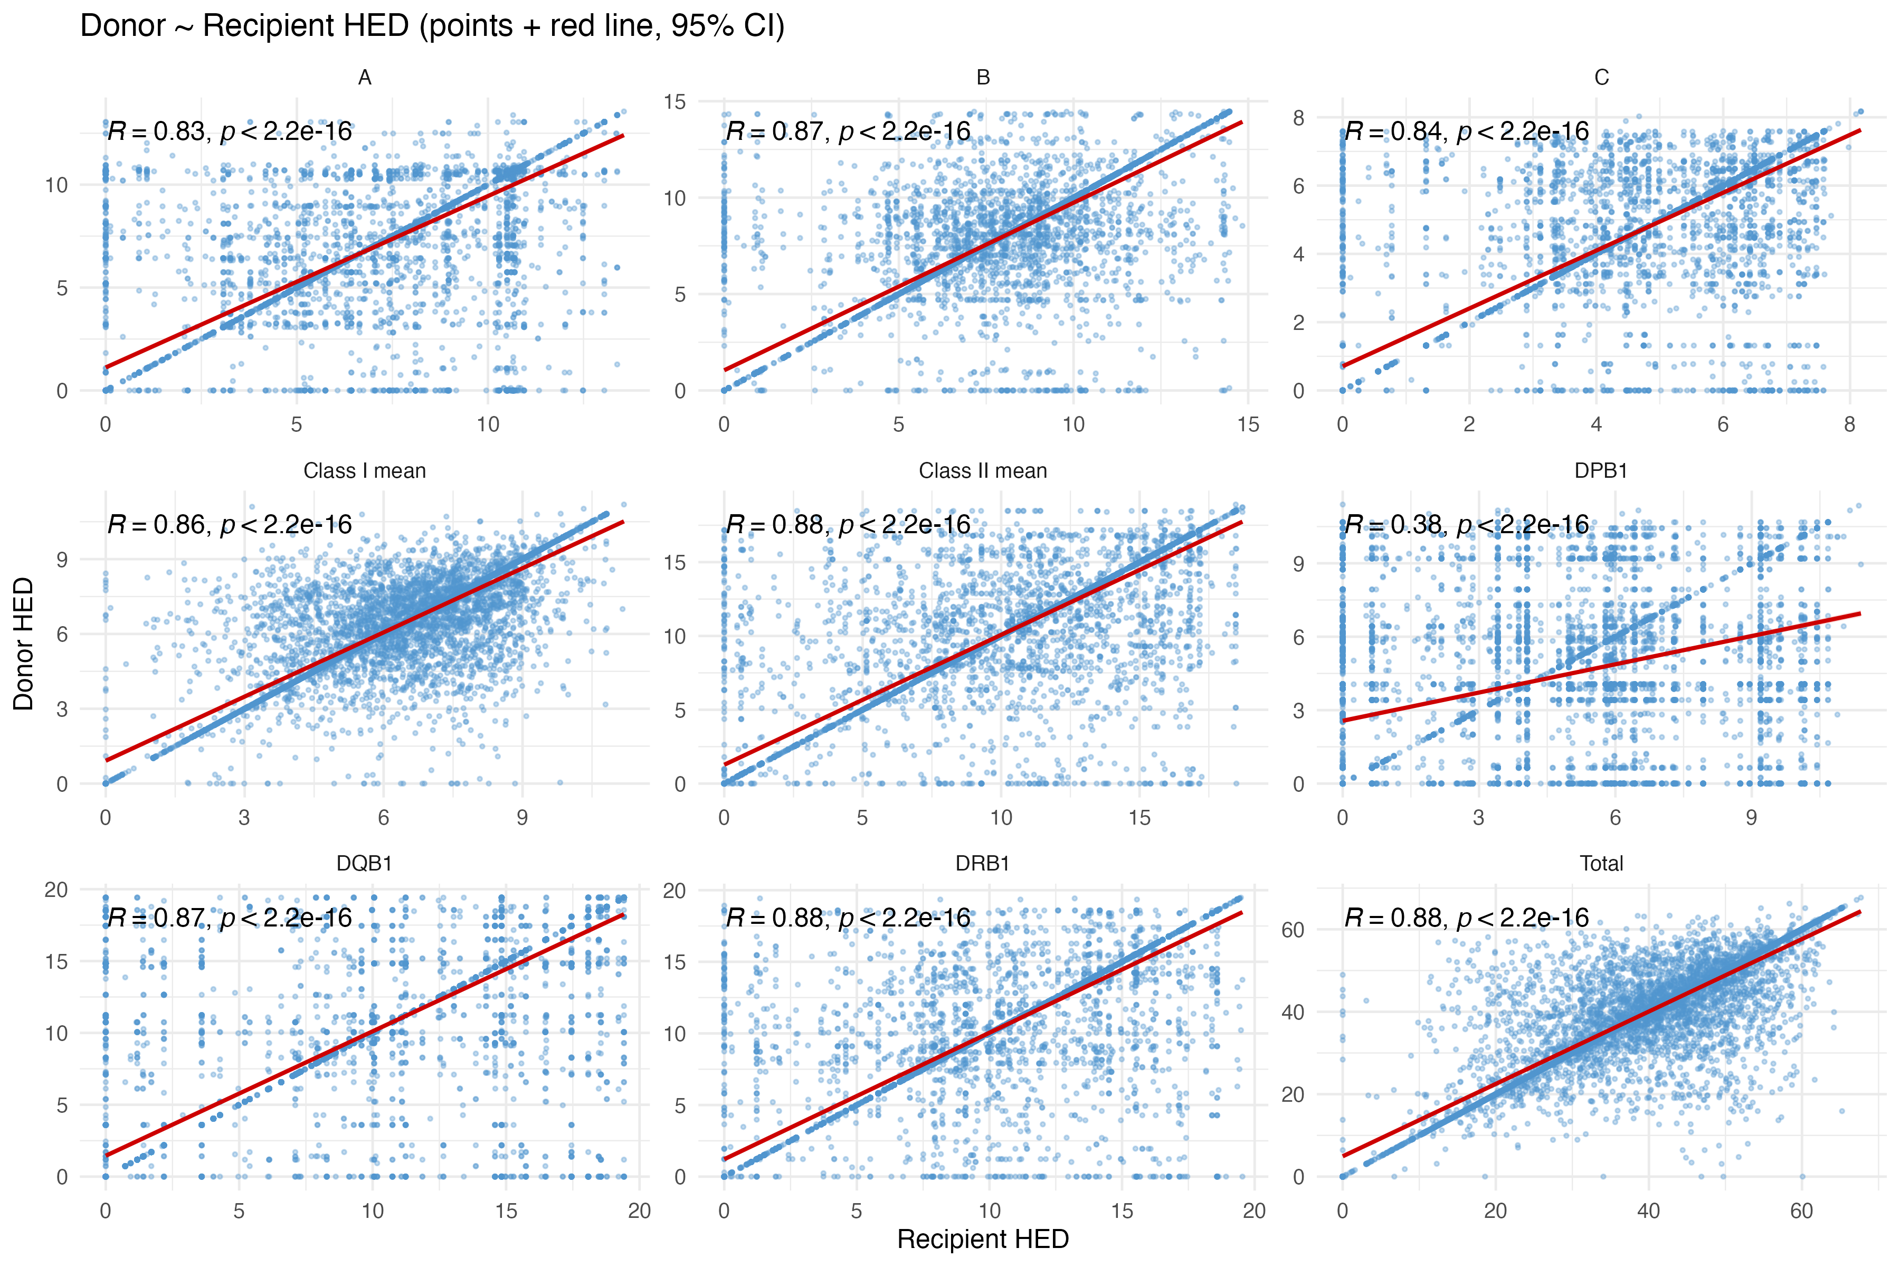
Figure S4. Correlation between recipient and donor HLA evolutionary divergence (HED).
Scatterplots show the relationship between recipient HED (x-axis) and donor HED (y-axis) for individual loci (A, B, C, DPB1, DQB1, DRB1), mean class I and class II HED, and total HED in the full cohort. Each point represents a donor–recipient pair; the red line indicates the fitted linear regression. Pearson correlation coefficients (R) and corresponding p values are reported on each panel, showing strong positive correlations between recipient and donor HED across loci and summary measures, with a weaker correlation for DPB

Figure S5

Figure S5. Correlation between recipient and donor HLA evolutionary divergence (HED) in the mismatched subgroup (N=1769).
Scatterplots show the relationship between recipient HED (x-axis) and donor HED (y-axis) for individual loci (A, B, C, DPB1, DQB1, DRB1), mean class I and class II HED, and total HED in the full cohort. Each point represents a donor–recipient pair; the red line indicates the fitted linear regression. Pearson correlation coefficients (R) and corresponding p values are reported on each panel, showing strong positive correlations between recipient and donor HED across loci and summary measures, with a weaker correlation for DPB1

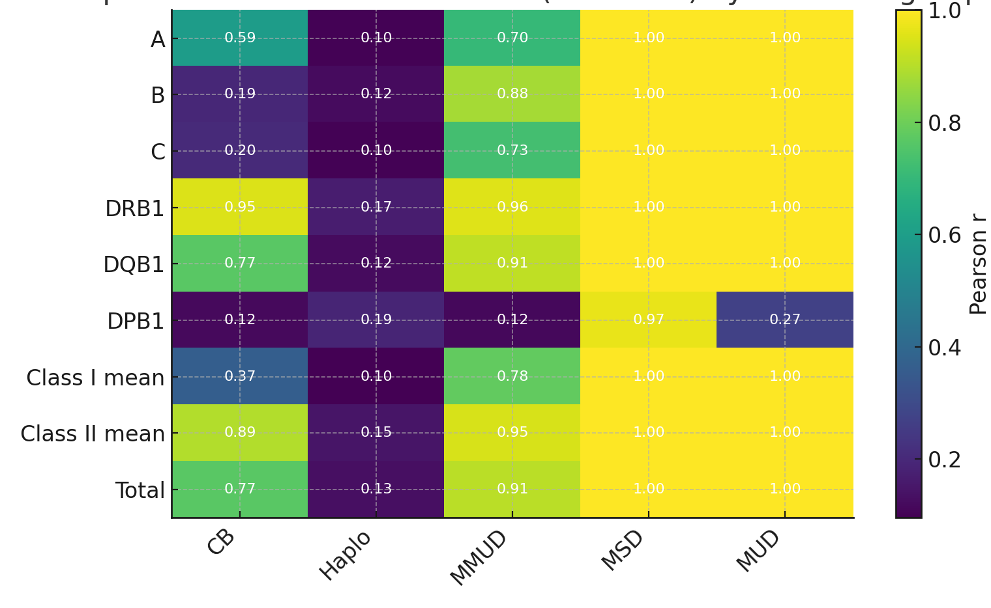

Figure S6. Recipient–donor HED correlations by donor subgroup.
Heatmap showing Pearson correlation coefficients (r) between recipient and donor HED for individual loci (A, B, C, DRB1, DQB1, DPB1), mean class I and class II HED, and total HED, stratified by donor type (cord blood [CB], haploidentical [Haplo], mismatched unrelated donor [MMUD], matched sibling donor [MSD], and matched unrelated donor [MUD]). Each cell reports the correlation value, with color intensity reflecting its magnitude. Strong correlations are observed for most loci and summary scores in MSD and MUD pairs, whereas correlations are weaker in CB and haploidentical transplants. DPB1 correlations were weak across all transplant types except MSD. Cord blood (CB) transplants showed a more heterogeneous pattern, with comparatively weaker correlations at loci A, B, C and DPB1, but stronger correlations at DQB1 and DRB1.

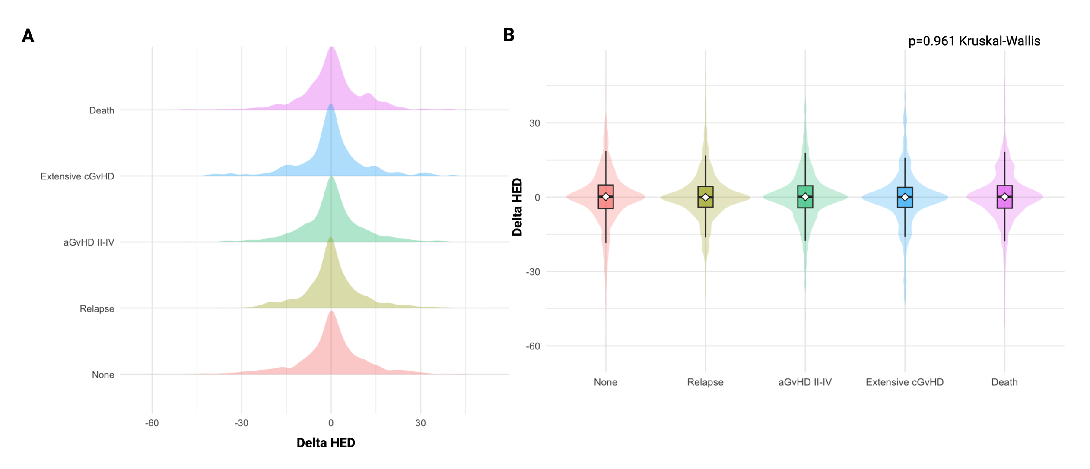

Figure S7. Donor–recipient HED difference (Delta HED) across first GRFS events in the HLA-mismatched subset.
Analyses were restricted to donor–recipient pairs with at least one HLA mismatch (mismatched set only). (A) Ridgeline density plots showing the distribution of Delta HED (donor minus recipient) stratified by the first event contributing to the GRFS composite endpoint (none, relapse, grade II–IV acute GvHD, extensive chronic GvHD, or death – as binary status). (B) Violin plots with embedded boxplots summarizing Delta HED for each event category (median and interquartile range). Distributions were comparable across groups, with no evidence of heterogeneity in Delta HED by first-event category (Kruskal–Wallis p=0.961).

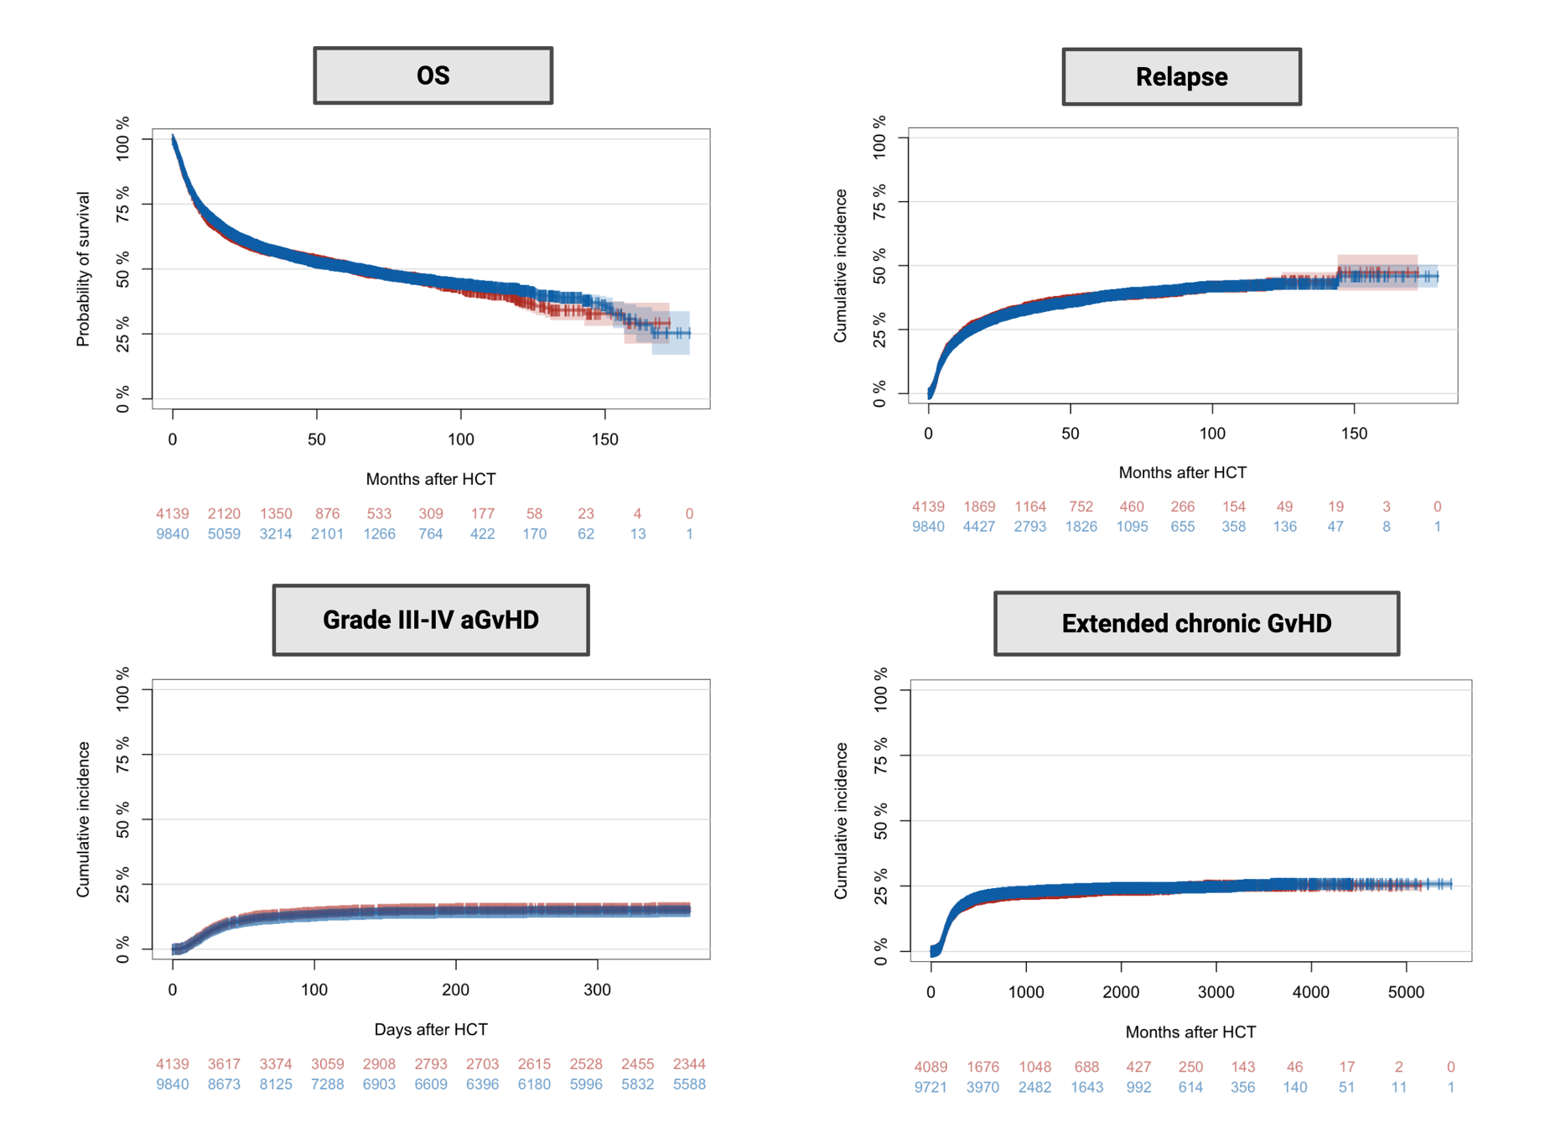

Figure S8 : Baseline outcome patterns in the development cohorts. (from SFGM-TC cohort)
Kaplan–Meier and cumulative-incidence curves describing the major components of the GRFS composite endpoint in the SFGM-TC development dataset. Overall survival (OS) is shown as Kaplan–Meier survival probability, whereas relapse, grade III–IV acute GvHD (aGvHD), and extensive chronic GvHD (cGvHD) are shown as cumulative incidence over follow-up. Curves are displayed for the training cohort (N=9,840) and the independent hold-out test cohort (N=4,139) (blue and red, respectively), with shaded bands indicating 95% confidence intervals. Numbers at risk (or remaining under observation for cumulative-incidence curves, as applicable) are provided below each panel.

Figure S9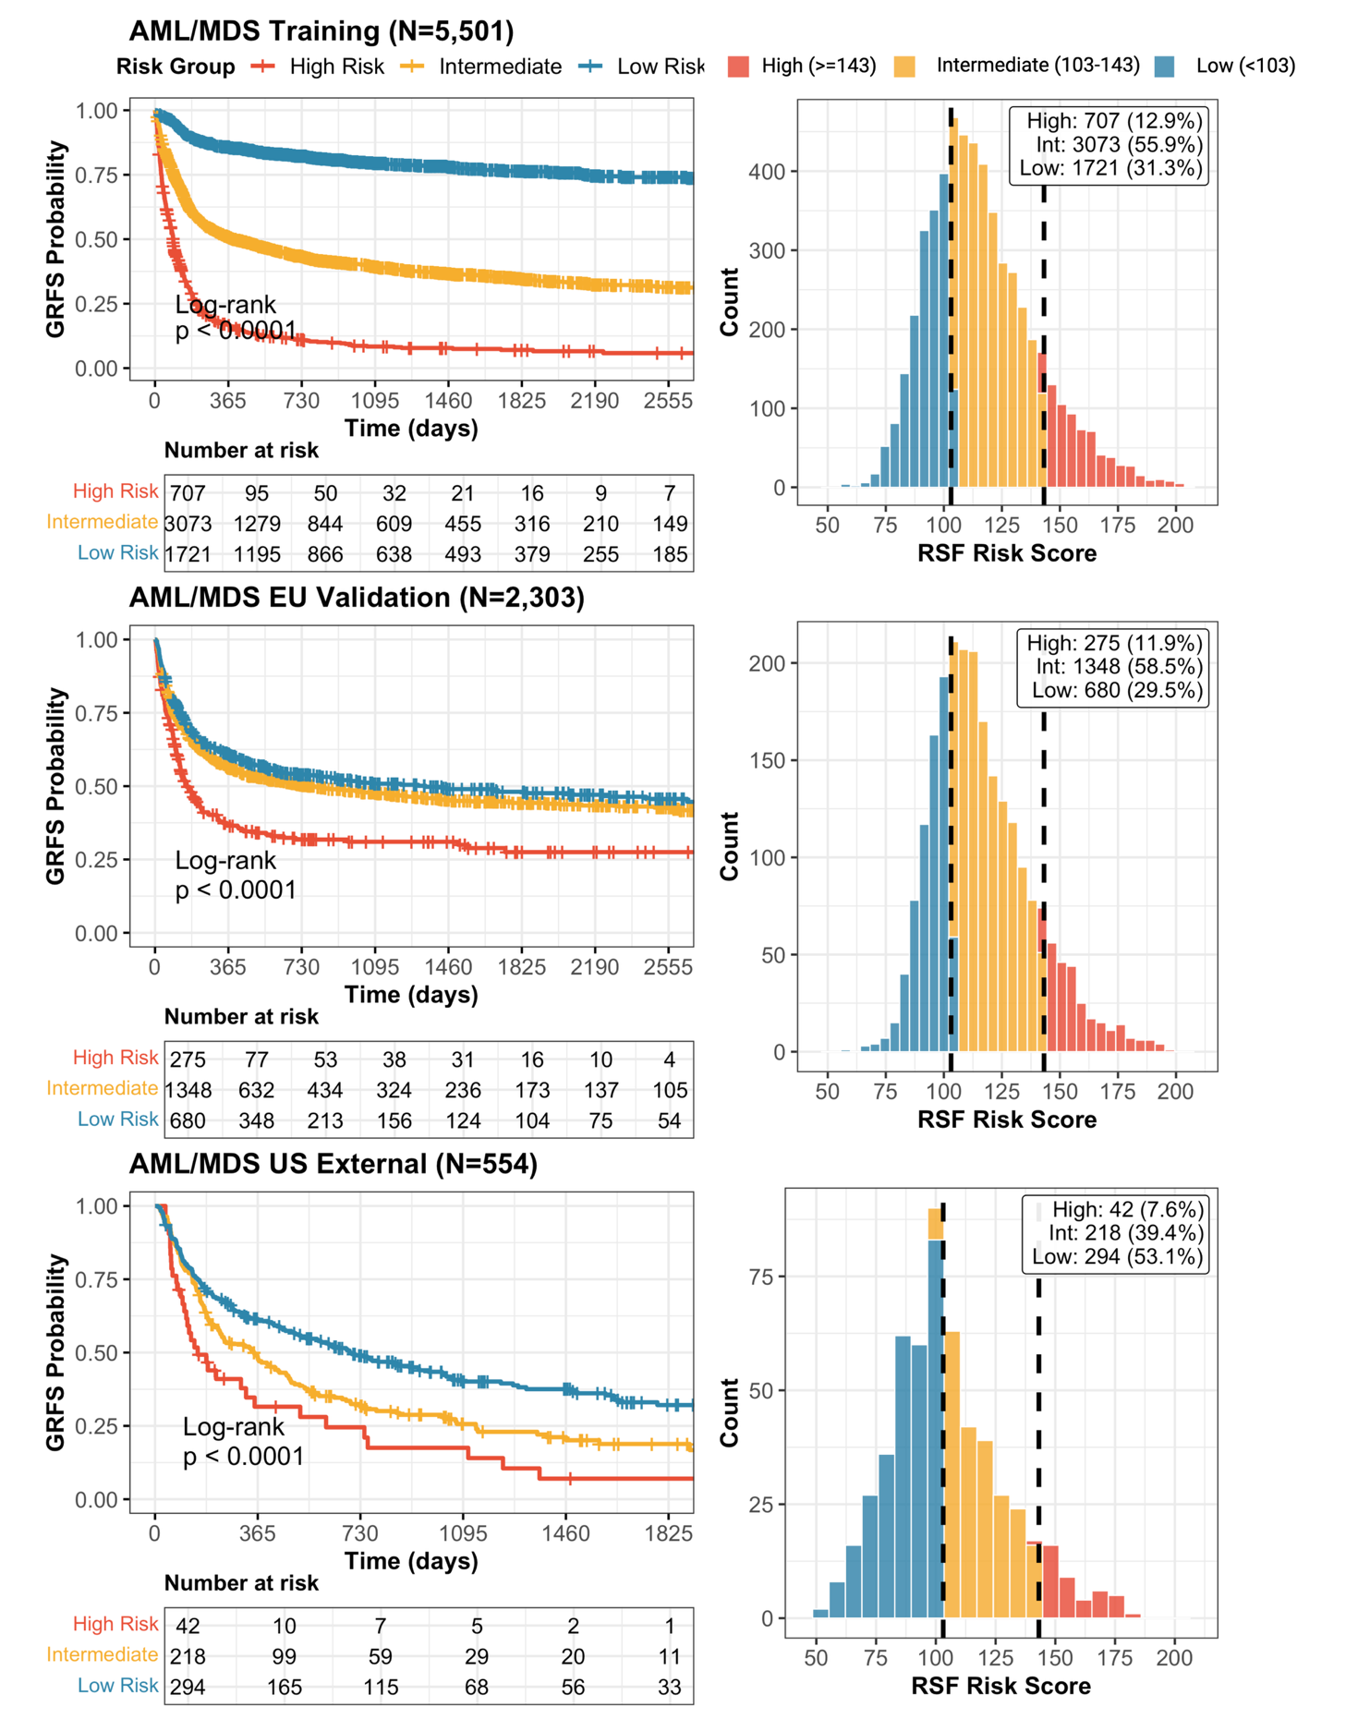

Figure S9 : RSF-based GRFS risk stratification in AML/MDS across training and validation cohorts.
Kaplan–Meier curves (left) show graft-versus-host disease–free/relapse-free survival (GRFS) after allo-HCT stratified by three risk groups (low, intermediate, high) defined using the random survival forest (RSF) full-model risk score in patients with AML/MDS. Risk-group thresholds were predefined (low <103, intermediate 103–143, high ≥143) and applied unchanged across cohorts. Histograms (right) display the distribution of RSF risk scores within each cohort, colored by risk group; vertical dashed lines indicate the cut points. Analyses are shown for the AML/MDS training cohort (N=5,501), an independent French validation cohort (N=2,303), and an external U.S. cohort (N=554). Insets report the number and proportion of patients in each risk category, and numbers at risk are shown below each survival curve; between-group differences were assessed using the log-rank test.

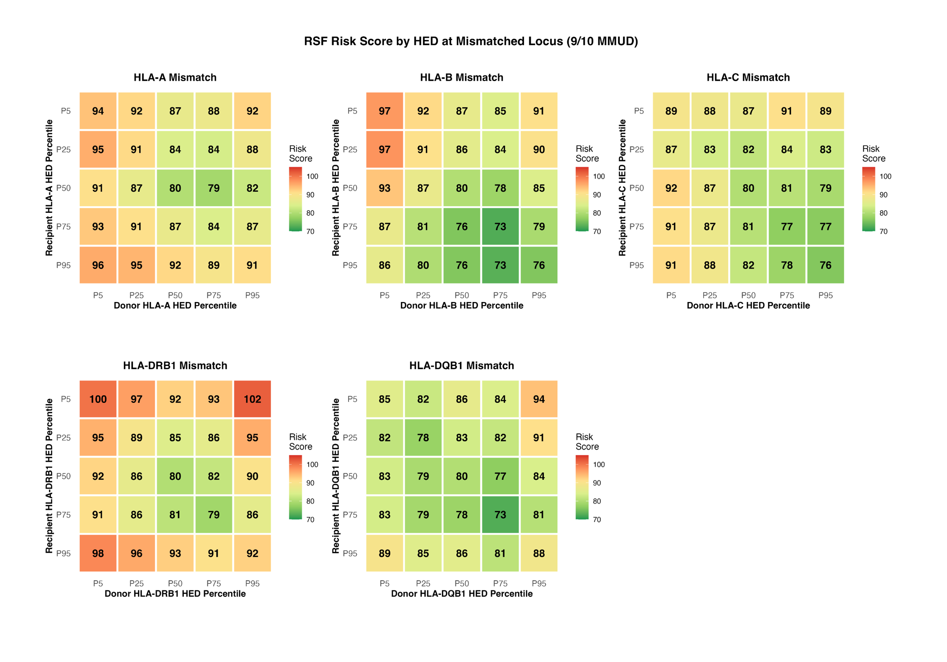

Figure S10 : Locus-specific recipient–donor HED interactions at the mismatched locus in 9/10 MMUD transplants.
Heatmaps display the predicted random survival forest (RSF) GRFS risk score across combinations of recipient (y-axis) and donor (x-axis) HED percentiles at the mismatched HLA locus, restricted to 9/10 mismatched unrelated donor (MMUD) pairs. Separate panels are shown for mismatches at HLA-A, -B, -C, -DRB1, and -DQB1. Each cell reports the model-predicted RSF risk score for the corresponding recipient–donor percentile pairing, with color intensity indicating risk (green = lower predicted risk; red = higher predicted risk). Percentiles (P5–P95) are computed within the cohort-specific distribution of locus-level HED. These simulations illustrate that the predicted impact of immunogenetic diversity is locus dependent and may vary with the joint recipient–donor HED configuration at the mismatched locus.

Table S1 : Center list involved from the SFGM-TC cohort (Training and Hold-out test sets). Excel file

Table S2 : Patient characteristics in the external validation cohort (US)
Characteristic | All Patients  (n=1,931) | Complete Cases  (n=616)
Patient Characteristics
Patient age, years, median (IQR) | 59.0 (49.0-65.7) | 58.7 (46.9-65.0)
Patient sex, n (%)
Male | 1,083 (56.1%) | 355 (57.6%)
Female | 848 (43.9%) | 261 (42.4%)
Disease Characteristics
Diagnosis, n (%)
Acute myeloid leukemia | 1,140 (59.0%) | 373 (60.6%)
Acute lymphoblastic leukemia | 49 (2.5%) | 0 (0.0%)
Myelodysplastic syndrome | 546 (28.3%) | 181 (29.4%)
Myeloproliferative neoplasm | 185 (9.6%) | 62 (10.1%)
Multiple myeloma/PCL | 5 (0.3%) | 0 (0.0%)
Disease status at transplant, n (%)
Complete remission | 794 (41.1%) | 321 (52.1%)
Active disease | 701 (36.3%) | 295 (47.9%)
Missing | 436 (22.6%) | -
Donor Characteristics
Donor age, years, median (IQR) | 32.0 (24.0-46.0) | 29.0 (23.0-41.0)
Missing | 1,033 (53.5%) | -
Donor type, n (%)
Matched sibling donor | 450 (23.3%) | 100 (16.2%)
Matched unrelated donor | 938 (48.6%) | 313 (50.8%)
Mismatched unrelated donor | 84 (4.4%) | 0 (0.0%)
Haploidentical donor | 450 (23.3%) | 203 (33.0%)
Transplant Characteristics
Stem cell source, n (%)
Peripheral blood | 1,523 (78.9%) | 485 (78.7%)
Bone marrow | 408 (21.1%) | 131 (21.3%)
Conditioning regimen, n (%)
Myeloablative conditioning | 480 (24.9%) | 105 (17.0%)
Reduced-intensity conditioning | 1,451 (75.1%) | 511 (83.0%)
GvHD prophylaxis, n (%)
CNI alone | 3 (0.2%) | 2 (0.3%)
CNI + mycophenolate mofetil | 326 (16.9%) | 210 (34.1%)
CNI + methotrexate | 436 (22.6%) | 145 (23.5%)
Other | 394 (20.4%) | 259 (42.0%)
Missing | 772 (40.0%) | -
HLA Mismatches
HLA-A mismatch, n (%)
0 | 1,627 (84.3%) | 524 (85.1%)
1 | 263 (13.6%) | 92 (14.9%)
Missing | 41 (2.1%) | -
HLA-B mismatch, n (%)
0 | 1,765 (91.4%) | 567 (92.0%)
1 | 128 (6.6%) | 49 (8.0%)
Missing | 38 (2.0%) | -
HLA-C mismatch, n (%)
0 | 1,700 (88.0%) | 553 (89.8%)
1 | 170 (8.8%) | 63 (10.2%)
Missing | 61 (3.2%) | -
HLA-DRB1 mismatch, n (%)
0 | 1,719 (89.0%) | 565 (91.7%)
1 | 168 (8.7%) | 51 (8.3%)
Missing | 44 (2.3%) | -
HLA-DQB1 mismatch, n (%)
0 | 1,629 (84.4%) | 542 (88.0%)
1 | 225 (11.7%) | 74 (12.0%)
Missing | 77 (4.0%) | -
HLA-DPB1 mismatch, n (%)
0 | 833 (43.1%) | 298 (48.4%)
1 | 270 (14.0%) | 90 (14.6%)
Missing | 828 (42.9%) | 228 (37.0%)
Patient HED Scores
HED-A, median (IQR) | 7.0 (4.1-10.5) [missing: 40] | 6.4 (3.5-10.5)
HED-B, median (IQR) | 8.4 (6.7-10.3) [missing: 42] | 8.6 (6.6-10.3)
HED-C, median (IQR) | 4.8 (3.4-6.5) [missing: 61] | 4.8 (3.1-6.6)
HED-DRB1, median (IQR) | 10.8 (7.9-14.2) [missing: 44] | 10.6 (7.9-14.2)
HED-DQB1, median (IQR) | 11.1 (5.5-15.7) [missing: 77] | 10.7 (7.1-15.2)
HED-DPB1, median (IQR) | 4.1 (0.6-6.7) [missing: 839] | 4.1 (1.6-6.8) [missing: 228]
Donor HED Scores
Donor HED-A, median (IQR) | 7.0 (4.2-10.3) [missing: 472] | 7.0 (3.9-10.5)
Donor HED-B, median (IQR) | 8.3 (6.6-10.2) [missing: 472] | 8.4 (6.3-10.3)
Donor HED-C, median (IQR) | 4.9 (3.4-6.5) [missing: 489] | 5.0 (3.4-6.6)
Donor HED-DRB1, median (IQR) | 11.0 (7.9-14.2) [missing: 475] | 10.8 (7.9-14.2)
Donor HED-DQB1, median (IQR) | 11.2 (6.8-15.7) [missing: 584] | 11.1 (7.1-15.9)
Donor HED-DPB1, median (IQR) | 4.1 (0.2-6.4) [missing: 934] | 4.1 (0.6-6.4) [missing: 218]

Table S3 : Allele specific GRFS impact at 2 years. Excel file.

Table S4 : Multivariable cox regression model of recipient HED variables on outcomes. Excel file.

Table S5. Training Set Performance (n = 9,196)
Model | C-index (Clinical) | C-index (Clinical + HED)
Random Survival Forest | 0.544 | 0.550
XGBoost | 0.594 | 0.603
Elastic-Net Cox | 0.435 | 0.436
Table S6. Test Set Performance (n = 3,826)
Model | C-index (Clinical) | C-index (Clinical + HED)
Random Survival Forest | 0.548 | 0.558
XGBoost | 0.558 | 0.546
Elastic-Net Cox | 0.557 | 0.557

Table S7. GRFS Risk Stratification by Clinico-Immunogenetic Composite Score
Cutpoints: < 103 (Low Risk) | 103–143 (Intermediate) | ≥ 143 (High Risk)
Panel A — Pairwise Log-Rank Comparisons (p-values)
Cohort) | N | Overall p | Low vs Intermediate | Intermediate vs High
Training (French cohort) | 9,196 | < 2×10⁻¹⁶ | < 2×10⁻¹⁶ | < 2×10⁻¹⁶
Hold-out test (French cohort) | 3,826 | < 2×10⁻¹⁶ | 0.028 | < 2×10⁻¹⁴
External validation (US cohort) | 616 | 6×10⁻⁷ | 4×10⁻⁵ | 0.034
Panel B — Risk Group Distribution
Cohort | Low Risk | Intermediate | High Risk
 | < 103 | 103 – 143 | ≥ 143
Training (French cohort) | 2,299 (25%) | 5,517 (60%) | 1,380 (15%)
Hold-out test (French cohort) | 860 (22%) | 2,446 (64%) | 520 (14%)
External validation (US cohort) | 320 (52%) | 250 (41%) | 46 (7%)
Note: Risk groups defined by clinico-immunogenetic composite score cutpoints derived from the training cohort. All pairwise comparisons reached statistical significance across all three cohorts, confirming robust internal and external validation. The US external cohort shows a shift toward lower-risk distribution, consistent with differences in donor-type composition (higher MSD proportion).
Abbreviations: GRFS, GvHD-free relapse-free survival; EU, European Union; US, United States;

Table S8 Optimal Donor Selection in Haploidentical Transplantation
Risk Simulation: Clinico-Immunogenetic Risk Score by Donor HED Profile

Reference Patient Profile
Age / Sex | 56 yo male |  | Disease | AML in CR |  |  | Donor Type | Haploidentical
Stem Cell Source | PBSC |  | Conditioning | RIC |  |  | GvHD Prophylaxis | CNI/MMF/PTCY
Predicted Composite Risk Score by Recipient & Donor HED Percentile
Recipient |  | Optimal Donor (Lowest Risk) |  |  |  | Worst Donor (Highest Risk) |  |  |  | Benefit
HED  Percentile | Total HED  Score | Donor  Percentile | Donor HED  Score | Predicted  Risk Score | Donor  Percentile |  | Donor HED  Score | Predicted  Risk Score | Δ Risk  Reduction
P5 | 0 | P5 | 0 | 97 | P95 |  | 69 | 119 | 21 pts
P10 | 6 | P5 | 0 | 99 | P95 |  | 69 | 116 | 18 pts
P25 | 27 | P25 | 28 | 83 | P95 |  | 69 | 111 | 28 pts
P50 | 42 | P75 | 57 | 82 | P95 |  | 69 | 102 | 20 pts
P75 | 57 | P75 | 57 | 79 | P95 |  | 69 | 96 | 17 pts
P90 | 65 | P90 | 65 | 85 | P25 |  | 28 | 100 | 15 pts
P95 | 69 | P90 | 65 | 97 | P25 |  | 28 | 106 | 10 pts
Score interpretation: lower = better prognosis. Risk scores derived from the best-performing clinico-immunogenetic model (RSF). HED = HLA Evolutionary Divergence.

Table S9. GRFS Outcomes by HLA Locus Mismatch Status in MMUD Cohort (N=1,671)

HLA Locus | N  (Mismatch) | Median GRFS  (No Mismatch) | Median GRFS  (Mismatch) | 2-yr GRFS  (No Mismatch) | 2-yr GRFS  (Mismatch) | p-value
HLA-A | 683 (40.9%) | 553 | 617 | 47.4% | 49.4% | 0.532
HLA-B | 339 (20.3%) | 614 | 447 | 49.0% | 45.1% | 0.575
HLA-C | 531 (31.8%) | 549 | 656 | 47.7% | 49.3% | 0.812
HLA-DRB1 | 268 (16.0%) | 573 | 486 | 48.3% | 47.8% | 0.760
HLA-DQB1 | 349 (20.9%) | 490 | 994 | 46.8% | 53.4% | 0.086

Abbreviations: GRFS, graft-versus-host disease-free, relapse-free survival; MMUD, mismatched unrelated donor; HLA, human leukocyte antigen. Note: Median GRFS is reported in days.

