Appendix A. Representative Measurement Structure
The detailed measurement structure of the constructs is presented in Figure A1. Each construct is represented by a set of observed indicators derived from the survey instrument. The displayed item weights are based on exploratory first-component analysis and are included for illustrative purposes only.
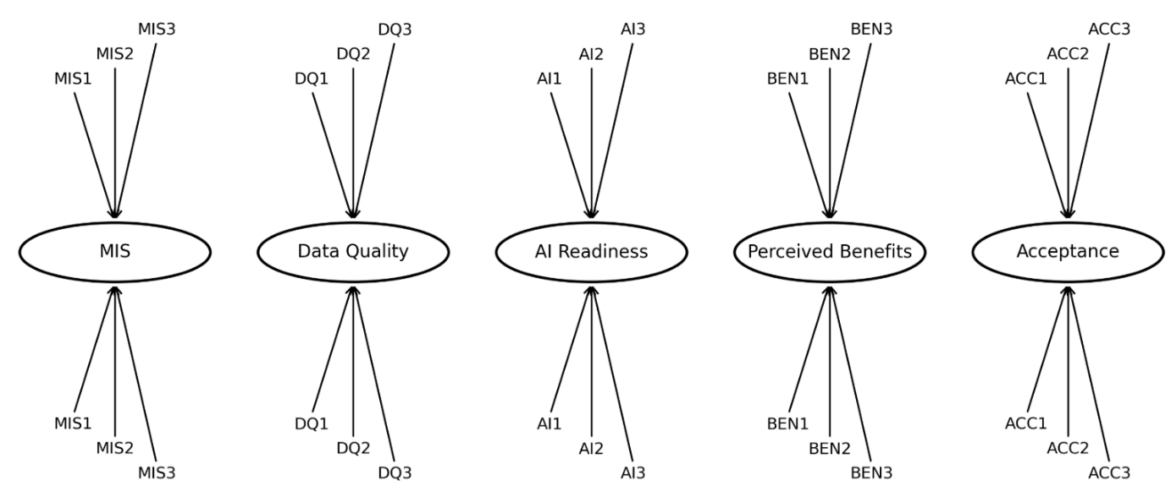
Figure A1. Measurement model (representative indicators).
The figure presents representative observed indicators for each construct based on exploratory first-component item weights. These values are used for visualization purposes only and should not be interpreted as confirmatory factor loadings.

