Supplemental Figure 2: XGBoost models for A) Endocrine dysfunction; B) MMSE <24; C) MRI changes at 6 months; D) Patient assessment; E) Physician assessment
A.
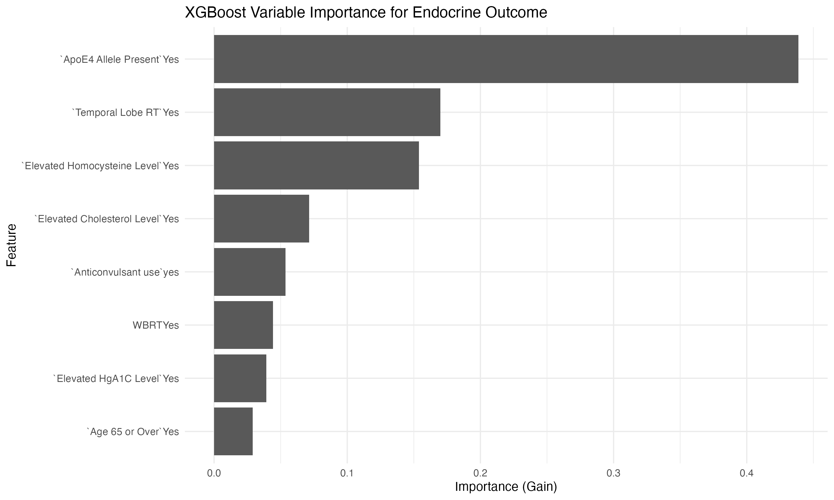
B.
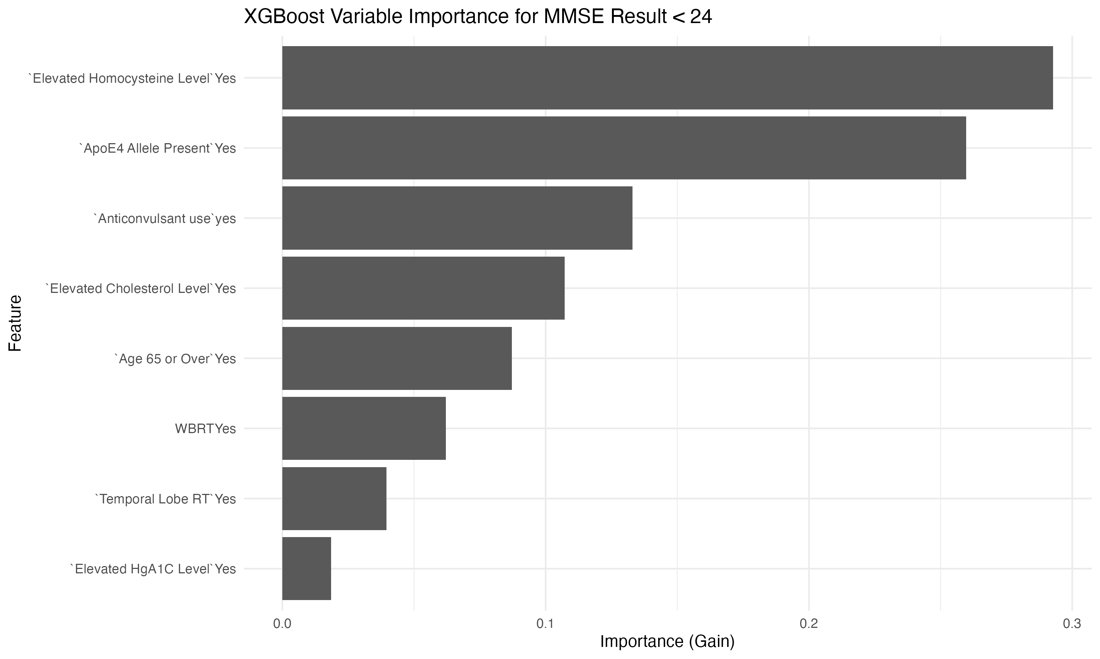

C.
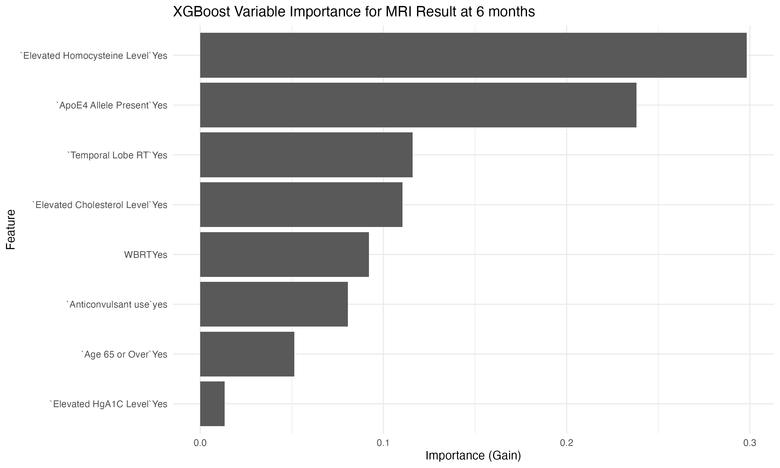
D.
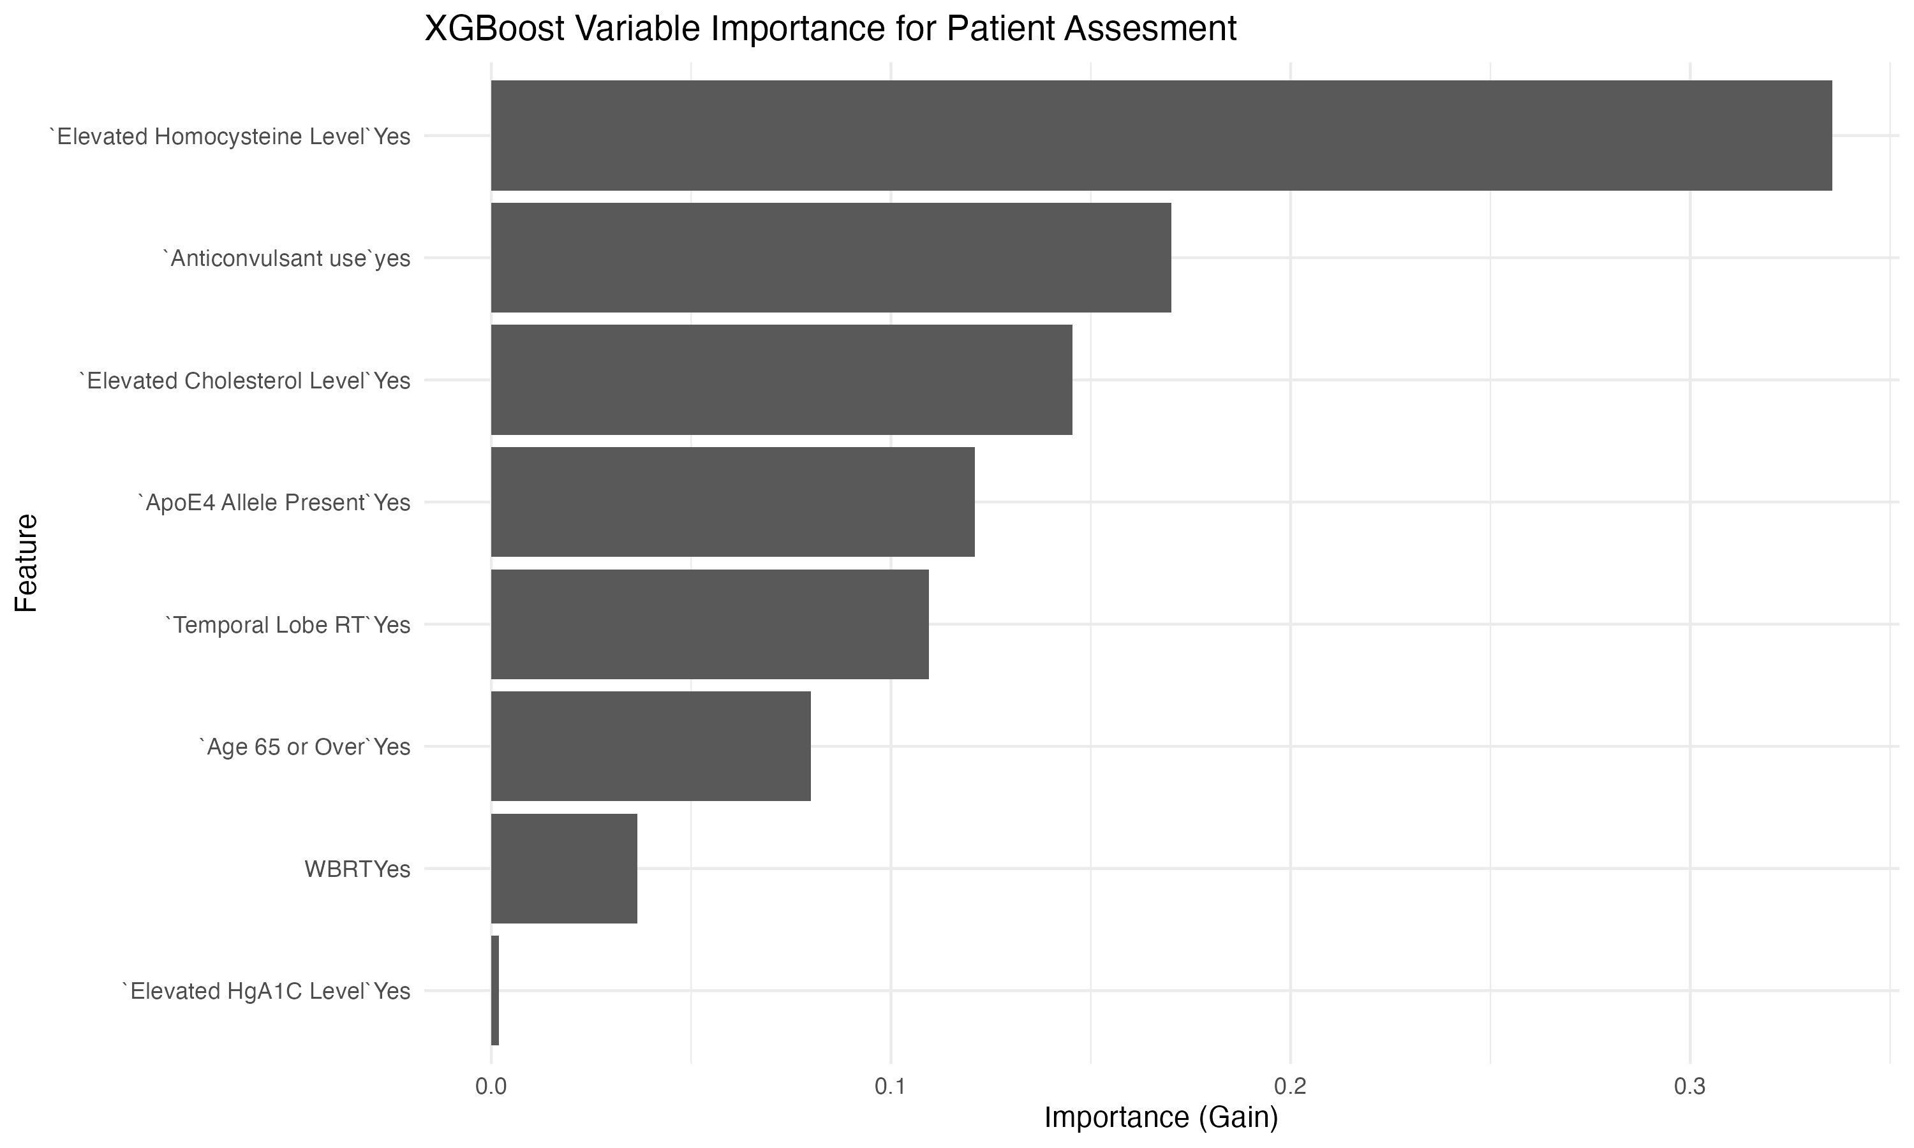

E.
