Brain Topography

Neural Complexity Signatures of Visual Mental Imagery: Lempel-Ziv Complexity and Higuchi Fractal Dimension Reveal Topographic Reorganization in High-Density EEG
Yu Gao^{a,b*}, José Miguel Diniz^{c}
ªDepartment of Electrical and Computer Engineering, Faculty of Engineering, University of Porto. Porto, Portugal.
^{b}CISTER/ISEP - Research Centre in Real-Time and Embedded Computing Systems, School of Engineering, Porto, Portugal
^{c}PhD Program in Health Data Science, Faculty of Medicine, University of Porto. Porto, Portugal.
*Corresponding author: Faculdade de Engenharia da Universidade do Porto Rua Dr. Roberto Frias, 4200 – 465, Porto, Portugal. Email: Yu_Gao@alumni.baylor.edu
Tel: +351-935856231

Supplementary Figures

Fig. S1 — ICA Component Rejection Distribution
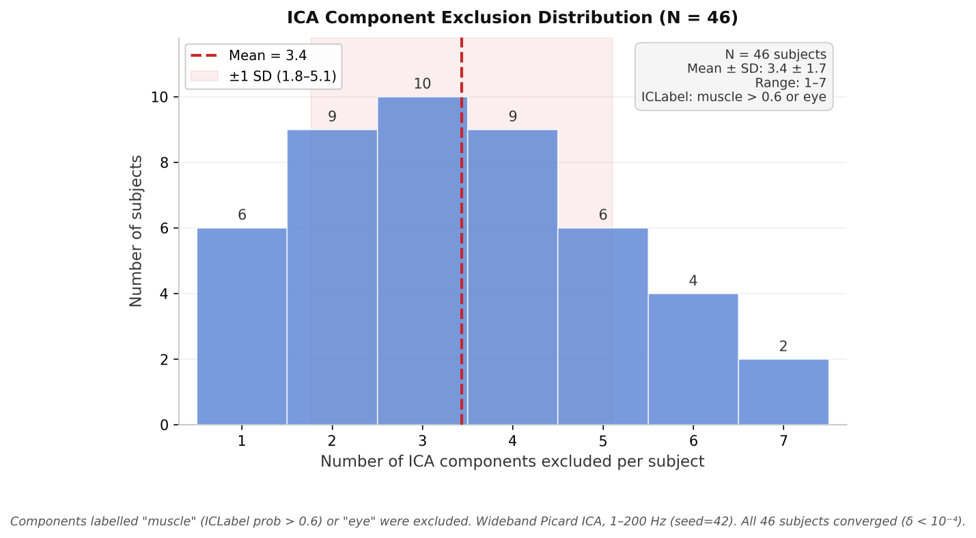
Fig. S1. Distribution of independent components (ICs) removed during the wideband Picard ICA cleaning step. Across the cohort (N = 46), an average of 3.2 ± 1.8 artefactual components (predominantly muscle and ocular artefacts) were rejected per subject, ranging from 1 to 7 components.

Fig. S2 — LZC Effect Sizes Across Frequency Bands
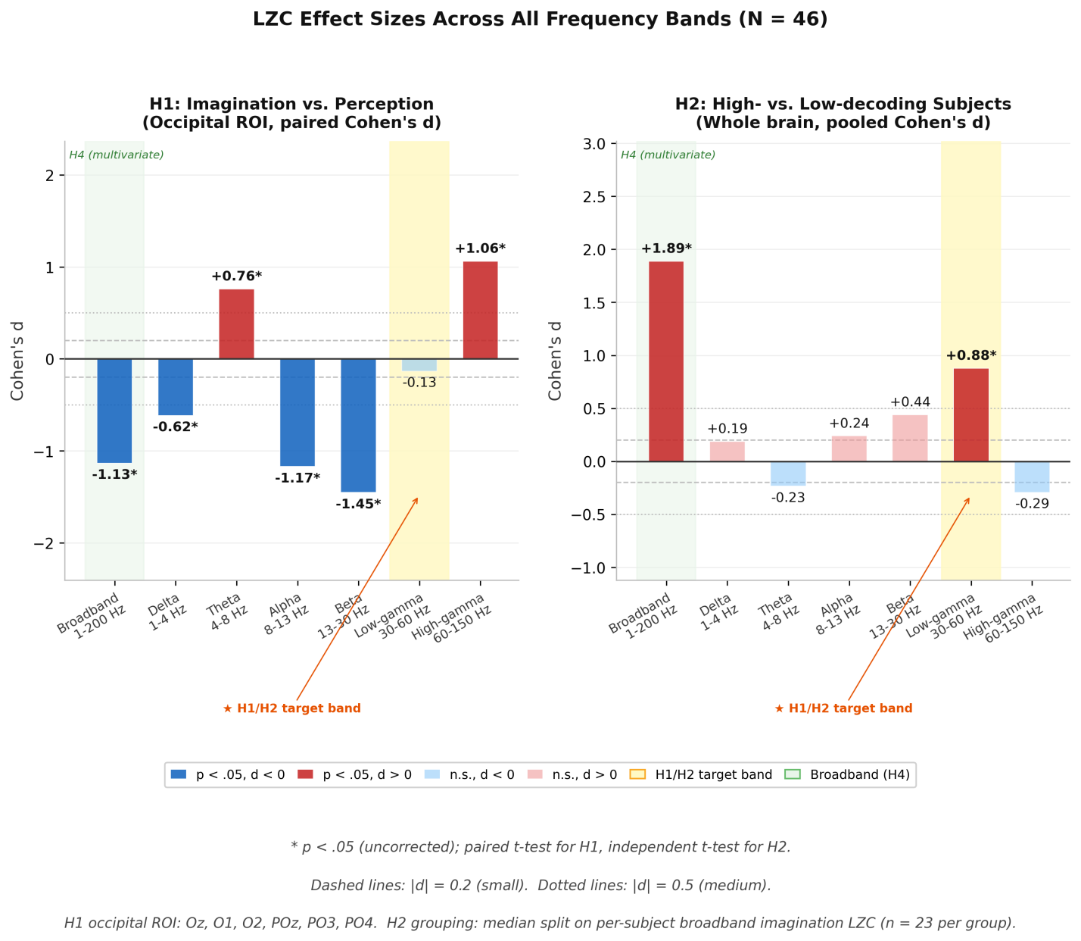
Fig. S2. Cohen’s d effect sizes for H1 (imagination vs. perception, occipital ROI; left panel) and H2 (high-decoding vs. low-decoding, full 58-channel array; right panel) across seven frequency bands (N = 46). Yellow shading marks the low-gamma band (30–60 Hz) targeted by H1/H2; green shading marks the broadband condition evaluated by the multivariate H4 test. Negative d indicates the first group showed lower LZC than the comparator, opposite to predictions. Reference lines at |d| = 0.2 (dashed, small) and |d| = 0.5 (dotted, medium).
Fig. S3 — Enhanced LZC Topographic Maps
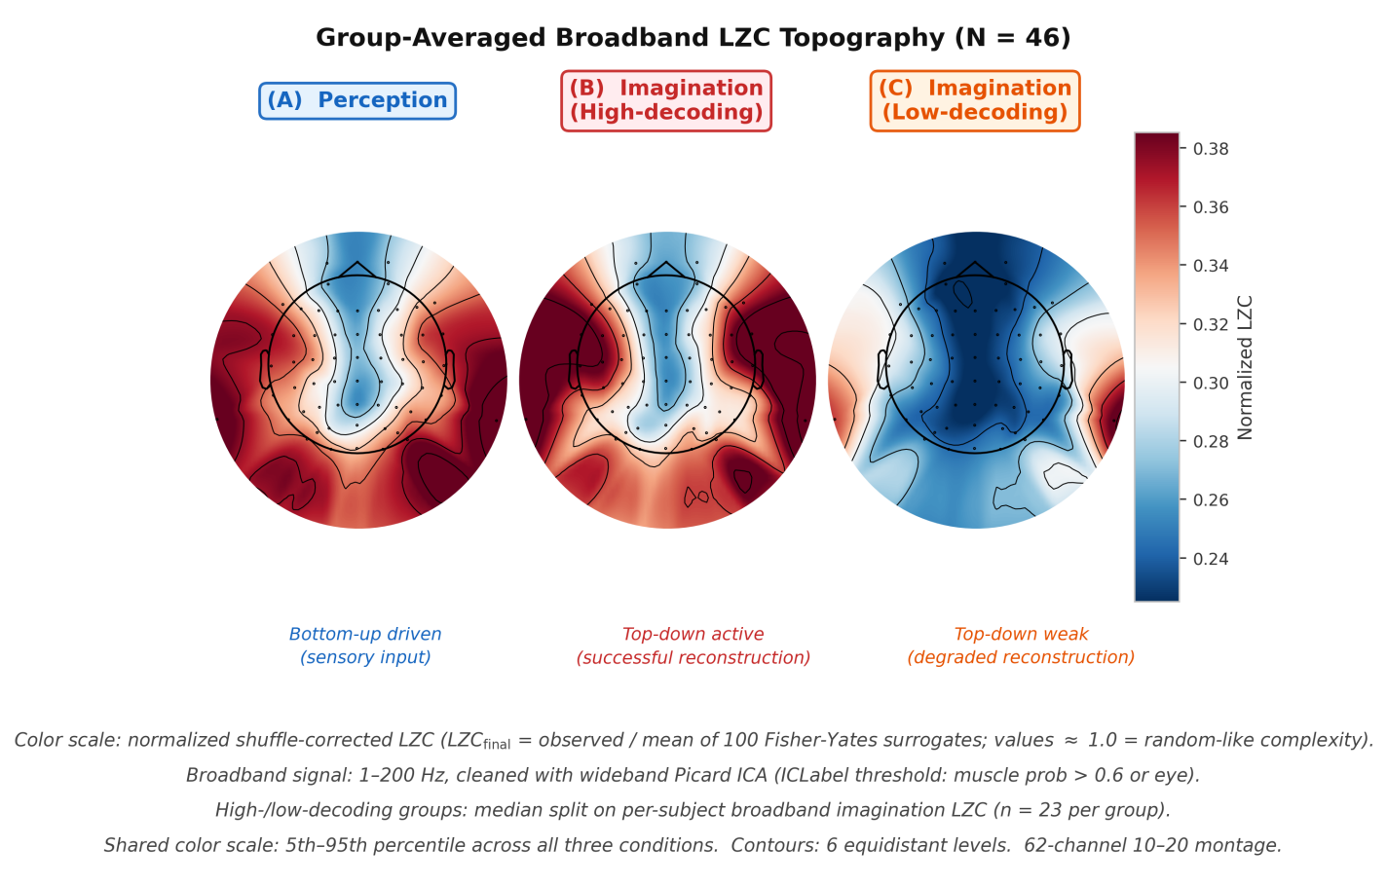
Fig. S3. Group-averaged broadband LZC topographic maps for three conditions (N = 46). (A) Perception: relatively uniform complexity. (B) High-decoding imagination: augmented frontal complexity with maintained occipital values, consistent with top-down reconstruction. (C) Low-decoding imagination: reduced right parieto-occipital complexity with weaker frontal engagement. Color scale: normalized LZC (0.20–0.40). Black dots mark electrode positions.

Fig. S4 — Spatial Clustering of Broadband LZC Differences
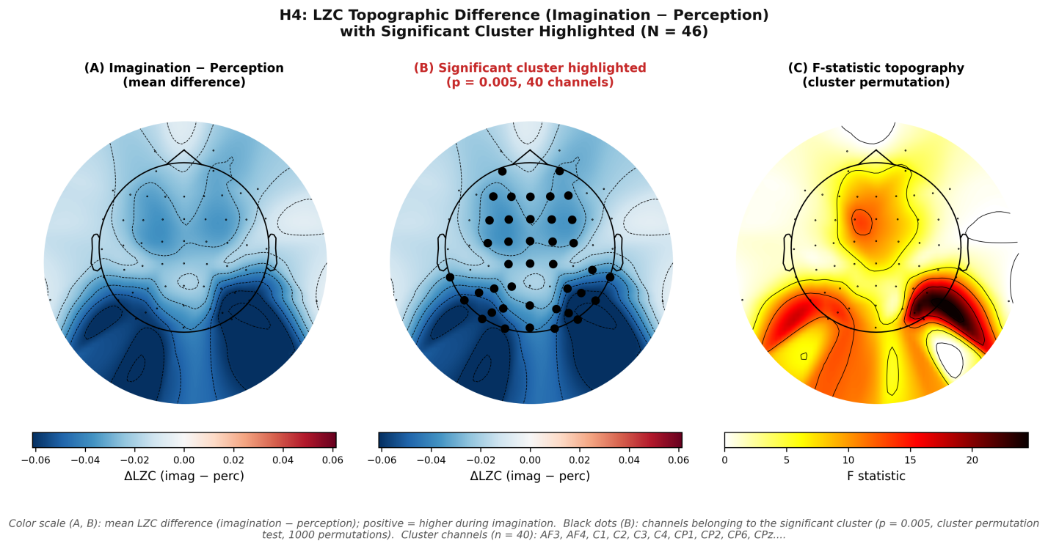
Fig. S4. Cluster-based permutation test results for broadband LZC topographic differences between imagination and perception (Hypothesis H4). (A) Unthresholded difference topography (Imagination minus Perception). (B) Difference topography overlayed with significant spatial clusters, where black dots mark the constituent scalp channels driving the significant effect (p = 0.005, 1000 permutations ). (C) Topography of the corresponding statistical values.

Fig. S5 — LZC Magnitudes Across Frequency Bands
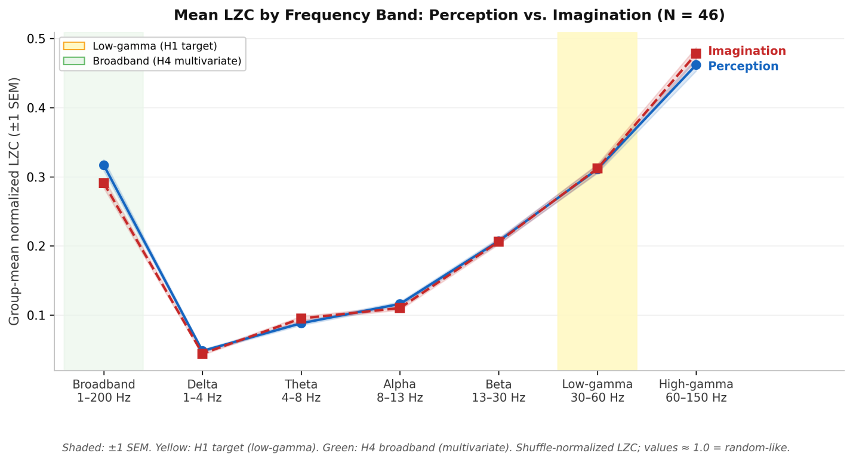
Fig. S5. Group-averaged LZC magnitudes across the seven evaluated frequency bands (N = 46). The solid blue line and dashed red line represent visual perception and mental imagination, respectively, with shaded regions denoting ±1 standard error of the mean (SEM). The low-gamma band (30–60 Hz), which was the target of hypothesis H1, is highlighted, visually confirming the absence of the predicted complexity elevation during imagery.

