Fig.S1. DNA methylation patterns in hulless barely genome.
TSS: in 2kb upstream of the transcription start site; gene body: protein coding sequence; TTS:2kb downstream of the transcription termination site; XL:drought-tolerant variety hulless barely; DQ: the drought-sensitive hulless barely; CK: hulless barely were exposed to normal conditions; S: hulless barely were exposed to drought conditions

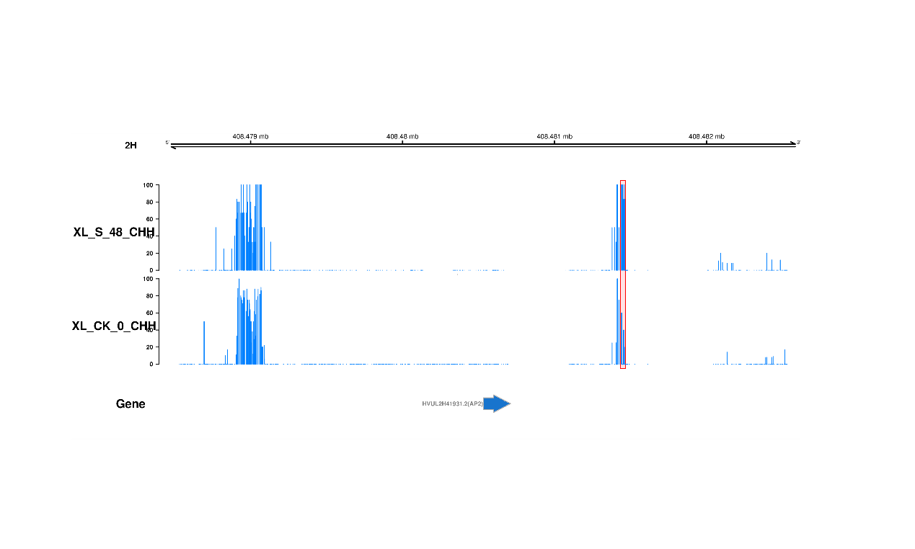
Fig. S2. Methylation status of DMR related transcription factors HVUL2H41931.2. XL:drought-tolerant variety hulless barely; DQ: the drought-sensitive hulless barely;
CK: hulless barely were exposed to normal conditions; DR: hulless barely were exposed to drought conditions.

