Figure S1: The percentages of memory CD8+ T cell subsets.

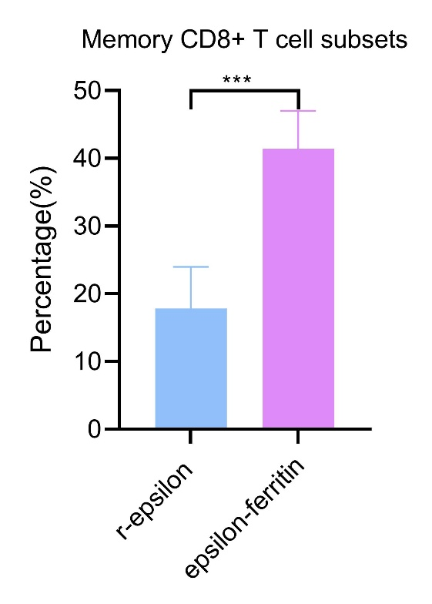

Notes: At weeks 15, spleen cells of mice from r-epsilon or epsilon-ferritin nanoparticles were taken and stained with antibodies. Flow analysis showed that memory CD8+ cells in the epsilon-ferritin nanoparticle group were significantly higher than those in the epsilon group(p<0.001).

