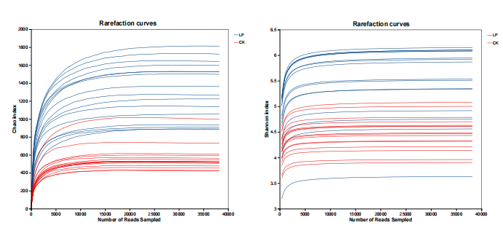
Fig. S1 Rarefaction curves of Chao and Shannon index.

