Supporting Information for

Rhizosphere bacteria exhibit narrower environmental adaptation in proso millet than in foxtail millet and sorghum in agricultural fields

Lixin Tian¹·Feifei Zhang¹·Pengliang Chen¹·Panpan Zhang²·Zhijun Gao³·Yang Dong⁴·Feng Yan⁴·Pu, Yang¹·Xiaoli Gao^{1*}·Baili Feng^{1*}
¹ State Key Laboratory of Crop Stress Biology in Arid Areas/Shaanxi Research Station of Crop Gene Resources & Germplasm Enhancement, Ministry of Agriculture, College of Agronomy, Northwest A & F University, Yangling, Shaanxi 712100, PR China
² College of Life Siencec, Yulin University, Yulin, Shaanxi 719000, China
³ Inner Mongolia Erdos Institute of Agriculture and Animal Husbandry, Erdos, Inner Mongolia 017200 PR China
⁴ Qiqihar Branch, Heilongjiang Academy of Agricultural Sciences, Qiqihar, Heilongjiang 161006, PR China

* Corresponding author: Prof. Baili Feng and Xiaoli Gao
E–mail: fengbaili@nwafu.edu.cn and gao2123@nwsuaf.edu.cn
Phone: +86–29–87082889
Fax: +86–29–87082889
TABLE S4 Envfit results for the environmental variables used in the non-metric multi-dimensional scaling ordination.
Environmental variables | Foxtail millet |  | Proso millet |  | Sorghum
Environmental variables | R² | P-value | R² | P-value | R² | P-value
pH | 0.693 | 0.001 | 0.727 | 0.001 | 0.624 | 0.005
OM | 0.860 | 0.001 | 0.694 | 0.001 | 0.773 | 0.001
TN | 0.922 | 0.001 | 0.725 | 0.001 | 0.698 | 0.001
AP | 0.013 | 0.875 | 0.352 | 0.006 | 0.102 | 0.272
AK | 0.307 | 0.012 | 0.178 | 0.075 | 0.038 | 0.634
NH4 | 0.851 | 0.001 | 0.227 | 0.036 | 0.579 | 0.001
NO3 | 0.873 | 0.001 | 0.114 | 0.199 | 0.039 | 0.617
MAT | 0.356 | 0.006 | 0.484 | 0.003 | 0.509 | 0.001
MAP | 0.110 | 0.253 | 0.163 | 0.115 | 0.201 | 0.059
OM, organic matter; TN, total nitrogen; AP, available phosphorus; AK, available potassium; NH4, ammonium-nitrogen; NO3, Nitrate-nitrogen; MAT, mean annul temperature; MAP, mean annul precipitation

TABLE S5 Partial mantel test results showing relationship between phylogenetic turnover versus mean average temperature (MAT), and spatial/environmental distances for three minor grain crop communities after controlling for the other two explanatory distance constants in agricultural soils
Variables | Controlling for | Foxtail millet | Proso millet | Sorghum
MAT | Spatial + Environmental (excluding MAT) | 0.300** | 0.350* | -0.337
Spatial | Environmental (excluding MAT) + MAT | -0.066 | -0.000 | -0.166
Environmental (excluding MAT) | Spatial + MAT | -0.094 | -0.002 | 0.090

Table S6 Fit of the neutral model in microbial communities in three minor grain crop fields.
Habitats | m | R²
Foxtail millet | 0.5271429 | 0.7714982
Proso millet | 0.5692736 | 0.7801293
Sorghum | 0.5054658 | 0.7569077
R² and m values indicate the fit to the neutral model and the estimated migration rate, respectively.

Fig. S1 Location of the nine sampling sites of three minor crops in agricultural fields.
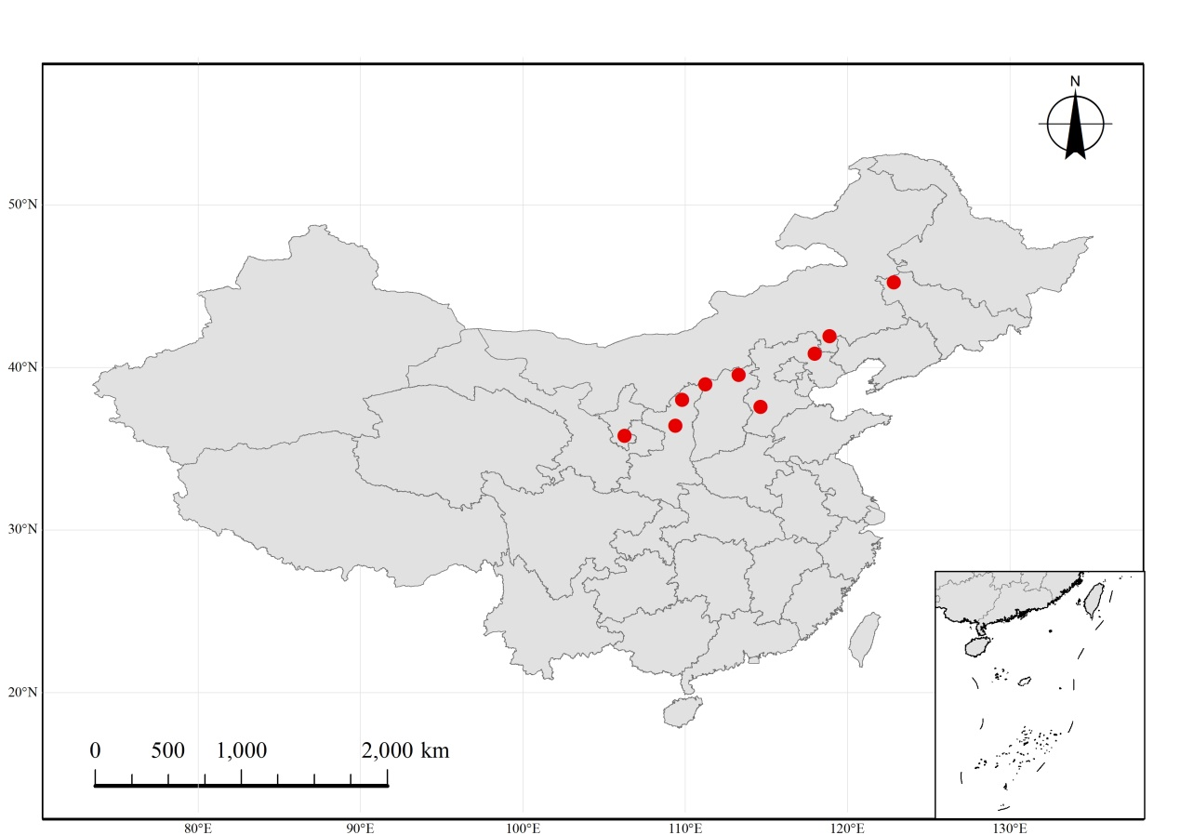

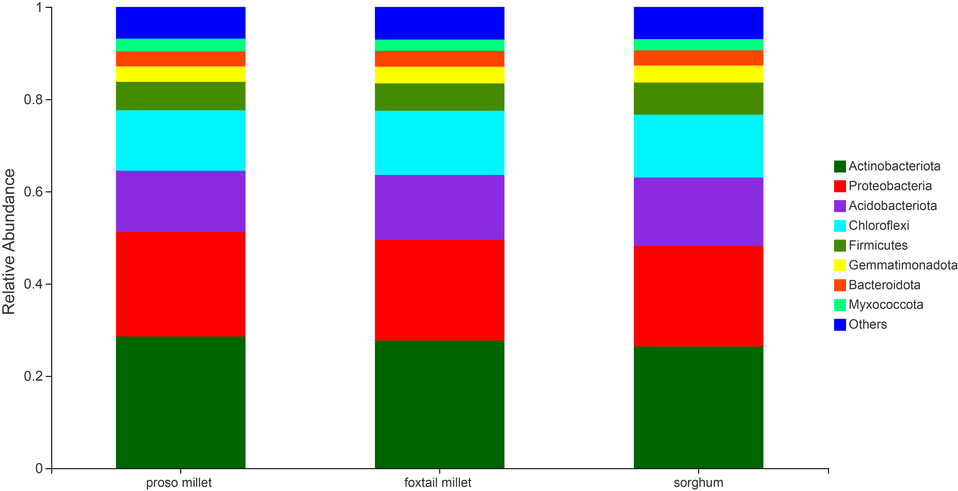
Fig. S2 Relative abundances of dominant phyla in the rhizosphere soils of three minor crops.

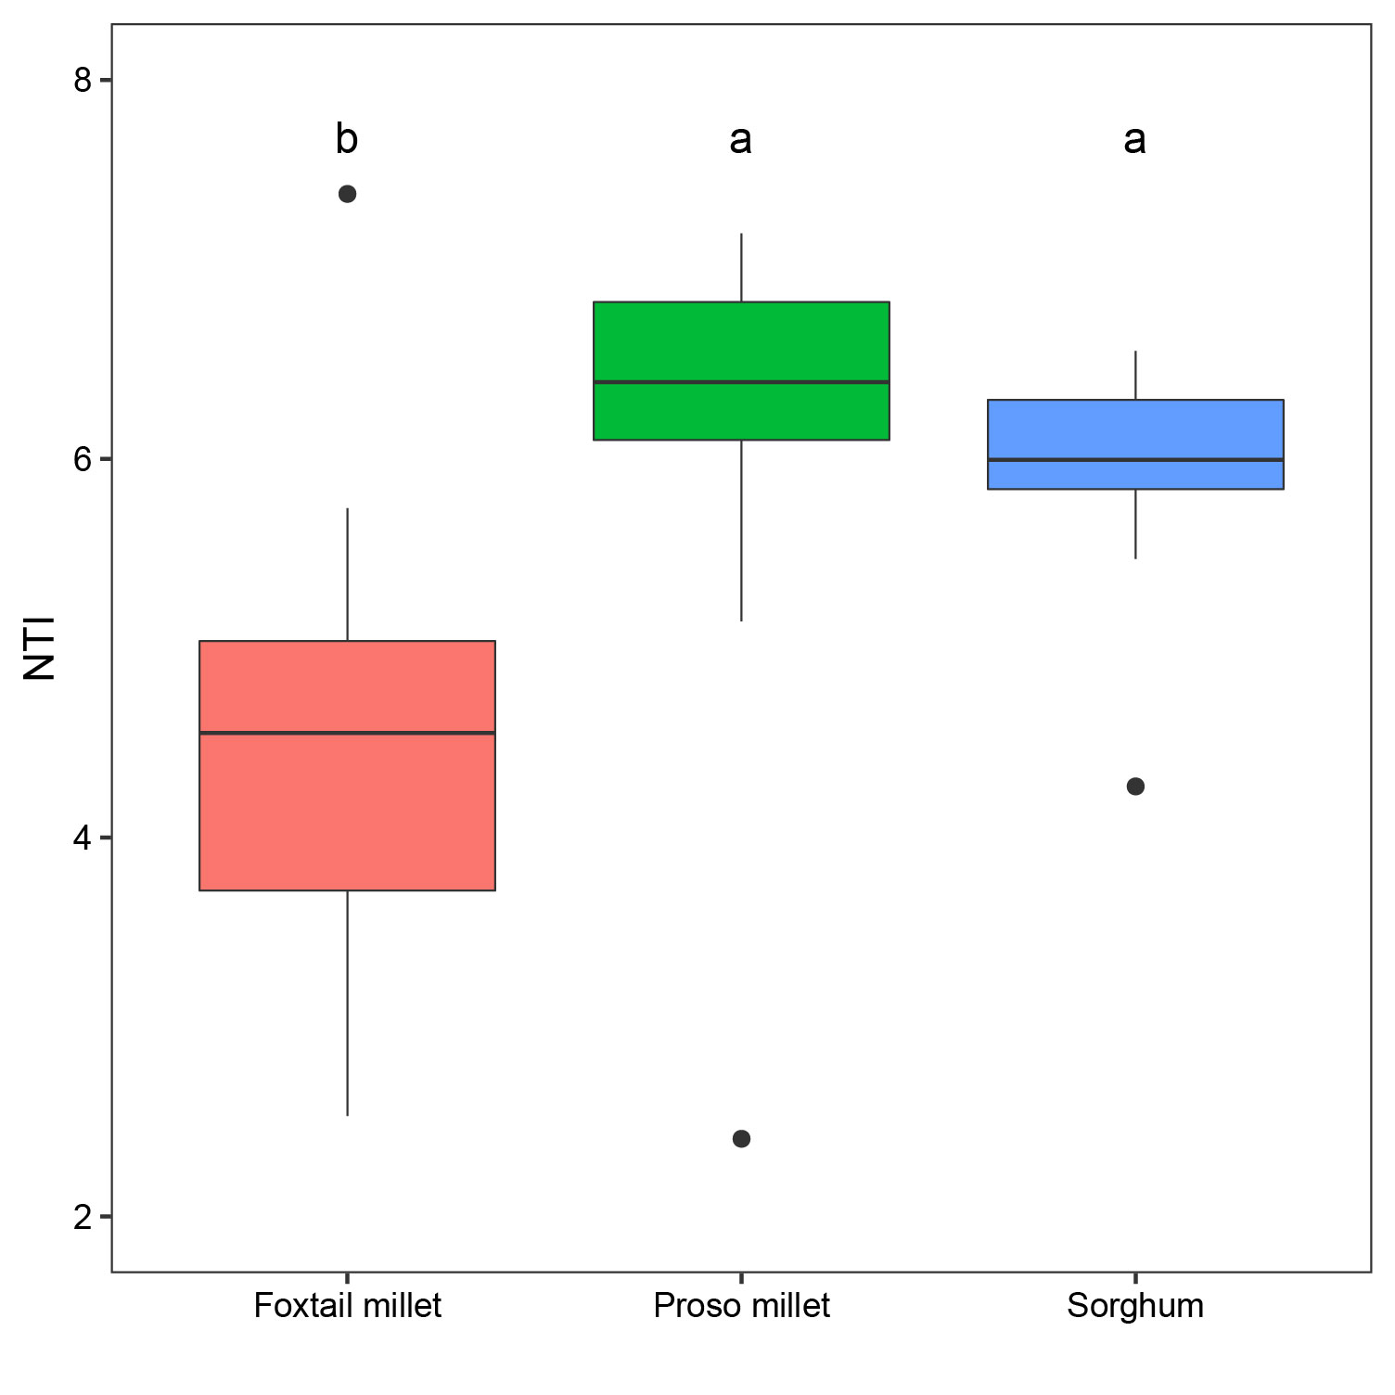
Fig. S3 Boxplot showing difference in NTI values of rhizosphere bacterial communities among three minor grain crops.

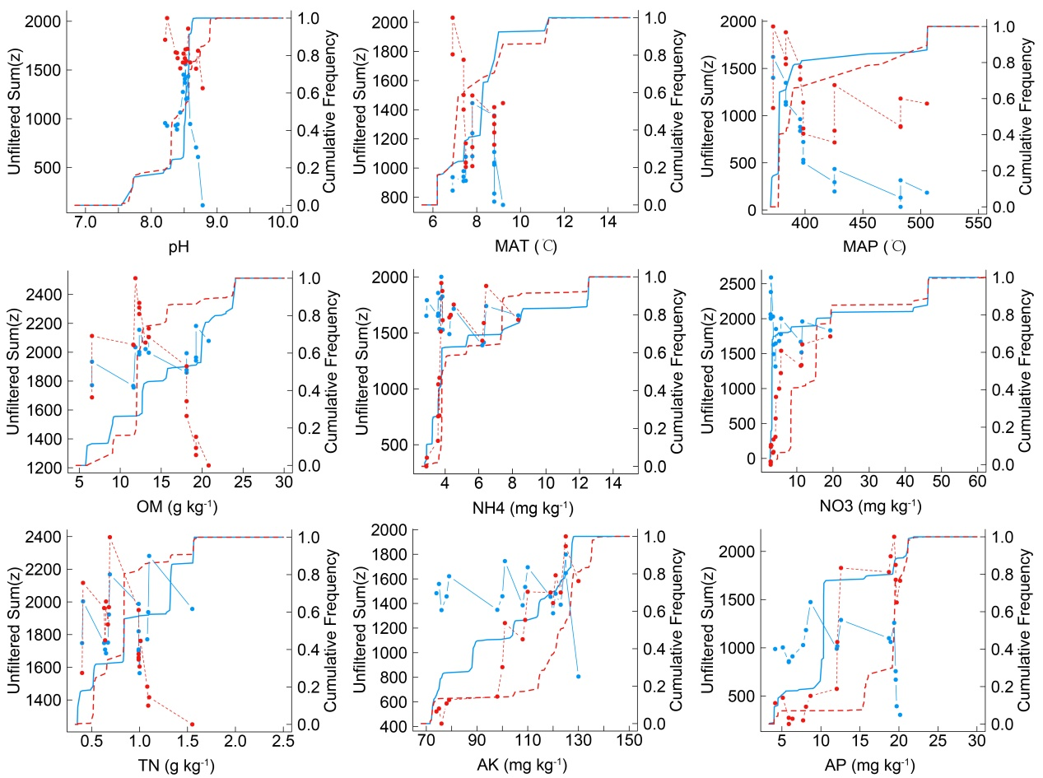
FIGURE S4 Occurrence thresholds of bacteria of foxtail millet in agricultural soils with respect to environmental variables with significant effects on community composition and structure: pH, MAT, MAP, OM, NH4, NO3, TN, AK, and AP. The z-scores of all community members are shown. Blue symbols show taxa declining with increasing environmental gradient (z-), while red symbols depict increasing taxa (z+).
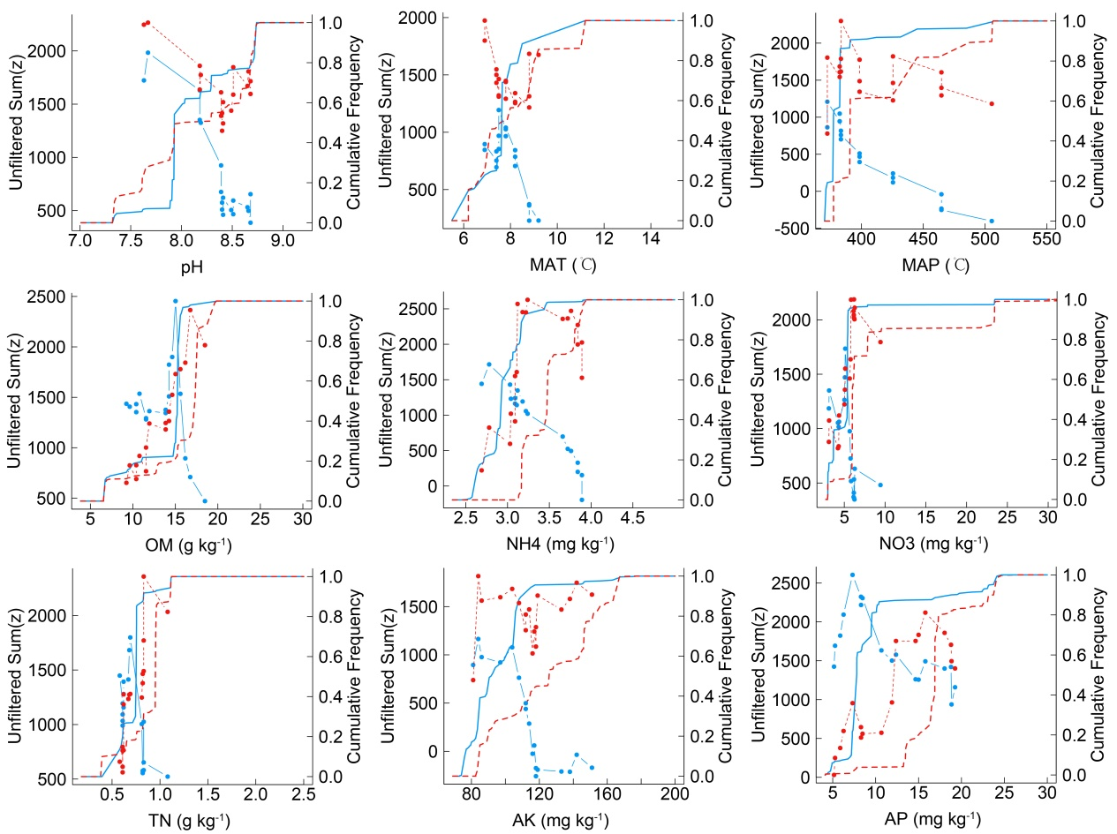
FIGURE S5 Occurrence thresholds of bacteria of proso millet in agricultural soils with respect to environmental variables with significant effects on community composition and structure: pH, MAT, MAP, OM, NH4, NO3, TN, AK, and AP. The z-scores of all community members are shown. Blue symbols show taxa declining with increasing environmental gradient (z-), while red symbols depict increasing taxa (z+).

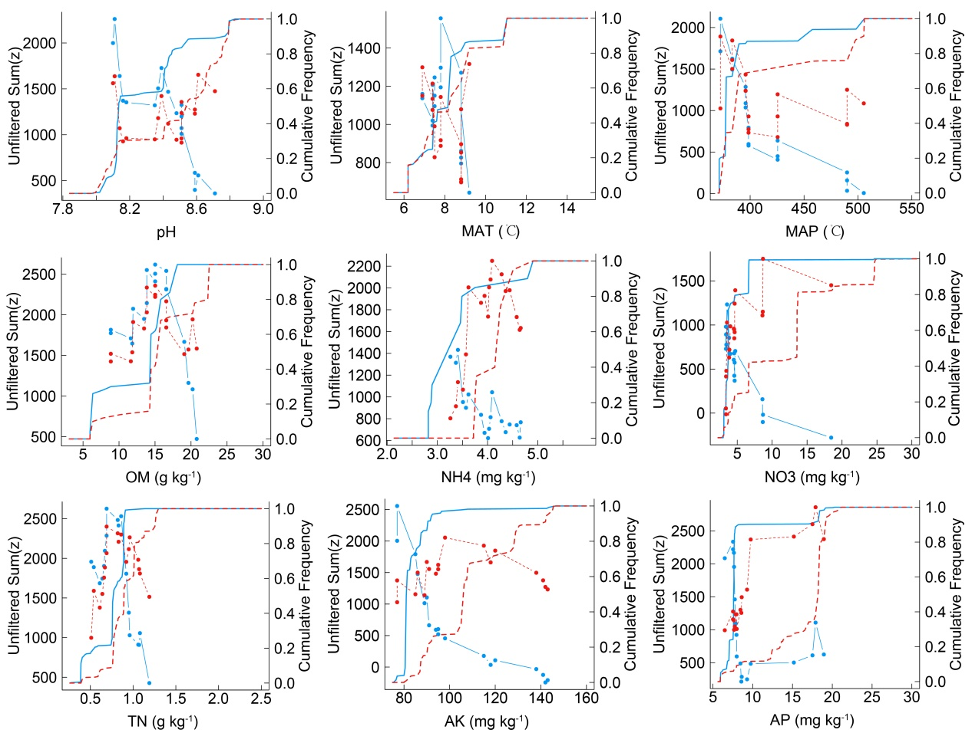
FIGURE S6 Occurrence thresholds of bacteria of sorghum in agricultural soils with respect to environmental variables with significant effects on community composition and structure: pH, MAT, MAP, OM, NH4, NO3, TN, AK, and AP. The z-scores of all community members are shown. Blue symbols show taxa declining with increasing environmental gradient (z-), while red symbols depict increasing taxa (z+).

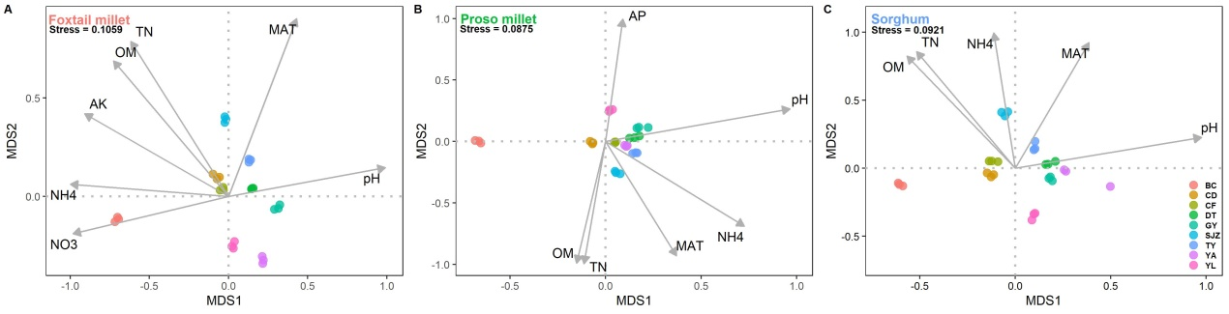
Fig. S7 Global non-metric multidimensional scaling ordination of bacteria community composition in three minor grain crop rhizosphere soils. Arrows show the direction and strength of correlation of the most-influential environmental variables according to the significance <0.05. Abbreviations of environmental variables are defined in Fig. 1

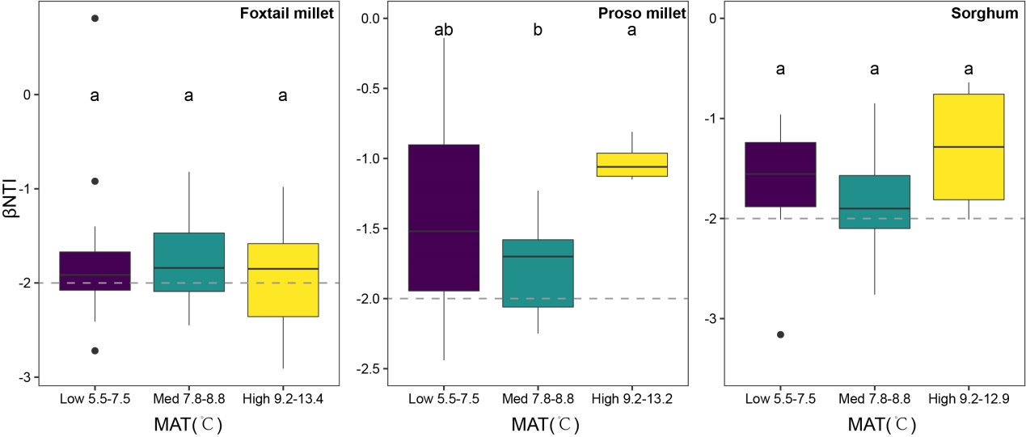
Fig. S8 Patterns of βNTI across different categories in MAT for the foxtail millet, proso millet, and sorghum rhizosphere bacteria communities. Different letters above the column represent significant level (p < 0.05).

