Supporting Information

Programming Biomimetic Self-Assembly through Solvent-Encoded Pathway Selection
Guangdi Wang, ¹ Zhibing Wu, ¹ Xiang Zhou, ¹ Li-Wei Liu, ¹ Lin-Lin Yang,^{1, 2}* Zheng Zhao, ³* and Song Yang ¹*

¹National Key Laboratory of Green Pesticide, Key Laboratory of Green Pesticide and Agricultural Bioengineering, Ministry of Education, Center for R&D of Fine Chemicals of Guizhou University, Guiyang, 550025, China.
²College of Materials Science and Engineering, Guiyang University, 550005 Guiyang, China
³Guangdong Basic Research Center of Excellence for Aggregate Science, School of Science and Engineering, The Chinese University of Hong Kong (Shenzhen), Longgang, Shenzhen, Guangdong 518172, China.

*Corresponding author.
E-mail: yangll0325@126.com; zhaozheng@cuhk.edu.cn; jhzx.msm@gmail.com
Materials
All amino acids were purchased from Sanen Chemical Technology Co., Ltd. (Shanghai, China). Methanol, ethanol and n-pentanol were provided by Zhiyuan Chemical Reagent Co., Ltd. (Tianjin, China). Sodium borate was procured from Fenglan Industrial Development Co., Ltd. (Guizhou, China). Hydrogen peroxide (H₂O₂) was purchased from InnoChem Science & Technology Co., Ltd. (Beijing, China). 2,2,6,6-Tetramethylpiperidine-1-oxyl (TEMPO), glutathione (GSH), dithiothreitol (DTT), N, N-dimethylformamide and tetrahydrofuran were all purchased from Zesheng Technology Co., Ltd. (Anhui, China). Dimethylaniline and N-methylbenzylamine were bought from Sanen Chemical Technology Co., Ltd. (Shanghai, China). Deuterated solvents, namely methanol-D₄ and deuterated dimethyl sulfoxide (d-DMSO), were also purchased from Zesheng Technology Co., Ltd. (Anhui, China). It should be noted that all reagents need to be further purified before being used in the experiments.
Supplementary Figures
 |  | δ_{d} | δₚ | δₕ | Relative Energy Difference (RED)
 | FC | 19.5 | 7 | 8.9 | 0
1 | Anisole (Anis) | 17.8 | 4.4 | 6.9 | 0.59
2 | Methylene Chloride (DCM) | 17 | 7.3 | 7.1 | 0.67
3 | Tetrahydrofuran (THF) | 16.8 | 5.7 | 8 | 0.7
4 | n-Methyl-2-Pyrrolidone (NMP) | 18 | 12.3 | 7.2 | 0.79
5 | 1,4-Dioxane (1,4-Diox) | 17.5 | 1.8 | 9 | 0.82
6 | N, N-Dimethyl Acetamide (N, N-DMAc) | 16.8 | 11.5 | 10.2 | 0.89
7 | Ethyl Acetate (EA) | 15.8 | 5.3 | 7.2 | 0.97
8 | n-Amyl Alcohol (AmOH) | 15.9 | 5.9 | 13.9 | 1.1
9 | Acetone (Ac) | 15.5 | 10.4 | 7 | 1.11
10 | Toluene (Tol) | 18 | 1.4 | 2 | 1.17
11 | Dimethyl Sulfoxide (DMSO) | 18.4 | 16.4 | 10.2 | 1.22
12 | Benzene (Benz) | 18.4 | 0 | 2 | 1.26
13 | 2-Propanol (IPA) | 15.8 | 6.1 | 16.4 | 1.32
14 | Acetic Acid (AcOH) | 14.5 | 8 | 13.5 | 1.38
15 | Ethanol (EtOH) | 15.8 | 8.8 | 19.4 | 1.62
16 | Acetonitrile (MeCN) | 15.3 | 18 | 6.1 | 1.77
17 | Methanol (MeOH) | 14.7 | 12.3 | 22.3 | 2.16
18 | Water (H₂O) | 15.5 | 16 | 42.3 | 4.44
Table 1. 3D Hansen Solubility Parameters for FC and 18 Solvents.
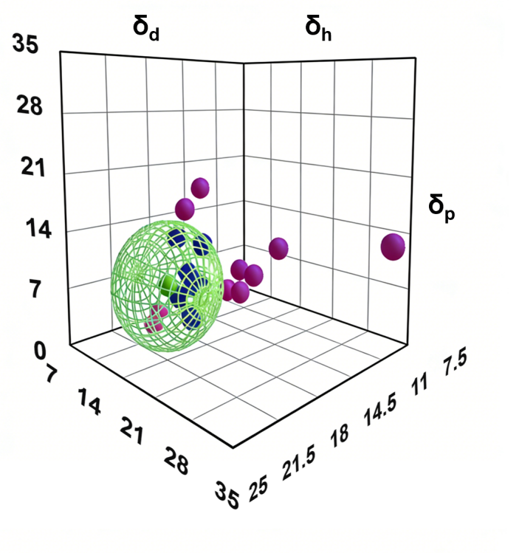
Figure S1. 3D Hansen Solubility Space of 18 Solvents in FC Computational Simulation.
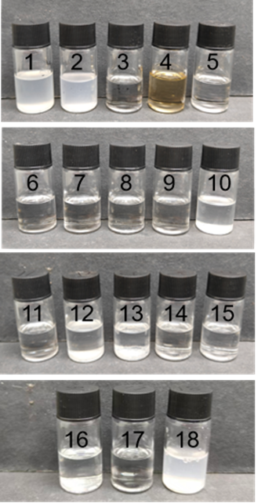
Figure S2. Digital photographs of FC in 18 different solvents.
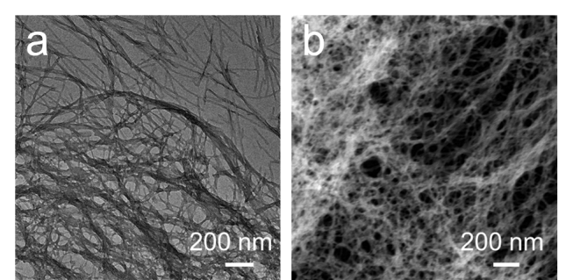
Figure S3. TEM and STEM images of FC in 50% v/v MeOH-H₂O mixture. (a) TEM image; (b) STEM image.
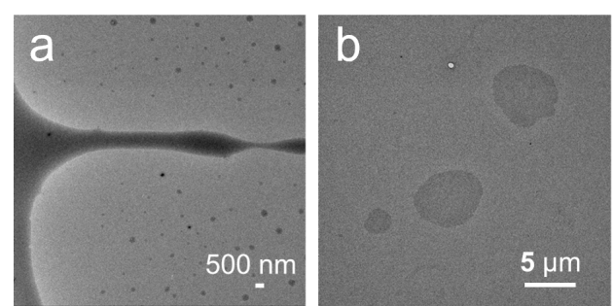
Figure S4. TEM images of FC before self-assembly in EtOH and AmOH systems. (a) EtOH; (b) AmOH.
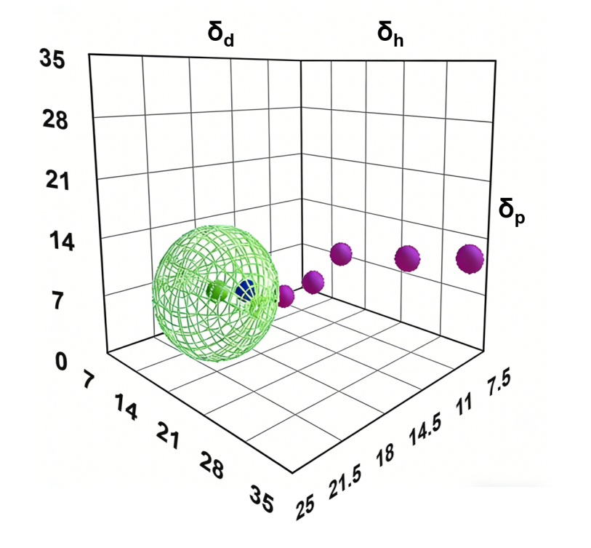
Figure S5. 3D Hansen Solubility Space from H₂O to AmOH in FC Computational Simulation.
 |  | δd | δₚ | δₕ | Relative Energy Difference (RED)
 | FC | 19.5 | 7 | 8.9 | 0
1 | THF | 16.8 | 5.7 | 8 | 0.7
2 | AmOH | 15.9 | 5.9 | 13.9 | 1.1
3 | EtOH | 15.8 | 8.8 | 19.4 | 1.62
4 | MeOH | 14.7 | 12.3 | 22.3 | 2.16
5 | 50% (v/v) MeOH-H₂O | 15.3 | 14.27 | 33.81 | 3.41
6 | H₂O | 15.5 | 16 | 42.3 | 4.44
Table 2. 3D Hansen Solubility Parameters from H₂O to AmOH and THF.
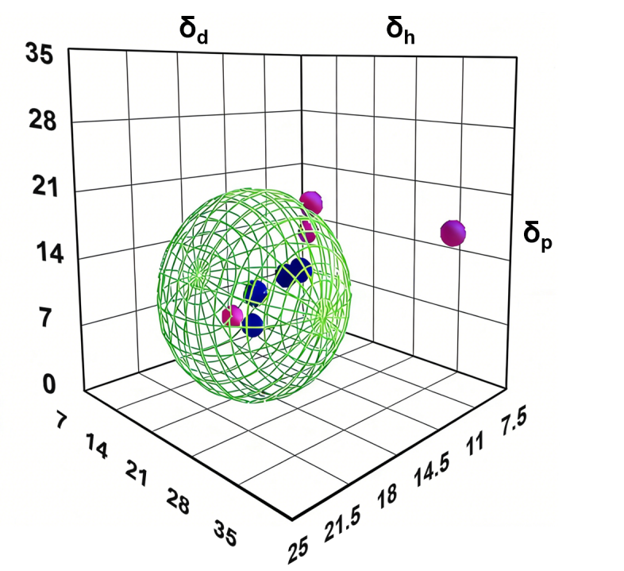
Figure S6. 3D Hansen Solubility Space of Fine-Tuned Mixed Solvents in FC Computational Simulation.
 |  | δ_{d} | δₚ | δₕ | Relative Energy Difference (RED)
 | FC | 19.5 | 7 | 8.9 | 0
1 | DMF | 17.4 | 13.7 | 11.3 | 1.03
2 | Ac | 15.5 | 10.4 | 7 | 1.11
3 | Tol | 18 | 1.4 | 2 | 1.17
4 | MeOH | 14.7 | 12.3 | 22.3 | 2.16
5 | 6% (v/v) DMF-H₂O | 15.62 | 15.85 | 40.2 | 4.18
6 | 2% (v/v) MeOH-H₂O | 15.48 | 15.91 | 41.8 | 4.38
7 | 10% (v/v) MeOH-Tol | 17.67 | 2.49 | 4.03 | 0.95
8 | 10% (v/v) THF-Tol | 17.88 | 2.83 | 1.6 | 1.13
9 | 10% (v/v) MeOH-DCM | 16.77 | 7.8 | 8.62 | 0.69
10 | 10% (v/v) THF-DCM | 16.98 | 7.14 | 7.19 | 0.67
9 | H₂O | 15.5 | 16 | 42.3 | 4.44
Table 3. 3D Hansen Solubility Parameters for Aromatic Solvents and Fine-Tuned Mixed Solvents.
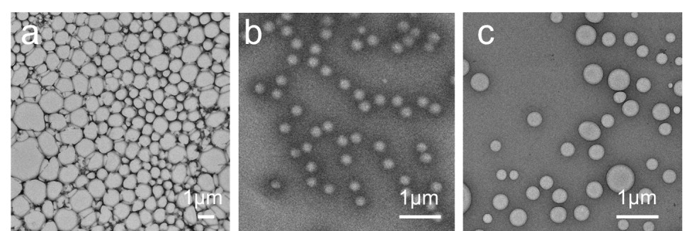
Figure S7. TEM images of the FC pure DCM system or Tol system. TEM images of the 2% v/v MeOH-DCM system (a). TEM images of the 2% v/v MeOH-Tol system (b). TEM images of the 2% v/v THF-DCM system (c).
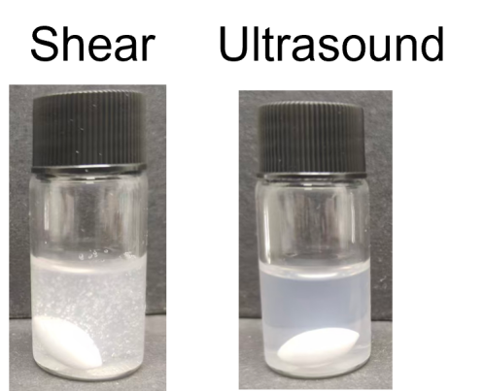
Figure S8. Macroscopic images of FC aqueous system under shear and ultrasonic treatment in H₂O system. Note: The bright spots are bubbles.
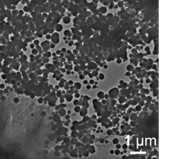
Figure S9. TEM images of nanospheres in shear-treated FC–MeOH system after several months.
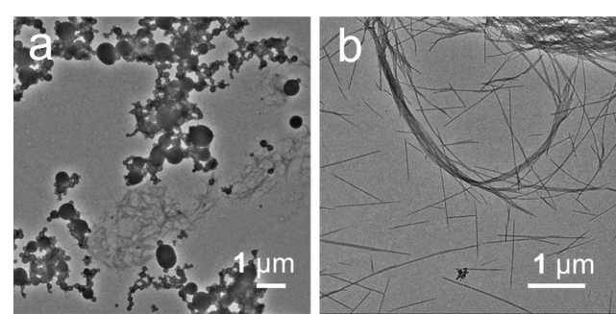
Figure S10. TEM images of FC at various concentrations in ultrasonic MeOH system. (a–b) represent 5–10 mg/ml FC.
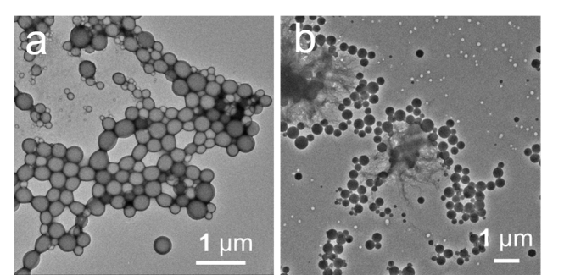
Figure S11. TEM images of FC at various concentrations in shear-treated MeOH system. (a–b) represent 5–10 mg/ml FC.
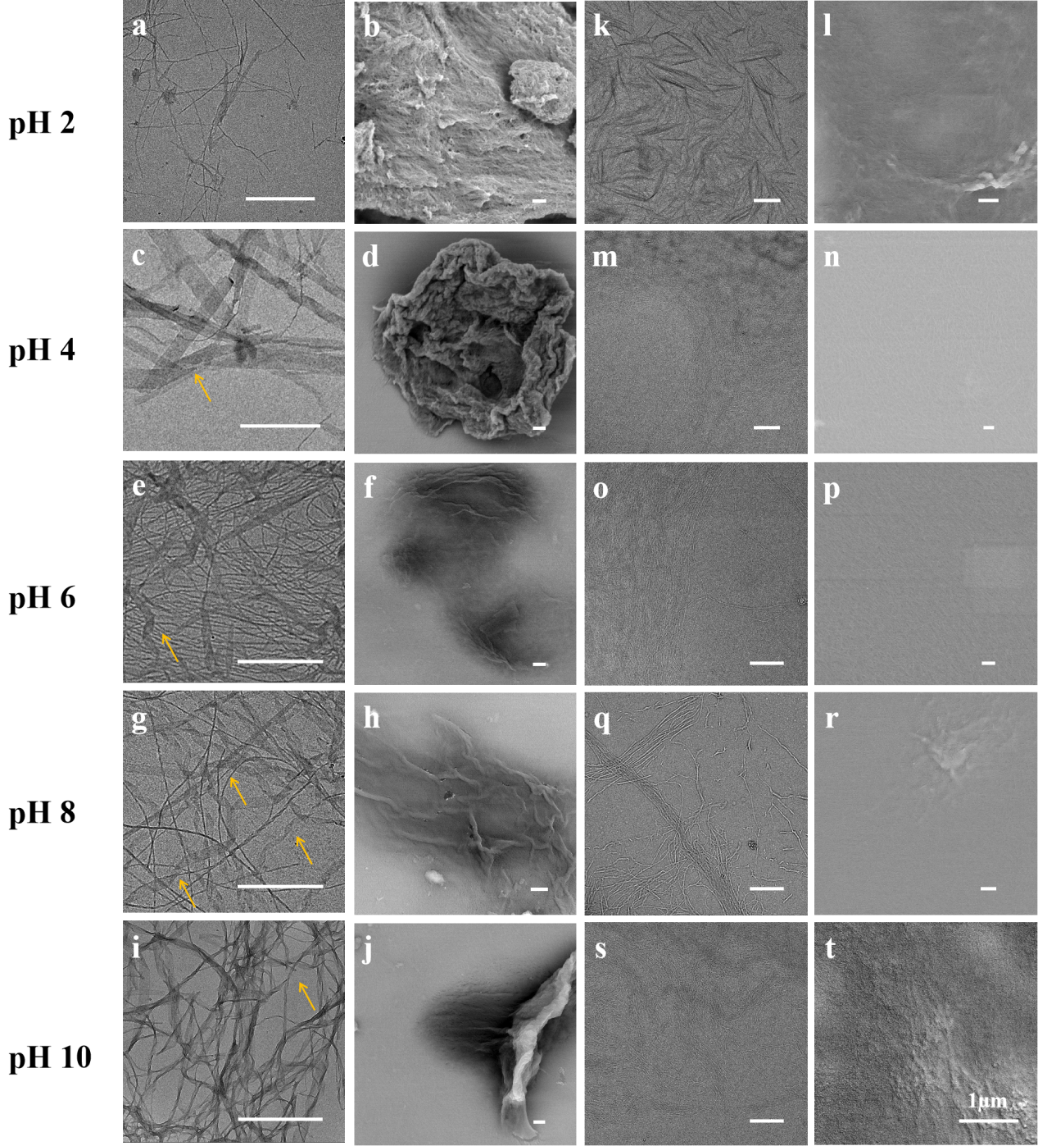
Figure S12. TEM and SEM images of the FC 2% v/v MeOH-H₂O system and the FC 6% v/v DMF-H₂O system under different pH values. (a–j) correspond to the FC 2% v/v MeOH-H₂O system, and (p–t) correspond to the FC 6% v/v DMF-H₂O system.
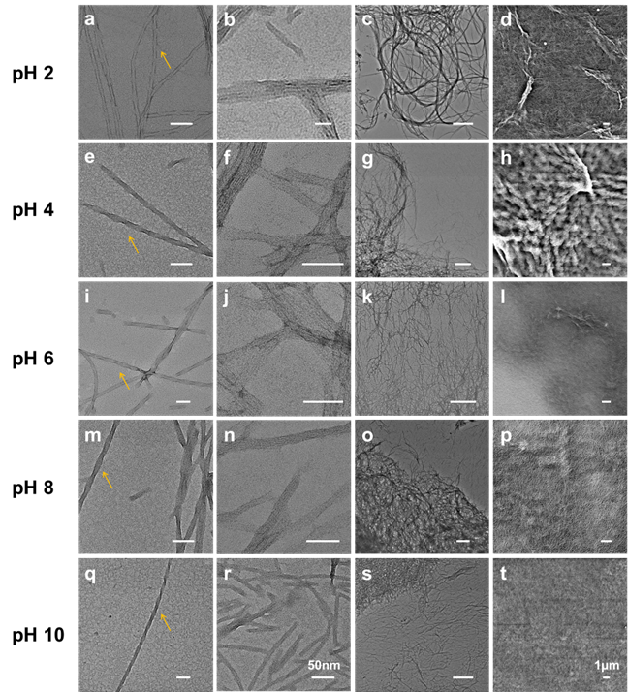
Figure S13. TEM and SEM images of the FC 50% v/v MeOH-H₂O system under different pH values. (a–o) are TEM images, and (p–t) are SEM images. Scale bars: the first and the second columns are 50 nm, and the third and the fourth columns are 1 µm.
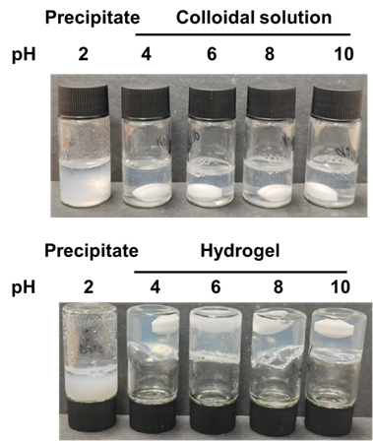
Figure S14. Macroscopic images of FC in 2% v/v MeOH-H₂O or 6% v/v THF-H₂O systems at different pH values.
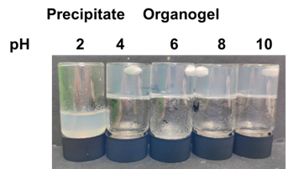
Figure S15. Macroscopic images of the FC 50% v/v MeOH-H₂O system under different pH values.
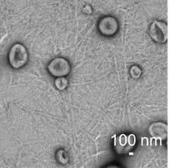
Figure S16. TEM images of wrinkled nanocapsules in FC aqueous solution at pH 2.

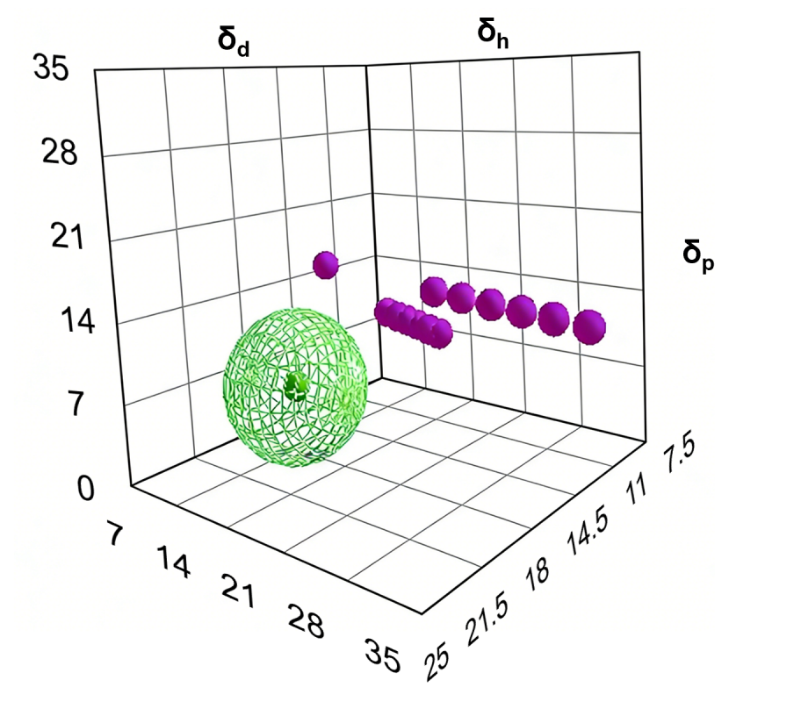
Figure S17. 3D Hansen Solubility Space of H₂O-MeCN and MeOH-MeCN in FC Computational Simulation.
 |  | δ_{d} | δₚ | δₕ | Relative Energy Difference (RED)
 | FC | 19.5 | 7 | 8.9 | 0
1 | MeCN | 15.3 | 18 | 6.1 | 1.77
2 | 50% (v/v) MeCN-MeOH | 15.3 | 13.95 | 15.85 | 1.62
3 | 40% (v/v) MeCN-MeOH | 15.18 | 13.62 | 17.14 | 1.71
4 | 30% (v/v) MeCN-MeOH | 15.06 | 13.29 | 18.43 | 1.81
5 | 20% (v/v) MeCN-MeOH | 14.94 | 12.96 | 19.72 | 1.92
6 | 10% (v/v) MeCN-MeOH | 14.82 | 12.63 | 21.01 | 2.04
7 | MeOH | 14.7 | 12.3 | 22.3 | 2.16
8 | 50% (v/v) MeCN-H₂O | 15.4 | 17 | 23.03 | 2.39
9 | 40% (v/v) MeCN-H₂O | 15.42 | 16.8 | 26.85 | 2.75
10 | 30% (v/v) MeCN-H₂O | 15.44 | 16.6 | 30.67 | 3.14
11 | 20% (v/v) MeCN-H₂O | 15.46 | 16.4 | 34.49 | 3.55
12 | 10% (v/v) MeCN-H₂O | 15.48 | 16.2 | 38.31 | 3.98
13 | H₂O | 15.5 | 16 | 42.3 | 4.44
Table 4. 3D Hansen Solubility Parameters for H₂O-MeCN and MeOH-MeCN.
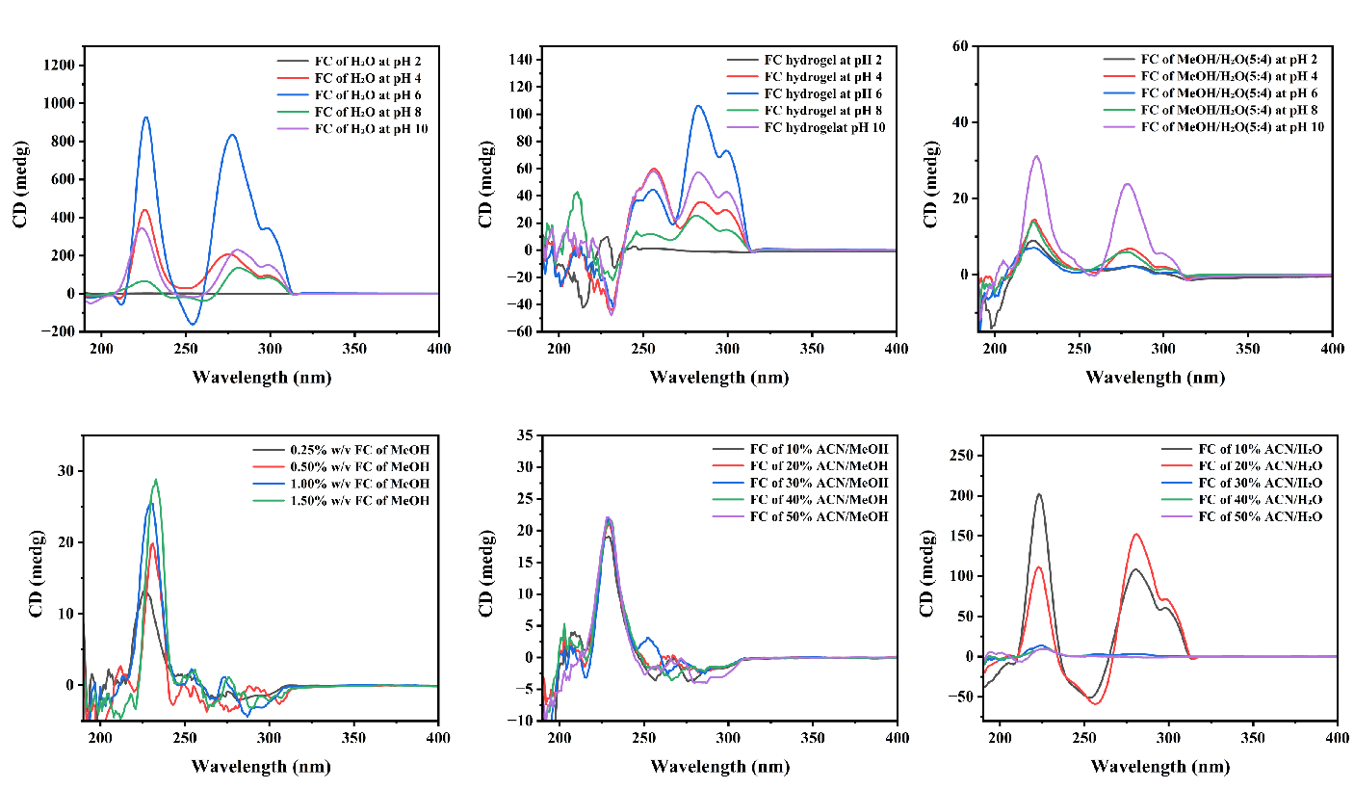
Figure S18. CD spectra of FC sol No.1, FC hydrogel No.2, organogel No.3, the FC sheared MeOH system, the MeCN-H₂O mixed system and the MeCN-MeOH mixed system.
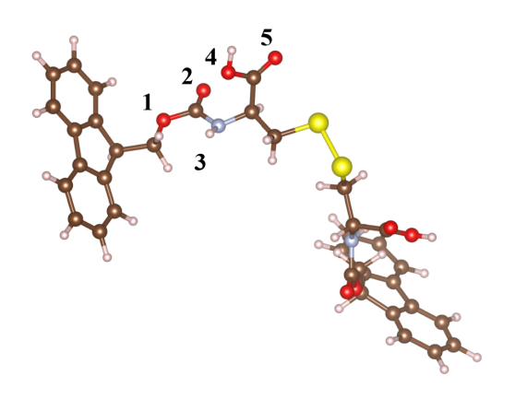
Figure S19. Five sites where a single solvent molecule is most likely to combine with FC molecules.
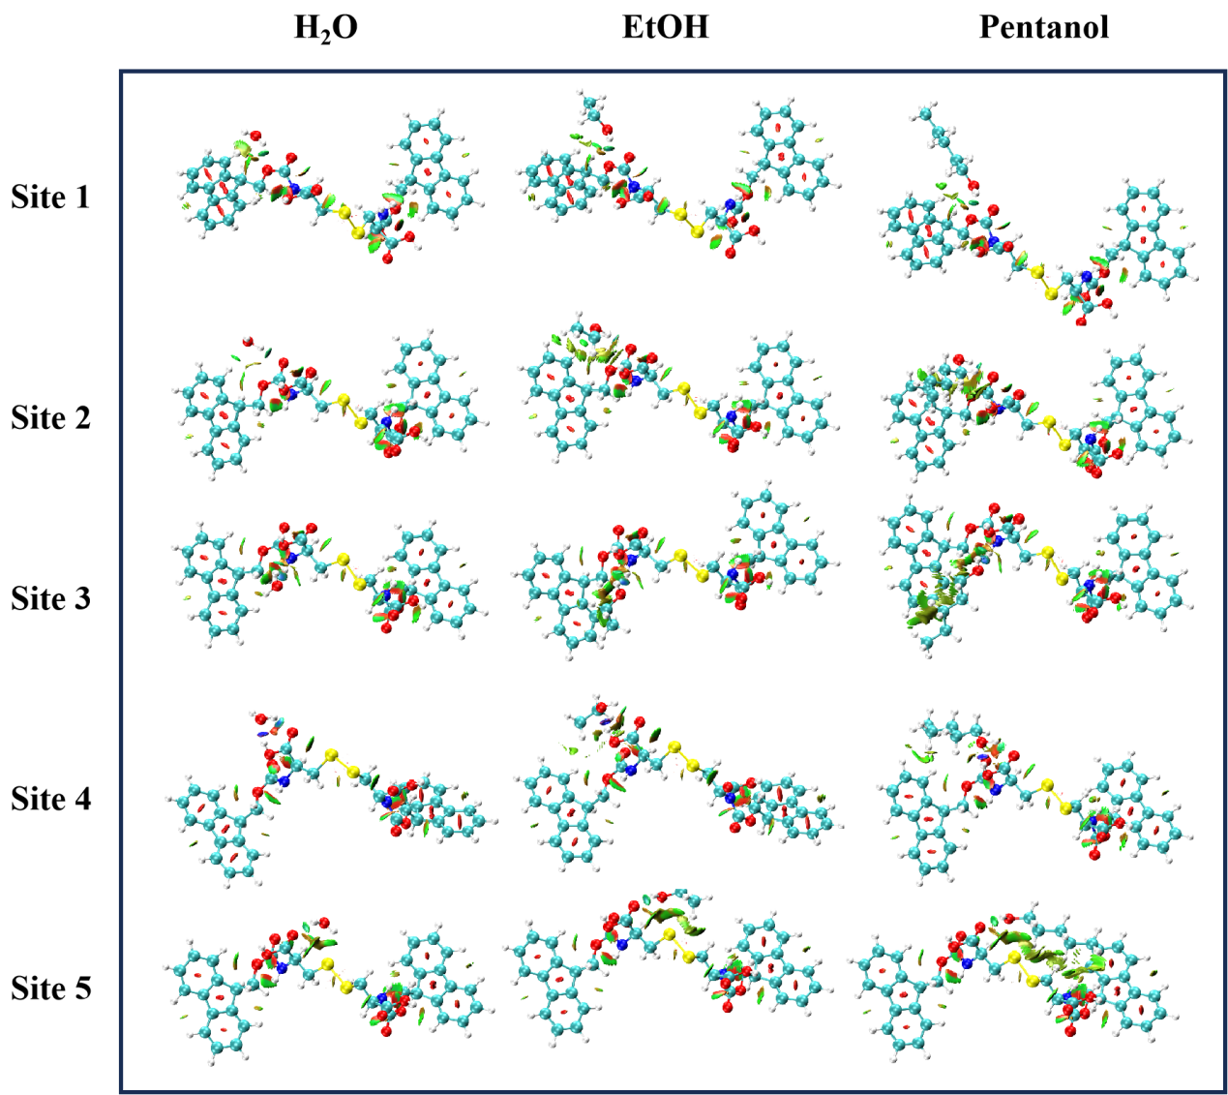
Figure 20. NCI analysis of the five sites where different solvent molecules are most likely to combine with FC molecules.
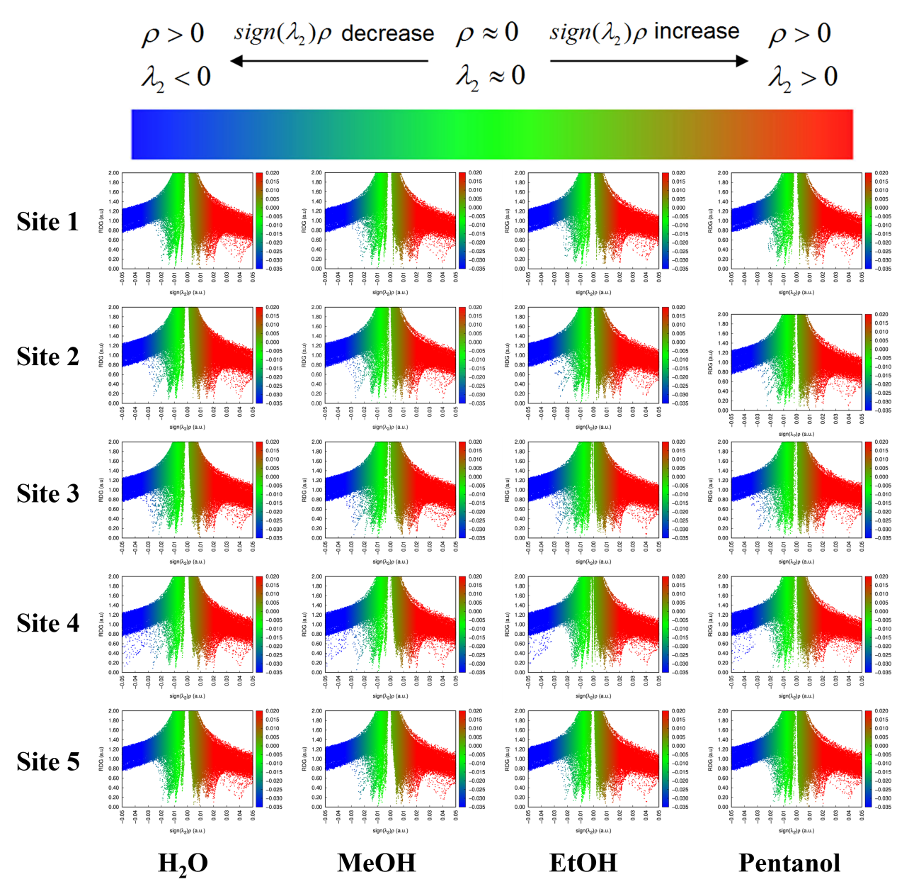
Figure S21. Scatter plot of the NCI (Non-Covalent Interaction) analysis on the five sites where different solvent molecules are most likely to combine with FC molecules.

