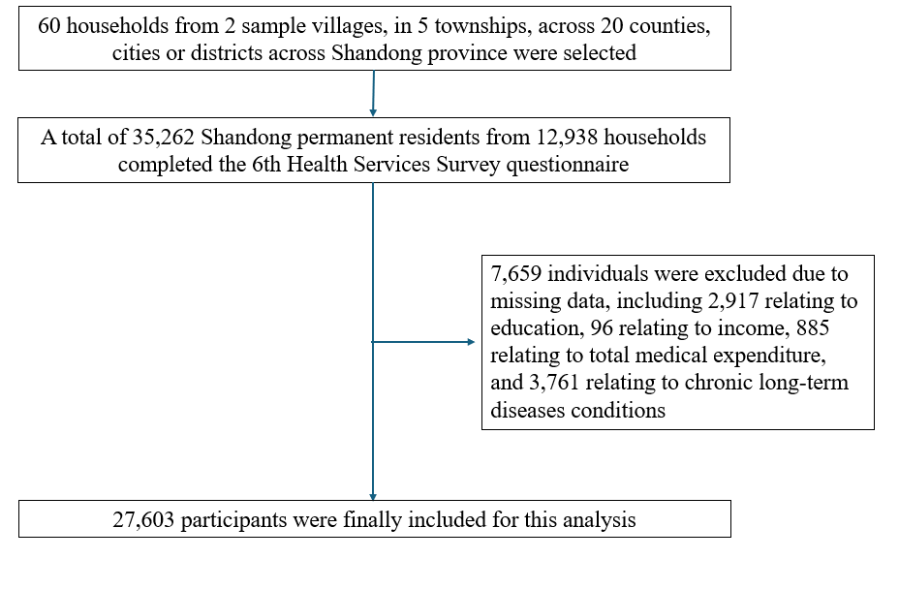
Figure 1. Study sample selection process

Table 1. Socioeconomic and environmental indicators for prefecture-level cities in Shandong province, 2024^{1, 2}
 | Population (10,000 persons) | PM2.5 concentration (µg/m³) | Green area (ha) | GDP (100 million CNY)
Jinan | 951.47 | 36 | 37,281 | 13,005
Qingdao | 1044.25 | 26 | 49,548 | 15,973
Zibo | 463.67 | 40 | 22,053 | 4,677
Zaozhuang | 380.50 | 40 | 9,857 | 2,276
Dongying | 220.83 | 33 | 12,282 | 4,081
Yantai | 703.52 | 25 | 18,568 | 10,266
Weifang | 931.99 | 35 | 13,678 | 7,782
Jining | 818.73 | 39 | 11,684 | 5,642
Taian | 529.15 | 38 | 7,970 | 3,448
Weihai | 291.46 | 20 | 10,753 | 3,565
Rizhao | 292.88 | 30 | 6,102 | 2,455
Linyi | 1084.84 | 38 | 17,565 | 6,270
Dezhou | 548.28 | 42 | 9,342 | 3,886
Liaocheng | 580.34 | 42 | 12,681 | 3,044
Binzhou | 387.44 | 38 | 8,565 | 3,241
Heze | 850.82 | 44 | 10,343 | 4,587

Table 2. STROBE reporting checklist for cross-sectional studies
 | Item No | Recommendation | Reported on page
Title and abstract | 1 | (a) Indicate the study’s design with a commonly used term in the title or the abstract
Title and abstract | 1 | (b) Provide in the abstract an informative and balanced summary of what was done and what was found
Introduction
Background/rationale | 2 | Explain the scientific background and rationale for the investigation being reported
Objectives | 3 | State specific objectives, including any prespecified hypotheses
Methods
Study design | 4 | Present key elements of study design early in the paper
Setting | 5 | Describe the setting, locations, and relevant dates, including periods of recruitment, exposure, follow-up, and data collection
Participants | 6 | (a) Give the eligibility criteria, and the sources and methods of selection of participants
Variables | 7 | Clearly define all outcomes, exposures, predictors, potential confounders, and effect modifiers. Give diagnostic criteria, if applicable
Data sources/ measurement | 8* | For each variable of interest, give sources of data and details of methods of assessment (measurement). Describe comparability of assessment methods if there is more than one group
Bias | 9 | Describe any efforts to address potential sources of bias
Study size | 10 | Explain how the study size was arrived at
Quantitative variables | 11 | Explain how quantitative variables were handled in the analyses. If applicable, describe which groupings were chosen and why
Statistical methods | 12 | (a) Describe all statistical methods, including those used to control for confounding
Statistical methods | 12 | (b) Describe any methods used to examine subgroups and interactions
Statistical methods | 12 | (c) Explain how missing data were addressed
Statistical methods | 12 | (d) If applicable, describe analytical methods taking account of sampling strategy
Statistical methods | 12 | (e) Describe any sensitivity analyses
Results
Participants | 13* | (a) Report numbers of individuals at each stage of study—eg numbers potentially eligible, examined for eligibility, confirmed eligible, included in the study, completing follow-up, and analysed
Participants | 13* | (b) Give reasons for non-participation at each stage
Participants | 13* | (c) Consider use of a flow diagram
Descriptive data | 14* | (a) Give characteristics of study participants (eg demographic, clinical, social) and information on exposures and potential confounders
Descriptive data | 14* | (b) Indicate number of participants with missing data for each variable of interest
Outcome data | 15* | Report numbers of outcome events or summary measures
Main results | 16 | (a) Give unadjusted estimates and, if applicable, confounder-adjusted estimates and their precision (eg, 95% confidence interval). Make clear which confounders were adjusted for and why they were included
Main results | 16 | (b) Report category boundaries when continuous variables were categorized
Main results | 16 | (c) If relevant, consider translating estimates of relative risk into absolute risk for a meaningful time period
Other analyses | 17 | Report other analyses done—eg analyses of subgroups and interactions, and sensitivity analyses
Discussion
Key results | 18 | Summarise key results with reference to study objectives
Limitations | 19 | Discuss limitations of the study, taking into account sources of potential bias or imprecision. Discuss both direction and magnitude of any potential bias
Interpretation | 20 | Give a cautious overall interpretation of results considering objectives, limitations, multiplicity of analyses, results from similar studies, and other relevant evidence
Generalisability | 21 | Discuss the generalisability (external validity) of the study results
Other information
Funding | 22 | Give the source of funding and the role of the funders for the present study and, if applicable, for the original study on which the present article is based

Table 3. Disease classification list for the Health Services Survey in Shandong province
- Infectious disease
Hepatitis B
- Cancer and tumors
Nasopharyngeal carcinoma
Esophageal cancer
Gastric cancer
Colorectal cancer
Rectal and anal cancer
Liver cancer
Pancreatic cancer
Tracheal, bronchial, and lung cancer
Breast cancer
Cervical cancer
Leukemia
Other types of cancer
Benign uterine tumor
Benign brain tumor
Other benign tumors
Carcinoma in situ
- Endocrine, nutritional, metabolic diseases and immune disorders
Hyperthyroidism
Diabetes
Malnutrition
Rickets
Obesity and other nutritional disorders
Other endocrine, nutritional, metabolic, and immune disorders
- Blood and hematopoietic organ diseases
Anemia
Other blood and hematopoietic organ diseases
- Psychiatric disorders
Senile and pre-senile organic mental disorders
Schizophrenia
Depression
Other mental disorders
- Neurological diseases
Meningitis
Epilepsy
Parkinson's disease
Other neurological disorders
- Eye and adnexal diseases
Glaucoma
Cataract
Corneal diseases
Other eye and adnexal diseases
Ear and mastoid diseases
Otitis media and mastoiditis
Other ear and mastoid diseases
- Circulatory system diseases
Chronic rheumatic heart disease
Other ischemic heart diseases
Pulmonary heart disease
Other types of heart disease
Hypertension
Cerebrovascular diseases
Varicose veins
Other circulatory system diseases
- Respiratory system diseases
Pneumonia
Chronic pharyngitis and laryngitis
Emphysema
Other chronic obstructive pulmonary disease (COPD), including chronic bronchitis, etc.
Asthma
Other chronic respiratory system diseases
- Digestive system diseases
Dental diseases
Other oral, salivary gland, and jaw diseases
Chronic gastroenteritis
Peptic ulcer
Abdominal hernia
Intestinal obstruction
Chronic liver disease
Liver cirrhosis
Cholelithiasis
Cholecystitis
Other Chronic digestive system disorders
- Genitourinary disorders
Nephropathy
Nephritis
Pyelonephritis
Urinary tract stones
Other Chronic urogenital disorders
Benign prostatic hyperplasia or inflammation
Other chronic male genital disorders
Breast disease
Salpingitis
Oophoritis
Uterine prolapse
Other chronic female genital disorders
- Skin and subcutaneous tissue disorders
Furuncle
Boil
Dermatitis
Other chronic skin and subcutaneous tissue disorders
- Musculoskeletal and connective tissue disorders
Rheumatoid arthritis
Intervertebral disc disease
Osteomyelitis
Other chronic musculoskeletal disorders
- Congenital disorders
Congenital heart disease
Other congenital abnormalities

Table 4. Sensitivity analysis of household medical expenditure across NDVI 2-5km buffers
Variables | β (95% CI) | P values
NDVI (base = ${NDVI}_{2000m}^{Q1}$)
Q2 | -0.17 (-0.24, -0.11) | <0.001
Q3 | -0.22 (-0.30, -0.15) | <0.001
Q4 | -0.17 (-0.26, -0.08) | <0.001
NDVI (base = ${NDVI}_{3000m}^{Q1}$)
Q2 | -0.04 (-0.08, -0.01) | <0.001
Q3 | -0.08 (-0.14, -0.02) | <0.01
Q4 | -0.02 (-0.09, 0.06) | 0.04
NDVI (base = ${NDVI}_{4000m}^{Q1}$)
Q2 | -0.03 (-0.06, 0.01) | <0.01
Q3 | -0.07 (-0.13, -0.01) | 0.05
Q4 | 0.07 (-0.01, 0.14) | 0.26
NDVI (base = ${NDVI}_{5000m}^{Q1}$)
Q2 | -0.02 (-0.05, 0.02) | 0.43
Q3 | 0.01 (-0.05, 0.06) | 0.91
Q4 | -0.02 (-0.09, 0.05) | 0.56

Table 5. Sensitivity analysis of household medical expenditure by PM2.5 using 4km, 5km, and 10km buffers
Variables | β (95% CI) | P values
PM2.5 (base = ${PM2.5}_{4000m}^{Q1}$)
Q2 | 0.06 (0.01, 0.11) | 0.01
Q3 | 0.05 (0.01, 0.10) | 0.05
Q4 | 0.28 (0.22, 0.33) | <0.001
PM2.5 (base = ${PM2.5}_{5000m}^{Q1}$)
Q2 | 0.12 (0.07, 0.17) | <0.001
Q3 | 0.06 (0.01, 0.11) | 0.04
Q4 | 0.31 (0.25, 0.36) | <0.001
PM2.5 (base = ${PM2.5}_{10000m}^{Q1}$)
Q2 | 0.12 (0.07, 0.17) | <0.001
Q3 | 0.04 (-0.12, 0.10) | 0.14
Q4 | 0.30 (0.24, 0.35) | <0.001

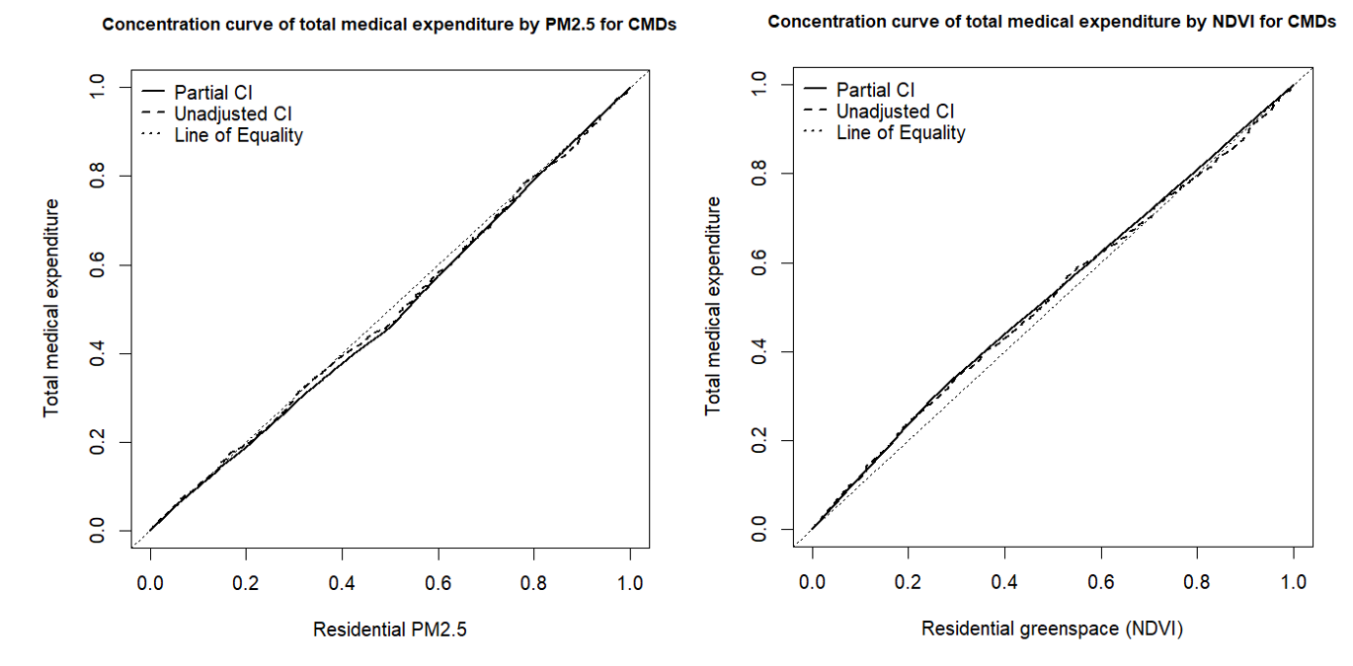

Figure 2. Concentration curve of annual household medical expenditure by residential greenspace and particulate matter exposure for cardiometabolic diseases

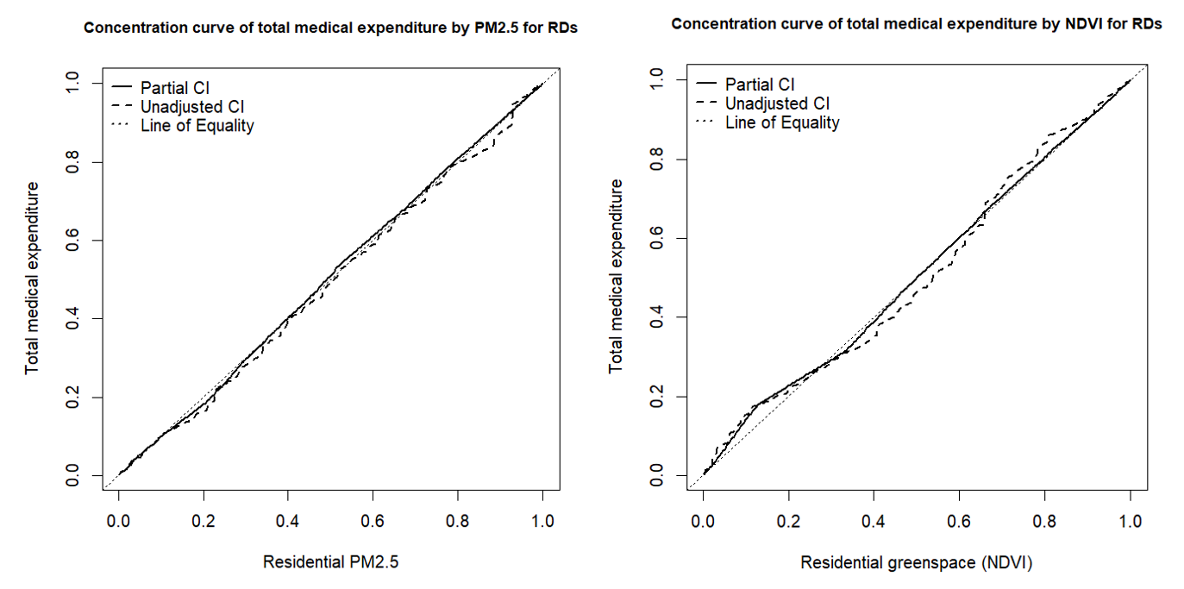

Figure 3. Concentration curve of annual household medical expenditure by residential greenspace and particulate matter exposure for chronic respiratory diseases

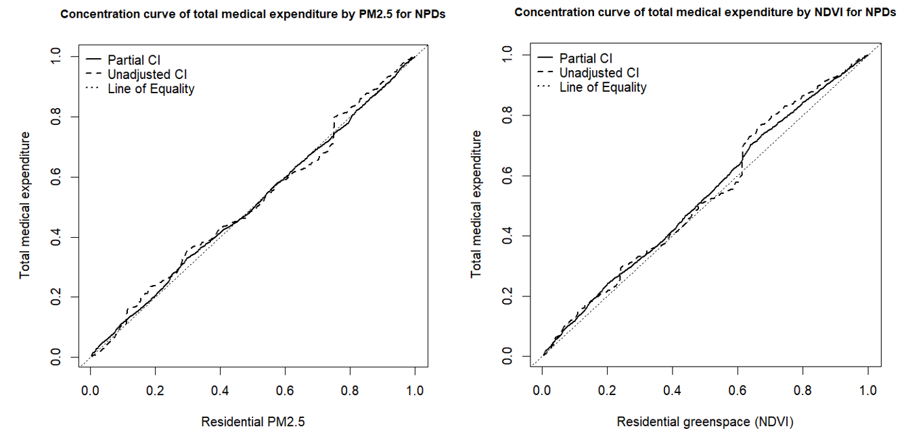
Figure 4. Concentration curve of annual household medical expenditure by residential greenspace and particulate matter exposure for neuropsychiatric disorders
References
1. Shandong Provincial Bureau of Statistics. Statistical Yearbook. Available from: http://tjj.shandong.gov.cn/col/col6279/index.html.
2. Shandong Provincial Government. Shandong Province ecological environment status report.

