Supplementary Table S1. Full search strategy for PubMed
Database: PubMed
From inception to January 2026
Language: English
Study type: Randomized controlled trials

Search step | Search terms
#1 | ("Aerobic Exercise"[Mesh] OR aerobic exercise OR physical activity OR exercise training)
#2 | ("Diet"[Mesh] OR diet* OR dietary intervention OR diet therapy OR lifestyle intervention)
#3 | ("Blood Glucose"[Mesh] OR fasting blood glucose OR fasting plasma glucose OR glycemic control)
#4 | ("Body Mass Index"[Mesh] OR BMI OR body weight OR obesity)
#5 | #1 AND #2
#6 | #3 OR #4
#7 | #5 AND #6
#8 | (randomized controlled trial[Publication Type] OR randomized OR randomised OR RCT)
#9 | #7 AND #8
The search strategy shown above was used as a representative example. Equivalent search strategies were adapted for other databases according to their specific syntax rules.

Supplementary Figure S1
Leave-one-out sensitivity analysis forest plot for fasting blood glucose (FBG).
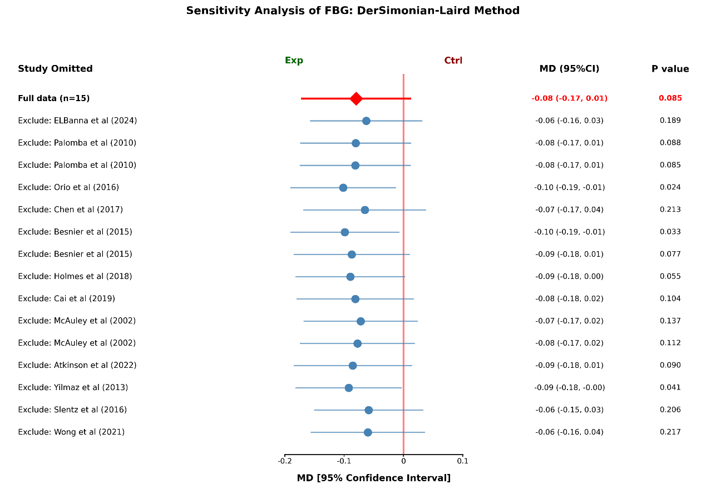
A leave-one-out sensitivity analysis was conducted using a random-effects model to assess the stability of the pooled mean difference (MD) for FBG. The baseline pooled MD was -0.08 mmol/L (95% CI: -0.17 to 0.01, P = 0.085). The forest plot shows that the pooled MD fluctuated between -0.06 and -0.10 mmol/L upon the sequential exclusion of individual studies. Notably, the exclusion of Orio et al. (2016) (MD = -0.10, 95% CI: -0.20 to -0.01, P = 0.024) or Besnier et al. (2015) (MD = -0.10, 95% CI: -0.17 to -0.02, P = 0.033) rendered the results statistically significant. This indicates that these specific trials had a conservative influence on the overall effect size.

Supplementary Figure S2
Effect of excluding individual studies on pooled effect size and heterogeneity for FBG.
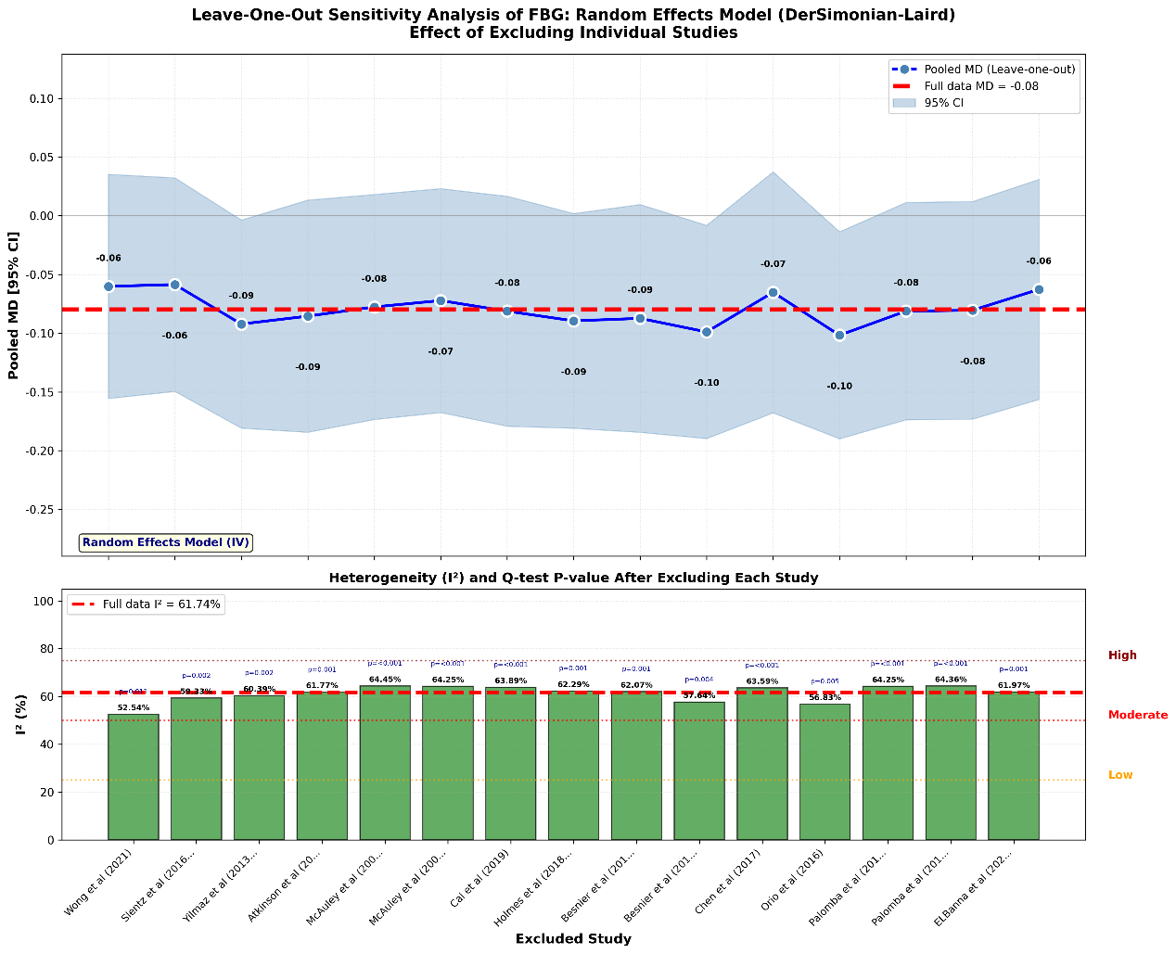
This plot illustrates the impact of each study on the overall heterogeneity (I²). The I² value fluctuated within the range of 52.54% to 64.45%. The exclusion of Wong et al. (2021) resulted in the most significant reduction in heterogeneity, with I² dropping to its minimum value of 52.54%, identifying this study as a major source of statistical variance in the FBG analysis.

Supplementary Figure S3
Leave-one-out sensitivity analysis forest plot for body mass index (BMI).
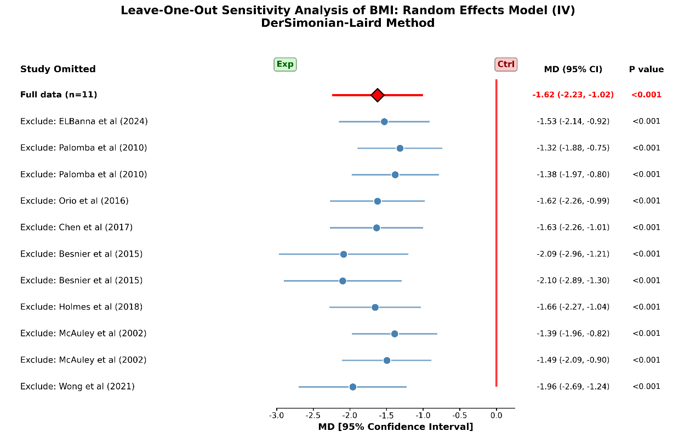
The leave-one-out analysis for BMI confirms the high robustness of the primary findings. The pooled MD for BMI remained remarkably stable, with values ranging from -1.32 to -2.10 kg/m². Across all iterations, the 95% CI remained entirely to the left of the null line, and the statistical significance consistently maintained a level of P < 0.001. This demonstrates that the significant weight-reduction effect of the combined intervention is consistent and not dependent on any single trial.

Supplementary Figure S4
Effect of excluding individual studies on pooled effect size and heterogeneity for BMI.
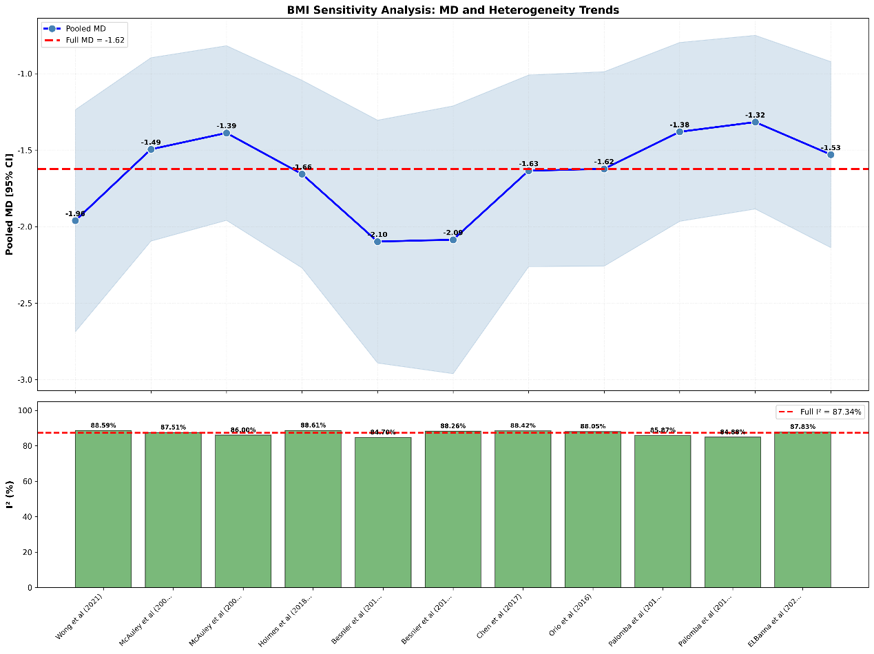
The trend plot for BMI heterogeneity indicates a persistent state of high variability (I² > 80%) throughout the analysis. The I² reached its lowest point (84.70%) after the removal of Besnier et al. (2015) and its highest point (88.61%) following the removal of Holmes et al. (2018). These results suggest that the high heterogeneity is intrinsically linked to broad clinical differences—such as varying baseline BMI levels and intervention intensities—across the included spectrum of high-risk populations, rather than being caused by a single outlier study.

