Biography
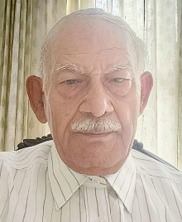
Vijay Kumar Khanna has diverse professional experience, 19 years in civil/structural engineering (design & review) and project management, 20 years in oil and gas sector project execution, and 17 years in marketing of process instruments and non-destructive evaluation tools for civil/structural applications. Currently engaged in engineering consultancy and technical writing. He has authored fourteen publications in the form of Discussions (ICE journals), Articles (HP, H2-TECH, PGJ), Conference Papers to GEOTECH-80, IBMAC (Australia-1984), Research Papers to AJCE. He earned B. Engineering & PGDBM.

