Supplementary Information for

20.8% slot-die coated MAPbI3 perovskite solar cells by optimal DMSO-content and age of 2-ME based precursor inks
Jinzhao Li^{1,4}, Janardan Dagar^{1,4}, Oleksandra Shargaieva¹, Daniel M. Többens³, Rahim Munir¹, Eva L. Unger^{1,2*}
¹Helmholtz-Zentrum Berlin für Materialien und Energie GmbH, Young Investigator Group Hybrid Materials Formation and Scaling, Albert Einstein Straße 16, Berlin 12489, Germany
²Chemical Physics and Nano Lund, Lund University, P.O. Box 124, Lund 22100, Sweden
³Helmholtz-Zentrum Berlin für Materialien und Energie, Albert-Einstein-Str. 15, 12489, Berlin, Germany
⁴These authors contributed equally: Jinzhao Li, Dr. Janardan Dagar

AUTHOR INFORMATION
Corresponding Author: Eva L. Unger

*eva.unger@helmholtz-berlin.de

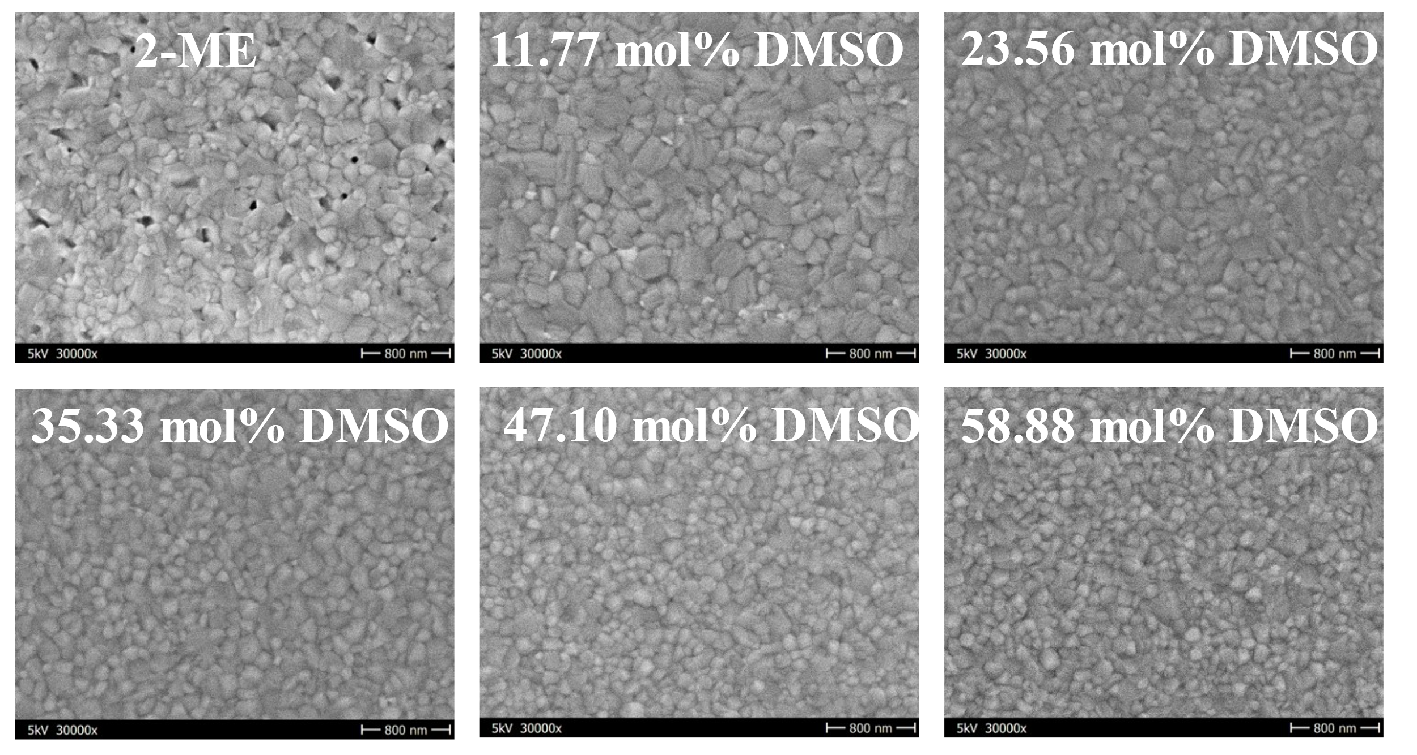
Supplementary Figure 1. The SEM top view images of 2-ME and 2-ME-DMSO samples with different contents of DMSO. The pinholes density was calculated by compared with the total are of pinholes and without, the 2-ME sample shows around 7% pinholes density.

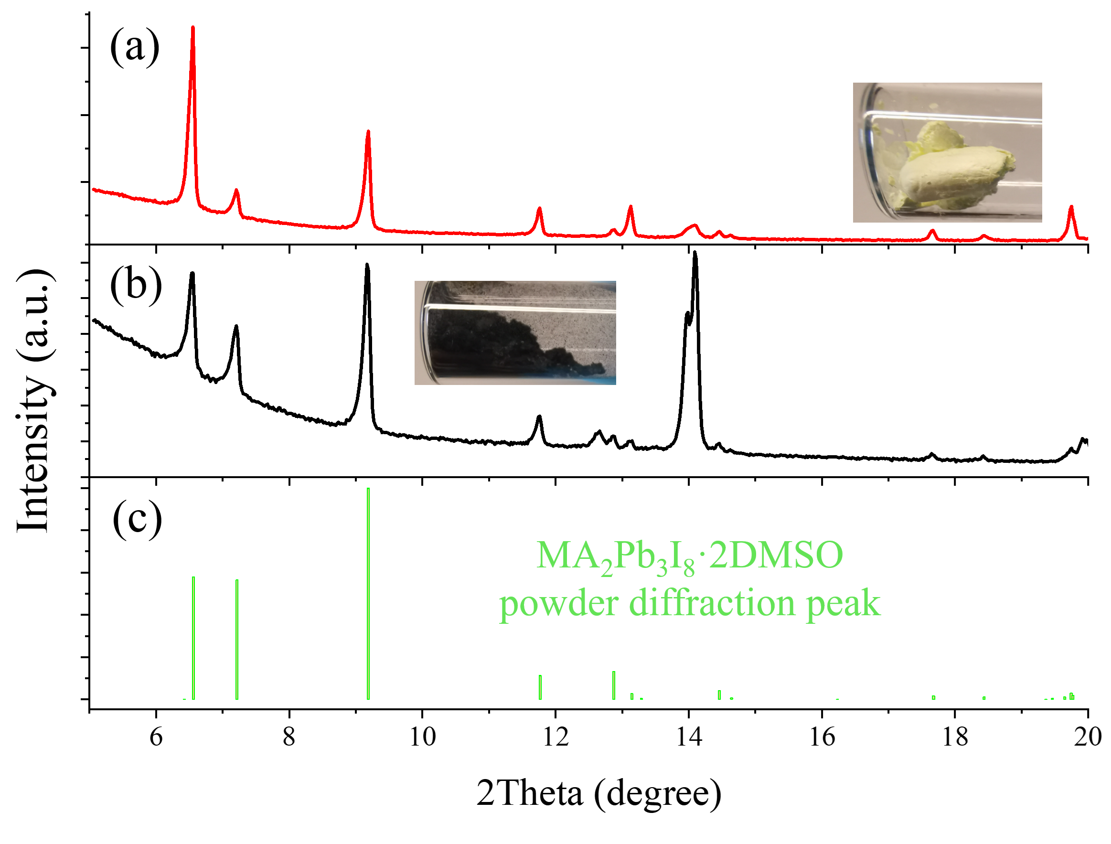
Supplementary Figure 2. a, XRD diffraction pattern of precipitate obtained from 58.88 mol% DMSO ink (14 hours after adding DMSO). The precipitate was washed by ether before measuring. b, XRD diffraction pattern of black powder obtained after annealing corresponding precipitate at 100 degree for 10 minutes. c, The standard powder diffraction pattern of MA₂Pb₃I₈·2DMSO.²

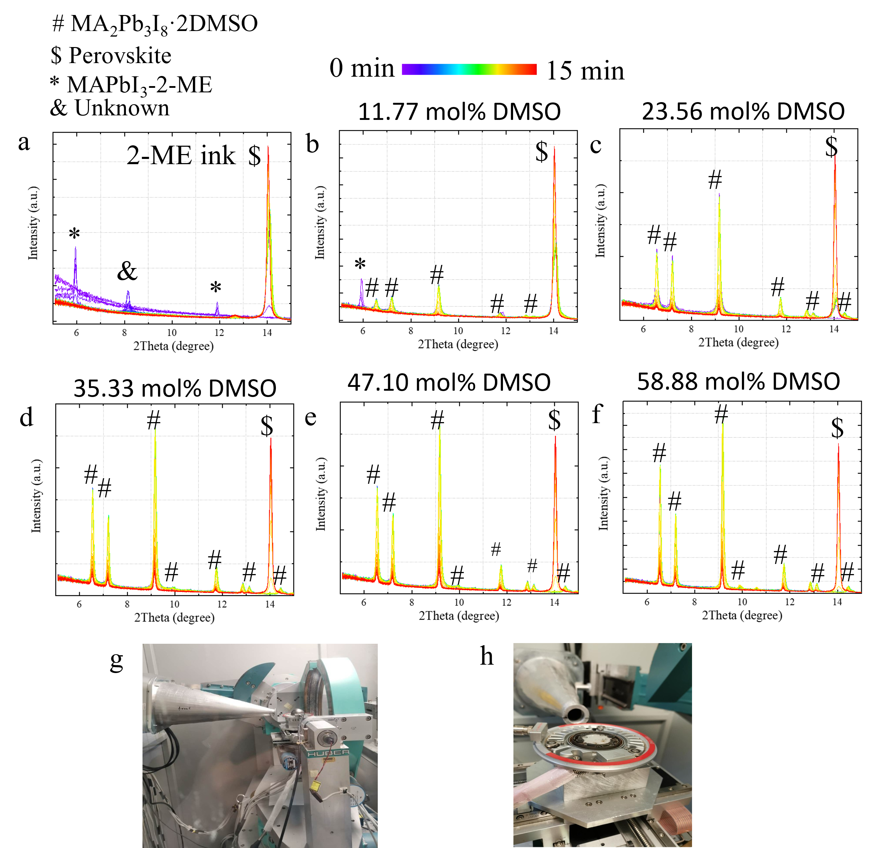
Supplementary Figure 3. 1D plots of time resolved in-situ GIWAXS data of a, 2-ME and b-f, 11.77 mol% to 58.88 mol% 2-ME-DMSO inks (inks are spread evenly over the glass by dipping, these inks are protected by inert atmosphere with an anton paar setup. g-h, picture taken from KMC-2 beamline¹.

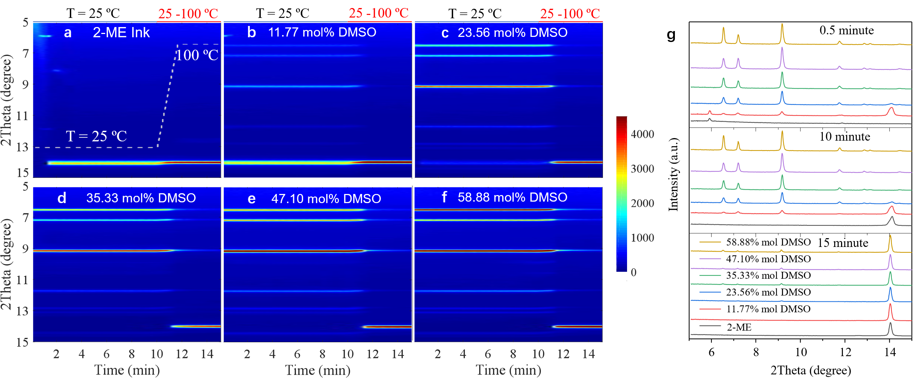
Supplementary Figure 4. In-situ GIWAXS measurements. a-f, Two-dimensional (2D) plots of time resolved in situ grazing incidence wide-angle X-ray scattering (GIWAXS) of 2-ME-DMSO inks (Temperature keep at 25 °C from 0 to 10 min, then accelerating to 100 °C with ramping of 45 °C/min, These experiments were performed at KMC-2 beamline at HZB). g, 1D plots of in-situ GIWAXS of 0.5 min, 10 min and 15 min.

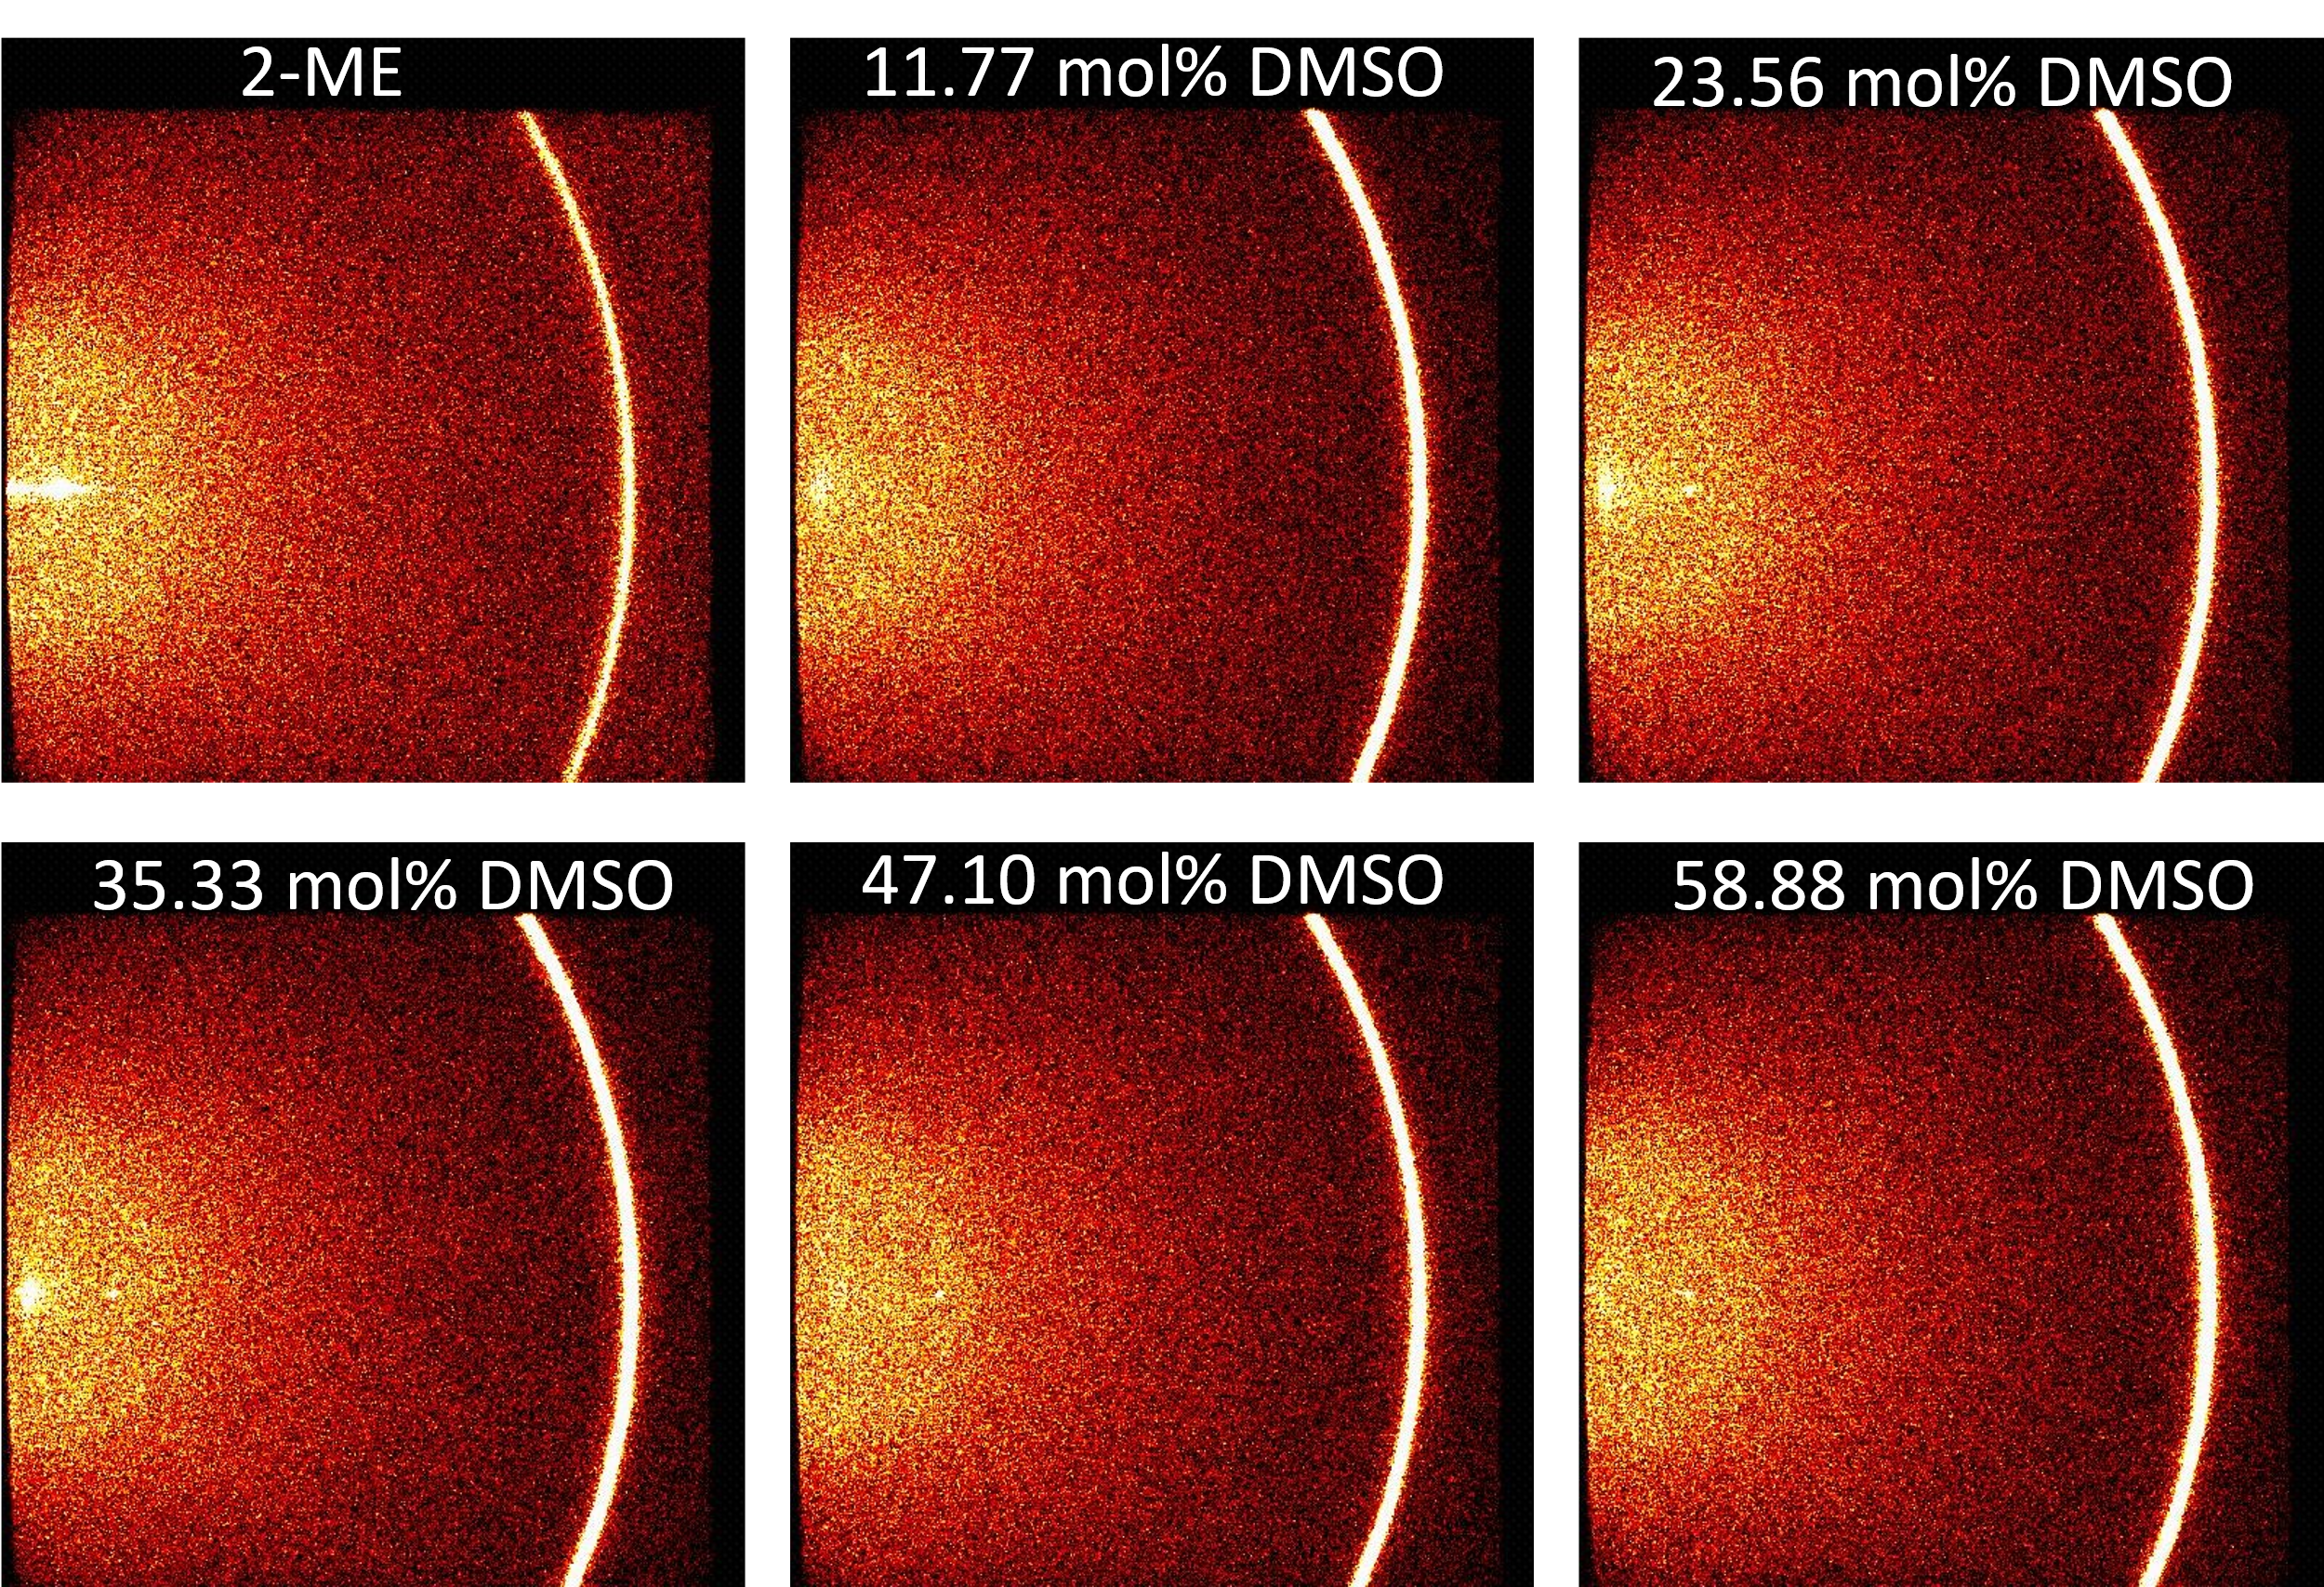
Supplementary Figure 5. The frames of ex-situ GIWAXS measurement, these experiments were performed at KMC-2 beamline at BESSY II.

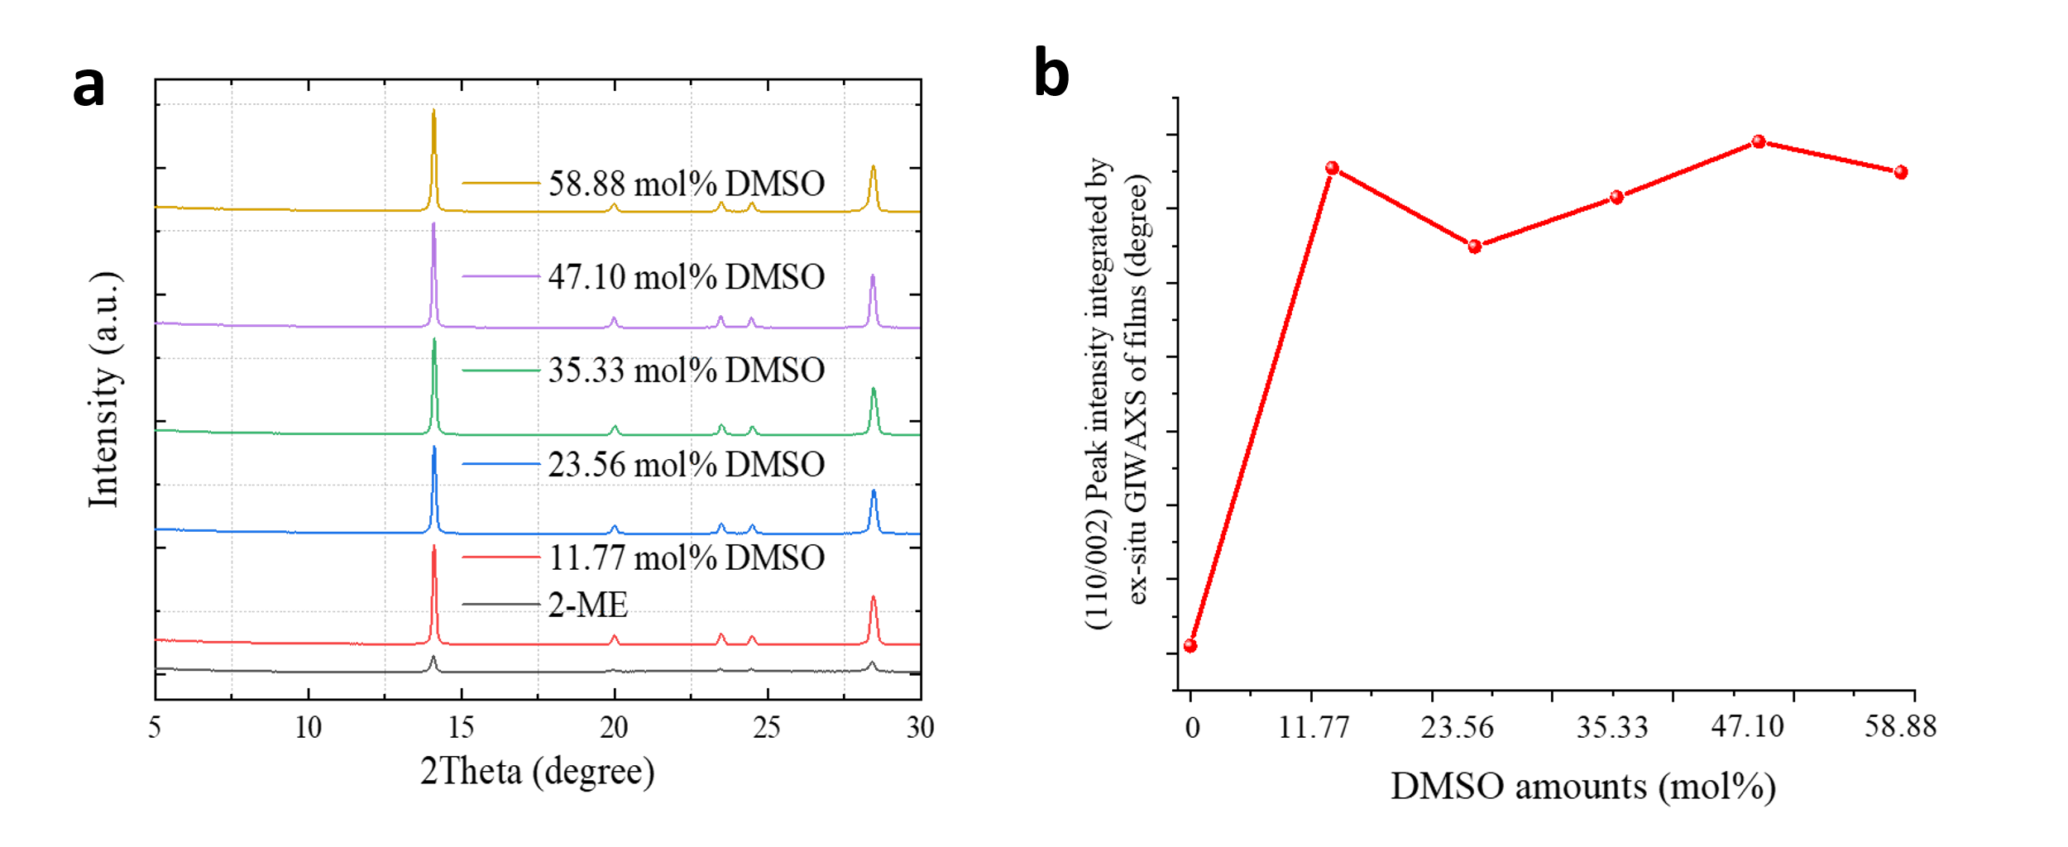
Supplementary Figure 6. a, 1D plots of ex-situ GIWAXS measurement of perovskite thin films fabricated by reference and modified inks. b, (110/002) peak position and intensity integrated by corresponding ex-situ GIWAXS data.

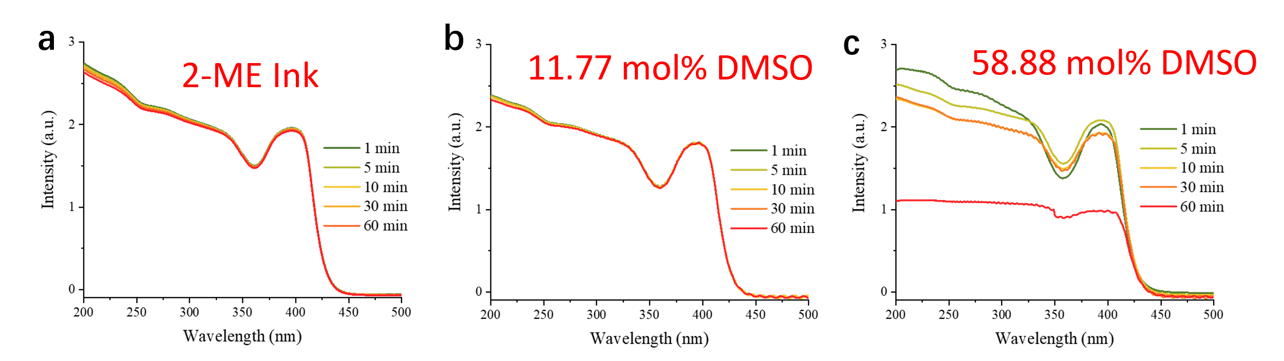
Supplementary Figure 7. in-situ UV-Vis measurement of 2-ME ink, 11.77 and 23.56 mol% 2-ME-DMSO inks versus storage time.

Initially, the addition of 11.77 and 58.88 mol% of DMSO does not influence solution species. In fact, all solutions exhibited absorption bands corresponding to [PbI_{3/4}]^{-/2-} similarly to 2ME ink. The 2ME-DMSO ink containing 11.77 mol% of DMSO did not show any dramatic changes in the intensity or position of the absorption bands confirming its superior stability, which is consistent with device’s performance. The 2ME-DMSO ink containing the highest amount of DMSO, on the other hand, shows a decrease in the absorption intensity after 5 minutes of measurement due to removal of the material via precipitate of the MA₂Pb₃I₈ 2DMSO and an increase of light scattering. These results correlate well with the observed device performance as a function of time.

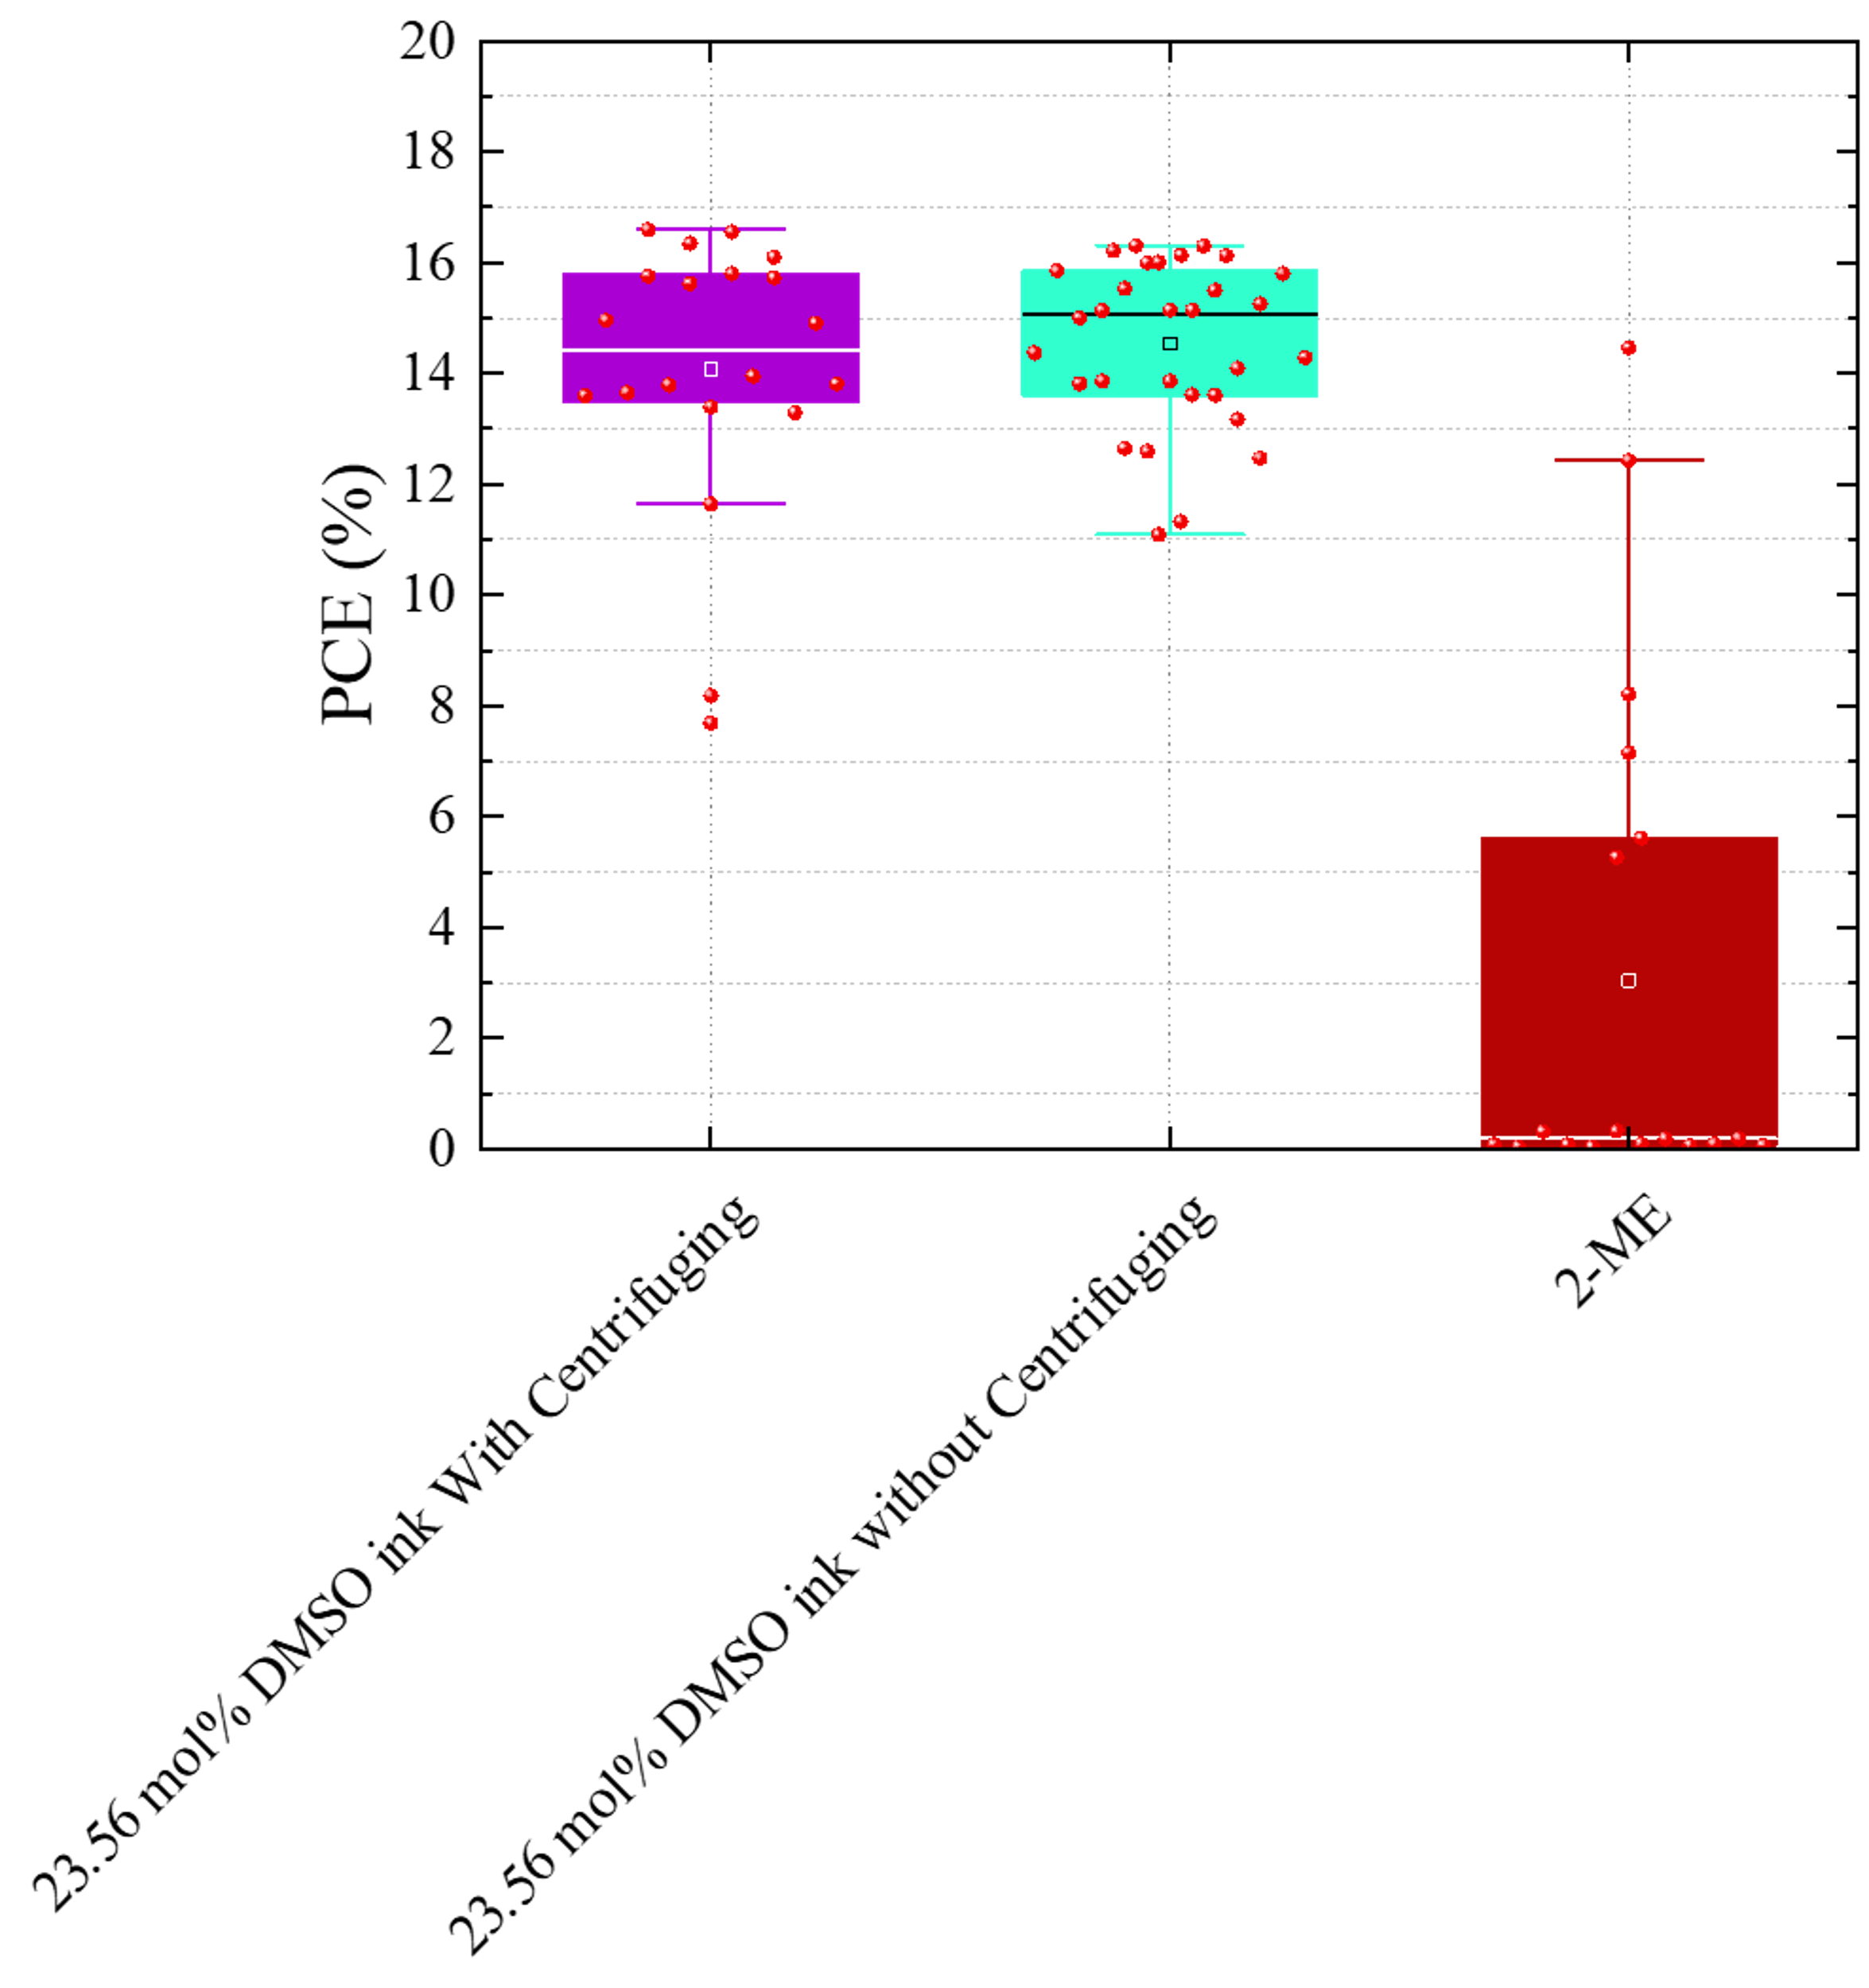
Supplementary Figure 8 The PCE distribution of devices fabricated by 23.56 mol% 2-ME-DMSO and 2-ME ink with and without centrifuging.

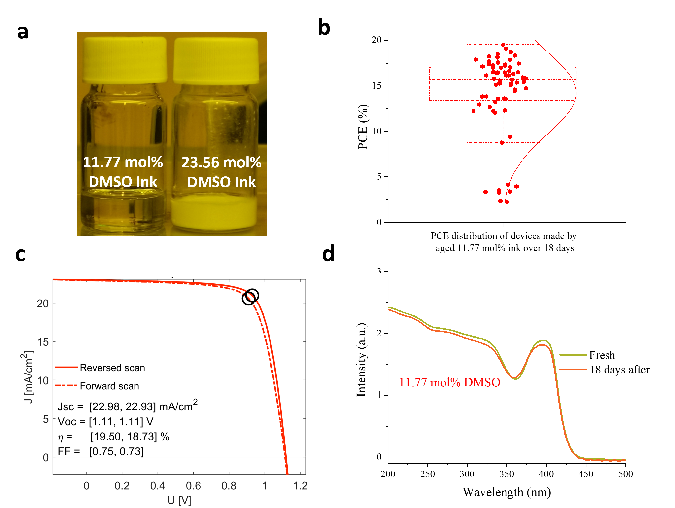
Supplementary Figure 9. a, The image of 18 days old inks. b, c, Efficiency distribution of devices fabricated by 18 days old 11.77 mol% 2-ME-DMSO ink. d, correspond UV-Vis spectra of fresh and aged inks.
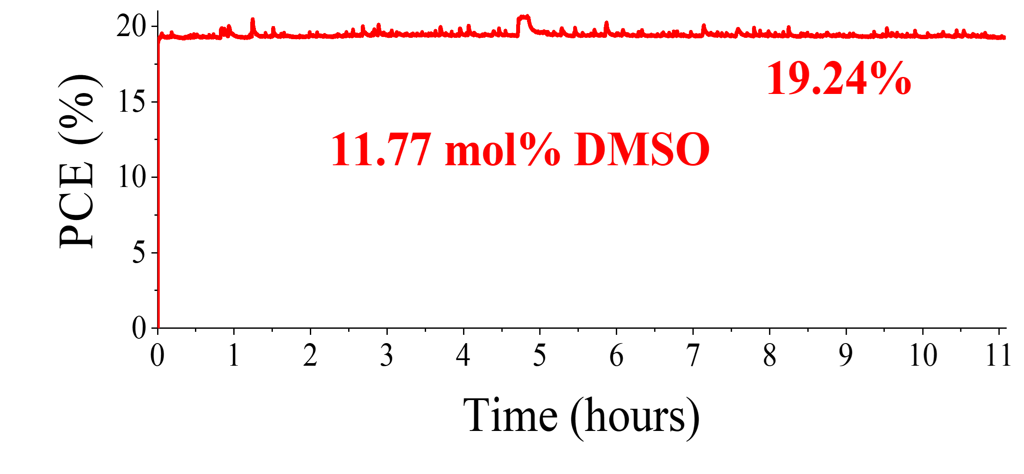
Supplementary Figure 10. MPP tracking of device made by 11.77 mol% 2-ME-DMSO ink over 11 hours at room temperature under continuous AM 1.5G 100 mW/cm² illumination in N2-filled glovebox.

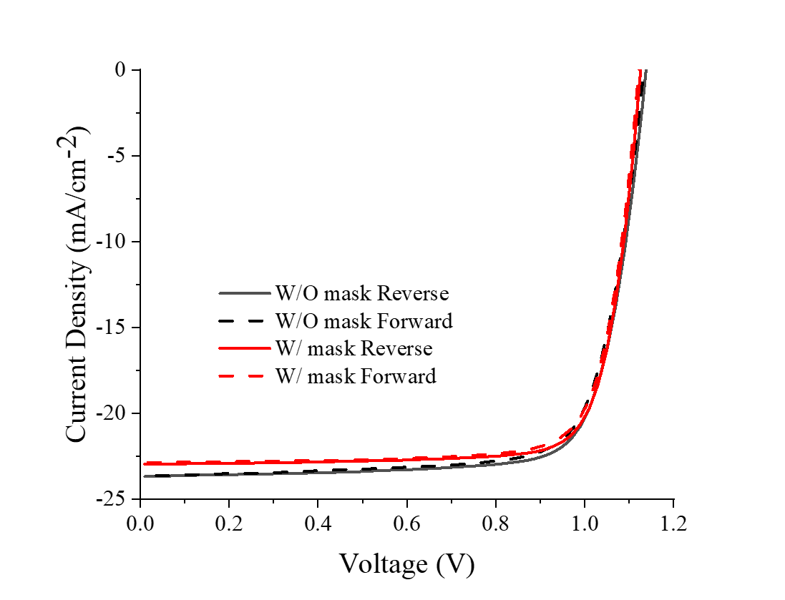
Supplementary Figure 11. The J-V curves of with (0.102 cm⁻²) and without mask (0.16 cm⁻²) champion device made by 11.77 mol% 2-ME-DMSO ink.

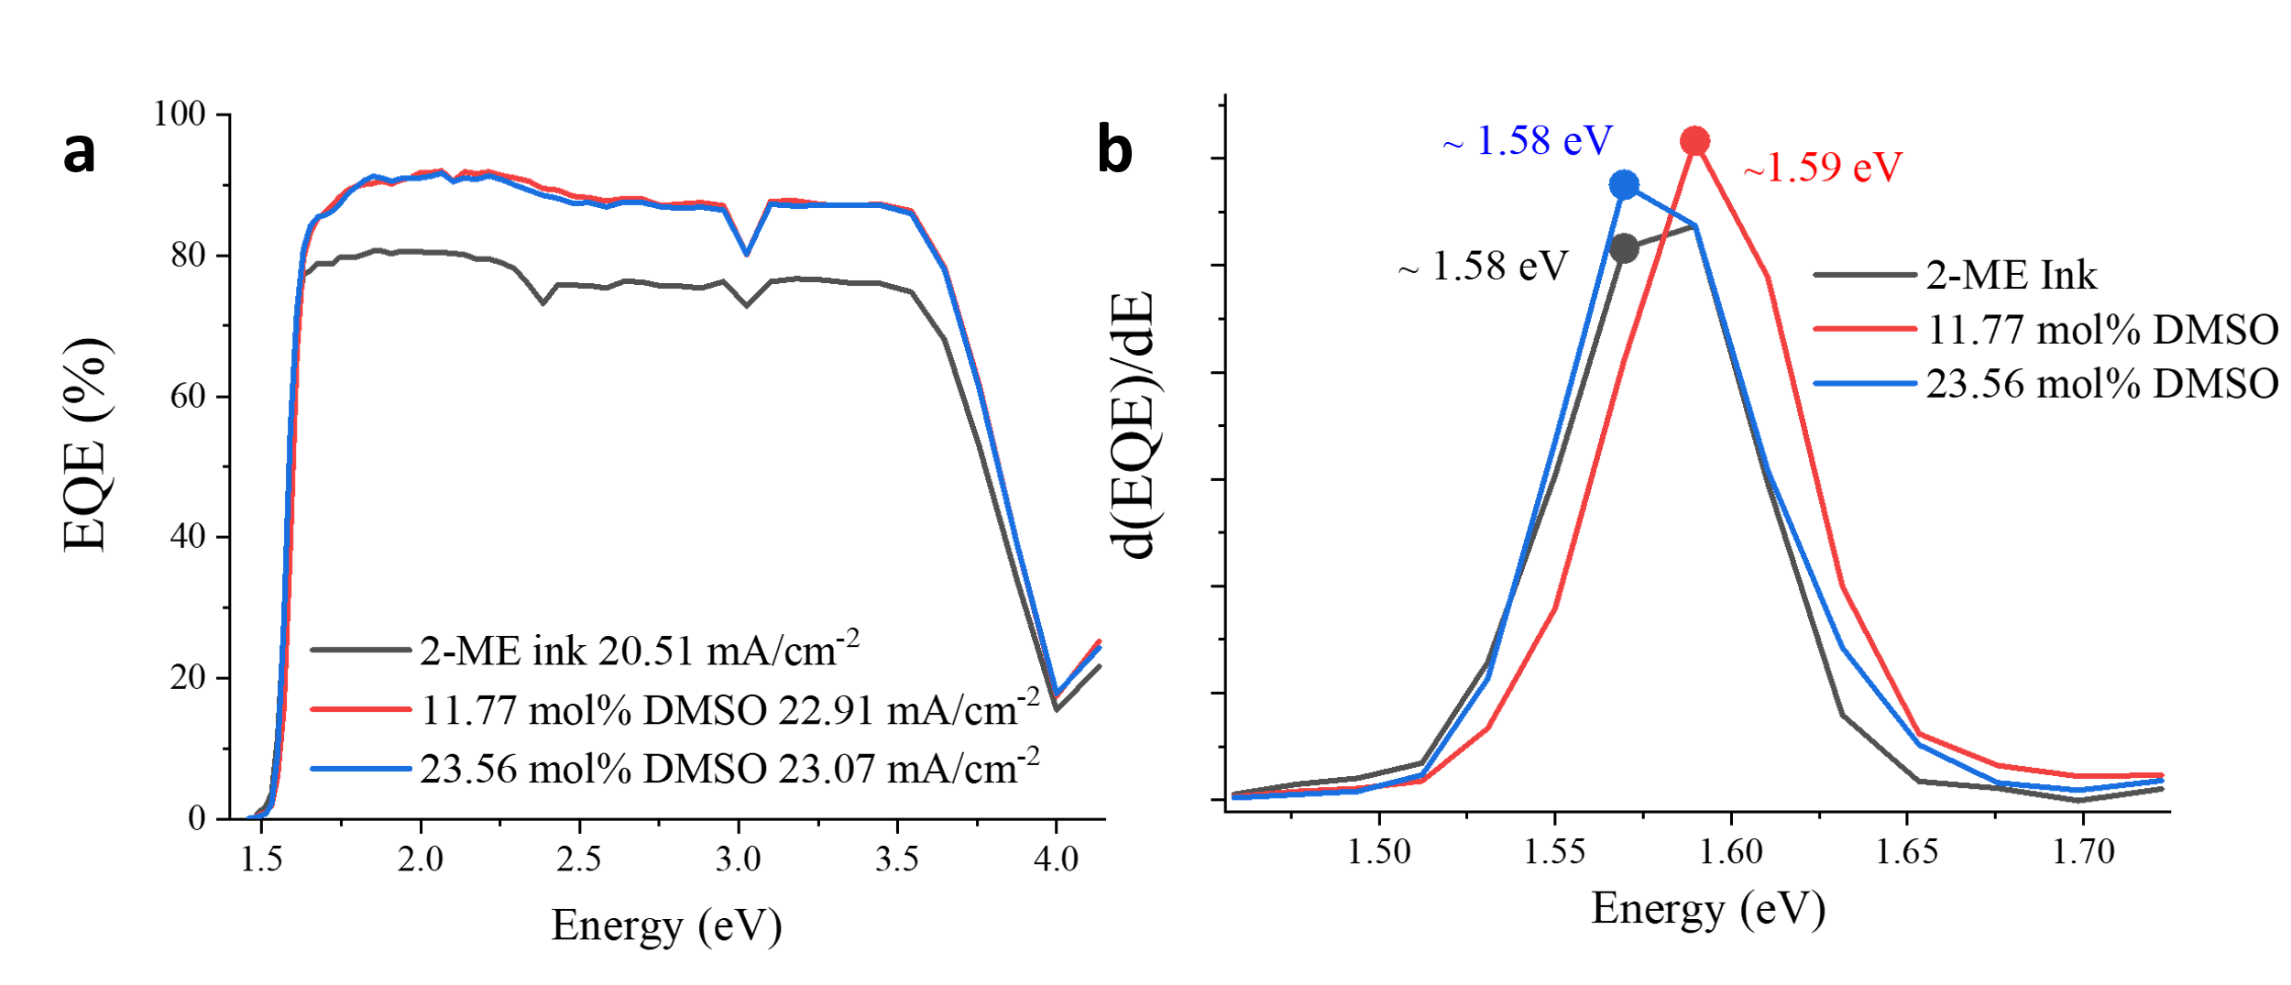
Supplementary Figure 12. a, b The EQE curves and Derivative of EQE spectrums with respect to photon energy for 2-ME, 11.77 mol% and 23.56 mol% 2-ME-DMSO devices.

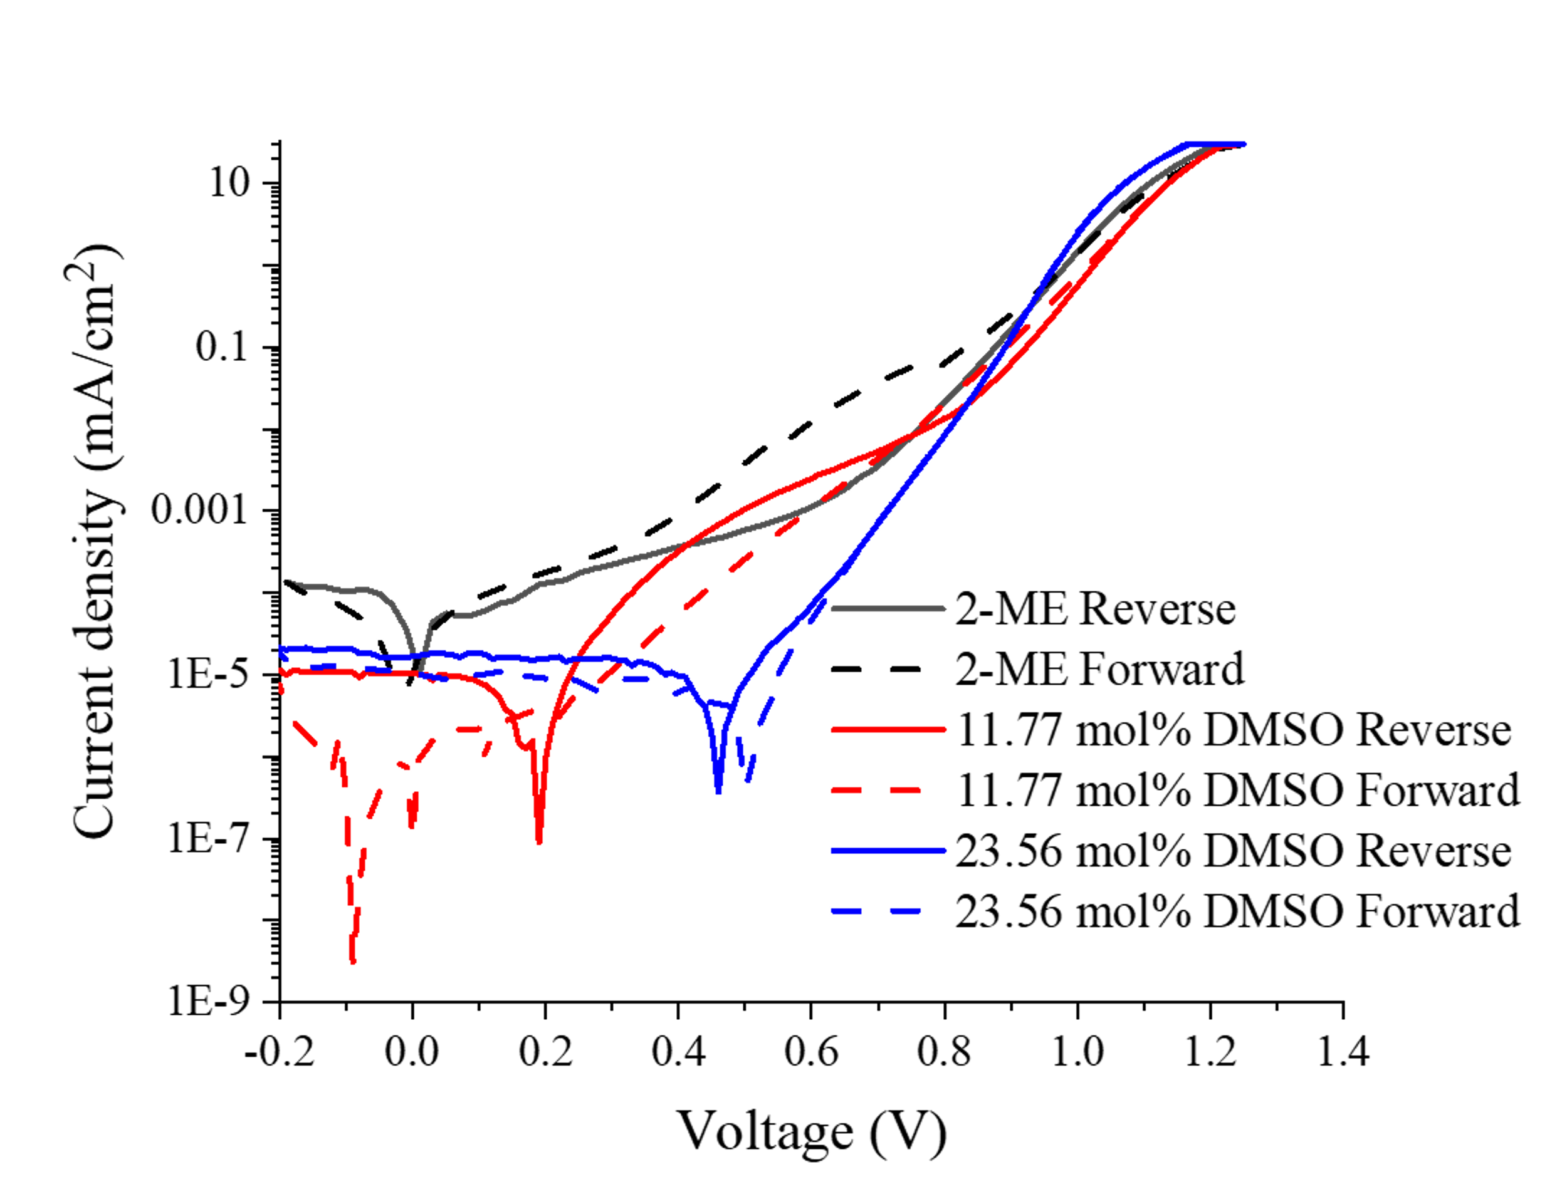
Supplementary Figure 13. The dark curve of representative 2-ME, 11.77 mol% and 23.56 mol% 2-ME-DMSO devices.
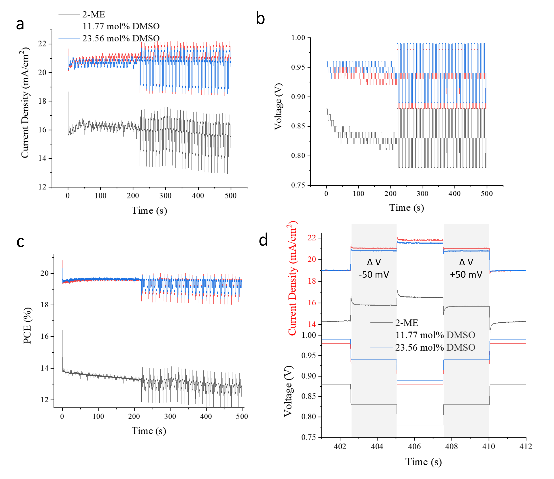
Supplementary Figure 14. TrAMPPT measurement of 11.77 mol%, 23.56 mol% 2-ME-DMSO and 2-ME devices in comparison. The temporal evolution of a, current density JMPP, b, maximum power point voltage VMPP and c, power conversion efficiency (equivalent to maximum power point, MPP). d, a close-up of one perturbation cycle of deliberate voltage perturbation around VMPP by a double step of +/- 50 mV.

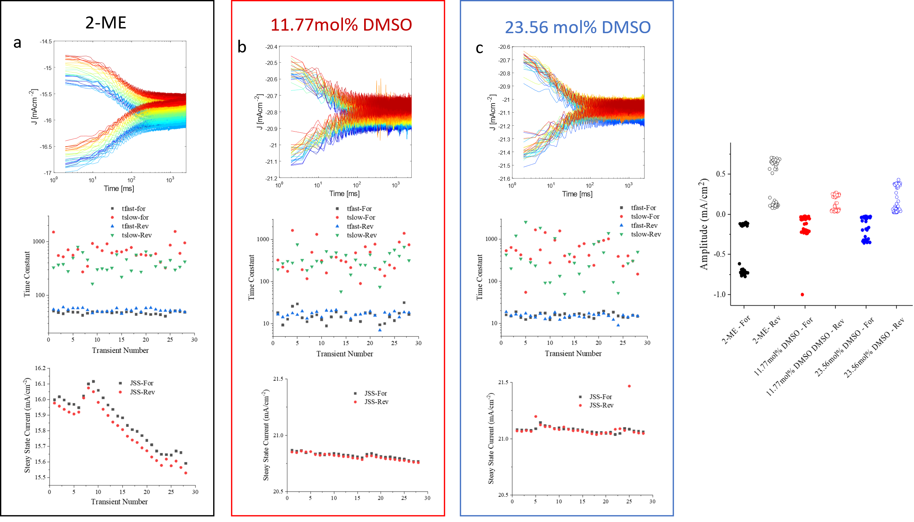
Supplementary Figure 15. a, b, c, Transients upon positive and negative voltage steps (+ 50mV and - 50mV respectively) during MPP perturbation for the reference and DMSO modified devices. Transient time constants τ_{fast} and τ_{slow} as well as steady-state current, J_{SS} determined from bi-exponential fits of transients according to equation (1):

$J\left(t\right)=J_{SS}+A_{fast}e^{-\left(\frac{t-t_{0}}{τ_{fast}}\right)}+A_{slow}e^{-\left(\frac{t-t_{0}}{τ_{slow}}\right)}$ (1)

Where τ_{fast}, τ_{slow} are fast and slow transient time constants and A_{fast}, A_{slow} are corresponding amplitudes as well as J_{SS} represents steady state current.
the fitting results of transient time constants are showing below:

 | Average τ_{fast}  (ms) | Average τ_{slow}  (ms)
2-ME | 50.56 | 549.34
11.77 mol% DMSO | 16.17 | 405.34
23.56 mol% DMSO | 15.37 |  | 664.91

d, Amplitudes (A_{fast}, A_{slow}) fitting results of 11.77, 23.56 mol% 2-ME-DMSO and 2-ME devices
The standard deviation was calculated from equation (2) :

$\frac{∆J(t)}{J_{SS}}= \frac{J_{trans,R}\left(t\right)-J_{trans,F}(t)}{J_{SS}}$ (2)

where $∆J(t)$ is the difference in the dynamic current density response, $J_{trans,R}\left(t\right)$ and $J_{trans,F}(t)$ are the discrepancy of reverse and forward in transient current response.

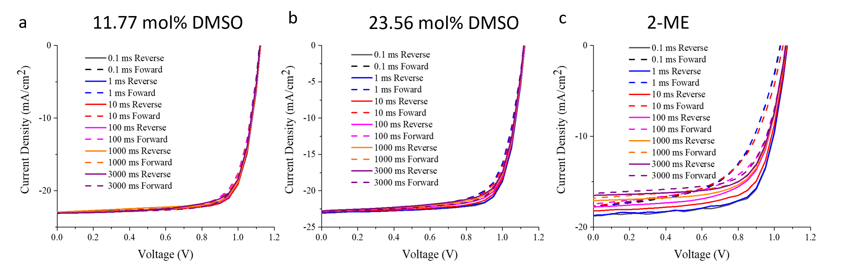
Supplementary Figure 16. J-V scans measured after TrAMPPT measurements at various delay times for the 2-ME, 11.77 mol% and 23.56 mol% 2-ME-DMSO inks.

The HI of corresponding devices with different delay time, derived from the J-V measurements was calculated by the equation below

$HI= \frac{\int_{V_{OC}}^{0 V}{J_{R}(V)}-\int_{0 V}^{V_{OC}}{J_{F}(V)}}{\int_{V_{OC}}^{0 V}{J_{R}(V)}}$

Supplementary Table 1 the summarizes of slot die coated perovskite solar cells.

Year | PCE (%) | J_{SC} (mA/cm²) | V_{OC}  (V) | FF | Stack | Confirgration | Ref
2017 | 15.1 | 21.9 | 0.97 | 0.71 | p-i-n | ITO/PEDOT:PSS/ CH₃NH₃PbI₃/PCBM/BCP/Ag | ³
2017 | 12.52 | 16.34 | 1 | 0.76 | p-i-n | ITO/PEDOT:PSS/ CH₃NH₃PbI₃/PCBM/BCP/Ag | ⁴
2017 | 2.9 | 10.52 | 0.75 | 0.38 | p-i-n | ITO/PET/PEDOT:PSS/ CH₃NH₃PbI_{3-x}Cl_{x}/PCBM/Ag | ⁵
2018 | 15.57 | 19.79 | 1.02 | 0.77 | p-i-n | ITO/PEDOT:PSS/ CH₃NH₃PbI₃/PCBM/Ca/Al | ⁶
2018 | 13.3 | 19.9 | 0.89 | 0.74 | p-i-n | ITO/PEDOT:PSS/ CH₃NH₃PbI₃/PCBM/BCP/Ag | ⁷
2019 | 12.5 | 16.6 | 1.06 | 0.70 | p-i-n | ITO/PEDOT:PSS/(BA)₂(MA)₃Pb₄I₁₃ /PCBM/PEIE/Ag | ⁸
2019 | 14.66 | 13.6 | 1.02 | 0.57 | p-i-n | ITO/m-PEDOT:PSS/ MA_{0.6}FA_{0.38}Cs_{0.02}PbI_{2.975}Br_{0.025}/PCBM/PEIE/Ag | ⁹
2019 | 12.2 | 21.35 | 1 | 0.68 | p-i-n | ITO/PEDOT:PSS/ CH₃NH₃PbI₃/PCBM/PEI/Ag | ¹⁰
2019 | 14 | 19.62 | 0.95 | 0.65 | p-i-n | ITO/PEDOT:PSS/ CH₃NH₃PbI₃/PCBM/BCP/Ag | ¹¹
2020 | 14.98 | 19.9 | 0.99 | 0.73 | p-i-n | FTO/ NiOx/CH₃NH₃PbI₃/PCBM/PEI/Ag | ¹²
2020 | 21.83 | 19.1 | 1.08 | 0.72 | p-i-n | ITO/PTAA/MAPbI₃/C₆₀/BCP/Cu | ¹³
2020 | 20.83 | 23.673 | 1.138 | 0.77 | p-i-n | ITO/SAM (2PACz)/MAPbI₃/C₆₀/BCP/Cu | This work
2015 | 11.96 | 19.89 | 0.95 | 0.53 | n-i-p | ITO/ZnO/ CH₃NH₃PbI₃/P3HT/Ag | ¹⁴
2016 | 9.2 | 16.8 | 0.73 | 0.75 | n-i-p | ITO/c-TiO₂/m-TiO₂/ CH₃NH₃PbI₃/Spiro-OMeTAD/Au | ¹⁵
2017 | 15.1 | 22.9 | 1.05 | 0.63 | n-i-p | ITO/ZnO/ CH₃NH₃PbI₃/Carbon | ¹⁶
2017 | 14.7 | 19.68 | 1.1 | 0.68 | n-i-p | ITO/ZnO/ CH₃NH₃PbI₃/Bifluo-OMeTA/Ag | ¹⁷
2017 | 14.4 | 21.3 | 1.08 | 0.62 | n-i-p | ITO/ZnO/FA_{0.4}MA_{0.6}PbI₃/P3HT/Ag | ¹⁸
2018 | 18.3 | 21.9 | 1.11 | 0.75 | n-i-p | FTO/SnO₂/ CH₃NH₃PbI₃/Spiro-OMeTAD/Au | ¹⁹
2018 | 18 | 21.5 | 1.1 | 0.76 | n-i-p | ITO/SnO₂/ CH₃NH₃PbI_{3-x}Cl_{x}/Spiro-OMeTAD/Au | ²⁰
2018 | 15.2 | 20.7 | 1.03 | 0.72 | n-i-p | ITO/SnO₂/ CH₃NH₃PbI₃/Spiro-OMeTAD/Au | ²¹
2018 | 3.6 | - | - | - | n-i-p | ITO/ZnO/ CH₃NH₃PbI₃/P3HT/Au | ²²
2018 | 16.8 | 22.1 | 1.03 | 0.74 | n-i-p | ITO/c-TiO₂/ CH₃NH₃PbI_{3−x}Cl_{x}/Spiro-OMeTAD/Au | ²³
2018 | 12.73 | 17.21 | 1.1 | 0.67 | n-i-p | ITO/ZnO/ CH₃NH₃PbI₃/Bifluo-OMeTA/Ag | ²⁴
2018 | 11 | 16.7 | 0.96 | 0.67 | n-i-p | ITO/M-TiO₂/c-TiO₂/ CH₃NH₃PbI₃/Spiro-OMeTAD/Au | ²⁵
2018 | 17.31 | 22.4 | 1.11 | 0.695 | n-i-p | FTO/SnO₂/ CH₃NH₃PbI₃/Spiro-OMeTAD/Au | ²⁶
2020 | 14.51 | 20.98 | 1.046 | 0.661 | n-i-p | FTO/c-TiO₂/ CH₃NH₃PbI₃/Spiro-OMeTAD/Au | ²⁷

Supplementary Table 2. Summary photovoltaic parameters of without (0.16 cm²) and with (0.105 cm²) mask devices.

 | 11.77 mol% 2-ME-DMSO  Reverse | 11.77 mol% 2-ME-DMSO  Forward |  | 11.77 mol% 2-ME-DMSO  mask Reverse | 11.77 mol% 2-ME-DMSO  mask Forward
J_{sc} (mA/cm²) | 23.673 | 23.633 |  | 22.942 | 22.869
V_{oc} (V) | 1.138 | 1.132 |  | 1.126 | 1.122
Fill factor | 77.322 | 76.426 |  | 79.837 | 79.020
PCE (%) | 20.831 |  | 20.459 | 20.621 |  | 20.268

Reference
1. Többens, D. M. & Zander, S. KMC-2: an X-ray beamline with dedicated diffraction and XAS endstations at BESSY II. J. large-scale Res. Facil. JLSRF 2, 1–6 (2016).
2. Rong, Y. et al. Solvent engineering towards controlled grain growth in perovskite planar heterojunction solar cells. Nanoscale 7, 10595–10599 (2015).
3. Hu, Q. et al. In situ dynamic observations of perovskite crystallisation and microstructure evolution intermediated from [PbI 6 ]4- cage nanoparticles. Nat. Commun. 8, 1–9 (2017).
4. Jung, Y. S. et al. One-Step Printable Perovskite Films Fabricated under Ambient Conditions for Efficient and Reproducible Solar Cells. ACS Appl. Mater. Interfaces 9, 27832–27838 (2017).
5. Ciro, J., Mejía-Escobar, M. A. & Jaramillo, F. Slot-die processing of flexible perovskite solar cells in ambient conditions. Sol. Energy 150, 570–576 (2017).
6. Zuo, C., Vak, D., Angmo, D., Ding, L. & Gao, M. One-step roll-to-roll air processed high efficiency perovskite solar cells. Nano Energy 46, 185–192 (2018).
7. Lee, D. et al. Slot-Die Coated Perovskite Films Using Mixed Lead Precursors for Highly Reproducible and Large-Area Solar Cells. ACS Appl. Mater. Interfaces 10, 16133–16139 (2018).
8. Zuo, C. et al. Self-Assembled 2D Perovskite Layers for Efficient Printable Solar Cells. Adv. Energy Mater. 9, 1–9 (2019).
9. Kim, J. E. et al. Humidity-Tolerant Roll-to-Roll Fabrication of Perovskite Solar Cells via Polymer-Additive-Assisted Hot Slot Die Deposition. Adv. Funct. Mater. 1809194, 1–9 (2019).
10. Huang, Y. C., Li, C. F., Huang, Z. H., Liu, P. H. & Tsao, C. S. Rapid and sheet-to-sheet slot-die coating manufacture of highly efficient perovskite solar cells processed under ambient air. Sol. Energy 177, 255–261 (2019).
11. Burkitt, D. et al. Acetonitrile based single step slot-die compatible perovskite ink for flexible photovoltaics. RSC Adv. 9, 37415–37423 (2019).
12. Huang, S. et al. Toward All Slot‐Die Fabricated High Efficiency Large Area Perovskite Solar Cell Using Rapid Near Infrared Heating in Ambient Air. Adv. Energy Mater. 2001567 (2020). doi:10.1002/aenm.202001567
13. Subbiah, A. S. et al. High-Performance Perovskite Single-Junction and Textured Perovskite / Silicon Tandem Solar Cells via Slot-Die Coating. (2020). doi:10.1021/acsenergylett.0c01297
14. Hwang, K. et al. Toward large scale roll-to-roll production of fully printed perovskite solar cells. Adv. Mater. 27, 1241–1247 (2015).
15. Cotella, G. et al. One-step deposition by slot-die coating of mixed lead halide perovskite for photovoltaic applications. Sol. Energy Mater. Sol. Cells 159, 362–369 (2016).
16. Cai, L. et al. Large area perovskite solar cell module. J. Semicond. 38, 2–5 (2017).
17. Qin, T. et al. Amorphous hole-transporting layer in slot-die coated perovskite solar cells. Nano Energy 31, 210–217 (2017).
18. Heo, Y. J. et al. Printing-friendly sequential deposition via intra-additive approach for roll-to-roll process of perovskite solar cells. Nano Energy 41, 443–451 (2017).
19. Kim, Y. Y. et al. Fast two-step deposition of perovskite via mediator extraction treatment for large-area, high-performance perovskite solar cells. J. Mater. Chem. A 6, 12447–12454 (2018).
20. Whitaker, J. et al. Scalable Slot-die Coating of High Performance Perovskite Solar Cells. Sustain. Energy Fuels 2, 2442–2449 (2018).
21. Galagan, Y., Giacomo, F. Di, Gorter, H., Kirchner, G. & Vries, I. De. Roll-to-Roll Slot Die Coated Perovskite for Efficient Flexible Solar Cells. Adv. Energy Mater. 1801935, 1–7 (2018).
22. Remeika, M., Ono, L. K., Maeda, M., Hu, Z. & Qi, Y. High-throughput surface preparation for flexible slot die coated perovskite solar cells. Org. Electron. physics, Mater. Appl. 54, 72–79 (2018).
23. Di Giacomo, F. et al. Up-scalable sheet-to-sheet production of high efficiency perovskite module and solar cells on 6-in. substrate using slot die coating. Sol. Energy Mater. Sol. Cells 181, 53–59 (2018).
24. Kim, J. E. et al. Slot die coated planar perovskite solar cells via blowing and heating assisted one step deposition. Sol. Energy Mater. Sol. Cells 179, 80–86 (2018).
25. Burkitt, D., Searle, J., A.Worsley, D. & Watson, T. Sequential slot-die deposition of perovskite solar cells using dimethylsulfoxide lead iodide ink. Materials (Basel). 11, (2018).
26. Dou, B. et al. Roll-to-Roll Printing of Perovskite Solar Cells. Prep. (2018). doi:10.1021/acsenergylett.8b01556
27. Vijayan, A. et al. Simple Method for Efficient Slot-Die Coating of MAPbI 3 Perovskite Thin Films in Ambient Air Conditions. ACS Appl. Energy Mater. 3, 4331–4337 (2020).

