Long-Term Culture of Bone Marrow Mesenchymal Stem Cells Produces Distinct Populations of Extracellular Vesicles without losing their functionalities and integrities
Doste R. Mamand^{1,2,3, *}Lovisa Blix^{1,3}, Felix Sandberg ^{1,3}, Mariana Castañeda Mesa^{1,3}, Osama Saher ^{1,4,5}, Hema Saranya Ilamathi^{1,3}, André Görgens^{1,4,5}, Oscar P.B Wiklander^{1,3}.

*Correspondence
E-mail: doste.mamand@ki.se, Oscar.wiklander@ki.se
¹Department of Laboratory Medicine, Division of Biomolecular and Cellular Medicine, Karolinska Institute, Stockholm, Sweden.
² Biology Research center, Research Center, University of Zakho, Zakho, 42002, Duhok, Kurdistan Region, Iraq.
³ Breast Center, Karolinska Comprehensive Cancer Center, Karolinska University Hospital, Stockholm, Sweden.
⁴Karolinska ATMP Center, ANA Futura, Huddinge, Sweden.
⁵Department of Cellular Therapy and Allogeneic Stem Cell Transplantation (CAST), Karolinska University Hospital, Huddinge, Sweden.

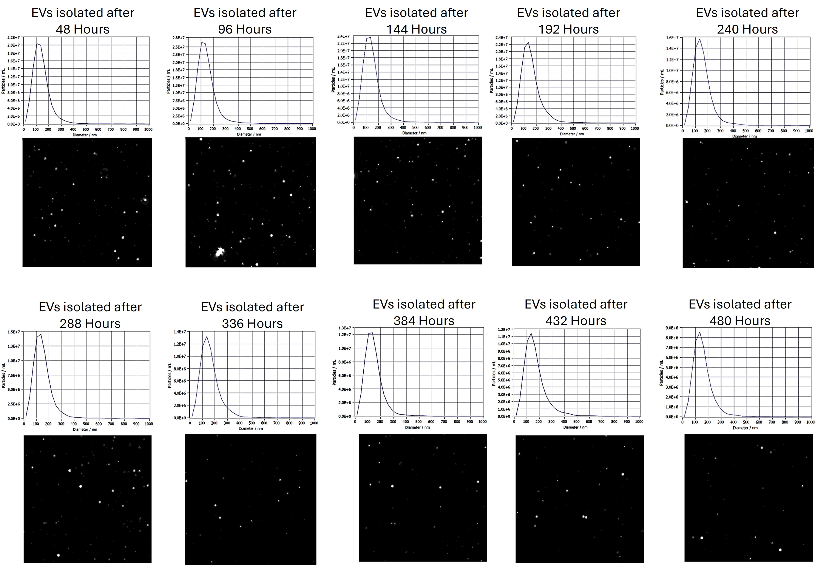
S. Figure 1. Mean size distribution of isolated EVs, represented as particle diameter (nm), measured using NTA. Data represent three biological replicates and are presented as mean ± SD (n = 3).

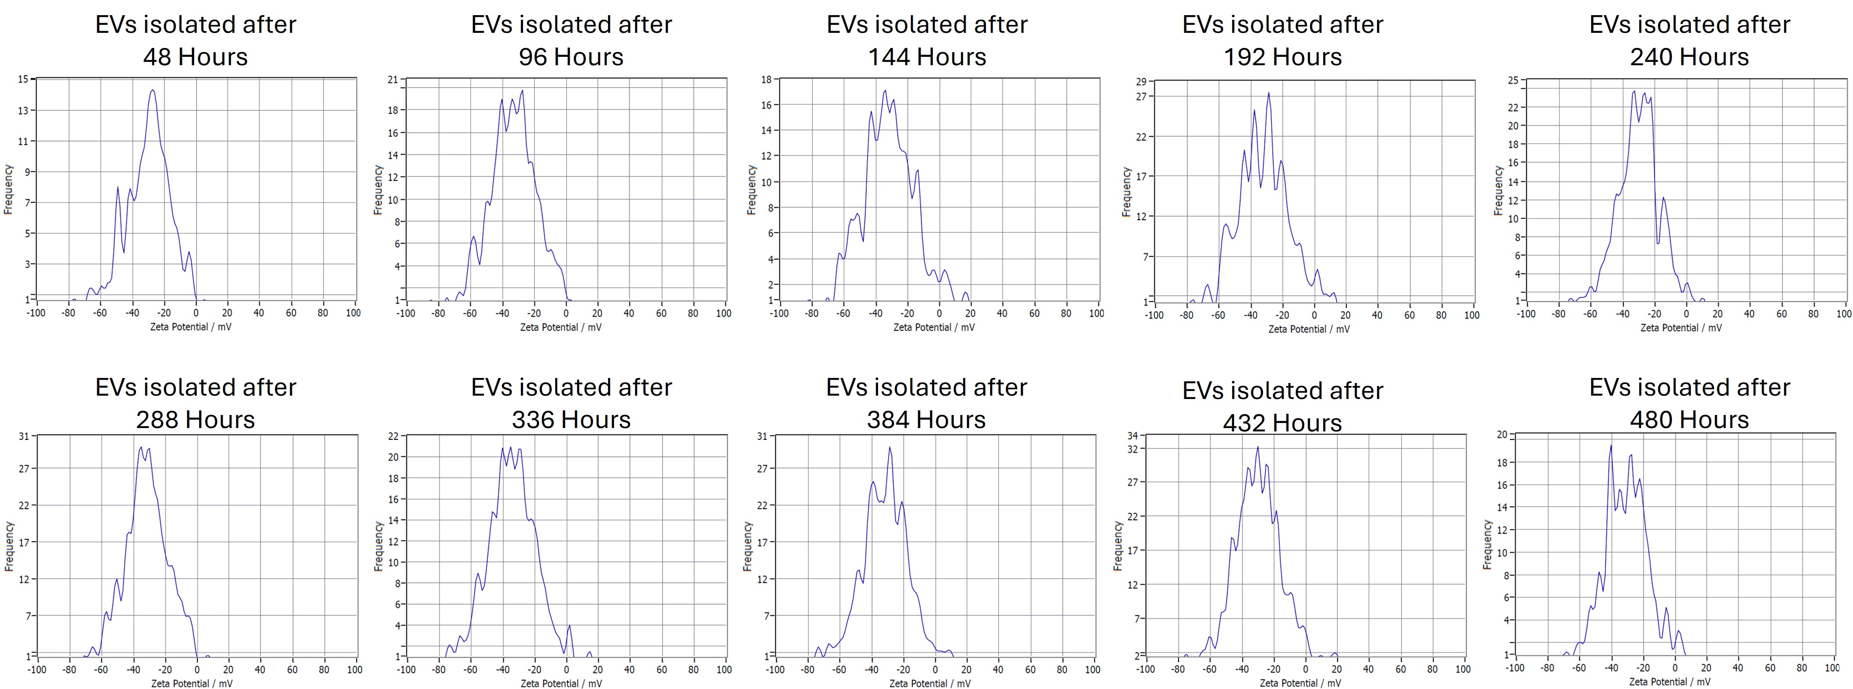
S. Figure 2. Zeta potential of isolated EVs measured using the Particle Metrix ZetaView®. Data represent three biological replicates and are presented as mean ± SD (n = 3).
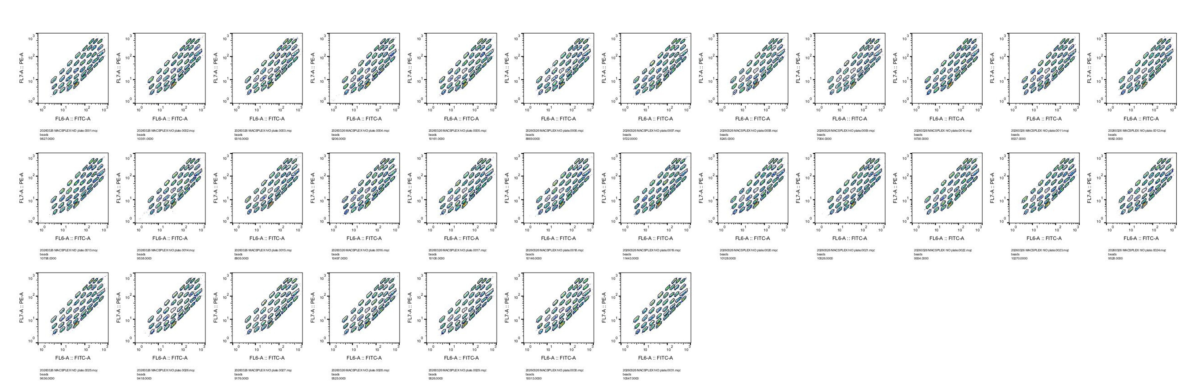
S. Figure 3. Multiplex bead-based flow cytometry of EV surface markers. Extracellular vesicle (EV) surface marker profiles and corresponding mean fluorescence intensities (MFI) for 37 markers were analyzed using the MACSPlex EV Kit (human; Miltenyi Biotec). EV samples (5 × 10⁸ particles, based on NTA) from three replicates were incubated overnight with capture beads, followed by staining with APC-conjugated CD9, CD63, and CD81 detection antibodies. Samples were acquired on a MACSQuant Analyzer 16 and analyzed using FlowJo v10.9.0. Data are presented as log₁₀-transformed fold change relative to non-EV buffer controls. Heatmaps were generated using hierarchical clustering (Euclidean distance, average linkage). Experiments were performed using three biological replicates (n = 3).
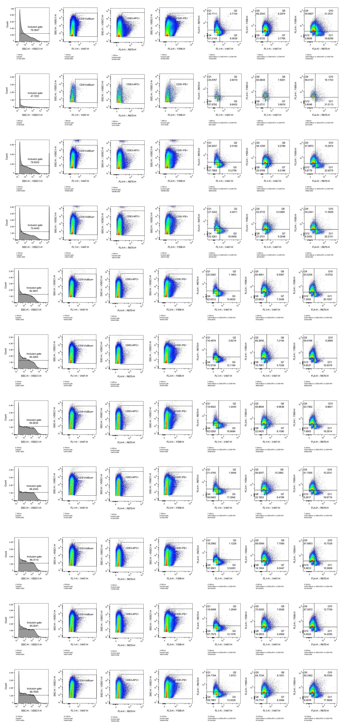
S. Figure 4. Characterisation of BMMSC-derived EV surface markers using nano flow cytometry. Surface marker expression of EVs isolated from BM-MSCs was analysed using nano flow cytometry (NanoFlex). Representative plots show EV populations positive for tetraspanin markers: BMMSC-EVs stained with CD9-VioBlue, BMMSC-EVs stained with CD63-APC, and BMMSC-EVs stained with CD81-PE. Ratios of double-positive EV populations, including CD9/CD63, CD9/CD81, and CD63/CD81, are shown. Experiments were performed using a single biological replicate (n = 1). Data were analysed using FlowJo software (version 10.10).

Figure 8. Wound healing assay in human SH-SY5Y cells following treatment with EVs. EVs (2 × 10⁹ EVs/well) isolated from BM-MSCs at different media change time points were added to SH-SY5Y cells. Cell migration was evaluated using a wound healing assay at 12, 24, and 48 h after treatment. (A) Representative microscopic images show progressive wound closure over time. Yellow lines indicate the wound boundaries used to assess cell migration at each time point. (B) Quantitative analysis of wound closure was performed using the following formula: wound closure (%) = [(initial gap − gap at time t) / initial gap] × 100. Statistical analysis was performed using two-way ANOVA, with statistical significance indicated as *p < 0.05, ***p < 0.001, ****p < 0.0001.

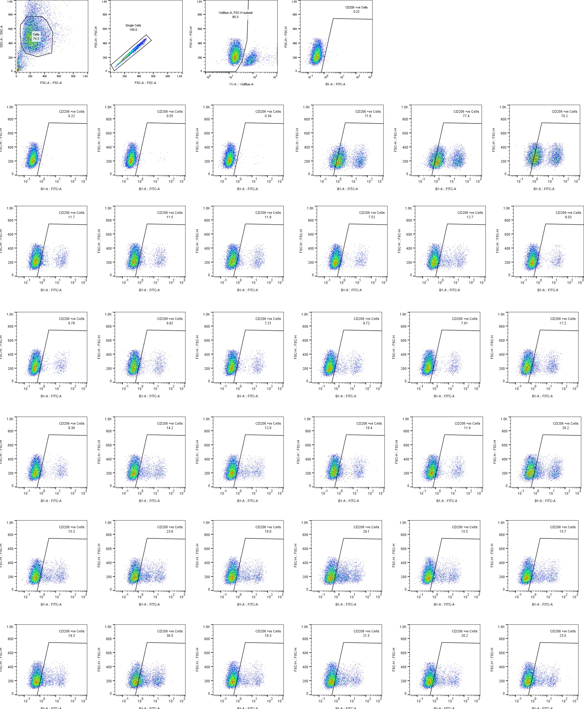
Figure 9. Immunomodulatory Assay of Isolated EVs at Different CM Collection Time Points. (A) Representative flow cytometry plots of THP-1 cells after polarizing to M2, stained with CD206 (Alexa Fluor), indicating the proportion of CD206-positive cells following treatment. Data are presented as mean ± standard deviation (SD) from three independent biological replicates (n = 3). Statistical analysis was performed using the one-way ANOVA.

