Appendix A
Table A1. Theoretical Integration: Mapping SCT, TPB, and COR onto the Dynamic Resource-Accumulation Framework
Core Theory & Function | Key Construct/Principle | Corresponding Construct in Our Model | Proposed Role in KS → IWB Process
Social Cognitive Theory (SCT) | Environmental Factor | Knowledge Sharing (KS) | Catalyst/Antecedent: Provides behavioral models, informational resources, and social cues.
Generative Mechanism | (Modeling, Social Persuasion)
 | Personal Factor: Self-Efficacy | Creative Self-Efficacy (CSE) | Core Personal Resource/Moderator: Belief in creative capability; the basis of PBC (TPB).
Theory of Planned Behavior (TPB) | Attitude toward the Behavior | Work Motivation (WM) | Mediator (Attitudinal Pathway): Positive evaluation and willingness to engage in IWB.
Structural Intention Model | Subjective Norm | Work Engagement (WE) | Mediator (Normative-Affective Pathway): Energetic state fueled by normative support for innovation.
 | Perceived Behavioral Control (PBC) | (Manifests as CSE) | Incorporated as CSE.
Conservation of Resources (COR) Theory | Personal Resource | Creative Self-Efficacy (CSE) | Generative Moderator: A key resource that amplifies the gain spiral from KS to WM/WE to IWB.
Resource Contingency Logic | Environmental Resource | Knowledge Sharing (KS) | A valuable resource to be acquired and utilized.
 | Resource Gain Spirals | The entire mediated model | Describes the conditional process where CSE enriches the translation of KS into WM/WE and IWB.

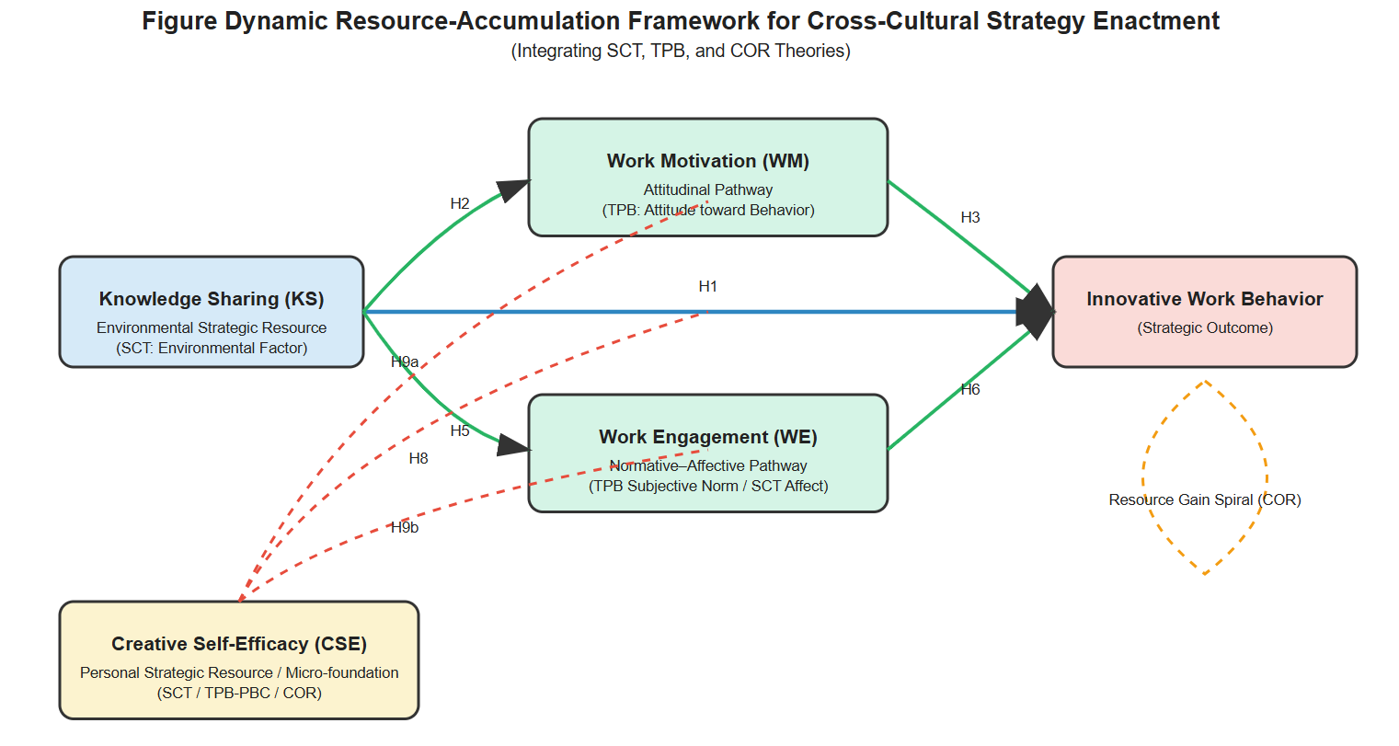
Figure A1. The Dynamic Resource-Accumulation Framework for Cross-Cultural Strategy Enactment.
The figure illustrates a multilevel, process-oriented framework integrating Social Cognitive Theory (SCT), the Theory of Planned Behavior (TPB), and Conservation of Resources (COR) theory. The KS functions as a strategic environmental resource that is translated into innovative work behavior through attitudinal (work motivation) and normative-affective (work engagement) pathways. Creative self-efficacy operates as a catalytic personal resource moderating both direct and indirect effects, thereby enabling a resource gain spiral underlying innovation strategy enactment in culturally embedded organizational contexts.

Appendix B: Detailed Theoretical Justification of Research Context
B.1 Collectivist Cultural Setting
Indonesia constitutes a high-collectivism context, evidenced by its low individualism score in Hofstede's framework (Bhagat & Hofstede, 2002; Triandis & Hofstede, 1993) and high in-group collectivism in the GLOBE study (House, R. J., Hanges, P. J., Javidan, M., Dorfman, P. W., & Gupta, 2005). This cultural profile—characterized by group harmony, strong in-group ties, and conformity to social norms—heightens the salience of the subjective norm construct from TPB (Ajzen, 1991). Consequently, the normative-affective pathway via work engagement becomes pronounced, as social and obligation-based cues inherent in KS influence individuals' sense of belonging and duty.
We treat national culture as a contextual proxy, justified by the relative homogeneity of collectivist values in Indonesia—particularly within the Javanese-majority region of East Java where data were collected. Beyond Hofstede, Triandis (2018) distinguishes vertical and horizontal collectivism, noting that in hierarchical collectivist societies like Javanese culture, normative conformity is reinforced by strong power distance. This configuration makes innovation-related behaviors evaluated not only on instrumental value but also on alignment with relational obligations and group harmony.
B.2 Empirical Validation from Indonesian SME Studies
Recent empirical work confirms this pattern:
- Singgih and Famiola (2024) found sustainability innovation in Indonesian B Corps emerges through collective value alignment rather than individual entrepreneurial initiative.
- Yulianto et al. (2025) demonstrated socio-cultural preservation—not just digital capability—is a stronger predictor of business competitiveness in traditional craft SMEs.
B.3 High-VUCA, Resource-Constrained Environment
Creative SMEs in emerging economies operate under significant volatility and resource scarcity, amplifying COR theory's relevance. When material resources are limited, psychological resources (CSE) and social resources (KS) become critical currencies for survival and innovation.
B.4 Underexplored Domain
The publishing industry is a traditional creative sector undergoing digital disruption, where innovation necessitates creative recombination of cultural knowledge—central to our KS-IWB model. This focus addresses calls to broaden the geographical and industrial scope of OB research (Tsui, 2007).

Appendix C. Measurement Instruments
Table C1. Construct Measurement Summary
Construct | Source | No. of Items | Example Item (Adapted) | Key Theoretical Alignment in Our Framework
Innovative Work Behavior (IWB) | Janssen (2000) | 6 | "I create new ideas for difficult issues in publishing projects." | Outcome Variable (TPB: Behavior)
Knowledge Sharing (KS) | van den Hooff & de Ridder (2004) | 7 | "I share my knowledge with colleagues when they ask for it." | Environmental Resource/Antecedent (SCT: Environmental Factor)
Work Motivation (WM) | Gagné et al. (2015) | 6 | "I have a say in how my editorial work gets done." | Mediator: Attitudinal Pathway (TPB: Attitude toward Behavior)
Work Engagement (WE) | Schaufeli et al. (2006) - UWES-9 | 9 | "At my work, I feel bursting with energy." | Mediator: Normative-Affective Pathway (TPB: Subjective Norm / SCT: Affective State)
Creative Self-Efficacy (CSE) | Tierney & Farmer (2002) | 3 | "I have confidence in my ability to solve problems creatively in my work." | Personal Resource/Moderator (SCT: Self-Efficacy / TPB: PBC / COR: Resource)

Note: All items measured on a 5-point Likert scale (1 = Strongly Disagree to 5 = Strongly Agree).

Appendix D

Table D1. Demographic Characteristics of Respondents (N = 267)
Characteristic | Category | Frequency | Percentage
Age | < 25 years | 80 | 30.0%
 | 26 – 30 years | 77 | 28.8%
 | 31 – 35 years | 42 | 15.7%
 | 36 – 40 years | 31 | 11.6%
 | 41 – 45 years | 23 | 8.6%
 | > 45 years | 14 | 5.2%
Organizational Tenure | < 5 years | 82 | 30.7%
 | 6 – 10 years | 103 | 38.6%
 | 11 – 15 years | 63 | 23.6%
 | 16 – 20 years | 13 | 4.9%
 | > 20 years | 6 | 2.2%

Table D2. Convergent Validity and Reliability of the Measurement Model
Construct | Item | Loading | CR | AVE
Innovative Work Behavior (IWB) | IWB1 | .82 | .888 | .666
 | IWB2 | .88
 | IWB3 | .79
 | IWB4 | .78
Knowledge Sharing (KS) | KS1 | .84 | .833 | .713
 | KS2 | .85
Work Motivation (WM) | WM1 | .86 | .917 | .786
 | WM2 | .88
 | WM3 | .92
Work Engagement (WE) | WE1 | .67 | .891 | .622
 | WE2 | .79
 | WE3 | .86
 | WE4 | .87
 | WE5 | .73
Creative Self-Efficacy (CSE) | CSE1 | .72 | .812 | .592
 | CSE2 | .84
 | CSE3 | .74
Note: CR = Composite Reliability; AVE = Average Variance Extracted.
Table D3. Discriminant Validity: Fornell-Larcker Criterion and Correlations
 | KS | WM | WE | CSE | IWB
KS | .844
WM | .421 | .887
WE | .438 | .487 | .789
CSE | .395 | .452 | .511 | .769
IWB | .523 | .538 | .562 | .498 | .816
Note: Diagonal elements (in bold) are the square root of the AVE. Off-diagonal elements are construct correlations.
Table D4. Structural Model Results and Hypothesis Testing Summary
Hypothesis & Path | β | SE | t-value | p-value | 95% Boot CI | f² / κ² | Result
Direct Effects
H1: KS → IWB | .284 | .069 | 4.112 | < .001 | — | .092 | Supported
H2: KS → WM | .184 | .070 | 2.642 | .008 | — | .035 | Supported
H3: KS → WE | .194 | .071 | 2.731 | .006 | — | .039 | Supported
H4: WM → IWB | .202 | .063 | 3.181 | .001 | — | .045 | Supported
H5: WE → IWB | .229 | .066 | 3.475 | < .001 | — | .057 | Supported
H8: KS × CSE → IWB | .118 | .048 | 2.458 | .014 | — | .018 | Supported
Indirect Effects (Mediation)
H6: KS → WM → IWB | .037 | .019 | — | — | [.005, .078] | .015 | Supported
H7: KS → WE → IWB | .044 | .021 | — | — | [.007, .089] | .018 | Supported
Moderated Mediation (Index)
H9a: Index via WM | .011 | .006 | — | — | [.001, .025] | — | Supported
H9b: Index via WM | .009 | .005 | — | — | [.001, .022] | — | Supported
Notes: β = Standardized coefficient; SE = Standard Error; Boot CI = Bias-corrected bootstrap 95% confidence interval (5,000 samples); f² = effect size for direct paths (small ≥ .02, medium ≥ .15, large ≥ .35); κ² = effect size for indirect paths (small ≥ .01). For H6, H7, H9, support is determined by Boot CI not including zero.

Appendix E

Figure E1. The Moderating Effect of Creative Self-Efficacy on the KS-IWB Relationship
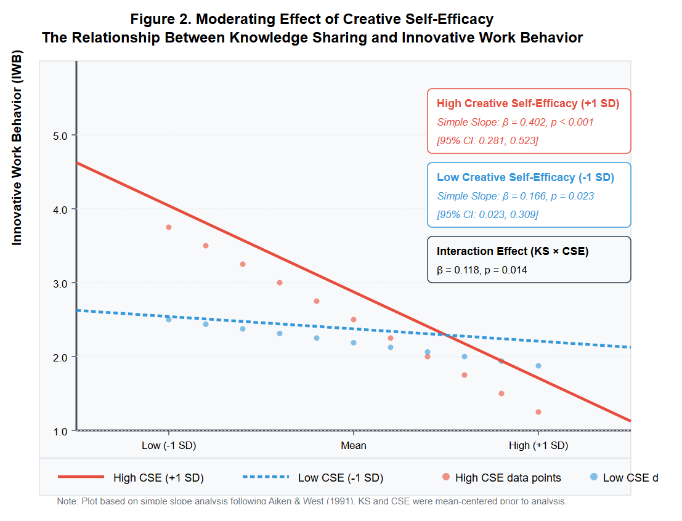
Note: The moderating effect of CSE on the relationship between KS and Innovative Work Behavior (IWB). The relationship is significantly stronger for individuals with high CSE (simple slope: β = .402, p < .001) than for those with low CSE (simple slope: β = .166, p = .023).

Appendix F
Table F1. Goodness-of-Fit Indices for the Final Structural Model
Fit Category | Fit Index | Model Result | Recommended Threshold | Evaluation
Absolute Fit | χ²/df | 1.251 | ≤ 3.0 | Excellent
 | RMSEA | .024 | ≤ .06 (Good) | Excellent
 | SRMR | .048 | ≤ .08 | Excellent
Incremental Fit | CFI | .987 | ≥ .95 | Excellent
 | TLI | .985 | ≥ .95 | Excellent
 | NFI | .953 | ≥ .90 | Excellent
Parsimonious Fit | PNFI | .785 | ≥ .50 | Excellent
 | PGFI | .688 | ≥ .50 | Excellent

Reference Appendix
Ajzen, I. (1991). The theory of planned behavior. Organizational Behavior and Human Decision Processes, 50(2), 179–211. https://doi.org/10.1016/0749-5978(91)90020-T
Bhagat, R. S., & Hofstede, G. (2002). Culture’s Consequences: Comparing Values, Behaviors, Institutions, and Organizations across Nations. The Academy of Management Review. https://doi.org/10.2307/4134391
Gagné, M., Forest, J., Vansteenkiste, M., Crevier-Braud, L., van den Broeck, A., Aspeli, A. K., Bellerose, J., Benabou, C., Chemolli, E., Güntert, S. T., Halvari, H., Indiyastuti, D. L., Johnson, P. A., Molstad, M. H., Naudin, M., Ndao, A., Olafsen, A. H., Roussel, P., Wang, Z., & Westbye, C. (2015). The Multidimensional Work Motivation Scale: Validation evidence in seven languages and nine countries. European Journal of Work and Organizational Psychology, 24(2), 178–196. https://doi.org/10.1080/1359432X.2013.877892
House, R. J., Hanges, P. J., Javidan, M., Dorfman, P. W., & Gupta, V. (Eds. ). (2005). Culture, leadership, and organizations: the GLOBE study of 62 societies. In Choice Reviews Online (Vol. 42, Issue 07). https://doi.org/10.5860/choice.42-4132
Janssen, O. (2000). Job demands, perceptions of effort‐reward fairness and innovative work behaviour. Journal of Occupational and Organizational Psychology, 73(3), 287–302. https://doi.org/10.1348/096317900167038
Schaufeli, W. B., Bakker, A. B., & Salanova, M. (2006). The Measurement of Work Engagement With a Short Questionnaire. Educational and Psychological Measurement, 66(4), 701–716. https://doi.org/10.1177/0013164405282471
Singgih, G. G., & Famiola, M. (2024). Core Values of Sustainable Innovation in Indonesian SMEs (pp. 39–74). https://doi.org/10.1007/978-3-031-78361-6_3
Tierney, P., & Farmer, S. M. (2002). CREATIVE SELF-EFFICACY: ITS POTENTIAL ANTECEDENTS AND RELATIONSHIP TO CREATIVE PERFORMANCE. Academy of Management Journal, 45(6), 1137–1148. https://doi.org/10.2307/3069429
Triandis, H. C. (2018). Individualism and collectivism. In Individualism and Collectivism. Routledge. https://doi.org/10.4324/9780429499845
Triandis, H. C., & Hofstede, G. (1993). Cultures and Organizations: Software of the Mind. Administrative Science Quarterly, 38(1), 132. https://doi.org/10.2307/2393257
Tsui, A. S. (2007). From Homogenization to Pluralism: International Management Research in the Academy and Beyond. Academy of Management Journal, 50(6), 1353–1364. https://doi.org/10.5465/amj.2007.28166121
van den Hooff, B., & de Ridder, J. A. (2004). Knowledge sharing in context: the influence of organizational commitment, communication climate and CMC use on knowledge sharing. Journal of Knowledge Management, 8(6), 117–130. https://doi.org/10.1108/13673270410567675
Yulianto, H. (2025). The Socio-Cultural Digital Innovation Capacity for Business Sustainability of Traditional Craft SMEs. Esaprom Journal.

