Supplementary
All features were extracted from pre-session EEG recordings using Welch power spectral density estimates. Values represent region-averaged PSD (log-scaled) for each canonical frequency band.
Table S1. Baseline EEG-Derived Features Used in the Main Models
Feature category | Definition | Feature name
Global spectral summary | Mean global theta-band power | global_theta_pre
Global spectral summary | Mean global alpha-band power | global_alpha_pre
Global spectral summary | Mean global beta-band power | global_beta_pre
Frontal spectral summary | Mean frontal theta-band power | frontal_theta_pre
Frontal spectral summary | Mean frontal alpha-band power | frontal_alpha_pre
Frontal spectral summary | Mean frontal beta-band power | frontal_beta_pre
Frontal asymmetry | ln(alpha_F4) − ln(alpha_F3) | FAA_F4F3_pre
Spectral ratio | frontal theta / frontal beta | theta_beta_ratio_pre
Spectral ratio | frontal alpha / frontal beta | alpha_beta_ratio_pre
Relative power | global theta / total canonical band power | relative_theta_pre
Relative power | global alpha / total canonical band power | relative_alpha_pre
Relative power | global beta / total canonical band power | relative_beta_pre

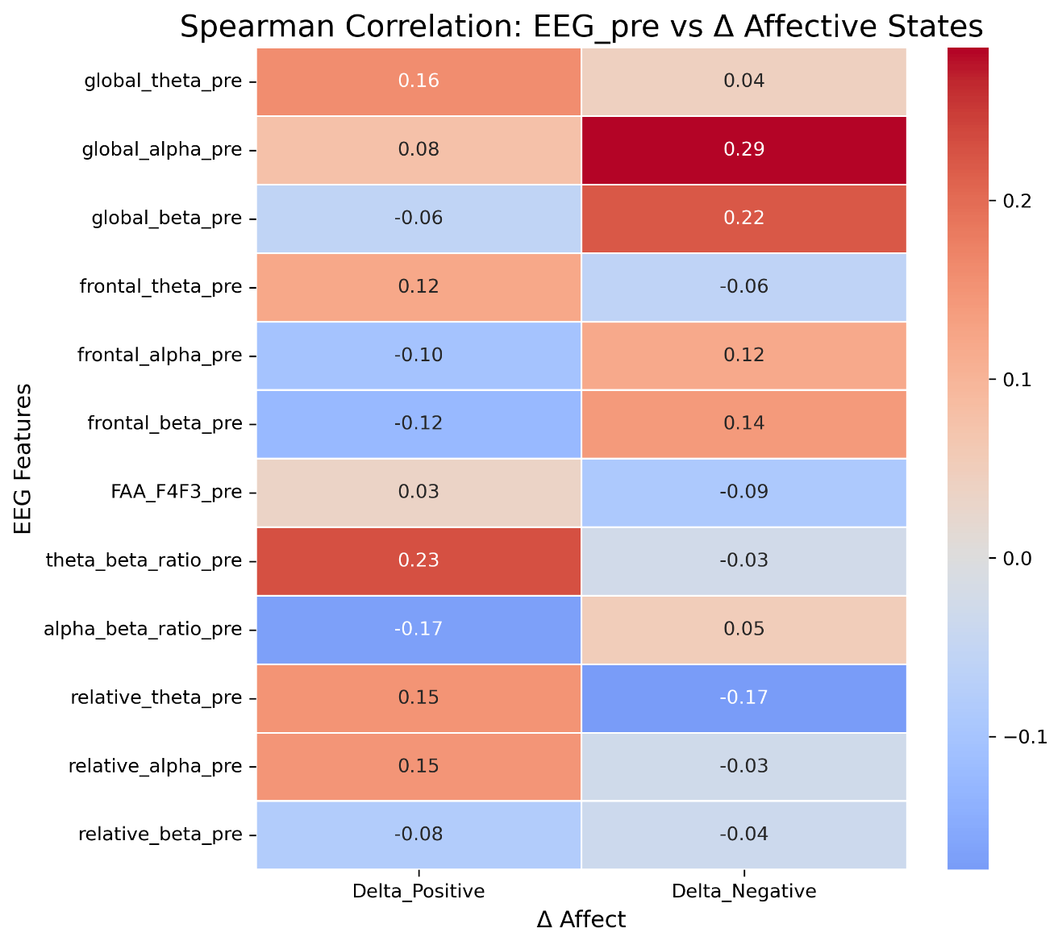
Supplementary Figure S1. Spearman correlation heatmap for baseline EEG-derived features and affective transitions.
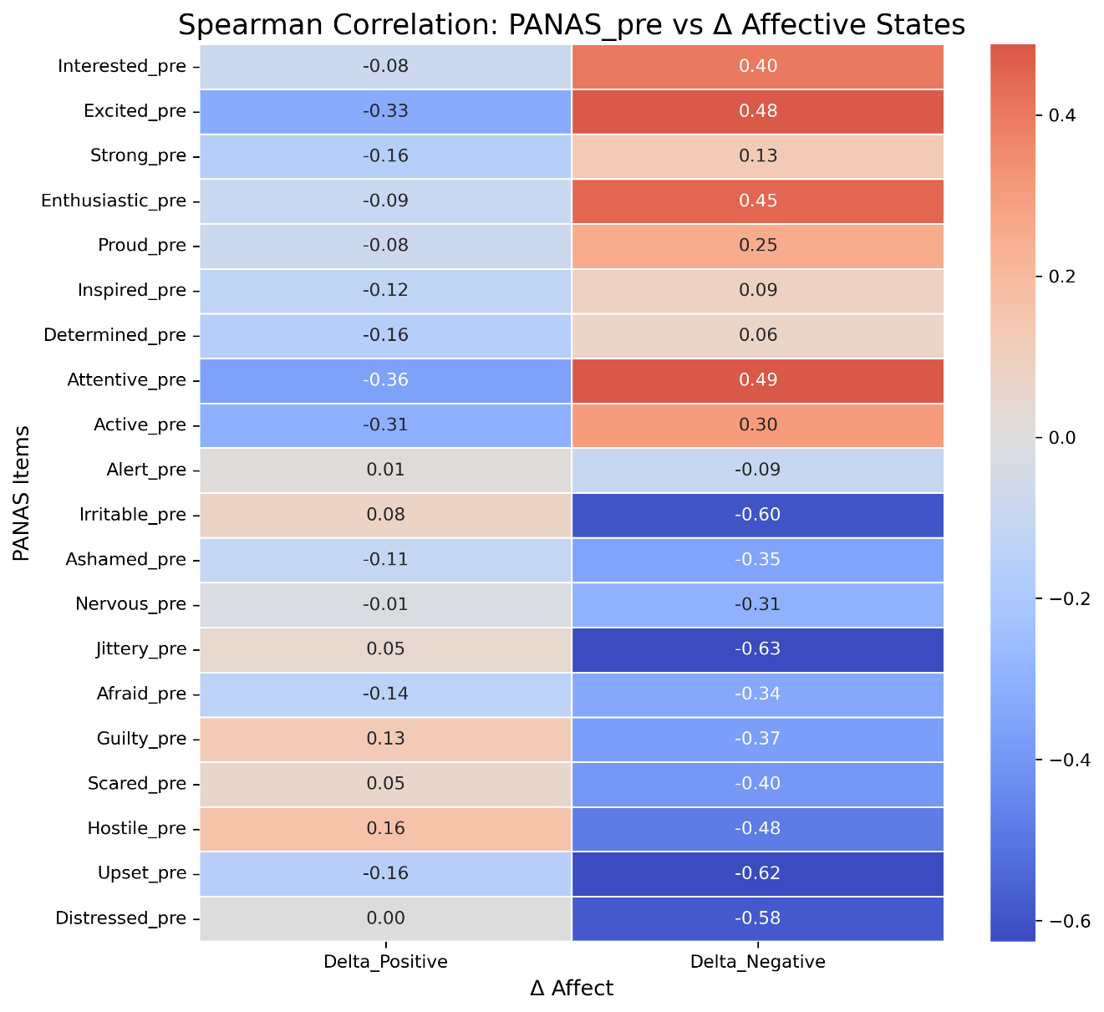
Supplementary Figure S2. Spearman correlation heatmap for baseline PANAS items and affective transitions.

