Supplementary Materials
Table of Contents

Supplementary Methods 2
DTI-ALPS 2
Free water diffusion metrics 2
Supplementary Figures 3
Supplementary Figure 1. 4
Supplementary Figure 2. 5
Supplementary Figure 3. 6
Supplementary Figure 4. 7
Supplementary Figure 5. 7
Supplementary Figure 6. 8
Supplementary Tables 8
Table S1: Diameters of peri-arterial space in HCP-Aging subjects. 8
Table S2: Diameters of peri-arterial space in ADNI subjects. 9
Table S3: Paired t-test results comparing FWVF in pAs and parenchymal regions across functional ROIs. 9
Table S4: Aβ-PET positivity classification using different glymphatic metrics and Tau PET SUVR. 9
Table S5: Diagnostic classification using different glymphatic metrics. 10
Table S6: Diagnostic classification using Tau PET SUVR and Aβ PET SUVR. 10
References 11

Supplementary Methods

DTI-ALPS

To measure the interstitial fluid efflux along the glymphatic clearance pathway, we will employ a diffusion-MRI based method known as diffusion tensor image analysis along the perivascular space (DTI-ALPS)¹. In this method, water diffusivity in the direction of the pVs is used to infer ISF movement. The pVs are hypothesized to run parallel to deep medullary veins at the level of the lateral ventricles. This direction is defined as the x-axis. Regions of interest (ROIs) will be defined as spheres with a 5 mm radius and placed in: projection fibers: superior corona radiata (SCR) and association fibers: superior longitudinal fasciculus (SLF). ROIs were defined on the JHU-ICBM-FA template. DWI images were both linearly and non-linearly registered to the JHU-ICBM-FA space to apply the masks automatically. Projection fibers run along the head-foot (y-axis) direction, and association fibers run along the anterior-posterior (z-axis) direction—both orthogonal to the pVs. The ALPS index will be therefore defined by the ratio of the mean of x-axis diffusivity in the area of projection fibers (D_{xx,proj}) and x-axis diffusivity in the area of association fibers (D_{xx,assoc}) to the mean of the y-axis diffusivity in the area of projection fibers (D_{yy,proj}) and z-axis diffusivity in the area of association fibers (D_{zz,assoc}).
$$ALPS=\frac{mean\left(D_{xx,proj}, D_{xx,assoc}\right)}{mean\left(D_{yy,proj},D_{zz,assoc}\right)}$$
Note that in ADNI dataset, due to the enlarged ventricles and white matter atrophy, we used eroded ROI by half of their radius so that the ROIs would not overlap with ventricles.

Free water diffusion metrics

Unlike the conventional free-water elimination DTI (FWE-DTI) model, in which the free-water compartment is modeled as an isotropic sphere with fixed diffusivity, our pipeline uses the Tissue–Tensor Imaging (TTI) framework². TTI assumes that diffusion within perivascular spaces exhibits directional preference due to the geometry of perivascular channels. and therefore allows the fluid compartment to express anisotropic diffusion characteristics³. As in the equation below, the QIT bi-tensor fitting⁴ yields fluid-compartment diffusivity measures (fAD, fRD, fMD, fFA) in addition to the tissue-compartment metrics (tAD, tRD, tMD, tFA).
$$S\left(b,g\right)=\left(1-f\right)exp\left(-bg^{T}D_{t}g\right)+fexp\left(-bg^{T}D_{f}g\right)$$
Where $S\left(b,g\right)$ is diffusion-weighted MR signal measured with b-value b and unit gradient direction $g$. $f$ is the volume fraction of fluid compartment, $D_{t}$ is tissue tensor (three eigenvalues $λ_{1}^{t},$ $λ_{2}^{t}$ and $λ_{3}^{t}$), and $D_{f}$ is tissue tensor (three eigenvalues $λ_{1}^{f},$ $λ_{2}^{f}$ and $λ_{3}^{f}$). This yields fluid-compartment metrics⁵: $FWAD=λ_{1}^{f}$, $FWRD=\frac{\left(λ_{2}^{f}+λ_{3}^{f}\right)}{2},$ $FWMD=\frac{\left(λ_{1}^{f}+λ_{2}^{f}+λ_{3}^{f}\right)}{3}. ADDIN EN.CITE <EndNote><Cite><Author>Pasternak</Author><Year>2009</Year><RecNum>1546</RecNum><record><rec-number>1546</rec-number><foreign-keys><key app="EN" db-id="wzxdfe2viptf06exea9pxvz2vsz55er0vt0p" timestamp="1751003071">1546</key></foreign-keys><ref-type name="Journal Article">17</ref-type><contributors><authors><author>Pasternak, O.</author><author>Sochen, N.</author><author>Gur, Y.</author><author>Intrator, N.</author><author>Assaf, Y.</author></authors></contributors><auth-address>Blavatnik School of Computer Science, Raymond and Beverly Sackler Faculty of Exact Sciences, Tel Aviv University, Tel Aviv, Israel. oferpas@post.tau.ac.il</auth-address><titles><title>Free water elimination and mapping from diffusion MRI</title><secondary-title>Magn Reson Med</secondary-title></titles><periodical><full-title>Magn Reson Med</full-title></periodical><pages>717-30</pages><volume>62</volume><number>3</number><edition>2009/07/23</edition><keywords><keyword>Adult</keyword><keyword>*Algorithms</keyword><keyword>*Artifacts</keyword><keyword>*Body Water</keyword><keyword>Brain/*pathology</keyword><keyword>Diffusion Magnetic Resonance Imaging/*methods</keyword><keyword>Humans</keyword><keyword>Image Enhancement/*methods</keyword><keyword>Image Interpretation, Computer-Assisted/*methods</keyword><keyword>Male</keyword><keyword>Meningeal Neoplasms/*pathology</keyword><keyword>Meningioma/*pathology</keyword><keyword>Middle Aged</keyword><keyword>Reproducibility of Results</keyword><keyword>Sensitivity and Specificity</keyword></keywords><dates><year>2009</year><pub-dates><date>Sep</date></pub-dates></dates><isbn>1522-2594 (Electronic)\&\#xD;0740-3194 (Linking)</isbn><accession-num>19623619</accession-num><urls><related-urls><url>https://www.ncbi.nlm.nih.gov/pubmed/19623619</url></related-urls></urls><electronic-resource-num>10.1002/mrm.22055</electronic-resource-num></record></Cite></EndNote>$ In this context, fAD represents the axial diffusivity of the anisotropic fluid tensor, and its biological interpretation relates to the directionality of fluid movement along perivascular pathways.

Supplementary Figures

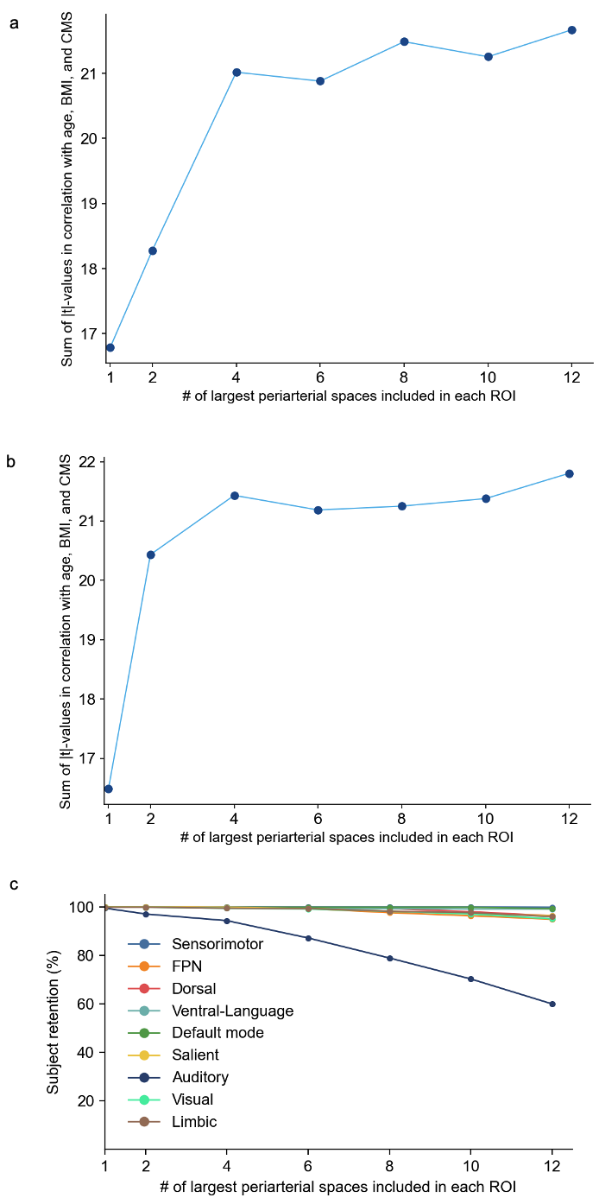

Supplementary Figure 1.
Whole brain correlation t-value summation using different number of pAs. a. FWAD; b. FWVF; c. percentage of subject retention in different ROIs using different number of pAs.

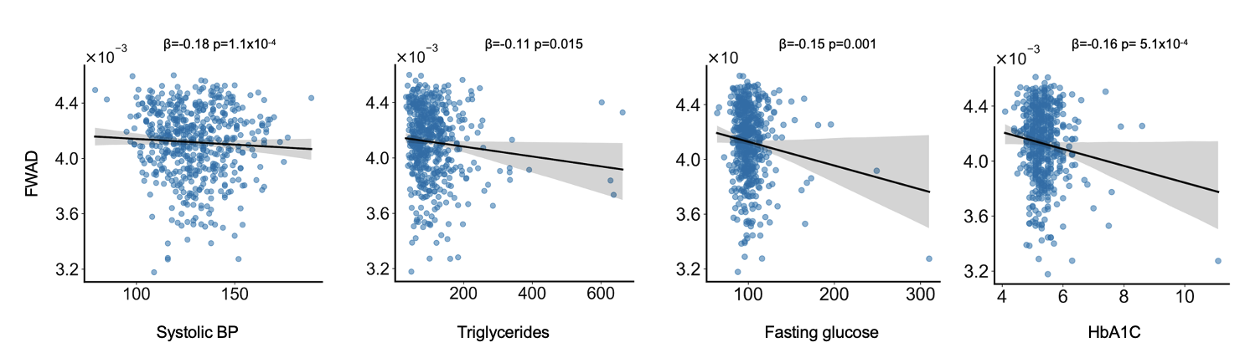

Supplementary Figure 2.
Correlation of whole brain FWAD in periarterial space with CMS risk factors. BP=blood pressure, HbA1C=Hemoglobin A1c.
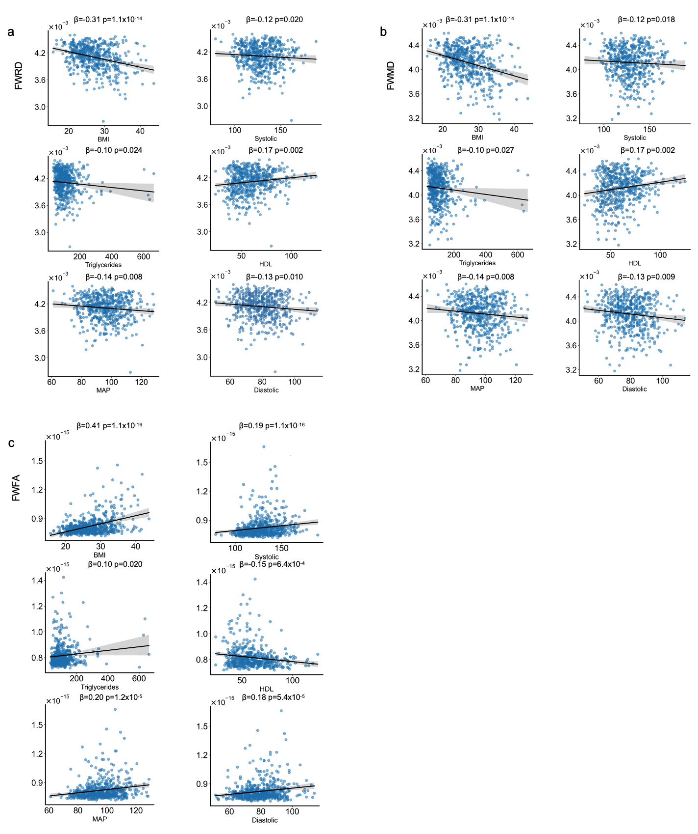

Supplementary Figure 3.
Correlation of whole brain free water radial diffusivity (FWRD), free water mean diffusivity (FWMD) and free water fractional anisotropy (FWFA) in periarterial space with CMS risk factors. BMI=body mass index, MAP=mean arterial pressure, HDL=high-density lipoprotein.
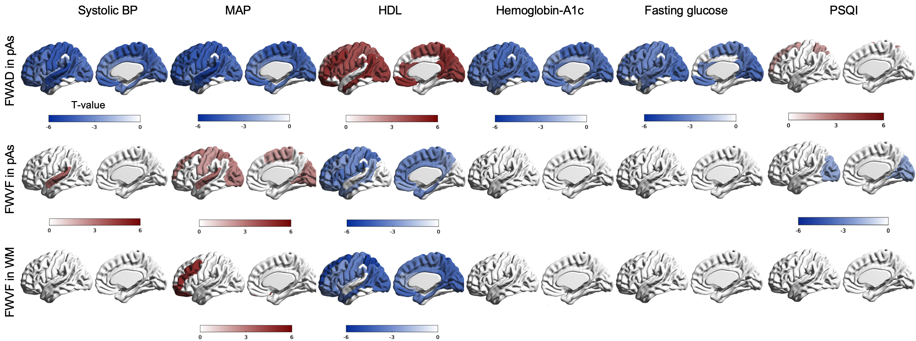

Supplementary Figure 4.
Regional correlation of FWVF and FWAD with CMS and Montreal Cognitive Assessment (MoCA).

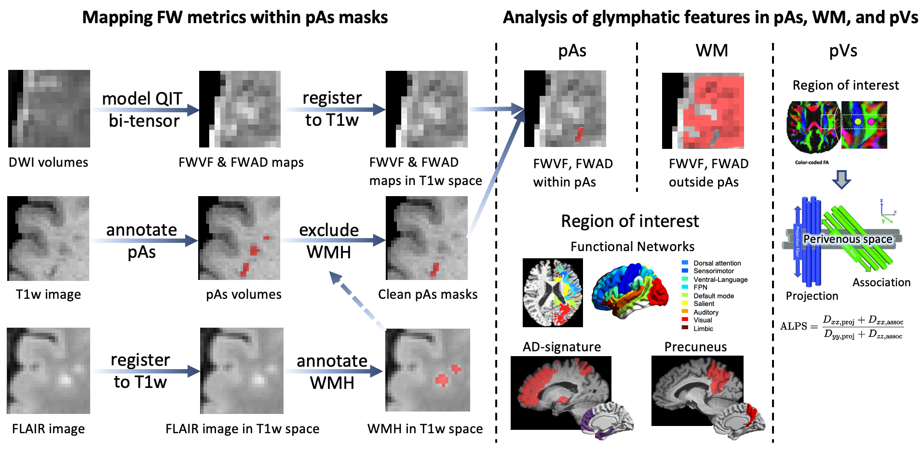

Supplementary Figure 5.
Workflow: extracting multimodal MRI features of glymphatic metrics in three compartments: periarterial space (pAs), white matter (WM), and perivenous space (pVs).
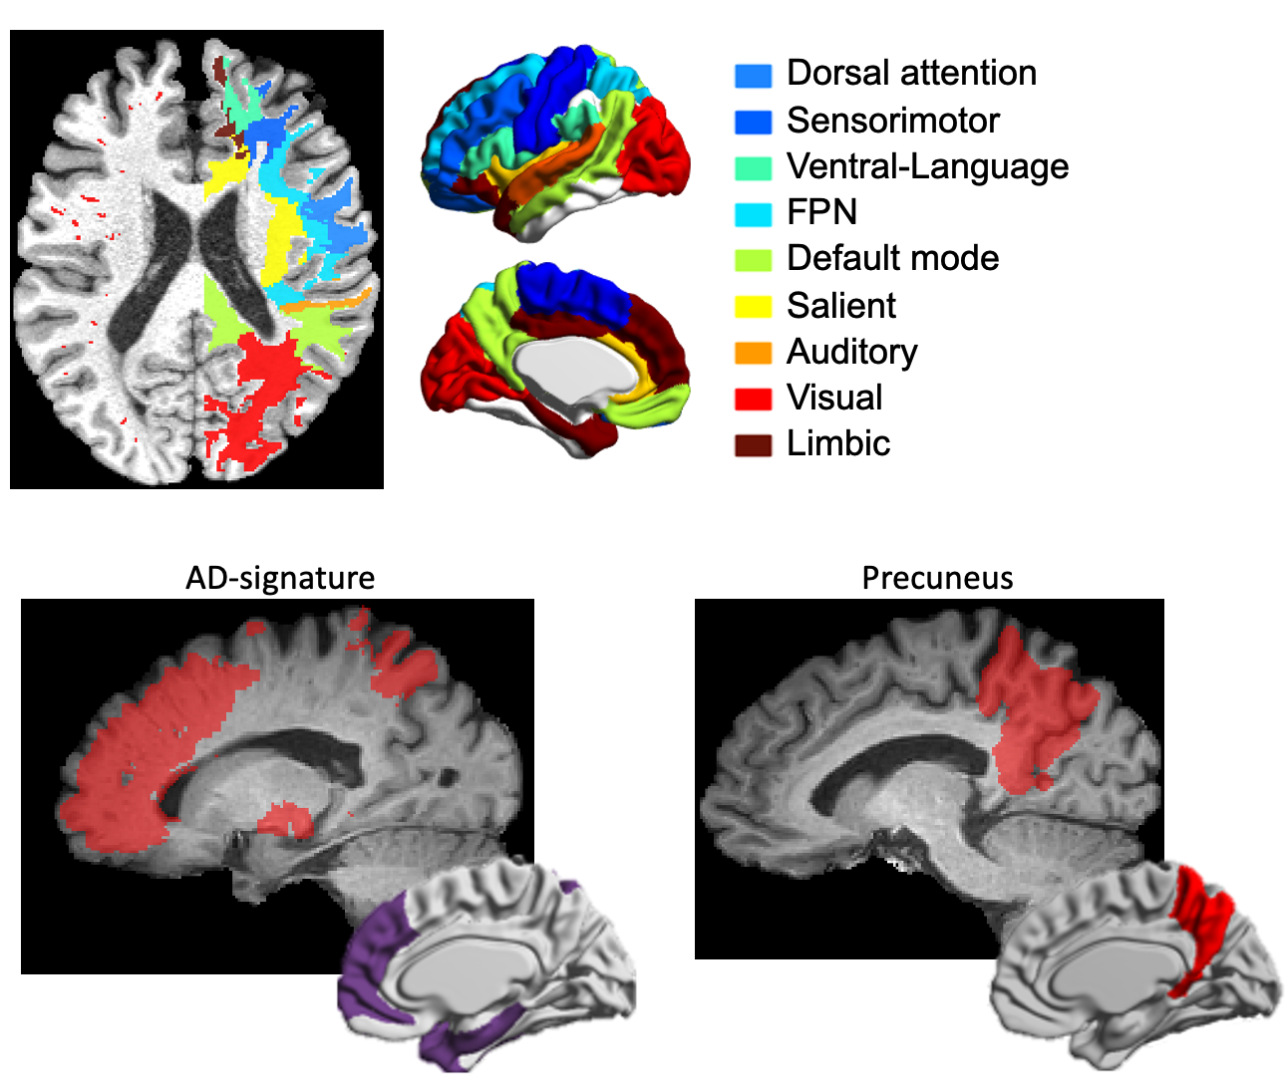

Supplementary Figure 6.
Functional region of interests (ROIs) and their overlapping with periarterial space. For analyses of CMS effects on glymphatic function for normal participants in HCP-A cohort, pAs volumes segmented are mapped onto nine functional ROIs. These ROIs are defined on the cortical surface using the Automated Anatomical Labeling (AAL) template, following prior work, and included the frontoparietal network, dorsal attention, ventral attention/language, sensorimotor, default mode, auditory, visual, salience, and functional cortex. For analyses of AD progression, ROIs corresponding to the AD signature—including bilateral hippocampi, temporal poles, and entorhinal, inferior temporal, superior frontal, inferior parietal, and anterior cingulate cortices—are also defined using the AAL template. The precuneus, implicated in early AD pathology, is separately delineated for targeted analyses. ROIs are propagated into adjacent superficial white matter using k-nearest neighbors (k-NN) clustering, constrained to a depth of 5 mm from the gray matter–WM boundary by Laplacian distance mapping. pAs volumes are assigned to an ROI if they overlap with the ROI mask.

Supplementary Tables

Table S1: Diameters of peri-arterial space in HCP-Aging subjects.
ROI | Diameter (mm)
Sensorimotor | 2.16 ± 0.42
Frontoparietal network | 1.94 ± 0.47
Dorsal attention network | 2.02 ± 0.49
Ventral language network | 2.07 ± 0.41
Default mode network | 2.12 ± 0.43
Salience | 2.05 ± 0.52
Auditory | 1.66 ± 0.45
Visual | 1.88 ± 0.46
Limbic | 1.96 ± 0.49
Whole Brain | 1.98 ± 0.46
Data are presented as mean ± standard deviation. The pAs diameter was estimated using a volume-normalized skeleton method⁶.

Table S2: Diameters of peri-arterial space in ADNI subjects.
ROI | Diameter (mm)
AD signature | 3.00 ± 0.58
Precuneus | 2.65 ± 0.61
Data are presented as mean ± standard deviation.

Table S3: Paired t-test results comparing FWVF in pAs and parenchymal regions across functional ROIs.
Measure | pAs average | WM average | t-value | p-value | q-value
Sensorimotor | 0.39 | 0.35 | -24.13 | 2.04E-89 | 2.04E-88
FPN | 0.39 | 0.38 | -8.86 | 9.68E-18 | 9.68E-18
Dorsal Attention | 0.39 | 0.37 | -16.2 | 6.52E-49 | 1.09E-48
Ventral Attention | 0.38 | 0.35 | -16.63 | 4.94E-51 | 9.88E-51
DMN | 0.39 | 0.36 | -17.61 | 7.76E-56 | 1.94E-55
Salience | 0.37 | 0.36 | -12.72 | 7.63E-33 | 9.53E-33
Auditory | 0.38 | 0.35 | -15.69 | 1.96E-46 | 2.80E-46
Visual | 0.39 | 0.35 | -22.42 | 1.63E-80 | 8.16E-80
Limbic | 0.38 | 0.36 | -10.71 | 1.59E-24 | 1.77E-24
Whole Brain | 0.39 | 0.36 | -19.97 | 8.20E-68 | 2.73E-67
q-values represent FDR-corrected p-values using Benjamini–Hochberg procedure across the nine ROI comparisons.

Table S4: Aβ-PET positivity classification using different glymphatic metrics and Tau PET SUVR.
CN vs MCI+AD
Model | pAs | WM | pVs | pVs & WM | All features | Tau
XGBoost | 0.63 ± 0.13 | 0.59 ± 0.11 | 0.52 ± 0.16 | 0.80 ± 0.07 | 0.82 ± 0.07 | 0.74 ± 0.15
GLM | 0.72 ± 0.10 | 0.62 ± 0.11 | 0.61 ± 0.15 | 0.74 ± 0.10 | 0.72 ± 0.09 | 0.80 ± 0.13
SVM (Linear) | 0.72 ± 0.11 | 0.62 ± 0.11 | 0.55 ± 0.08 | 0.72 ± 0.09 | 0.72 ± 0.09 | 0.80 ± 0.12
SVM (RBF) | 0.74 ± 0.13 | 0.63 ± 0.14 | 0.51 ± 0.08 | 0.79 ± 0.06 | 0.79 ± 0.06 | 0.81 ± 0.13
CV vs MCI
XGBoost | 0.63 ± 0.12 | 0.61 ± 0.12 | 0.60 ± 0.13 | 0.76 ± 0.13 | 0.79 ± 0.11 | 0.74 ± 0.17
GLM | 0.70 ± 0.09 | 0.60 ± 0.19 | 0.59 ± 0.11 | 0.74 ± 0.11 | 0.82 ± 0.06 | 0.79 ± 0.15
SVM (Linear) | 0.73 ± 0.08 | 0.63 ± 0.25 | 0.61 ± 0.11 | 0.79 ± 0.15 | 0.80 ± 0.07 | 0.80 ± 0.14
SVM (RBF) | 0.68 ± 0.14 | 0.62 ± 0.24 | 0.61 ± 0.11 | 0.80 ± 0.14 | 0.78 ± 0.02 | 0.80 ± 0.14
AUC values were computed using various linear and non-linear classifiers. Data are presented as mean ± standard deviation.

Table S5: Diagnostic classification using different glymphatic metrics.
CN vs MCI+AD
Model | pAs | WM | pVs | pVs & WM | All features
XGBoost | 0.74 ± 0.08 | 0.63 ± 0.10 | 0.60 ± 0.15 | 0.61 ± 0.12 | 0.82 ± 0.07
GLM | 0.77 ± 0.11 | 0.62 ± 0.11 | 0.59 ± 0.15 | 0.77 ± 0.10 | 0.76 ± 0.09
SVM (Linear) | 0.75 ± 0.11 | 0.61 ± 0.11 | 0.62 ± 0.11 | 0.79 ± 0.10 | 0.75 ± 0.09
SVM (RBF) | 0.80 ± 0.09 | 0.61 ± 0.13 | 0.58 ± 0.17 | 0.75 ± 0.13 | 0.79 ± 0.12
CN vs MCI
XGBoost | 0.80 ± 0.08 | 0.63 ± 0.09 | 0.60 ± 0.15 | 0.77 ± 0.08 | 0.81 ± 0.06
GLM | 0.72 ± 0.09 | 0.61 ± 0.11 | 0.49 ± 0.08 | 0.74 ± 0.08 | 0.73 ± 0.10
SVM (Linear) | 0.73 ± 0.07 | 0.62 ± 0.14 | 0.51 ± 0.08 | 0.76 ± 0.10 | 0.70 ± 0.08
SVM (RBF) | 0.71 ± 0.08 | 0.58 ± 0.10 | 0.54 ± 0.10 | 0.79 ± 0.06 | 0.79 ± 0.07
AUC values were computed using various linear and non-linear classifiers. Data are presented as mean ± standard deviation.

Table S6: Diagnostic classification using Tau PET SUVR and Aβ PET SUVR.
CN vs MCI+AD
Model | Aβ | Tau | Aβ and Tau
XGBoost | 0.61 ± 0.12 | 0.61 ± 0.09 | 0.65 ± 0.09
GLM | 0.67 ± 0.24 | 0.70 ± 0.09 | 0.72 ± 0.08
SVM (Linear) | 0.67 ± 0.25 | 0.74 ± 0.08 | 0.75 ± 0.08
SVM (RBF) | 0.62 ± 0.24 | 0.68 ± 0.14 | 0.68 ± 0.11
CN vs MCI
XGBoost | 0.60 ± 0.13 | 0.65 ± 0.10 | 0.64 ± 0.13
GLM | 0.59 ± 0.11 | 0.68 ± 0.11 | 0.62 ± 0.11
SVM (Linear) | 0.65 ± 0.11 | 0.68 ± 0.09 | 0.67 ± 0.14
SVM (RBF) | 0.62 ± 0.11 | 0.70 ± 0.12 | 0.69 ± 0.14
AUC values were computed using various linear and non-linear classifiers. Data are presented as mean ± standard deviation.

References

1 Taoka, T. et al. Evaluation of glymphatic system activity with the diffusion MR technique: diffusion tensor image analysis along the perivascular space (DTI-ALPS) in Alzheimer's disease cases. Jpn J Radiol 35, 172-178, doi:10.1007/s11604-017-0617-z (2017).
2 Hoy, A. R., Koay, C. G., Kecskemeti, S. R. & Alexander, A. L. Optimization of a free water elimination two-compartment model for diffusion tensor imaging. Neuroimage 103, 323-333, doi:10.1016/j.neuroimage.2014.09.053 (2014).
3 Sepehrband, F. et al. Perivascular space fluid contributes to diffusion tensor imaging changes in white matter. Neuroimage 197, 243-254, doi:10.1016/j.neuroimage.2019.04.070 (2019).
4 Cabeen, R. P., Laidlaw, D. H. & Toga, A. W. Quantitative imaging toolkit: software for interactive 3D visualization, data exploration, and computational analysis of neuroimaging datasets.
5 Pasternak, O., Sochen, N., Gur, Y., Intrator, N. & Assaf, Y. Free water elimination and mapping from diffusion MRI. Magn Reson Med 62, 717-730, doi:10.1002/mrm.22055 (2009).
6 Wang, X. et al. Skeleton-based cerebrovascular quantitative analysis. BMC Med Imaging 16, 68, doi:10.1186/s12880-016-0170-8 (2016).

