Supplementary Information (SI)
The Origins of the Senyar Tropical Cyclone over the Malacca Strait, Indonesia
Erma Yulihastin^{a*}, Sanaullah Zehri^{a,b}, Albertus Sulaimanª, Prawira Yudha Kombaraª, Narizka Nanda Purwadani^{a,c}, Eka Oktavia Sari^{d}, Bambang Adhi Priyambodho^{a,e}, Simon Barbot^{f} and Josephine Brown^{g}

ªResearch Center for Climate and Atmosphere, National Research and Innovation Agency, Bandung, Indonesia
^{b}Study Program of Physics, Bandung Institute of Technology, Bandung, Indonesia
^{c}Graduate Program of Earth Sciences, Bandung Institute of Technology, Bandung, Indonesia
^{d}Study Program of Atmosphere and Space Sciences, Sumatra Institute of Technology, Lampung, Indonesia
^{e}Department of Civil Engineering, Faculty of Engineering, Universitas Sultan Ageng Tirtayasa, Serang, Indonesia
^{f}Laboratoire d’Études en Géophysique et Océanographie Spatiales, Toulouse, France
^{g}ARC Centre of Excellence for the Weather, School of Geography, Earth and Atmospheric Sciences, The University of Melbourne, Melbourne, Australia

This supplementary file includes four texts, one table, and seven figures (Figures S1–S7). The four texts consist of: (1) analysis of vorticity and advection, (2) numerical simulation of Senyar, (3) identification of direct and indirect impact of Senyar, and (4) the vorticity model of Senyar.

T1: Analysis of the vorticity and advection
The equation of vorticity budget in calculating vorticity tendency based on pressure coordinates can be expressed in four components, consisting of vertical advection ${(ξ}_{vadv})$, horizontal advection ($ξ_{hadv})$, divergence ($ξ_{div})$, and tilting ($ξ_{tilt}$).
${\left(\frac{{∂ξ}_{p}}{∂t}\right)}_{p}=-\left[u{\left(\frac{∂ \left(ξ_{p }+f\right)}{∂_{x}}\right)}_{p}+v{\left(\frac{∂ \left(ξ_{p }+f\right)}{∂_{y}}\right)}_{p}\right]-ω {\left(\frac{{∂ξ}_{p}}{∂p}\right)}_{p}-\left(ξ_{p }+ f\right)\left[{\left(\frac{∂u}{∂x}\right)}_{p}+{\left(\frac{∂v}{∂y}\right)}_{p}\right]+\left[{\left(\frac{∂ω}{∂y}\right)}_{p}\frac{∂u}{∂p}-{\left(\frac{∂ω}{∂x}\right)}_{p}\frac{∂v}{∂p}\right]$ (1)
where $f$ is the Coriolis parameter, $ω=\frac{∂_{p}}{∂_{t}}$is the vertical velocity, and $ξ_{p}={\left(\frac{∂v}{∂x}\right)}_{p}-{\left(\frac{∂u}{∂y}\right)}_{p}$ is the vertical component of relative vorticity, with $u$ and $v$ representing the two horizontal wind components.
The subscript $p$ indicates pressure coordinates and is omitted for convenience in the following discussion. The terms on the right-hand side represent the main contributors to the vorticity tendency as follows:
$ξ_{hadv}=-\left(u\frac{∂\left(ξ+f\right)}{∂x}+v\frac{∂\left(ξ+f\right)}{∂y}\right)$, $ξ_{vadv}=-ω\left(\frac{∂ξ}{∂p}\right)$, $ξ_{div}=-\left(ξ+f\right)\left(\frac{∂u}{∂x}+\frac{∂v}{∂y}\right)$,
and $ξ_{tilt}=-\left(\frac{∂ω}{∂x}\frac{∂v}{∂p}-\frac{∂ω}{∂y}\frac{∂u}{∂p}\right)$ (2)
Thus, the local tendency of relative vorticity represents the local variation of relative vorticity and can be expressed as follows: $ξ_{ten}=\frac{{∂ξ}_{p}}{∂t}=ξ_{hadv}+ξ_{vadv}+ξ_{div}+ξ_{tilt}$ (3)

T2: Numerical simulation of Senyar

The TC simulations were performed using the current version of WRF (4.3.1) (Skamarock et al., 2008). Initial and boundary conditions were derived from Final Reanalysis (FNL) dataset, which provides high spatial (0.25°) and temporal (3-hourly) resolution. The simulation, designed to capture the initiation stage of Senyar TC, was integrated over a 72-hour period from 22 November 2025, 00:00 UTC (07:00 LT) to 25 November 2025, 00:00 UTC (07:00 LT), with the first 16 hours designated as spin-up.
The parameterization configuration schemes (Table S1) of the WRF model follow the previous methodology of Fonseca et al. (2015) and incorporate improvements from Yulihastin et al. (2021), whose scheme effectively reproduces the diurnal cycle of precipitation, as well as landward and offshore convective propagation in the Maritime Continent. Previous precipitation evaluations have also depicted a good agreement with both station-and satellite-based observations, particularly for capturing mesoscale phenomena of convective storms (i.e., squall line, back-building, mesoscale convective complex, cold pool) at the near-surface atmospheric level.

Table S1. Configuration of the Weather and Research Forecasting model for simulating the origins of Senyar tropical cyclone, at horizontal resolutions of 9 km (D01).
Region | D01
Horizontal grids | 117 × 117
Grid spacing (km) | 9
Cumulus scheme | Betts–Miller–Janjic
Vertical grid | 34 layers
Radiation | RRTM longwave scheme  Dudhia shortwave scheme
Microphysics | Thompson
Surface layer  Land surface | Eta Similarity  Unified Noah land-surface model
PBL  Initial boundary condition | Mellor-Yamada-Janjic (MYJ)  FNL

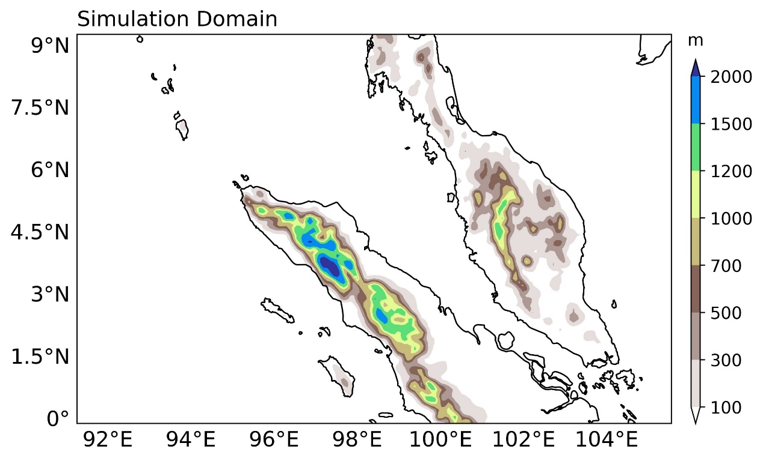

Fig. S1. Model domain and topographical parameters applied in the simulation of the Senyar tropical cyclone, covering the western Maritime Continent with a horizontal resolution of 9 km.

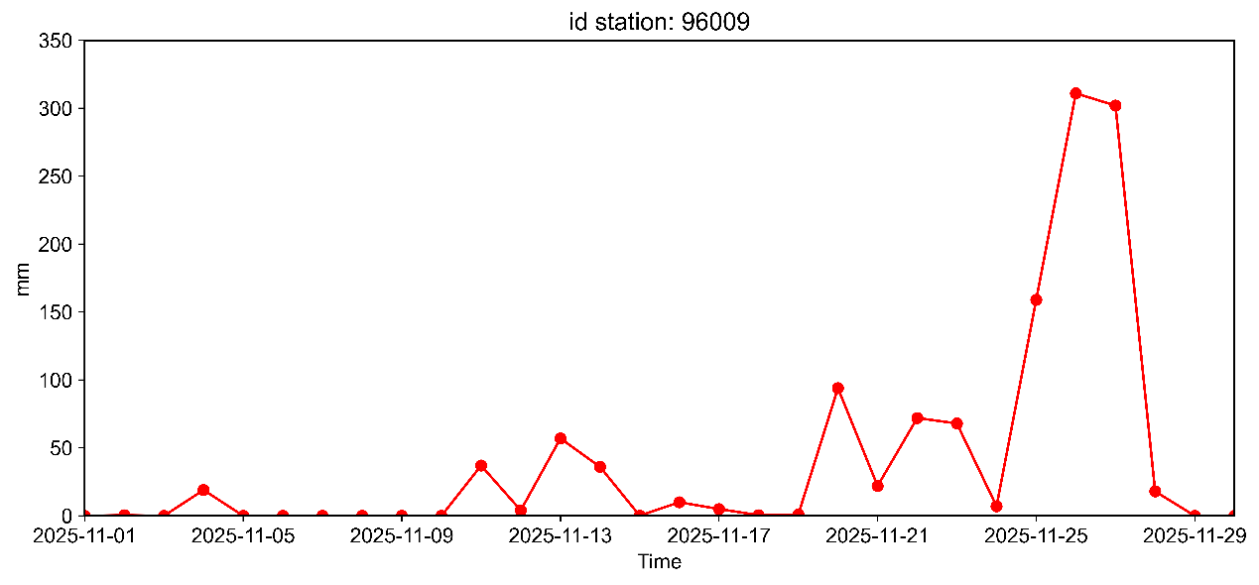

Fig. S2. Rainfall observed from the meteorological station of Malikussaleh, north Aceh, Sumatra, Indonesia.

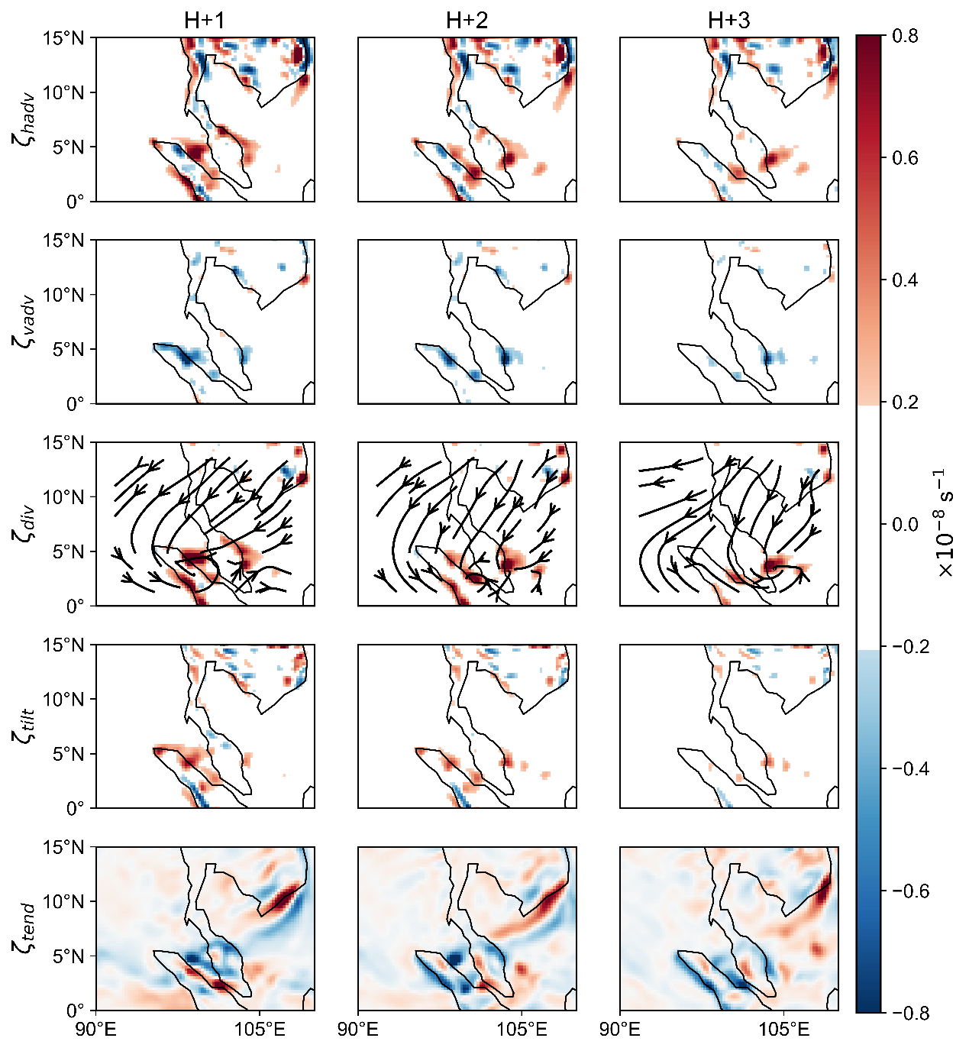
Fig. S3. Same as Figure 4, but for H+1 until H+3.

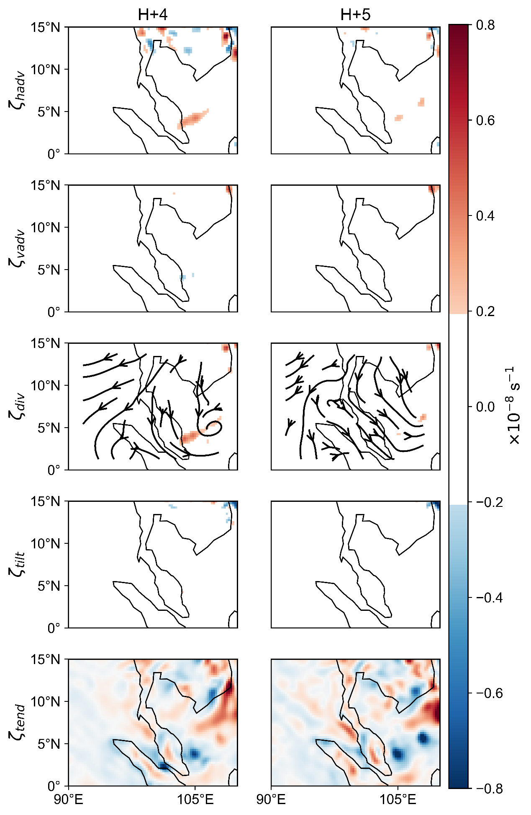
Fig. S4. Same as Figure S3, but for H+4 until H+5.

T3: Identification of direct and indirect area impacted of Senyar

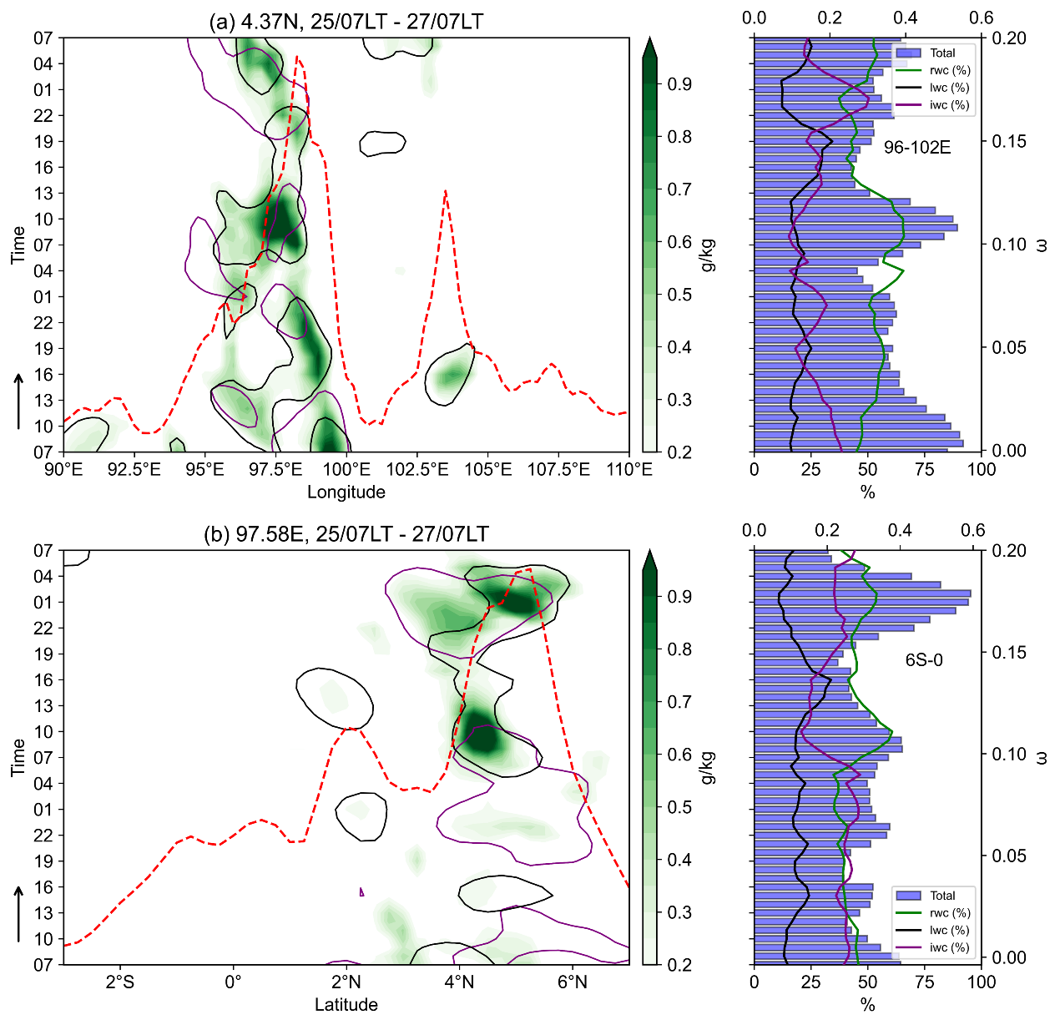
Fig. S5. Time-longitude cross-section from 25 to 27 November 2025 depicting (a) left-side panel: the rain-water content (green shading), ice-water content (purple solid-line), liquid-water content (black solid-line), and vertical velocity (red dashed-line), right-side panel: percentage of rain-water content, liquid-water content, ice-water content, and total. (b) Same as Figure S3a but for the time-latitude cross section.

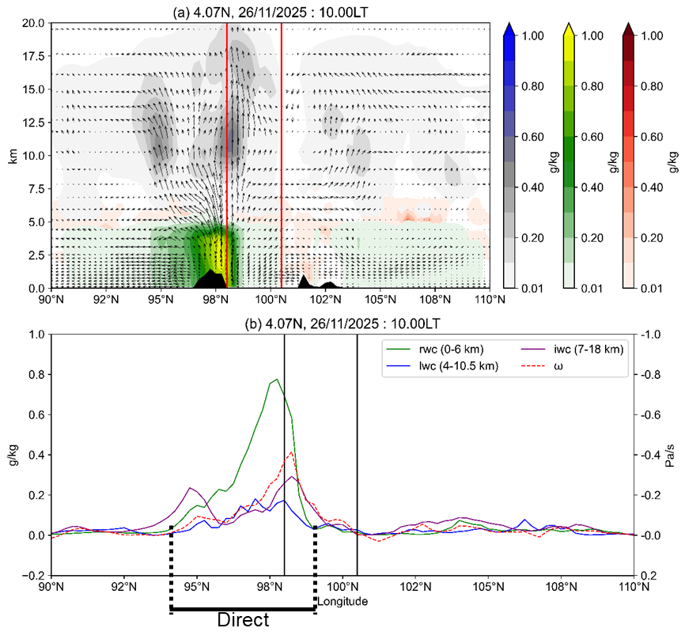
Fig. S6. Height-latitude cross-section depicting the rain-water content (green-yellow shading, rwc), liquid-water content (red shading, lwc), ice-water content (grey-blue shading, iwc), and the meridional wind vector during the Senyar landfall over northern Sumatra, Indonesia. The black shading background represents land, and the red vertical solid line represents the Malacca Strait. (b) As in panel (a) but showing the number of variables in each grid cell, presented as a line graph, and a black vertical solid line represents the Malacca Strait.

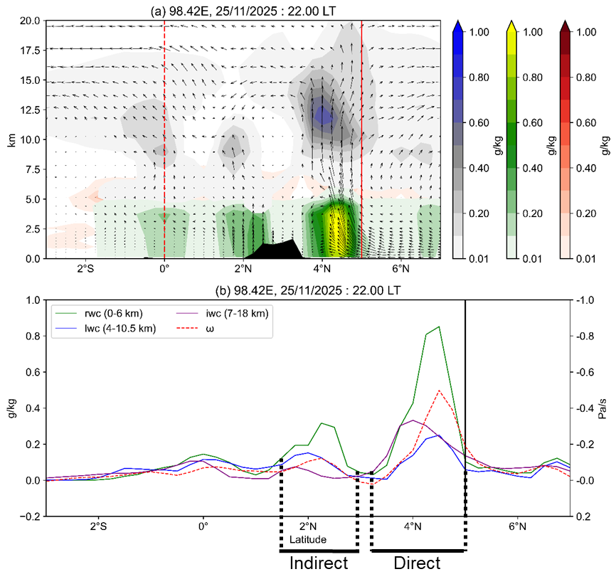
Fig. S7. Same as Figure S6, but for the latitudinal section. As in panel (a) red vertical dashed (solid) line represents the equatorial area (the Malacca Strait), but in panel (b) black vertical dashed (solid) line represents the impacted area of TC Senyar (the Malacca Strait).
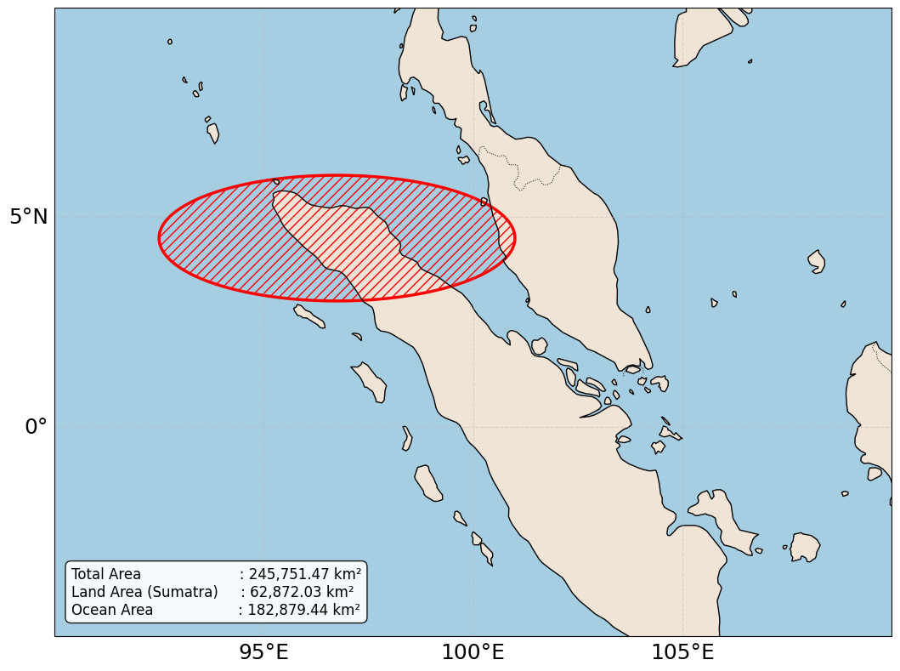
Fig. S8. Directed impact of Senyar, as calculated, refers to Figures S5–S7.

T4: The vorticity model of Senyar
WRF simulates the atmosphere in full detail, but we built a simpler model to focus on the key physical processes behind the Senyar phenomenon. By removing complex elements like WRF’s detailed microphysics, we can test whether the interaction between background winds (westerly burst and cold surges) and latent heat release in the Strait of Malacca drives the system. This minimal approach follows the principle of parsimony: explain complex events with only the necessary components. To show that the Senyar phenomenon is not just a numerical artifact of WRF’s parameterization, we must prove it results from dynamic interactions between regional circulation and surface heat fluxes.
We use the equatorial momentum equation in the presence of a background wind in the pressure coordinate (Karmakar et al 2022) and taking into account the latent heat release as follows,

(1)

where $\overline{(u,v,ω}$ are the background zonal, meridional and vertical velocity, (u’,v’,ω’) are the fluctuation of zonal, meridional, and vertical velocity, $\overline{ζ}$ is the background vorticity, ζ’ is the vorticity perturbation with the boundary condition is given by $ζ\left(x=0\right)=0$ and by $ζ\left(x=-∞\right)=0$ and the latent heat release is given by,

(2)

With ∆sea, ∆land, the difference in temperature between the atmosphere-sea and the atmosphere-land, respectively, Cp is the specific heat at the constant pressure, Q1 and Q2 are the diabatic heating at sea and land, respectively. –L₁ < x < 0 is the Malacca strait (sea) and -∞ <x ≤ L₁ is the Sumatra islands.
We further assume that the vorticity advection is dominated by background winds (representing cold surges and westerly winds), meaning that the equations become linear under disturbances and the system responds to external forces, such as latent heating. We also assume that the vorticity has no background, i.e. that bar = 0, so that cyclone Senyar is influenced by external forces such as latent heating, background winds, Rossby waves, and equatorial drift. In other words, the focus is on how diabatic heating (Q_{E}) from the Malacca Strait and the Sumatra mainland generates new vortices from a rotationally stationary state. Then Eq. (1) becomes,

(3)

Using column-integrated vorticity $Φ=1/g\int_{p1}^{p2}{ζ'dp}$, and define column-integrated of stream function $Ψ=1/g\int_{p1}^{p1}{ψdp}, v={∂ψ}/{∂x}$, $Φ=∇_{H}^{2}Ψ$
(4)

This is the linearized Forced Barotropic Vorticity Equation. In terms of stream function yields,

(5)

In this simulation, we use U as the westerly wind and V as the cold surge, and latent heat is divided into two components: ocean (-L₁ < x < 0) and land (-L₂ < x < L₁). The initial condition is the Borneo vortex, which we represent as a Gaussian vortex: Ψ₀ = -1.2 * exp(-((X - x_{c})² + (Y - y_{c})²) / (2 σ²)). We use a semi-implicit method, where the stream function is expressed in a Poisson solver. As
(6)

With the vorticity equation specified as follows:
(7)

and for each element expression below:

The simulation was conducted using Matlab R2017a. The result is depicted in Fig S7 below,
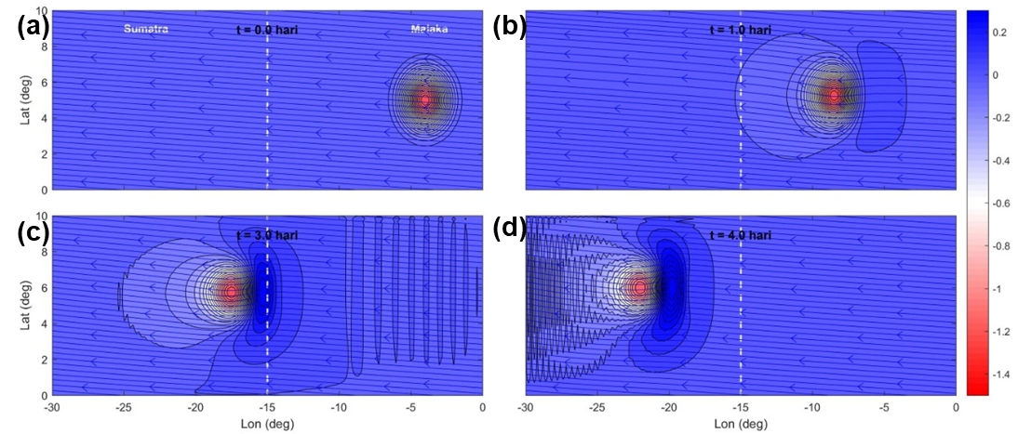
Fig. S9. A vorticity model of the origins of Senyar over the Malacca Strait based on the equatorial momentum equation in the presence of a background wind in the pressure coordinate and considering the latent heat release following Karmakar et al., 2022. The longitudinal section is shown unitless.

