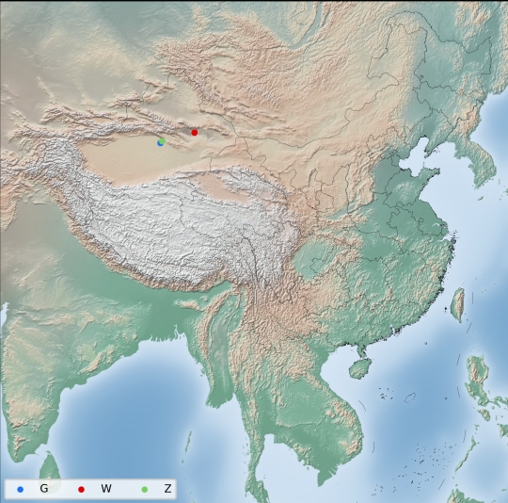
Fig. S1 Geographical Distribution Map of 45 Samples. (G: Glycyrrhiza glabra, W: Glycyrrhiza uralensis, Z: Glycyrrhiza inflata)

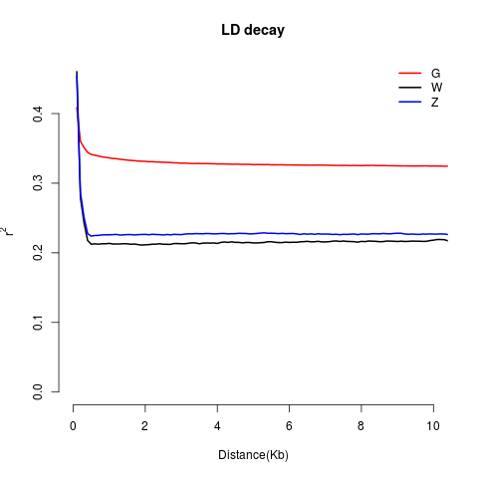
Fig. S2 Linkage disequilibrium (LD) analysis for three licorice populations; x-axis: distance, y-axis: LD coefficient.
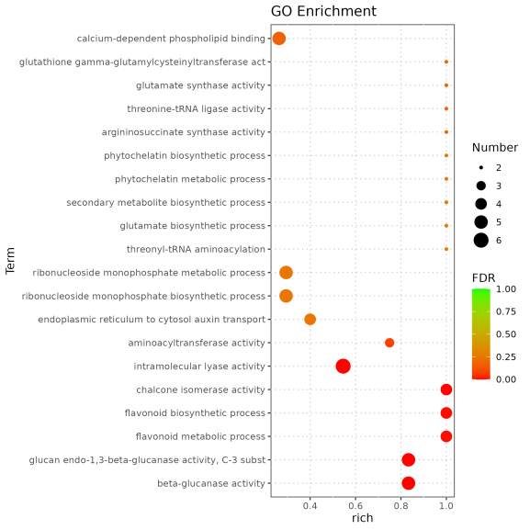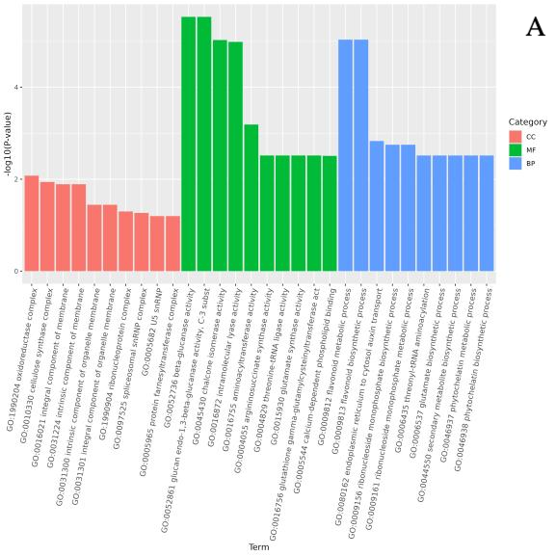
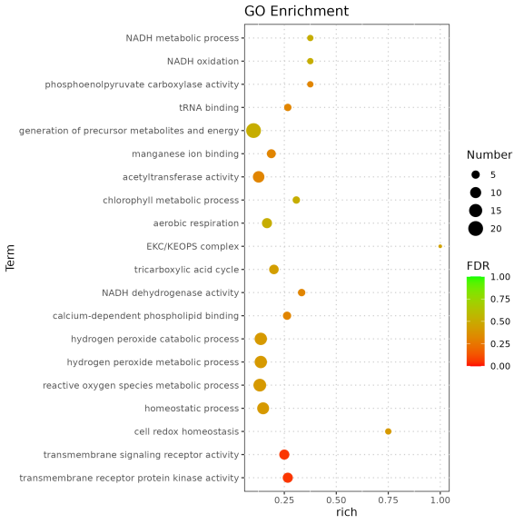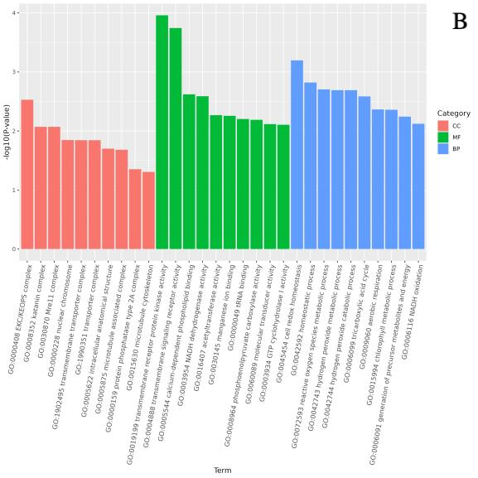
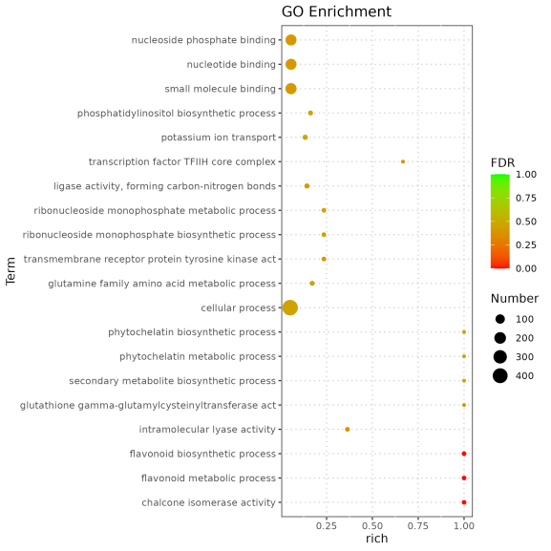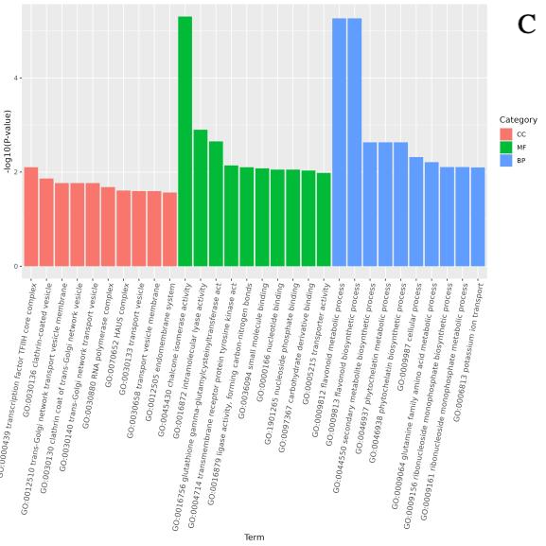
Fig. S3 Functional enrichment analysis based on Gene Ontology (GO). Bubble plots (left) show significantly enriched GO terms: Y-axis: GO term name; X-axis: Enrichment factor; Bubble color: FDR value; Bubble size: Number of genes. A)G. glabra vs G. uralensis (G-vs-W). B)G. glabra vs G. inflata (G-vs-Z). C)G. uralensis vs G. inflata (W-vs-Z).
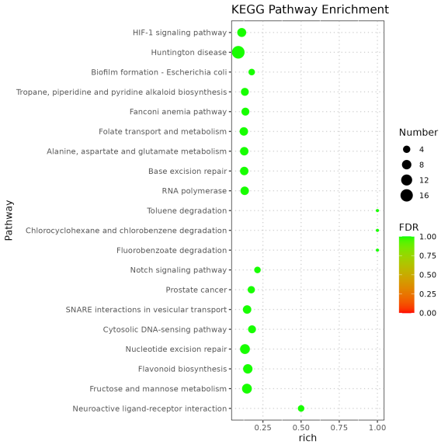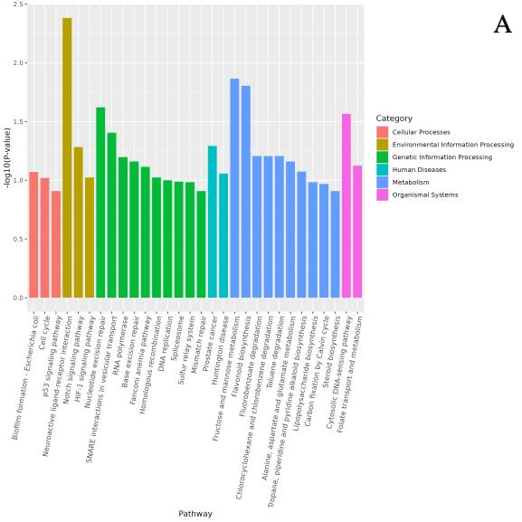
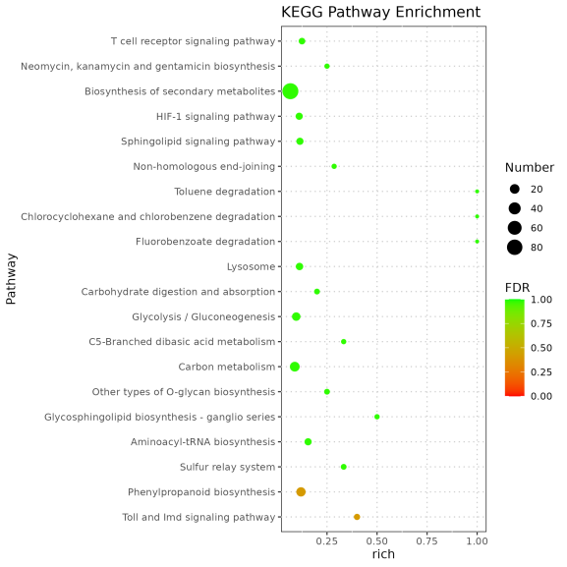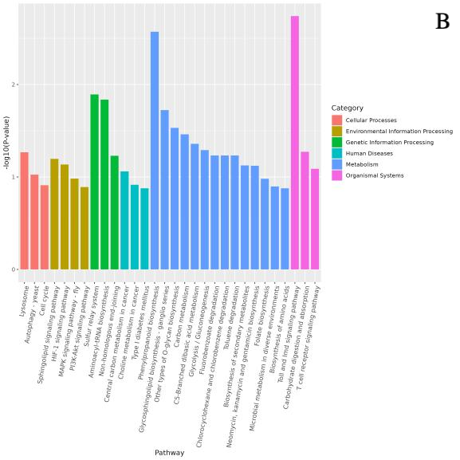
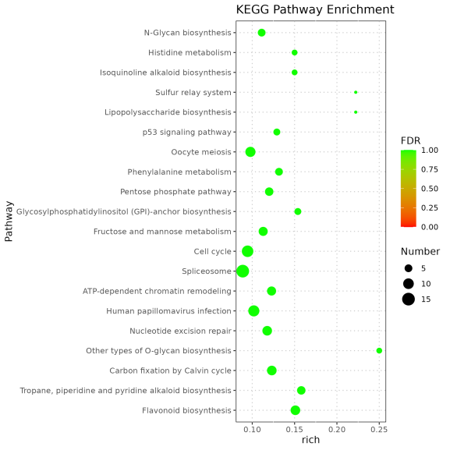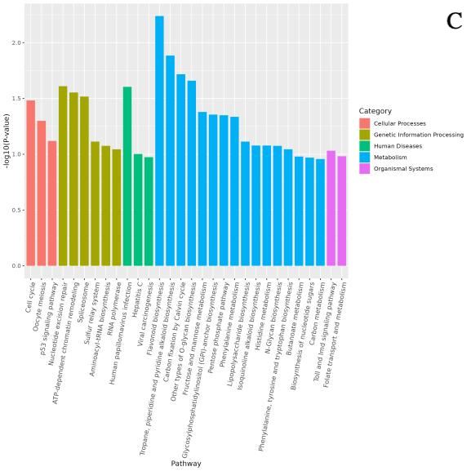
Fig. S4 Functional enrichment analysis based on Kyoto Encyclopedia of Genes and Genomes (KEGG). Bar chart Y-axis: -log10(P-value) (higher values indicate more significant pathway enrichment); X-axis: KEGG pathway names. Bubble chart elements: Bubble size represents gene count; color reflects enrichment significance. A)G. glabra vs G. uralensis (G-vs-W). B)G. glabra vs G. inflata (G-vs-Z). C)G. uralensis vs G. inflata (W-vs-Z).

