Supplementary Information for
Internal electric field design suppresses ion migration in perovskite solar cells

Zhichao Shen¹, Haoxiang Duan¹, Wenxin Yang¹, Yiushun Tong^{1,2}, Xinyang Tong¹, Yingke Zhu¹, Ming Gong¹, Ran Zheng^{1,2}, Yongzhen Wu³*, Wei Chen⁴*, Liyuan Han⁵*, Yang Yang^{1,2}*

*Corresponding Email: wu.yongzhen@ecust.edu.cn, wnlochenwei@hust.edu.cn, han.liyuan@sjtu.edu.cn, yangy@ucla.edu, yangyang@moleculax.com

The PDF file includes:
Supplementary Figs. 1 to 46
Supplementary Tables 1 to 8
Supplementary Notes 1 to 5

Supplementary Note 1.
Hydroxylation of the surface of alumina
We first characterized the particle size distribution of alumina dispersed in isopropanol (IPA) using dynamic light scattering (DLS). The results indicate that the alumina nanoparticles exhibit a size distribution centered around 50 nm (Supplementary Fig. 6). After depositing the dispersion onto transparent conductive oxide (TCO) substrates, scanning electron microscopy (SEM) revealed the surface morphology, showing some localized particle aggregation (Supplementary Fig. 7). To reduce aggregation and facilitate subsequent functionalization, we aimed to increase the surface hydroxyl coverage of the alumina, thereby promoting more efficient grafting of functional molecules. The detailed procedure is described in Supplementary Note 2.
The hydroxylated alumina powder was redispersed in IPA, and the particle size distribution was shown in Supplementary Fig. 6. Compared with pristine alumina, the hydroxylated particles exhibit improved dispersion stability, with a narrowed size distribution centered at approximately 43 nm. After spin coating the dispersion onto TCO substrates, the resulting surface morphology was presented in Supplementary Fig. 7. Owing to the enhanced colloidal stability and reduced particle aggregation induced by surface hydroxylation, the alumina film becomes more uniform and continuous, with suppressed large-scale agglomerates. Compared with the pristine alumina, surface hydroxylation increases the polarity of alumina, enhancing hydrogen-bond interactions with IPA molecules. The increased interparticle repulsion suppresses aggregation, leading to significantly retarded sedimentation (Supplementary Fig. 8).
The enhanced surface hydrophilicity after hydroxylation is further evidenced by a pronounced decrease in the water contact angle (Supplementary Fig. 9). The water contact angle of PTAA modified with alumina is measured to be 75°. After hydroxylation, the contact angle significantly decreases to 40.8°, suggesting the presence of abundant surface hydroxyl groups and a highly hydrophilic surface. To probe the surface chemical states, high-resolution X-ray photoelectron spectroscopy (XPS) of the O 1s core level were collected for alumina films deposited on substrate. Deconvolution of the O 1s spectra reveals contributions from lattice oxygen, hydroxyl species, and oxygen-deficient components (Supplementary Fig. 10) ^{1,2}, with the peak area ratio of hydroxyl groups to O 1s core level peak increasing from 10.43% to 24.08% after hydroxylation. Consistently, thermogravimetric analysis (TGA) shows an increased weight loss below 200 °C for hydroxylated alumina, which can be attributed to the removal of adsorbed water species (Supplementary Fig. 11).
Alumina surface grafting
Subsequently, HAPTES was grafted onto the hydroxylated alumina nanoparticles, following the procedure described in Supplementary Note 3. The successful grafting of HAPTES was first verified by XPS. As shown in Fig. 1e,f, the emergence of a Si 2p signal in the ~102 eV region, together with a pronounced increase in the N 1s peak intensity at ~400 eV, provides direct evidence for the presence of HAPTES on the alumina surface. A concomitant shift in the Al-related features further indicates modification of the local coordination environment (Fig. 1g). The Al 2p peak first shifts toward higher binding energy due to the formation of electronegative Al-OH bonds, then slightly retreats as these groups are consumed to form Al-O-Si linkages during HAPTES grafting. TGA reveals an increased mass loss after HAPTES functionalization compared with the hydroxylated alumina, reflecting the presence of grafted organic moieties (Supplementary Fig. 12). Consistently, water contact angle measurements show a distinct change in surface wettability upon HAPTES treatment (Supplementary Fig. 9). The contact angle increases because the non-polar propyl chains in HAPTES mask the high-energy surface hydroxyl groups, thereby reducing the surface energy and hydrophilicity. Taking together, these complementary characterizations confirm the formation of chemical bonds between HAPTES and hydroxylated alumina.

Supplementary Note 2.
First, 1 g of alumina powder was dispersed in 25 mL of deionized (DI) water and sonicated for 5 min to remove impurities and soluble organics, as well as to break down large agglomerates. The suspension was then centrifuged at 10000 rpm for 5 min, and the supernatant was discarded. The collected powder was dried under vacuum at room temperature for 12 h to completely remove the residual solvent. Subsequently, the dried powder was spread thinly onto a clean glass slide and subjected to UV-ozone treatment for 15 min. The treated powder was then transferred into 25 mL 5% H₂O₂ aqueous solution and sonicated for 30 min. Following another centrifugation step (10000 rpm, 5 min), the precipitate was washed by resuspension in DI water and centrifuged again. This washing process was repeated 3 times until the pH of the supernatant reached approximately 7. Finally, the alumina powder was vacuum-dried at room temperature for 24 h.

Supplementary Note 3.
First, 25 mL of isopropanol (IPA) and 1 g of the previously dried alumina powder were added into a dry centrifuge tube and sonicated for 5 min to achieve a uniform dispersion. Subsequently, inside a fume hood, 0.5 mL of (3-aminopropyl)triethoxysilane (APTES) was slowly added to the suspension. The mixture was then allowed to react under continuous magnetic stirring for 6 h at room temperature. Following the reaction, the mixture was centrifuged at 10000 rpm for 5 min, and the supernatant was discarded. The resulting precipitate was washed three times with IPA to remove any unreacted APTES and then vacuum-dried for 24 h. Finally, the functionalized powder was placed on a watch glass and annealed at 100 °C for 1 h inside a glovebox to complete the covalent grafting.

Supplementary Note 4.
Stable boding between HAPTES and alumina
To further demonstrate the formation of stable chemical bonding, five types of samples were prepared: (i) ITO/PTAA, (ii) ITO/PTAA with HAPTES directly deposited on the surface, (iii) ITO/PTAA with an alumina interlayer, (iv) ITO/PTAA with an alumina interlayer followed by HAPTES deposition, and (v) ITO/PTAA/BIBC. Each sample was rinsed with DMF three times under identical conditions. The potential of the samples before and after DMF rinsing were characterized by Kelvin probe force microscopy (KPFM), respectively (Supplementary Fig. 13). The measured work functions of the five fresh PTAA-based samples are 4.52, 4.64, 4.75, 4.87, and 4.90 eV, respectively. This increasing trend reflects the effect of interface modification: direct deposition of HAPTES slightly increases the work function, insertion of an alumina interlayer further raises it, and subsequent BIBC results in the highest work function. The increase in work function is attributed to the formation of a surface dipole from the oriented HAPTES molecules and the inductive effect of the electronegative alumina. While the HAPTES directly deposited on PTAA exhibited pronounced changes after DMF rinsing, the samples incorporating the BIBC showed negligible variations, indicating strong interfacial anchoring. The BIBC-modified interface exhibits strong interfacial anchoring because the surface hydroxyl groups on alumina react with HAPTES to form robust covalent bonds. In contrast, directly depositing HAPTES on surfaces mainly leads to weak physical adsorption, which is easily removed during solvent rinsing.
To further assess the robustness of the BIBC under photo-thermal conditions, the five samples mentioned above were illuminated under thermal annealing at 85 °C. After aging, the samples were rinsed with IPA to eliminate surface contamination, then characterized by KPFM (Supplementary Fig. 13). The BIBC exhibited minimal changes in surface potential after photo-thermal stress. In contrast, for sample (iv), physically adsorbed HAPTES on alumina adheres via weak van der Waals interactions or hydrogen bonding, forming multilayered or loosely bound molecules.
In addition, XPS was employed to evaluate the variation in HAPTES surface coverage before and after solvent rinsing and photo-thermal age for sample (iv) and sample (v). The relative coverage was quantified by tracking the elemental ratios of N to Al (Supplementary Fig. 14 and Supplementary Tables 1-2). Notably, the HAPTES directly deposited on alumina showed a substantial reduction of the N signal after rinsing, whereas the BIBC maintained nearly constant N/Al ratios, confirming the formation of chemically stable bonds. These results collectively demonstrate that the BIBC remains chemically and electronically stable under both highly polar solvent exposure and elevated-temperature photo-thermal aging, which is a critical prerequisite for realizing highly efficient and durable perovskite solar cells.

Supplementary Note 5.
Evolution of the perovskite film properties
To exclude possible interference from solvent rinsing at the buried interface, the molecules were intentionally deposited on top of the perovskite layer to directly probe the interaction. Accordingly, three types of samples were prepared: pristine perovskite, perovskite with alumina, and perovskite with HAPTES-modified alumina deposited on the surface. As a result, clear signatures of molecular-perovskite interaction were observed. The continuous decrease in Pb 4f binding energy is driven by the Lewis acid-base coordination where oxygen species and amine groups donate electrons to passivate Pb²⁺ defects, while the simultaneous increase in I 3d binding energy stems from the formation of an interfacial hydrogen-bonding network that polarizes and reduces the electron density around the iodide anions. The sequential increase in work function is resulting from the strong interfacial interaction where the alumina/BIBC donates electrons to passivate Pb²⁺ defects while anchoring iodide ions via hydrogen bonding (Supplementary Figs. 21-22, Fig. 2c,d).

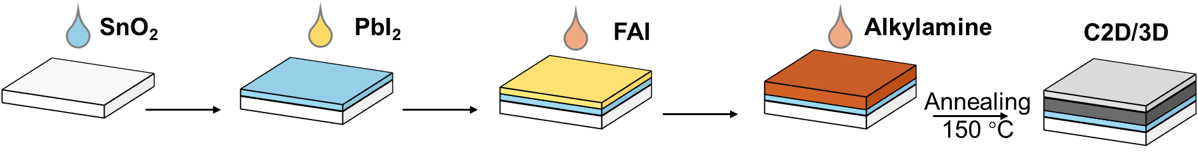
Supplementary Fig. 1. Schematic diagram of IBC structure fabrication process. For IBC sample, the hexan-1-amine hydroiodide solution with different concentrations was sprayed on the wet precursor film. And then, the precursor film was placed on the hot plate for thermal annealing to form the IBC structure.

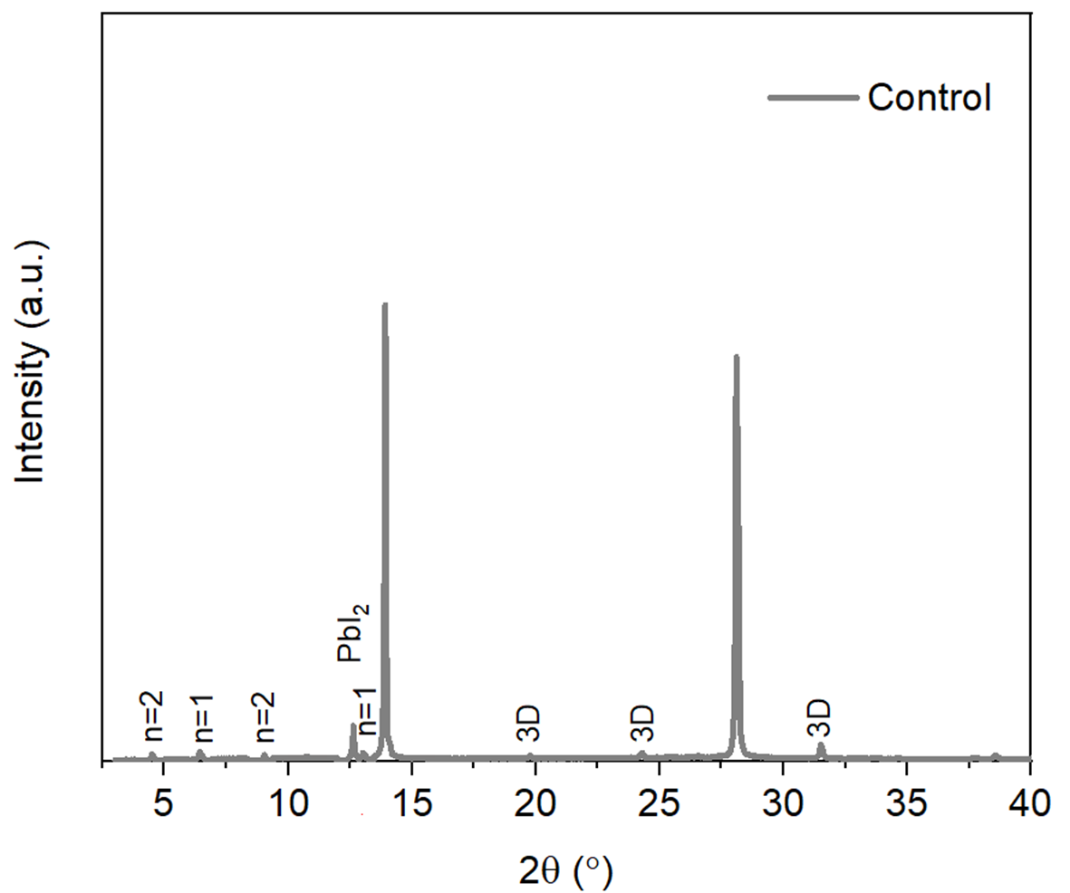
Supplementary Fig. 2. XRD result of the control perovskite film. The control perovskite film was obtained via traditional passivation method, that is, depositing the passivator on the annealed crystalline film.

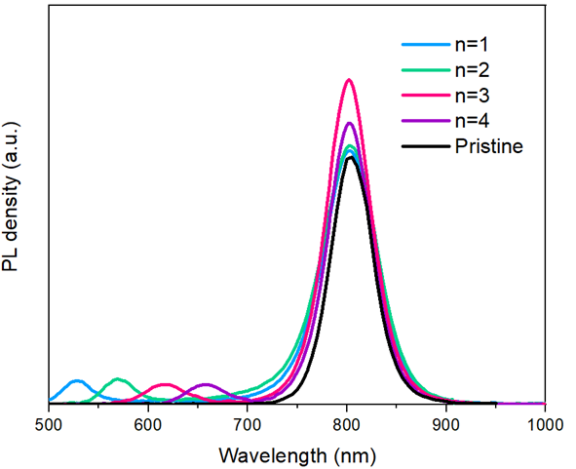
Supplementary Fig. 3. Steady-state PL results of pristine 3D perovskite film and IBC structure with different n values.

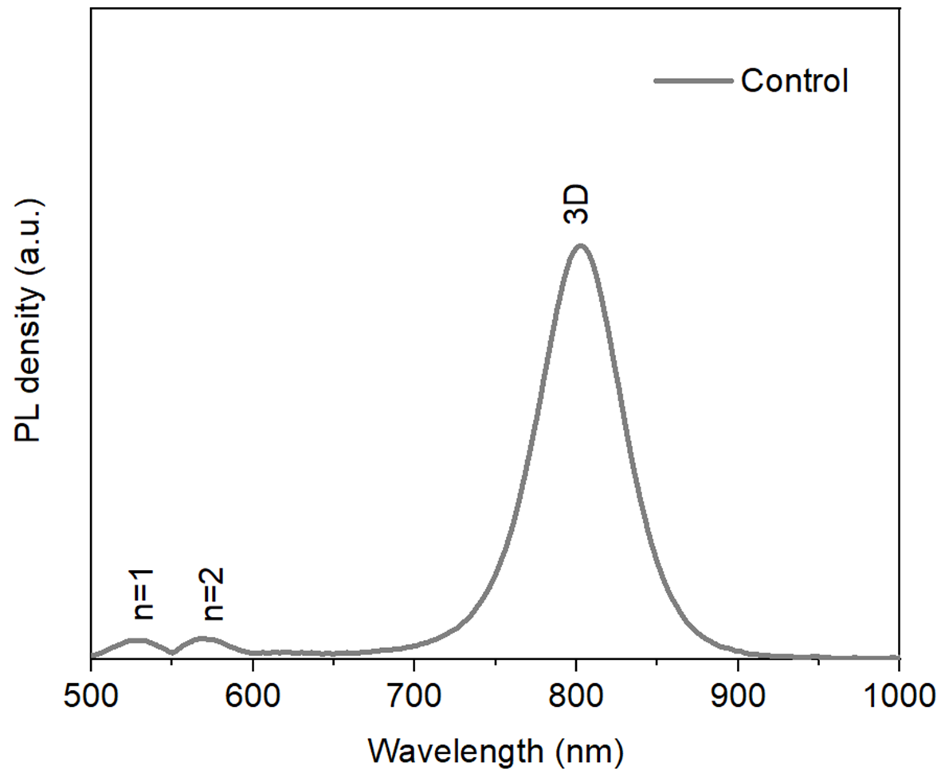
Supplementary Fig. 4. Steady-PL spectra of the control perovskite film. The control perovskite film was obtained via traditional passivation method, that is, depositing the passivator on the annealed crystalline film.

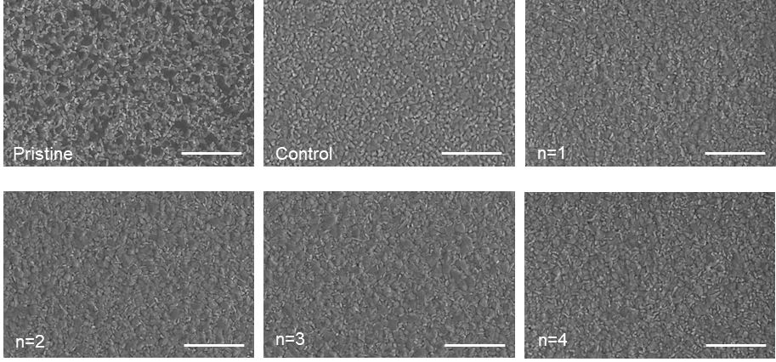

Supplementary Fig. 5. Surface SEM images of pristine 3D perovskite film wi/wo traditional passivation and IBC structure with different n values. The scale bar is 10 μm.

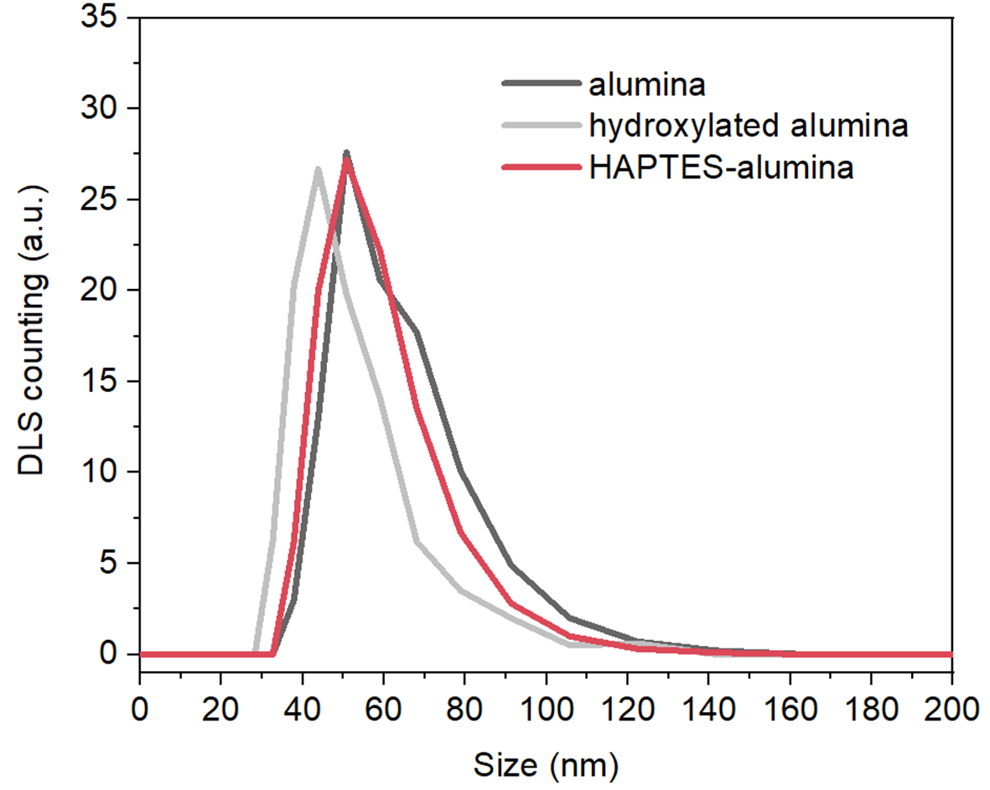
Supplementary Fig. 6. Particle size distribution in IPA measured by dynamic light scattering (DLS).

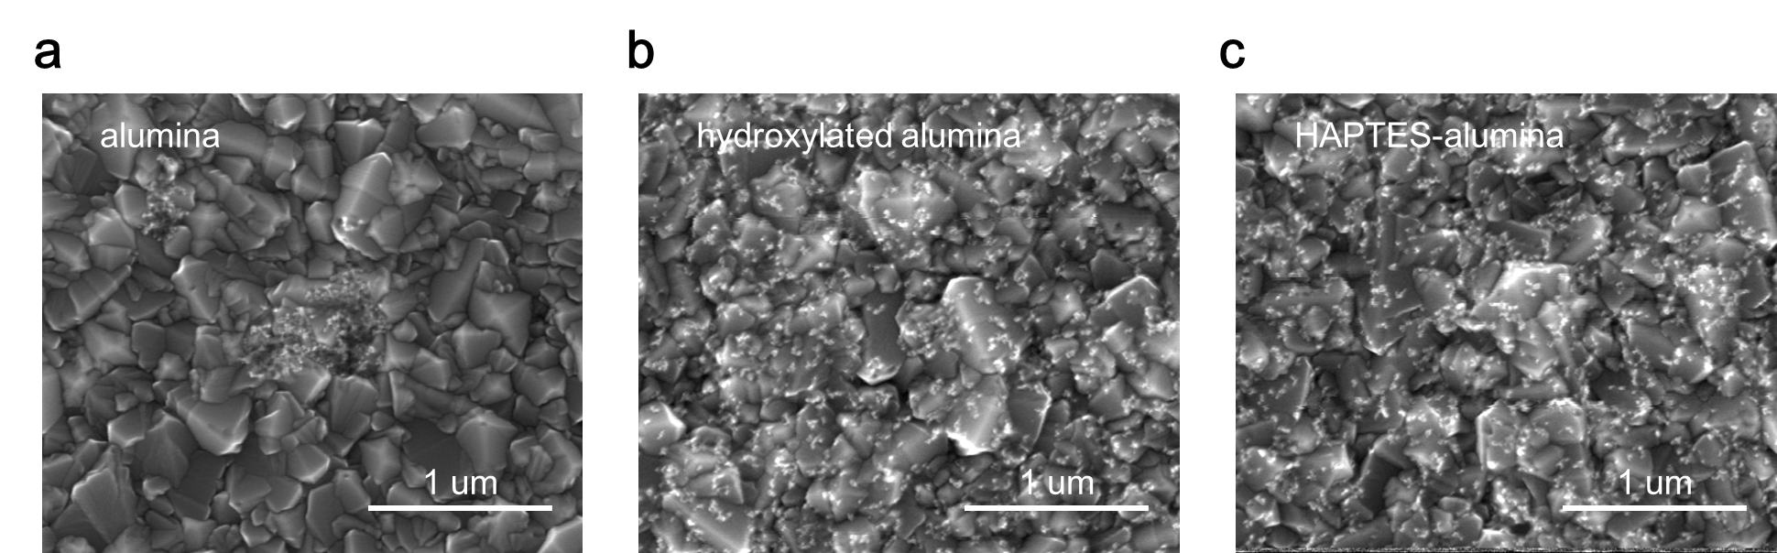
Supplementary Fig. 7. SEM images of alumina distribution on TCO before and after functionalization. a, alumina. b, hydroxylated alumina. c, HAPTES-alumina.

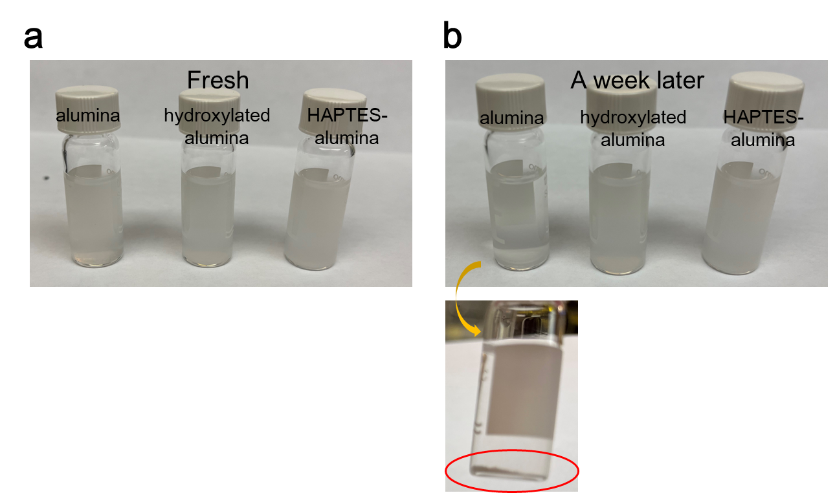
Supplementary Fig. 8. Photographs of alumina dispersions (before and after functionalization) taken immediately after preparation and after one week of storage. a, fresh. b, after a week. The inset shows that the unfunctionalized alumina exhibits significant sedimentation after one week.

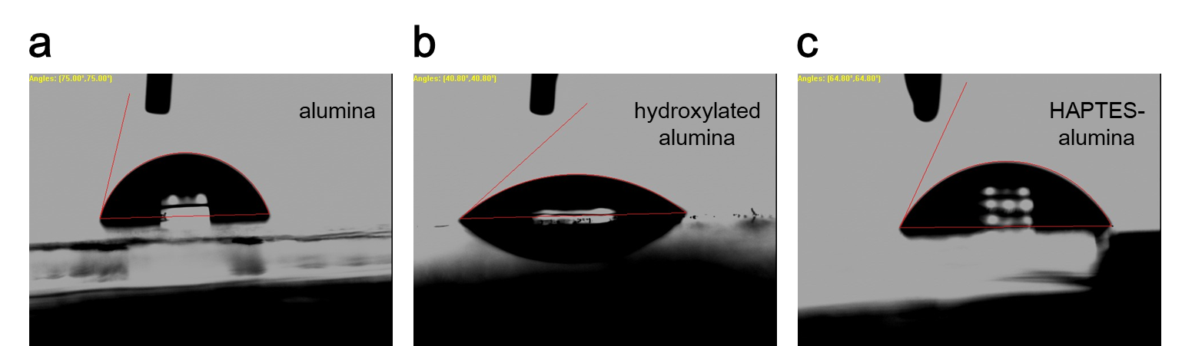
Supplementary Fig. 9. Contact angle measurements of alumina before and after functionalization. a, alumina on PTAA/TCO. b, hydroxylated alumina on PTAA/TCO. c. HAPTES-alumina on PTAA/TCO.

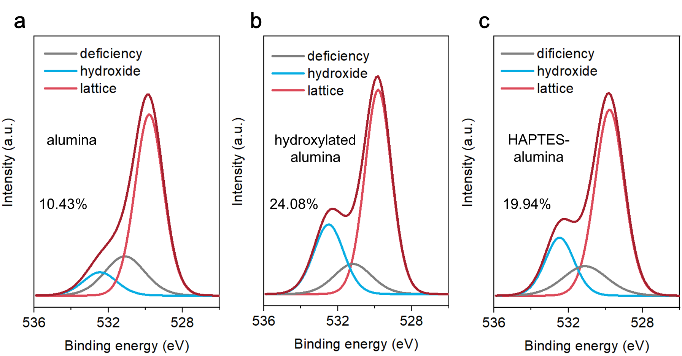
Supplementary Fig. 10. XPS of the O 1s core level on alumina (a), hydroxylated alumina (b), and HAPTES-alumina (c).

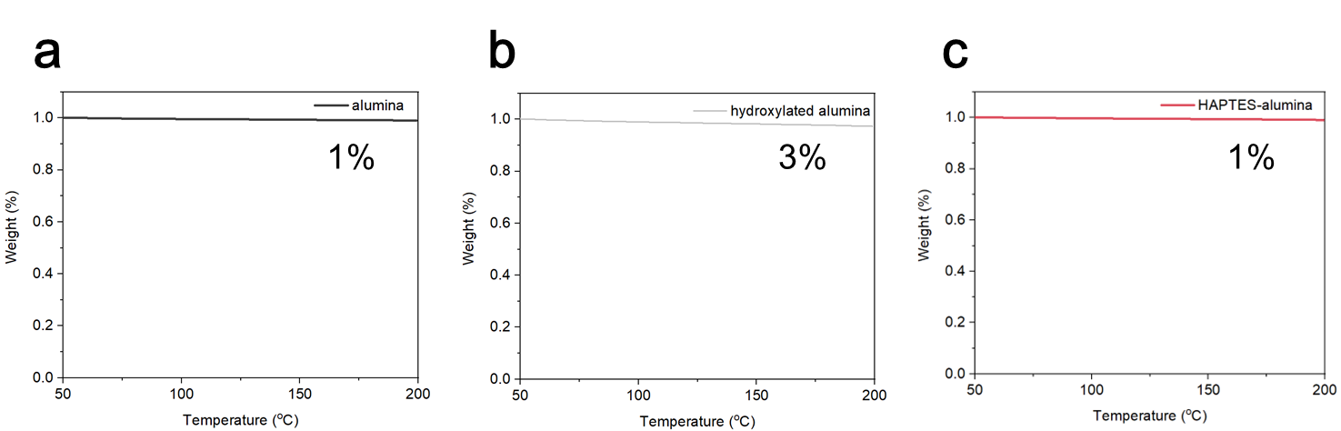
Supplementary Fig. 11. TGA curves of alumina before and after functionalization (0-200 °C). a, pristine alumina with ~1% weight loss. b, hydroxylated alumina with ~3% weight loss. c, HAPTES-functionalized alumina with ~1% weight loss.

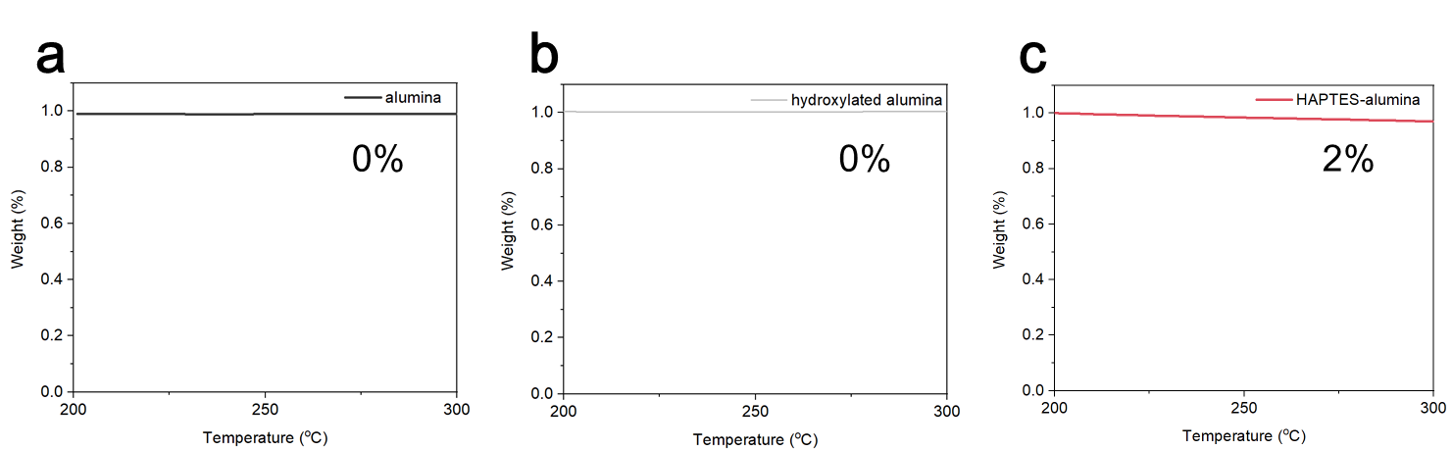
Supplementary Fig. 12. TGA curves of alumina before and after functionalization (200-300 °C). a, pristine alumina with ~0% weight loss. b, hydroxylated alumina with ~0% weight loss. c, HAPTES-functionalized alumina with ~2% weight loss.

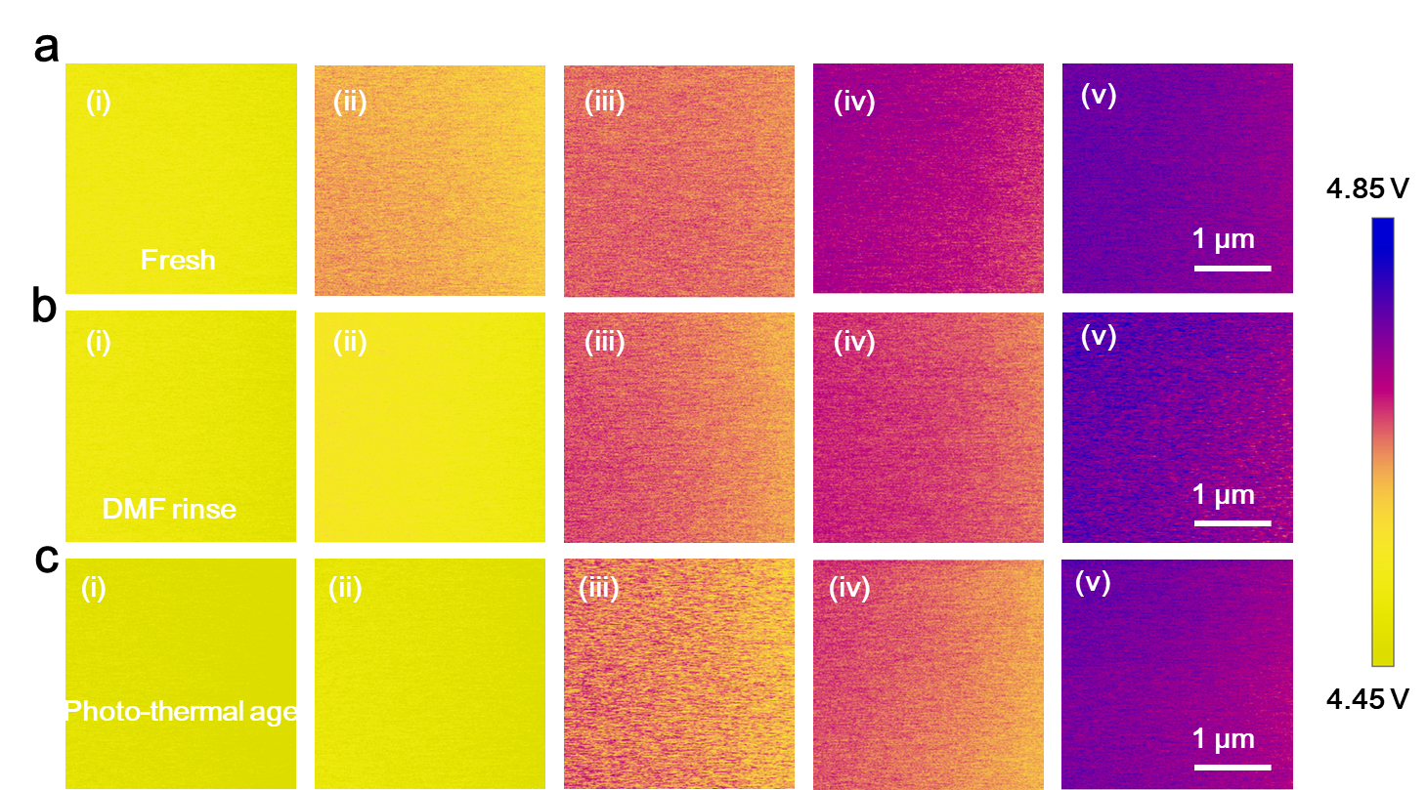
Supplementary Fig. 13. a-c, Surface potential measured by KPFM on fresh sample (a), sample after DMF rinse (b), and sample after photo-thermal aging under illumination and 85°C for 1000 hours (c). The structure of 5 samples is: (i) ITO/PTAA, (ii) ITO/PTAA with HAPTES directly deposited on the surface, (iii) ITO/PTAA with an alumina interlayer, (iv) ITO/PTAA with an alumina interlayer followed by HAPTES deposition, and (v) ITO/PTAA/BIBC.

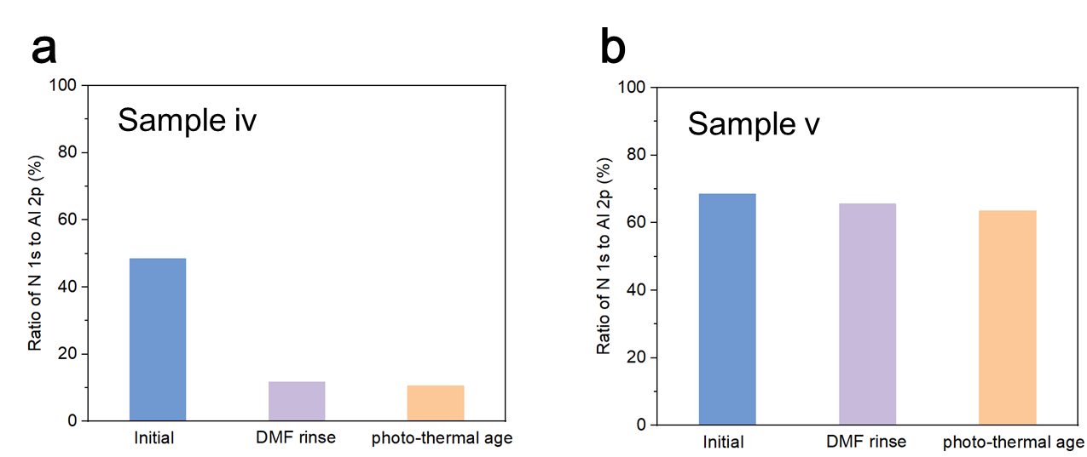
Supplementary Fig. 14. Changes in the N/Al elemental ratio after DMF rinsing or photo-thermal aging under illumination and 85°C for 1000 hours, as measured by XPS. a, sample iv: ITO/PTAA with an alumina interlayer followed by HAPTES deposition. b, sample v: ITO/PTAA/BIBC.
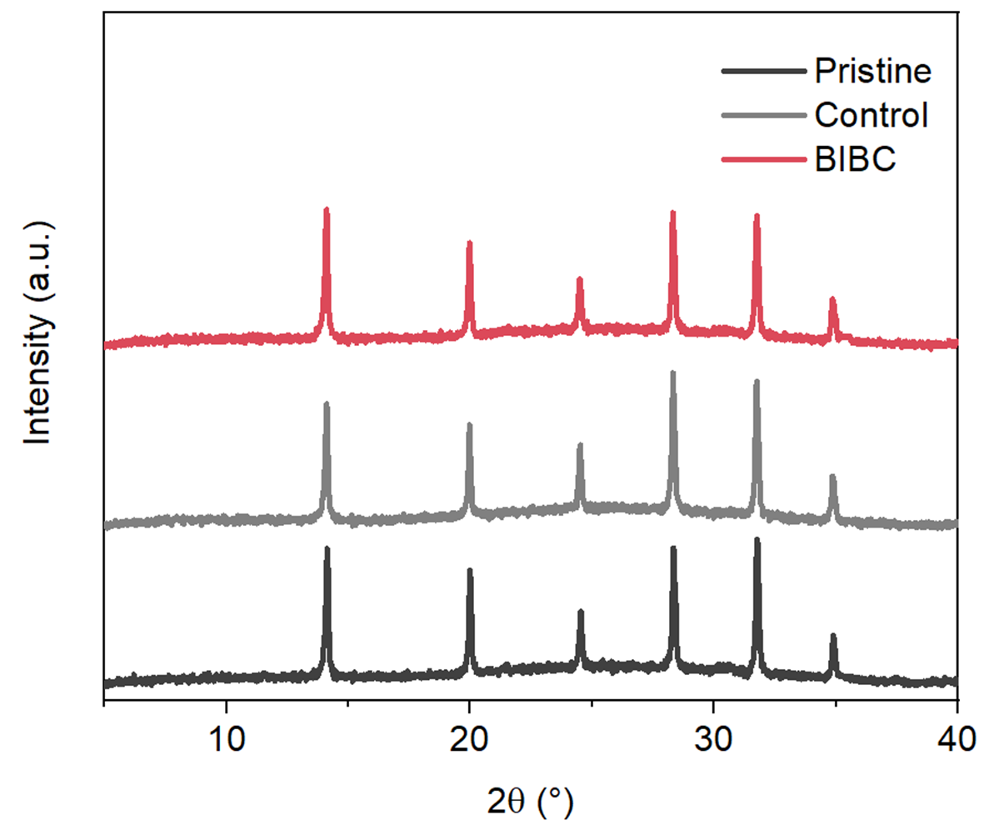
Supplementary Fig. 15. XRD test of perovskite layers deposit on different substrates. Pristine means perovskite on ITO/PTAA, control means perovskite on ITO/PTAA/alumina, and BIBC means perovskite on ITO/PTAA/BIBC.

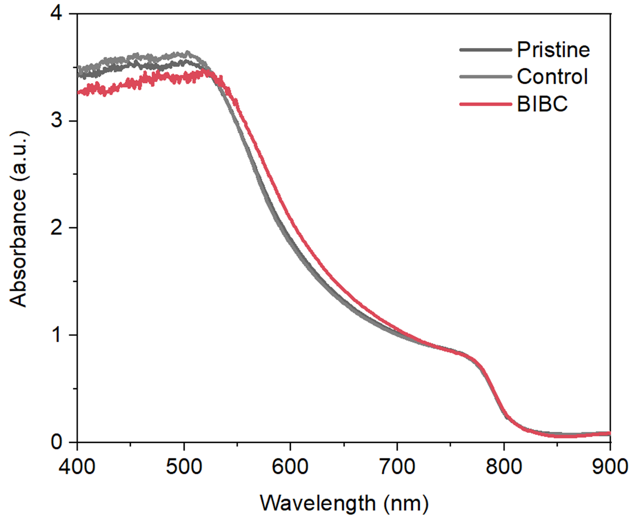
Supplementary Fig. 16. UV-vis absorption spectroscopy of perovskite layers deposit on different substrates. Pristine means perovskite on ITO/PTAA, control means perovskite on ITO/PTAA/alumina, and BIBC means perovskite on ITO/PTAA/BIBC.

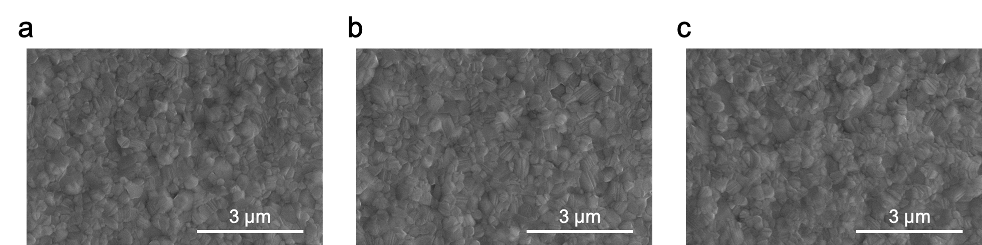
Supplementary Fig. 17. Top-view SEM of perovskite layers deposit on different substrates. a, Pristine means perovskite on ITO/PTAA. b, Control means perovskite on ITO/PTAA/alumina. c, BIBC means perovskite on ITO/PTAA/BIBC.

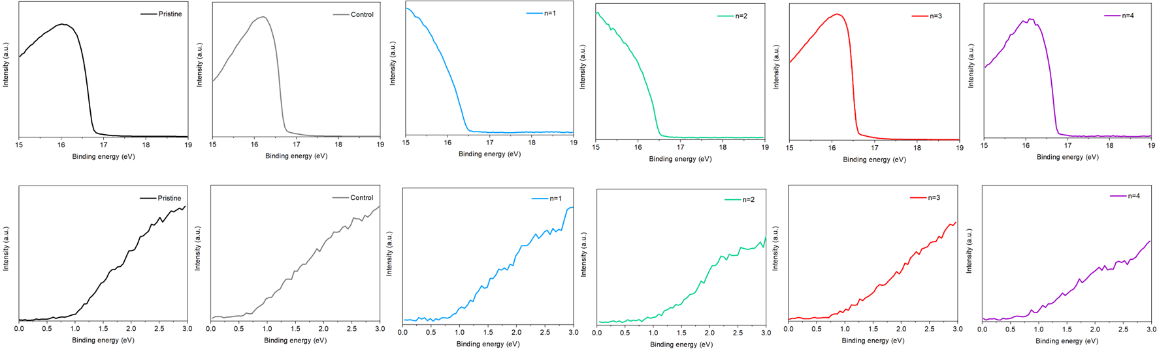

Supplementary Fig. 18. UPS results of the pristine perovskite film, control perovskite film, and IBC structure with different n values. The work function is determined by the difference between the incident photon energy (21.2 eV) and the binding energy of the secondary electron cut off. The difference between E_{F} and E_{V} is determined by the intersection of the linear portion of the spectra near the Fermi edge (low binding energy region) with the baseline.

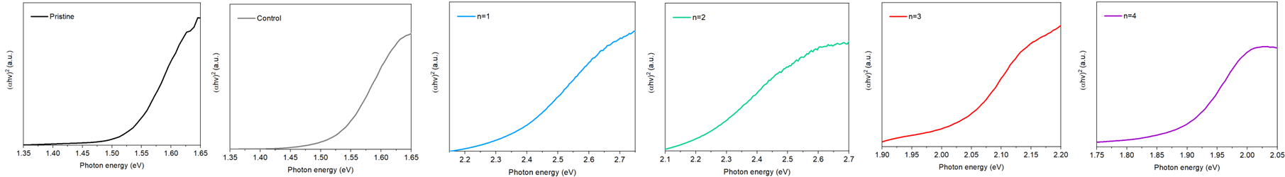

Supplementary Fig. 19. Tauc plot of the pristine perovskite film, control perovskite film, and IBC structure with different n values.

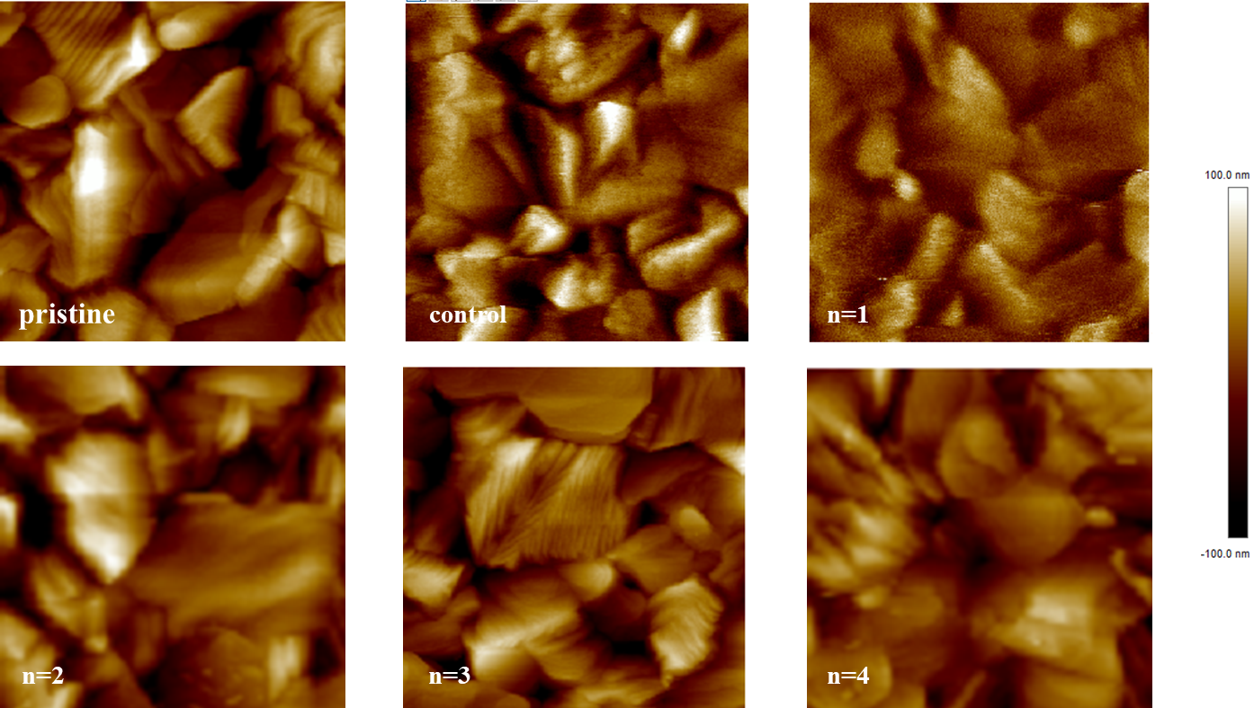

Supplementary Fig. 20. AFM images of the pristine perovskite film, control perovskite film, and IBC structure with different n values. The root-mean-square of the pristine and control sample is around 35 nm, and the root-mean-square of the IBC sample is around 30 nm. The test area is 3 μm by 3 μm.

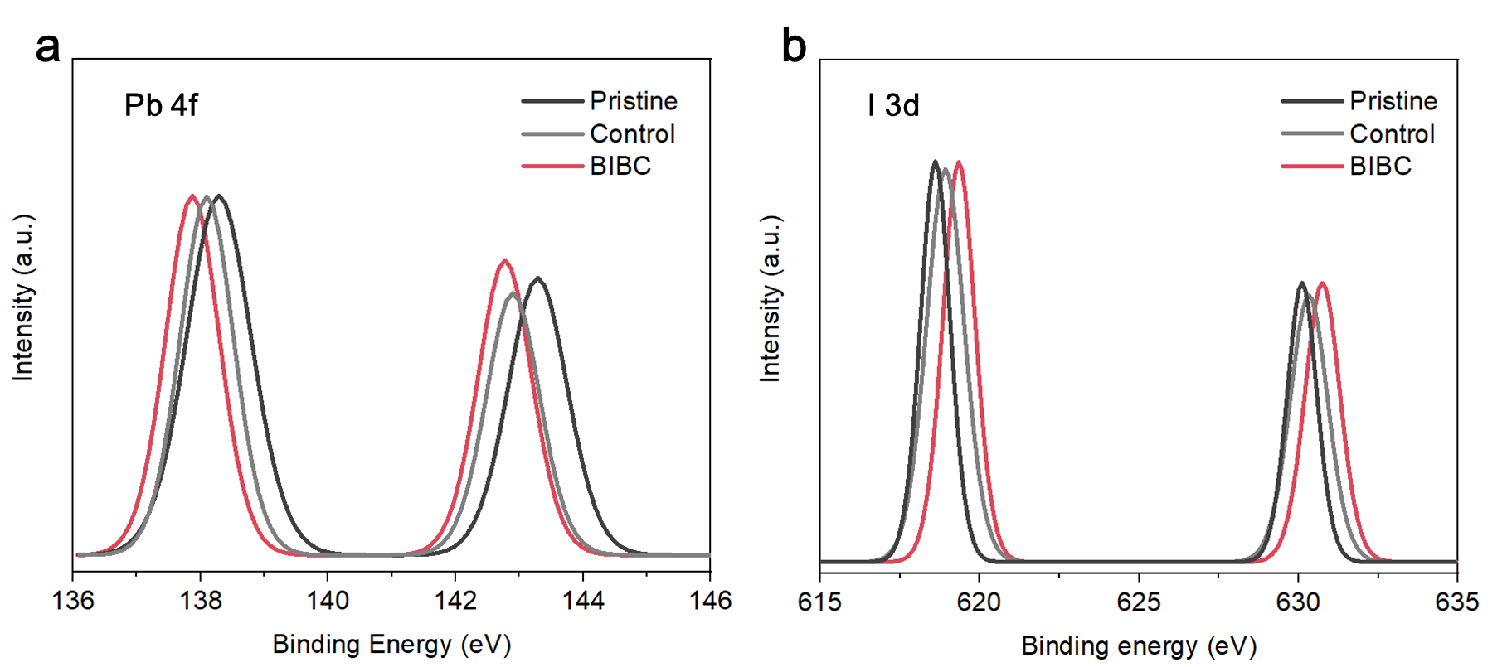
Supplementary Fig. 21. XPS test of Pb 4f and I 3d signals in perovskite films. Pristine means pure perovskite film. Control means perovskite film with alumina. BIBC means perovskite film with BIBC.

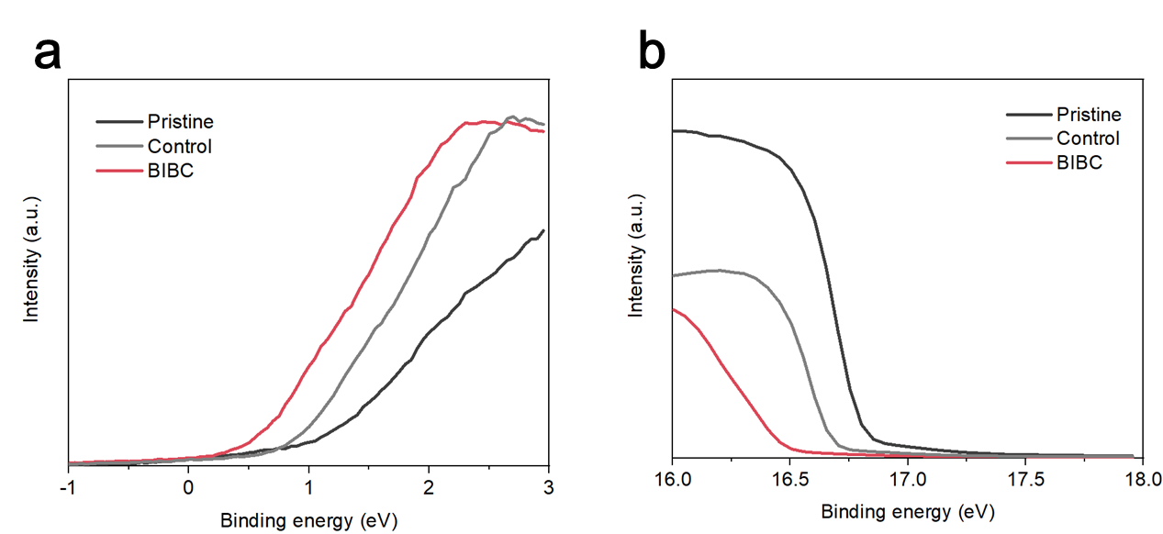
Supplementary Fig. 22. UPS spectra of perovskite films. Magnified views of (a) low-binding-energy region and (b) high-binding-energy region. Pristine means pure perovskite film. Control means perovskite film with alumina. BIBC means perovskite film with BIBC.

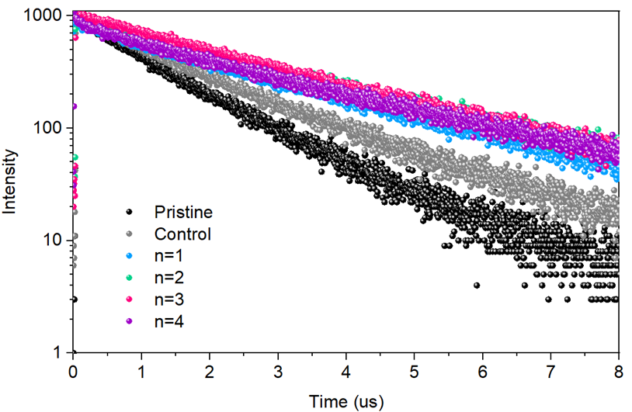
Supplementary Fig. 23. Time-resolved photoluminescence spectra of IBC structure with different n values.

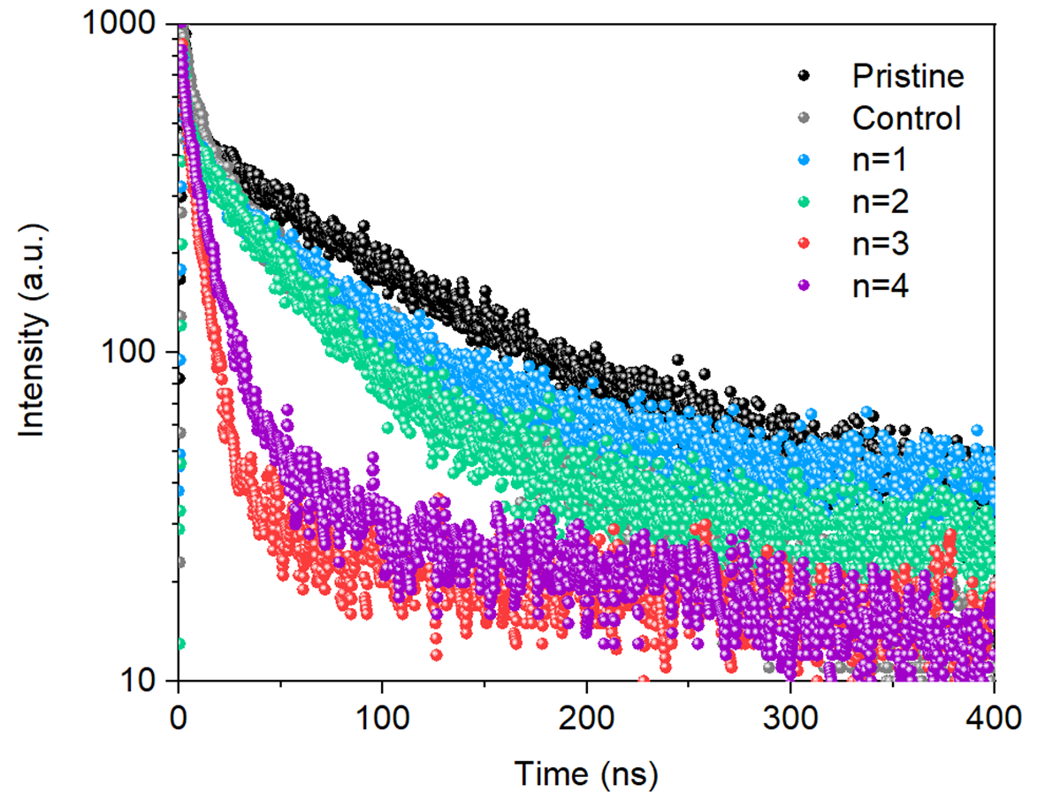
Supplementary Fig. 24. TRPL spectra of the pristine perovskite sample, control perovskite sample, and IBC sample with different n values. The structure of the test sample is substrate/perovskite/HTL.

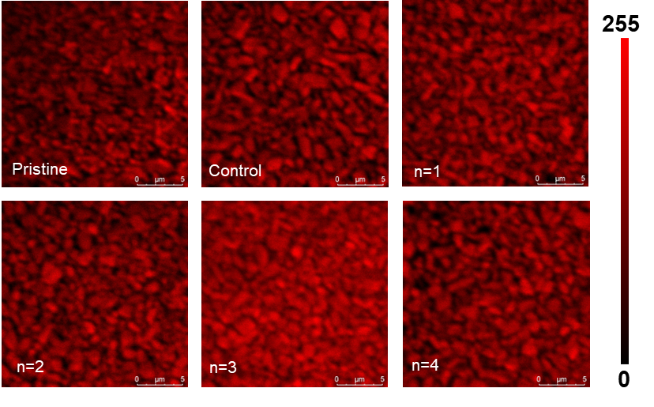
Supplementary Fig. 25. PL mapping of IBC structure with different n values. The scale bar is 5 μm.

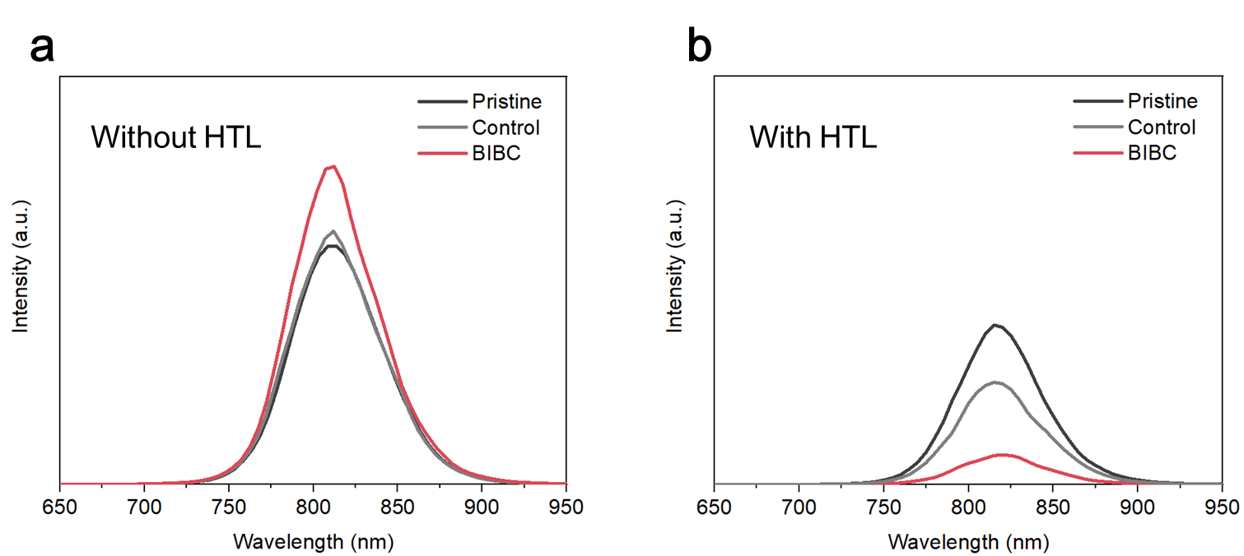
Supplementary Fig. 26. Photoluminescence spectra for perovskite films. a, Without HTL. b, With HTL.

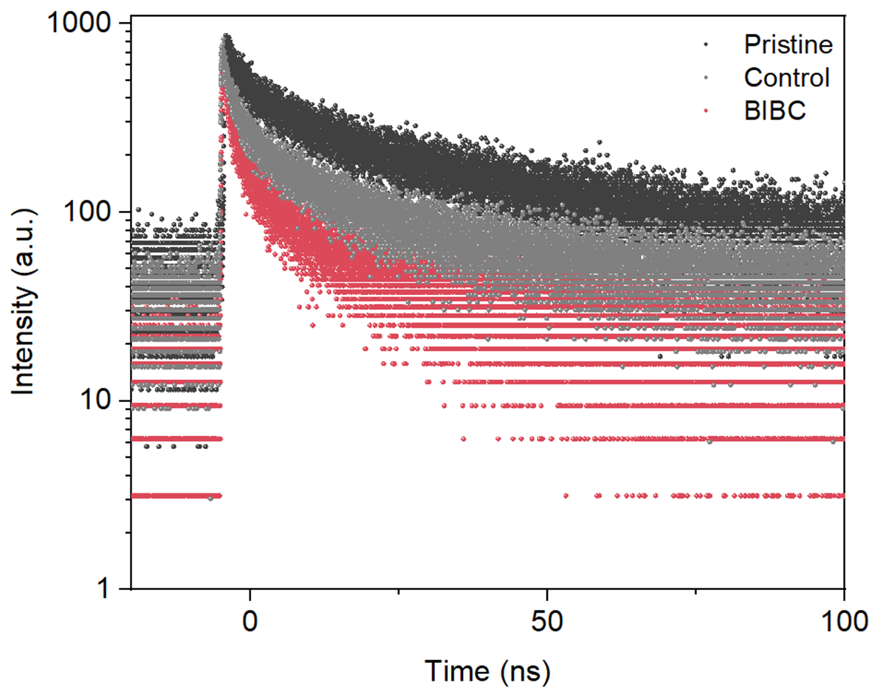
Supplementary Fig. 27. Time-resolved photoluminescence spectra for perovskite with HTL. Pristine means perovskite on ITO/PTAA. Control means perovskite on ITO/PTAA/alumina. BIBC means perovskite on ITO/PTAA/BIBC.

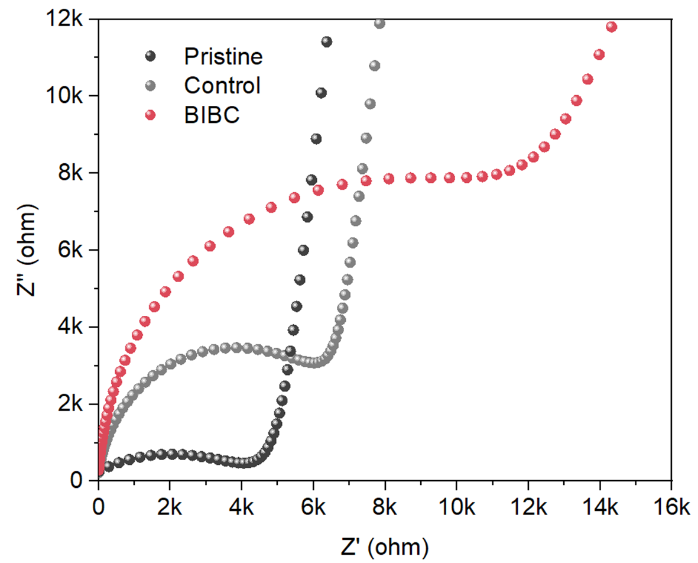
Supplementary Fig. 28. Nyquist plots of EIS for pristine, control and BIBC device.

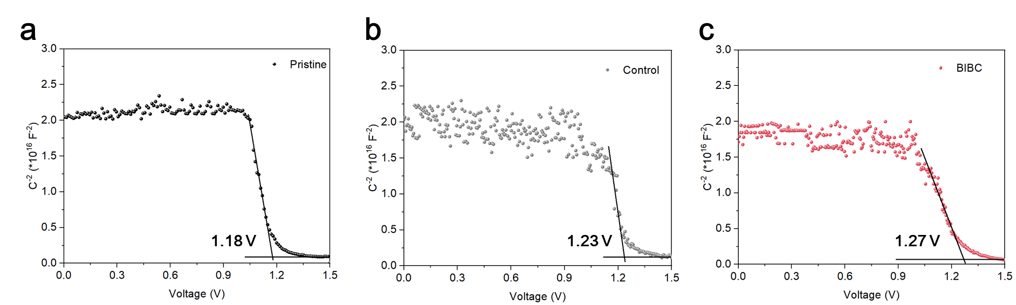
Supplementary Fig. 29. Capacitance-voltage curves of pristine, control and BIBC devices.

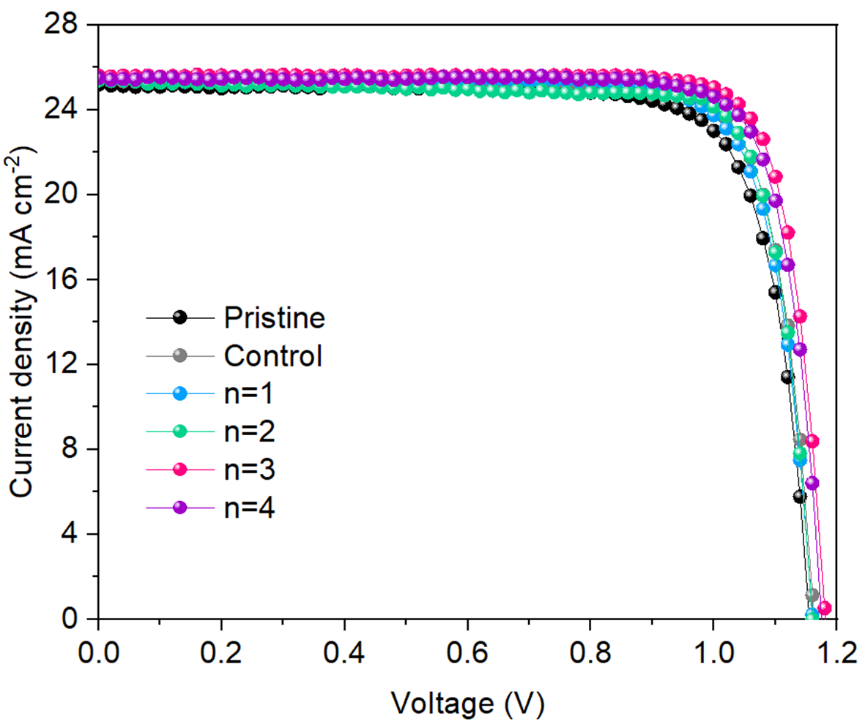
Supplementary Fig. 30. J-V curves of perovskite solar cells with PTAA as HTL. The device structure is TCO/tin oxide/perovskite/HTL/electrode.

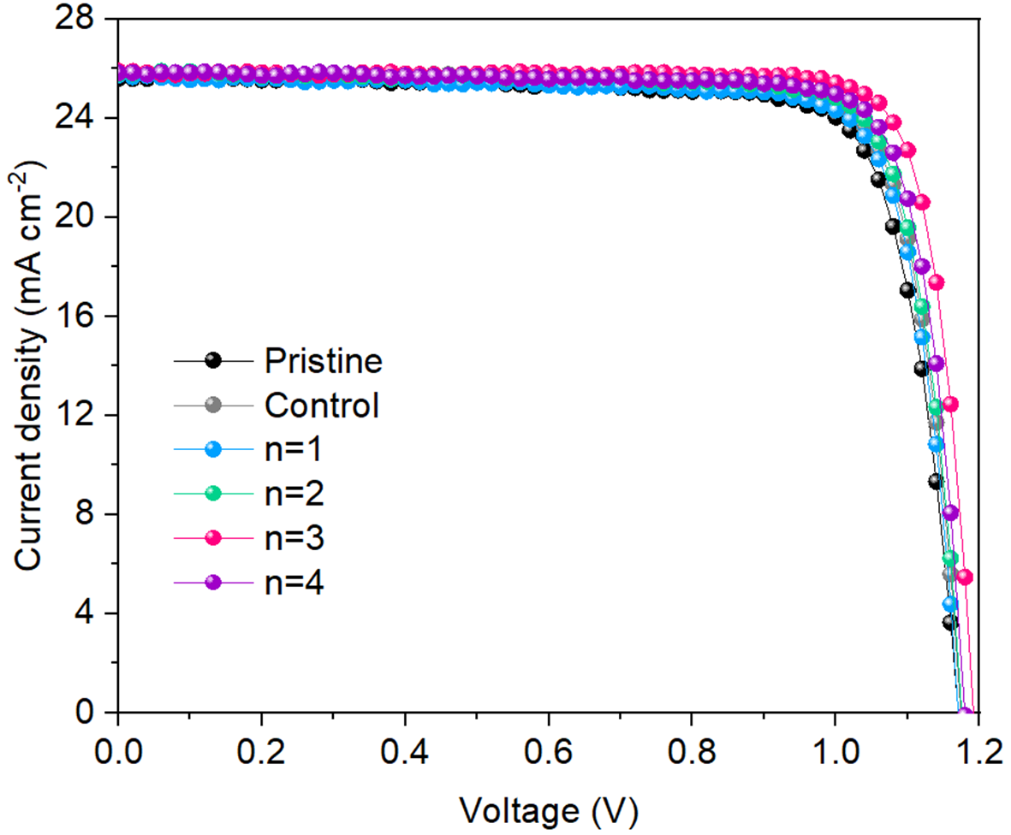
Supplementary Fig. 31. J-V curves of perovskite solar cells with spiro-OMeTAD as HTL. The device structure is TCO/tin oxide/perovskite/HTL/electrode.

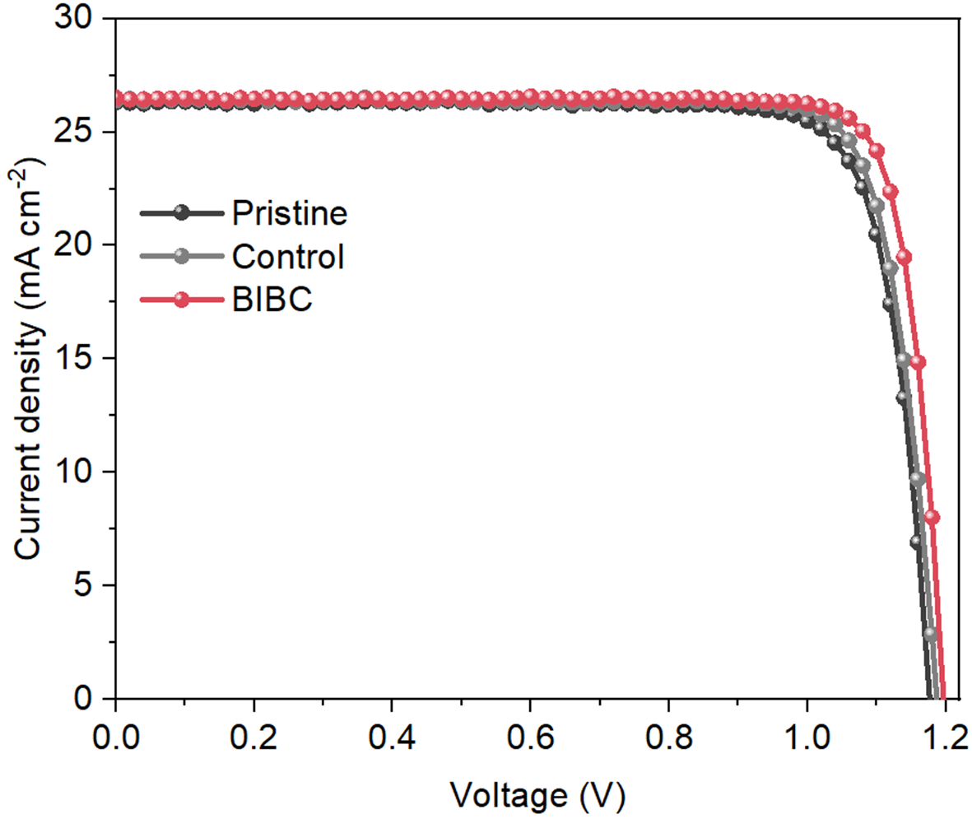
Supplementary Fig. 32. J-V curves of perovskite solar cells with 4PADCB as HTL for p-i-n device.

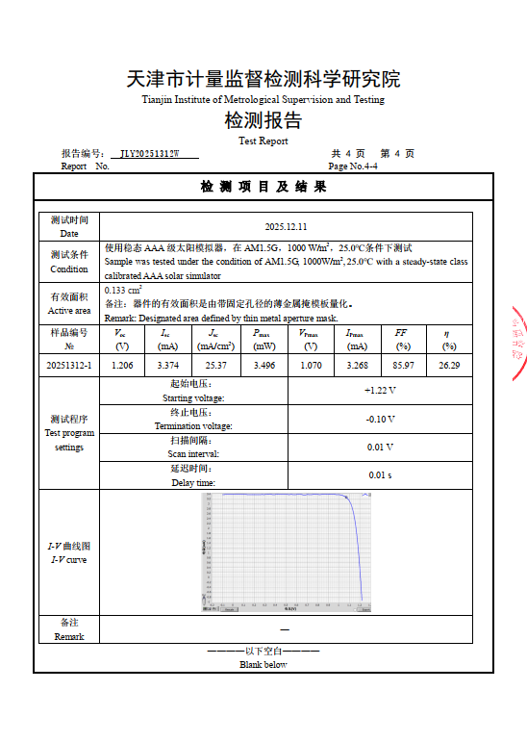
Supplementary Fig. 33. Certification report of normal structure PSC. A certified PCE of 26.29% was obtained from a champion IBC device.

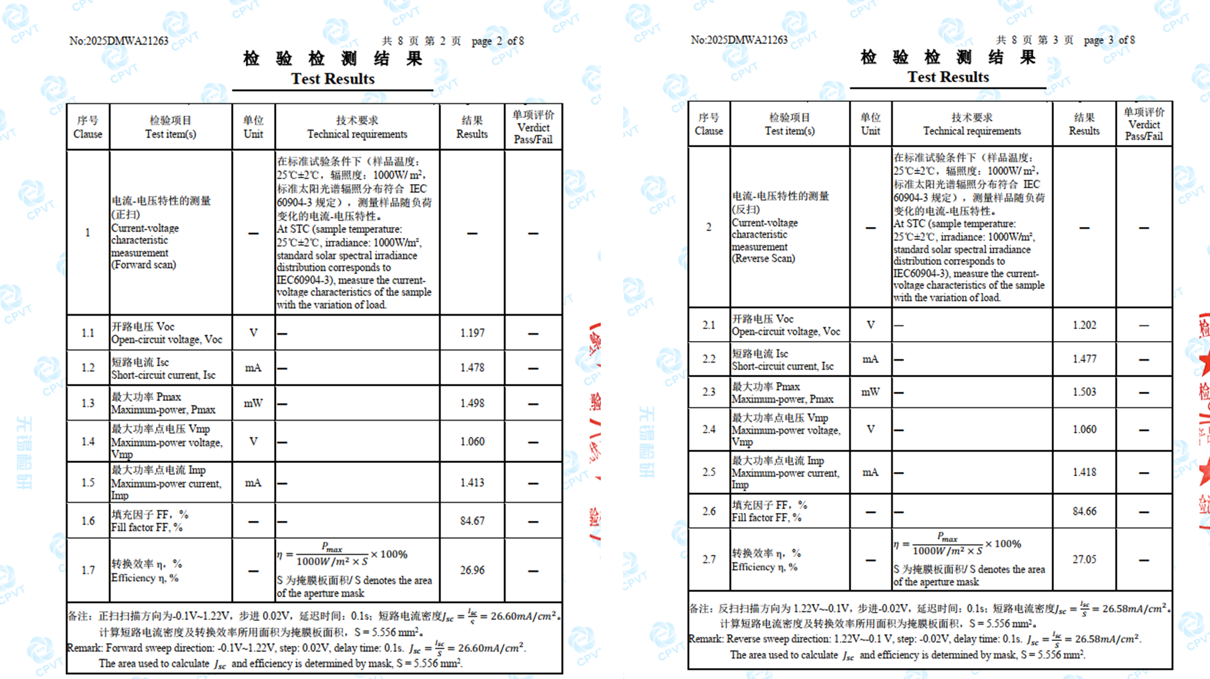
Supplementary Fig. 34. Certification report of BIBC device, with certified 26.96% from forward scan and 27.05% from reverse scan.

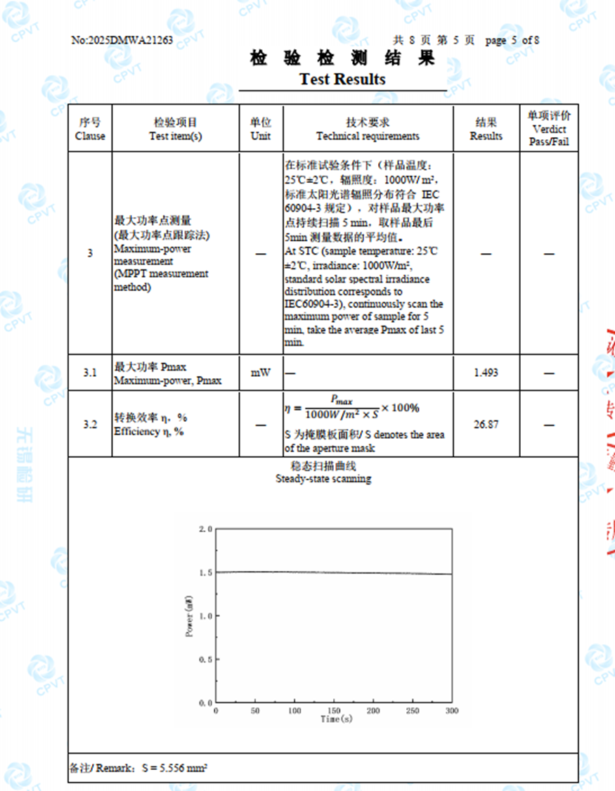
Supplementary Fig. 35. Certified maximum power point tracking of BIBC device. The stabilized PCE is 26.87%.

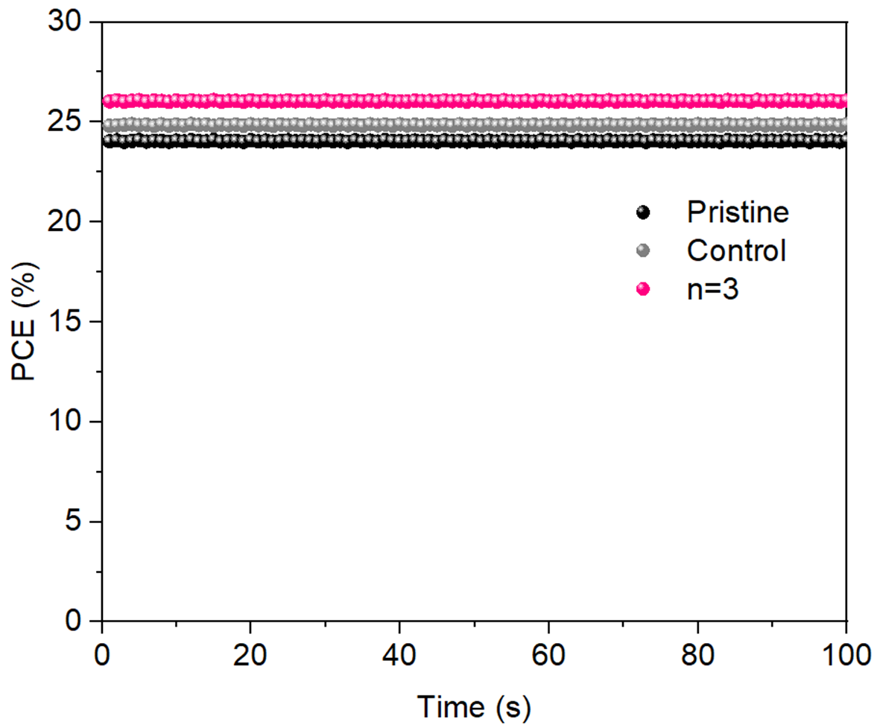
Supplementary Fig. 36. Stabilized PCE at the maximum power point tracking for pristine device, control device and the IBC device with n=3. The HTL is spiro-OMeTAD. The device structure is TCO/tin oxide/perovskite/HTL/electrode.

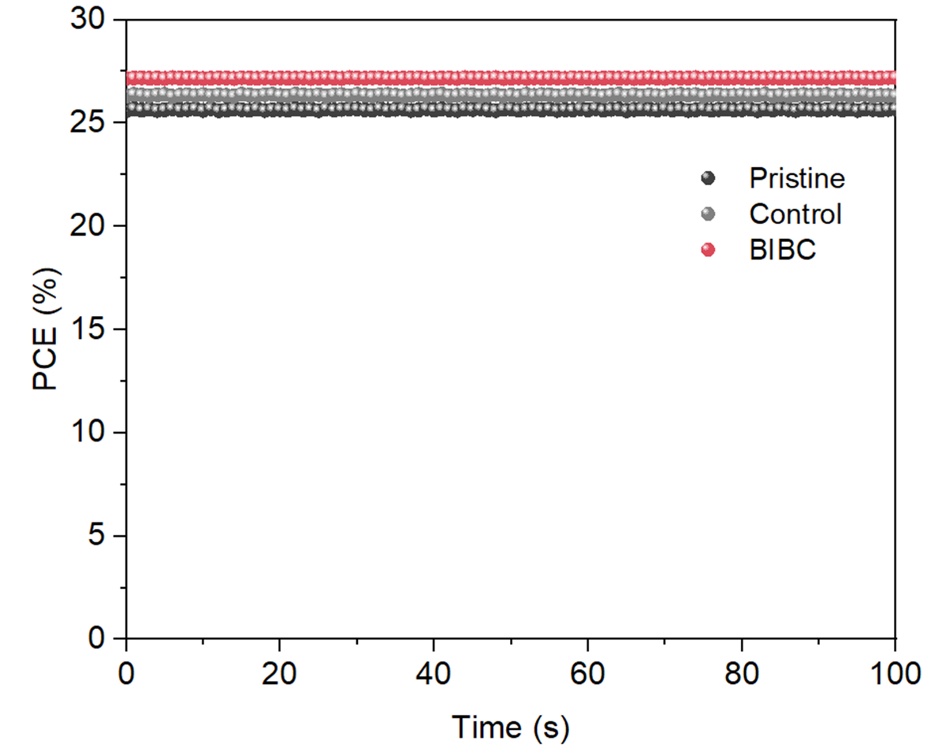
Supplementary Fig. 37. Stabilized PCE at the maximum power point tracking for pristine, control and BIBC devices.

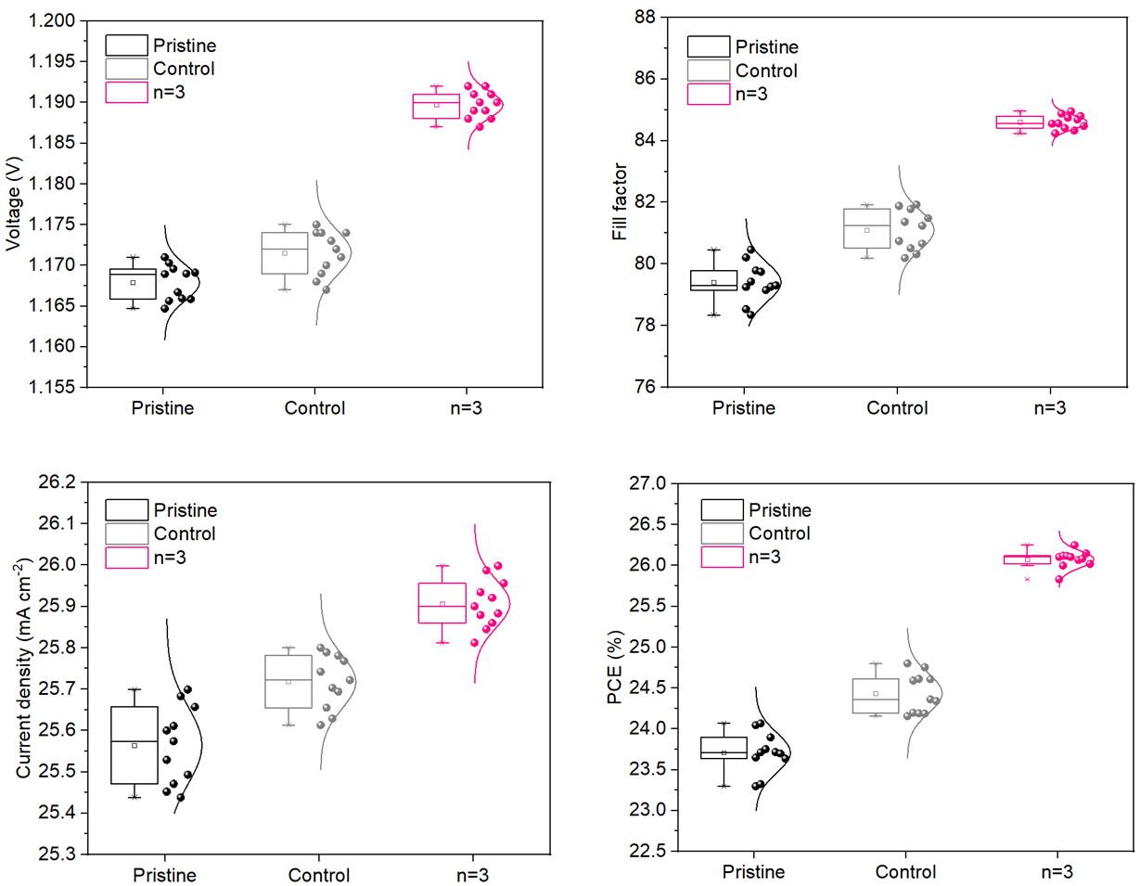

Supplementary Fig. 38. Parameter distribution of the solar cell performance for the pristine device, control device and the IBC device with n=3. The data was collected from 11 devices. The device structure is TCO/tin oxide/perovskite/HTL/electrode. The HTL is spiro-OMeTAD.

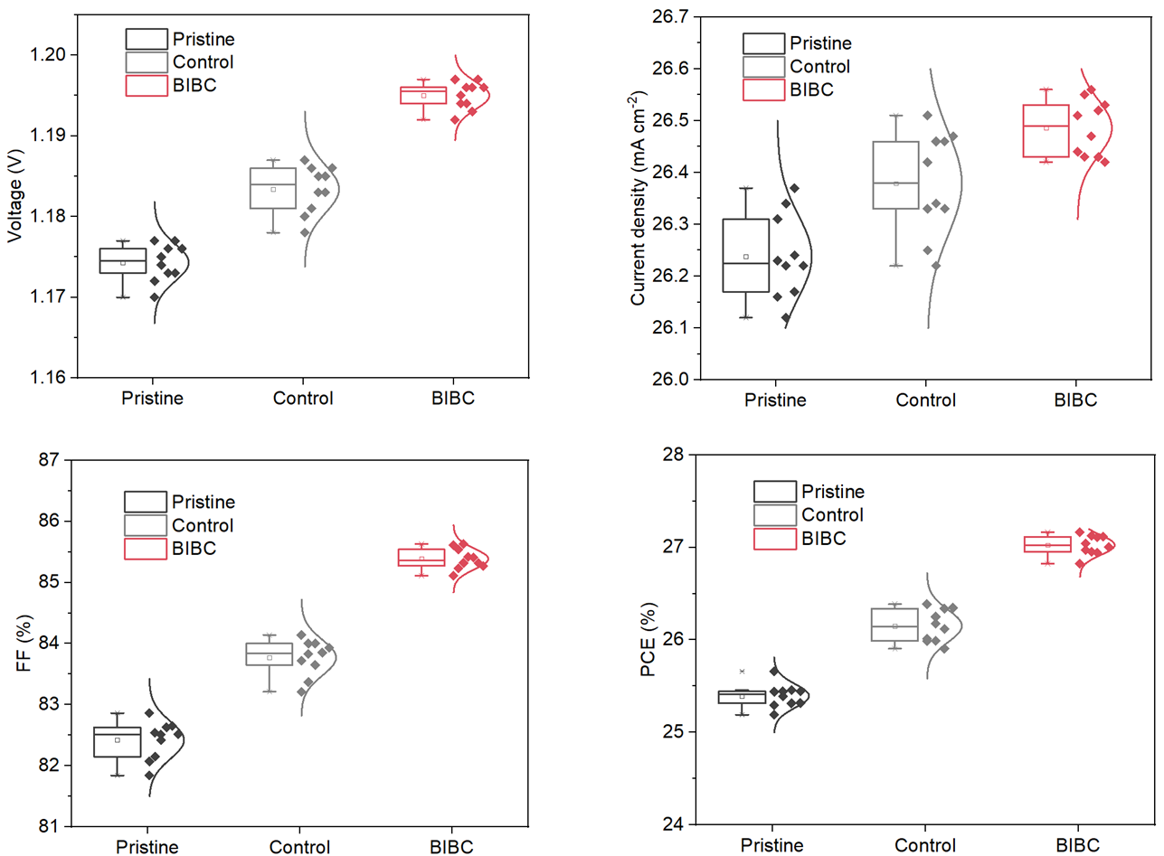
Supplementary Fig. 39. Parameter distribution of solar cell performance for
the pristine, control and BIBC p-i-n device.

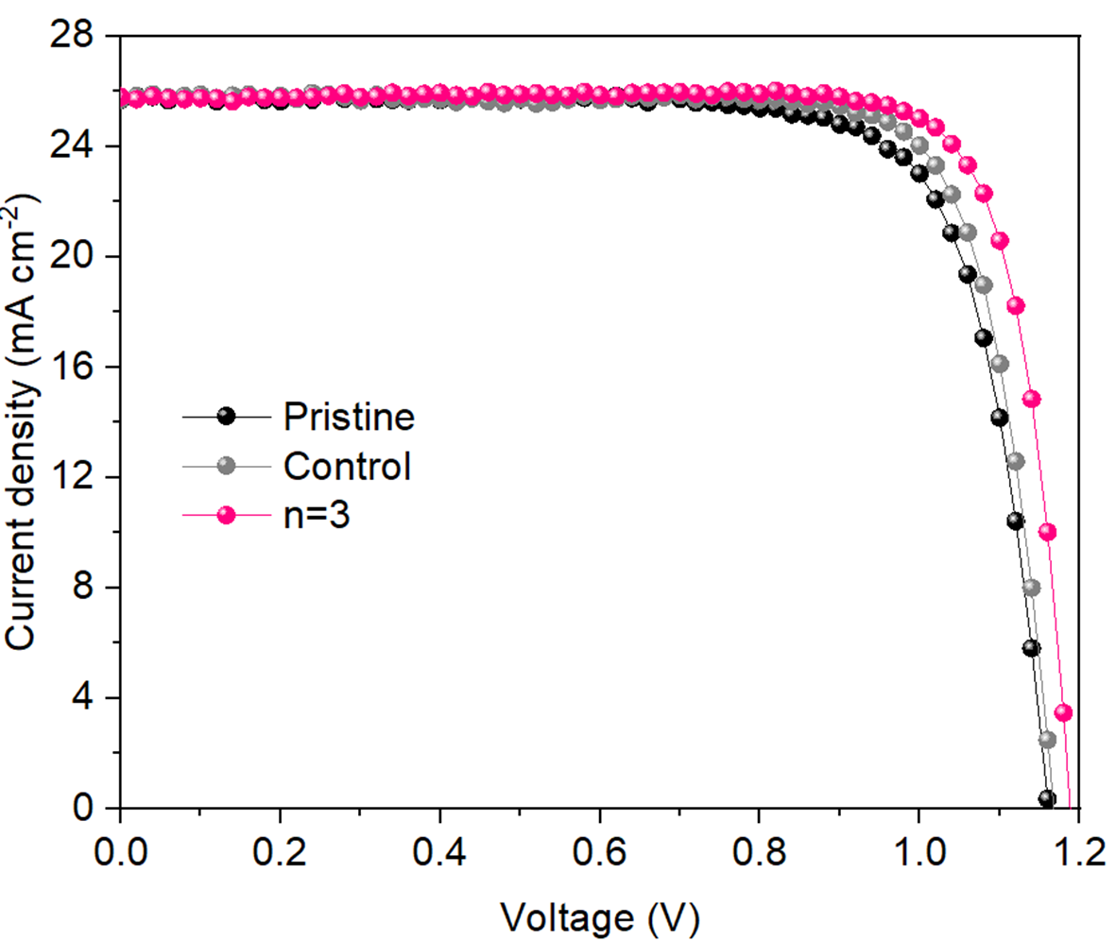
Supplementary Fig. 40. J-V curves of pristine device, control device and the IBC device with n=3. The device structure is TCO/tin oxide/perovskite/HTL/electrode. The HTL is spiro-OMeTAD. The mask area is 1 cm².

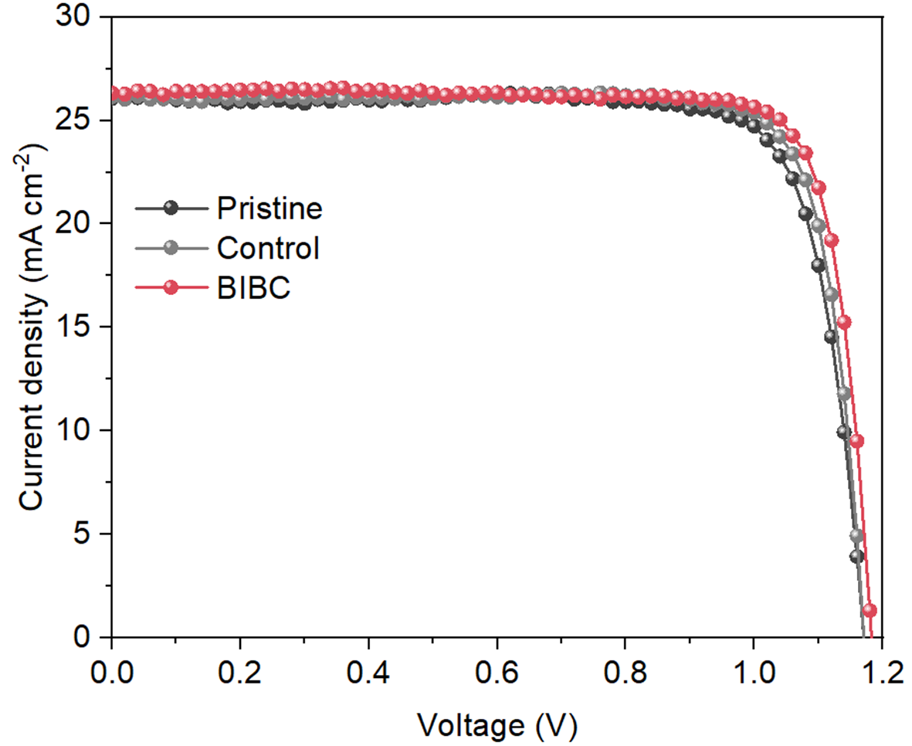
Supplementary Fig. 41. J-V curves of perovskite solar cells with 4PADCB as HTL. The mask area is 1 cm².

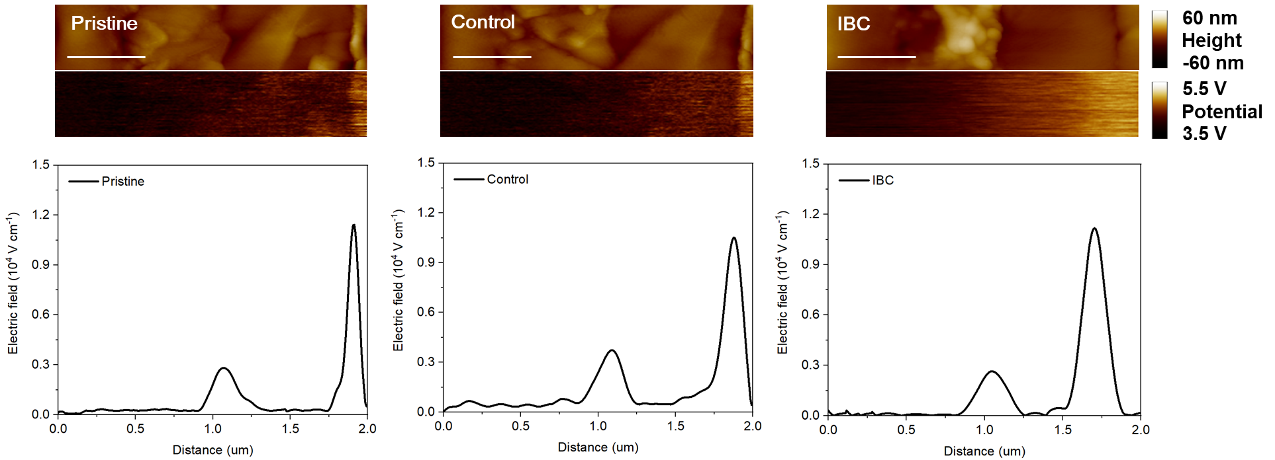

Supplementary Fig. 42. KPFM of the cross-section profiles from pristine device, control device and the IBC device with n=3. The scale bar is 500 nm. The color bar indicates the cross-section potential. The electric field intensity is obtained by differentiating the electric potential.

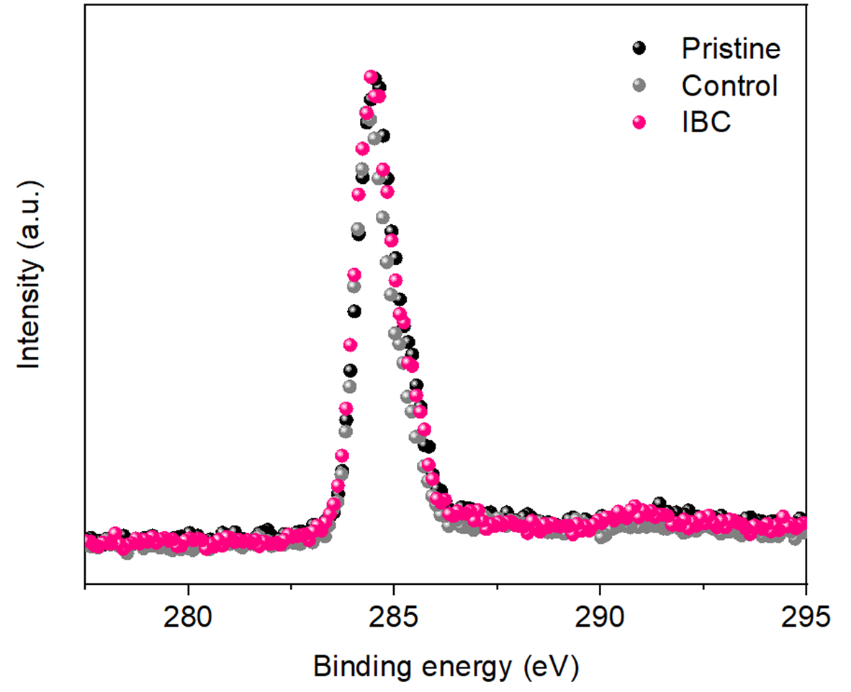

Supplementary Fig. 43. XPS results of carbon element signal for HTL of the pristine, control and the IBC device with n=3 after aging under MPP and 85 ℃ condition for 800, 800 and 1200 hours.

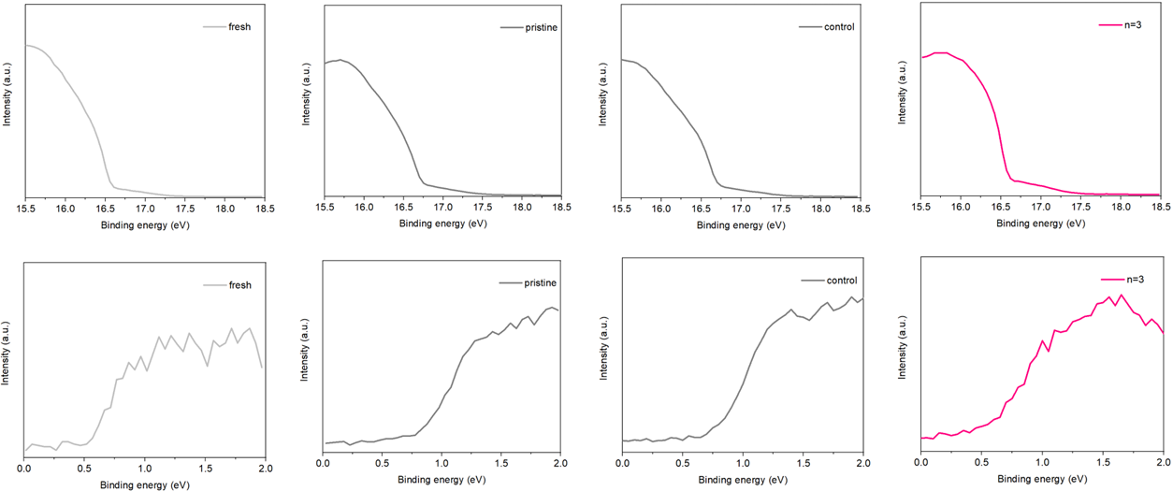
Supplementary Fig. 44. UPS results evolution of PTAA HTL before and after aging under MPP and 85 ℃ condition for 800, 800, and 1200 hours for the pristine, control and the IBC device with n=3 (n-i-p device).

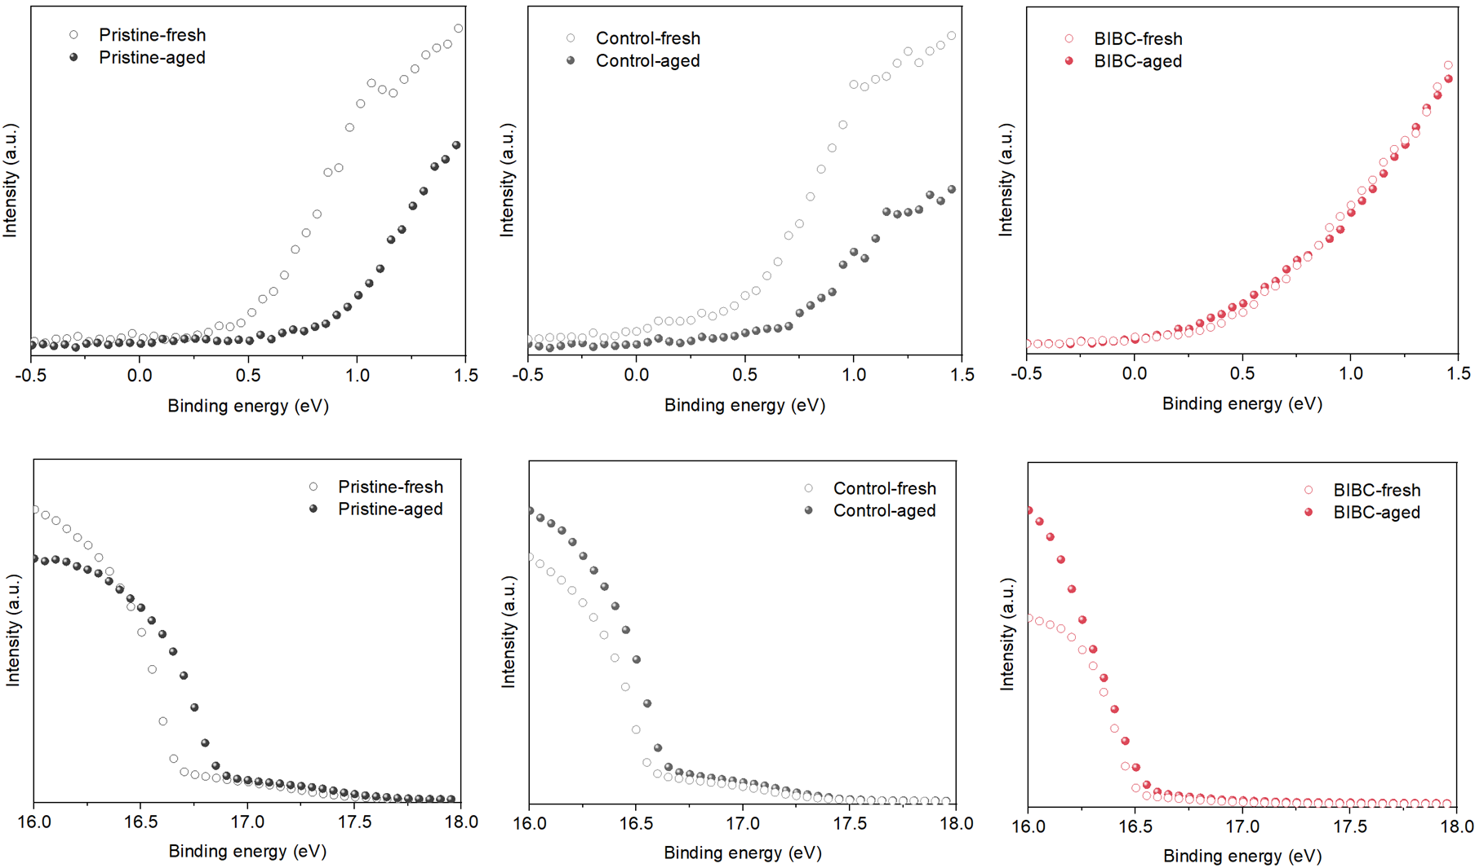
Supplementary Fig. 45. UPS spectra of fresh and aged HTL in p-i-n device. Magnified views of (a) low-binding-energy cutoff region and (b) high-binding-energy region. The devices were aged under MPPT and 85°C for 1000 hours.

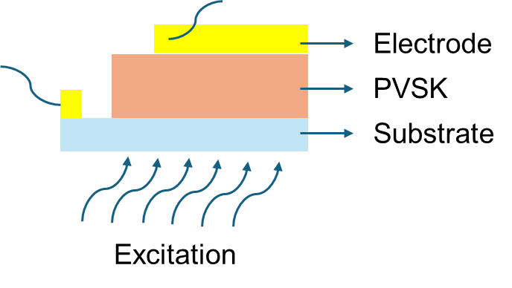
Supplementary Fig. 46. PL mapping test schematic diagram.

Supplementary Table 1. XPS of N 1s and Al 2p peak for sample (iv): ITO/PTAA with an alumina interlayer followed by HAPTES deposition.
Sample (iv) | N 1s area | Al 2p area | N to Al ratio
Initial | 297 | 614 | 48.37
DMF rinse | 74 | 632 | 11.71
Photo-thermal aging | 66 | 629 | 10.50

Supplementary Table 2. XPS of N 1s and Al 2p peak for sample (v): ITO/PTAA/BIBC.
Sample (iv) | N 1s area | Al 2p area | N to Al ratio
Initial | 374 | 547 | 68.37
DMF rinse | 361 | 551 | 65.52
Photo-thermal aging | 355 | 559 | 63.51

Supplementary Table 3. PCE, V_{OC}, J_{SC} and FF of PSC with PTAA as HTL for n-i-p device.
Device | V_{OC} (V) | J_{SC} (mA cm⁻²) | FF (%) | PCE (%)
Pristine | 1.155 | 25.2 | 79.21 | 23.05
Control | 1.162 | 25.4 | 81.74 | 24.12
n=1 | 1.160 | 25.4 | 80.54 | 23.73
n=2 | 1.160 | 25.4 | 82.10 | 24.19
n=3 | 1.181 | 25.6 | 83.48 | 25.24
n=4 | 1.175 | 25.5 | 82.56 | 24.74

Supplementary Table 4. PCE, V_{OC}, J_{SC} and FF of PSC with PTAA as HTL for p-i-n device.
Device | V_{OC} (V) | J_{SC} (mA cm⁻²) | FF (%) | PCE (%)
Pristine | 1.174 | 25.5 | 81.88 | 24.51
Control | 1.182 | 25.7 | 83.04 | 25.23
BIBC | 1.192 | 25.8 | 84.55 | 26.00

Supplementary Table 5. PCE, V_{OC}, J_{SC} and FF of PSC with spiro-OMeTAD as HTL for n-i-p device.
Device | V_{OC} (V) | J_{SC} (mA cm⁻²) | FF (%) | PCE (%)
Pristine | 1.171 | 25.6 | 80.21 | 24.04
Control | 1.174 | 25.8 | 81.88 | 24.80
n=1 | 1.170 | 25.7 | 81.14 | 24.40
n=2 | 1.175 | 25.8 | 82.44 | 25.00
n=3 | 1.192 | 25.9 | 84.55 | 26.10
n=4 | 1.180 | 25.8 | 83.11 | 25.30

Supplementary Table 6. PCE, V_{OC}, J_{SC} and FF of PSC with 4PADCB as HTL for p-i-n device.
Device | V_{OC} (V) | J_{SC} (mA cm⁻²) | FF (%) | PCE (%)
Pristine | 1.177 | 26.3 | 82.86 | 25.65
Control | 1.187 | 26.4 | 84.14 | 26.37
BIBC | 1.197 | 26.5 | 85.61 | 27.16

Supplementary Table 7. PCE, V_{OC}, J_{SC} and FF of PSC with spiro-OMeTAD as HTL for n-i-p device. The mask area is 1 cm².
Device | V_{OC} (V) | J_{SC} (mA cm⁻²) | FF (%) | PCE (%)
Pristine (forward) | 1.161 | 25.7 | 77.53 | 23.13
Pristine (reverse) | 1.160 | 25.7 | 77.92 | 23.23
Control (forward) | 1.168 | 25.7 | 80.10 | 24.04
Control (reverse) | 1.168 | 25.7 | 80.08 | 24.04
n=3 (forward) | 1.188 | 25.8 | 82.16 | 25.18
n=3 (reverse) | 1.187 | 25.8 | 82.19 | 25.17

Supplementary Table 8. PCE, V_{OC}, J_{SC} and FF of PSC with 4PADCB as HTL for p-i-n device. The mask area is 1 cm².
Device | V_{OC} (V) | J_{SC} (mA cm⁻²) | FF (%) | PCE (%)
Pristine | 1.171 | 26.0 | 81.06 | 24.68
Control | 1.171 | 26.1 | 82.95 | 25.35
BIBC | 1.182 | 26.3 | 83.65 | 26.00

1 Shen, Z. C. et al. Seed-Assisted Growth of Tin Oxide Transport Layer for Efficient Perovskite Solar Cells. Solar RRL 7, 2300101 (2023).
2 Liu, J. et al. Oxygen Vacancy Management for High-Temperature Mesoporous SnO₂ Electron Transport Layers in Printable Perovskite Solar Cells. Angew Chem Int Ed Engl 61, e202202012 (2022).

