Appendix S.1. Supplementary Descriptive Results
S.1.1 Number of publications by year
Figure S1 shows a clear long-run expansion in sustained competitive advantage (SCA) research. Annual publication output is limited in the early period (1991–2000), typically remaining in the single digits to low teens, but rises steadily during the 2000s, reaching the high teens and low twenties by the end of the decade. A pronounced increase occurs after 2011, when annual publications consistently reach the high twenties and thirties, indicating consolidation and mainstreaming of SCA within strategy and adjacent fields. The series peaks in the mid-2010s (38 publications in 2014), remains relatively high during 2016–2024 despite year-to-year variation (approximately 19–32 articles per year), and reaches a new maximum in 2025 (41 publications), suggesting renewed acceleration and diversification of SCA applications. The final observation (4 publications) most likely reflects partial-year coverage in the dataset and should not be interpreted as a substantive decline.

Figure S1. Number of publications over years of Sustained Competitive Advantage
S.1.2. Source of publication
Table S1 highlights both the main publication hubs and the high-impact knowledge bases in sustained competitive advantage (SCA) research. In terms of output volume, Strategic Management Journal is the leading outlet (24 articles), followed by the International Journal of Human Resource Management (18), Journal of Business Research (13), and Sustainability (12). This distribution indicates that SCA remains a core strategy topic while also being widely applied in HRM and broader business research.
In terms of influence, citations are highly concentrated in leading strategy and management journals. The Journal of Management records the largest citation count (32,325 citations from 8 articles), with the Strategic Management Journal close behind (25,653 citations from 24 articles). This pattern suggests a strong foundational canon effect in which a small number of seminal articles receive disproportionate scholarly attention. For example, the Journal of Management averages approximately 4,041 citations per article, compared with approximately 1,069 citations per article in the Strategic Management Journal. The remaining journals in the top list reflect thematic spillovers into adjacent disciplines, including information systems (for example, MIS Quarterly and the Journal of Strategic Information Systems) and marketing (for example, Industrial Marketing Management). Overall, the journal profile indicates an intellectual structure anchored in premier strategy and management outlets, alongside sustained cross-disciplinary diffusion into HRM, IS, and applied sustainability venues.
Table S1. Top 10 journals of Sustained Competitive Advantage.
Journal Name | Number of articles | Citations
Strategic Management Journal | 24 | 25653
International Journal of Human Resource Management | 18 | 1415
Journal of Business Research | 13 | 1442
Sustainability | 12 | 249
Industrial Marketing Management | 10 | 874
Journal of Strategic Information Systems | 9 | 921
Journal of Management | 8 | 32325
MIS Quarterly | 8 | 2794
Academy of Management Review | 7 | 1856
Academy of Management Journal | 6 | 4635
S.1.3. Author and co-authorship analysis
Figure S2 depicts the author collaboration (co-authorship) network in sustained competitive advantage (SCA) research. The network is sparse, with many authors appearing as isolated nodes and only a limited number of co-authorship ties under the applied threshold settings. This structure suggests that SCA functions primarily as a widely adopted theoretical lens used across multiple disciplinary conversations, rather than as a cohesive research community organized around large, stable collaborative teams. The presence of influential authors as disconnected nodes further implies that knowledge production is driven by several parallel research programs with relatively limited cross-stream integration. Overall, the network indicates a decentralized field and highlights an opportunity for future work to strengthen cross-institutional and cross-domain collaboration to consolidate SCA concepts, measurement approaches, and boundary conditions.
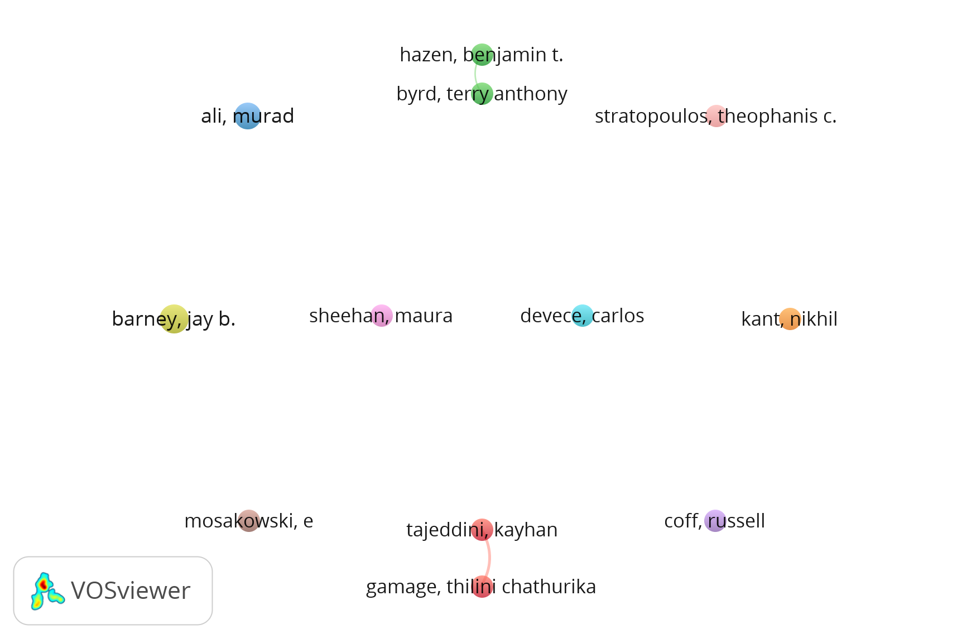
Figure S2. Author collaboration network analysis in Sustained Competitive Advantage
S.1.4. Affiliation analysis
Table S2 identifies the leading institutional contributors to the sustained competitive advantage (SCA) literature. Publication output is concentrated in a small set of research-intensive universities, largely based in the United States, with additional representation from Australia. Ohio State University and Auburn University are the most productive affiliations (8 articles each), followed by the University of Illinois System, Michigan State University, and the University of Queensland (7 articles each).
Citation performance, however, does not fully track publication volume. The Rutgers University System records the highest citation count (2,539 citations from 5 articles), indicating that a smaller number of publications can generate disproportionate influence. Ohio State University also shows strong impact (2,363 citations from 8 articles), whereas several institutions with similar publication output exhibit lower citation intensity. Overall, the results suggest that SCA knowledge production is institutionally concentrated and that scholarly influence reflects both sustained publication activity and a limited number of highly cited contributions.
Table S2. Top 10 organizations with largest number of Sustained Competitive Advantage
Affiliations | Number of articles | Citations
Ohio State University | 8 | 2363
Auburn University | 8 | 1086
University of Illinois System | 7 | 977
Michigan State University | 7 | 772
University of Queensland | 7 | 548
University of Wisconsin Madison | 6 | 733
Georgia State University | 6 | 638
Pennsylvania State University | 6 | 470
University of Wollongong | 6 | 323
Rutgers University System | 5 | 2539

S.1.5. Country/region analysis
Table S3 indicates a highly concentrated geographic distribution of sustained competitive advantage (SCA) publications and impact. The United States dominates both productivity and influence, contributing 239 articles and 38,865 citations. This corresponds to approximately 39.2% of the top-10 publication output but 66.7% of the top-10 citations, indicating a disproportionate share of highly cited work. A second tier of publication activity includes England (65 articles), Australia (58), and China (56), followed by Spain (42) and Canada and India (36 each).
Citation intensity varies substantially across countries. The United States (approximately 162.6 citations per article) and Canada (approximately 117.8) exhibit the highest impact per paper, while England (approximately 62.0), France (approximately 65.0), Spain (approximately 58.8), and Germany (approximately 56.4) form a mid-impact group. In contrast, several high-output contributors show lower citation intensity, particularly China (approximately 30.7 citations per article) and India (approximately 14.7). This pattern may reflect more recent entry into the domain, greater topical dispersion toward applied themes, or weaker integration into the core citation canon. Overall, the table suggests that SCA scholarship remains anchored in Anglophone research systems, with expanding participation from Europe and Asia, while influence remains concentrated in a small set of countries.
Table S3. Top 10 countries/regions with most publications in Sustained Competitive Advantage
Country/Region | Number of articles | Citations
USA | 239 | 38865
England | 65 | 4030
Australia | 58 | 2400
China | 56 | 1719
Spain | 42 | 2468
Canada | 36 | 4241
India | 36 | 528
Germany | 29 | 1637
Taiwan | 27 | 1000
France | 21 | 1366

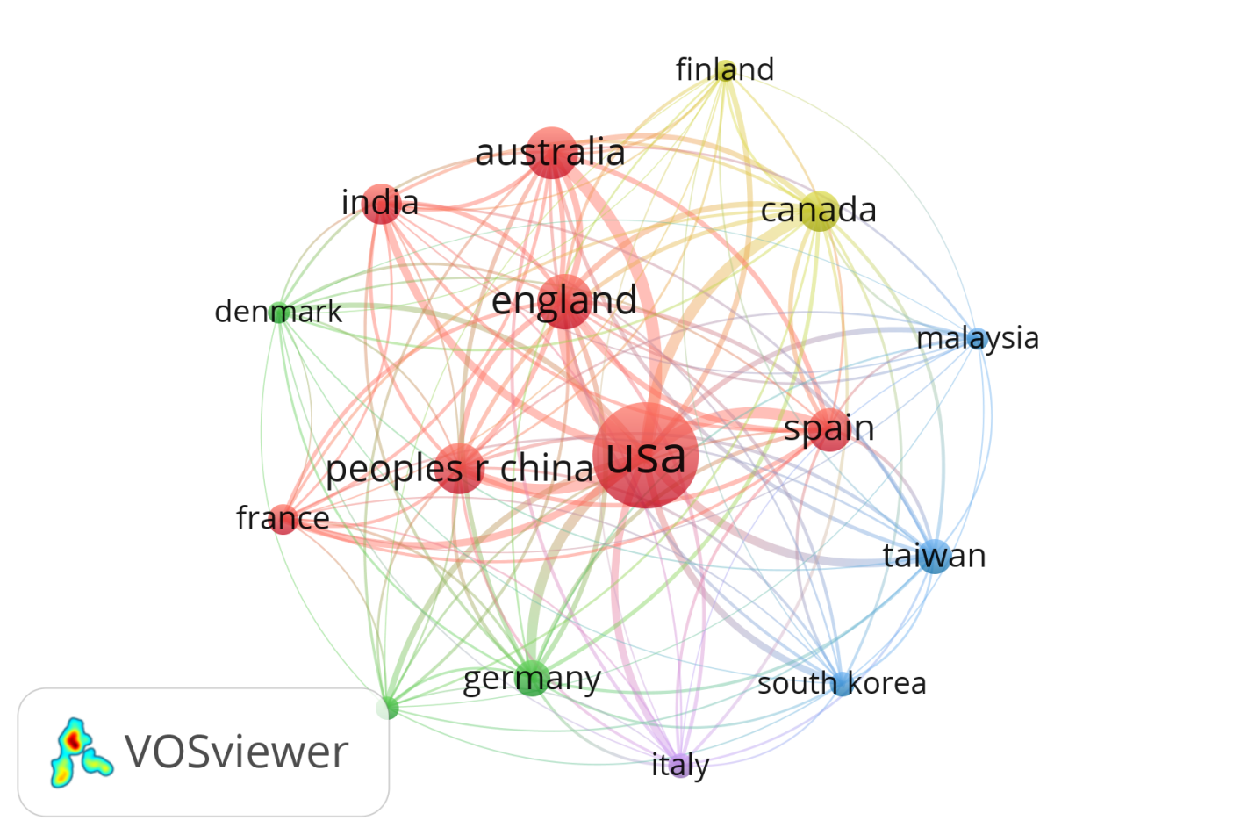
Figure S3. Country collaboration network analysis in Sustained Competitive Advantage

S.1.6. Co-citation analysis
Table S4 reveals a highly concentrated intellectual backbone underpinning sustained competitive advantage (SCA) research in this dataset. Jay Barney is the most influential author (941 citations), and Barney (1991) is the single most cited reference (407 citations), confirming the resource-based view (RBV) as the dominant theoretical foundation. This RBV-centered canon is reinforced by Wernerfelt (1984), Peteraf (1993), and Amit and Schoemaker (1993), which collectively articulate strategic assets, rent generation, and boundary conditions for sustained advantage. The continued prominence of Dierickx and Cool (1989) further indicates sustained reliance on isolating mechanisms and asset stock accumulation to explain why advantages persist over time.
In parallel, dynamic capability theory forms a second pillar, evidenced by the prominence of Teece et al. (1997) and Eisenhardt and Martin (2000), which emphasize capability renewal and reconfiguration in volatile environments. The most-cited references also indicate cross-disciplinary diffusion of SCA into applied domains, particularly information systems (Mata et al., 1995; Bharadwaj, 2000) and strategic HRM (Lado & Wilson, 1994). Finally, the presence of Porter and Williamson suggests complementary links to industry positioning and governance or transaction-cost explanations that further contextualize how sustained advantage is created and protected.
Table S4. Top 10 authors and articles cited in Sustained Competitive Advantage
Author | Citations | Article | Citations
Jay Barney | 941 | Barney (1991) | 407
David J. Teece | 446 | Wernerfelt (1984) | 177
Michael Porter | 254 | Teece et al. (1997) | 172
Robert M. Grant | 210 | Mata et al. (1995) | 117
Birger Wernerfelt | 205 | Peteraf (1993) | 106
Patrick M. Wright | 197 | Dierickx and Cool (1989) | 100
Kathleen M. Eisenhardt | 184 | Eisenhardt and Martin (2000) | 100
José Mata | 139 | Lado and Wilson (1994) | 94
Margaret A. Peteraf | 132 | Bharadwaj (2000) | 90
Oliver E. Williamson | 121 | Amit and Schoemaker (1993) | 87
References
Amit, R., & Schoemaker, P. J. H. (1993). Strategic assets and organizational rent. Strategic Management Journal, 14(1), 33–46. https://doi.org/10.1002/smj.4250140105
Barney, J. (1991). Firm resources and sustained competitive advantage. Journal of Management, 17(1), 99–120. https://doi.org/10.1177/014920639101700108
Bharadwaj, A. S. (2000). A Resource-Based Perspective on Information Technology Capability and Firm Performance: An Empirical investigation1. MIS Quarterly, 24(1), 169–196. https://doi.org/10.2307/3250983
Dierickx, I., & Cool, K. (1989). Asset stock accumulation and sustainability of competitive advantage. Management Science, 35(12), 1504–1511. https://doi.org/10.1287/mnsc.35.12.1504
Eisenhardt, K. M., & Martin, J. A. (2000). Dynamic capabilities: what are they? Strategic Management Journal, 21(10–11), 1105–1121. https://doi.org/10.1002/1097-0266(200010/11)21:10/11
Lado, A. A., & Wilson, M. C. (1994). Human Resource Systems and Sustained Competitive Advantage: A Competency-Based Perspective. Academy of Management Review, 19(4), 699. https://doi.org/10.2307/258742
Mata, F. J., Fuerst, W. L., & Barney, J. B. (1995). Information Technology and Sustained Competitive Advantage: A Resource-Based Analysis. MIS Quarterly, 19(4), 487–505. https://doi.org/10.2307/249630
Peteraf, M. A. (1993). The cornerstones of competitive advantage: A resource‐based view. Strategic Management Journal, 14(3), 179–191. https://doi.org/10.1002/smj.4250140303
Teece, D. J., Pisano, G., & Shuen, A. (1997). Dynamic capabilities and strategic management. Strategic Management Journal, 18(7), 509–533. https://doi.org/10.1002/(sici)1097-0266(199708)18:7
Wernerfelt, B. (1984). A resource‐based view of the firm. Strategic Management Journal, 5(2), 171–180. https://doi.org/10.1002/smj.4250050207

