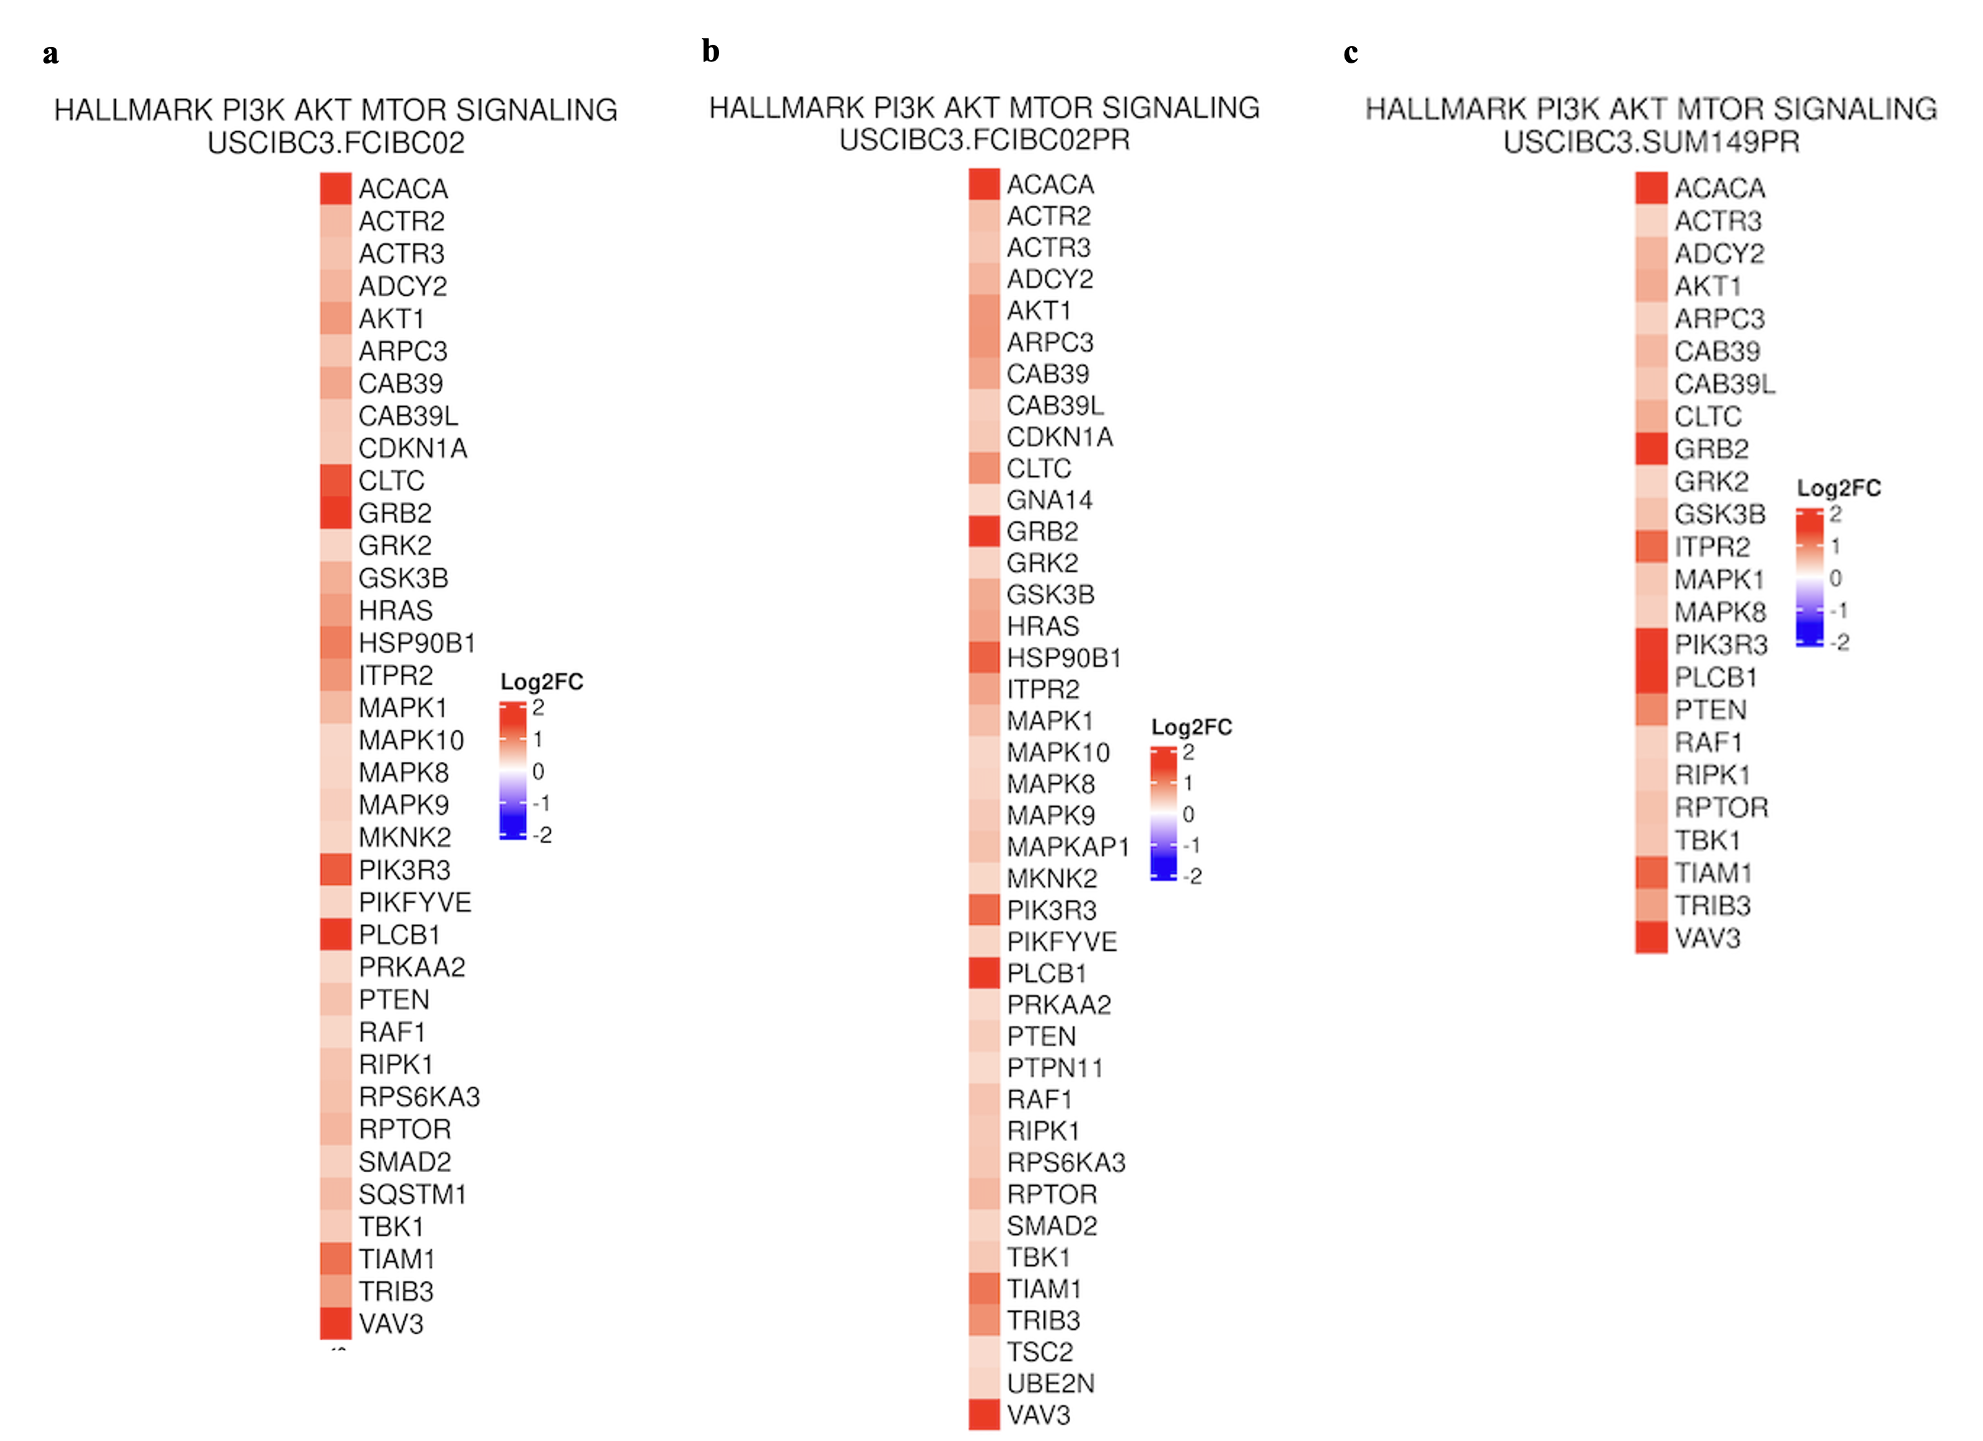
Supplementary Figure 1: Comparative Pathway Analysis between the USCIBC3 PDX and Three Inflammatory Breast Cancer (IBC) Cell Lines. Pathway enrichment analysis was performed on transcriptomic data from the USCIBC3 patient-derived xenograft (PDX) and three established IBC cell lines. Differentially regulated pathways, including signaling, proliferation, and metabolic programs, are shown to highlight similarities and distinctions in molecular programs between the PDX and in vitro models. This analysis identifies pathways uniquely enriched in USCIBC3 as well as those conserved across IBC models, providing insight into tumor-specific biology and potential therapeutic targets.

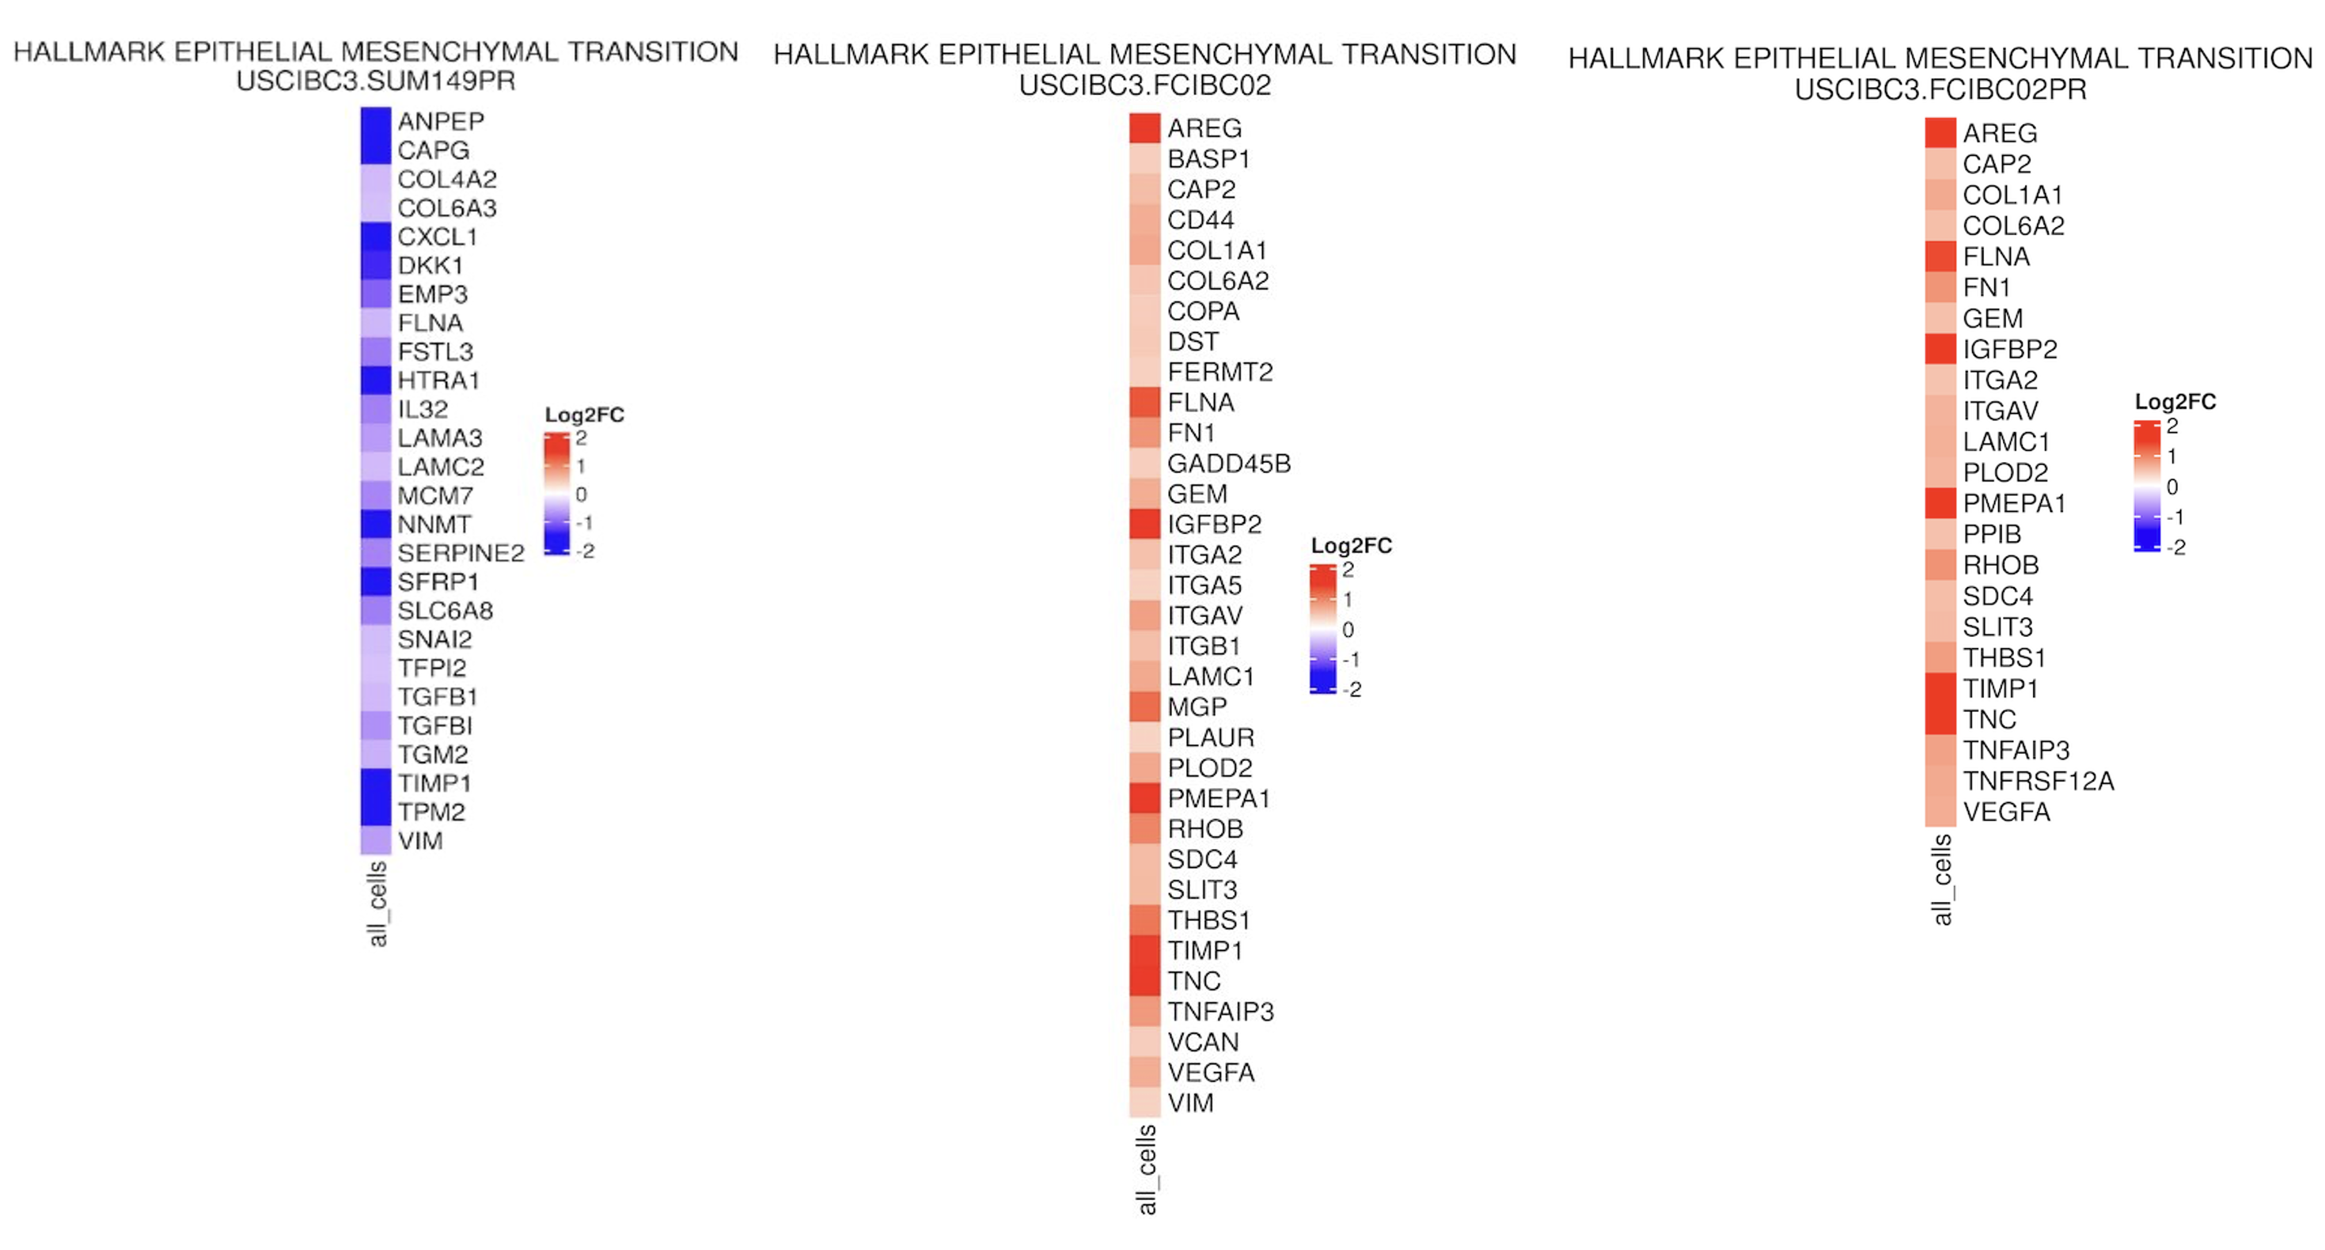
Supplementary Figure 1b: Comparison of Epithelial Mesenchymal Transition Pathway and PI3K-AKT MTOR Signaling Pathway Expression between the USCIBC3 PDX and Three Inflammatory Breast Cancer (IBC) Cell Lines.

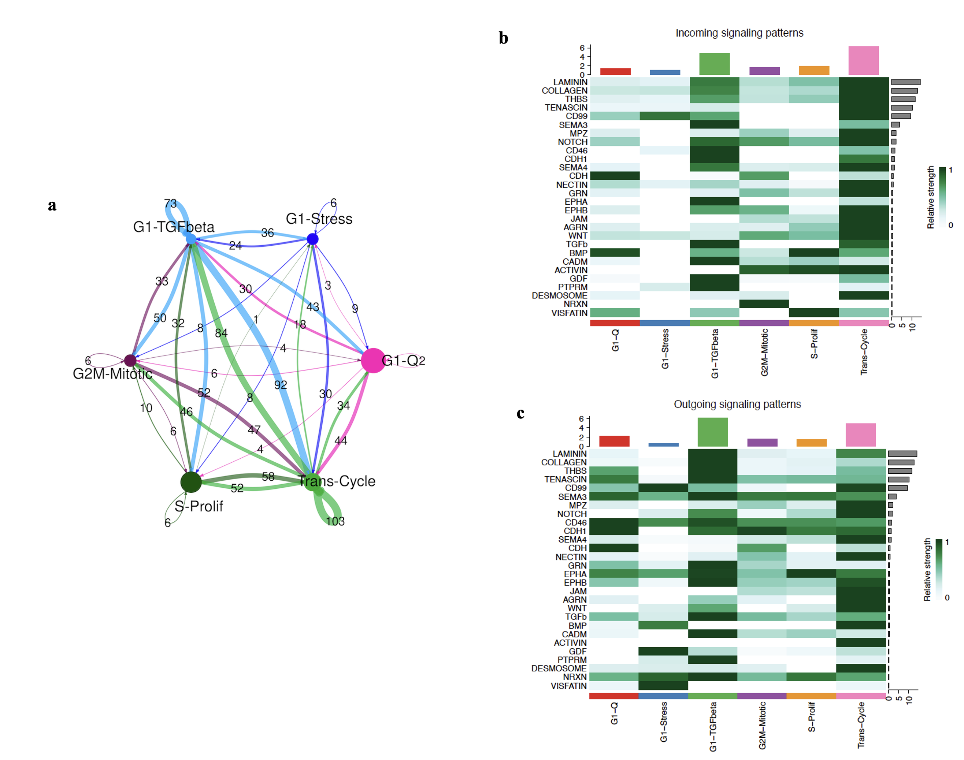Supplementary Figure 2: Cell–cell Communication and Transcriptional Heterogeneity among Six Epithelial Tumor Clusters Identified in the USCIBC3 Inflammatory Breast Cancer PDX.CellChat analysis of single-cell RNA sequencing data from approximately 1,000 cells revealed six transcriptionally distinct epithelial tumor clusters within the USCIBC3 PDX.
(a) Network analysis depicting predicted communication interactions between clusters.
(b) Analysis of incoming signaling pathways, showing which clusters predominantly receive signals.
(c) Analysis of outgoing signaling pathways, highlighting which clusters primarily send signals, revealing functional interactions and potential regulatory hierarchies among tumor epithelial populations.

