Supplementary Material

Effects of treatments on numerical discrimination using the estimates and the raw data
Table S1.- Median and 95% Highest Density Intervals (95% HPDI) of the estimated probability of choosing first the higher amount (Choice) and the estimated interest for the higher amount of food (Interest) per treatment group for each of the numerical tests performed. 95% HPDI test the hypothesis that Choice = 0.5, and Interest = 0, which would indicate a preference towards one of choices.
 |  | Choice |  | Interest
Test | Treatment | Median | 95% HPDI | Median | 95% HPDI
1VS4 | Cold-CORT (n = 20) | 0.33 | [0.12 , 0.58] | 8.13 | [-30.19 , 49.74]
 |  | 0.47 | [0.24 , 0.73] | -2.59 | [-43.24 , 32.78]
 |  | 0.60 | [0.34 , 0.84] | -13.17 | [-53.15 , 27.08]
 |  | 0.43 | [0.18 , 0.68] | -4.26 | [-44.94 , 32.05]
1VS3 | Cold-CORT (n = 20) | 0.39 | [0.16 , 0.65] | -18.94 | [-57.92 , 22.1]
 |  | 0.65 | [0.4 , 0.86] | -2.75 | [-41.41 , 35.55]
 |  | 0.81 | [0.61 , 0.97] | 31.15 | [-7.91 , 69]
 |  | 0.64 | [0.38 , 0.86] | -8.39 | [-48.97 , 30.31]
2VS4 | Cold-CORT (n = 20) | 0.50 | [0.24 , 0.75] | 12.57 | [-27.51 , 52.01]
 |  | 0.48 | [0.25 , 0.73] | -3.31 | [-40.15 , 34.38]
 |  | 0.45 | [0.21 , 0.71] | -10.15 | [-48.22 , 29.5]
 |  | 0.55 | [0.3 , 0.8] | 8.60 | [-30.24 , 48.08]
2VS3 | Cold-CORT (n = 20) | 0.60 | [0.32 , 0.83] | -9.81 | [-50.56 , 29.55]
 |  | 0.76 | [0.53 , 0.93] | 27.89 | [-10.95 , 65.24]
 |  | 0.45 | [0.19 , 0.7] | 3.51 | [-38.02 , 42]
 |  | 0.37 | [0.13 , 0.62] | -28.99 | [-68.73 , 9.31]
3VS4 | Cold-CORT (n = 20) | 0.41 | [0.17 , 0.67] | -30.23 | [-72.01 , 9.51]
 |  | 0.59 | [0.35 , 0.83] | 21.92 | [-16.53 , 60.1]
 |  | 0.65 | [0.39 , 0.88] | -14.11 | [-56.08 , 25.61]
 |  | 0.70 | [0.45 , 0.9] | 14.29 | [-25.82 , 53.5]

Table S2.- Performance of each treatment in each of the numerical tests using the raw data. For the variable Latency and Interest, we show the median and the 95% CI. For the variable Choice, we show the proportion of individuals that chose the higher number of crickets first.
 |  |  |  | Tests
Variable | Treatment | 1 VS 4 | 1 VS 3 | 2 VS 4 | 2 VS 3 | 3 VS 4
Latency | Hot-Control (n = 20) | 595.5  [55.88 , 1593.72] | 721.25  [192.5 , 2074.55] | 622.8  [74.23 , 1447.22] | 666.35  [84.63 , 2311.7] | 742.2  [71.33 , 2344.85]
 | Hot-CORT (n = 20) | 1235.7  [257.98 , 4483.92] | 1011.5  [203.12 , 2379.73] | 852.4  [115.38 , 2527.57] | 840.9  [98.2 , 2524.95] | 1360.25  [145.43 , 6131.73]
 | Cold-Control (n = 20) | 663.35  [84.93 , 2605.7] | 729.95  [92.8 , 3099.77] | 630.5  [94.1 , 2500.82] | 575  [70.75 , 1679.95] | 491.15  [24.63 , 1915.57]
 | Cold-CORT (n = 20) | 880.25  [29.75 , 4557.85] | 760.3  [60.08 , 3493.4] | 703  [30.88 , 3522.77] | 962.15  [35.93 , 4747.52] | 1031.05  [19.88 , 4106.82]
Choice | Hot-Control (n = 20) | 8 | 12 | 10 | 7 | 13
 | Hot-CORT (n = 20) | 11 | 15 | 9 | 9 | 11
 | Cold-Control (n = 20) | 10 | 13 | 10 | 15 | 12
 | Cold-CORT (n = 20) | 8 | 9 | 11 | 12 | 9
Interest | Hot-Control (n = 20) | -6.5  [-126.97 , 163.07] | -10.68  [-180.9 , 113.25] | 6.6  [-85.05 , 162.3] | -31.1  [-118.62 , 56.62] | 12.05  [-186.6 , 228.85]
 | Hot-CORT (n = 20) | -15.11  [-152.65 , 61.45] | 28.65  [-152.27 , 185.65] | -12.74  [-120.8 , 182] | 1.68  [-108.4 , 120.55] | -15.71  [-148 , 84.4]
 | Cold-Control (n = 20) | -2.75  [-141.42 , 204.65] | -3.05  [-152.55 , 179.07] | -3.95  [-142.12 , 104] | 27.25  [-77.38 , 130] | 21.55  [-101 , 164.22]
 | Cold-CORT (n = 20) | 12.9  [-188.15 , 195.67] | -14.15  [-203.8 , 123.02] | 17.6  [-105.78 , 186.17] | -4.68  [-119.05 , 79.8] | -24.84  [-182.8 , 74.95]

Model results
Table S3A.- Summary of the model fitted for loglatency (Latency)
variable | mean | median | sd | q5 | q95 | rhat | ess_bulk | ess_tail
b_loglatency_Intercept | 6.47 | 6.47 | 0.31 | 5.96 | 7.00 | 1.00 | 4547.93 | 6871.87
b_loglatency_test_type1VS3 | -0.03 | -0.03 | 0.21 | -0.37 | 0.31 | 1.00 | 5851.20 | 8069.68
b_loglatency_test_type2VS4 | -0.13 | -0.13 | 0.21 | -0.46 | 0.21 | 1.00 | 5607.53 | 8779.16
b_loglatency_test_type2VS3 | -0.02 | -0.02 | 0.21 | -0.36 | 0.33 | 1.00 | 5792.88 | 8099.56
b_loglatency_test_type3VS4 | -0.07 | -0.07 | 0.21 | -0.42 | 0.27 | 1.00 | 5394.76 | 8113.94
b_loglatency_tempHot | 0.05 | 0.05 | 0.45 | -0.69 | 0.80 | 1.00 | 4240.55 | 6468.22
b_loglatency_cortControl | 0.09 | 0.09 | 0.35 | -0.50 | 0.66 | 1.00 | 3501.90 | 6160.76
b_loglatency_sexm | -0.46 | -0.45 | 0.22 | -0.82 | -0.10 | 1.00 | 5456.02 | 7259.40
b_loglatency_age | 0.06 | 0.06 | 0.02 | 0.02 | 0.10 | 1.00 | 5242.87 | 6844.75
b_loglatency_test_type1VS3:tempHot | -0.03 | -0.03 | 0.30 | -0.52 | 0.46 | 1.00 | 5246.33 | 7514.61
b_loglatency_test_type2VS4:tempHot | -0.18 | -0.18 | 0.30 | -0.67 | 0.31 | 1.00 | 5432.60 | 8115.85
b_loglatency_test_type2VS3:tempHot | -0.25 | -0.25 | 0.30 | -0.74 | 0.25 | 1.00 | 5517.51 | 7473.31
b_loglatency_test_type3VS4:tempHot | -0.10 | -0.11 | 0.30 | -0.60 | 0.39 | 1.00 | 5247.17 | 7570.16
b_loglatency_test_type1VS3:cortControl | 0.04 | 0.04 | 0.29 | -0.43 | 0.53 | 1.00 | 5376.57 | 7715.18
b_loglatency_test_type2VS4:cortControl | 0.15 | 0.16 | 0.29 | -0.33 | 0.64 | 1.00 | 5492.31 | 8062.19
b_loglatency_test_type2VS3:cortControl | -0.04 | -0.04 | 0.29 | -0.52 | 0.44 | 1.00 | 5459.05 | 7755.73
b_loglatency_test_type3VS4:cortControl | -0.38 | -0.38 | 0.29 | -0.87 | 0.09 | 1.00 | 5264.74 | 8063.37
b_loglatency_tempHot:cortControl | -0.78 | -0.78 | 0.49 | -1.58 | 0.03 | 1.00 | 3491.24 | 5908.08
b_loglatency_test_type1VS3:tempHot:cortControl | 0.25 | 0.25 | 0.42 | -0.43 | 0.94 | 1.00 | 5103.28 | 7366.37
b_loglatency_test_type2VS4:tempHot:cortControl | 0.28 | 0.28 | 0.42 | -0.40 | 0.97 | 1.00 | 4860.78 | 7733.09
b_loglatency_test_type2VS3:tempHot:cortControl | 0.37 | 0.37 | 0.42 | -0.32 | 1.05 | 1.00 | 5243.01 | 8532.21
b_loglatency_test_type3VS4:tempHot:cortControl | 0.74 | 0.75 | 0.42 | 0.05 | 1.44 | 1.00 | 5119.54 | 7726.59
Table S3B.- Summary of the model fitted for Choice
variable | mean | median | sd | q5 | q95 | rhat | ess_bulk | ess_tail
b_choice_Intercept | -0.68 | -0.68 | 0.58 | -1.64 | 0.26 | 1.00 | 4717.07 | 6912.29
b_choice_test_type1VS3 | 0.24 | 0.24 | 0.69 | -0.89 | 1.38 | 1.00 | 5106.43 | 7093.98
b_choice_test_type2VS4 | 0.71 | 0.70 | 0.69 | -0.42 | 1.86 | 1.00 | 4984.93 | 7514.81
b_choice_test_type2VS3 | 1.12 | 1.10 | 0.73 | -0.06 | 2.35 | 1.00 | 4902.86 | 6926.45
b_choice_test_type3VS4 | 0.33 | 0.32 | 0.70 | -0.82 | 1.48 | 1.00 | 5219.20 | 7158.11
b_choice_tempHot | 1.13 | 1.12 | 0.83 | -0.23 | 2.50 | 1.00 | 4283.18 | 6599.41
b_choice_cortControl | 0.61 | 0.60 | 0.74 | -0.59 | 1.84 | 1.00 | 3922.51 | 6114.01
b_choice_sexm | -0.06 | -0.06 | 0.30 | -0.54 | 0.43 | 1.00 | 14505.46 | 8697.98
b_choice_age | -0.04 | -0.04 | 0.03 | -0.09 | 0.01 | 1.00 | 12392.71 | 8820.47
b_choice_test_type1VS3:tempHot | 0.80 | 0.79 | 1.04 | -0.88 | 2.55 | 1.00 | 4972.18 | 6745.87
b_choice_test_type2VS4:tempHot | -1.33 | -1.33 | 1.00 | -2.98 | 0.29 | 1.00 | 4886.89 | 7191.48
b_choice_test_type2VS3:tempHot | -1.77 | -1.77 | 1.04 | -3.49 | -0.09 | 1.00 | 4289.06 | 6024.53
b_choice_test_type3VS4:tempHot | -0.13 | -0.13 | 1.02 | -1.80 | 1.57 | 1.00 | 4538.82 | 7185.57
b_choice_test_type1VS3:cortControl | 0.48 | 0.47 | 0.99 | -1.15 | 2.12 | 1.00 | 4938.94 | 7818.41
b_choice_test_type2VS4:cortControl | -0.70 | -0.69 | 0.98 | -2.32 | 0.90 | 1.00 | 4749.40 | 7672.85
b_choice_test_type2VS3:cortControl | 0.15 | 0.16 | 1.04 | -1.53 | 1.85 | 1.00 | 4980.80 | 8127.50
b_choice_test_type3VS4:cortControl | 0.14 | 0.13 | 1.00 | -1.50 | 1.77 | 1.00 | 4881.82 | 7388.95
b_choice_tempHot:cortControl | -1.33 | -1.32 | 1.06 | -3.06 | 0.40 | 1.00 | 3598.45 | 6418.88
b_choice_test_type1VS3:tempHot:cortControl | -0.65 | -0.64 | 1.44 | -3.01 | 1.71 | 1.00 | 4947.05 | 7258.07
b_choice_test_type2VS4:tempHot:cortControl | 1.82 | 1.79 | 1.41 | -0.52 | 4.12 | 1.00 | 4832.87 | 7213.76
b_choice_test_type2VS3:tempHot:cortControl | 0.25 | 0.25 | 1.45 | -2.12 | 2.59 | 1.00 | 4689.39 | 7011.19
b_choice_test_type3VS4:tempHot:cortControl | 0.81 | 0.80 | 1.44 | -1.57 | 3.20 | 1.00 | 4767.29 | 7038.46

Table S3C.- Summary of the model fitted for Interest
variable | mean | median | sd | q5 | q95 | rhat | ess_bulk | ess_tail
b_comparedinterest_Intercept | 12.58 | 12.75 | 20.03 | -20.62 | 45.52 | 1.00 | 4226.87 | 6914.84
b_comparedinterest_test_type1VS3 | -27.45 | -27.46 | 24.85 | -68.46 | 13.12 | 1.00 | 5057.66 | 7251.20
b_comparedinterest_test_type2VS4 | 4.45 | 4.37 | 25.04 | -36.11 | 45.40 | 1.00 | 4955.22 | 7144.03
b_comparedinterest_test_type2VS3 | -18.02 | -18.08 | 25.03 | -59.03 | 23.55 | 1.00 | 4608.81 | 7655.14
b_comparedinterest_test_type3VS4 | -38.45 | -38.44 | 25.60 | -80.23 | 3.89 | 1.00 | 4974.12 | 7540.36
b_comparedinterest_tempHot | -21.42 | -21.25 | 28.74 | -68.59 | 25.65 | 1.00 | 3724.65 | 6038.13
b_comparedinterest_cortControl | -10.87 | -10.78 | 25.67 | -53.25 | 31.15 | 1.00 | 3414.61 | 5708.73
b_comparedinterest_sexm | -8.60 | -8.64 | 9.32 | -23.92 | 7.03 | 1.00 | 17607.01 | 8664.01
b_comparedinterest_age | -0.68 | -0.67 | 0.97 | -2.25 | 0.91 | 1.00 | 15664.51 | 9250.40
b_comparedinterest_test_type1VS3:tempHot | 71.62 | 71.63 | 35.19 | 13.31 | 129.60 | 1.00 | 4600.90 | 6586.40
b_comparedinterest_test_type2VS4:tempHot | -1.40 | -1.38 | 35.97 | -59.74 | 58.37 | 1.00 | 4594.12 | 6529.68
b_comparedinterest_test_type2VS3:tempHot | 34.51 | 34.43 | 35.89 | -23.35 | 93.63 | 1.00 | 4206.05 | 6855.33
b_comparedinterest_test_type3VS4:tempHot | 37.54 | 37.66 | 36.94 | -22.35 | 97.98 | 1.00 | 4702.14 | 7554.35
b_comparedinterest_test_type1VS3:cortControl | 27.46 | 27.64 | 35.35 | -30.54 | 86.37 | 1.00 | 4866.97 | 7599.14
b_comparedinterest_test_type2VS4:cortControl | -5.20 | -5.27 | 35.16 | -62.72 | 52.41 | 1.00 | 4362.77 | 6797.39
b_comparedinterest_test_type2VS3:cortControl | 48.43 | 48.30 | 35.49 | -9.54 | 106.81 | 1.00 | 4047.11 | 6637.73
b_comparedinterest_test_type3VS4:cortControl | 63.11 | 62.88 | 35.72 | 4.22 | 122.72 | 1.00 | 4618.01 | 7533.53
b_comparedinterest_tempHot:cortControl | 19.41 | 19.72 | 36.63 | -40.29 | 79.85 | 1.00 | 3346.75 | 5960.45
b_comparedinterest_test_type1VS3:tempHot:cortControl | -75.56 | -75.33 | 50.52 | -157.46 | 7.56 | 1.00 | 4608.18 | 7070.71
b_comparedinterest_test_type2VS4:tempHot:cortControl | 15.19 | 15.16 | 50.30 | -69.06 | 97.00 | 1.00 | 4217.24 | 6394.78
b_comparedinterest_test_type2VS3:tempHot:cortControl | -89.54 | -88.78 | 50.35 | -173.98 | -6.66 | 1.00 | 3896.04 | 6636.15
b_comparedinterest_test_type3VS4:tempHot:cortControl | -43.38 | -43.71 | 51.44 | -127.24 | 41.39 | 1.00 | 4491.70 | 6562.71

Table S3D.- Summary of the model fitted for other effects
variable | mean | median | sd | q5 | q95 | rhat | ess_bulk | ess_tail
sd_clutch__loglatency_Intercept | 0.34 | 0.34 | 0.19 | 0.04 | 0.67 | 1.01 | 716.16 | 2313.13
sd_lizard_id__loglatency_Intercept | 0.81 | 0.81 | 0.10 | 0.64 | 0.97 | 1.00 | 1725.51 | 2777.99
sd_clutch__choice_Intercept | 0.26 | 0.23 | 0.18 | 0.02 | 0.60 | 1.00 | 3913.70 | 5803.67
sd_lizard_id__choice_Intercept | 0.59 | 0.60 | 0.25 | 0.13 | 0.99 | 1.00 | 2047.51 | 3110.77
sd_clutch__comparedinterest_Intercept | 9.92 | 9.22 | 6.32 | 1.03 | 21.27 | 1.00 | 4065.36 | 6333.93
sd_lizard_id__comparedinterest_Intercept | 9.31 | 8.34 | 6.38 | 0.81 | 20.85 | 1.00 | 3847.09 | 5748.30
sigma_loglatency | 0.65 | 0.65 | 0.03 | 0.61 | 0.70 | 1.00 | 12611.43 | 8861.89
sigma_comparedinterest | 78.78 | 78.70 | 3.03 | 73.99 | 83.90 | 1.00 | 15359.76 | 8383.11
lprior | -29.26 | -29.25 | 0.08 | -29.40 | -29.13 | 1.00 | 8343.29 | 9738.65
lp__ | -3440.63 | -3440.02 | 18.68 | -3472.06 | -3410.58 | 1.00 | 2890.39 | 5974.94

Testing potential side biases
Table S4.- Number of individuals per treatment that chose the right (R) or left (L) side in each of the numerical tests. p-value indicates the result of the binomial test comparing the number of choices between sides.
 | 1 VS 4 | 1 VS 3 | 2 VS 4 | 2 VS 3 | 3 VS 4
Control-Cold (n = 20) | R = 12 | L = 8 , p = 0.5 | R = 12 | L = 8 , p = 0.5 | R = 9 | L = 11 , p = 0.82 | R = 12 | L = 8 , p = 0.5 | R = 12 | L = 8 , p = 0.5
Control-Hot (n = 20) | R = 12 | L = 8 , p = 0.5 | R = 5 | L = 15 , p = 0.04 | R = 9 | L = 11 , p = 0.82 | R = 10 | L = 10 , p = 1 | R = 11 | L = 9 , p = 0.82
CORT-Cold (n = 20) | R = 11 | L = 9 , p = 0.82 | R = 11 | L = 9 , p = 0.82 | R = 11 | L = 9 , p = 0.82 | R = 10 | L = 10 , p = 1 | R = 11 | L = 9 , p = 0.82
CORT-Hot (n = 20) | R = 11 | L = 9 , p = 0.82 | R = 9 | L = 11 , p = 0.82 | R = 9 | L = 11 , p = 0.82 | R = 10 | L = 10 , p = 1 | R = 11 | L = 9 , p = 0.82

Control of size in both options
On the videos of half of the lizards, we estimated the length of both options using the ruler tool on Photoshop 2024. For each choice in each test, we first calibrated the masure of one centimeter using the length of the bottom of the platform (see Fig below). After calibrating, we measured the length of the crickets at their maximum length, trying to keep the line parallel to the bottom of the platform (see below). The results are shown in Table S4.
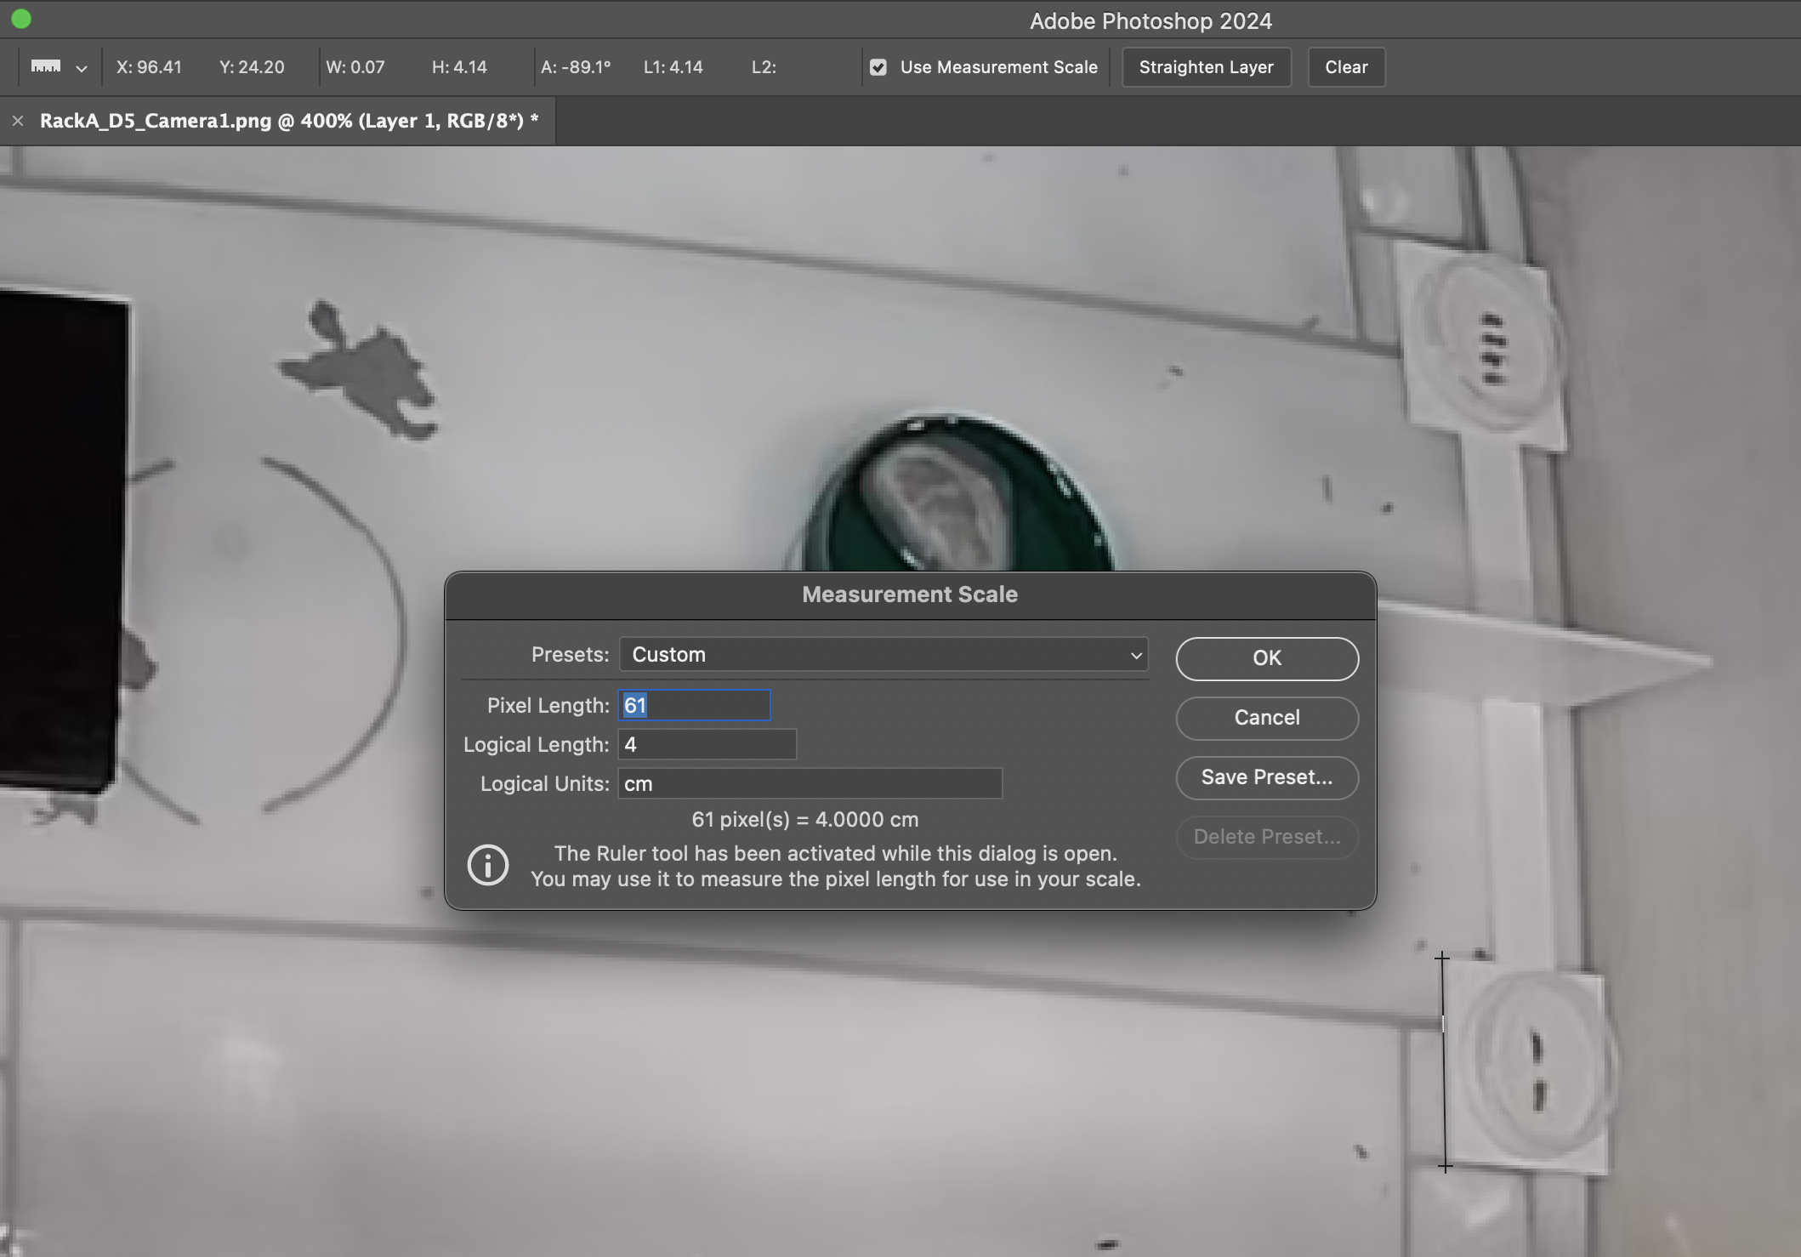
Fig S1— Calibration of the ruler tool in Photoshop 2024. The bottom of the platform was used to calibrate the ruler tool to measure the length of the crickets.


Fig S2— Measurement of the length of the crickets. The ruler tool was used to measure the length of the crickets at their maximum length.
Table S4.- Mean length (cm) of the crickets in each of the numerical tests. The difference in length between the two options is also shown, with the 95% CI.
Test | Mean length small (cm) | Mean length large (cm) | Mean differences in length | 95% CI differences in length
1 VS 3 | 0.81 | 1.53 | 0.72 | [0.31 , 1.15]
1 VS 4 | 0.81 | 1.86 | 1.05 | [0.61 , 1.61]
2 VS 3 | 1.72 | 1.58 | -0.14 | [-0.61 , 0.32]
2 VS 4 | 1.76 | 1.85 | 0.10 | [-0.23 , 0.56]
3 VS 4 | 1.55 | 1.85 | 0.30 | [-0.19 , 0.89]

Prey orientation test
We performed a choice test to investigate if the orientation of crickets affected the lizards’ choice. We used the same platform and Petri dish as in the numerical discrimination task, but we placed one cricket on each side of the platform, one oriented vertically in respect to the shelter position (see Fig. 1 B) and the other one horizontal to the shelter. We performed a unique trial randomising the position of the orientation of the cricket. We recorded the number of individuals that chose the cricket oriented vertically and horizontally. Results are shown in the table below.
Table S5.- Number of individuals per treatment that chose the cricket oriented horizontally (Horizontal) or vertically (Vertical) in our control tests. p-value indicates the result of the binomial test comparing the number of choices between both choices.
 | Horizontal | Vertical | p-value
Cold-Control (n = 20) | 8 | 12 | 0.503
Hot-Control (n = 20) | 7 | 13 | 0.263
Cold-CORT (n = 20) | 12 | 8 | 0.503
Hot-CORT (n = 20) | 9 | 11 | 0.824

Searching for relevant literature
To look for relevant literature about the effects of early environment on numerical discrimination, we searched in the Web of Science and Scopus using the terms on respectively. The queries employed are detailed below. We looked for manuscripts for all years available. The last search was conducted on the 11th of October 2024; the results below refer to this last search.
We found 24 articles on Web of Science and 22 on Scopus, plus one preprint on Scopus. Out of all the documents, only one study was relevant to our search: Vila Pouca et al. (2019). That study appeared in both databases and was the only one that explored the effects of early environment on numerical abilities.

Fig S3— Search query on Web of Science.


Fig S4— Search query on Scopus.

Lizards age by Treatment

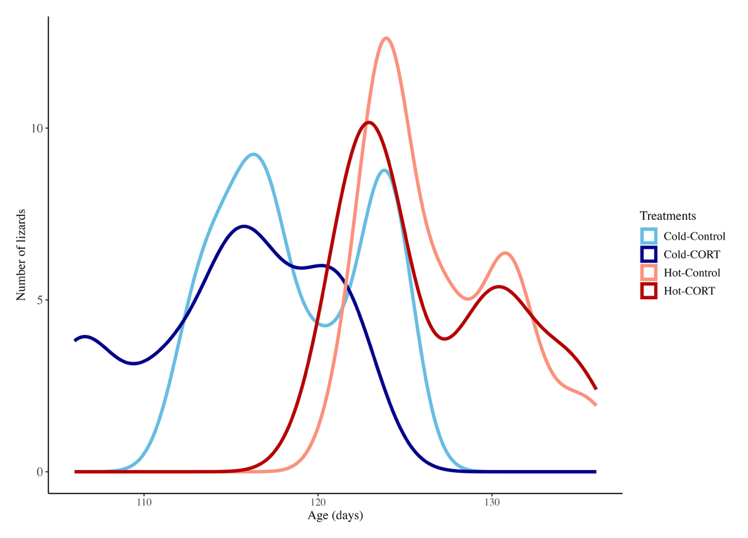

Fig S5— Distribution of the age of the lizards by treatment

