Supplementary Information 1

Equitable nature-based solutions begin with addressing the root causes of inequity
Holden P^{1,2}, Hoffman T³, Shackleton S², Anderson M^{1,2}, Forbes C^{1,2}, Humphrey G^{1,2}, Onyeagoziri A^{1,2}, Ziervogel G², New M², Visser V ^{1,4}
¹ People in Nature and Climate Lab, African Climate and Development Initiative, University of Cape Town, Cape Town, South Africa
² African Climate and Development Initiative, University of Cape Town, Cape Town, South Africa
³ Honeyguide Strategic Communication, Cape Town, South Africa
⁴ Centre for Statistics in Ecology, the Environment and Conservation, Department of Statistical Sciences, University of Cape Town, South Africa

Description of studies identified for review
Our search of the scientific literature on social inequity and NbS in southern Africa identified a total of 634 articles. We analysed 93 peer-reviewed papers given our inclusion and exclusion criteria and time-based review stopping criteria (Supplementary 1 Fig. 1, Supplementary 2 Table 3).
These reviewed and coded studies were published across 70 academic journals, from 1997 to 2021 and followed a similar distribution to the 351 papers for potential review (Main paper, Fig 1a). More than three quarters (78%) of the papers reviewed were published from 2012 with more than half (59%) from 2015. Less than 10% were published before 2005. Top journals with highest numbers of articles were Ecosystem Services, Journal of Environmental Management, Society and Natural Resources, Ecological Economics, and Land Use Policy.

Assessment type used for determining NbS outcomes
Most studies were qualitative (51%) or used mixed methods (29%), with 20% using quantitative data. Assessments were primarily empirical (76%), followed by literature syntheses (23%), and modelling with observed data (1%). Empirical studies comprised fully empirical studies (58%), and those which integrated empirical data with modelling and/or literature syntheses (18%). Literature syntheses including narrative reviews based on academic literature (8%), systematic reviews (4%), document analysis (2%), and those that integrated narrative reviews with document analysis (9%).

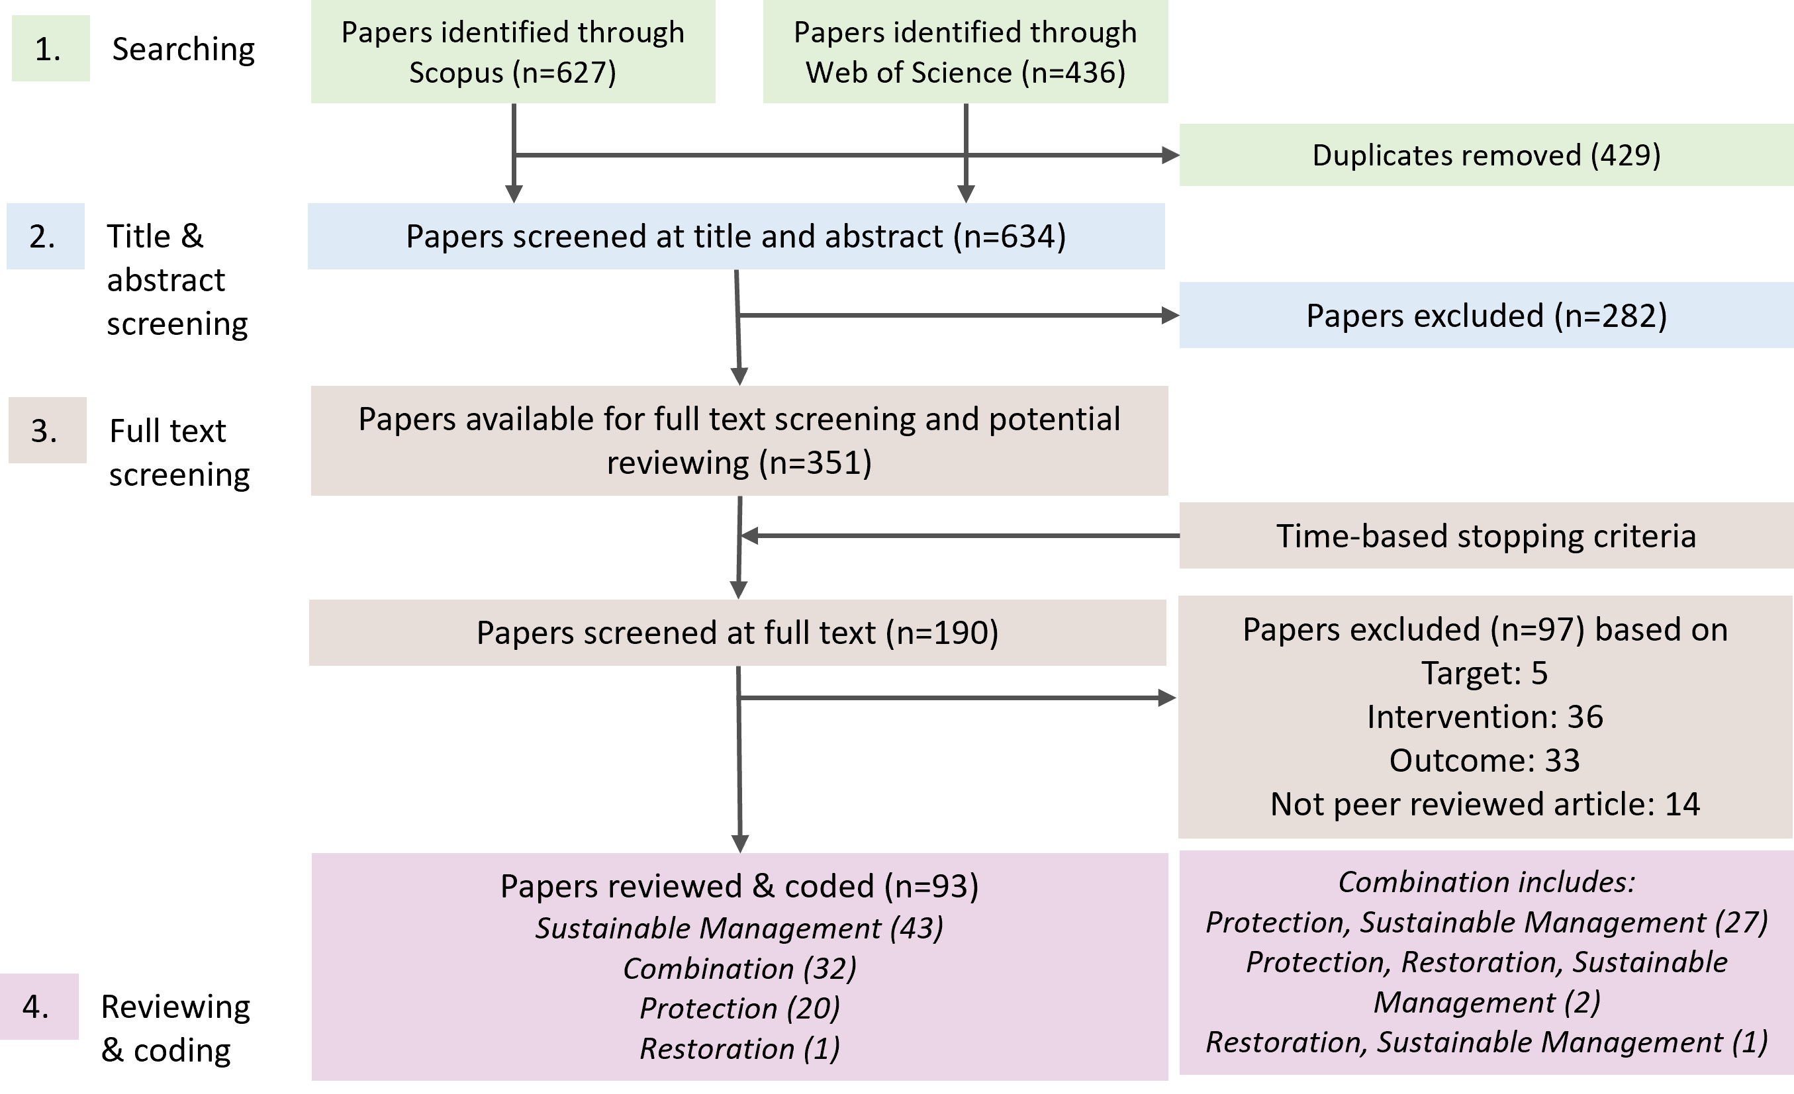
Supplementary 1 Fig. 1 Protocol for screening and reviewing the papers identified through a search of Scopus and Web of Science databases. We analysed (reviewed and coded in step 4) 93 papers identified for inclusion from an initial full set of 634 papers identified spanning the years 1960-2021.

Author affiliations
The authors had affiliations across 32 countries from 6 continents, but author affiliations were mostly from Southern Africa (87%), Europe (66%) and North America (34%), with a few from other African institutions (18%) (Supplementary 1 Fig. 2a).
Of those with Southern African author affiliations, most were South African (37%) or Zimbabwean (24%), followed by affiliations from Malawi, Madagascar, Zambia, Botswana, Namibia and Mozambique (1-10%) with zero affiliations from Angola, Eswatini, or Lesotho (Supplementary 1 Fig. 2b).
The lead author affiliations followed a similar distribution to all authors listed with most of the lead authors being based at institutions in Southern Africa (52%) (Supplementary 1 Fig. 2c) and with most of these coming from South Africa (28%) (Supplementary 1 Fig. 2d).

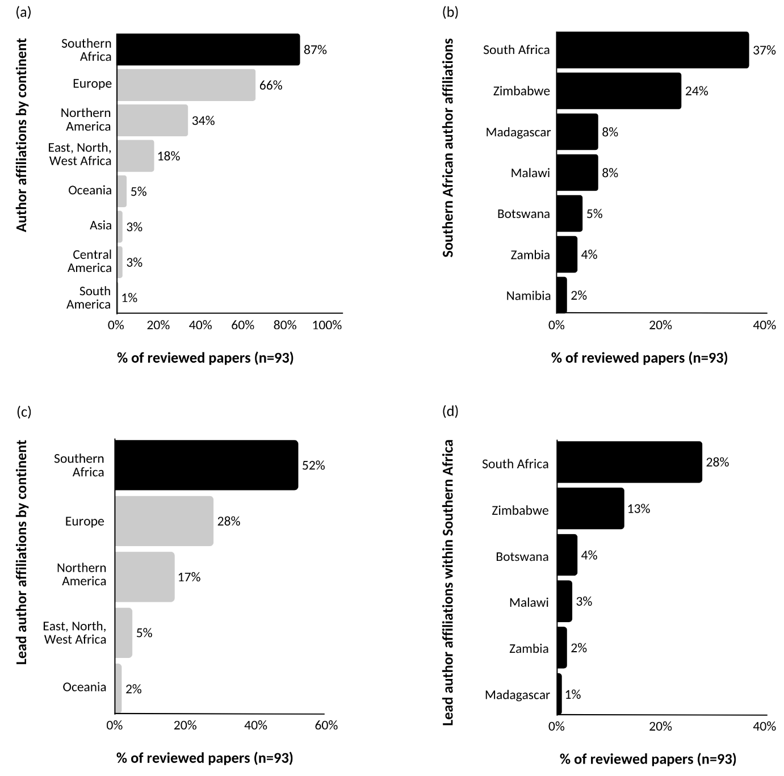
Supplementary Fig. 2 Author affiliations of research on inequitable impacts of NbS in Southern Africa a) All author affiliations of the reviewed studies grouped by continent; (b) Southern African all author affiliations grouped by countries; (c) Lead author affiliations of the reviewed studies grouped by continent; (d) Lead Southern African all author affiliations grouped by countries.

NbS location
Evidence of inequitable impacts was reported for NbS that had been implemented in all eleven focal southern African countries with the highest concentration being almost equal between South Africa (29%), Malawi (27%) and Zimbabwe (28%) (Main paper, Fig 4a). This was following by Madagascar, Mozambique, Zambia, Namibia and Botswana (12-18%) with few studies from Angola, Eswatini and Lesotho (2-3%).

NbS targeted societal challenges
The NbS reviewed in the papers were described as aiming to address a wide range of societal challenges (Main paper Fig 4b). Most of the NbS set out to address societal challenges related to local economic development, environmental degradation, unsustainable livelihoods, local social development, food security, and poverty. Just over a third of the NbS had a specific focus on biodiversity loss and 15-16% on climate change adaptation or mitigation. There were only a few examples associated with societal challenges related to human health, water security, energy security and disaster risk reduction (<11%). Almost all (92%) focused on addressing more than one societal challenge. A total of 50% aimed to address 5-8 different societal challenges. while 43% aimed to address 2-4 societal challenges.

Nature-based solution types
Most of the papers reviewed focused on sustainable management NbS types (46%), this was followed by a combination of NbS types (32%), protection (20%) and restoration (1%) (Main paper, Fig 1b). Studies reported on interventions in natural/semi-natural ecosystems (47%) and farming/cultural lands (27%), and a combination of these (26%) (Main paper Fig. 4c).
The most frequent actions under these main NbS types included protected areas (52%) (e.g., public, community, private, transboundary); sustainable natural resource management (40%) (e.g., harvesting regulations, agreements or quotas or designated natural resource use zones), followed by conservation agriculture (23%), agroforestry (23%) and sustainable forest management (22%). There were very few studies on inequitable NbS outcomes on sustainable rangeland management (7%), sustainable fire management (2%), or ecosystem restoration (including reforestation; 4%) (Main paper Fig. 4d).

Emerging themes in recommendations for enabling social equity in NbS
We present narratives for the six recurring themes that point to pathways for enabling social equity in NbS below. A synthesised table of these can be found in Supplementary 3 Table 3.

7.1 Represent multidimensional and pluralistic values and value systems
NbS should recognise and engage with multidimensional and pluralistic values. There is a need to frame potential NbS values from a reciprocal lens, with a focus on mutually beneficial, relational, and respectful engagement with nature and the environment. Integrating human-nature reciprocity and values that might be intangible, relational, cultural, and multispecies ^{1–3} provides an opportunity to strengthen deliberation around synergies and trade-offs to support the development of more equitable benefit sharing agreements. Biocultural values are particularly important for supporting intergenerational learning and for recognising people’s relationships with the environment beyond material benefits, including through religion, art, culture and sense of oneness ^{4,5}. However, in some contexts, particularly with high levels of poverty and in areas highly transformed or degraded, a stronger emphasis may be needed on livelihoods and socio-economic values where reciprocity is not the dominant way of relating to nature for those most vulnerable. NbS design and implementation should be women- and youth-centric to ensure these groups are not overlooked. This includes integrating sporting activities, crafts or religion-based aspects tied to contexts ⁶. There is a need for more research and practice on how community mobilisation, along with relational values, can strengthen social and community movements and challenge the broader inequalities that influence NbS across Africa ⁷.

7.2 Integrate diverse forms of knowledge and information as evidence
NbS planning and design should more deliberately embrace diverse forms of knowledge and information by elevating the role of transdisciplinary approaches and social science qualitative research, including participatory and arts-based forms, in generating evidence alongside natural science, quantitative and interdisciplinary approaches. This includes actively removing barriers which exist in discounting these approaches as valid forms of evidence. Here the calls for integrating science and Indigenous and Local Knowledge will not be achievable without the acceptance of social science qualitative, arts-based and interpretative approaches into mainstream natural science dominated scientific platforms ^{5,8}. In most cases the struggles to bring in other forms of non-scientific evidence parallel barriers that exist against qualitative social science approaches, particularly participatory and arts-based forms ^{9,10}.

7.3 Focus on locally relevant financial mechanisms, incentives, safety nets and land security
NbS funding should focus on building on and strengthening social networks and institutions at a local level. This includes exploring which financial management and mechanisms work to promote and sustain NbS at this level ¹¹. Here insurance and safety nets need to be actively considered within NbS design to ensure that those involved have a buffer during unpredictable extremes ¹². Monetary incentives can sometimes be critically important alongside non-rival and non-excludable NbS benefits, and NbS should find innovative ways to integrate these ^{13,14}. Incentives must be sufﬁcient and appropriate to support adoption and maintain participation over the medium to long term ¹⁵. Land security is equally important to ensure that those who invest in NbS can retain the benefits and, where this cannot be guaranteed, alternative measures should support those who may lose land after benefits accrue ¹². There should be a focus on polices and economic structures that can accommodate small-scale farm models including home and communal vegetable gardens and small-scale crop fields ¹⁶. Short- or longer-term opportunity costs need to be explicitly recognised. If NbS aim to decrease natural resource use, there is a need to ensure that households can access affordable alternatives ^{3,17–20}. Further there is a need to ensure that those who have lost out in past NbS interventions get adequately compensated in current and future interventions ²¹.

7.4 Create safe multi-actor networks and spaces for deliberating trade-offs and synergies
NbS should involve local communities and consider local contexts genuinely and comprehensively. This includes engaging in traditional structures and institutions and supporting local actors that already work within the local settings ^{22–24}. Planning processes should meaningfully capture local aspirations and needs, including priorities linked to poverty reduction ¹⁷. Locally important trade-offs should be made visible and deliberated within safe multi-actor spaces. Here attention should focus on bringing together the perceptions of community members and external actors around which benefits matter most and for whom ^{19,25–27}. It is likely that different community member’s views of equitable benefits may differ to each other and to other actors, emphasising the importance of exploring local cultural norms before deciding what is ‘equitable’ ^{10,28}. It is important to recognise that the full range of local actors and knowledge holders and givers might not be represented within traditional and formal governance institutions ²⁹. Success stories around managing and reducing power dynamics in engagements and partnerships are needed to show the transformative potential of NbS when power dynamics are adequately addressed and negotiations are fair ¹⁶.

7.5 Use facilitation to foster capability, collaboration, trust and transparency
NbS processes should invest in careful, transparent and well-facilitated engagement that builds trust over time through open, honest and regular communication ^{17,30,31}. Participation needs to be real, responsive and institutionalised, with clear communication of rules, expectations and resource use through locally trusted structures and leaders ^{32,33}. Proactive collaboration between local actors, external facilitators and interdisciplinary teams can help reduce misunderstandings and ease tensions between social and environmental goals ^{15,34}. At the same time, NbS should strengthen local capabilities in governance, financial management and organisational skills, while recognising that external support may still be needed in the short term and should be used to support community ownership and accountable local institutions ^{2,20,35–38}. NbS should empower representative local institutions that are both legitimate and accountable to their members and that have adequate capacity and structures for good governance ².

7.6 Focus on poverty and vulnerability
NbS should adopt an explicit focus on those most vulnerable including integrating poorer households, those with limited access to resources, and those facing compounding vulnerabilities within design and implementation processes ³⁹. This includes support such as subsidised access to inputs, pro-poor technologies and institutional arrangements, targeted incentives, and fair access to jobs and livelihood opportunities ^{17,40,41}. In many contexts, particularly highly transformed environments and low-income areas, NbS should first focus on social empowerment and economic development, with seemingly intangible climate and biodiversity benefits emerging as longer-term outcomes rather than starting points ⁴². NbS must also ensure that the costs of NbS are not shifted onto the poorest and most marginalised groups ⁴³.

References
1. Cundill, G., Bezerra, J. C., De Vos, A. & Ntingana, N. Beyond benefit sharing: Place attachment and the importance of access to protected areas for surrounding communities. Ecosystem Services 28, 140–148 (2017).
2. Scanlon, L. J. & Kull, C. A. Untangling the links between wildlife benefits and community-based conservation at Torra Conservancy, Namibia. Development Southern Africa 26, 75–93 (2009).
3. Ward, C., Stringer, L. & Holmes, G. Changing governance, changing inequalities: Protected area co-management and access to forest ecosystem services: a Madagascar case study. Ecosystem Services 30, 137–148 (2018).
4. Boonzaaier, C. & Wels, H. Juxtaposing a cultural reading of landscape with institutional boundaries: the case of the Masebe Nature Reserve, South Africa. Landscape Research 41, 922–933 (2016).
5. Constant, N. L. & Taylor, P. J. Restoring the forest revives our culture: Ecosystem services and values for ecological restoration across the rural-urban nexus in South Africa. Forest Policy and Economics 118, 102222 (2020).
6. Silva, J. A. & Mosimane, A. W. Conservation-Based Rural Development in Namibia: A Mixed-Methods Assessment of Economic Benefits. The Journal of Environment & Development 22, 25–50 (2012).
7. Hewitson, L. J. & Sullivan, S. Producing elephant commodities for ‘conservation hunting’ in Namibian communal-area conservancies. Journal of Political Ecology 28, (2021).
8. Llopis, J. C. et al. Year-to-year ecosystem services supply in conservation contexts in north-eastern Madagascar: Trade-offs between global demands and local needs. Ecosystem Services 48, 101249 (2021).
9. Llopis, J. C. et al. Capabilities Under Telecoupling: Human Well-Being Between Cash Crops and Protected Areas in North-Eastern Madagascar. Front. Sustain. Food Syst. 3, (2020).
10. Swemmer, L., Grant, R., Annecke, W. & Freitag-Ronaldson, S. Toward More Effective Benefit Sharing in South African National Parks. Society & Natural Resources 28, 4–20 (2015).
11. Senganimalunje, T. C., Chirwa, P. W., Babalola, F. D. & Graham, M. A. Does participatory forest management program lead to efficient forest resource use and improved rural livelihoods? Experiences from Mua-Livulezi Forest Reserve, Malawi. Agroforest Syst 90, 691–710 (2016).
12. Branca, G. et al. Assessing the economic and mitigation benefits of climate-smart agriculture and its implications for political economy: A case study in Southern Africa. Journal of Cleaner Production 285, 125161 (2021).
13. Groom, B. & Palmer, C. REDD+ and rural livelihoods. Biological Conservation 154, 42–52 (2012).
14. Sommerville, M., Jones, J. P. G., Rahajaharison, M. & Milner-Gulland, E. J. The role of fairness and benefit distribution in community-based Payment for Environmental Services interventions: A case study from Menabe, Madagascar. Ecological Economics 69, 1262–1271 (2010).
15. Suich, H. The effectiveness of economic incentives for sustaining community based natural resource management. Land Use Policy 31, 441–449 (2013).
16. Crane, W. Biodiversity conservation and land rights in South Africa: Whither the farm dwellers? Geoforum 37, 1035–1045 (2006).
17. Frost, P. et al. In Search of Improved Rural Livelihoods in Semi-Arid Regions through Local Management of Natural Resources: Lessons from Case Studies in Zimbabwe. World Development 35, 1961–1974 (2007).
18. Neudert, R. et al. Opportunity costs of conserving a dry tropical forest under REDD+: The case of the spiny dry forest in southwestern Madagascar. Forest Policy and Economics 95, 102–114 (2018).
19. Rodenburg, J., Büchi, L. & Haggar, J. Adoption by adaptation: moving from Conservation Agriculture to conservation practices. International Journal of Agricultural Sustainability 19, 437–455 (2021).
20. Zulu, L. Bringing People Back into Protected Forests in Developing Countries: Insights from Co-Management in Malawi. Sustainability 5, 1917–1943 (2013).
21. Du-Pont, T., Vilakazi, C. M. N., Thondhlana, G. & Vedeld, P. Livestock income and household welfare for communities adjacent to the Great Fish River Nature Reserve, South Africa. Environmental Development 33, 100508 (2020).
22. Ajayi, O. C., Akinnifesi, F. K. & Ajayi, A. O. How by-laws and collective action influence farmers’ adoption of agroforestry and natural resource management technologies: lessons from Zambia. Forests, Trees and Livelihoods 25, 102–113 (2016).
23. Dhital, N., Vololomboahangy, R. R. & Khasa, D. P. Issues and challenges of forest governance in Madagascar. Canadian Journal of Development Studies / Revue canadienne d’études du développement 36, 38–56 (2015).
24. Mutekwa, V. T. & Gambiza, J. Forest protected areas governance in Zimbabwe: Shift needed away from a long history of local community exclusion. Journal of Environmental Management 198, 330–339 (2017).
25. Farnworth, C. R. et al. Gender and conservation agriculture in East and Southern Africa: towards a research agenda. International Journal of Agricultural Sustainability 14, 142–165 (2015).
26. Mutanga, C. N., Muboko, N. & Gandiwa, E. Protected area staff and local community viewpoints: A qualitative assessment of conservation relationships in Zimbabwe. PLOS ONE 12, e0177153 (2017).
27. Queiros, D. & Mearns, K. Khanyayo village and Mkhambathi Nature Reserve, South Africa: a pragmatic qualitative investigation into attitudes towards a protected area. Journal of Sustainable Tourism 27, 750–772 (2019).
28. Ward, C., Stringer, L. C. & Holmes, G. Protected area co-management and perceived livelihood impacts. Journal of Environmental Management 228, 1–12 (2018).
29. Mashapa, C., Gandiwa, E. & Muboko, N. Socio-economic and ecological outcomes of woodland management in mutema-musikavanhu communal areas in save valley, southeastern lowveld of zimbabwe. in (2019).
30. Dahlberg, A. C. & Burlando, C. Addressing Trade-offs: Experiences from Conservation and Development Initiatives in the Mkuze Wetlands, South Africa. Ecology and Society 14, (2009).
31. Snyman, S. Partnership between a private sector ecotourism operator and a local community in the Okavango Delta, Botswana: the case of the Okavango Community Trust and Wilderness Safaris. Journal of Ecotourism 13, 110–127 (2014).
32. Mutamba, E. Community Participation in Natural Resources Management: Reality or Rhetoric? Environ Monit Assess 99, 105–113 (2004).
33. Robertson, J. & Lawes, M. J. User perceptions of conservation and participatory management of iGxalingenwa forest, South Africa. Environmental Conservation 32, 64–75 (2005).
34. Gezon, L. L. Who wins and who loses? Unpacking the “local people” concept in ecotourism: a longitudinal study of community equity in Ankarana, Madagascar. Journal of Sustainable Tourism 22, 821–838 (2014).
35. Balint, P. J. & Mashinya, J. The decline of a model community-based conservation project: Governance, capacity, and devolution in Mahenye, Zimbabwe. Geoforum 37, 805–815 (2006).
36. Chinsamy, M. & Koitsiwe, M. Indigenous Knowledge-based Vegetable Garden Projects for Poverty Alleviation in South Africa. Journal of Social Sciences 46, 137–145 (2016).
37. Hlengwa, D. C. & Maruta, A. A framework for facilitation of community participation in and beneficiation from CBT around the Save Valley Conservancy. African Journal of Hospitality, Tourism and Leisure (2020).
38. Manyena, S. B., Collins, A. E., Mudimba, F. & Mudimba, D. ‘Are You Serious to Ask Me about Who Owns Wildlife?’ Politics of Autonomy over Wildlife Resources in the Zambezi Valley, Zimbabwe. Forum for Development Studies 40, 87–109 (2013).
39. Makate, C., Makate, M., Mango, N. & Siziba, S. Increasing resilience of smallholder farmers to climate change through multiple adoption of proven climate-smart agriculture innovations. Lessons from Southern Africa. Journal of Environmental Management 231, 858–868 (2019).
40. Makate, C., Makate, M. & Mango, N. Wealth-related inequalities in adoption of drought-tolerant maize and conservation agriculture in Zimbabwe. Food Sec. 11, 881–896 (2019).
41. Spenceley, A. & Goodwin, H. Nature-Based Tourism and Poverty Alleviation: Impacts of Private Sector and Parastatal Enterprises In and Around Kruger National Park, South Africa. Current Issues in Tourism 10, 255–277 (2007).
42. Mbaiwa, J. E. The Success and Sustainability of Community-Based Natural Resource Management in the Okavango Delta, Botswana. South African Geographical Journal 86, 44–53 (2004).
43. Ward, C., Holmes, G. & Stringer, L. Perceived barriers to and drivers of community participation in protected-area governance. Conserv Biol 32, 437–446 (2018).

