Supplemental Tables & Figures:

Title: Dimeric architecture and membrane thinning govern substrate recognition by human signal peptide peptidase

Authors: Owain J. Bryant^{1,2}, Nikita Sergejevs³, Fiorin Giacomo⁴, Jacob Robson-Tull², Justin C. Deme², Lucy R. Forrest⁴, Pedro Carvalho³*, Susan M. Lea^{1,2,}*

Affiliations:
¹Structural Biology, St Jude Children’s Research Hospital, Memphis, TN 38105, USA.
²Center for Structural Biology, Center for Cancer Research, National Cancer Institute, Frederick, MD 21702, USA.
³Sir William Dunn School of Pathology, University of Oxford, Oxford, UK.
⁴Computational Structural Biology Section, National Institute of Neurological Disorders and Stroke, National Institutes of Health, Bethesda, MD 20892.

Lead author: susan.lea@stjude.org
*Correspondence to: pedro.carvalho@path.ox.ac.uk; susan.lea@stjude.org

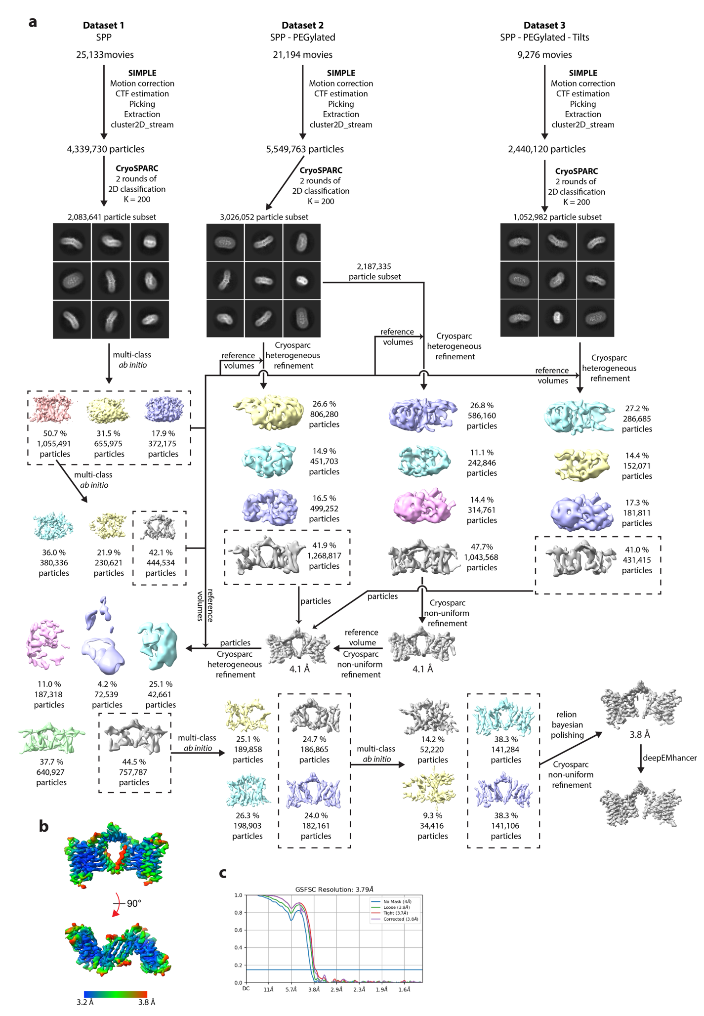
Figure S1. Cryo-EM workflows for apo Human SPP.
a, Image processing workflow. b, Local resolution estimate of the volume. c, Gold-standard Fourier Shell Correlation (FSC) curves used for global resolution estimation.

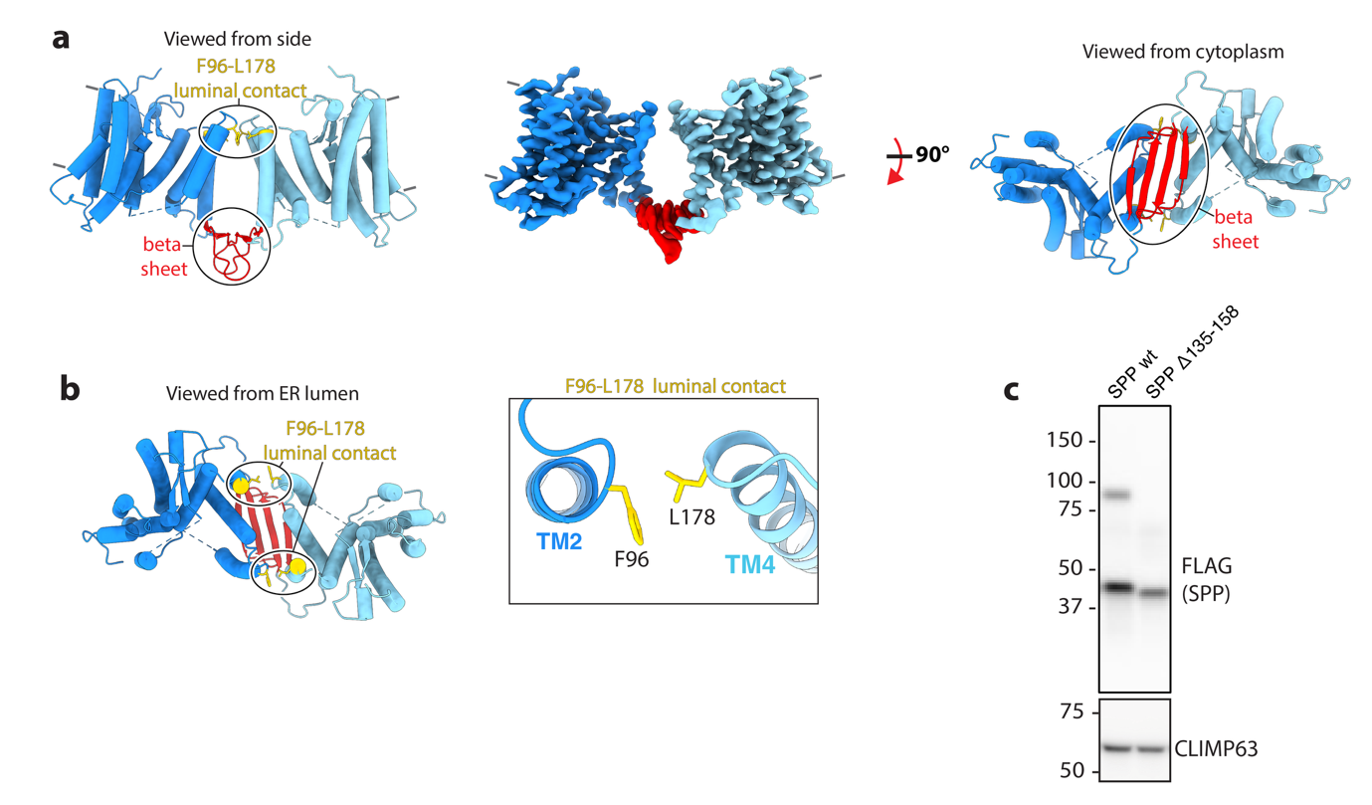
Figure S2. A β-sheet on the cytoplasmic side of the ER membrane is required for SPP dimer formation.
a, Cartoon representation of the SPP dimer (blue) viewed from the membrane (top left) or viewed from the cytoplasm (top right). The β-sheet is coloured red and the Phenylalanine-96 – Leucine-178 contact is coloured in gold. Cryo-EM volume of the SPP dimer (bottom left, contour level 0.19) viewed from the plane of the membrane.
b, Cartoon representation of the SPP dimer (blue) viewed from luminal side of the membrane.. The β-sheet is coloured red and the Phenylalanine-96 – Leucine-178 contact is coloured in gold.
c, Whole cell levels of wild type SPP and a β-sheet deletion variant of SPP. HEK293 SPP T-Rex Flip In knock out cells (ΔSPP) were transfected with vectors encoding either FLAG-tagged wild type SPP (SPP wild type) or the β-sheet deletion variant of SPP (SPP Δ135-158) and incubated for 48 hours. Proteins from whole cell fractions were detected by immunoblotting. CLIMP63 was used as a loading control.

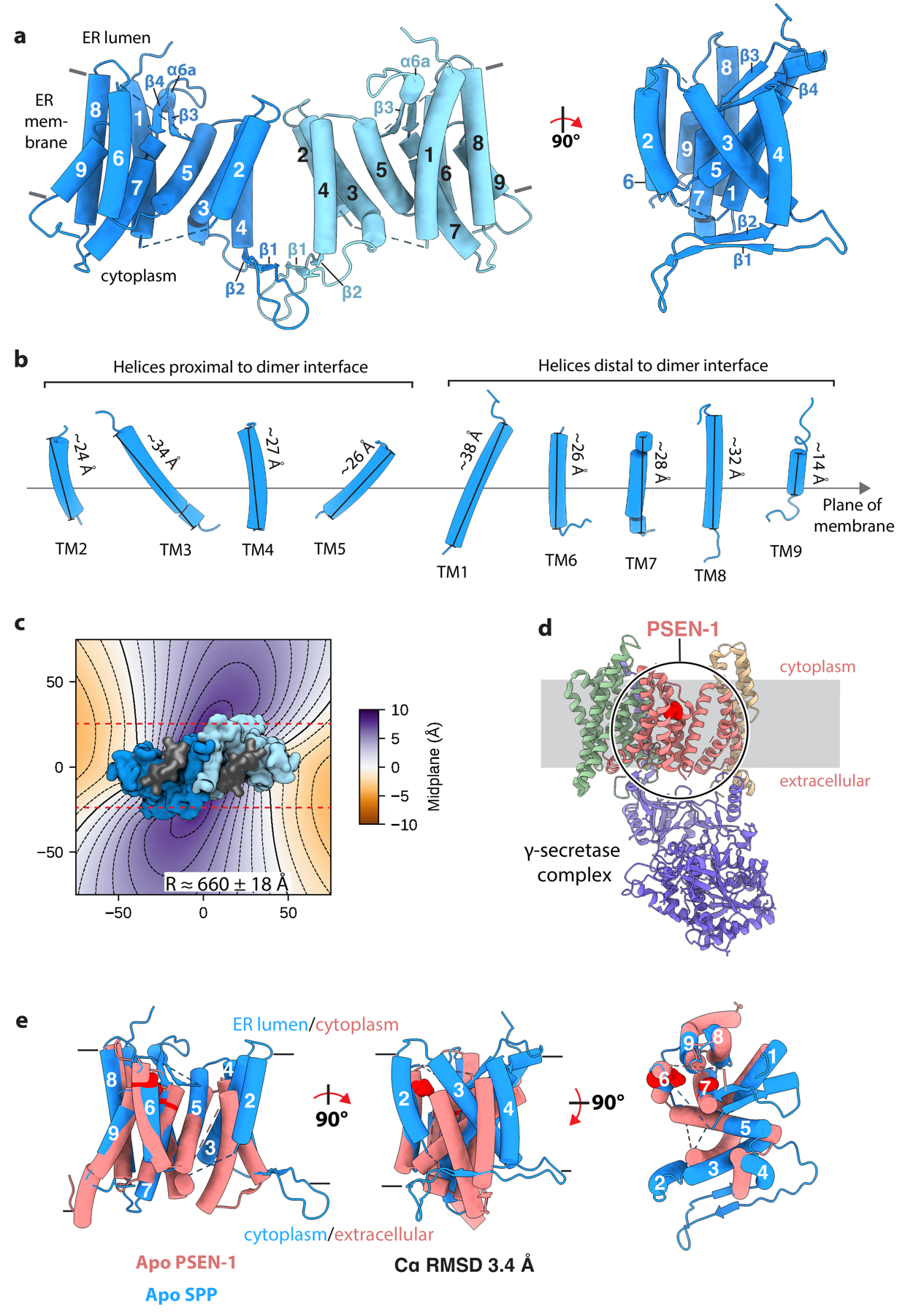
Figure S3. TM tilting leads to thinning of the detergent micelle around SPP and structural alignments of SPP and Presenilin-1.
a, Cartoon representation of the apo SPP dimer (blue, left) or single copy of SPP (blue, right) viewed from the membrane with TM’s and β-strands numbered as indicated.
b, All nine TM’s of SPP viewed in isolation with the length of each TM shown.
c, Curvature of the membrane’s midplane around the apo SPP dimer from coarse-grained MD simulations; the solid contour line indicates the midplane’s average position, and dashed lines are in 1 Å increments; modeled protein regions are in dark gray. The radius of curvature in each system was estimated within the band defined by magenta dashed lines; see Methods.
d, Cartoon model of the human gamma secretase complex (PDB 5A63; left), composed of the SPP homologue Prenesilin-1 (PSEN-1, red), APH-1 (green), Nicastrin (purple) and presenilin enhancer 2 (PEN-2, brown). Catalytic aspartate residues within the SPP homologue Prenesilin-1 (PSEN-1) are coloured in red and depicted as spheres.
e, Structural alignment of the SPP model presented in this study (blue) against the model of Prenesilin-1 (red; PDB 5A63). Residues 182-333 of SPP were used for alignment. Alignments and RMSD were calculated using the MatchMaker command in ChimeraX.

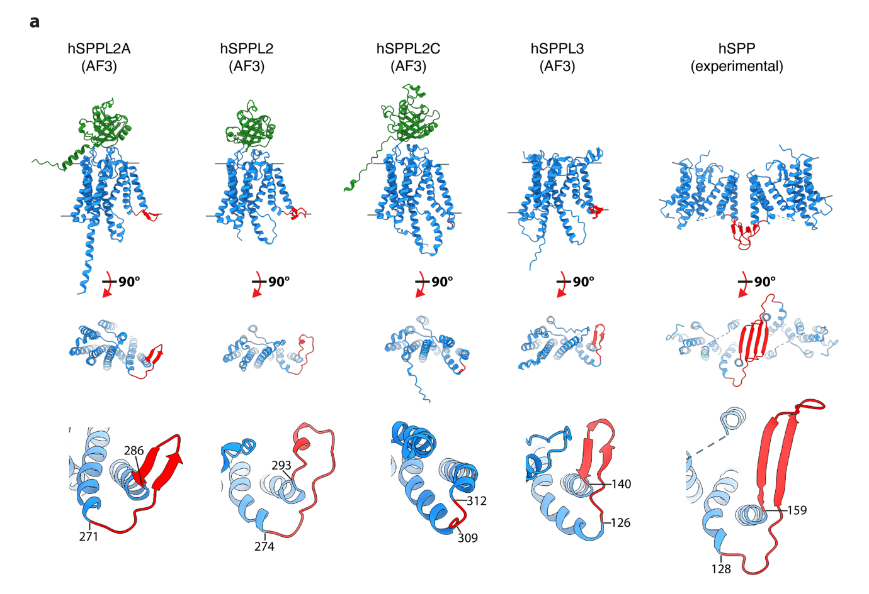
Figure S4. SPP contains a large insertion between TM3 and TM4 that forms a β-sheet.
a, AlphaFold 3.0 predictions of human SPPL2A, SPPL2B, SPPL2C and SPPL3, and the cryo-EM structure of human SPP viewed from the plane from the membrane (top) or from the cytoplasm (middle and bottom). Insertions between TM3 and TM4 are coloured in red. Extramembrane domains of SPPL2A, SPPL2B and SPPL2C are coloured in green.

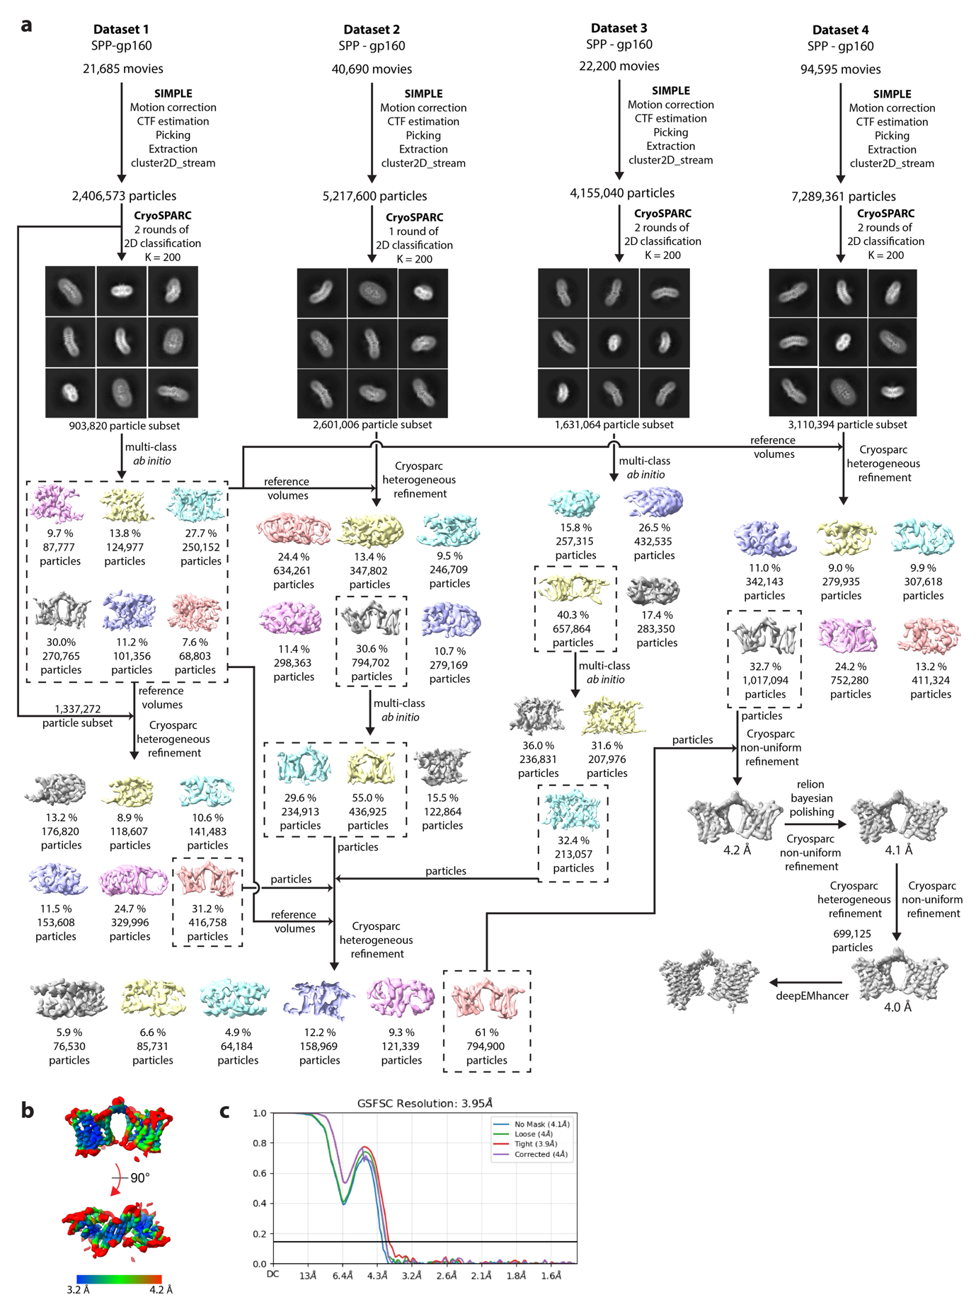
Figure S5. Cryo-EM workflows for the Human SPP-D265A – gp160 signal peptide complex.
a, Image processing workflow. b, Local resolution estimate of the volume. c, Gold-standard Fourier Shell Correlation (FSC) curves used for global resolution estimation.

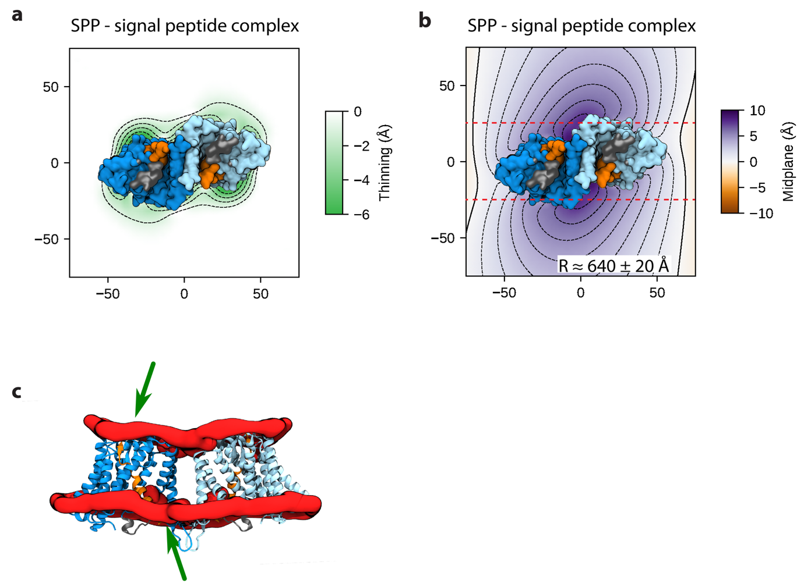
Figure S6. Membrane perturbations around SPP from coarse-grained molecular dynamics simulations.
a, Simulations of substrate-bound SPP. SPP (blues, with AlphaFold modeled regions in gray) and substrate signal peptide (orange) are shown as a surface. Local map of the bilayer thickness around the protein, as shown also in Fig. 1(e). Each dashed line is 1 Å thinner than the average bilayer thickness.
b, Two-dimensional maps of the curvature the lipid bilayer’s midplane in a 150×150 Å² section around the protein. The solid contour line represents the average midplane position, and each dashed line indicates a 1 Å increment above or below that position. The radius of curvature in each system was estimated within the band defined by magenta dashed lines; see Methods.
c, Density of the lipid phosphate groups near the protein; green arrows point to regions where lipid phosphate groups retract into the hydrophobic core, further decreasing membrane thickness.

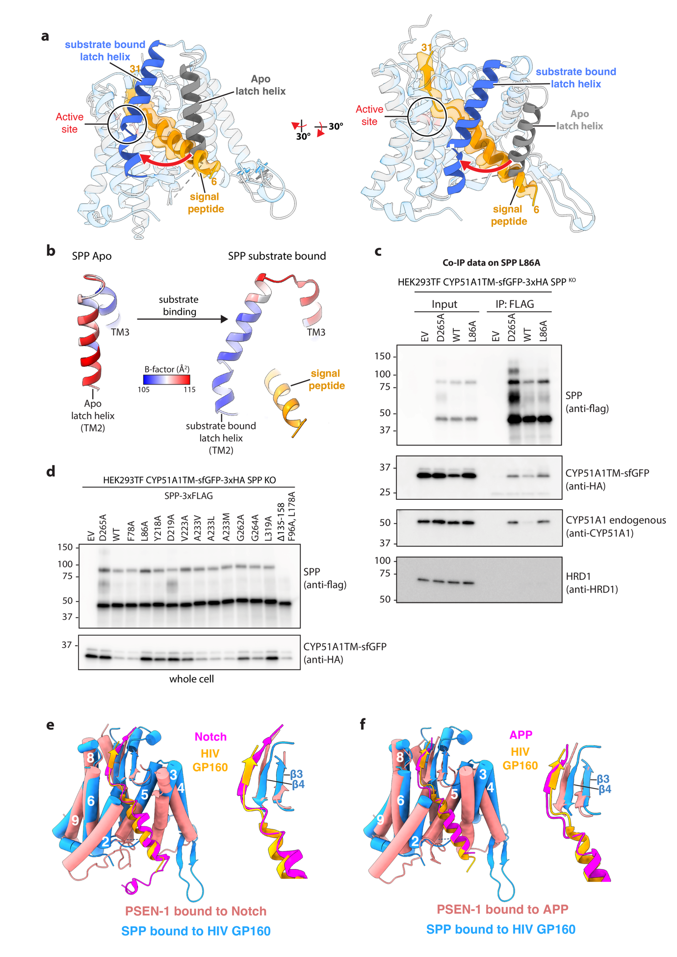
Figure S7. The SPP latch helix (TM2) rearranges to secure the substrate in place for cleavage.
a, Structural alignment of the apo- (grey) and signal peptide SPP complexes (blue and orange). One SPP-signal peptide unit viewed from the plane of the membrane. The HIV gp160 signal peptide is shown in the cryo-EM volume (transparent orange surface). The location of the catalytic aspartate residues are highlighted in red. (arrow shows movement of the latch helix upon signal peptide binding).
b, The ordering of the SPP latch helix (TM2) increases on signal peptide binding. Cartoon representation of SPP coloured by B factors for the apo (left) and gp160 signal peptide-bound (right) SPP complexes. Signal peptide is coloured in orange.
c, The ability of the SPP-L86A mutant to bind substrate molecules was assessed by asking whether residues 1-61 of CYP51A1 fused to sfGFP and endogenous CYP51A1 is pulled down by the resin-immobilised SPP_FLAG. Proteins were detected by immunoblotting. The inactive SPP(D265A) variant was used as a positive control and the active wild type SPP (which would process any signal peptide that binds) was used as a negative control. HRD1 was immunoblotted as a loading control for the Input fractions.
d. Proteins in whole cell fractions of cells used for Flow cytometry experiments shown in Fig. 2G and 3D-3E were detected by immunoblotting.
e, Structural alignment of the SPP-D265A – gp160 signal peptide model presented in this study (SPP: blue, gp160: orange) against the model of Prenesilin-1 (PSEN-1) bound to Notch (PSEN-1: red, Notch: pink; PDB 6IDF) or f, the model of Prenesilin-1 (PSEN-1) bound to APP (red: PSEN-1, APP: pink; PDB 8X54)

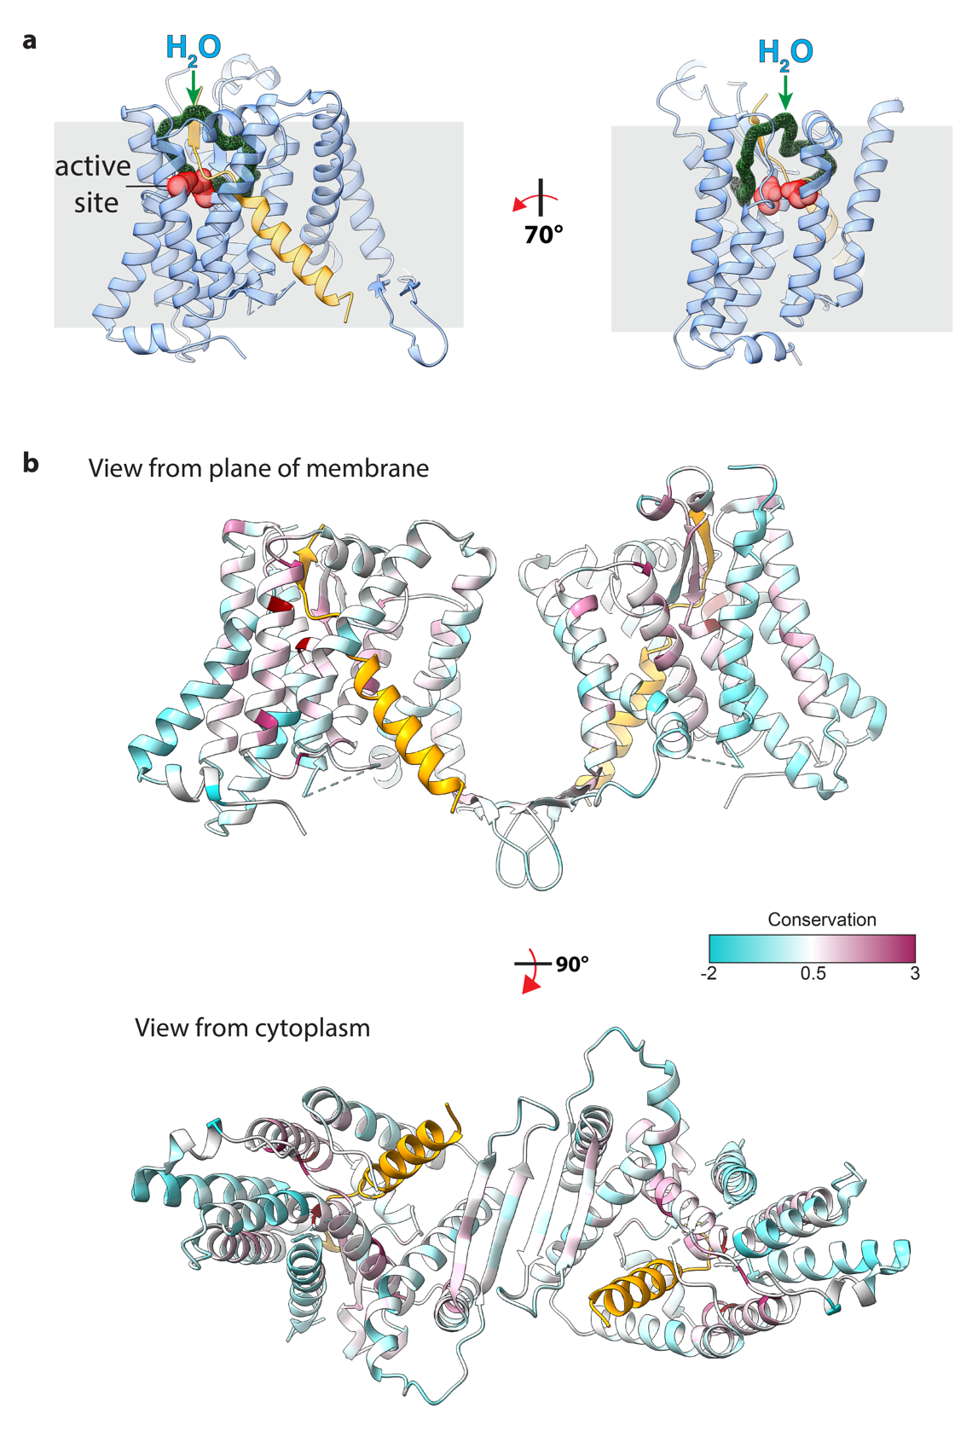
Figure S8. A water channel in SPP allows the access of water molecules to active site in the membrane.
a, Cartoon model of a single SPP subunit, water channels were identified with CAVER and visualised as a mesh (green). The location of the catalytic aspartate residues are depicted as spheres. b, The degree of sequence conservation is color-coded, with the cyan and maroon colors indicating low and high degrees of conservation, respectively. The conservation map was generated using ChimeraX.

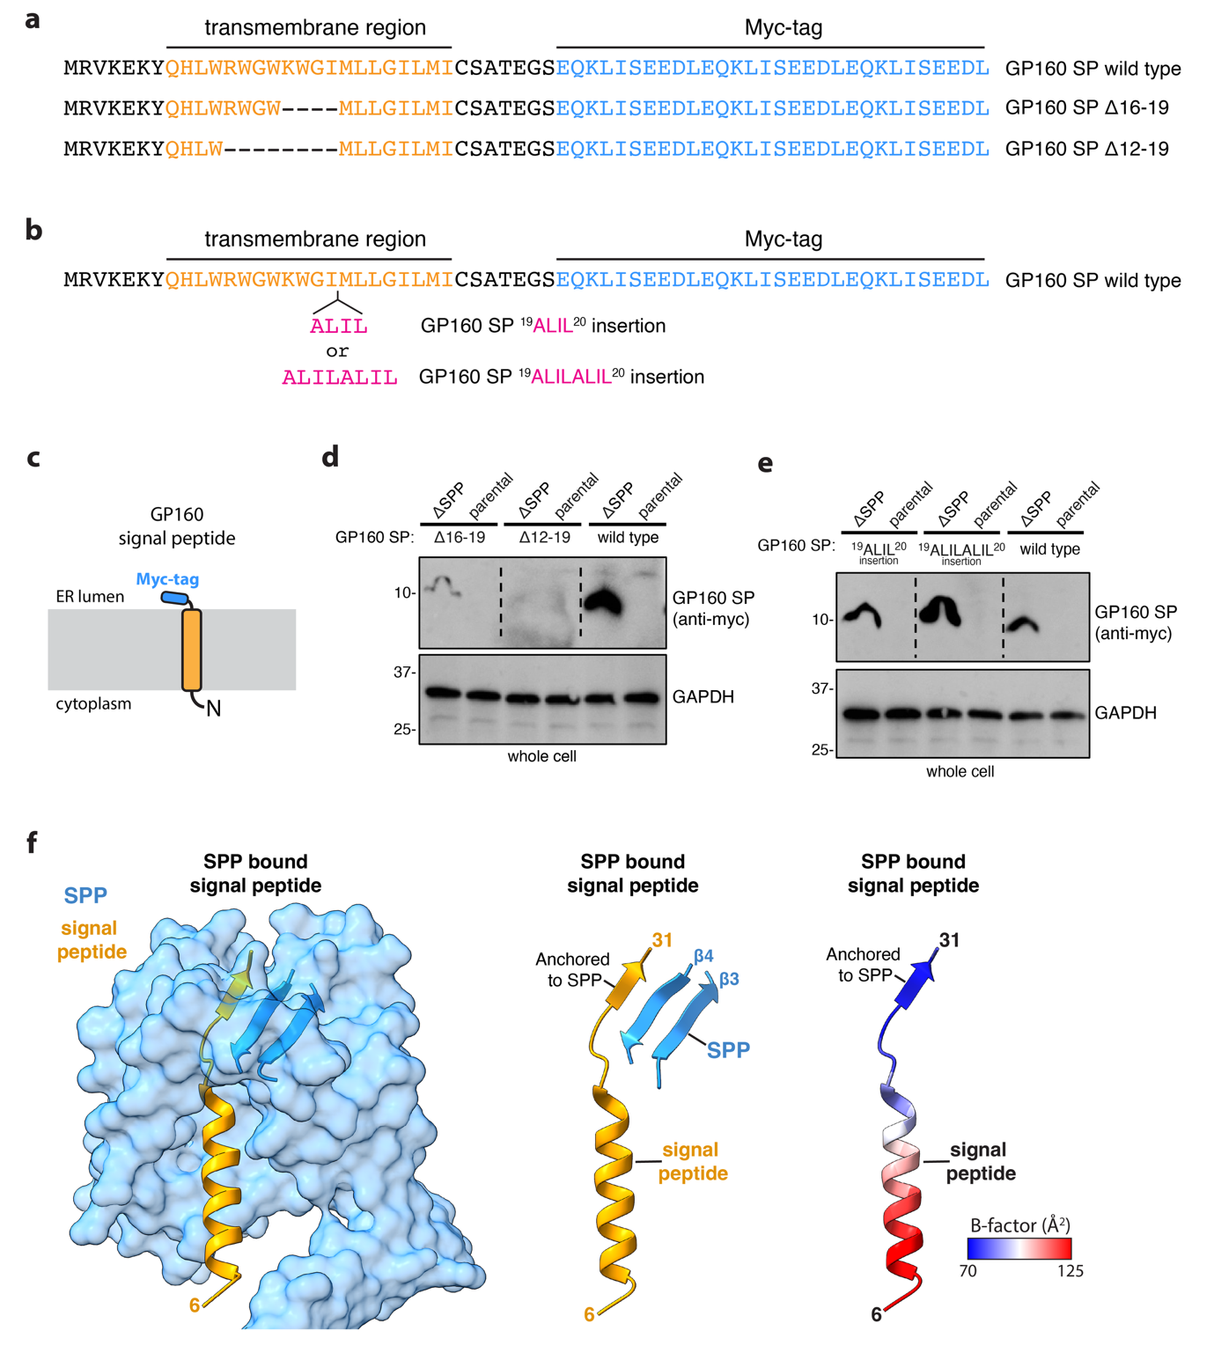
Figure S9. Processing of HIV gp160 signal peptide variants by SPP.
a, Sequences of the signal peptide of wild type HIV gp160 and its deletion variants variant. The transmembrane region is highlighted in orange and the C-terminal Myc-tag coloured in blue.
b, Sequences of the signal peptide of wild type HIV gp160 and its insertion variants. The transmembrane region is highlighted in orange and the C-terminal Myc-tag coloured in blue.
c, Schematic of the HIV GP160 signal peptide.
d-e, Processing of signal peptide mutants by SPP was assessed by reconstituting activity in HEK293 cells. HEK293 T-Rex Flip In SPP knock out cells (ΔSPP) and HEK293 T-Rex Flip In parental cells (parental) were transfected with vectors encoding wild type signal peptide of HIV gp160 or its variants and incubated for 48 hours. Proteins from whole cell fractions were detected by immunoblotting. GAPDH was used as a loading control.
f, Structure of a single unit of the SPP-D265A – HIV gp160 signal peptide complex. SPP (blue) is depicted as a semi-transparent surface and residues 240-245 and 256-262 depicted as a cartoon (blue, left and middle). The HIV gp160 signal peptide is coloured in orange. Cartoon representation of the SPP-bound HIV gp160 signal peptide coloured by B factors.

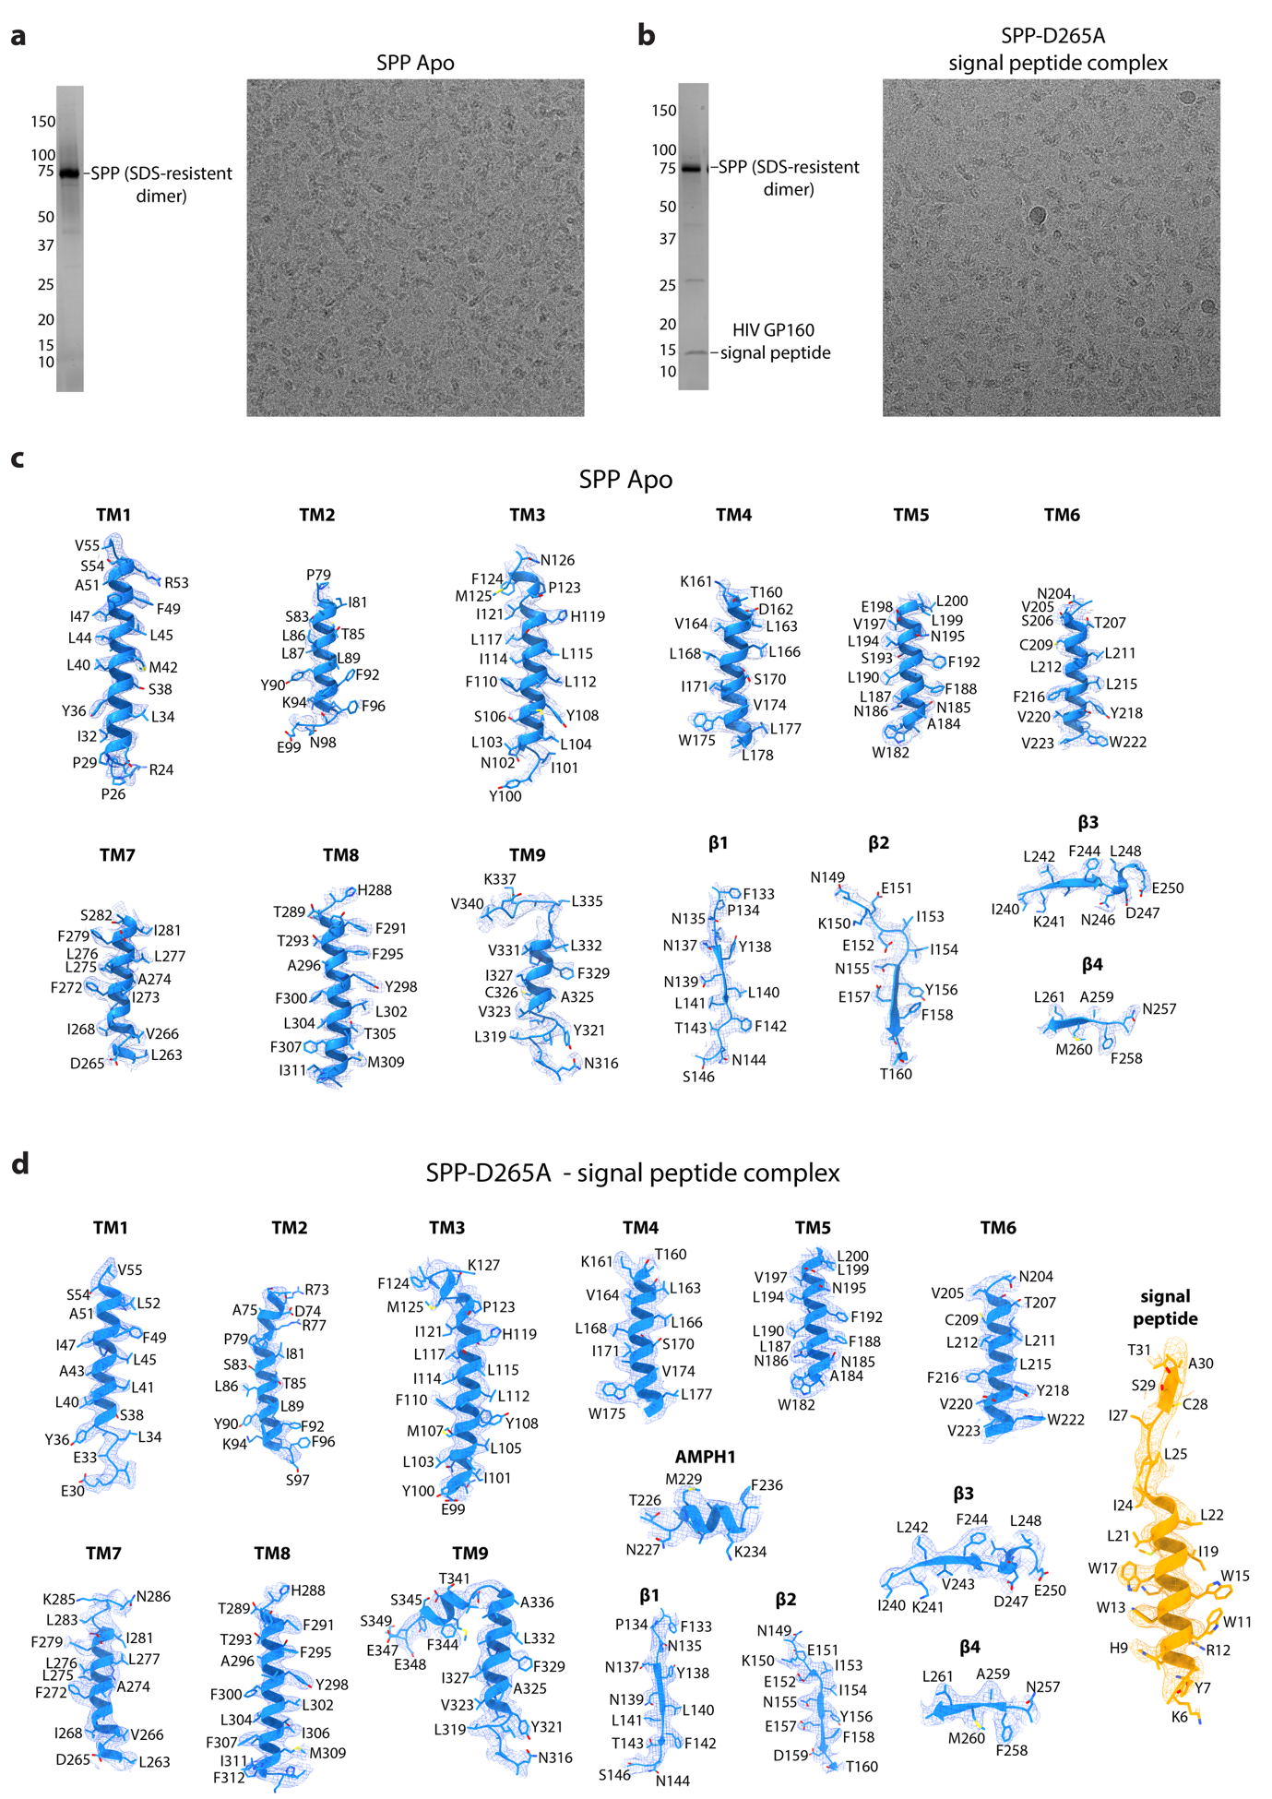
Figure S10. EM density maps for the TMs and β-strands of the apo and substrate bound SPP complexes.
a, Coomassie stained SDS-PAGE gel (left) of the apo SPP sample and a representative micrograph (right).
b, Coomassie stained SDS-PAGE gel (left) of the SPP-D265A – HIV gp160 signal peptide sample and a representative micrograph (right).
c, The EM density maps for the apo SPP dimer. Models (blue) are shown in the cryo-EM volumes (semi-transparent, blue).
d, The EM density maps for the SPP-D265A – gp160 HIV complex. Models (SPP: blue, signal peptide: orange) are shown in the cryo-EM volumes (semi-transparent, blue and orange).

Table S1. Cryo-EM data collection, refinement, and validation statistics

 | SPP  (EMDB-75261)  (PDB 10LC) | SPP-D265A – gp160 signal peptide  (EMDB-75262)  (PDB 10LF)
Data collection and processing
Magnification | 165,000 | 165,000
Voltage (kV) | 300 | 300
Electron exposure (e–/Å²) | 54.2-56.3 | 51.1-62.9
Defocus range (μm) | -2.0 to -0.5 | -2.0 to -0.5
Pixel size (Å) | 0.732 | 0.732
Symmetry imposed | C2 | C1
Initial particle images (no.) | 12,329,613 | 19,068,574
Final particle images (no.) | 282,390 | 794,900
Map resolution (Å)  FSC threshold | 3.8  0.143 | 4.0  0.143
Map resolution range (Å) | 3.1-49.8 | 3.2-33.2
Refinement
Model resolution (Å)  FSC threshold | 4.0  0.5 | 4.2  0.5
Map sharpening B factor (Å²) | deepEMhancer | deepEMhancer
Model composition  Non-hydrogen atoms  Protein residues  Ligands | 4402  556  0 | 5334  670  0
B factors (Å²)  Protein  Ligand | 64.9  --- | 87.9  ---
R.m.s. deviations  Bond lengths (Å)  Bond angles (°) | 0.003  0.574 | 0.003  0.620
Validation  MolProbity score  Clashscore  Poor rotamers (%) | 2.25  7.28  2.95 | 2.26  7.89  4.93
Ramachandran plot  Favored (%)  Allowed (%)  Disallowed (%) | 91.9  8.1  0.0 | 95.6  4.4  0.0
CC (mask) | 0.71 | 0.71

Table S2. Cell lines and Plasmids used in study
Cell lines | Description | Source/Reference
Lenti-X 293T | HEK293T derivative selected for high-titer lentivirus production. | Takara/Clontech, Cat# 632180
HEK-293S GnTI⁻ Tet^{R} | Modified HEK293 cell line engineered for inducible protein expression in suspension | DOI: 10.1073/pnas.212519299
HEK293 T-Rex Flip In | Modified HEK293 cell line engineered for inducible protein expression, featuring a stable, single integration site (FRT) for precise gene insertion. | Invitrogen (Thermo Fisher Scientific), Cat# R78007
HEK293 T-Rex Flip In ΔSPP | Modified HEK293 cell line engineered for inducible protein expression, featuring a stable, single integration site (FRT) for precise gene insertion and deleted for the gene encoding SPP. | DOI: 10.1242/jcs.262333
HEK293 T-Rex Flip In ΔSPP_CYP51A1TM–sfGFP_3xHA | Modified HEK293 cell line featuring a stable inserted CYP51 1-61_sfGFP_3xHA integrated into the site FRT site for Tetracycline inducible expression and deleted for the gene encoding SPP. | DOI: 10.1242/jcs.262333
Plasmid | Description | Source/Reference
pMD2.G | lentiviral envelope plasmid | Addgene, Cat# 12259
psPAX2 | lentiviral packaging plasmid | Addgene, Cat# 12260
pHR-CMV-TetO₂ | Transfer plasmid containing CMV promoter. | DOI: 10.1038/s41596-018-0075-9
pHR-CMV-TetO₂ SPP-TEV_mVenus_Twin-Strep | Transfer plasmid carrying gene encoding wild type human SPP and a C-terminal TEV-mVenus -Twin-Strep tag fusion | This study
pHR-CMV-TetO₂ SPP_D265A_Twin-Strep | Transfer plasmid carrying the gene encoding human SPP containing an Asp-265 to Ala mutation and a C-terminal Twin-Strep tag | This study
pHR-CMV-TetO₂ gp160_1-32_(His)₆ | Transfer plasmid carrying the gene encoding residues 1-32 of gp160 (from Human Immunodeficiency Virus (HIV)) and a C-terminal hexa-His tag. | This study
pHR-CMV-TetO₂ gp160_1-32_Myc | Transfer plasmid carrying the gene encoding residues 1-32 of gp160 (from Human Immunodeficiency Virus (HIV)) and a C-terminal Myc tag. | This study
pHR-CMV-TetO₂ CYP51A1_1-61_Myc | Transfer plasmid carrying the gene encoding residues 1-61 of human CYP51A1 and a C-terminal Myc tag. | This study
pHR-CMV-TetO₂ SPP_3xFLAG | Transfer plasmid carrying the gene encoding wild type human SPP and a C-terminal TEV-Twin-Strep tag | This study
pHR-CMV-TetO₂ SPP_D265A_3xFLAG | Transfer plasmid carrying the gene encoding human SPP containing an Asp-265 to Ala mutation and a C-terminal 3xFLAG tag | This study
pHR-CMV-TetO₂ SPP_Δ135-156_3xFLAG | Transfer plasmid carrying the gene encoding human SPP containing deleted for sequence encoding residues 135-156 and a C-terminal 3xFLAG tag | This study
pHR-CMV-TetO₂ SPP-L86A-TEV-3xFLAG | Transfer plasmid carrying the gene encoding human SPP containing a Leu 86 to Ala mutation and a C-terminal TEV-3xFLAG tag | This study
pHR-CMV-TetO₂ gp160_1-32_G23A_Myc | Transfer plasmid carrying the gene encoding residues 1-32 of gp160 (from Human Immunodeficiency Virus (HIV)) containing an Gly-23 to Ala mutation and a C-terminal Myc tag. | This study
pHR-CMV-TetO₂ gp160_1-32_G23P_Myc | Transfer plasmid carrying the gene encoding residues 1-32 of gp160 (from Human Immunodeficiency Virus (HIV)) containing an Gly-23 to Pro mutation and a C-terminal Myc tag. | This study
pHR-CMV-TetO₂ gp160_1-32_I24A_Myc | Transfer plasmid carrying the gene encoding residues 1-32 of gp160 (from Human Immunodeficiency Virus (HIV)) containing an Iso-24 to Ala mutation and a C-terminal Myc tag. | This study
pHR-CMV-TetO₂ gp160_1-32_L25A_Myc | Transfer plasmid carrying the gene encoding residues 1-32 of gp160 (from Human Immunodeficiency Virus (HIV)) containing an Leu-25 to Ala mutation and a C-terminal Myc tag. | This study
pHR-CMV-TetO₂ gp160_1-32_M26A_Myc | Transfer plasmid carrying the gene encoding residues 1-32 of gp160 (from Human Immunodeficiency Virus (HIV)) containing an Met-26 to Ala mutation and a C-terminal Myc tag. | This study
pHR-CMV-TetO₂ gp160_1-32_I27A_Myc | Transfer plasmid carrying the gene encoding residues 1-32 of gp160 (from Human Immunodeficiency Virus (HIV)) containing an Iso-27 to Ala mutation and a C-terminal Myc tag. | This study
pHR-CMV-TetO₂ gp160_1-15_20-31_Myc (gp160_Δ16-19) | Transfer plasmid carrying the gene encoding residues 1-15 fused to residues 20-31of gp160 (from Human Immunodeficiency Virus (HIV)) containing a C-terminal Myc tag. | This study
pHR-CMV-TetO₂ gp160_1-11_20-31_Myc (gp160_Δ12-19) | Transfer plasmid carrying the gene encoding residues 1-11 fused to residues 20-31of gp160 (from Human Immunodeficiency Virus (HIV)) containing a C-terminal Myc tag. | This study
pHR-CMV-TetO₂ gp160_1-19_ALIL_20-31_Myc (gp160_¹⁹ALIL²⁰) | Transfer plasmid carrying the gene encoding residues 1-32 of gp160 (from Human Immunodeficiency Virus (HIV)) containing an Ala-Leu-Iso-Leu insertion between residues 19 and 20 and a C-terminal Myc tag. | This study
pHR-CMV-TetO₂ gp160_1-19_ALILALIL_20-31_Myc (gp160_¹⁹ALIL²⁰) | Transfer plasmid carrying the gene encoding residues 1-32 of gp160 (from Human Immunodeficiency Virus (HIV)) containing an Ala-Leu-Iso-Leu-Ala-Leu-Iso-Leu insertion between residues 19 and 20 and a C-terminal Myc tag. | This study
RP-172 | Plasmid containing EIF1a promoter for transient transfection. | DOI: 10.1038/ncomms4832
RP-172 SPP_WT-3xFLAG | Plasmid carrying the human SPP gene containing a C-terminal triple FLAG tag. | This study
RP-172 SPP_Δ135-158-3xFLAG | Plasmid carrying the human SPP gene deleted for sequence encoding residues 135-158 and containing a C-terminal triple FLAG tag. | This study
RP-172 SPP_L86A-3xFLAG | Plasmid carrying the human SPP gene containing Leu-86 to Ala mutation and a C-terminal triple FLAG tag. | This study
RP-172 SPP_Y218A-3xFLAG | Plasmid carrying the human SPP gene containing Tyr-218 to Ala mutation and a C-terminal triple FLAG tag. | This study
RP-172 SPP_D219A-3xFLAG | Plasmid carrying the human SPP gene containing Asp-219 to Ala mutation and a C-terminal triple FLAG tag. | This study
RP-172 SPP_V223A-3xFLAG | Plasmid carrying the human SPP gene containing Val-223 to Ala mutation and a C-terminal triple FLAG tag. | This study
RP-172 SPP_A233V-3xFLAG | Plasmid carrying the human SPP gene containing Ala-233 to Val mutation and a C-terminal triple FLAG tag | This study
RP-172 SPP_A233L-3xFLAG | Plasmid carrying the human SPP gene containing Ala-233 to Leu mutation and a C-terminal triple FLAG tag | This study
RP-172 SPP_A233M-3xFLAG | Plasmid carrying the human SPP gene containing Ala-233 to Met mutation and a C-terminal triple FLAG tag | This study
RP-172 SPP_G262A-3xFLAG | Plasmid carrying the human SPP gene containing Gly-262 to Ala mutation and a C-terminal triple FLAG tag | This study
RP-172 SPP_G264A-3xFLAG | Plasmid carrying the human SPP gene containing Gly-264 to Ala mutation and a C-terminal triple FLAG tag | This study
RP-172 SPP_L319A-3xFLAG | Plasmid carrying the human SPP gene containing Leu-319 to Ala mutation and a C-terminal triple FLAG tag | This study

