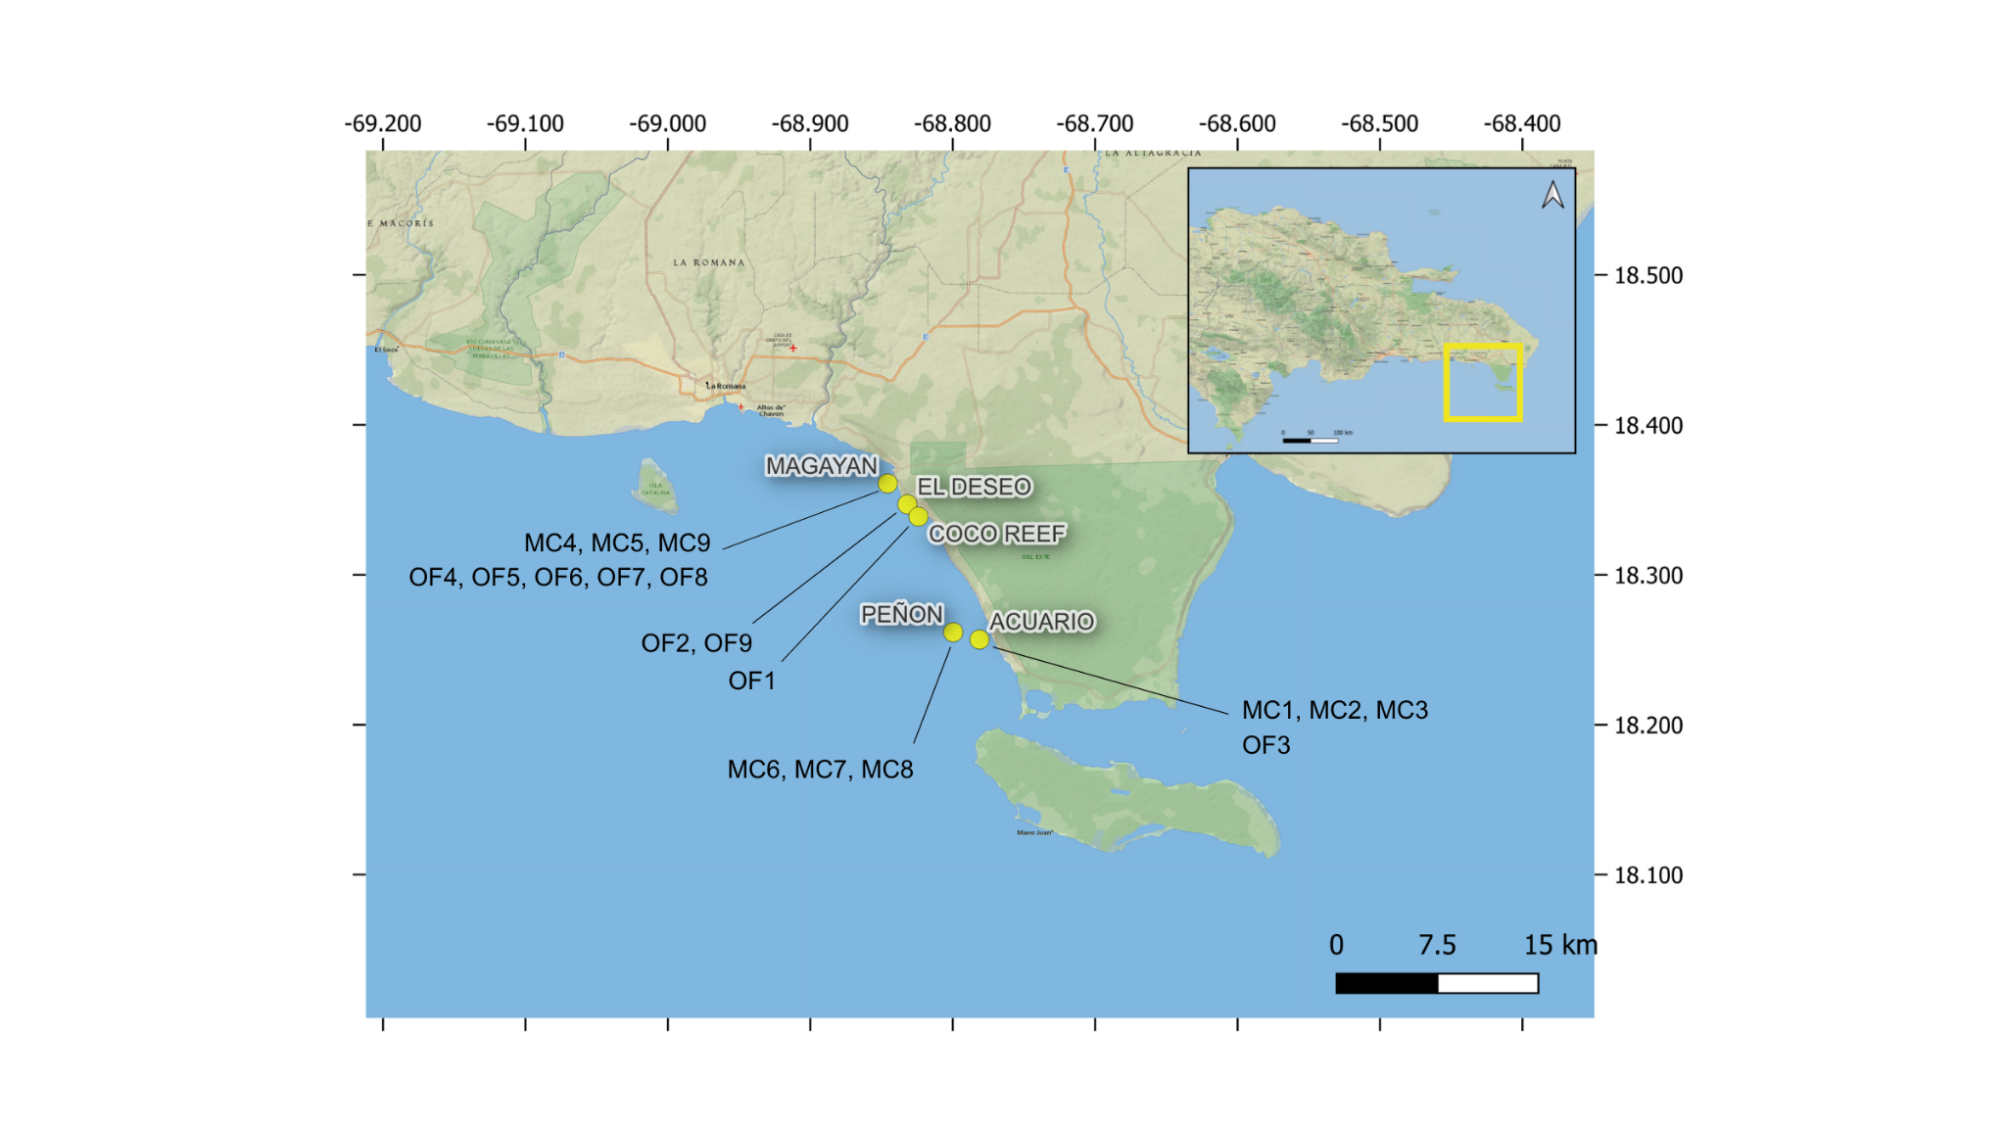Figure S1. Collection sites in the Dominican Republic showing the locations where fragments of Montastraea cavernosa (MC) and Orbicella faveolata (OF) were collected in August 2024. A total of 18 colonies were sampled across five sites: Magayan (18.3609° N, -68.8456° W), Deseo (18.3470° N, -68.831694° W), Coco Reef (18.33882° N, -68.8239° W), Peñón (18.261667° N, -68.799556° W), and Acuario (18.25681° N, -68.78107° W).

Table S1. Experimental coral colonies used in the study, including experimental colony ID, species, parental repository colony ID, reef label corresponding to collection sites shown in Fig. S1, collection depth (m), and reef of origin in the Dominican Republic.

Experimental colony ID | Species | Repository colony ID | Reef label | Depth (m) | REEF
MCAV-1 | Montastraea cavernosa | MC093 | 541 | 9.8 | Acuario
MCAV-2 | Montastraea cavernosa | MC094 | 543 | 10.3 | Acuario
MCAV-3 | Montastraea cavernosa | MC095 | 545 | 9.3 | Acuario
MCAV-4 | Montastraea cavernosa | MCUK4 | 786 | 11.1 | Magayan
MCAV-5 | Montastraea cavernosa | MCUK5 | 789 | 11.3 | Magayan
MCAV-6 | Montastraea cavernosa | MCUK1 | No label | 10 | Peñon
MCAV-7 | Montastraea cavernosa | MCUK2 | No label | 10.1 | Peñon
MCAV-8 | Montastraea cavernosa | MCUK3 | No label | 9.3 | Peñon
MCAV-9 | Montastraea cavernosa | MCUK9 | 777 | 11.3 | Magayan
OFAV-1 | Orbicella faveolata | OF076 | 595 | 12.4 | Coco
OFAV-2 | Orbicella faveolata | OFUK1 | 789 | 3.6 | Deseo
OFAV-3 | Orbicella faveolata | OF091 | 544 | 9.8 | Acuario
OFAV-4 | Orbicella faveolata | OFUK2 | 788 | 10.7 | Magallan
OFAV-5 | Orbicella faveolata | OFUK3 | 787 | 11 | Magayan
OFAV-6 | Orbicella faveolata | OF095 | 353 | 11.1 | Magayan
OFAV-7 | Orbicella faveolata | OF096 | 751 | 11.7 | Magayan
OFAV-8 | Orbicella faveolata | OF097 | 273 | 11.3 | Magayan
OFAV-9 | Orbicella faveolata | OFUK4 | 778 | 4.6 | Deseo

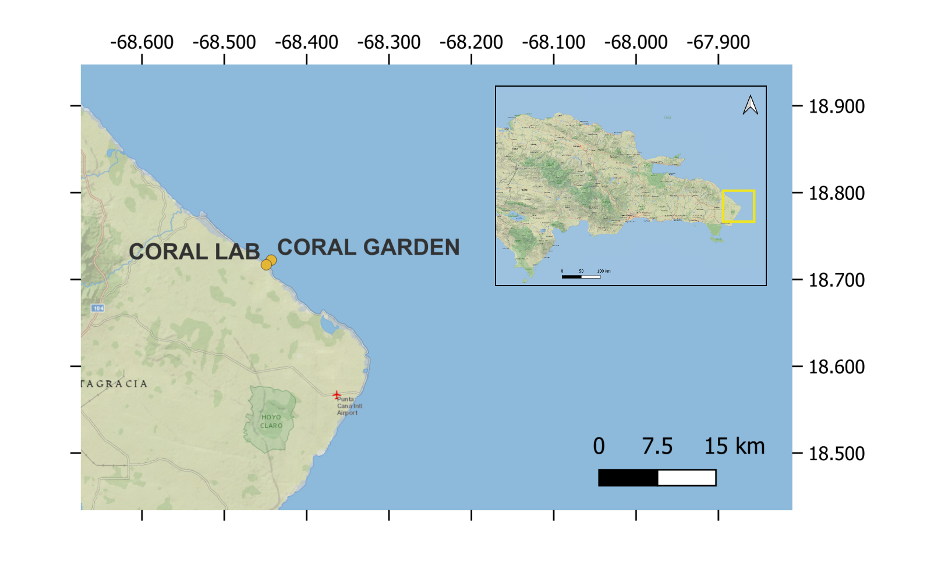
Figure S2. Location of the coral outplanting site (Coral Garden; 18.7224° N, -68.4430° W), and the Coral Lab (18.7165° N, -68.4495° W), where ex-situ experiments were conducted in August 2024 in Bávaro, Dominican Republic.

- Acclimation B) Experiment
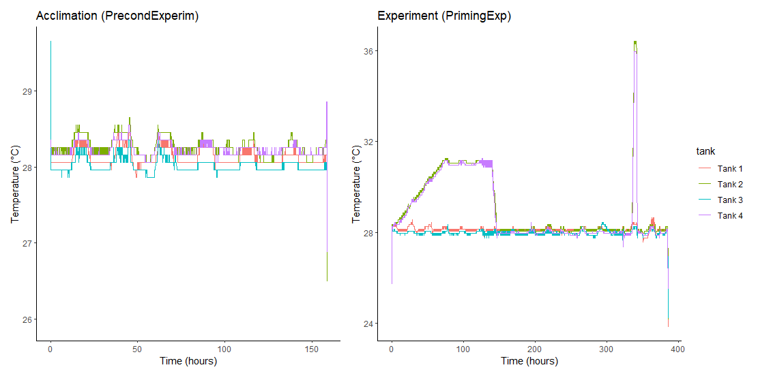
Figure S3. Temperatures (°C) recorded during the (A) acclimation period, and (B) experimental phase (Priming, Recovery and Heat Assay). Temperature was logged continuously in four independent tanks and plotted as a function of time (hours since the start of each phase).

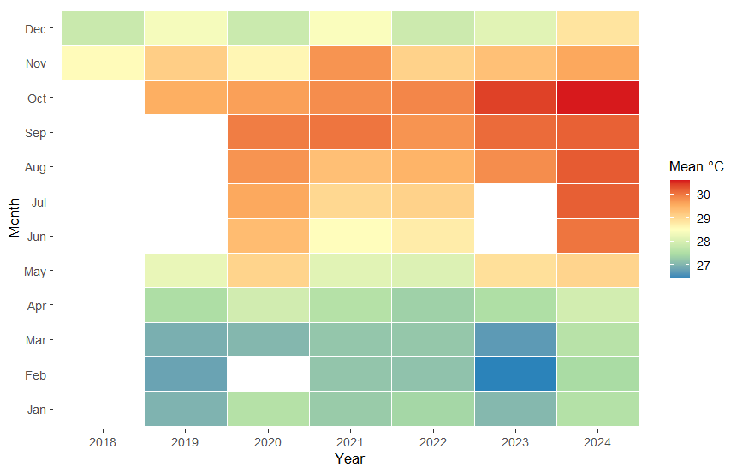
Figure S4. Mean monthly seawater temperatures (°C) at Coco Reef (2018-2024) derived from continuous in situ logger records. Color gradients represent increasing temperature from cooler (blue) to warmer (red) conditions.
Table S2. Metadata for all coral tissue samples processed for symbiont community characterization.

Species | Experimental colony ID | Treatment | Collection timepoint | Sample ID
Montastraea cavernosa | MCAV-1 | Naive | After priming | MC1_N_EX
Montastraea cavernosa | MCAV-2 | Naive | After priming | MC2_N_EX
Montastraea cavernosa | MCAV-4 | Naive | After priming | MC4_N_EX
Montastraea cavernosa | MCAV-5 | Naive | After priming | MC5_N_EX
Montastraea cavernosa | MCAV-6 | Naive | After priming | MC6_N_EX
Montastraea cavernosa | MCAV-7 | Naive | After priming | MC7_N_EX
Montastraea cavernosa | MCAV-9 | Naive | After priming | MC9_N_EX
Montastraea cavernosa | MCAV-1 | Preconditioned | After priming | MC1_P_EX
Montastraea cavernosa | MCAV-2 | Preconditioned | After priming | MC2_P_EX
Montastraea cavernosa | MCAV-4 | Preconditioned | After priming | MC4_P_EX
Montastraea cavernosa | MCAV-5 | Preconditioned | After priming | MC5_P_EX
Montastraea cavernosa | MCAV-6 | Preconditioned | After priming | MC6_P_EX
Montastraea cavernosa | MCAV-7 | Preconditioned | After priming | MC7_P_EX
Montastraea cavernosa | MCAV-9 | Preconditioned | After priming | MC9_P_EX
Montastraea cavernosa | MCAV-1 | Naive | After recovery | MC1_N_RE
Montastraea cavernosa | MCAV-2 | Naive | After recovery | MC2_N_RE
Montastraea cavernosa | MCAV–4 | Naive | After recovery | MC4_N_RE
Montastraea cavernosa | MCAV-5 | Naive | After recovery | MC5_N_RE
Montastraea cavernosa | MCAV-7 | Naive | After recovery | MC7_N_RE
Montastraea cavernosa | MCAV-9 | Naive | After recovery | MC9_N_RE
Montastraea cavernosa | MCAV-1 | Preconditioned | After recovery | MC1_P_RE
Montastraea cavernosa | MCAV-2 | Preconditioned | After recovery | MC2_P_RE
Montastraea cavernosa | MCAV-4 | Preconditioned | After recovery | MC4_P_RE
Montastraea cavernosa | MCAV-5 | Preconditioned | After recovery | MC5_P_RE
Montastraea cavernosa | MCAV-7 | Preconditioned | After recovery | MC7_P_RE
Montastraea cavernosa | MCAV-9 | Preconditioned | After recovery | MC9_P_RE
Orbicella faveolata | OFAV-1 | Naive | After recovery | OF1_N_EX
Orbicella faveolata | OFAV-2 | Naive | After priming | OF2_N_EX
Orbicella faveolata | OFAV-3 | Naive | After priming | OF3_N_EX
Orbicella faveolata | OFAV-4 | Naive | After priming | OF4_N_EX
Orbicella faveolata | OFAV-5 | Naive | After priming | OF5_N_EX
Orbicella faveolata | OFAV-6 | Naive | After priming | OF6_N_EX
Orbicella faveolata | OFAV-7 | Naive | After priming | OF7_N_EX
Orbicella faveolata | OFAV-8 | Naive | After priming | OF8_N_EX
Orbicella faveolata | OFAV-9 | Naive | After priming | OF9_N_EX
Orbicella faveolata | OFAV-1 | Preconditioned | After priming | OF1_P_EX
Orbicella faveolata | OFAV-2 | Preconditioned | After priming | OF2_P_EX
Orbicella faveolata | OFAV-3 | Preconditioned | After priming | OF3_P_EX
Orbicella faveolata | OFAV-4 | Preconditioned | After priming | OF4_P_EX
Orbicella faveolata | OFAV-5 | Preconditioned | After priming | OF5_P_EX
Orbicella faveolata | OFAV-6 | Preconditioned | After priming | OF6_P_EX
Orbicella faveolata | OFAV-7 | Preconditioned | After priming | OF7_P_EX
Orbicella faveolata | OFAV-8 | Preconditioned | After priming | OF8_P_EX
Orbicella faveolata | OFAV-9 | Preconditioned | After priming | OF9_P_EX
Orbicella faveolata | OFAV-1 | Naive | After recovery | OF1_N_RE
Orbicella faveolata | OFAV-3 | Naive | After recovery | OF3_N_RE
Orbicella faveolata | OFAV-4 | Naive | After recovery | OF4_N_RE
Orbicella faveolata | OFAV-7 | Naive | After recovery | OF7_N_RE
Orbicella faveolata | OFAV-9 | Naive | After recovery | OF9_N_RE
Orbicella faveolata | OFAV-1 | Preconditioned | After recovery | OF1_P_RE
Orbicella faveolata | OFAV-3 | Preconditioned | After recovery | OF3_P_RE
Orbicella faveolata | OFAV-4 | Preconditioned | After recovery | OF4_P_RE
Orbicella faveolata | OFAV-7 | Preconditioned | After recovery | OF7_P_RE
Orbicella faveolata | OFAV-9 | Preconditioned | After recovery | OF9_P_RE

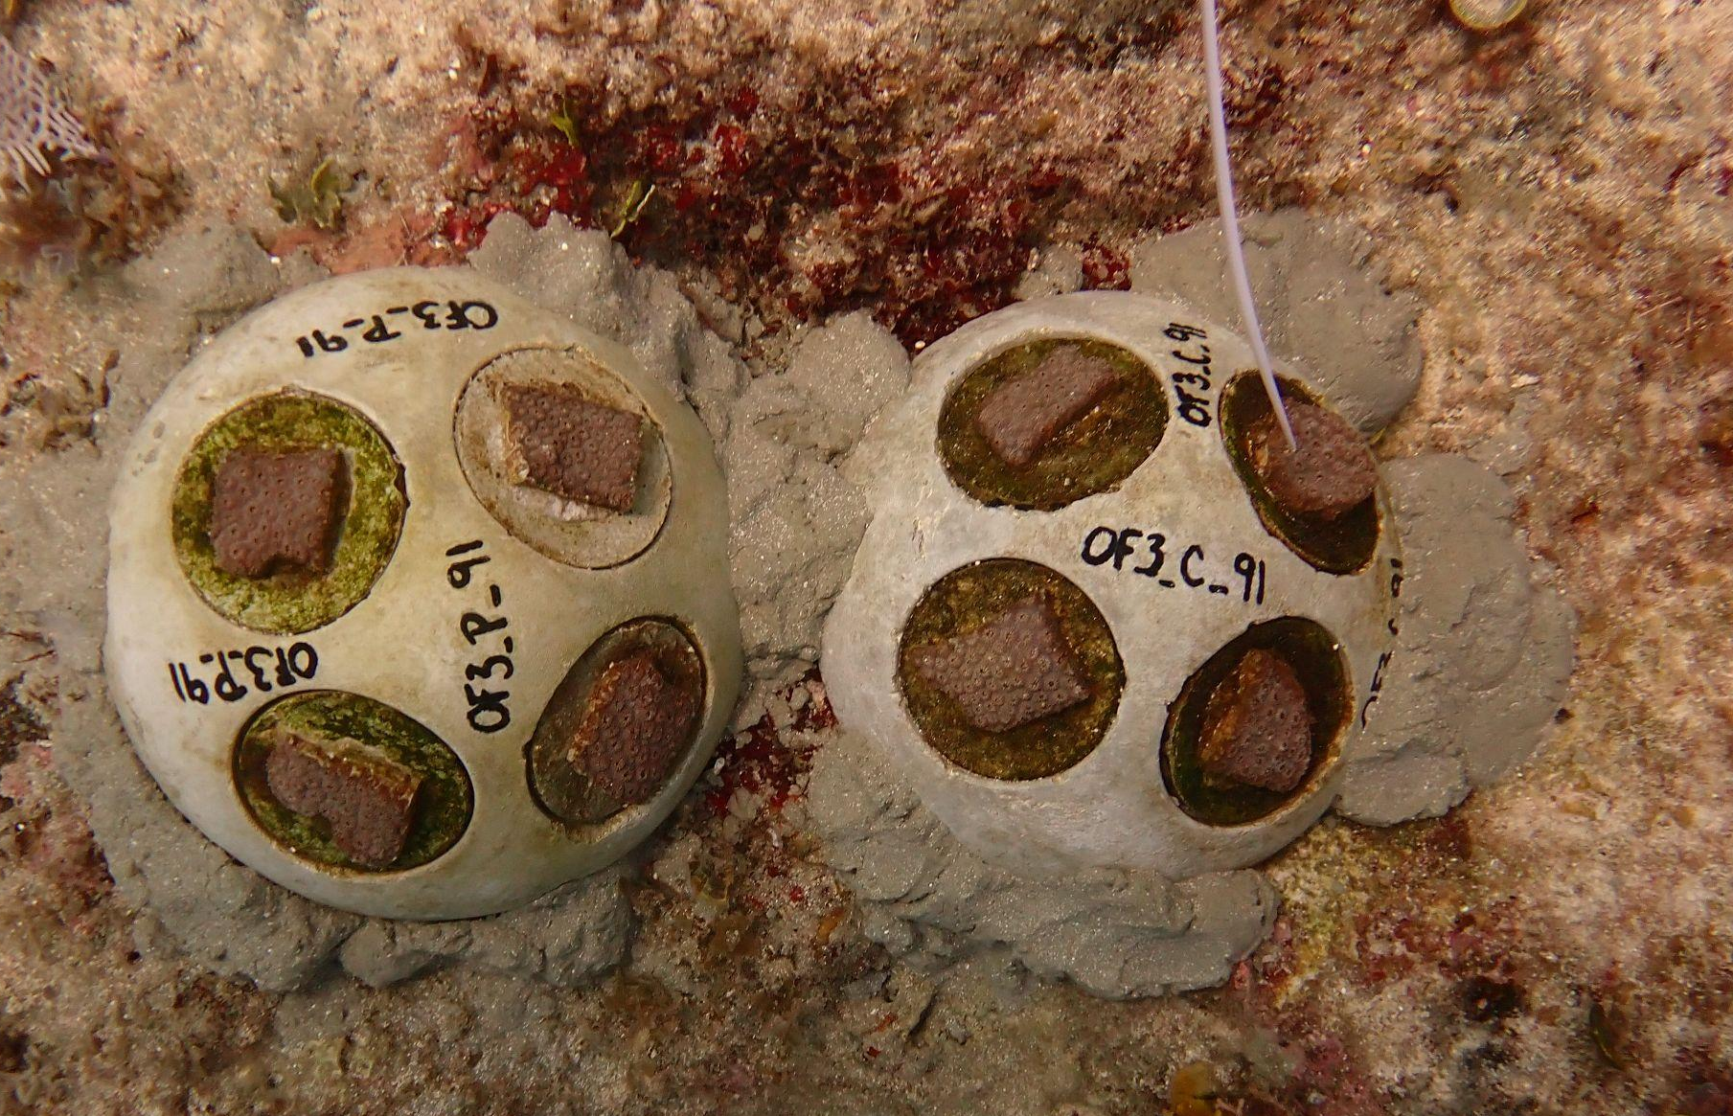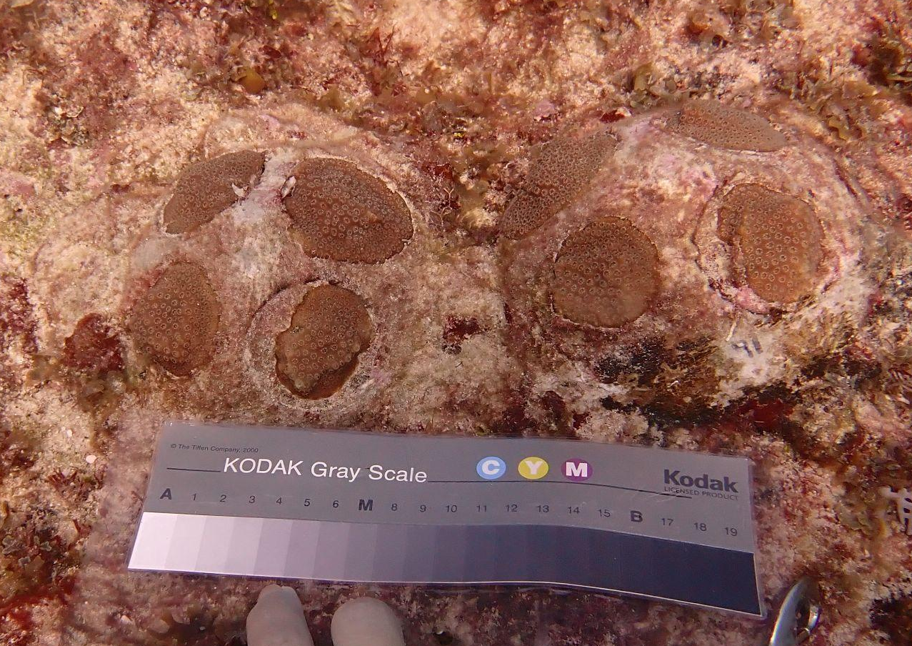

Figure S5. Examples of preconditioned and control outplants of Orbicella faveolata (colony OFAV-3) from August 2024 (left) and November 2025 (right).

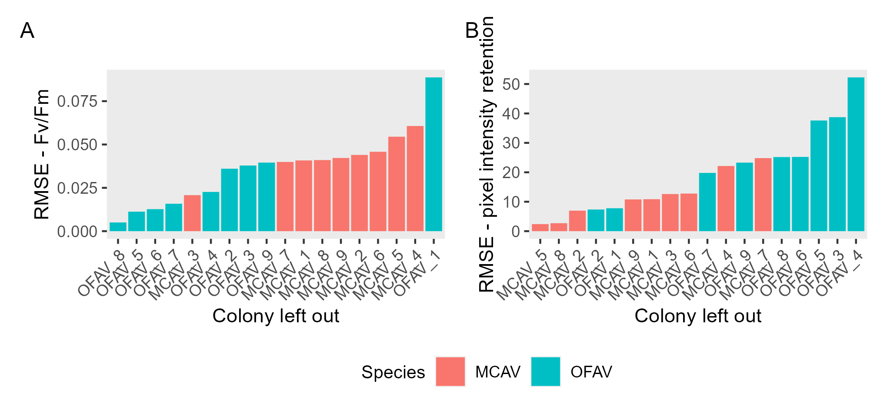
Figure S6. Colony-level leave-one-out (LOO) predictive error for physiological responses to thermal stress. Root mean square error (RMSE) values are shown for colony-level mean photosynthetic efficiency (F_{v}/F_{m}; A) and pixel intensity retention (B), calculated by sequentially excluding individual colonies from treatment models and predicting their responses. Bars are coloured by species: Montastraea cavernosa (MCAV) and Orbicella faveolata (OFAV). RMSE values quantify the magnitude of deviation between observed and predicted values for each excluded colony.

Table S3. Summary of mixed-effects model results and post hoc pairwise comparisons for pixel intensity retention (%) in outplanted coral fragments.
Mixed-effects model (Type III ANOVA)
Effect | F-value | p-value
Time | 16.63 | <0.001
Treatment | 12.48 | 0.001
Species | 7.36 | 0.012
Treatment × Time | 2.21 | 0.057
Treatment × Species | 3.36 | 0.076
Time × Species | 1.89 | 0.099
Treatment × Time × Species | 0.54 | 0.748

Treatment contrasts (control - preconditioned)
M. cavernosa O. faveolata
Timepoint | Estimate | p-value |  | Timepoint | Estimate | p-value
Oct-2024 | +41.0 | 0.0002 |  | Oct-2024 | +14.4 | 0.251
Nov-2024 | +48.3 | 0.0003 |  | Nov-2024 | +11.3 | 0.383
Jan-2025 | +39.5 | 0.0022 |  | Jan-2025 | +27.9 | 0.028
Apr-2025 | +20.7 | 0.075 |  | Apr-2025 | +7.5 | 0.557
Jul-2025 | +15.0 | 0.226 |  | Jul-2025 | −2.8 | 0.841
Aug-2025 | +36.4 | 0.0042 |  | Aug-2025 | +5.2 | 0.700

Species contrasts (M. cavernosa - O. faveolata)
Treatment | Timepoint | Estimate | p-value
Control | Oct-2024 | +41.0 | 0.0011
Control | Nov-2024 | +43.0 | 0.0018
Control | Jan-2025 | +29.2 | 0.0299
Control | Apr-2025 | +27.4 | 0.0280
Control | Jul-2025 | +10.3 | 0.430
Control | Aug-2025 | +27.8 | 0.0333
Preconditioned | All | — | >0.15

