Supplementary material:

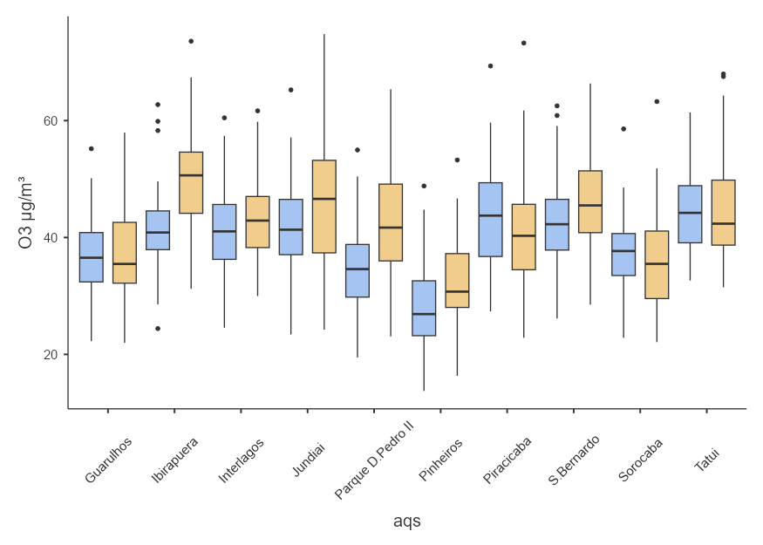
Figure S1. Distribution of monthly ozone (O₃) concentrations (μg m⁻³) for the period 2018–2024 at the 10 air quality monitoring stations (AQS) located in São Paulo, Brazil. The boxplots represent the aggregated monthly values for each station, with the blue boxes corresponding to the pre-lockdown period and the orange boxes to the post-lockdown period.
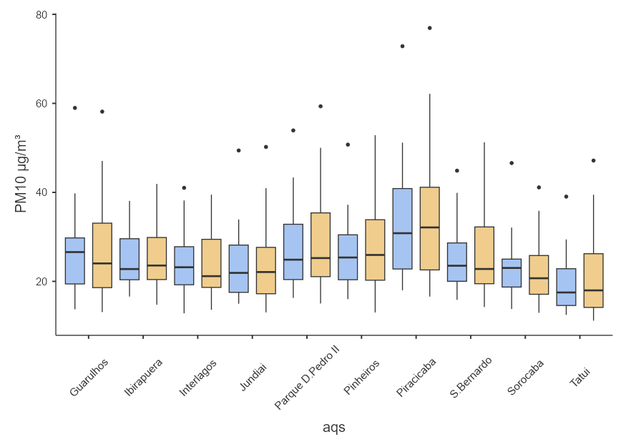
Figure S2. Distribution of monthly concentrations of particulate matter (PM₁₀; μg m⁻³) for the period 2018–2024 at the 10 air quality monitoring stations (AQS) located in São Paulo, Brazil. The boxplots represent the aggregated monthly values for each station, with the blue boxes corresponding to the pre-lockdown period and the orange boxes to the post-lockdown period.

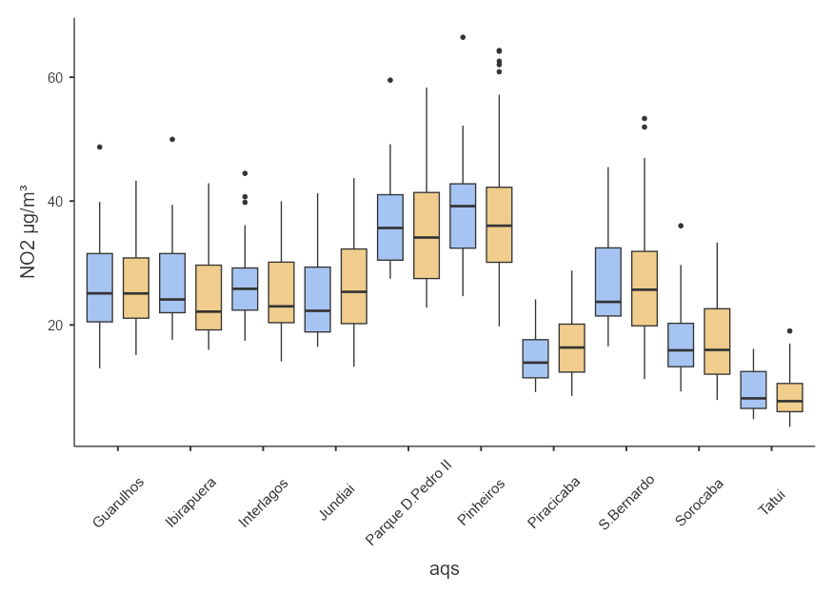
Figure S3. Distribution of monthly nitrogen dioxide (NO₂; μg m⁻³) concentrations from2018 to 2024 at the 10 air quality monitoring stations (AQS) located in São Paulo, Brazil.The boxplots represent the aggregated monthly values for each station, with the blueboxes corresponding to the pre-lockdown period and the orange boxes to the post-lockdown period.

Table S1. Mean values of atmospheric pollutants and environmental variables from 2018 to 2024 across the 10 study sites, including PM₁₀, NO₂, and O₃ (µg m⁻³), air temperature (TC; °C), relative humidity (RH; %), wind speed (WS; m s⁻¹), solar radiation (RAD; W m⁻²), monthly accumulated precipitation (mm), and monthly fire hotspot counts. Results are shown for the pre- and post-lockdown periods.
AQS | Intervention | PM₁₀ | NO₂ | O₃ | TC | RH | WS | RAD | Montlhy precipitation | Fire Hotspots counts
Guarulhos | pre | 26.6±9.4 | 26.6±8.3 | 37.0±7.5 | 21.1±2.2 | 76.0±6.5 | 1.7±0.2 | 161.9±32.6 | 117.9±91.7 | 224
Guarulhos | post | 26.6±10.0 | 25.9±6.5 | 37.0±8.0 | 20.7±2.3 | 73.2±4.5 | 1.7±0.2 | 168.0±29.0 | 111.8±99.3 | 491
Ibirapuera | pre | 25.0±5.7 | 27.1±7.8 | 42.0±8.8 | 21.2±2.2 | 73.9±3.5 | 1.9±0.2 | 162.1±32.3 | 118.2±91.4 | 3
Ibirapuera | post | 25.3±6.3 | 24.6±6.6 | 50.4±8.8 | 20.6±2.2 | 72.0±4.4 | 1.9±0.2 | 167.7±29.8 | 114.8±101.6 | 5
Interlagos | pre | 24.0±6.9 | 27.3±7.0 | 41.5±8.1 | 20.6±2.3 | 84.8±5.6 | 2.8±0.3 | 161.7±32.2 | 129.8±95.4 | 6
Interlagos | post | 23.7±7.0 | 25.2±6.8 | 43.2±7.4 | 20.3±2.3 | 87.8±4.0 | 2.7±0.3 | 166.9±29.5 | 128.4±106.6 | 25
Jundiai | pre | 23.5±7.9 | 24.6±6.8 | 42.1±9.8 | 21.7±2.3 | 74.5±4.4 | 2.8±0.3 | 169.8±28.8 | 106.6±89.4 | 21
Jundiai | post | 23.2±7.7 | 26.7±8.0 | 46.6±11.9 | 21.4±2.4 | 74.5±6.2 | 3.3±0.5 | 176.2±26.1 | 95.7±94.2 | 69
Parque D.Pedro II | pre | 27.4±9.1 | 36.8±7.9 | 35.4±8.3 | 21.4±2.2 | 73.0±3.7 | 1.4±0.2 | 162.0±32.3 | 118.2±91.8 | 3
Parque D.Pedro II | post | 29.0±9.8 | 35.6±9.3 | 42.2±9.8 | 21.2±2.3 | 70.9±4.7 | 1.3±0.1 | 167.7±29.6 | 113.1±100.7 | 3
Pinheiros | pre | 26.7±7.7 | 39.2±9.2 | 28.9±8.2 | 21.7±2.3 | 72.1±3.3 | 1.7±0.3 | 162.7±32.0 | 118.4±92.0 | 5
Pinheiros | post | 27.8±9.5 | 37.6±11.3 | 31.8±7.8 | 21.1±2.7 | 71.0±3.8 | 1.7±0.2 | 168.6±29.1 | 112.7±100.9 | 10
Piracicaba | pre | 33.1±12.9 | 14.6±3.9 | 44.3±9.8 | 23.1±2.3 | 71.2±5.0 | 2.1±0.3 | 171.3±26.5 | 93.5±82.7 | 26
Piracicaba | post | 33.5±12.8 | 16.7±5.2 | 41.4±10.4 | 22.7±2.8 | 68.1±6.4 | 2.1±0.3 | 178.4±25.4 | 78.0±79.3 | 63
S.Bernardo do Campo | pre | 25.3±7.3 | 26.6±8.0 | 43.5±8.5 | 20.9±2.3 | 80.2±6.5 | 1.8±0.2 | 160.1±32.6 | 129.3±93.7 | 54
S.Bernardo do Campo | post | 26.3±8.7 | 27.4±9.4 | 45.9±8.3 | 20.3±2.2 | 76.8±5.2 | 1.8±0.2 | 165.3±29.5 | 129.6±105.5 | 208
Sorocaba | pre | 23.2±6.6 | 17.7±6.6 | 37.6±7.3 | 22.8±2.2 | 69.0±4.3 | 1.9±0.2 | 168.5±29.6 | 94.1±78.1 | 25
Sorocaba | post | 22.3±6.8 | 17.8±6.6 | 36.2±8.0 | 22.0±2.4 | 66.7±5.0 | 1.9±0.2 | 173.3±26.4 | 81.5±75.6 | 54
Tatui | pre | 19.5±6.6 | 9.3±3.8 | 45.0±7.5 | 21.8±2.4 | 76.0±5.1 | 2.7±0.4 | 169.2±29.2 | 92.1±79.7 | 22
Tatui | post | 21.2±8.5 | 8.8±3.7 | 45.1±8.7 | 21.4±2.4 | 71.3±7.4 | 2.8±0.4 | 175.0±26.8 | 77.8±74.2 | 27

Table S2. Summary of missing data proportions, imputation methods, and model performance for environmental variables
Parameter | Missing data (%) | Method | R² (%) | Cross Validation | RMSE
PM₁₀ | 26% | Gradient Boost | 81% | 10 folds | 4.333
NO₂ | 14% | Gradient Boost | 89% | 10 folds | 4.18
O₃ | 0.1% | Gradient Boost | 80% | 10 folds | 4.427
Temperature (ºC) | 33% | Linear regression | 90% | 10 folds | 0.709
RH (%) | 34% | Gradient Boost | 71% | 10 folds | 3.549
Wind speed | 21% | Gradient Boost | 96% | 10 folds | 0.136

