- Oncol Park (+Al)
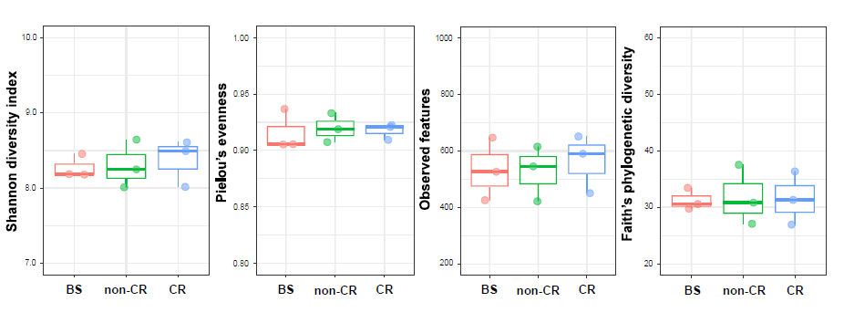
- Rucamanque Park (-Al)

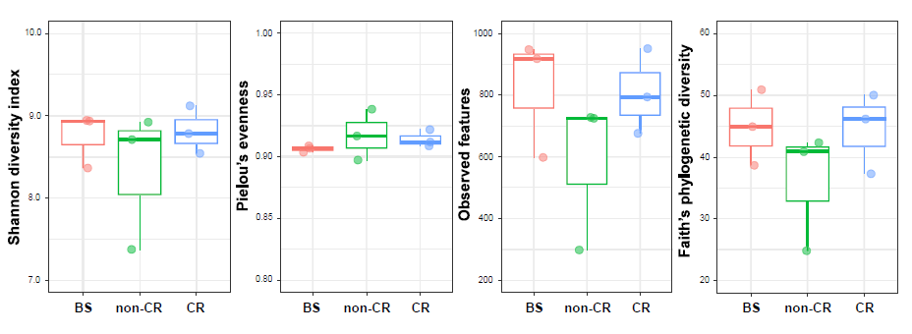
Supplementary Fig. S1. The boxplot of alpha diversity of Shannon index; Pielou´s evenness, Observed features and Faith´s phylogenetic diversity. A- Oncol Park (+Al site). B- Rucamanque Park (-Al site).

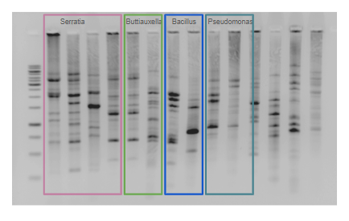
Supplementary Fig.S2: ERIC-PCR electrophoresis on a 2% (m/v) agarose gel. Bacterial strains, grouped by genus, are indicated in colored boxes.

Supplementary Table S1. The relative abundance of the dominant bacterial phyla (%).
Phylum | Oncol Park (+Al) |  |  | Rucamanque Park (-Al)
 | BS | non-CR | CR | BS | non-CR | CR
Proteobacteria | 21.27±2.83 | 27.31±3.33 | 28.27±3.00 | 24.40±1.49 | 29.66±6.03 | 27.10±1.34
Acidobacteriota | 26.73±2.01 | 23.68±1.62 | 21.37±3.86 | 21.72±2.58 | 20.35±8.22 | 18.99±1.81
Planctomycetota | 21.77±2.58 | 24.55±0.83 | 24.15±4.33 | 20.87±0.87 | 17.76±5.96 | 20.81±1.68
Verrucomicrobiota | 10.51±1.83 | 11.18±1.83 | 10.06±1.84 | 19.68±1.51 | 18.35±7.21 | 14.88±5.96
Chloroflexi | 13.16±2.90 | 6.07±1.98 | 8.03±4.92 | 2.38±0.53 | 1.48±0.21 | 4.27±2.87
Bacteroidota | 2.13±0.81 | 2.78±0.65 | 2.68±0.16 | 4.23±1.61 | 4.82±1.62 | 5.14±2.07
Actinobacteriota | 1.83±0.64 | 2.57±0.29 | 3.52±0.88 | 2.92±0.02 | 4.22±0.51 | 5.31±1.43
Firmicutes | 0.42±0.14 | 0.25±0.05 | 0.41±0.31 | 1.98±0.21 | 0.38±0.09 | 0.99±0.26
Myxococcota | 0.34±0.19 | 0.45±0.24 | 0.40±0.30 | 0.72±0.24 | 0.95±0.32 | 0.87±0.14
Armatimonadota | 0.64±0.75 | 0.41±0.26 | 0.37±0.14 | 0.02±0.01 | 0.18±0.18 | 0.31±0.20
Patescibacteria | 0.08±0.05 | 0.03±0.05 | 0.08±0.04 | 0.15±0.06 | 0.59±0.28 | 0.43±0.23
Gemmatimonadota | 0.15±0.10 | 0.22±0.13 | 0.17±0.03 | 0.21±0.09 | 0.26±0.18 | 0.34±0.07
Desulfobacterota | 0.39±0.41 | 0.01±0.01 | 0.00±0.00 | 0.21±0.14 | 0.03±0.03 | 0.04±0.04
WPS-2 | 0.29±0.24 | 0.16±0.02 | 0.17±0.15 | 0.00±0.00 | 0.01±0.02 | 0.02±0.02
Cyanobacteria | 0.05±0.06 | 0.11±0.06 | 0.13±0.14 | 0.03±0.03 | 0.02±0.01 | 0.00±0.00
FCPU426 | 0.05±0.05 | 0.00±0.00 | 0.00±0.00 | 0.07±0.03 | 0.17±0.13 | 0.05±0.02
Bdellovibrionota | 0.03±0.03 | 0.11±0.00 | 0.08±0.07 | 0.06±0.02 | 0.01±0.01 | 0.05±0.04
Elusimicrobiota | 0.10±0.08 | 0.04±0.08 | 0.03±0.05 | 0.05±0.04 | 0.05±0.04 | 0.04±0.04
RCP2-54 | 0.02±0.02 | 0.01±0.02 | 0.04±0.03 | 0.08±0.03 | 0.09±0.08 | 0.02±0.02
Methylomirabilota | 0.00±0.00 | 0.00±0.00 | 0.00±0.00 | 0.01±0.02 | 0.07±0.08 | 0.04±0.04

Supplementary Table S2. The relative abundance of the dominant bacterial families (%).

Family | Oncol Park (+Al) |  |  | Rucamanque Park (-Al)
 | BS | non-CR | CR | BS | non-CR | CR
Xanthobacteraceae | 8.98±1.61 | 10.46±1.04 | 10.39±1.14 | 9.96±0.60 | 11.05±3.25 | 10.93±1.36
Subgroup2 | 9.92±2.35 | 8.77±0.38 | 6.65±2.44 | 6.92±0.96 | 4.13±0.71 | 5.12±0.35
Gemmataceae | 8.89±1.60 | 8.62±2.19 | 6.77±2.18 | 7.41±1.11 | 4.36±1.68 | 5.28±0.30
Chthoniobacteraceae | 1.82±1.08 | 1.11±0.51 | 1.63±0.44 | 11.16±1.09 | 10.62±4.38 | 9.02±4.41
WD2101 soil group | 5.00±4.79 | 5.95±0.62 | 6.55±0.68 | 3.34±1.43 | 5.72±1.49 | 5.58±0.40
Ktedonobacteraceae | 11.64±2.24 | 5.27±1.47 | 7.29±5.13 | 1.81±0.59 | 0.79±0.49 | 3.45±2.42
Xiphinematobacteraceae | 5.15±2.56 | 6.03±1.26 | 5.79±1.22 | 4.62±1.02 | 2.94±1.65 | 2.20±1.33
Isosphaeraceae | 3.39±1.05 | 3.85±1.22 | 4.63±1.21 | 4.24±0.04 | 2.07±0.74 | 3.40±0.71
Acidobacteriaceae (Subgroup 1) | 2.67±0.67 | 3.07±0.69 | 3.77±0.62 | 3.34±0.27 | 3.86±3.54 | 2.88±0.09
Pedosphaeraceae | 2.89±0.47 | 3.05±0.76 | 1.98±0.36 | 3.35±0.56 | 3.61±1.96 | 2.36±0.38
Pirellulaceae | 1.40±0.27 | 2.54±1.23 | 2.9±2.06 | 2.23±0.61 | 3.14±2.22 | 3.58±0.81
Solibacteraceae | 2.54±0.29 | 2.26±0.77 | 2.67±0.22 | 2.62±0.84 | 2.97±1.97 | 2.55±0.10
WD260 | 2.15±1.38 | 3.47±1.49 | 3.22±0.69 | 0.87±0.28 | 2.52±3.65 | 1.86±0.77
Bryobacteraceae | 2.15±0.64 | 2.00±0.10 | 2.08±0.11 | 1.72±0.15 | 1.91±1.21 | 1.97±0.38
Chitinophagaceae | 1.16±0.31 | 1.69±0.58 | 1.67±0.24 | 1.43±0.41 | 1.52±0.48 | 1.88±0.55
Acetobacteraceae | 0.87±0.19 | 1.41±0.49 | 2.44±1.07 | 0.70±0.10 | 1.51±1.45 | 0.98±0.06
Beijerinckiaceae | 1.49±0.21 | 1.63±0.79 | 2.09±0.37 | 1.14±0.14 | 0.49±0.13 | 0.68±0.49
Reyranellaceae | 0.48±0.15 | 0.82±0.12 | 0.75±0.17 | 1.94±0.02 | 1.24±0.18 | 1.56±0.18
Burkholderiaceae | 0.26±0.13 | 1.01±0.43 | 1.37±0.79 | 0.74±0.17 | 1.40±1.32 | 1.08±0.12
Koribacteraceae | 1.53±0.82 | 1.84±1.22 | 1.35±0.76 | 0.40±0.09 | 0.14±0.13 | 0.15±0.04

Supplementary Table S3. Permutational multivariate analysis of variance (PERMANOVA).

 | Df | SumOfSqs | R2 | F | Pr(>F)
Sites (+Al/-Al) | 1 | 1222.15724 | 0.237389048 | 5.546997526 | 0.001
Soil Sample (BS/non-CR/CR) | 2 | 668.2017011 | 0.129789982 | 1.51638147 | 0.051
Sites:SoilSample | 2 | 614.0389337 | 0.119269529 | 1.393467361 | 0.082
Residual | 12 | 2643.932471 | 0.513551442 | NA | NA
Total | 17 | 5148.330345 | 1 | NA | NA

Supplementary Table S4. Colony and morphological characteristics of the isolated Al tolerant bacterial strains

Oncol Park (+Al)
Strain | Colors | Shape | Morphology | Gram character
CR+Al01 | Yellow | Irregular, smooth | Bacillus | Gram-positive
CR+Al02 | Opaque white | Circular, smooth | Diplococcus | Gram-positive
CR+Al03 | Opaque yellow | Circular, smooth | Diplococcus | Gram-positive
CR+Al04 | White | Circular, smooth | Bacillus | Gram-positive
BS+Al01 | White | Circular, rough | Diplococcus | Gram-positive
BS+Al03 | White | Circular, rough | Coccus | Gram-positive
BS+Al04 | White | Circular, rough | Bacillus | Gram-positive
BS+Al05 | Yellow | Circular, irregular, smooth | Bacillus | Gram-positive
Rucamanque Park (-Al)
Strain | Colors | Shape | Morphology | Gram character
CR-Al01 | White | Circular, smooth | Coccus | Gram-negative
CR-Al04 | White | Circular, smooth | Coccus | Gram-positive
CR-Al05 | Light white | Circular, smooth | Coccus | Gram-positive

Supplementary Table S5: Diameter of the solubilization halo formed by the strains from four sources of inorganic phosphate (Ca₃(PO₄)₂, Phosphate rock, AlPO₄ and FePO₄) using NBRIP medium.

Halo (cm) *
Strain | Organism | Ca₃(PO₄)₂ |  | Rock |  | AlPO₄ |  | FePO₄
CR-Al5 | Rahnella victoriana | 3.86 ± | 0,09 a | 3.86 ± | 0.32 a | 3.74 ± | 0.09 a | 3.69 ± | 0.20 a
CR-Al4 | Serratia sp | 0.61 ± | 0.10 b | 0.83 ± | 0.25 bc | 0.73 ± | 0.10 c | 0.78 ± | 0.10 b
CR-Al1 | Serratia proteamaculans | 0.90 ± | 0.18 b | 0.88 ± | 0.10 bc | 0.76 ± | 0.07 c | 0.80 ± | 0.14 b
CR+Al3 | Buttiauxella sp | 0.80 ± | 0.15 b | 0.84 ± | 0.11 bc | 0.89 ± | 0.14 bc | 0.86 ± | 0.18 b
CR+Al2 | Buttiauxella sp | 0.90 ± | 0.14 b | 0.70 ± | 0.08 bc | 0.80 ± | 0.07 c | 0.86 ± | 0.05 b
BS+Al4 | Pseudomonas sp | 0.79 ± | 0.06 b | 1.15 ± | 0.13 b | 0.94 ± | 0.07 bc | 0.76 ± | 0.05 b
NCR+Al2 | Serratia sp | 0.81 ± | 0.09 b | 0.76 ± | 0.07 c | 1.06 ± | 0.11 b | 0.79 ± | 0.09 b
BS+Al1 | Pseudomonas sp | 0.89 ± | 0.09 b | 0.69 ± | 0.09 c | 0.74 ± | 0.15 c | 0.88 ± | 0.13 b

*Each value is the mean of four repetitions. Different letters denote significant differences (Tuckey´s test, P ≤ 0.05).

