Supplementary Material
The Slow Revolution: AI Skills Demand in U.S. Healthcare Job Postings
Faezeh Najafi | PhD Candidate, Department of Economics
Virginia Polytechnic Institute and State University (Virginia Tech)
Blacksburg, VA 24060, United States
This supplementary file contains four tables (S1–S4) and two figures (S1–S2) that provide supporting detail for the main manuscript. Table S1 reports year-by-year AI adoption counts; Table S2 summarises the pre/post-COVID comparison; Table S3 lists the AI keyword categories; and Table S4 provides illustrative AI-enabled roles by hospital job type. Figures S1 and S2 present additional cross-sector comparisons.

Supplementary Tables
Table S1. Yearly AI Adoption in U.S. Hospitals, 2015–2023
Year | AI Posts | Total Posts | % AI | AI Hosps. | % Hosps.
2015 | 496 | 1,105,083 | 0.0449 | 93 | 3.82
2016 | 749 | 1,344,395 | 0.0557 | 100 | 4.11
2017 | 815 | 1,397,859 | 0.0583 | 134 | 5.51
2018 | 1,401 | 1,416,837 | 0.0989 | 180 | 7.41
2019 | 2,092 | 1,493,982 | 0.1400 | 233 | 9.58
2020 | 1,962 | 1,514,039 | 0.1296 | 216 | 8.88
2021 | 2,978 | 1,773,238 | 0.1679 | 253 | 10.40
2022 | 4,840 | 1,998,336 | 0.2422 | 295 | 12.13
2023 | 3,031 | 1,800,061 | 0.1684 | 233 | 9.58
Total | 18,364 | 13,843,830 | 0.1327
"AI Hosps." = number of distinct employers posting at least one AI role in that year. Goldfarb Core keyword definition. CAGR (2015–2023) ≈ 18%.
Table S2. Pre- vs. Post-COVID Adoption Summary
Period | AI Posts | Total Posts | % AI | Peak Hosps. | Peak %
2015–2019 | 5,553 | 6,758,156 | 0.0822 | 233 (2019) | 9.58
2020–2023 | 12,811 | 7,085,674 | 0.1808 | 295 (2022) | 12.13
Overall | 18,364 | 13,843,830 | 0.1327 | 295 (2022) | 12.13
AI posting share approximately doubles from the pre- to post-COVID window.
Table S3. AI Keyword Categories and Representative Terms
Category | Representative Keywords
Machine Learning | machine learning, predictive modeling, random forest, gradient boosting
Deep Learning | deep learning, neural network, convolutional neural network, transformer
NLP | natural language processing, text mining, sentiment analysis, speech recognition
Computer Vision | computer vision, image recognition, object detection
General AI | artificial intelligence, AI algorithm, large language model, generative AI
Automation Tools | robotic process automation, intelligent automation, workflow optimization
Keywords from Goldfarb et al. (2020). Conservative list targets stable, unambiguous AI terminology.
Table S4. Illustrative AI-Enabled Roles by Hospital Job Type
Job Type | Illustrative AI-Enabled Roles
Clinical | Radiologist (ML for imaging); Nurse Practitioner (NLP for note summarisation); Physician (AI risk stratification)
Research | Biostatistician (ML for disease progression); Research Scientist (AI-powered genomic analysis)
IT | Informatics Specialist (clinical decision support AI); Data Engineer (ML pipeline development)
Administrative | Billing Specialist (NLP for automated coding); Revenue Cycle Analyst (AI fraud detection)
Teaching | Clinical Instructor (AI simulation tools); Medical Educator (AI curriculum personalisation)
Other/Unspecified | Information Manager (NLP for patient records); Compliance Officer (ML for regulatory violation detection)

Supplementary Figures
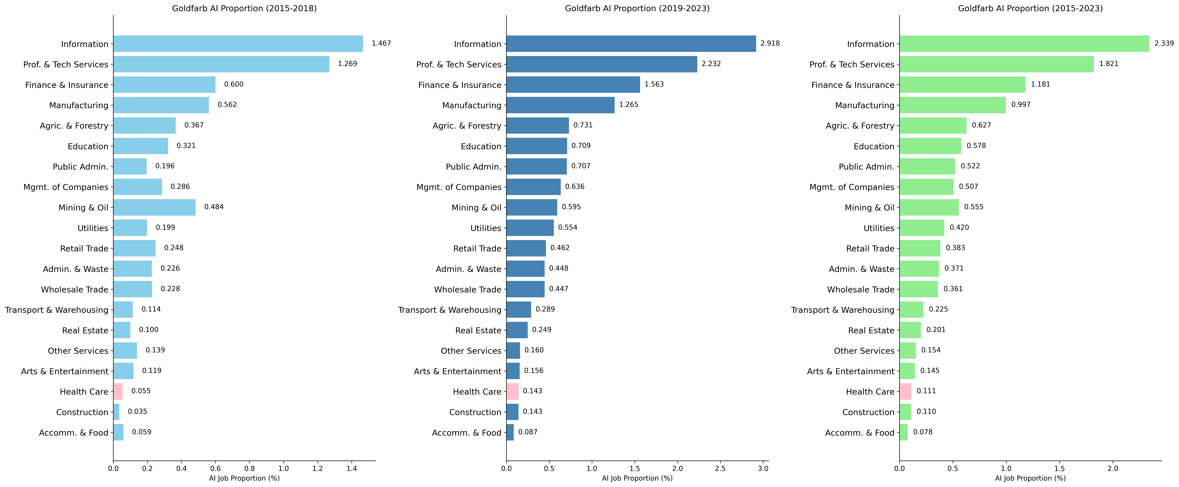
Figure S1. Goldfarb AI posting share by sector, 2015–2023: proportion comparison. This figure provides an alternative sector-level view complementing Figure 3 of the main manuscript. Healthcare consistently shows the lowest AI posting share of all sectors.
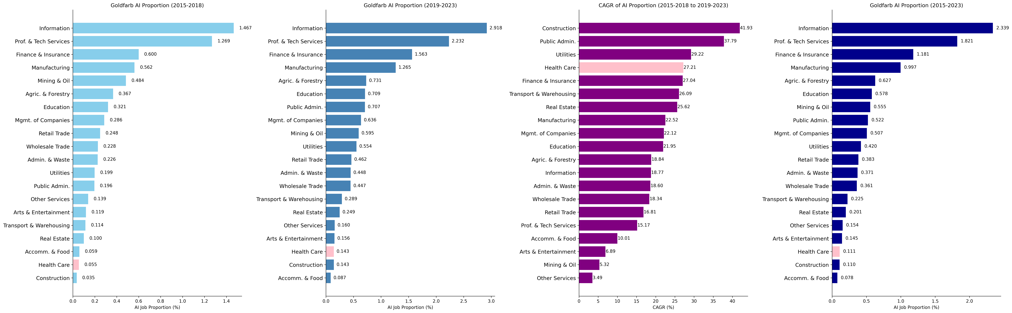
Figure S2. Goldfarb AI posting share and compound annual growth rate (CAGR) comparison by sector, 2015–2023, sorted by CAGR. Healthcare exhibits a high CAGR from a very low base. This figure complements Figure 6 of the main manuscript.

