EyeDx: A Scalable and Interpretable Multitask Deep Learning Framework for Comprehensive Ocular Disease Detection in Fundus Images
Author: Franck Mbanya Tchafa
Affiliations: Feat Healthcare, Consulting & Applied Research, Dallas, Texas, USA
E-mail: franck.tchafa@feathealthcare.com
ORCID: https://orcid.org/0000-0003-2527-8343

Abstract
Diabetic retinopathy, glaucoma, and cataracts are leading causes of vision loss worldwide. However, access to eye screening remains limited. Deep learning models can assist in early detection, but many current studies lack clinical relevance because they focus on single-disease detection, have limited dataset diversity, lack sufficient methodological transparency, and provide minimal interpretability. These limitations hinder real-world implementation.
In this study, we propose a transparent, interpretable, multitask deep learning algorithm for automated detection of various eye diseases from a single fundus image. Unlike previous studies, our work specifically tackles the limitations identified earlier in ophthalmic AI research. Using a curated dataset of 14,375 images from 6 public sources, we evaluated several deep CNN architectures. The model uses a shared pretrained DenseNet backbone followed by four lightweight adapter modules and disease‑specific multilayer perceptron (MLP) classifiers. Sharing the backbone allows all classifiers to learn from the same retinal representations while preserving independent, clinically faithful decision boundaries. Freezing the backbone further stabilizes training across datasets with variable annotation quality and improves generalization.
Performance was assessed using the Area Under the Receiver Operating Characteristic Curve (AUROC), Area Under the Precision–Recall Curve (AUPRC), and a range of threshold-based metrics. Gradient-weighted Class Activation Mapping (Grad-CAM) visualizations were implemented to enhance interpretability. The model consistently demonstrated strong performance on the held-out test set across all diagnostic tasks, with AUROC values of 0.987–0.998 and AUPRC values of 0.965–0.994. Sensitivity ranged from 0.902 to 0.976, and specificity from 0.906 to 0.993, indicating balanced error profiles and reliable discrimination despite significant variability in image quality, acquisition devices, and label completeness across datasets. Each metric was reported with 95% confidence intervals. Grad-CAMs confirmed that predictions depended on clinically relevant retinal regions.
Importantly, the modular multitask design allows scalable expansion to include new diseases without full retraining, enabling a single, parameter-efficient architecture to provide accurate multi-disease detection from a single fundus image and support practical deployment in primary care, tele-ophthalmology, and large-scale screening programs.
Keywords: Fundus imaging, diabetic retinopathy, glaucoma, cataract, multi-disease classification, multitask learning, deep learning, clinical decision support

Introduction
Eye diseases such as diabetic retinopathy (DR), glaucoma, and cataracts are among the leading causes of visual impairment worldwide [1–3]. As populations age and the prevalence of diabetes, hypertension, and other systemic risk factors continues to increase, the burden of these eye conditions is expected to grow [4,5].
Early detection is essential for preventing vision loss. Prompt diagnosis helps prevent irreversible damage, lowers treatment costs, and improves long-term outcomes [6,7]. Yet access to timely care remains uneven, especially in remote or underserved areas where eye specialists are scarce [8,9]. This mismatch between rising disease burden and limited specialist availability underscores the need for scalable, automated tools to support healthcare providers and expand access to screening services.
Artificial intelligence (AI) has emerged as a promising solution. Automated systems not only help close this gap but also offer accessible diagnostic expertise to underserved communities. Despite advancements in AI for ophthalmology, several limitations persist. Many existing models are trained on a single dataset, limiting their ability to generalize across diverse populations, devices, and imaging conditions [10,11]. Other models are designed for binary classification tasks, such as distinguishing between glaucoma and non-glaucoma cases [12–28]. However, this approach does not accurately reflect clinical realities, where patients frequently present with multiple co-occurring ocular diseases [29]. Developing and maintaining separate models for each condition is both time-consuming and costly.
Methodological transparency is also inconsistent: some studies lack detailed descriptions, which limits reproducibility and transparency [10]. Additionally, they report only select performance metrics, making clinical interpretation difficult. Furthermore, interpretability is often limited or missing, which hampers clinical adoption and reduces clinicians’ trust. [30,31].
These gaps highlight the need for transparent models trained on diverse datasets and label sources. Such systems more closely reflect real‑world screening conditions and enhance the reliability of AI‑driven clinical decision support. Our study directly addresses these limitations through a unified, interpretable, and scalable model. The proposed model features a shared DenseNet backbone with task-specific classifiers, enabling the simultaneous detection of multiple eye diseases from a single fundus image. This architecture captures shared retinal representations while allowing each prediction branch to specialize, improving data efficiency and enhancing generalization across different imaging conditions.
The model is trained on multiple publicly available datasets, incorporating patient‑level splitting when metadata permits to prevent information leakage. By integrating diverse imaging sources and applying data augmentation techniques that mimic real‑world acquisition variability, the system learns robust, device‑agnostic features that support reliable performance across populations and clinical settings.
To ensure clinical relevance, we provide a comprehensive set of evaluation metrics, including the AUROC, AUPRC, F1 score, positive predictive value (PPV), negative predictive value (NPV), sensitivity, specificity, and accuracy. These metrics provide a complete performance assessment across all classes. Interpretability is further improved by Grad-CAM visualizations, which offer clear insights into the model’s decision-making process and support regulatory approval and clinical adoption. Collectively, these design choices position the multitask model as a scalable, clinically aligned solution that enables multi-disease screening in fundus images across diverse clinical settings.

Methodology

Datasets

Dataset Composition
A total of six publicly available fundus image datasets were used in this study: APTOS, DRISHTI, HYGD, PAPILA, AIROGS, and ODIR [32–37]. These datasets were selected to capture a broad spectrum of ocular diseases, imaging devices, demographic backgrounds, and labeling annotations. Their combined diversity provides a robust foundation for training and evaluating a multitask model capable of detecting multiple co‑occurring diseases.
The datasets vary significantly in their labeling scope, which influences how each one contributes to the multitask framework. APTOS is a strategically valuable choice for the DR head because it offers high-quality annotations and a consistent grading protocol, unlike many public DR datasets that suffer from notable label noise. However, APTOS does not include annotations for glaucoma or cataract.
In contrast, glaucoma‑focused datasets such as DRISHTI, HYGD, PAPILA, and AIROGS provide detailed optic nerve labels but lack annotations for DR and cataracts. When combined, these glaucoma datasets provide rich optic disc variability across multiple devices, populations, and clinical settings, thereby strengthening the glaucoma classifier’s ability to learn robust structural cues associated with glaucomatous damage.
ODIR provides multi‑disease labels, including cataract, but does not grade DR severity. ODIR’s main advantage is its high variability across imaging devices and acquisition conditions [37]. Images were gathered from various screening centers with different cameras, resolutions, optics, and lighting. This diversity closely mimics real-world screening settings, where fundus images are taken by various devices and from a diverse population.
Together, this heterogeneous mix reflects real‑world screening conditions, where datasets often have partial, task‑specific, or incomplete labels, underscoring the need for a multitask architecture.

Inclusion/Exclusion Criteria and Disease‑Specific Subsets
Fundus images were included if they were color fundus photographs of adequate resolution for clinical interpretation and had at least one disease-specific label relevant to a prediction branch. And fundus images were excluded if they were duplicates of the same eye or patient, grayscale or non‑fundus images, or missing essential metadata required to assign them to the appropriate disease-specific task.
Each task-specific classifier or disease head was trained on datasets that contained valid labels for that condition. Because labels were not consistently available across datasets, each head used a different subset of the overall dataset. Table 1 summarizes the contribution of each dataset to the Normal, DR, Glaucoma, and Cataract training tasks.
Table 1. Dataset utilization for training each task-specific classifier
Dataset | Normal | DR | Glaucoma | Cataract
APTOS |  |  | 
ODIR
DRISHTI
AIROGS
PAPILA
HYGD

The Normal head was trained on images from ODIR (Normal and Cataract samples), APTOS (excluding grade 0), DRISHTI, and AIROGS. These datasets collectively provided 6,500 images, including 2,059 positives and 4,441 negatives. This head helps detect healthy eyes.
To train the Cataract classifier, we obtained labels from ODIR, the only dataset in this collection with explicit cataract annotations. In total, we used 2,303 fundus images, including 244 positives and 2,059 negatives. Cataract images were included not only for cataract detection but also because cataract introduces blur, reduces contrast, and obscures retinal structures. Incorporating these images improves the model’s robustness to real‑world image degradation and enhances generalization across diverse screening environments.
For DR detection, we collected images from APTOS and ODIR. In total, we used 5721 samples: 3,864 non-DR images (including normal fundus images and grade 0) and 1,805 DR images (grades 1 to 4). It is important to note that grade 0 in these datasets does not guarantee the absence of other eye diseases.
Finally, to train the Glaucoma branch, we combined fundus images from HYGD, PAPILA, DRISHTI, and AIROGS, along with healthy samples from the ODIR dataset. Overall, we collected 8,410 fundus images (5,388 positives and 3,022 negatives).

Dataset Heterogeneity and Clinical Realism
Together, these datasets offer significant variability and enhance generalization. The combined dataset includes different camera types, resolutions, lighting conditions, patient demographics, disease prevalence, and labeling standards, reflecting the variability of real-world screening settings. This diversity is crucial for training a multitask model designed for broad clinical application, as it exposes the model to a wide variety of retinal appearances while each prediction branch learns from high-quality, task-specific labels.
Integrating various datasets with partial annotations expands the model’s representation space without compromising label fidelity for any individual task. The curated collection ultimately provides comprehensive coverage of DR, glaucoma, cataract, and healthy fundus images, ensuring each task receives a good mix of positive and negative examples. Table 2 shows the distribution of fundus images across the training, cross-validation, and testing datasets used in this study.
Table 2. Distribution of fundus images by task
Classes | Train | Validation | Test
Normal | 4,407 | 1,081 | 1,012
DR | 4,159 | 787 | 775
Glaucoma | 6,258 | 1,165 | 987
Cataract | 1,379 | 464 | 460

Many ophthalmic AI studies rely on image-level splits, which can inadvertently place near-duplicate images in different sets, artificially inflating model performance. To avoid this, we enforce strict separation across all sets using dataset and clinical metadata, ensuring that no patient or repeated fundus images from the same eye appear in more than one split. This yields realistic performance estimates that better reflect real‑world deployment conditions.

Preprocessing and Data Augmentation
Given the heterogeneity of the curated dataset, a series of preprocessing techniques was applied to standardize the images and enhance features that improve model performance. Below are the preprocessing steps and data augmentation techniques used in this study:
- Resizing: All images were resized to 224 x 224 from their original size.
- Contrast-Limited Adaptive Histogram Equalization (CLAHE): A preprocessing technique to enhance local contrast in areas with poor illumination [38]. CLAHE improves the clarity of vessels, microaneurysms, and subtle lesions while avoiding noise amplification. This helps the model capture more informative features from each image.
- Random flip: An augmentation technique to mimic natural variability in fundus images and reduce the model’s dependence on fixed spatial patterns.
- Gamma Jitter: A global intensity transformation that mimics illumination changes caused by camera differences, pupil dilation, and patient factors, improving robustness to under- and overexposed images frequently seen in clinical workflows.
- Random cropping: To simulate partial views of the retina that occur when patients blink or move, or when the camera is misaligned. This augmentation technique improves robustness to real‑world acquisition variability by forcing the model to learn from incomplete or off‑center images rather than relying solely on perfectly centered optic discs or maculae.
- Gaussian Blur: A method to introduce mild defocus, replicating real‑world issues such as poor fixation, motion blur, or suboptimal camera focus.
- Normalization: A preprocessing step that adjusts pixel intensities to the [0, 1] range, ensuring consistent input scaling across images and supporting stable and efficient model training.
This combination of preprocessing and augmentation methods exposes the model to a wide range of image conditions that mimic real-world acquisition variability. As a result, these techniques further improve robustness and generalization across different populations, devices, and clinical workflows.

Model Architecture

Backbone
In preliminary studies, we explored several deep CNN architectures, and DenseNet121 was selected as the most dependable backbone for this task. Its densely connected architecture facilitates efficient feature propagation, as each layer receives feature maps from all preceding layers, enabling extensive feature reuse [39]. These properties make DenseNet121 a robust and stable foundation for fundus image representation
Pretrained on ImageNet, DenseNet121 is used as the common feature extractor for all tasks. The top classification layer is removed, and the network outputs a $7×7×1024$feature map. All backbone weights are kept frozen during training of the task-specific classifiers. Freezing the backbone ensures consistent low- and mid-level retinal representations across tasks, prevents interference between diseases with different label availability, and stabilizes training on datasets of varying size and annotation quality.

Adapter Block
Building upon this backbone, the model includes a lightweight adapter block and four task‑specific MLP classifiers. This modular design leverages shared retinal features extracted by DenseNet121 while enabling simultaneous prediction of Normal fundus, DR, Glaucoma, and Cataract with minimal parameter redundancy.
Each prediction branch processes the shared feature map through an adapter block that transforms it for task-specific learning (See Figure 1). The adapter block comprises two consecutive $1×1$ convolutional layers, each followed by batch normalization (BN) and ReLU activation. The first convolutional layer has 256 filters, and the second has 1024.
The adapter functions as a channel-mixing module, allowing each classifier to emphasize or suppress feature channels without altering spatial resolution. It adds minimal computational overhead while providing each task with its own dedicated representations.

MLP Heads

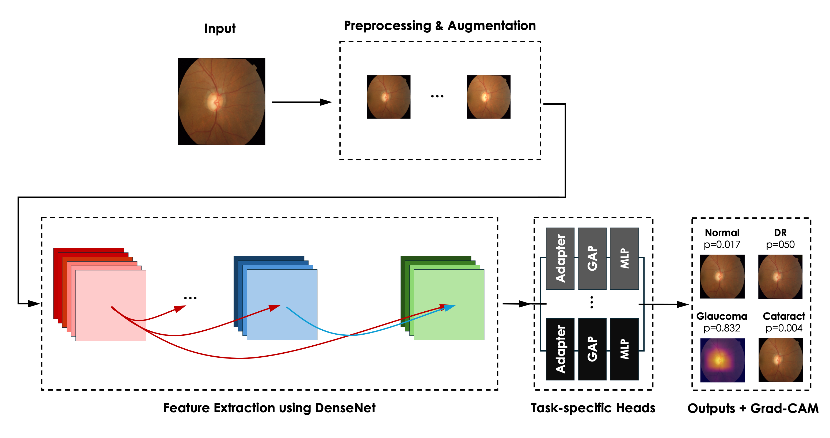Figure 1. Architecture of the proposed multitask deep learning model for fundus image analysis and ocular disease detection

After the adapter block, each prediction branch applies a bespoke MLP suited to the complexity of its label space. The Normal, Glaucoma, and Cataract branches share an architecture designed to capture complex or diverse visual patterns. They include a global average pooling (GAP) layer, followed by a Dense layer with 128 units, BN, and ReLU. A dropout layer with a rate of 0.3 is used to reduce overfitting, then a second Dense layer with 64 units, again with BN and ReLU. The final layer is a Dense layer with 1 unit and sigmoid activation, producing a binary probability. This structure enhances the model’s ability to accurately identify positive versus negative cases.

For DR detection, benefiting from high-quality, well-graded labels, a simplified MLP head is used. It consists of a GAP layer, a Dense layer with 64 units, BN, ReLU, and a final Dense layer with 1 unit and sigmoid activation. This streamlined design minimizes overfitting while maintaining strong discriminative performance.

Unified Multitask Model
After training each head independently with the backbone frozen, all components are integrated into a single architecture. As illustrated in Figure 1, a forward pass through the model starts with resizing each fundus image to 224 × 224 pixels, followed by preprocessing. The processed image is fed into the shared backbone, which extracts detailed retinal feature maps capturing vessel structure, optic disc morphology, macular texture, and illumination patterns. These shared features are routed in parallel to all branches (adapter and MLP heads), enabling the model to produce simultaneous predictions for all four classes.
Since all classifiers use the same features, the architecture is scalable and allows for efficient deployment while enabling task-specific specialization. The forward pass also produces Grad-CAM visualizations for each branch, offering interpretable heatmaps that highlight influential retinal regions for each prediction.

Loss Functions
For each classifier, the losses are weighted to address class imbalance (which is very common in medical datasets). For example, Cataract is underrepresented in our curated dataset. Ignoring this imbalance can cause the model to predict only the dominant classes, posing a clear risk in clinical settings. Thus, for each task, training is performed using a class‑balanced weighted binary cross‑entropy loss.
Given an input image $X$and its binary label $y_{i}∈\{0, 1\}$ for disease $i$, the loss is defined as:
$$L\left(X,y\right)= -w_{+,i}y_{i}\log{p\left(Y_{i}=1 | X\right) -w_{-,i}({1-y}_{i})\log{p\left(Y_{i}=0 | X\right)}}$$
where $p(Y_{i}=1|X)$ represents the model‑assigned probability that the image contains the disease, and $p(Y_{i}=0|X)$ is the probability that it does not. The terms $w_{+,i}$ and $w_{-,i}$ are class-specific positive and negative weights designed to correct for class imbalance for that task. This weighting scheme increases the contribution of rare but clinically important positive cases, thereby improving sensitivity without disproportionately inflating false positives.

Training Procedure
During training, images undergo data augmentation. This process introduces controlled perturbations that expose each classifier to a wide range of real-world variations, reduce the risk of overfitting, improve generalization to unseen data, and enhance robustness against the inconsistent image quality commonly encountered in clinical fundus imaging.
The task-specific classifiers are optimized using Adam with default parameters ($β_{1}=0.9$ and $β_{1}=0.999$) and a weight decay term of $1×{10}^{-5}$ [40]. Training is performed with mini‑batches of 16 and follows a two‑stage learning‑rate schedule: an initial warmup phase of three epochs at $1×{10}^{-4}$, followed by fine‑tuning at $1×{10}^{-5}$ for the remaining epochs. The model checkpoints are saved after each epoch during fine-tuning.

Performance Evaluation and Uncertainty Estimation
We report a suite of metrics to comprehensively assess the model’s performance in a clinically meaningful way. The AUROC provides a threshold‑independent measure of the model’s ability to distinguish between positive and negative cases [41]. This is particularly important in screening settings where operating thresholds may vary across clinics or populations.
The AUPRC is another key metric reported in this study. It provides a threshold‑agnostic summary of the model’s ability to detect true cases while minimizing false positives across the full precision–recall spectrum. [42]. Since our dataset is imbalanced, AUPRC is especially important because AUROC can appear overly optimistic when the negative class greatly outnumbers the positive class.
Our comprehensive suite of threshold-dependent metrics includes sensitivity, specificity, PPV, NPV, F1, AUC, and accuracy. Thresholds are selected to optimize the F1 score. Each metric reflects a specific trade-off and offers insight into real-world decision-making.
For example, the F1 score captures the balance between identifying true positives and avoiding excessive false positives. Sensitivity reflects the model’s ability to correctly identify unhealthy eyes, and it is critical for avoiding missed diagnoses. Specificity reflects the model’s ability to accurately identify healthy eyes, and it is important for minimizing unnecessary referrals. PPV and NPV quantify the likelihood that the model’s positive or negative prediction is correct.
Although accuracy is included for completeness, it is interpreted with caution because it can be misleading in imbalanced settings. High accuracy may simply reflect the predominance of negative cases rather than true diagnostic ability. For example, in a dataset with 1% disease prevalence, a model could achieve 99% accuracy by predicting every case as negative while missing all true positives. This illustrates why accuracy alone is insufficient and why threshold‑based metrics that better capture minority‑class performance are essential.
To assess the reliability of the reported metrics, we estimated 95% confidence intervals (CIs) using nonparametric bootstrapping with 1,000 resamples. We followed the percentile method of Efron and Tibshirani [43]. Reporting each metric with its CI reflects statistical uncertainty and provides a more dependable estimate of expected performance in clinical deployment. Together, these metrics offer a robust, clinically grounded assessment of the model’s behavior across operating conditions.

Interpretability
Interpretability is essential for the clinical adoption of AI models. And this is especially true in ophthalmology because diagnostic decisions carry significant consequences. Clinicians need to understand why a model makes a prediction and not just whether it is correct. Therefore, we implemented Grad-CAM visualizations to generate heatmaps that highlight the image regions most influential to the model’s predictions for a given task.
Grad‑CAMs enable clinicians to assess whether the model is attending to real anatomical and pathological signals instead of noise. It helps build trust and identify errors. Moreover, Grad‑CAM facilitates regulatory acceptance, enabling clinicians to confidently integrate AI-driven insights into their workflows.
To generate these visualizations, a fundus image is passed through the model, and activation maps from the final convolutional layer are extracted. Grad‑CAM then computes the gradient of the class score with respect to these maps and averages the gradients to produce importance weights. The class‑specific heatmap is computed by a weighted sum of the activation maps, followed by a ReLU activation [44].
By projecting these heatmaps onto the original image, clinicians can verify whether the model focused on relevant retinal structures, such as the optic disc, macula, or lesion-specific features, during eye disease detection. Figure 2 displays a Grad-CAM visualization in which the model correctly detects the disease and highlights the most indicative region.

Results
Each classifier was evaluated independently, producing its own probability estimate of the presence or absence of its corresponding disease. This approach supports the detection of multiple co-occurring conditions in a single fundus image and provides a more realistic clinical evaluation of eye health.
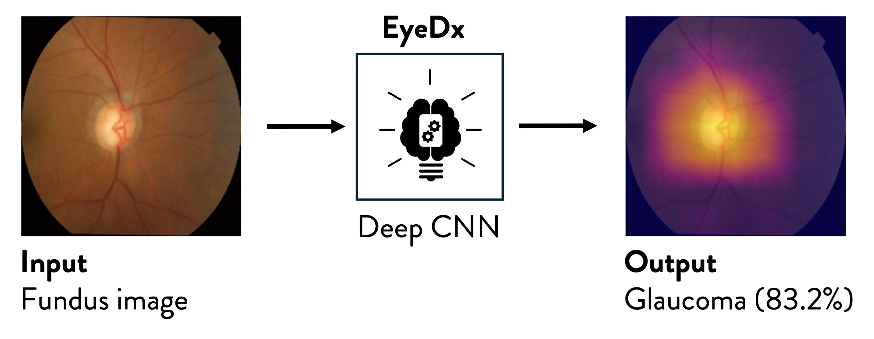
Figure 2. Grad-CAM visualization: The model correctly identifies glaucoma and highlights the region of the image most indicative of the disease.

As previously mentioned, we evaluated each prediction branch on various metrics, including AUROC and AUPRC. Figure 3 shows the AUROC curves per task, and the area under the curve (AUC) quantifies the overall discriminative performance. A higher AUC indicates stronger separation between the positive and negative cases. As shown, AUCs range from 0.984 to 0.999, reflecting robust performance.
Figure 3 also shows the PR plots. A higher AUPRC indicates better detection of true positives while maintaining high precision across decision thresholds. With high average precision (AP) values ranging from 0.97 to 0.997 across all classes, the model demonstrates reliable, well-balanced predictive performance.
Table 3 summarizes the validation‑set performance for each task, showing consistently strong results with narrow confidence intervals and no notable weaknesses across classes.
For example, DR achieves the highest overall metrics, with a sensitivity of 0.990 (CI: 0.974–1.000), specificity of 0.993 (CI: 0.987–0.998), PPV of 0.980 (CI: 0.960–0.995), and an F1‑score of 0.985 (CI: 0.972–0.995), reflecting the strength of the APTOS dataset and the model’s ability to discriminate DR from non‑DR cases with near‑perfect reliability.
Glaucoma performance is similarly robust, with sensitivity of 0.965 (CI: 0.948–0.980), specificity of 0.939 (CI: 0.920–0.957), PPV of 0.932 (CI: 0.912–0.951), and an AUC of 0.991 (CI: 0.987–0.994), indicating excellent detection of optic nerve pathology despite substantial cross‑dataset variability.
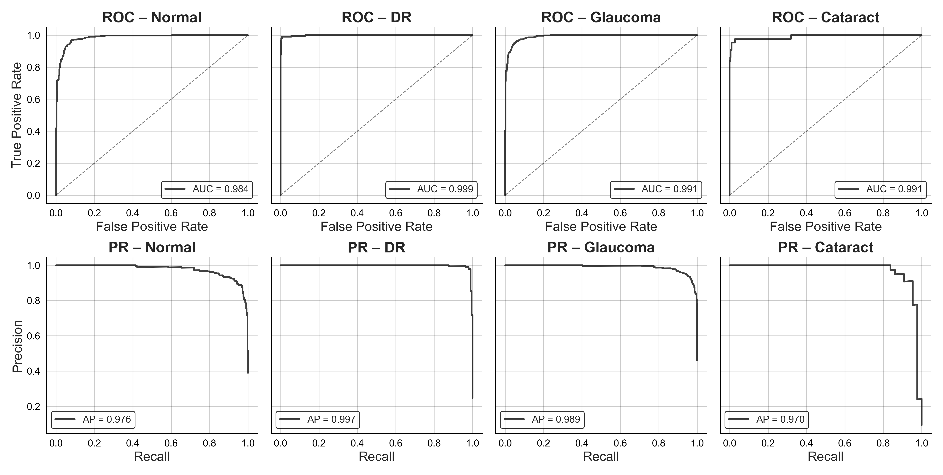
Figure 3. Performance evaluation of the multitask model using Receiver Operating Characteristic (ROC) and Precision–Recall (PR) curves on the validation set.

Normal classification also performs strongly, achieving a sensitivity of 0.962 (CI: 0.943–0.979), a specificity of 0.923 (CI: 0.902–0.942), a PPV of 0.888 (CI: 0.862–0.914), and an AUC of 0.984 (CI: 0.978–0.990), demonstrating reliable separation between healthy and unhealthy fundus images.
Cataract detection, although trained on the smallest dataset, maintains a high sensitivity of 0.954 (CI: 0.884–1.000), specificity of 0.990 (CI: 0.981–0.998), PPV of 0.912 (CI: 0.830–0.977), and an AUC of 0.991 (CI: 0.974–1.000). The slightly wider confidence intervals reflect the limited number of positive cases, but the results clearly demonstrate that the classifier effectively identifies cataract. Across all tasks, accuracy remains high (ranging from 0.938 to 0.987), highlighting the stability of the multitask model and its ability to generalize across diverse disease presentations.
Table 3. Performance metrics of the multitask classifier on the validation set, with each metric reported alongside its 95% confidence interval.
Metric | Normal | DR | Glaucoma | Cataract
Sensitivity | 0.962 (0.943–0.979) | 0.990 (0.974–1.000) | 0.965 (0.948–0.980) | 0.954 (0.884–1.000)
Specificity | 0.923 (0.902–0.942) | 0.993 (0.987–0.998) | 0.939 (0.920–0.957) | 0.990 (0.981–0.998)
PPV | 0.888 (0.862–0.914) | 0.980 (0.960–0.995) | 0.932 (0.912–0.951) | 0.912 (0.830–0.977)
NPV | 0.975 (0.962–0.986) | 0.997 (0.992–1.000) | 0.969 (0.954–0.982) | 0.995 (0.988–1.000)
F1 | 0.924 (0.906–0.940) | 0.985 (0.972–0.995) | 0.948 (0.934–0.960) | 0.932 (0.874–0.977)
AUC | 0.984 (0.978–0.990) | 0.999 (0.997–1.000) | 0.991 (0.987–0.994) | 0.991 (0.974–1.000)
Accuracy | 0.938 (0.923–0.952) | 0.992 (0.986–0.997) | 0.951 (0.938–0.963) | 0.987 (0.976–0.996)

Table 4. Confusion matrix on the validation set.
Classes | TP | TN | FP | FN
Normal | 405 | 609 | 51 | 16
DR | 192 | 589 | 4 | 2
Glaucoma | 518 | 590 | 38 | 19
Cataract | 41 | 417 | 4 | 2

Overall, the model demonstrates highly reliable performance across all four classes, with exceptional results for Normal, DR, and Glaucoma classification. DR achieves near‑perfect discrimination, and both Glaucoma and Normal prediction branches show strong balance between sensitivity and specificity with high AUC values. Cataract detection is likewise robust, achieving high sensitivity, excellent specificity, and an AUC comparable to the other prediction branches, despite being trained on the smallest dataset. These findings highlight a multitask model that performs consistently well across diverse retinal conditions, delivering clinically meaningful results for all four classes.
Table 4 presents the class‑wise confusion summary, showing the distribution of true positives (TP), false positives (FP), true negatives (TN), and false negatives (FN) for all tasks. The table complements the AUROC and AUPRC analyses by illustrating how the algorithm behaves when making discrete predictions, offering a clear view of its classification tendencies and errors.
The model performs reliably across all tasks, with a strong balance between correctly identifying positive cases and correctly rejecting negatives. Across all tasks, TPs and TNs dominate the error profile, while FPs and FNs remain comparatively low, indicating stable discrimination between positive and negative cases.
Normal, Glaucoma, and DR all show high volumes of correct classifications, reflecting strong sensitivity and specificity in large validation sets. Cataract, despite having the fewest positive samples, still achieves a favorable distribution with very few misclassifications, reinforcing the model’s robustness even under limited data conditions.
Overall, the confusion‑matrix patterns confirm that the multitask model maintains consistent, high‑quality decision boundaries across diverse retinal conditions and supports reliable multi‑disease screening from a single fundus image.
Table 5 presents the performance metrics of the multitask model on the held-out test set. Across all prediction branches, the test‑set metrics closely reflect the trends observed during validation. DR continues to show excellent discrimination, with a sensitivity of 0.976 (CI: 0.952–0.994) and an AUC of 0.998 (CI: 0.997–1.000), confirming the model’s strong ability to generalize well to unseen data.
Table 5. Performance metrics of the multitask classifier on the test set, with each metric reported alongside its 95% confidence interval.
Metric | Normal | DR | Glaucoma | Cataract
Sensitivity | 0.971 (0.954–0.985) | 0.976 (0.952–0.994) | 0.969 (0.953–0.982) | 0.903 (0.823–0.980)
Specificity | 0.905 (0.881–0.929) | 0.985 (0.975–0.993) | 0.929 (0.904–0.950) | 0.993 (0.983–1.000)
PPV | 0.874 (0.847–0.902) | 0.948 (0.915–0.976) | 0.935 (0.915–0.954) | 0.940 (0.867–1.000)
NPV | 0.979 (0.966–0.989) | 0.993 (0.987–0.998) | 0.965 (0.949–0.980) | 0.988 (0.978–0.998)
F1 | 0.920 (0.903–0.937) | 0.962 (0.940–0.979) | 0.952 (0.939–0.964) | 0.920 (0.860–0.970)
AUC | 0.987 (0.982–0.991) | 0.998 (0.997–1.000) | 0.988 (0.982–0.994) | 0.991 (0.978–0.999)
Accuracy | 0.932 (0.916–0.947) | 0.983 (0.974–0.991) | 0.949 (0.935–0.963) | 0.983 (0.970–0.993)

The Glaucoma and Normal classification heads also remain strong, with sensitivities of 0.969 (CI: 0.953–0.982) and 0.971 (CI: 0.954–0.985) and AUC values of 0.988 (CI: 0.982–0.994) and 0.987 (CI: 0.982–0.991), respectively. There is also strong agreement in specificity values for both tasks between the validation and test sets.
Cataract performance shows a slight decrease in sensitivity (-0.051) compared to the validation set but maintains excellent specificity of 0.993 (CI: 0.983–1.000) and an AUC of 0.991 (CI: 0.978–0.999). These results demonstrate that the model continues to reliably detect cataract cases despite having fewer positive samples.
The close match between validation and test metrics indicates that the proposed multitask model delivers consistent, reliable performance even on new data. All four heads preserve high discriminative power, with consistently high AUC values and balanced sensitivity–specificity profiles that reflect well‑calibrated decision boundaries rather than dataset‑specific tuning.
This stability is closely tied to the architectural design: the shared DenseNet backbone offers a unified representation of the retinal structure, while the task‑specific adapters and MLPs allow each branch to specialize without interfering with the others. The outcome is a model that captures common retinal features efficiently while retaining the flexibility needed to distinguish disease‑specific patterns.
The model’s ability to maintain strong performance across all classes—despite differences in prevalence, imaging characteristics, and sample size—demonstrates its robustness and suitability for real‑world multi‑disease screening workflows. This level of generalization indicates that the architecture can operate reliably across diverse clinical environments, a key requirement for scalable ophthalmic AI systems.

Model Interpretability
We implemented Grad‑CAM visualizations to investigate the spatial cues driving the model’s predictions (See Figure 4). The colormap provides an intuitive, clinically interpretable representation of algorithm attention.
High‑intensity activations appear in bright yellow. These regions reflect the strongest model relevance. Intermediate activation levels are shown with a pink‑to‑purple gradient and represent moderate contributions to the model’s response. Low‑intensity areas appear in dark blue, representing minimal or no attention. The smooth color gradient integrates naturally with fundus images and helps clinicians interpret classification outputs.
As shown in Figure 4, the maps consistently highlighted clinically meaningful retinal structures and revealed distinct activation patterns for each condition. These visual explanations enhance transparency, support the interpretability of the model’s outputs, help build clinicians’ trust, and assist regulatory acceptance.

Discussion
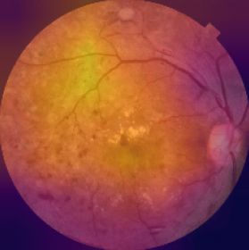DR: p=0.994 | 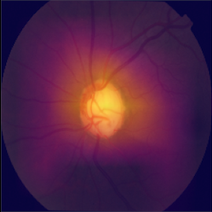  Glaucoma: P=0.929 | 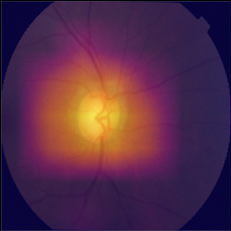  Glaucoma: p=0.832
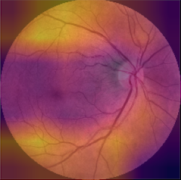Normal: p=0.999 | 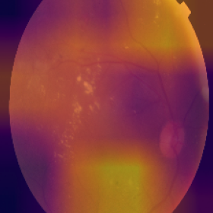DR: p=1.000 | 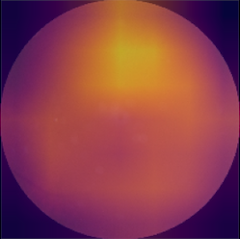  Cataract: p=1.000

Figure 4. Interpreting model predictions with Grad‑CAM. The visualizations highlight the retinal regions most influential to each disease prediction, providing spatial insight into the model’s decision‑making.
The proposed multitask model showed strong discriminative ability across all four classes, with consistently high sensitivity, specificity, accuracy, and F1 scores. The backbone (DenseNet), combined with lightweight adapters and task-specific MLPs, delivered stable, transferable retinal representations that generalized well across different datasets. Notably, the model maintained balanced error profiles despite large differences in image qualities, annotations, and acquisition devices. Grad-CAM visualizations confirmed that the model focuses on relevant retinal regions and improves interpretability. Overall, the results indicate that a shared-backbone multitask approach can effectively utilize cross-disease retinal features while maintaining task-specific discriminative power.
Previous studies on automated ocular disease detection have typically focused on single‑disease classification, particularly DR or glaucoma, and have often used curated datasets with limited variability. While recent works have explored multi‑label classification or multi‑disease prediction, many rely on datasets with incomplete annotations and lack explicit task separation, which can lead to label noise and reduced clinical interpretability.
In contrast, our approach integrates multiple datasets with diverse labeling schemes while preserving label fidelity through dedicated task‑specific classifiers. This modular architecture aligns with published recommendations for extensible diagnostic systems and advances the field by enabling new disease tasks to be added without retraining the entire model.
A key strength of this study is the integration of diverse datasets covering multiple acquisition devices, clinical sites, and patient populations. This heterogeneity enhances the model’s robustness and reduces the risk of overfitting to any single imaging domain. The multitask architecture also offers parameter efficiency, enabling the simultaneous detection of multiple diseases without duplicating the large backbone network.
Freezing the pretrained DenseNet121 backbone further stabilizes training across tasks with uneven sample sizes and variable annotation quality. Additionally, the modular design allows each head to learn from high‑quality, task‑specific labels while benefiting from shared retinal representations.
Including Grad-CAM enhances transparency in the model’s decision-making process. This is crucial for regulatory approval and essential for clinical use. We also reported both threshold-independent metrics and a broad set of threshold-based performance metrics, providing a comprehensive view of the model’s performance across all classes. In brief, the proposed framework offers a unified, scalable, and clinically robust platform that currently supports four high-priority ophthalmic conditions and can be easily expanded to include more diseases as new datasets become available.
While the results are strong, several limitations remain. The dataset is still imbalanced, with cataract represented by relatively few samples. Additionally, some images have only a single expert annotation, introducing some uncertainty in the ground‑truth labels and highlighting the value of consensus‑based grading in future datasets. Despite merging multiple sources and applying augmentation, the curated dataset may not fully capture the breadth of imaging conditions encountered in practice. Finally, the model relies solely on fundus photographs, which limits access to clinical factors that influence disease presentation; incorporating metadata such as age, diabetes duration, hemoglobin A1c, hypertension status, or refractive error could further enhance performance and support richer patient‑level assessments.
Future work should focus on fine-tuning the model’s weights and expanding the architecture to include additional conditions, such as AMD, hypertensive retinopathy, or optic nerve anomalies, to further enhance clinical usefulness. This involves expanding the dataset to include more diverse patient populations, imaging conditions, and disease presentations, increasing variability and improving generalizability. A larger dataset and greater diversity will further strengthen the model’s robustness in real‑world clinical settings. Finally, prospective validation across diverse clinical environments is essential to assess real‑world performance, fairness, and generalizability.

Conclusion

This study presents a unified multitask deep learning framework capable of simultaneously detecting diabetic retinopathy, glaucoma, cataract, and normal fundus appearance across different retinal datasets. Using a shared DenseNet121 backbone with lightweight, disease-specific classifiers, the model integrates information from datasets with varying annotation standards while preserving label accuracy for each task. The model exhibits strong, balanced performance across all four conditions, demonstrating that shared retinal representations combined with task-specific classifiers can effectively support multi-disease detection within a single architecture.
Despite challenges like mixed labeling and limited sample availability, especially for cataract, the model consistently remains effective and offers a scalable foundation for comprehensive eye-disease screening. Overall, this work advances automated fundus image analysis by demonstrating that a single, parameter-efficient architecture can provide reliable multi-disease detection without sacrificing performance. The proposed framework presents a practical path for broader deployment of AI-enabled screening in primary care, tele-ophthalmology, and high-volume public health programs.

Data Availability
The datasets in this study are publicly available; see references 32–38.

Acknowledgements
We thank Dr. C. Tchapga for providing helpful feedback on the manuscript.

Author Contributions
The author solely conceived the study and carried out all components of the work, from data curation and model development to analysis, visualization, and manuscript preparation.

Competing Interests
The author(s) declare no competing interests.

References
1. Tham, Y.-C. et al. Global Prevalence of Glaucoma and Projections of Glaucoma Burden through 2040: A Systematic Review and Meta-Analysis. Ophthalmology 121, 2081–2090 (2014).
2. Seth Flaxman et al. Global causes of blindness and distance vision impairment 1990-2020: a systematic review and meta-analysis. Lancet Glob Health 5, e1221–e1234 (2017).
3. Yau, J. W. Y. et al. Global Prevalence and Major Risk Factors of Diabetic Retinopathy. Diabetes Care 35, 556–564 (2012).
4. Cho, N. H. et al. IDF Diabetes Atlas: Global estimates of diabetes prevalence for 2017 and projections for 2045. Diabetes Res. Clin. Pract. 138, 271–281 (2018).
5. Wong, T. & Mitchell, P. The eye in hypertension. The Lancet 369, 425–435 (2007).
6. Varma, R. et al. Visual Impairment and Blindness in Adults in the United States: Demographic and Geographic Variations From 2015 to 2050. JAMA Ophthalmol. 134 7, 802–9 (2016).
7. Flaxman, S. R. et al. Global causes of blindness and distance vision impairment 1990–2020: a systematic review and meta-analysis. Lancet Glob. Health 5, e1221–e1234 (2017).
8. Burton, M. J. et al. The Lancet Global Health Commission on Global Eye Health: vision beyond 2020. Lancet Glob. Health 9, e489–e551 (2021).
9. Resnikoff, S., Felch, W., Gauthier, T.-M. & Spivey, B. The number of ophthalmologists in practice and training worldwide: a growing gap despite more than 200 000 practitioners. Br. J. Ophthalmol. 96, 783 (2012).
10. S. K. Dash, P. K. Sethy, A. Das, S. Jena, & A. Nanthaamornphong. Advancements in Deep Learning for Automated Diagnosis of Ophthalmic Diseases: A Comprehensive Review. IEEE Access 12, 171221–171240 (2024).
11. B. Goutam, M. F. Hashmi, Z. W. Geem, & N. D. Bokde. A Comprehensive Review of Deep Learning Strategies in Retinal Disease Diagnosis Using Fundus Images. IEEE Access 10, 57796–57823 (2022).
12. Ajitha, S., Akkara, J. D. & Judy, M. V. Identification of glaucoma from fundus images using deep learning techniques. Indian J. Ophthalmol. 69, (2021).
13. Al-Absi, H. R. H. et al. DiaNet v2 deep learning based method for diabetes diagnosis using retinal images. Sci. Rep. 14, 1595 (2024).
14. Angeline, R., Vani, R., Jeshron Sonali, A. & Rao, D. A. Automated Detection of Cataract Using a Deep Learning Technique. in Computational Intelligence in Machine Learning (eds Kumar, A., Zurada, J. M., Gunjan, V. K. & Balasubramanian, R.) 399–408 (Springer Nature Singapore, Singapore, 2022).
15. Juneja, M. et al. Automated detection of Glaucoma using deep learning convolution network (G-net). Multimed. Tools Appl. 79, 15531–15553 (2020).
16. Das, D., Biswas, S. K. & Bandyopadhyay, S. Detection of Diabetic Retinopathy using Convolutional Neural Networks for Feature Extraction and Classification (DRFEC). Multimed. Tools Appl. 82, 29943–30001 (2023).
17. Gulshan, V. et al. Development and Validation of a Deep Learning Algorithm for Detection of Diabetic Retinopathy in Retinal Fundus Photographs. JAMA 316 22, 2402–2410 (2016).
18. D’Souza, G., Siddalingaswamy, P. C. & Pandya, M. A. AlterNet-K: a small and compact model for the detection of glaucoma. Biomed. Eng. Lett. 14, 23–33 (2024).
19. Meedeniya, D., Shyamalee, T., Lim, G. & Yogarajah, P. Glaucoma identification with retinal fundus images using deep learning: Systematic review. Inform. Med. Unlocked 56, 101644 (2025).
20. D. A. Hasan et al. Machine Learning-based Diabetic Retinopathy Early Detection and Classification Systems- A Survey. in 2021 1st Babylon International Conference on Information Technology and Science (BICITS) 16–21 (2021). doi:10.1109/BICITS51482.2021.9509920.
21. Hemelings, R. et al. Deep learning on fundus images detects glaucoma beyond the optic disc. Sci. Rep. 11, 20313 (2021).
22. Jones, A., Abisheek, K., Dinesh Kumar, R. & Madesh, M. Cataract Detection Using Deep Convolutional Neural Networks. in Soft Computing and Signal Processing (eds Reddy, V. S., Prasad, V. K., Wang, J. & Reddy, K. T. V.) 505–519 (Springer Nature Singapore, Singapore, 2022).
23. Juneja, M. et al. GC-NET for classification of glaucoma in the retinal fundus image. Mach. Vis. Appl. 31, 38 (2020).
24. S. Mishra, S. Hanchate, & Z. Saquib. Diabetic Retinopathy Detection using Deep Learning. in 2020 International Conference on Smart Technologies in Computing, Electrical and Electronics (ICSTCEE) 515–520 (2020). doi:10.1109/ICSTCEE49637.2020.9277506.
25. Mohanty, C. et al. Using Deep Learning Architectures for Detection and Classification of Diabetic Retinopathy. Sensors 23, 5726 (2023).
26. Saha, S., Vignarajan, J. & Frost, S. A fast and fully automated system for glaucoma detection using color fundus photographs. Sci. Rep. 13, 18408 (2023).
27. Sahayam, S., Silambarasan, J. & Jayaraman, U. Detection of Cataract from Fundus Images Using Deep Transfer Learning. in Computer Vision and Image Processing (eds Raman, B., Murala, S., Chowdhury, A., Dhall, A. & Goyal, P.) 175–186 (Springer International Publishing, Cham, 2022).
28. Varma, N., Yadav, S. & Yadav, J. K. P. S. A reliable automatic cataract detection using deep learning. Int. J. Syst. Assur. Eng. Manag. 14, 1089–1102 (2023).
29. Chu, J. et al. Characterization of prevalence of ocular comorbidities and risk of legal blindness across the United States. Invest. Ophthalmol. Vis. Sci. 64, 4217–4217 (2023).
30. De Fauw, J. et al. Clinically applicable deep learning for diagnosis and referral in retinal disease. Nat. Med. 24, 1342–1350 (2018).
31. Ting, D. S. W. et al. Artificial intelligence and deep learning in ophthalmology. Br. J. Ophthalmol. 103, 167 (2019).
32. Asia Pacific Tele‑Ophthalmology Society (APTOS). APTOS 2019 Blindness Detection Dataset. Kaggle. (Accessed 2025).
33. J. Sivaswamy, S. R. Krishnadas, G. Datt Joshi, M. Jain, & A. U. Syed Tabish. Drishti-GS: Retinal image dataset for optic nerve head(ONH) segmentation. in 2014 IEEE 11th International Symposium on Biomedical Imaging (ISBI) 53–56 (2014). doi:10.1109/ISBI.2014.6867807.
34. Abramovich, O. et al. Hillel Yaffe Glaucoma Dataset (HYGD): A Gold-Standard Annotated Fundus Dataset for Glaucoma Detection. PhysioNet https://doi.org/10.13026/Z0AK-KM33.
35. Kovalyk, O. et al. PAPILA: Dataset with fundus images and clinical data of both eyes of the same patient for glaucoma assessment. Sci. Data 9, 291 (2022).
36. C. de Vente et al. AIROGS: Artificial Intelligence for Robust Glaucoma Screening Challenge. IEEE Trans. Med. Imaging 43, 542–557 (2024).
37. Shanggong Medical Technology Co., Ltd. Ocular Disease Intelligent Recognition (ODIR-5K) Dataset. (2019).
38. Zuiderveld, K. J. Contrast Limited Adaptive Histogram Equalization. in Graphics gems (1994).
39. G. Huang, Z. Liu, L. Van Der Maaten, & K. Q. Weinberger. Densely Connected Convolutional Networks. in 2017 IEEE Conference on Computer Vision and Pattern Recognition (CVPR) 2261–2269 (2017). doi:10.1109/CVPR.2017.243.
40. Kingma, D. P. & Ba, J. Adam: A Method for Stochastic Optimization. in 3rd International Conference on Learning Representations, ICLR 2015, San Diego, CA, USA, May 7-9, 2015, Conference Track Proceedings (2015).
41. Fawcett, T. An introduction to ROC analysis. Pattern Recognit Lett 27, 861–874 (2006).
42. Davis, J. & Goadrich, M. The relationship between Precision-Recall and ROC curves. in Proceedings of the 23rd International Conference on Machine Learning 233–240 (Association for Computing Machinery, New York, NY, USA, 2006). doi:10.1145/1143844.1143874.
43. Efron, B. & Tibshirani, R. An Introduction to the Bootstrap. in (1995).
44. R. R. Selvaraju et al. Grad-CAM: Visual Explanations from Deep Networks via Gradient-Based Localization. in 2017 IEEE International Conference on Computer Vision (ICCV) 618–626 (2017). doi:10.1109/ICCV.2017.74.

