Supplementary table 1 A summary of concomitant agents of all enrolled patients
 | All RA patients | IL-2 combination treatment
n | 888 | 233
Use of concomitant agents (no. of patients)
Methotrexate | 153 | 46
Leflunomide | 300 | 79
Sulfasalazine | 14 | 4
Cyclophosphamide | 103 | 30
Hydroxychloroquine | 89 | 23
Thalidomide | 13 | 1
Sirolimus | 88 | 9
Tretinoin tablets | 7 | 2
Biological agents | 59 | 24
Tripterysium glycosides | 66 | 22
Total Glucosides of Paeony Capsules | 42 | 11

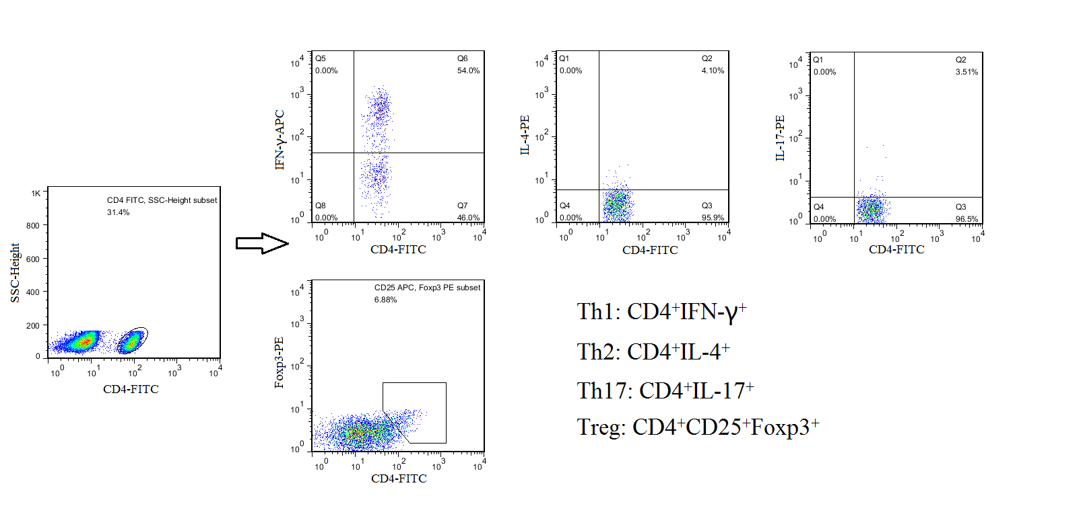
Supplementary Figure 1: Phenotypic characterization of CD4+T lymphocyte subsets by Flow cytometry.

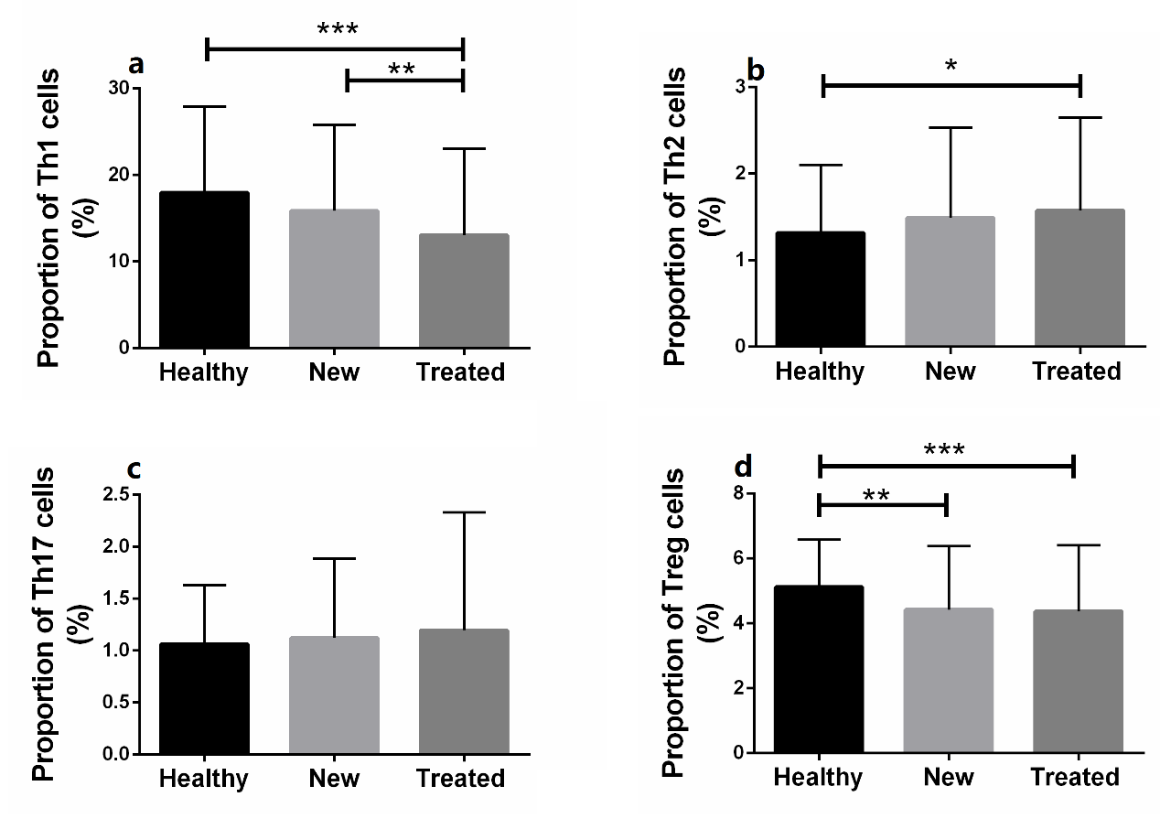
Supplementary Figure 2: Differences in the proportion of CD4+T subsets in peripheral blood between patients with RA, including new and previously treated patients, and healthy controls. (a–d) Proportions of Th1, Th2, and Tregs were significantly lower in treated patients than in healthy individuals; the proportion of Th17 cells did not differ significantly. New RA patients had a higher level of Th1 cells than previously treated RA patients, had a lower level of Tregs than healthy subjects. * P < 0.05, ** P < 0.01, *** P < 0.001. Significance values are asymptotic (2-sided tests) and the significance level is P < 0.05.

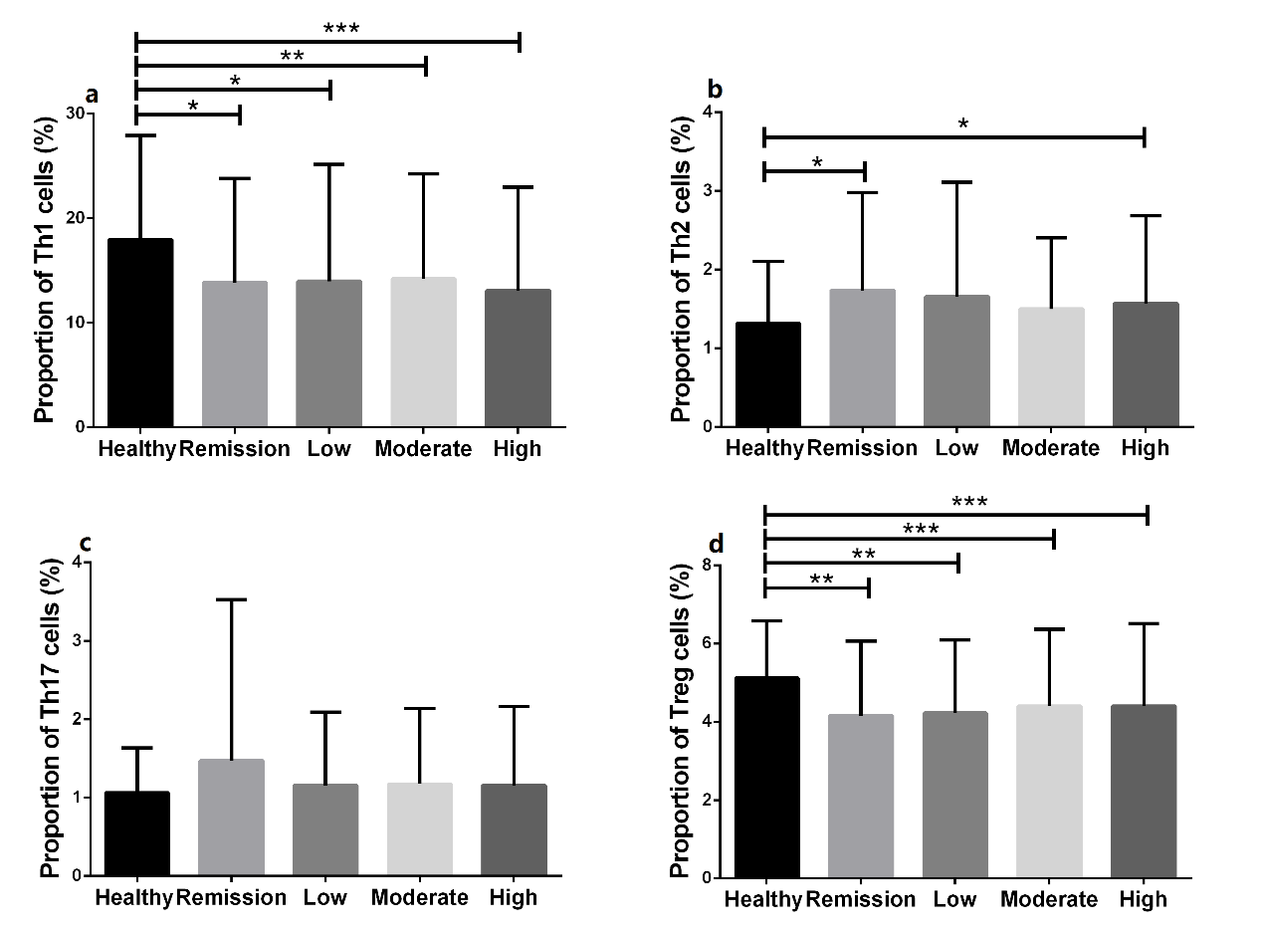
Supplementary Figure 3: Changes in the proportion of circulating CD4+T subsets between RA patients with different levels of DAS28 and healthy controls. (a–d) , The percentages of CD4+T subpopulations, except for Th17 cells, decreased with increasing disease activity compared with healthy controls, although this difference was not significant. * P < 0.05, ** P < 0.01, *** P < 0.001. Significance values are asymptotic (2-sided tests) and the significance level is P < 0.05.

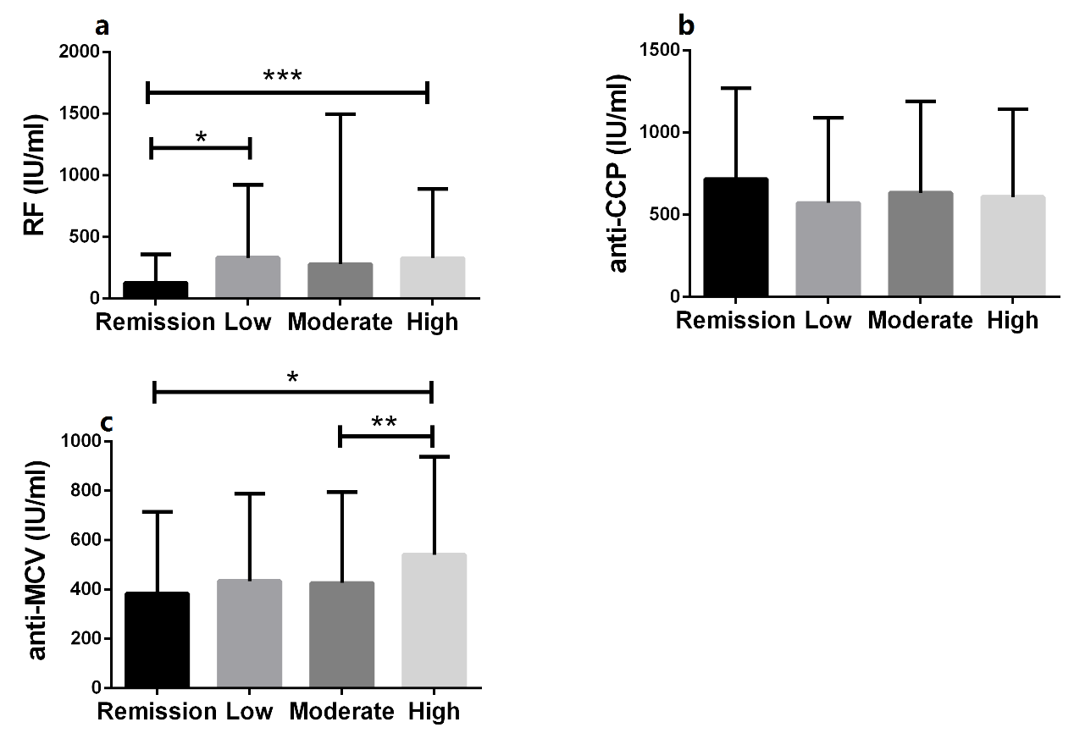
Supplementary Figure 4: Differences in levels of RA-related autoantibodies among RA patients differing in disease activity level. (a) RA patients in remission had lower RF levels than patients with low or high disease activity levels. (b) There was no significant difference in anti-CCP level among RA patients differing in disease activity level. (c) Patients with a high disease activity level had higher anti-MCV levels than patients in remission or with moderate disease activity. *P < 0.05, **P <0.01, ***P <0.001. Significance values are asymptotic (2-sided tests) and the significance level is P < 0.05. RF: rheumatoid factor, anti-CCP: anti-cyclic citrullinated peptide antibody, anti-MCV: anti-mutated citrullinated vimentin antibody.
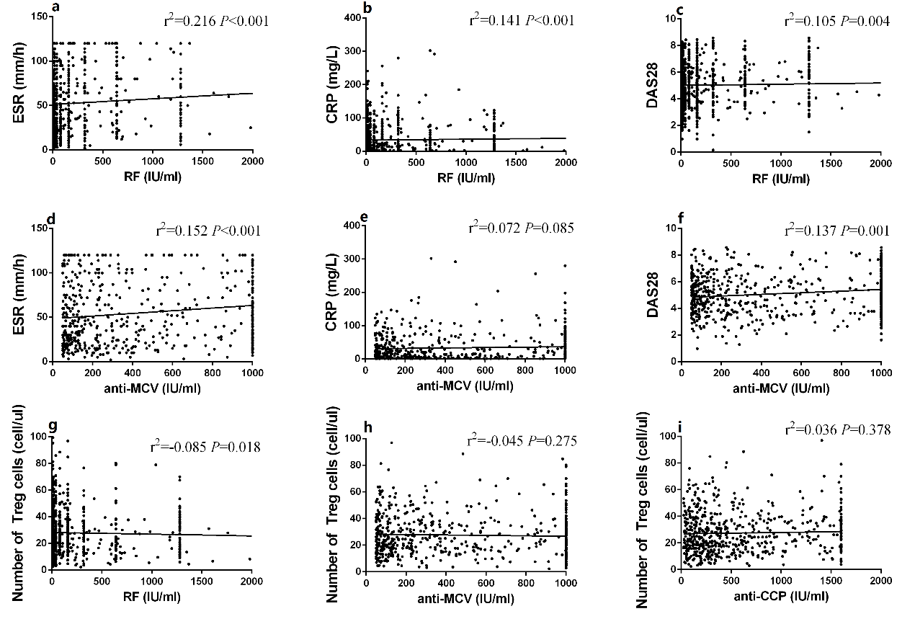
Supplementary Figure 5: Correlation of autoantibodies with markers of disease activity and Tregs. (a–c) The level of RF was significantly correlated with DAS28, ESR, and CRP. (d–f) The anti-MCV level was significantly correlated with DAS28 and ESR. (g–i) Only RF was significantly correlated with the absolute count of peripheral Tregs. RF: rheumatoid factor, anti-CCP: anti-cyclic citrullinated peptide antibody, anti-MCV: anti-mutated citrullinated vimentin antibody.
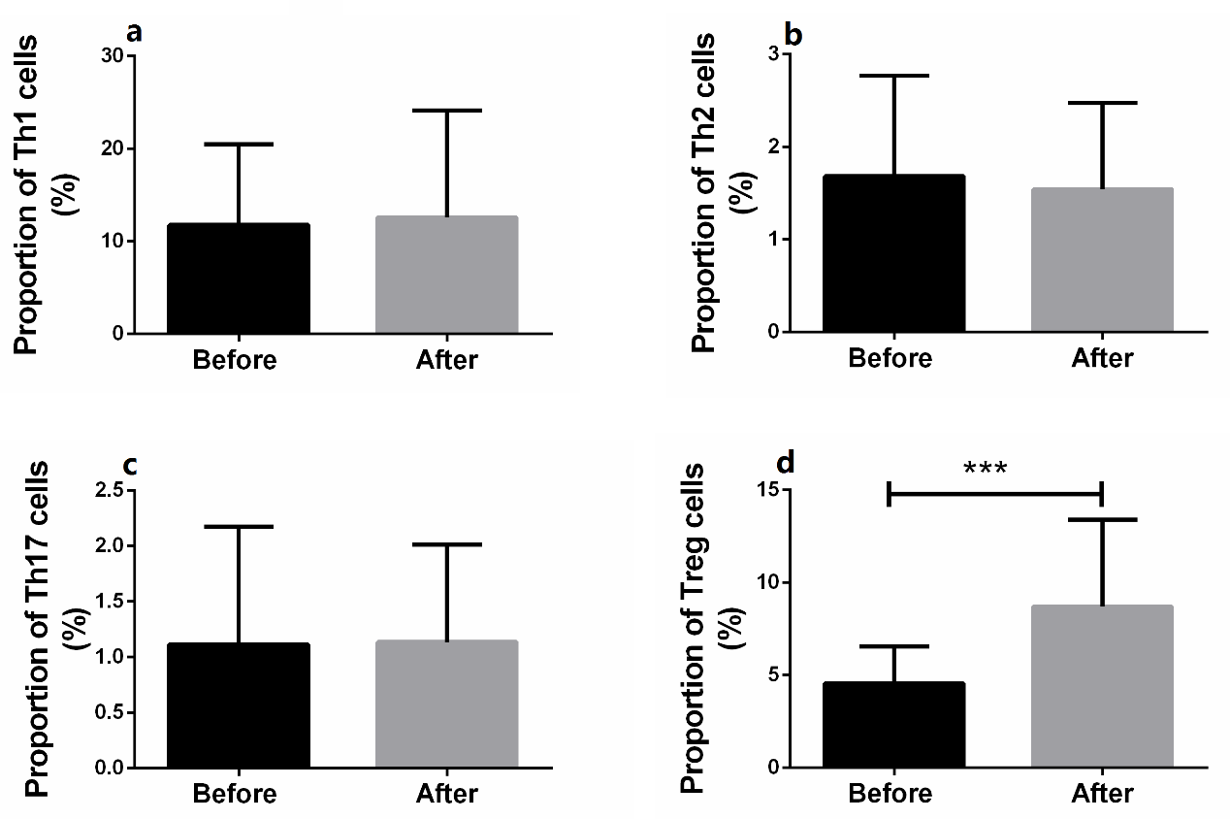
Supplementary Figure 6: Effects of low-dose IL-2 treatment on the proportion of peripheral CD4+T subsets in patients with RA. (a–d) The proportion of Tregs increased significantly in RA patients following IL-2 treatment compared with baseline values, while those of Th1, Th2, and Th17 cells did not change. *** P < 0.001. Significance values are asymptotic (2-sided tests) and the significance level is P < 0.05.

