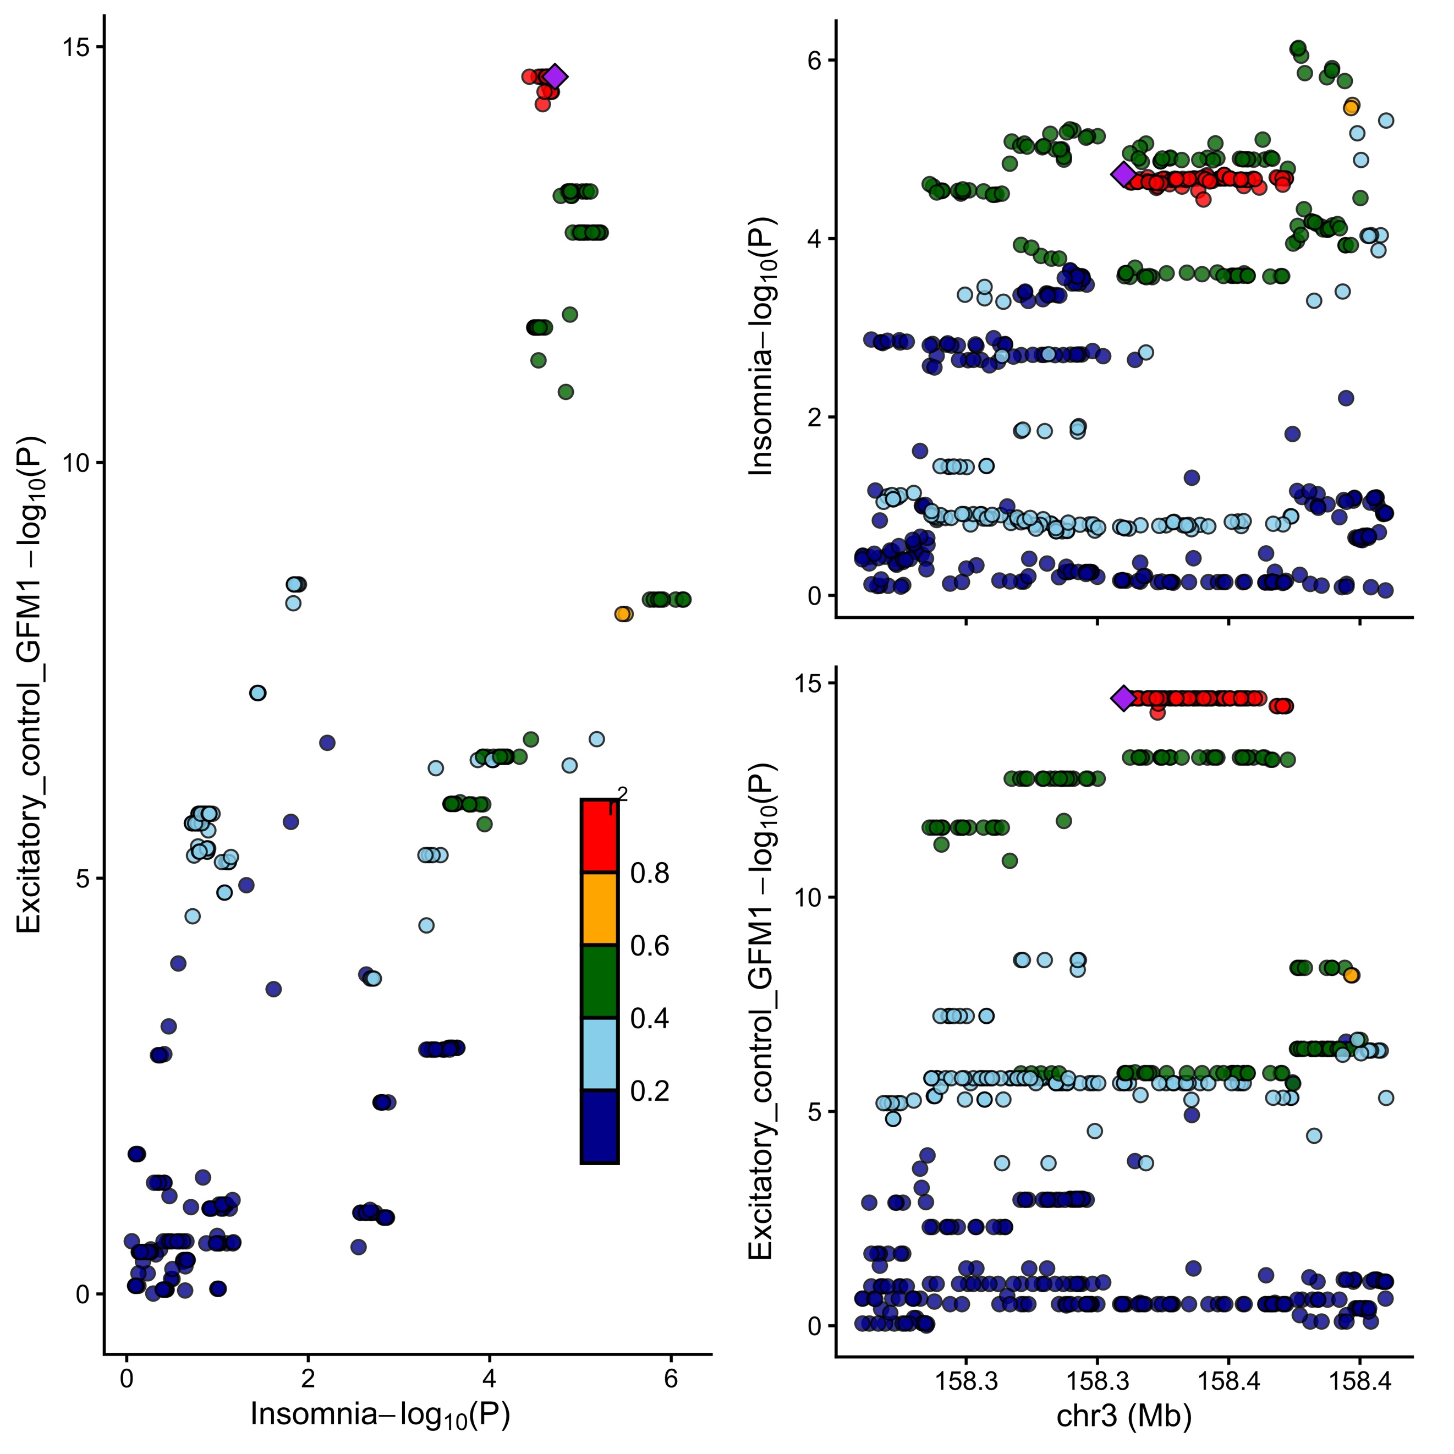
Figure S1. Colocalization of GFM1 expression and insomnia risk.Scatter and regional plots showing colocalization between GFM1 expression (excitatory neurons) and insomnia GWAS signal. Colocalization posterior probability (PP.H4) = 0.717.
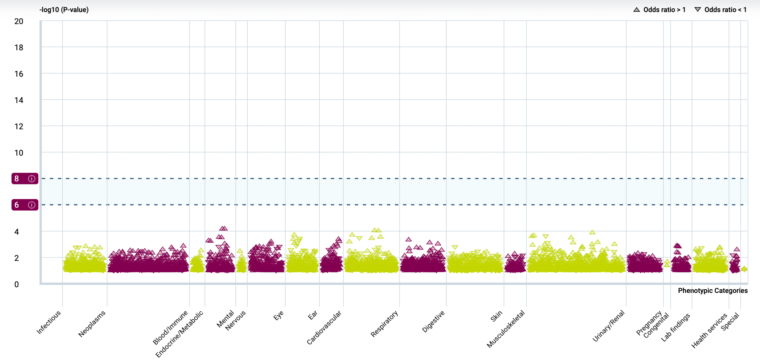
Figure S2. Phenome-wide association analysis (PheWAS) of the GFM1 instrument SNP. PheWAS plot showing –log₁₀(P) values for the lead GFM1 cis-eQTL across multiple phenotypic categories. No associations surpassed the Bonferroni-corrected significance threshold (dashed lines), indicating phenotype specificity and minimal pleiotropy.

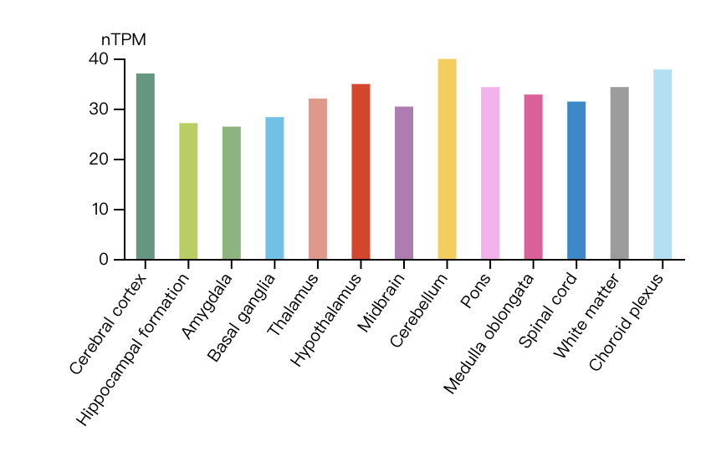
Figure S3. GFM1 expression across human brain regions.Normalized transcript expression levels (nTPM) of GFM1 in 14 brain regions from the Human Protein Atlas.

