SUPPLEMENTARY MATERIAL

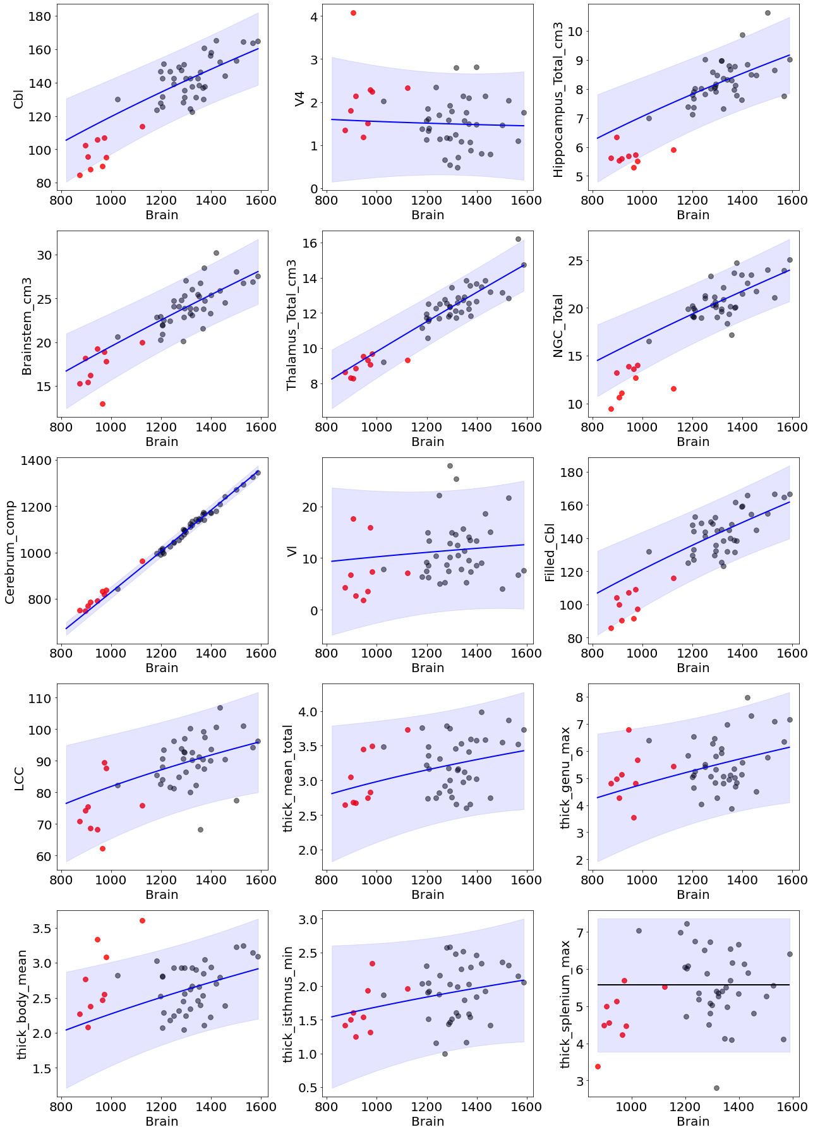
Supplementary Figure 1. Comparison of allometric and linear models on patients and controls
Scaling laws for all brain regions among controls (black), and relative location of PQBP1 (red) subjects’ volumes compared to total hemispheric volume. Plain blue line = scaling model based on power law. Note that for the splenium [thick_splenium_max], the power law model failed to establish an adequate negative scaling relationship, contrary to the expected results supported by large study groups (Fraize et al., 2023; Kerdreux et al., 2025). This inadequate fit, likely due to a sampling bias in our control group (3 leverage points), led us to prefer the use of a conservative but more robust constant model to evaluate absolute group differences for this specific anatomical feature. LCC: Length of Corpus Callosum; NGC: Basal Ganglia; Cbl: Cerebellum; V4: Fourth Ventricle; Vl: Lateral Ventricles.

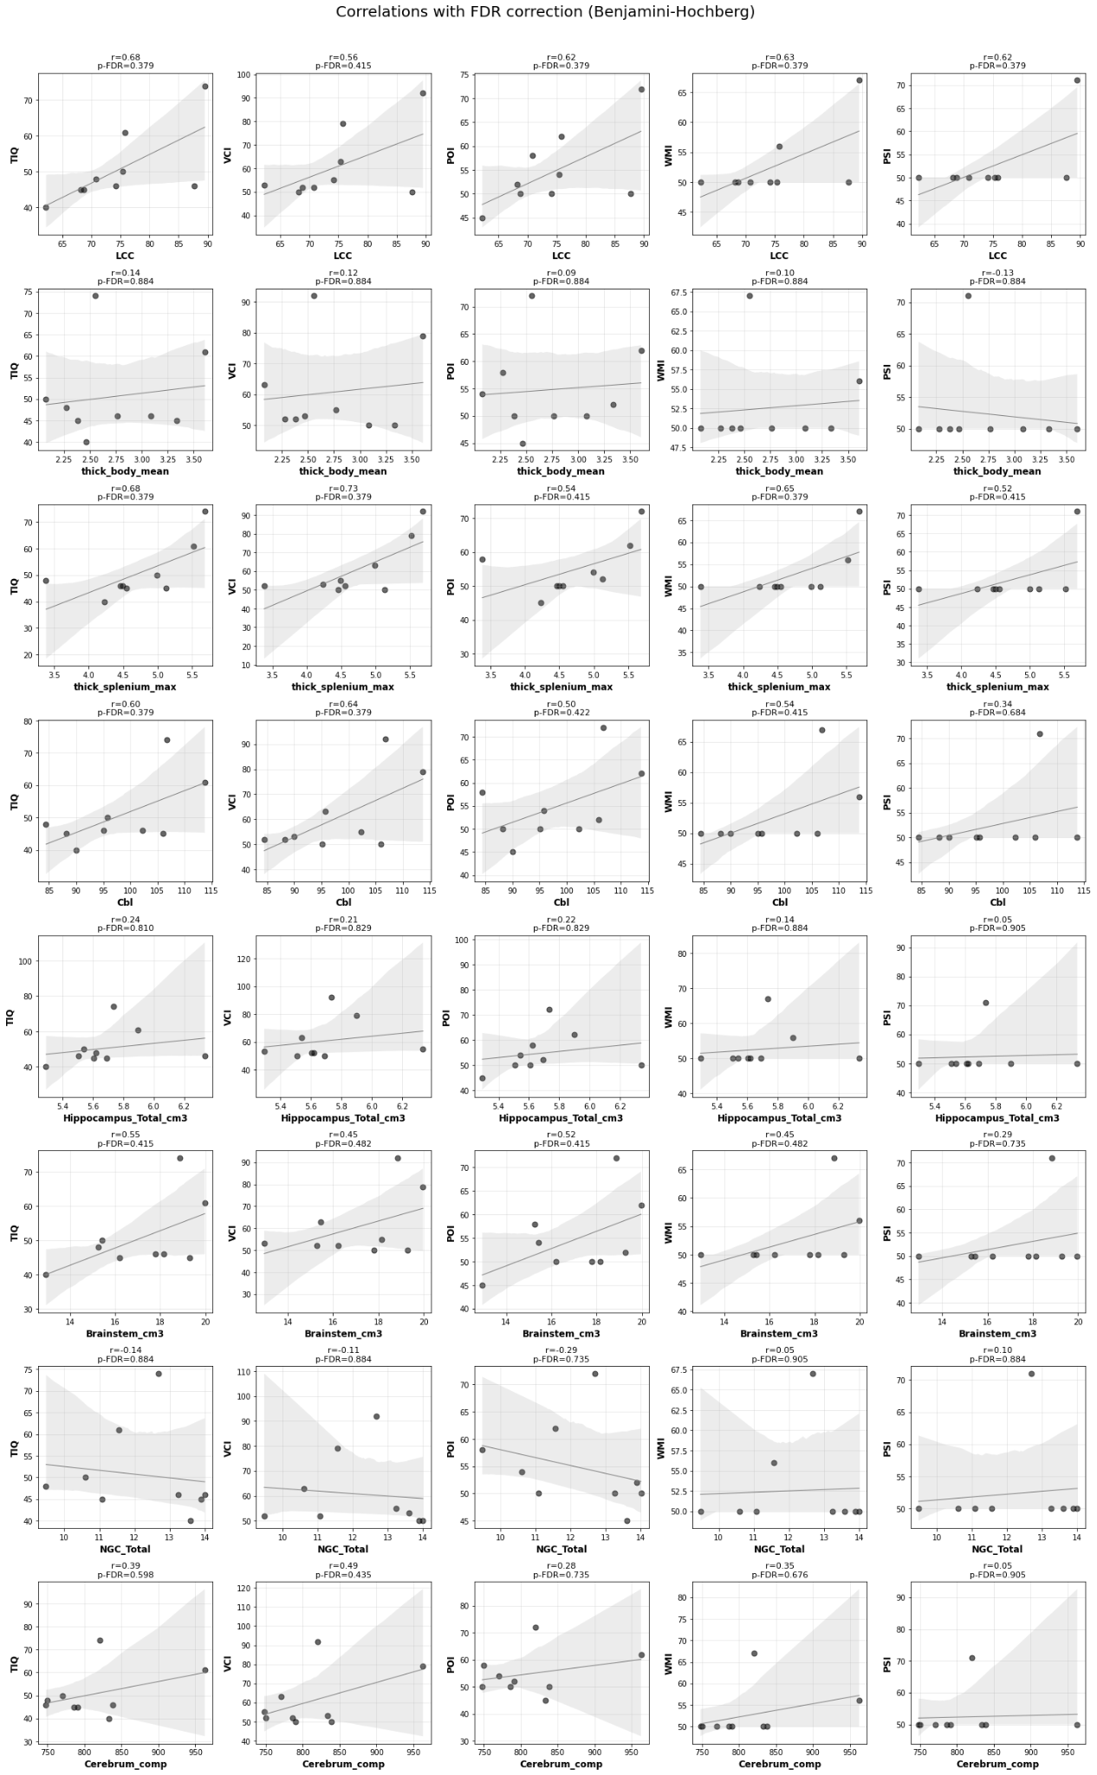
Supplementary Figure 2. Correlation Matrix between neuroanatomical features and Cognitive Scores in PQBP1 Patients.
Scatterplots showing Pearson correlations between regional brain measures and cognitive indices (TIQ, VCI, POI, WMI, PSI). Included ROIs (rows) exhibited significant deviations from normative growth in prior scaling analyses. p-FDR: Benjamini-Hochberg FDR corrected p-value; TIQ: Full-Scale IQ; VCI: Verbal Comprehension; POI: Perceptual Organization; WMI: Working Memory; PSI: Processing Speed; LCC: Length of Corpus Callosum; NGC: Basal Ganglia; Cbl: Cerebellum; V4: Fourth Ventricle; Vl: Lateral Ventricles.

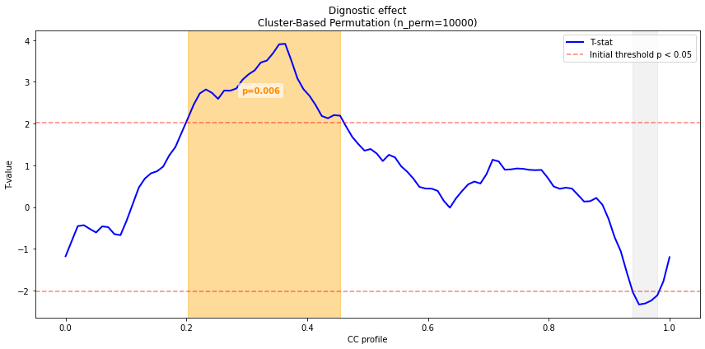
Supplementary Figure 3. Statistical Mapping of Corpus Callosum Thickness Deviations
The solid blue line represents the t-values of the difference between groups at each normalized anatomical point along the corpus callosum axis. The dotted red line represents the significant threshold before correction. The orange area indicates a significant cluster identified through permutation-based cluster analysis (p = 0.006).

 | N | Mean | SD | [min; max]
 |  |  |  |  | PIII-1 | RFIII-2 | AHIII-7 | SIII-3 | RFIII-1 | BIII-1 | AHIII-5 | SIII-1 | CBIII-1
A. Medical history
OFC at birth (cm) | 7 | 32 | 1.2 | [31;34] | 31 | 32 | 32 | 33 | 31 | 31 | . | 34 | .
OFCz (DS) | 7 | -3 | 1.1 | [-4.2;-1.2] | -3.5 | -3 | -3.1 | -2 | -4.2 | -4.2 | . | -1.2 | .
Age (years) at clinical exam | 9 | 22.6 | 10.7 | [7.4;43.8] | 7.4 | 15.5 | 14.5 | 18.8 | 21.7 | 22.4 | 27.6 | 31.7 | 43.8
OFC (cm) | 9 | 50.5 | 2.4 | [46;54] | 46 | 49.7 | 49.5 | 54 | 49.5 | 51.5 | 49.5 | 53.5 | 51
OFCz (DS) | 9 | -3.9 | 1.1 | [-5;-2] | -5 | -4 | -4 | -2 | -5 | -3.8 | -5 | -2.3 | -4
Age (years) at MRI | 9 | 25.1 | 11.2 | [9.3;46.5] | 9.3 | 15.0 | 17.8 | 21.6 | 24.6 | 25.7 | 30.8 | 34.5 | 46.5
B. Cognitive characteristics
Age (years) at neuropsychological assessment | 8 | 26.1 | 10.7 | [10.3;46.3] | 10.3 | . | 17.8 | 21.6 | 24.6 | 25.6 | 30.8 | 32 | 46.3
Full Scale IQ | 8 | 51.3 | 11 | [40.74] | 40* | . | 46 | 61 | 48 | 45 | 46 | 74 | 50
Verbal Comprehension Index | 8 |  |  |  | 53 | . | 50 | 79 | 52 | 50 | 55 | 92 | 63
Perceptual Reasoning Index | 8 |  |  |  | 45 | . | 50 | 62 | 58 | 52 | 50 | 72 | 54
Working Memory Index | 8 |  |  |  | 50 | . | 50 | 56 | 50 | 50 | 50 | 67 | 50
Processing Speed Index | 8 |  |  |  | 50 | . | 50 | 50 | 50 | 50 | 50 | 71 | 50
Verbal IQ | 7 |  |  |  |  | . | 49 | 66 | 48 | 45 | 49 | 80 | 53
Performance IQ | 7 |  |  |  |  | . | 47 | 57 | 52 | 48 | 47 | 70 | 51

Supplementary table 1. Individual characteristics of the PQBP1 patients (n=9)
SD: Standard Deviation; OFC: Occipitofrontal Circumference; OFCz: Occipitofrontal Circumference z-score; DS: Deviation Score (standard deviation units).

 | Variate | F-stat | p-FDR
Cerebral Volumes
Brainstem | Diagnosis | 65,37 | < 0,001
 | Age | 0,18 | 0,7248
Cerebellum | Diagnosis | 99,37 | < 0,001
 | Age | 0,95 | 0,5194
Cerebrum | Diagnosis | 74,63 | < 0,001
 | Age | 0,58 | 0,5848
Filled Cerebellum | Diagnosis | 94,29 | < 0,001
 | Age | 0,75 | 0,5667
Hippocampi | Diagnosis | 104,34 | < 0,001
 | Age | 1,91 | 0,3004
Basal ganglia | Diagnosis | 161,84 | < 0,001
 | Age | 4,97 | 0,1163
Thalami | Diagnosis | 90,77 | < 0,001
 | Age | 4,72 | 0,1218
V4 | Diagnosis | 8,57 | 0,1055
 | Age | 3,73 | 0,1421
Vl | Diagnosis | 2,94 | 0,191
 | Age | 7,18 | 0,0465
Corpus Callosum
TCL | Diagnosis | 25,53 | < 0,001
 | Age | 2,14 | 0,4403
Mean thickness | Diagnosis | 1,6 | 0,4403
 | Age | 1,11 | 0,4709
Genu | Diagnosis | 1,6 | 0,4403
 | Age | 1,5 | 0,4403
Body | Diagnosis | 0,39 | 0,642
 | Age | 0,07 | 0,7896
Isthmus | Diagnosis | 2,56 | 0,4403
 | Age | 1,28 | 0,4403
Splenium | Diagnosis | 5,75 | 0,3119
 | Age | 0,17 | 0,709

Supplementary Table 2. Summary of ANCOVA assessing the main effects of Diagnosis and Age on neuroanatomical features.
P-values were adjusted for multiple comparisons using the Benjamini-Hochberg False Discovery Rate procedure. Significant effects (p < 0.05 after correction) are highlighted with bold typo. TCL: Total Length of Corpus Callosum

REFERENCES
Fraize, J., Leprince, Y., Elmaleh-Bergès, M., Kerdreux, E., Delorme, R., Hertz-Pannier, L., Lefèvre, J., Germanaud, D., 2023. Spectral-based thickness profiling of the corpus callosum enhances anomaly detection in fetal alcohol spectrum disorders. Front Neurosci 17, 1289013. https://doi.org/10.3389/fnins.2023.1289013
Kerdreux, E., Fraize, J., Ntorkou, A., Garzón, P., Delorme, R., Elmaleh-Berges, M., Duchesnay, E., Hertz-Pannier, L., Leprince, Y., Mangin, J.-F., Germanaud, D., 2025. Pattern of Deep Grey Matter Undersizing Boosts MRI-Based Diagnostic Classifiers in Fetal Alcohol Spectrum Disorders. Hum Brain Mapp 46, e70233. https://doi.org/10.1002/hbm.70233

