Supplemental Material
Table S1. Fertilization design for the 2024 and 2025 experiments.
Treatment | Basal fertilizer (BF) (kg/ha) |  |  |  |  | Topdressing (TD) (kg/ha)
Treatment | Compound Fertilizer (CF) | Urea | KCl | Calcium Magnesium Fertilizer (CMF) |  | Compound Fertilizer (CF) | Urea | KCl
T1 | 0 | 0 | 0 | 0 |  | 0 | 0 | 0
T2 | 213 | 113 | 47 | 0 |  | 640 | 338 | 140
T3 | 213 | 67 | 47 | 0 |  | 640 | 202 | 140
T4 | 213 | 22 | 47 | 0 |  | 640 | 66 | 140
T5 | 0 | 0 | 0 | 500 |  | 0 | 0 | 0
T6 | 213 | 113 | 47 | 500 |  | 640 | 338 | 140
T7 | 213 | 67 | 47 | 500 |  | 640 | 202 | 140
T8 | 213 | 22 | 47 | 500 |  | 640 | 66 | 140
Note: T1: No fertilization; T2: Conventional fertilization; T3: 25% N reduction; T4: 50% N reduction; T5–T8: Corresponding treatments to T1–T4 with the addition of 750 kg/ha Ca-Mg fertilizer.

Table S2. Soil chemical properties and their abbreviations.
Parameter | Abbreviation |  | Parameter | Abbreviation
Soil pH | pH |  | Total Phosphorus (g/kg) | TP
Organic Matter (g/kg) | OM |  | Total Potassium (g/kg) | TK
Organic Carbon (g/kg) | OC |  | Alkali-Hydrolyzable Nitrogen (mg/kg) | AHN
Water-Soluble Organic Carbon (mg/kg) | WSOC |  | Available Phosphorus (mg/kg) | AP
Total Nitrogen (g/kg) | TN |  | Available Potassium (mg/kg) | AK

Table S3. Specifications and acquisition details of the Jilin-1 satellite imagery.
Sensor type | Sensor ID | Acquisition date | Growth stage | Band name | Wavelength (nm) | Resolution (m)
Jilin-1 GF Series | GF03D-DP08 | April 15, 2024 | Seedling stage | Blue | 430–520 | 3.0
Jilin-1 GF Series | GF03D-53 | April 2, 2025 | Seedling stage | Green | 520–610 | 3.0
Jilin-1 GF Series | GF02A | July 5, 2024 | Tillering stage | Red | 610–690 | 3.0
Jilin-1 GF Series | GF03D-20 | September 13, 2024 | Elongation stage | Near-infrared | 770–895 | 3.0
Jilin-1 GF Series | GF03D-21 | October 22, 2024 | Maturation stage | Pan | 450 – 700 | 0.75
Jilin-1 KF Series |  |  |  | Blue | 450–510 | 2.0
Jilin-1 KF Series | KF02B-03 | July 7, 2025 | Tillering stage | Green | 510–580 | 2.0
Jilin-1 KF Series | KF02B-02 | September 6, 2025 | Elongation stage | Red | 630–690 | 2.0
Jilin-1 KF Series | KF02B-01 | October 17, 2025 | Maturation stage | Near-infrared | 770–895 | 2.0
Jilin-1 KF Series |  |  |  | Pan | 450–800 | 0.5

Table S4. Vegetation indices used in this study.
Vegetation Index | Formulation | Reference
Pan NDVI (PNDVI) | $$(NIR−(B+G+R)/(NIR+(B+G+R))$$ | (Wang et al., 2007)
Red Blue NDVI (RBNDVI) | $$(NIR−(R+B))/(NIR+(R+B))$$ | (Wang et al., 2007)
Green Red NDVI (GRNDVI) | $(NIR−(G+R))/(NIR +(G+R))$ | (Wang et al., 2007)
Green Blue NDVI (GBNDVI) | $$(NIR−(G+B))/(NIR+(G+B))$$ | (Wang et al., 2007)
Green-Normalized Difference Vegetation Index (GNDVI) | $(NIR−G)/(NIR+G)$ | (Wang et al., 2007)
Blue-Normalized Difference Index (BNDVI) | $(NIR−B)/(NIR+B)$ | (Wang et al., 2007)
Normalized Difference Vegetation Index (NDVI) | $(NIR−R)/(NIR+R)$ | (Zhou et al., 2020;  Trevisiol et al., 2024)
Normalized Green/Red Difference Index (NGRDI) | $$(G−R)/(G+R)$$ | (Hassan et al., 2019)
Soil Adjusted Vegetation Index (SAVI) | $$(NIR−R)/(NIR+R+L)×(1+L)$$ | (Trevisiol et al., 2024)
Modified Soil Adjusted Vegetation Index (MSAVI) | $$(2×NIR+1−{\left(2× NIR+1\right)}^{2}−8×(NIR−R))/2$$ | (Zhao et al., 2025)
Wide Dynamic Range Vegetation Index (WDRVI) | $$(a×(NIR−R))/(NIR+a×R)$$ | (Hancock and Dougherty, 2007)
Green Ratio Vegetation Index (GRVI) | $$NIR/G$$ | (Maresma et al., 2016)
Ratio Vegetation Index (RVI) | $$NIR/R$$ | (Zhou et al., 2020)
Green Difference Vegetation Index (GDVI) | $$NIR−G$$ | (Tucker et al., 1979)
Difference Vegetation Index (DVI) | $$NIR−R$$ | (Zhou et al., 2017)
Chlorophyll Vegetation Index (CVI) | $$NIR×R/G^{2}$$ | (Vincini et al., 2008)
Enhanced Vegetation Index (EVI) | $$(2.5 ×(NIR−R))/(NIR+6×R−7.5×B+0.5)$$ | (Trevisiol et al., 2024)
Green Leaf Index (GLI) | $$\left(2×G−R−B\right)/(2×G+R+B)$$ | (Hunt et al., 2011)
Chlorophyll Index Green (CI_{green}) | $$NIR/G−1$$ | (Zhou et al., 2020)
Coloration Index (CI) | $(R−B)/R$ | (Kalambukattu et al., 2018)
Note: In the table, B, G, R, and NIR represent the reflectance of the blue, green, red, and near-infrared bands, respectively; L represents the soil adjustment factor (set to 0.5 here); a represents the weighting factor (set to 0.1 here).

Table S5. Selected GLCM texture features and their abbreviations and equations.
Parameter | Abbreviation | Formulas | Reference
Mean | MEA | $$\sum_{i,j}{iP(i,j)}$$ | (Yuan et al., 2023, Xuan et al., 2025)
Variance | VAR | $$\sum_{i,j}{P\left(ⅈ,j\right)·{\left(i−μ\right)}^{2}}$$ | (Yuan et al., 2023, Xuan et al., 2025)
Homogeneity | HOM | $$\sum_{i,j}{\frac{P(i,j)}{{1+(i−j)}^{2}}}$$ | (Yuan et al., 2023, Xuan et al., 2025)
Contrast | CON | $$\sum_{i,j}{P\left(ⅈ,j\right)·{\left(i−j\right)}^{2}}$$ | (Yuan et al., 2023, Xuan et al., 2025)
Dissimilarity | DIS | $$\sum_{i,j}{P\left(ⅈ,j\right)·|i−j|}$$ | (Yuan et al., 2023, Xuan et al., 2025)
Entropy | ENT | $$−\sum_{i,j}{P\left(i,j\right)·log(P(i,j))}$$ | (Yuan et al., 2023, Xuan et al., 2025)
Angular Second Moment | ASM | $$\sum_{i,j}{{P(i,j)}^{2}}$$ | (Yuan et al., 2023, Xuan et al., 2025)
Correlation | COR | $$\sum_{i,j}{\frac{(i−μ_{i})(j−μ_{j})P(i,j)}{σ_{i}σ_{j}}}$$ | (Yuan et al., 2023, Xuan et al., 2025)
Note: N represents the total number of elements in the GLCM; i and j represent the row and column indices of the GLCM, denoting the pixel gray value and the gray value of its adjacent pixel, respectively; P(i, j) represents the probability value at position (i, j) in the GLCM, indicating the joint probability of the occurrence of a pixel with gray value i and a pixel with gray value j; μ represents the mean of the gray values, while μ_{i} and μ_{j} represent the means of gray values i and j, respectively; and σ_{i} and σ_{j} represent the standard deviations of gray values i and j, respectively.
Table S6. Hyperparameter search spaces for the four machine learning models.
Model | Parameters | Value range
RR | Alpha  Solver | {0.001, 0.01, 0.1, 0.5, 1.0, 5.0, 10, 50.0, 100.0, 500.0, 1000}  {auto, svd, cholesky, lsqr, sparse_cg, sag, saga}
GPR | Constant value | [10⁻³, 10³]
GPR | Length scale | [10⁻²,10²]
GPR | Noise level | [10⁻⁵,10¹]
 | Optimizer restarts | 10
CatBoost | Iterations | {20, 50, 100}
CatBoost | Depth | {2, 3, 4}
CatBoost | Learning rate | {0.01, 0.03, 0.05, 0.1}
CatBoost | L2 regularization | {1, 3, 5, 7, 9}
CatBoost | Min samples per leaf | {5, 10, 15}
CatBoost | Max leaves | {8, 16, 31}
CatBoost | Subsample | {0.6, 0.8, 1.0}
SVR | C | [10⁻³, 10³]
SVR | Epsilon | [10⁻², 1]
SVR | Kernel | {linear，rbf，poly，sigmoid}
Note: For SVR, the parameter grid for C consists of 50 values log-spaced, and epsilon consists of 50 values linearly spaced.

Table S7. Optimal texture window sizes for different phenotypic traits at each growth stage.
Growth stage | Texture window size
Growth stage | Yield |  | Millable Stalks |  | Brix
Seedling stage | 5×5 |  | 3×3 |  | 3×3
Tillering stage | 7×7 |  | 7×7 |  | 3×3
Elongation stage | 5×5 |  | 5×5 |  | 3×3
Maturation stage | 3×3 |  | 3×3 |  | 3×3

Table S8. Performance of yield prediction models with different input combinations across growth stages.
Modeling  methods | Input  parameters | Seedling stage |  |  | Tillering stage |  |  | Elongation stage |  |  | Maturation stage
Modeling  methods | Input  parameters | R²_{CV} | RMSE_{CV} | RPD_{CV} | R²_{CV} | RMSE_{CV} | RPD_{CV} | R²_{CV} | RMSE_{CV} | RPD_{CV} | R²_{CV} | RMSE_{CV} | RPD_{CV}
SVR | VIs | 0.29 | 21.42 | 1.18 | 0.60 | 16.02 | 1.58 | 0.47 | 18.41 | 1.38 | 0.54 | 17.22 | 1.47
SVR | VIs + TIs | 0.38 | 20.02 | 1.27 | 0.55 | 17.08 | 1.49 | 0.63 | 15.36 | 1.65 | 0.54 | 17.13 | 1.48
SVR | VIs + TIs + SCPs + FI | 0.65 | 15.08 | 1.68 | 0.70 | 13.84 | 1.83 | 0.50 | 17.91 | 1.42 | 0.67 | 14.63 | 1.73
GPR | VIs | 0.19 | 22.80 | 1.11 | 0.57 | 16.66 | 1.52 | 0.37 | 20.15 | 1.26 | 0.50 | 18.01 | 1.41
GPR | VIs + TIs | 0.23 | 22.19 | 1.14 | 0.56 | 16.78 | 1.51 | 0.54 | 17.25 | 1.47 | 0.49 | 18.18 | 1.40
GPR | VIs + TIs + SCPs + FI | 0.64 | 15.32 | 1.66 | 0.69 | 14.11 | 1.80 | 0.51 | 17.78 | 1.43 | 0.64 | 15.15 | 1.67
RR | VIs | 0.27 | 21.66 | 1.17 | 0.59 | 16.28 | 1.56 | 0.41 | 19.48 | 1.30 | 0.53 | 17.44 | 1.45
RR | VIs + TIs | 0.30 | 21.25 | 1.19 | 0.65 | 15.06 | 1.68 | 0.58 | 16.52 | 1.54 | 0.54 | 17.19 | 1.48
RR | VIs + TIs + SCPs + FI | 0.65 | 15.01 | 1.69 | 0.66 | 14.70 | 1.73 | 0.51 | 17.74 | 1.43 | 0.67 | 14.53 | 1.75
CatBoost | VIs | 0.14 | 23.55 | 1.08 | 0.60 | 16.04 | 1.58 | 0.36 | 20.32 | 1.25 | 0.40 | 19.72 | 1.29
CatBoost | VIs + TIs | 0.48 | 18.26 | 1.39 | 0.54 | 17.27 | 1.47 | 0.44 | 19.04 | 1.33 | 0.42 | 19.24 | 1.32
CatBoost | VIs + TIs + SCPs + FI | 0.57 | 16.68 | 1.52 | 0.63 | 15.46 | 1.64 | 0.48 | 18.35 | 1.38 | 0.57 | 16.64 | 1.52

Table S9. Performance of millable stalk population prediction models with different input combinations across different growth stages.
Modeling  methods | Input  parameters | Seedling stage |  |  | Tillering stage |  |  | Elongation stage |  |  | Maturation stage
Modeling  methods | Input  parameters | R²_{CV} | RMSE_{CV} | RPD_{CV} | R²_{CV} | RMSE_{CV} | RPD_{CV} | R²_{CV} | RMSE_{CV} | RPD_{CV} | R²_{CV} | RMSE_{CV} | RPD_{CV}
SVR | VIs | 0.33 | 8954 | 1.22 | 0.41 | 8482 | 1.30 | 0.47 | 7987 | 1.37 | 0.57 | 7181 | 1.52
SVR | VIs + TIs | 0.38 | 8640 | 1.32 | 0.45 | 8267 | 1.32 | 0.45 | 8080 | 1.35 | 0.63 | 6602 | 1.66
SVR | VIs + TIs + SCPs + FI | 0.50 | 7727 | 1.41 | 0.56 | 7271 | 1.50 | 0.62 | 6733 | 1.62 | 0.49 | 7813 | 1.40
GPR | VIs | 0.31 | 9093 | 1.20 | 0.37 | 8690 | 1.26 | 0.41 | 8416 | 1.30 | 0.34 | 8864 | 1.23
GPR | VIs + TIs | 0.27 | 9321 | 1.17 | 0.40 | 8480 | 1.29 | 0.38 | 8628 | 1.27 | 0.60 | 6902 | 1.58
GPR | VIs + TIs + SCPs + FI | 0.55 | 7347 | 1.49 | 0.47 | 7940 | 1.38 | 0.39 | 8531 | 1.28 | 0.47 | 7989 | 1.37
RR | VIs | 0.32 | 8989 | 1.22 | 0.38 | 8576 | 1.27 | 0.45 | 8084 | 1.35 | 0.37 | 8705 | 1.26
RR | VIs + TIs | 0.39 | 8533 | 1.28 | 0.42 | 8292 | 1.32 | 0.45 | 8128 | 1.34 | 0.55 | 7347 | 1.49
RR | VIs + TIs + SCPs + FI | 0.55 | 7313 | 1.49 | 0.46 | 7999 | 1.37 | 0.44 | 8162 | 1.34 | 0.49 | 7822 | 1.40
CatBoost | VIs | 0.27 | 9357 | 1.17 | 0.36 | 8763 | 1.25 | 0.40 | 8493 | 1.29 | 0.31 | 9081 | 1.20
CatBoost | VIs + TIs | 0.28 | 9267 | 1.18 | 0.46 | 8064 | 1.36 | 0.38 | 8624 | 1.27 | 0.51 | 7660 | 1.43
CatBoost | VIs + TIs + SCPs + FI | 0.41 | 8423 | 1.30 | 0.36 | 8735 | 1.25 | 0.34 | 8912 | 1.23 | 0.48 | 7866 | 1.39

Table S10. Performance of the SVR model for predicting Brix with different input combinations across different growth stages.
Modeling  methods | Input  parameters | Seedling stage |  |  | Tillering stage |  |  | Elongation stage |  |  | Maturation stage
Modeling  methods | Input  parameters | R²_{CV} | RMSE_{CV} | RPD_{CV} | R²_{CV} | RMSE_{CV} | RPD_{CV} | R²_{CV} | RMSE_{CV} | RPD_{CV} | R²_{CV} | RMSE_{CV} | RPD_{CV}
SVR | VIs | 0.21 | 0.63 | 1.12 | 0.04 | 0.69 | 1.02 | 0.16 | 0.64 | 1.09 | 0.07 | 0.68 | 1.04
SVR | VIs + TIs | 0.40 | 0.55 | 1.29 | 0.19 | 0.63 | 1.11 | 0.24 | 0.61 | 1.15 | 0.36 | 0.56 | 1.26
SVR | VIs + TIs + SCPs + FI | 0.42 | 0.54 | 1.31 | 0.25 | 0.61 | 1.15 | 0.15 | 0.65 | 1.09 | 0.44 | 0.53 | 1.33

Table S11. Descriptive statistics of single-stalk weight, stalk diameter, and plant height at the early maturation stage based on 20 plants sampled per plot.

Sugarcane Traits | Year | Mean | SD | Min | Max | CV (%)
Plant height (cm) | 2024 | 197.25 | 20.66 | 158.34 | 238.34 | 10.89
Plant height (cm) | 2025 | 199.42 | 30.50 | 143.72 | 253.51 | 15.61
Stalk diameter (cm) | 2024 | 2.66 | 0.35 | 1.99 | 3.28 | 13.22
Stalk diameter (cm) | 2025 | 2.80 | 0.37 | 2.11 | 3.49. | 13.31
Single stalk weight (g) | 2024 | 1199.11 | 322.96 | 656.68 | 1847.01 | 27.84
Single stalk weight (g) | 2025 | 1334.12 | 415.45 | 676.52 | 2208.88 | 31.40

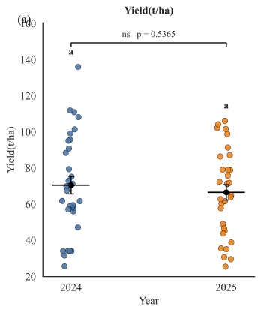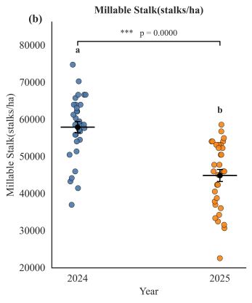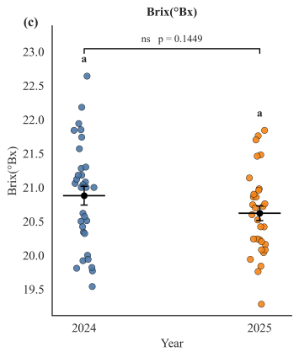
Fig. S1. Distribution characteristics of the measured phenotypic traits. (a) Yield, (b) Millable Stalk population, (c) Brix.
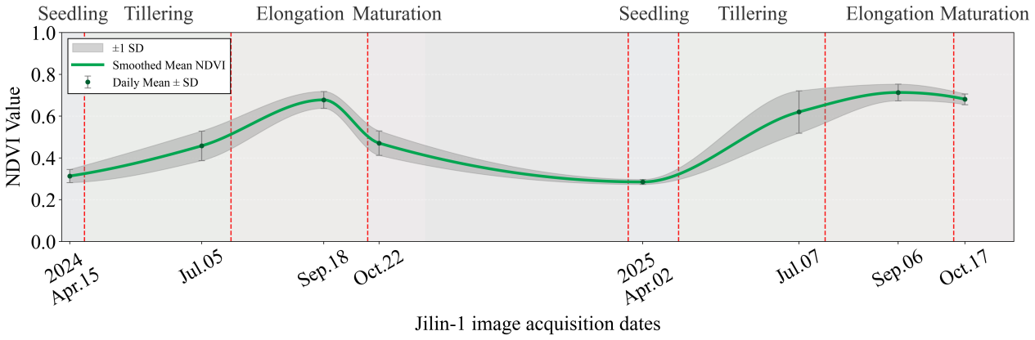
(a)

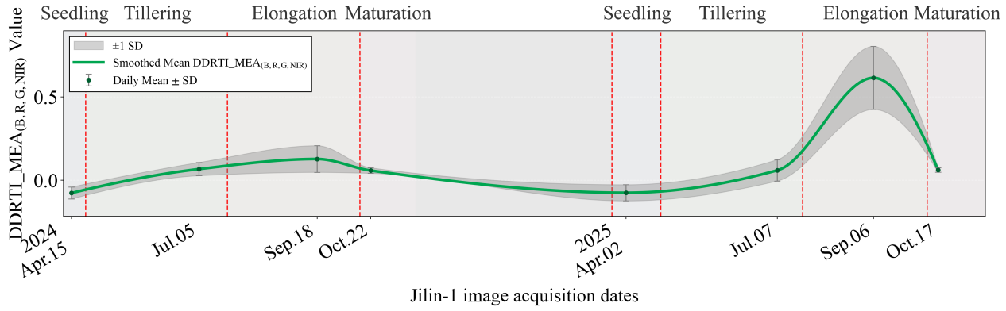
(b)

Fig. S2. The seasonal deviation of NDVI and DDRTI_MEA _{(B, R, G, NIR)} values across two years.

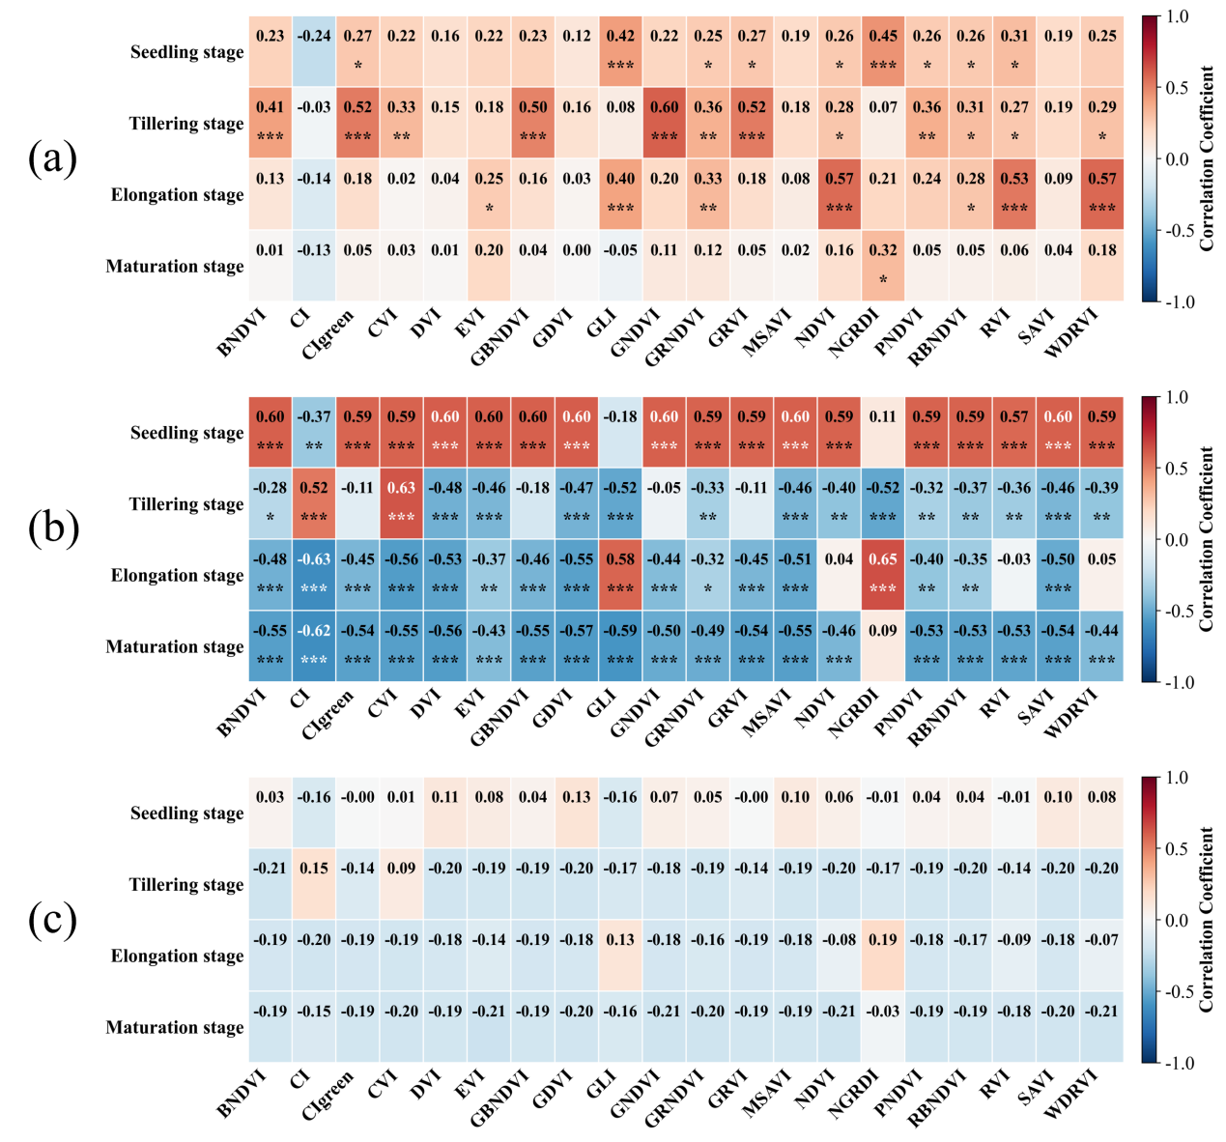Fig. S3. Correlation analysis between vegetation indices and phenotypic traits. (a) Yield, (b) Millabl Stalk Population, (c) Brix. The numbers in the figure represent correlation coefficients, and * indicates p<0.05 (significant difference), ** indicates p<0.01 (highly significant difference), *** indicates p<0.001 (extremely significant difference).

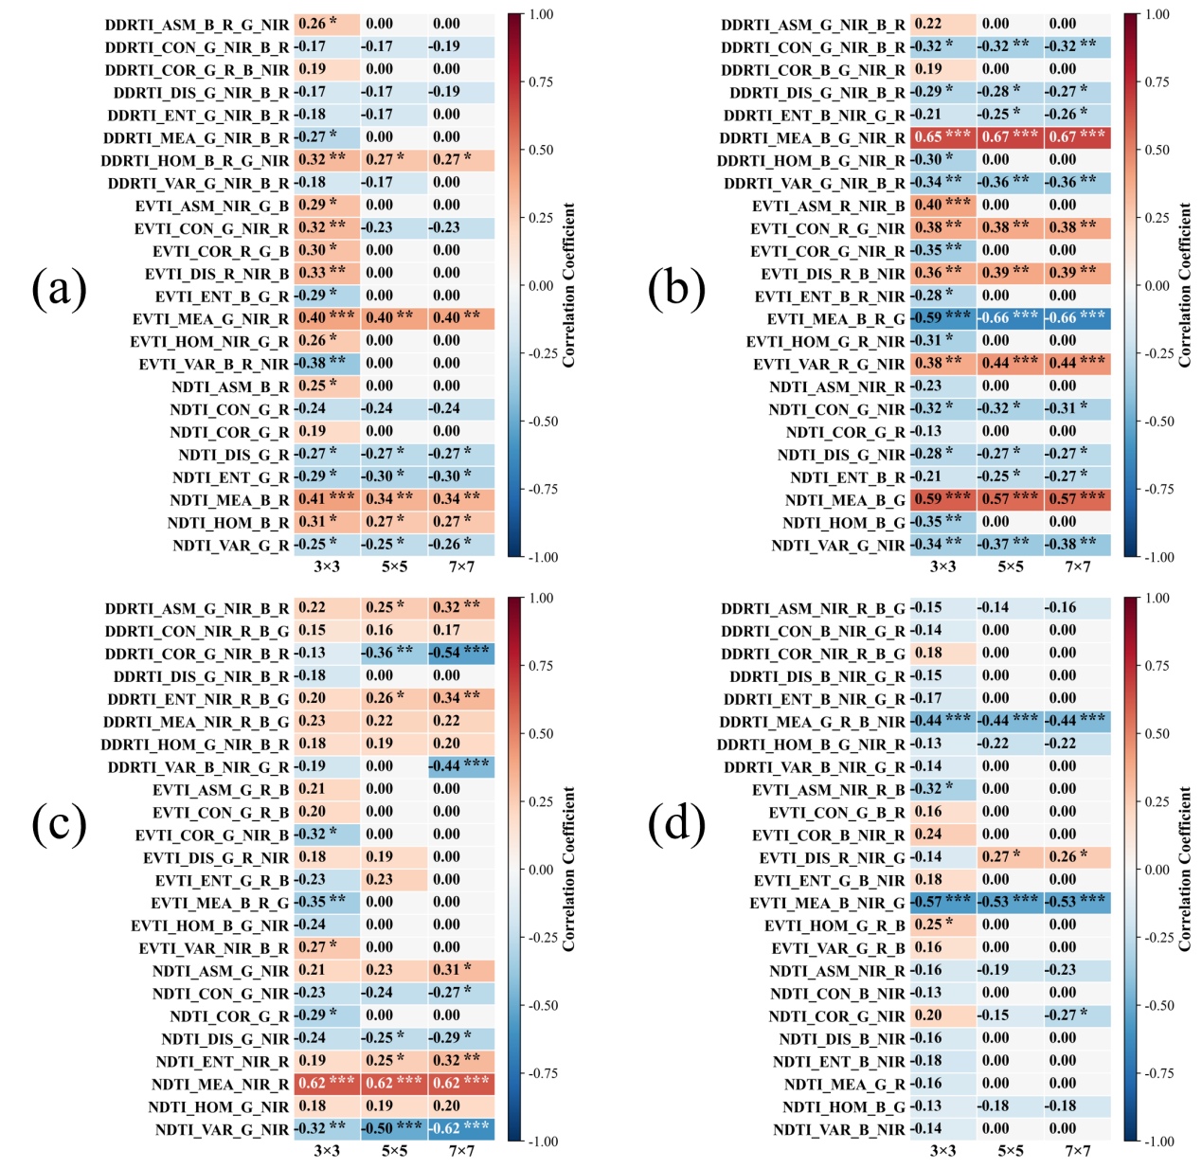
Fig. S4.The correlation between texture indices and yield at different growth stages under different texture window sizes. (a) Seedling Stage, (b) Tillering Stage, (c) Elongation Stage, (d) Maturation Stage.
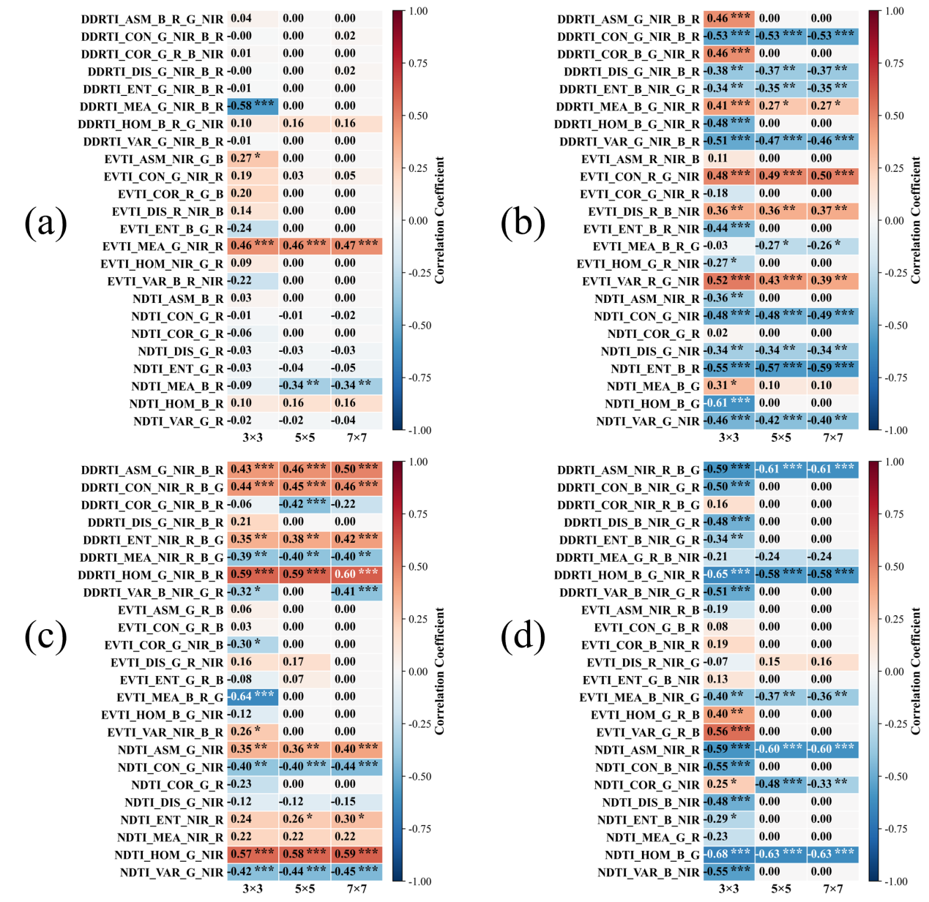
Fig. S5.The correlation between texture indices and millable stalks at different growth stages under different texture window sizes. (a) Seedling Stage, (b) Tillering Stage, (c) Elongation Stage, (d) Maturation Stage.

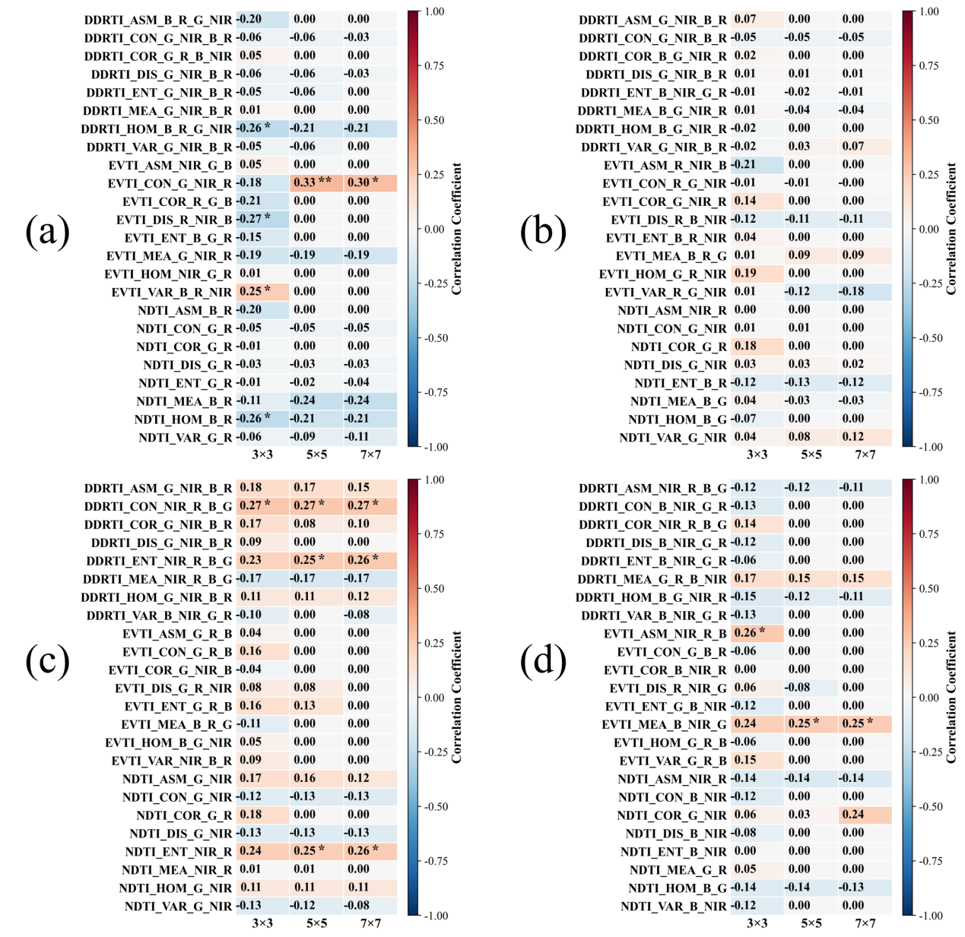
Fig. S6. The correlation between texture indices and Brix at different growth stages under different texture window sizes. (a) Seedling Stage, (b) Tillering Stage, (c) Elongation Stage, (d) Maturation Stage.

Fig. S7. Correlation analysis of soil physicochemical properties, fertilization and sugarcane traits.

Supplementary References

