Supplementary Methods and Results

Details of Molecular Indexing of Proteins by Self-Assembly (MIPSA) Profiling
Antibody profiling provided by MIPSA is the comprehensive analysis of antibody binding (“antibody reactivity”) to a large set of specific antigens (typically > 10,000). Antibody reactivities are detected via immunocapture and high-throughput sequencing of antigen-conjugated DNA barcodes. The resulting sequencing data is then processed through Infinity Bio’s bioinformatics analysis pipeline to detect the reactive antibodies and assign numerical values based on signal intensity.
Samples are processed in 96-well plate format, and 8 samples are reserved for internal controls: 3 positive and negative library-specific controls and 5 phosphate buffered saline (PBS) controls to represent “mock IP” or “beads only” wells. The “mock IP” samples are used to correct for fold-over-background signals in downstream calculations. Each sample, including the internal control samples, is individually compared against the complete set of mock IPs associated with the project. This comparison involves the use of the edgeR software package for data normalization, statistical testing and fold-over-background estimation. “Hits” are defined as library members with FDR-adjusted P-values < 0.05 to reject the null-hypothesis that the data is drawn from the background distribution.
To ensure high quality data, the following metrics are achieved for the dataset:
- The mapped barcode reads per sample must be at least 10-times the library complexity for at least 90% of the project samples
- The average Pearson correlation of -log10 FDR-adjusted P-values among the same internal serum controls must average at least 0.90 or higher
- The average number of false positives detected per mock IP must be less than 1

Samples are mixed with the MIPSA reagent, each with a set of unique DNA barcodes. For viral antigens (VirSIGHT), these are comprised of 20-63 amino acid long peptides; for human autoantigens (HuSIGHT), these are comprised of full-length human proteins. Antibodies in samples bind to antigens introduced by the MIPSA reagent, and antibodies and their bound members are captured via Dyna magnetic beads coated with protein A/G, which binds to all subclasses of human immunoglobulins. Barcodes on captured antigen library members are amplified via PCR, and PCR products are submitted for sequencing on an Illumina platform. Once sequencing results are obtained, FASTQ reads for each individual sample are run through the Infinity Bio bioinformatics pipeline.

Supplementary Results
Cohort Characteristics
The MGBB-LLF discovery cohort included a higher proportion of females (70.4%) and older participants (mean [sd]=58.44 [14.84] years) compared to the MGBB-LEC replication cohort (46.8% female, mean [sd]=54.97 [16.94] years). Individuals in MGBB-LLF also had a higher proportion of individuals with comorbidities and worse Charlson index indicators of health,²⁸ with 10.9% having an age-adjusted Charlson Index ≥7, compared to 8.9% of individuals in MGBB-LEC. MGBB-LLF and MGBB-LEC cohorts were comparable for other features such as self-reported race and ethnicity, smoking history, alcohol consumption, and body mass index (Figure 1).

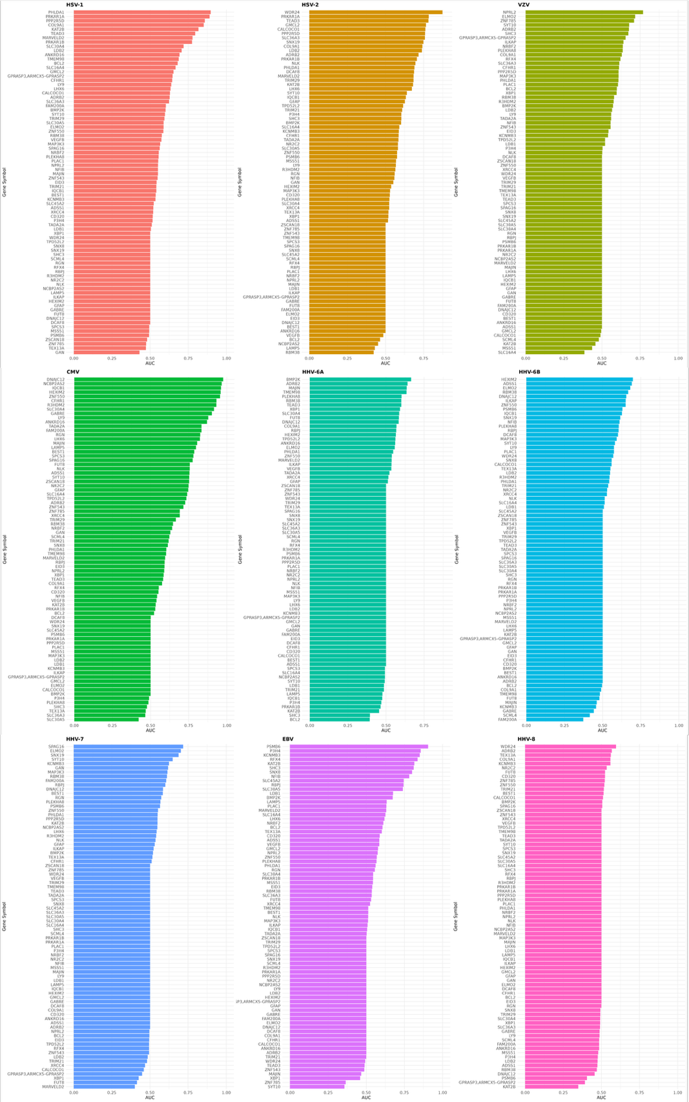
Supplementary Figure 1. Prediction of all associated autoantigens by herpesviruses. AUC for prediction models between all autoantigens associated with at least one viral peptide included in prediction models. Results are shown for all autoantigen prediction results in the MGBB-LEC test cohort.

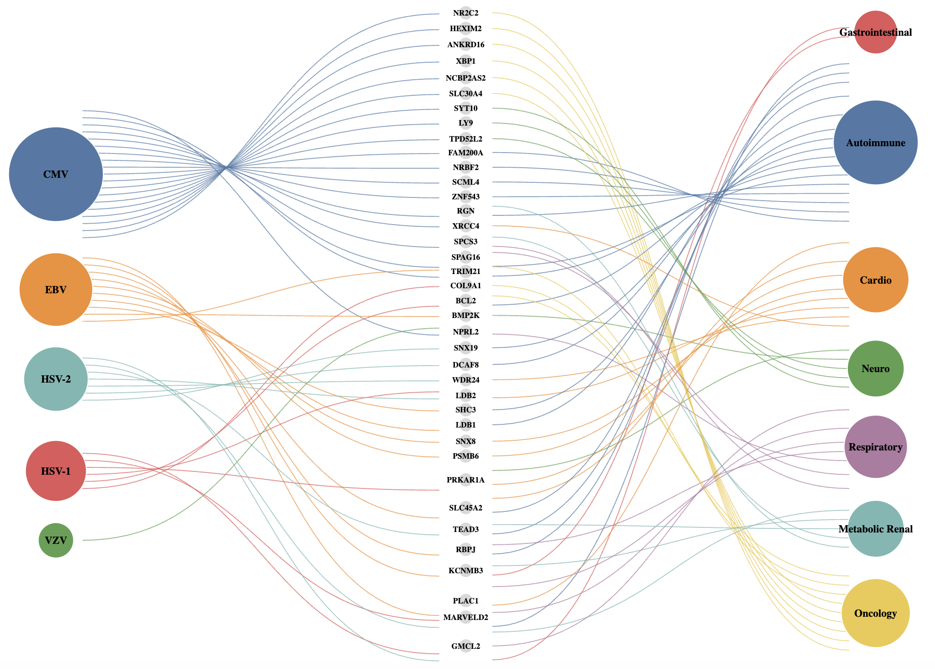
Supplementary Figure 2. Summary of the relationship between herpesviruses, autoantigens, and their associated disease domains. Viral-autoantigen association edges are colored by herpesvirus species and ordered from highest to lowest degree from top to bottom: CMV (blue), EBV (orange), HSV-2 (teal), HSV-1 (red), and VZV (green). Autoantigen nodes are sized equally due to spacing, but nodes with associations to multiple disease domains sorted towards the bottom; 9 autoantigens were linked to 2 disease domains: PRKAR1A, SLC45A2, TEAD3, RBPJ, KCNMB3, PLAC1, MARVELD2, RGN, and BCL2; a single autoantigen was linked to 3 disease domains: GMCL2. Disease domain nodes are colored by type, with edges between autoantigens and domains corresponding to colors.

Supplementary Table 1. Summary of attempted replication of herpesvirus peptide and full-length human autoantigen associations in MGBB-LEC. MGBB-LEC was treated as a replication cohort, and available viral peptides and full-length human autoantigens from MGBB-LLF associated at an FDR<0.05 threshold were included in the replication in MGBB-LEC. For each herpesvirus species, the available viral peptides and human proteins available in the MGBB-LEC dataset are expressed in total and as a percentage of the significant viral peptides and human proteins, respectively, that made up the significant associations in MGBB-LLF. The total tests column represents the total tests attempted by matching exact viral peptide-human protein pairs from the MIPSA dataset, and these were also noted as a percentage of the total tests that passed a significance threshold in MGBB-LLF. The total significant associations in MGBB-LEC between viral peptides and full-length human proteins are included as a reference from Figure 3 in the main manuscript. Significant associations in MGBB-LEC were also held to an FDR<0.05 threshold and must have shown a consistent direction of effect.
Herpesvirus species | Significant Tests Attempted in MGBB-LEC Replication |  Total Sig. in MGBB-LLF | Available Viral Peptides in MGBB-LEC (%) |  Total Sig. in MGBB-LLF | Available Autoantigens in MGBB-LEC (%) |  Total Sig. in MGBB-LLF | Significant Associations in MGBB-LEC  (% of Attempted Tests)
HSV-1 | 2,049 (73.4%) | 2,792 | 421 (92.1%) | 457 | 112 (40.3%) | 278 | 538 (26.2%)
HSV-2 | 1,180 (51.4%) | 2,294 | 276 (85.7%) | 322 | 116 (39.6%) | 293 | 180 (15.3%)
VZV | 109 (44.5%) | 245 | 61 (82.4%) | 74 | 30 (28.3%) | 106 | 6 (5.5%)
CMV | 8,152 (73.7%) | 11,055 | 585 (87.8%) | 666 | 183 (38.3 %) | 478 | 3,050 (37.4%)
HHV-6A | 86 (31.6%) | 272 | 41 (63.1%) | 65 | 36 (33.0%) | 109 | 9 (10.5%)
HHV-6B | 85 (21.4%) | 397 | 42 (72.4%) | 58 | 38 (39.2%) | 97 | 7 (8.2%)
HHV-7 | 18 (23.1%) | 78 | 9 (45.0%) | 20 | 13 (26.0%) | 50 | 0 (0%)
EBV | 1,386 (69.5%) | 1,994 | 417 (88.3%) | 472 | 74 (37.8%) | 196 | 153 (11.0%)
HHV-8 | 67 (27.6%) | 243 | 37 (75.5%) | 49 | 19 (24.4%) | 78 | 0 (0%)
Total | 13,312 (69.1%) | 19,270 | 1,889 (86.5%) | 2,183 | 442 (44.6%) | 992 | 3,943 (29.6%)

Supplementary Table Legends for Attached Files and Supplementary Table 5
Supplementary Table 2. Significant associations between herpesvirus reactivities and autoantigen reactivities in MGBB-LLF (FDR<0.05). Results of regression models estimating associations between herpesviruses and full-length autoantigen proteins are shown. Association models were adjusted for age, sex, body mass index, alcohol consumption, smoking, Charlson comorbidity index, and inhaled corticosteroid medications. Viral genus and viral species are listed along with relevant UniProt annotations.

Supplementary Table 3. Replicated associations between herpesvirus reactivities and autoantigen reactivities in MGBB-LLF (FDR<0.05) and MGBB-LEC (FDR<0.05). Results of regression models estimating associations between herpesviruses and full-length autoantigen proteins are shown. Association models were adjusted for age, sex, body mass index, alcohol consumption, smoking, and Charlson comorbidity index in both cohorts; MGBB-LLF included an additional adjustment for use of inhaled corticosteroid medications. Viral genus and viral species are listed along with relevant UniProt annotations. Associations were considered replicated in MGBB-LEC if they demonstrated consistent directions of effect, contained the same MIPSA Viral ID-MIPSA Autoantigen ID pair, and reached a nominal P<0.05 threshold in MGBB-LEC.

Supplementary Table 4. Prediction models for virus-autoantigen pairs with AUC>0.85 in test set and AUC>0.80 in the held-out training set. Prediction models were adjusted for age, sex, body mass index, alcohol consumption, smoking, and Charlson comorbidity index in both cohorts; MGBB-LLF included an additional adjustment for use of inhaled corticosteroid medications. Elastic net regression models were utilized to assess the ability of herpesvirus peptides to predict reactivity to autoantigen targets included in MIPSA. Individual viral peptide predictors retained in each model are shown for 11 virus-autoantigen pairs. Results are shown for prediction models in MGBB-LLF training set and MGBB-LEC test set.

Supplementary Table 5. Prediction models for all autoantigen in MGBB-LEC test set. Prediction models were adjusted for age, sex, body mass index, alcohol consumption, smoking, and Charlson comorbidity index in both cohorts; MGBB-LLF included an additional adjustment for use of inhaled corticosteroid medications. Elastic net regression models were utilized to assess the ability of herpesvirus peptides to predict reactivity to all full-length autoantigens associate with herpesviruses.

Supplementary Table 6. Sequence alignment summaries using Smith-Waterman algorithm. For each of the virus-autoantigen pair selected from the prediction models, the number of associated peptides included in alignment analysis, number significant against the empirical null, proportion significant against the empirical null, and range of quantiles for significantly aligned peptides are provided. In addition, the mean and standard deviation (SD) of the alignment scores, and mean and SD of alignment length.
Viral Species | Auto-  antigen | Associated Peptides | Sig. Against Null | Proportion Sig. | Range Quantiles | Score Mean | Score SD | Length Mean | Length SD
HSV-1 | PHLDA1 | 256 | 39 | 0.15 | 0.989-1 | 100.16 | 83.90 | 218.05 | 158.32
CMV | ZNF550 | 293 | 119 | 0.41 | 0.953-0.999 | 56.73 | 18.95 | 168.45 | 88.00
CMV | LY9 | 3 | 1 | 0.33 | 0.968-0.968 | 48.43 | 21.65 | 183.62 | 322.11
CMV | IQCB1 | 116 | 4 | 0.03 | 0.964-0.987 | 46.90 | 12.78 | 167.75 | 122.23
CMV | HEXIM2 | 77 | 3 | 0.04 | 0.957-0.957 | 45.68 | 14.05 | 122.08 | 101.35
CMV | CFHR1 | 89 | 3 | 0.03 | 0.959-0.979 | 41.03 | 8.20 | 118.20 | 81.60
CMV | SLC30A4 | 97 | 2 | 0.02 | 0.963-0.963 | 40.37 | 8.75 | 138.43 | 109.36
CMV | R3HDM2 | 34 | 3 | 0.09 | 0.952-0.967 | 39.83 | 6.75 | 121.00 | 56.63
CMV | DNAJC12 | 213 | 0 | 0.00 | NA | 38.07 | 9.00 | 83.54 | 46.58
EBV | KCNMB3 | 8 | 0 | 0.00 | NA | 35.06 | 8.53 | 59.75 | 26.33
EBV | PSMB6 | 1 | 0 | 0.00 | NA | 21.00 | NA | 12.00 | NA

Supplementary Table 7. Significant associations between MIPSA viral peptides and incident diseases meeting an FDR<0.05 threshold in a pooled analysis of MGBB-LLF and MGBB-LEC. Beta estimates, standard error, Z-value, and nominal P-values are shown. Models were adjusted for age, sex, body mass index, alcohol consumption, smoking, and Charlson comorbidity index in both cohorts; MGBB-LLF included an additional adjustment for use of inhaled corticosteroid medications. The numbers of cases and controls for each disease are shown, as well as the number of cases and controls with each respective viral peptide reactivity.

Supplementary Table 8. Significant associations between MIPSA full-length autoantigens and incident diseases meeting and FDR<0.05 threshold in a pooled analysis of MGBB-LLF and MGBB-LEC. Beta estimates, standard error, Z-value, and nominal P-values are shown. Models were adjusted for age, sex, body mass index, alcohol consumption, smoking, and Charlson comorbidity index in both cohorts; MGBB-LLF included an additional adjustment for use of inhaled corticosteroid medications. The numbers of cases and controls for each disease are shown, as well as the number of cases and controls with each respective autoantigen reactivity.

