Supporting Information of

Chemically Programmed Living Catalytic Probiotics to Overcome Fungal Barriers in Antitumor Immunotherapy

Ziyi Han,^{[a]} Xinyu Zhang,^{[a]} Jiaji Yu,^{[a]} Cancan Luo,^{[a]} Xiaoyuan Chen ^{[b]}* and Junjie Cheng^{[a]}*
- Department of Nutrition and Food Hygiene, School of Public Health, Southeast University, Nanjing, 210009, China. Email: jjcheng@ustc.edu.cn; jjcheng@seu.edu.cn
- Center for Nuclear Medicine and Molecular Imaging, Shandong Cancer Hospital and Institute, Jinan, 250117, China. Email: chen9647@gmail.com

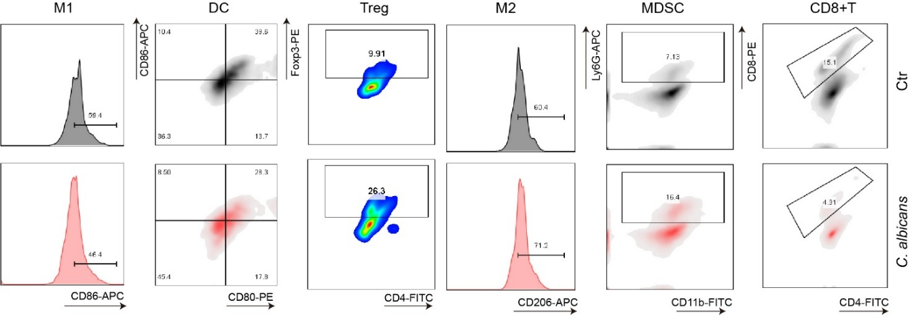
FigureS1. Tumor immune microenvironment (TIME) analysis by FCM in mice. M1 macrophages, M2 macrophages, DCs, MDSCs, CD8⁺T cells and Treg cells were compared in the control group and C. albicans group.

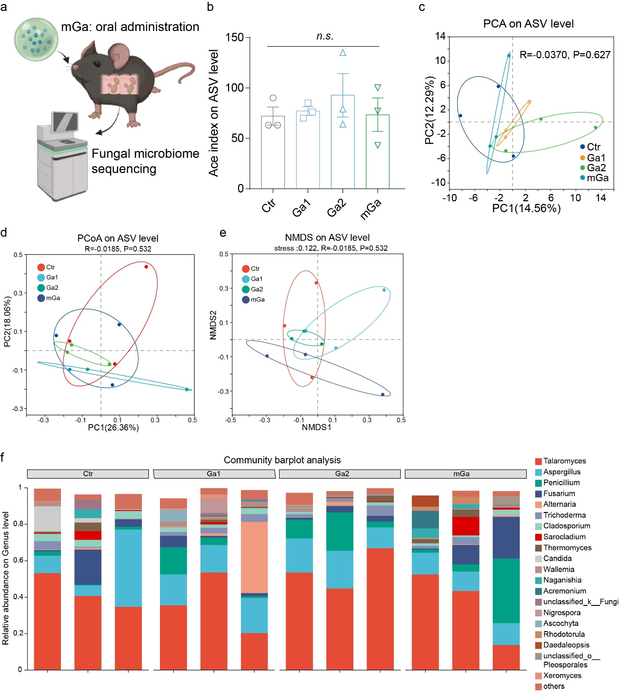
FigureS2. 18S rRNA sequencing of mouse feces after treatment with different concentrations of Ga³⁺ and mGa. (a) Schematic illustration of 18S rRNA sequencing of mouse feces. (b) Alpha diversity of fungal microbiota in mouse feces (Ace index). n = 3 independent samples. (c) PCA analysis of mouse fecal fungi, representing β-diversity. n = 3 independent samples. (d) PCoA analysis of mouse fecal fungi, representing β-diversity. (e) NMDS analysis of mouse fecal fungi, representing β-diversity. (f) Relative abundance of different species in mouse fecal fungal microbiota after different treatments. n = 3 independent samples.

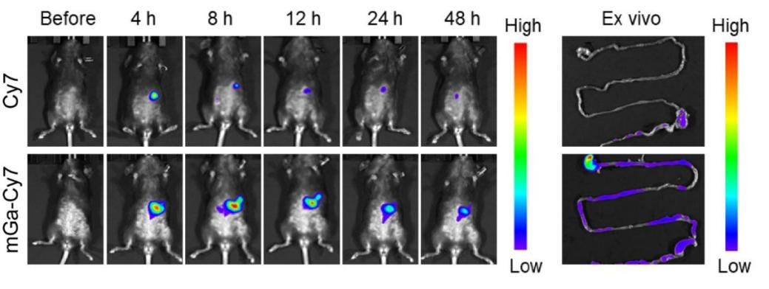
FigureS3. IVIS fluorescence monitoring in mice at different time points after oral administration of Cy7 alone or Cy7 loaded into mGa, with dissection at 48 hours to observe ex vivo intestinal fluorescence.

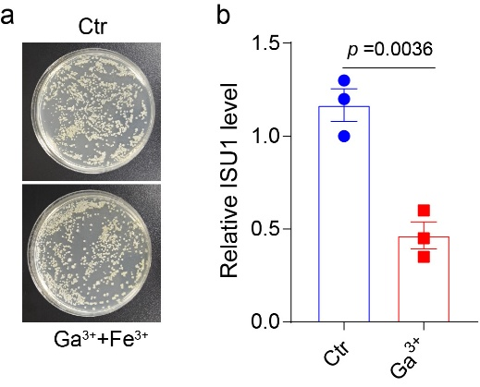
Figure S4. (a) Colony images analysis of C. albicans treated with Ga³⁺ in combination with Fe³⁺. (b) Expression level of the ISU1 gene in C. albicans after treatment with Ga³⁺. Data are presented as the mean ± sem. Statistical significance was determined by unpaired two-tailed Student’s t-test.

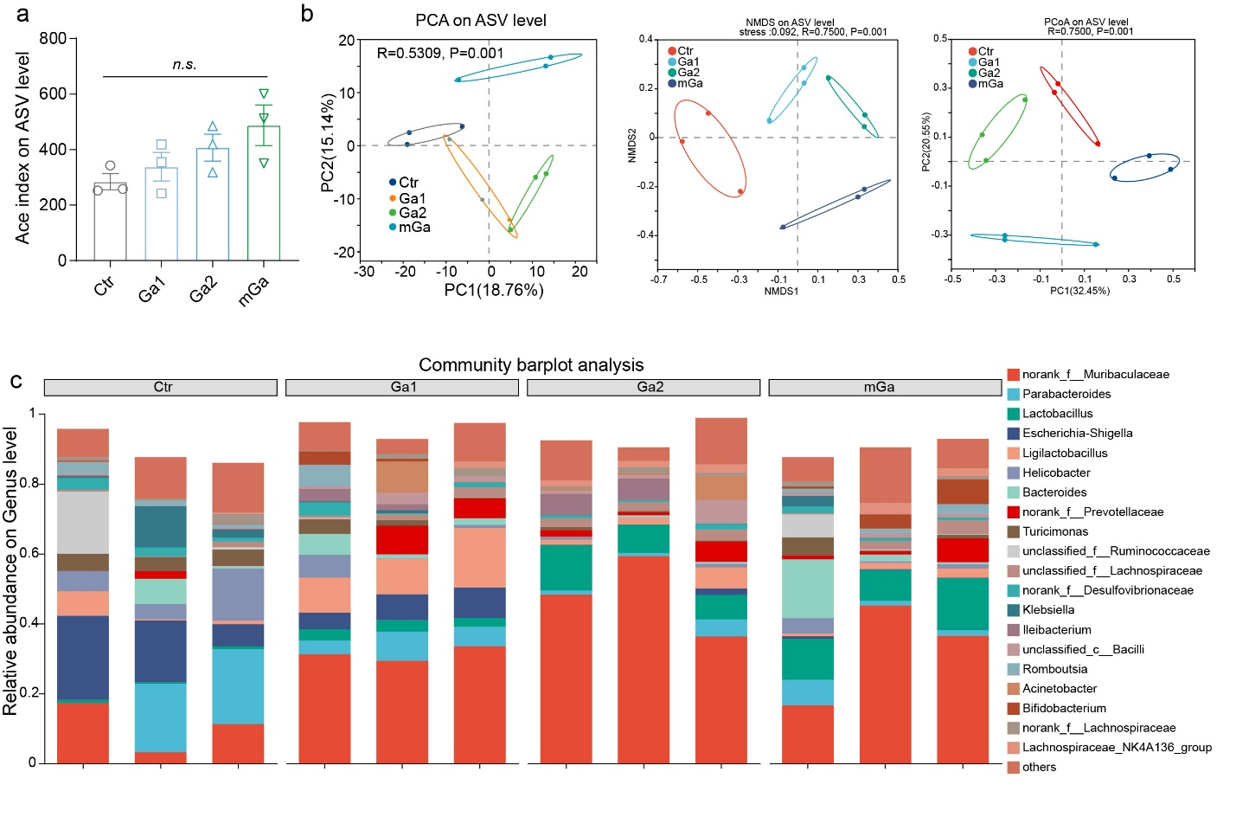
FigureS5. 16S rRNA sequencing of mouse feces after treatment with different concentrations of Ga³⁺ and mGa. (a) Alpha diversity of the bacterial microbiota in mouse feces (Ace index). n = 3 independent samples. (b) PCA, NMDS, and PCoA analysis of mouse fecal bacteria, representing β-diversity. n = 3 independent samples. (c) Relative abundance of different species in mouse fecal bacterial microbiota after different treatments. n = 3 independent samples.

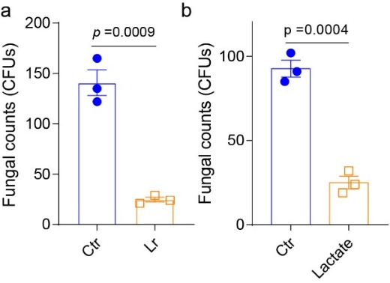
Figure S6. (a) Antifungal effect of L. reuteri in vitro. (b) Antifungal effect of lactate in vitro. Data are presented as the mean ± sem. Statistical significance was determined by unpaired two-tailed Student’s t-test.
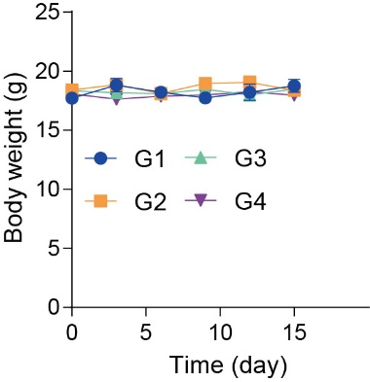
Figure S7. Monitoring of mouse body weight after different treatments. n = 5 independent samples. G1: Ctr; G2: Ga1; G2: Ga2; and G4: mGa.

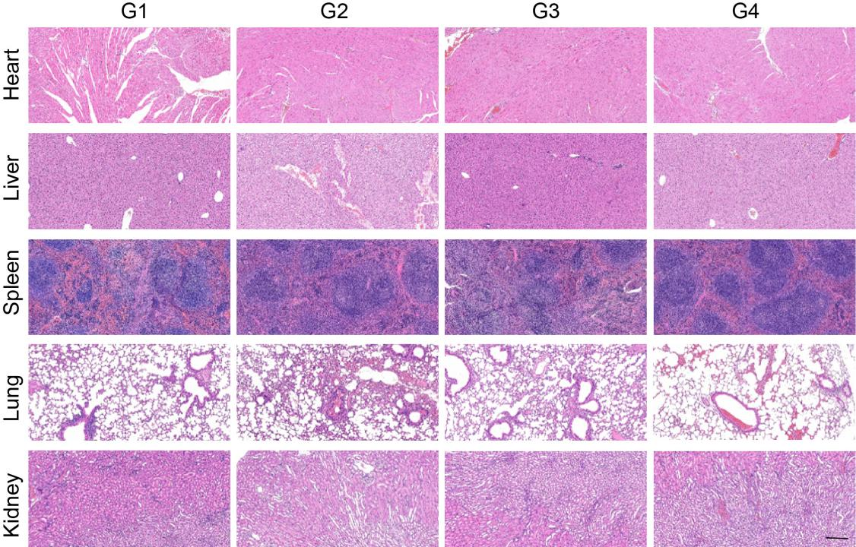
Figure S8. H&E staining of major organs in mice after different treatments. The scale bar is 100 µm. G1: Ctr; G2: Ga1; G2: Ga2; and G4: mGa.
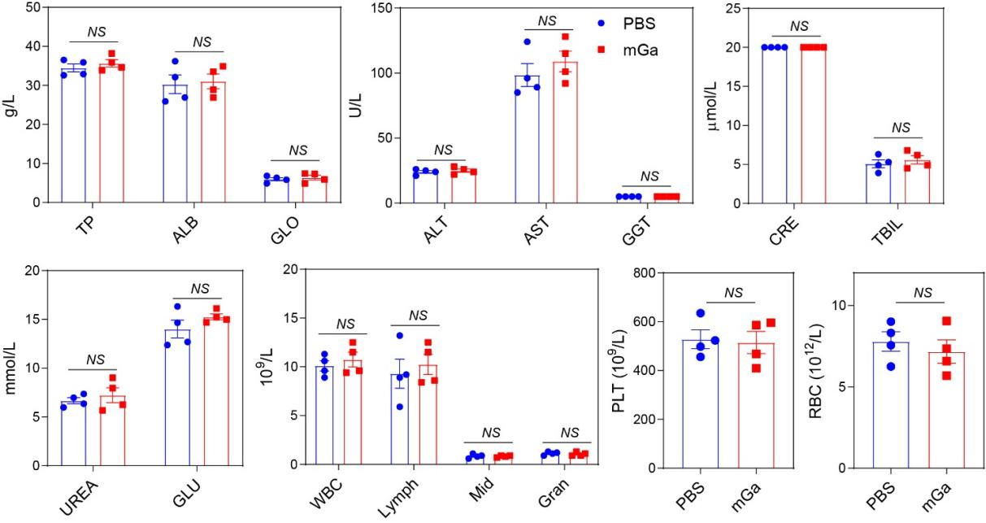
FigureS9. Liver function and kidney function and hematological tests of mice after different treatments. n = 4 independent samples. Data are presented as the mean ± sem. Statistical significance was determined by unpaired two-tailed Student’s t-test. NS means no significance.

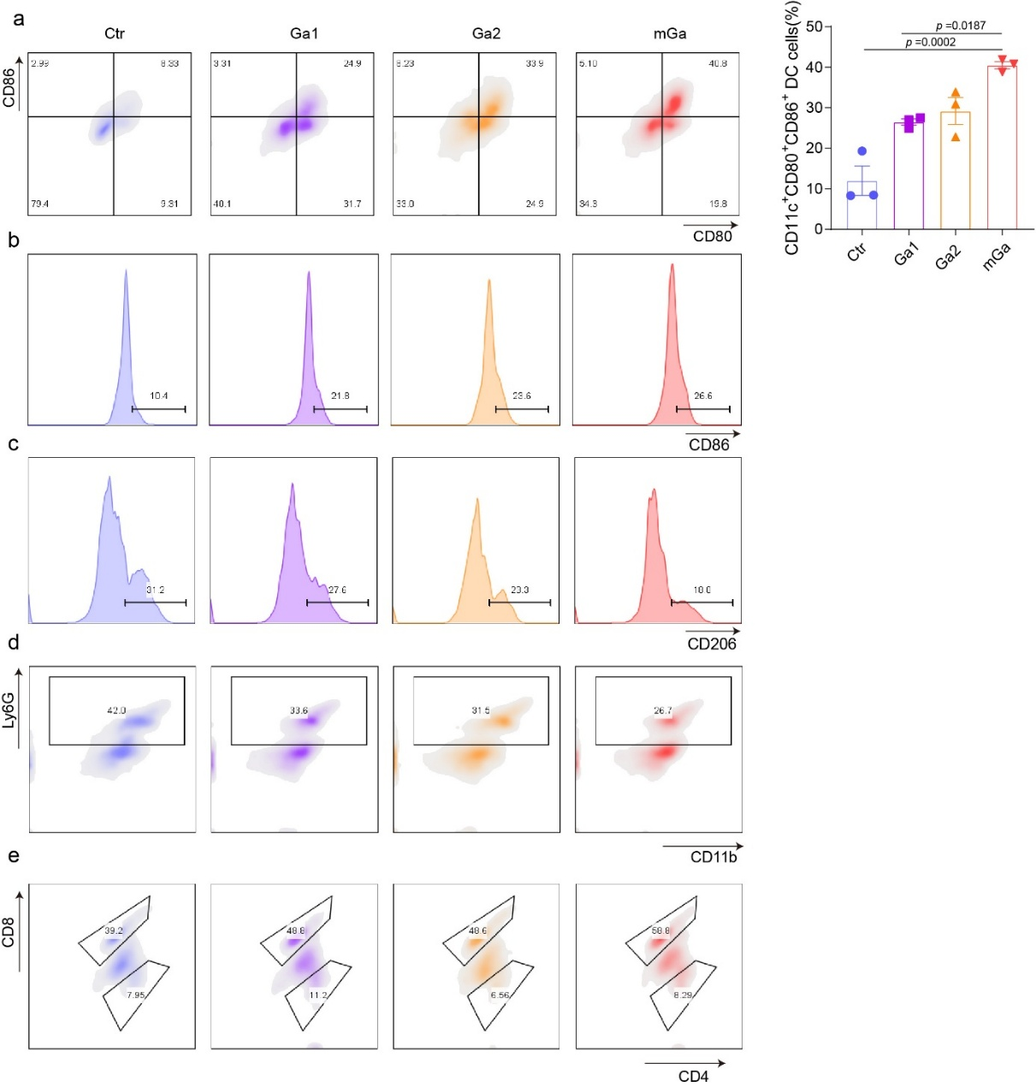
FigureS10. TIME analysis in mice. (a) FCM plots and quantitative analysis of mature DCs in tumors in each group. (b-c) FCM plots of M1 (b), M2 (c) macrophages, in tumors in each group. (d) FCM plots of MDSCs in tumors in each group. (e) FCM plots of CD3⁺CD8⁺T cells in tumors in each group. n = 3 independent samples. Data are presented as the mean ± sem. Statistical significance was determined by one-way ANOVA with Tukey’s post hoc correction (a).

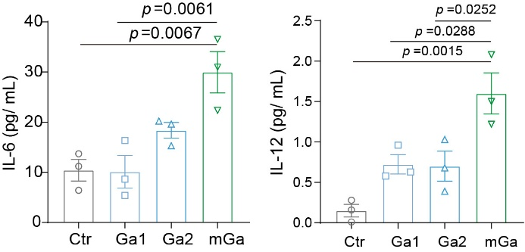
FigureS11. Measurement of cytokine concentrations (including IL-6 and IL-12) in mouse tumors after different treatments. n = 3 independent samples. Data are presented as the mean ± sem. Statistical significance was determined by one-way ANOVA with Tukey’s post hoc correction.

Figure S12. TEM images of the as-synthesized ZIF precursor.

Figure S13. X-ray-diffraction patterns of the synthesized ZIF-8 nanocrystals and the simulated result.

Figure S14. TEM images of the synthesized porous nitrogen-doped carbon (NC) obtained after pyrolysis and acid leaching.

Figure S15. Powder XRD patterns of porous NC and Ca-NC nanozyme, confirming the carbonaceous structure and the absence of crystalline Ca-containing phases.

Figure S16. Ca K-edge XANES spectra of Ca–NC nanozyme and reference samples.
Figure S17. (A) High-resolution C 1s XPS spectrum and (B) Ca 2p XPS spectrum of Ca–NC nanozyme.

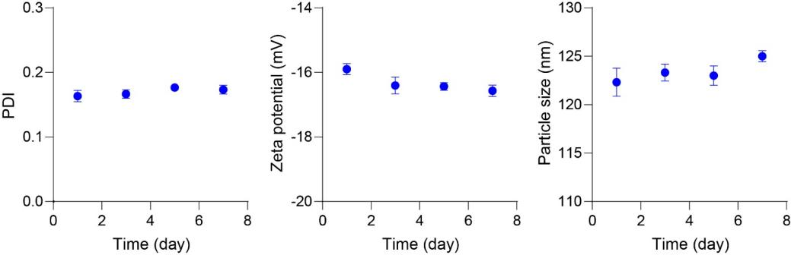
Figure S18. The stability of CaNC nanoparticles. The particle size, zeta potential, an PDI of CaNC nanoparticles within 7 days were evaluated. n = 3 independent samples.

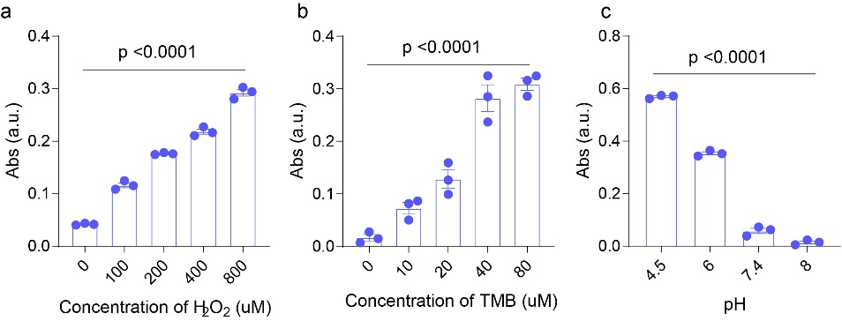
Figure S19. The enzyme-like activity of CaNC. (a) UV-vis absorbance of TMB oxidation of CaNC with different H₂O₂ concentrations. (b) UV-vis absorbance of TMB oxidation of CaNC with different TMB concentrations. (a) UV-vis absorbance of TMB oxidation of CaNC with different pH concentrations. n = 3 independent samples. Data are presented as the mean ± sem. Statistical significance was determined by one-way ANOVA with Tukey’s post hoc correction.
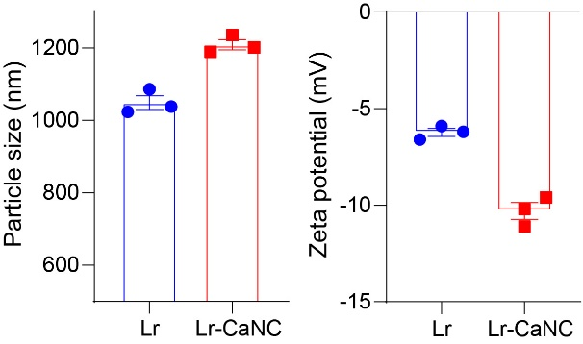
Figure S20. The particle size and zeta potential of bare Lr and Lr-CaNC. n = 3 independent samples.

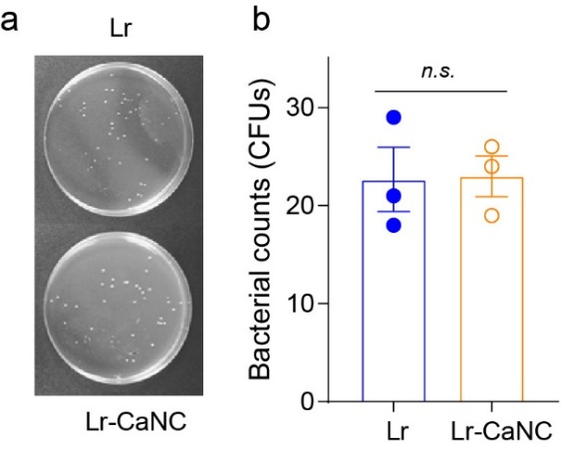
Figure S21. (a) Colony images and (b) quantitative analysis of Lr on agar plates in Lr group and Lr-CaNC group. Data are presented as the mean ± sem. Statistical significance was determined by unpaired two-tailed Student’s t-test. n.s. means no significance.

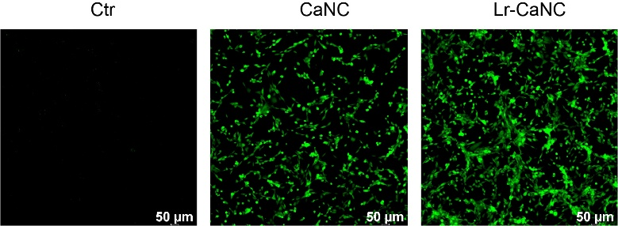
Figure S22. CLSM images of MC38 cells treatment with CaNC and Lr-CaNC. Cells were stained with DCFH-DA.

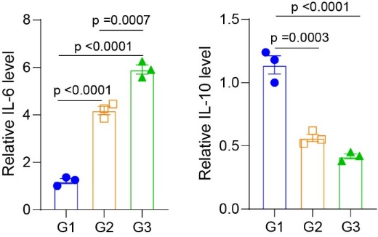
Figure S23. Relative concentrations of IL-6 and IL-10 secreted from RAW264.7 cells after treatment with different materials. n= 3. Data are presented as the mean ± sem. Statistical significance was determined by one-way ANOVA with Tukey’s post hoc correction. G1: Control group, G2: CaNC group, G3: Lr-CaNC group.

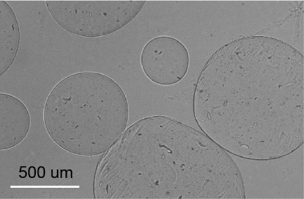
Figure S24. Bright field of blank calcium alginate microspheres.

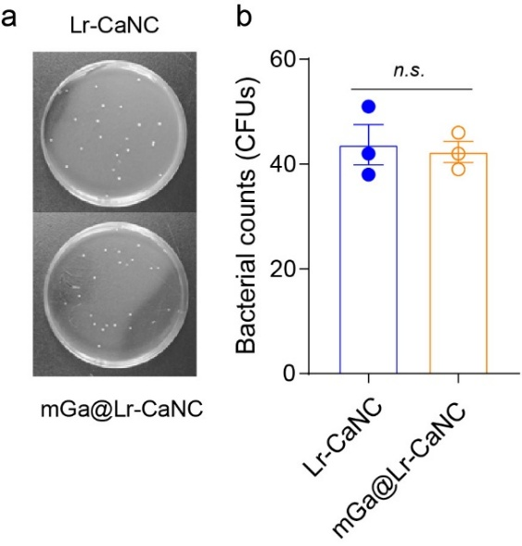
Figure S25. (a) Colony images and (b) quantitative analysis of Lr on agar plates in Lr-CaNC group and mGa@Lr-CaNC group. n =3. Data are presented as the mean ± sem. Statistical significance was determined by unpaired two-tailed Student’s t-test.
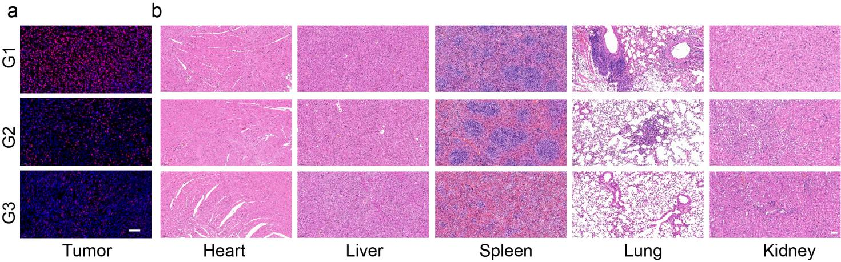
Figure S26. Therapeutic efficacy of mGa@Lr-CaNC in vivo. (a) Immunofluorescence staining of KI67 in mouse tumors after different treatments. The scale bar is 50 µm. (b) H&E staining of major organs in mice after different treatments. The scale bar is 100 µm. G1: Control group, G2: Lr-CaNC group, G3: mGa@Lr-CaNC group.

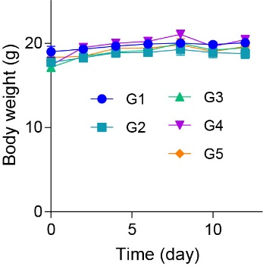
Figure S27. Analysis of mouse body weight after different treatments. n = 5 independent samples. Ctr group (G1); Lr-CaNC (G2); mGa@Lr-CaNC (G3); α-PDL1 (G4); mGa@Lr-CaNC combined with α-PDL1 (G5).

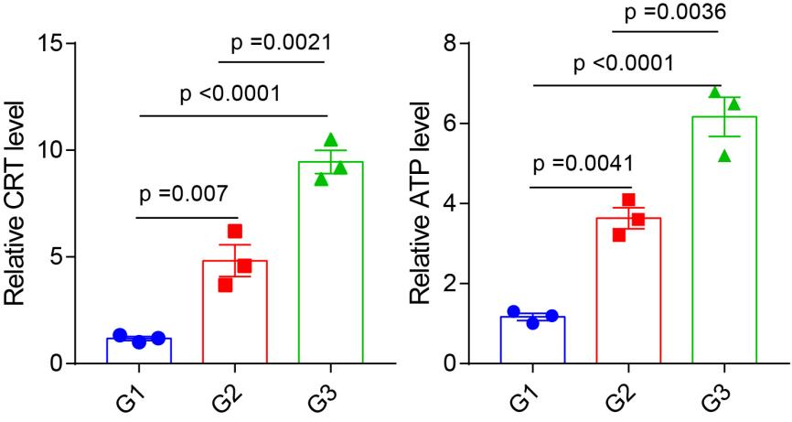
Figure S28. The assessment of ICD within tumors after different treatments (G1: Ctr; G2: Lr-CaNC; G3: mGa@Lr-CaNC). The relative CRT level and ATP level were evaluated. n = 3 independent samples. Data are presented as the mean ± sem. Statistical significance was determined by one-way ANOVA with Tukey’s post hoc correction.
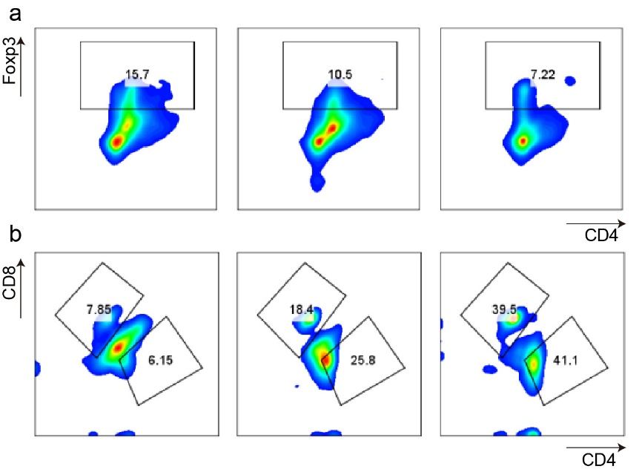
Figure S29. FCM plots of Tregs (a) and CD8⁺T cells (b), in tumors in each group. From left to right: Ctr; Lr-CaNC; and mGa@Lr-CaNC.

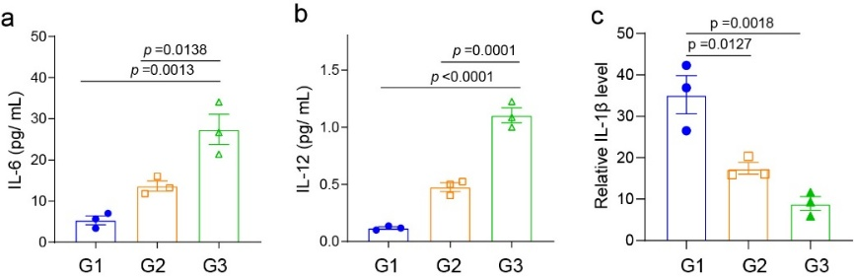
Figure S30. Relative concentrations of cytokines within tumors after different treatments. n = 3. Data are presented as the mean ± sem. Statistical significance was determined by one-way ANOVA with Tukey’s post hoc correction. G1: Ctr; G2: Lr-CaNC; G3: mGa@Lr-CaNC.

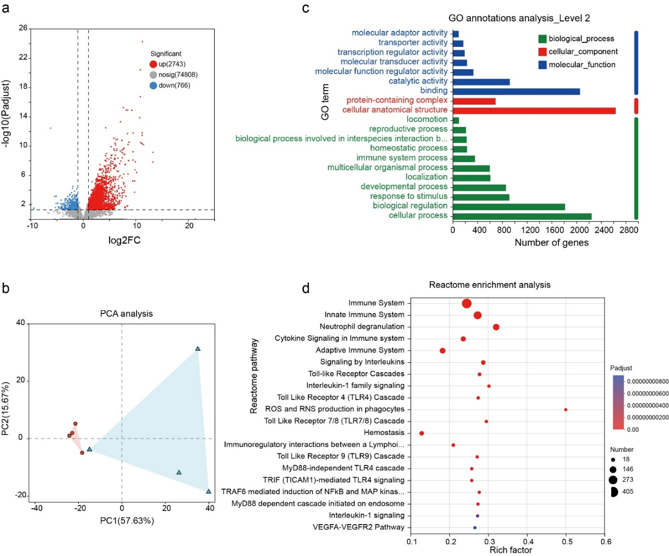
Figure S31. Transcriptomics analysis of tumors after mGa@Lr-CaNC treatment. (a) Volcano plot for identifying differentially expressed genes with and without mGa@Lr-CaNC treatment (n = 4 samples). Differential expression genes were determined using the DESeq2 R package. The P-values were adjusted using the Benjamini and Hochberg’s approach for controlling the false discovery rate, Padj ≤ 0.05 and |log2(fold change)| ≥ 1.0 were set as the thresholds for significant differential expression. (b) PCA analysis in the control group and the mGa@Lr-CaNC group (n = 4 samples). (c) GO annotations analysis after mGa@Lr-CaNC treatment (n = 4 samples). (d) Reactome enrichment pathway analysis of different genes of tumors treated with mGa@Lr-CaNC, and the top 20 terms were selected (n = 4 samples). Statistical significance was assessed using a two-sided hypergeometric test, with p-values adjusted for multiple comparisons using the Benjamini-Hochberg method.

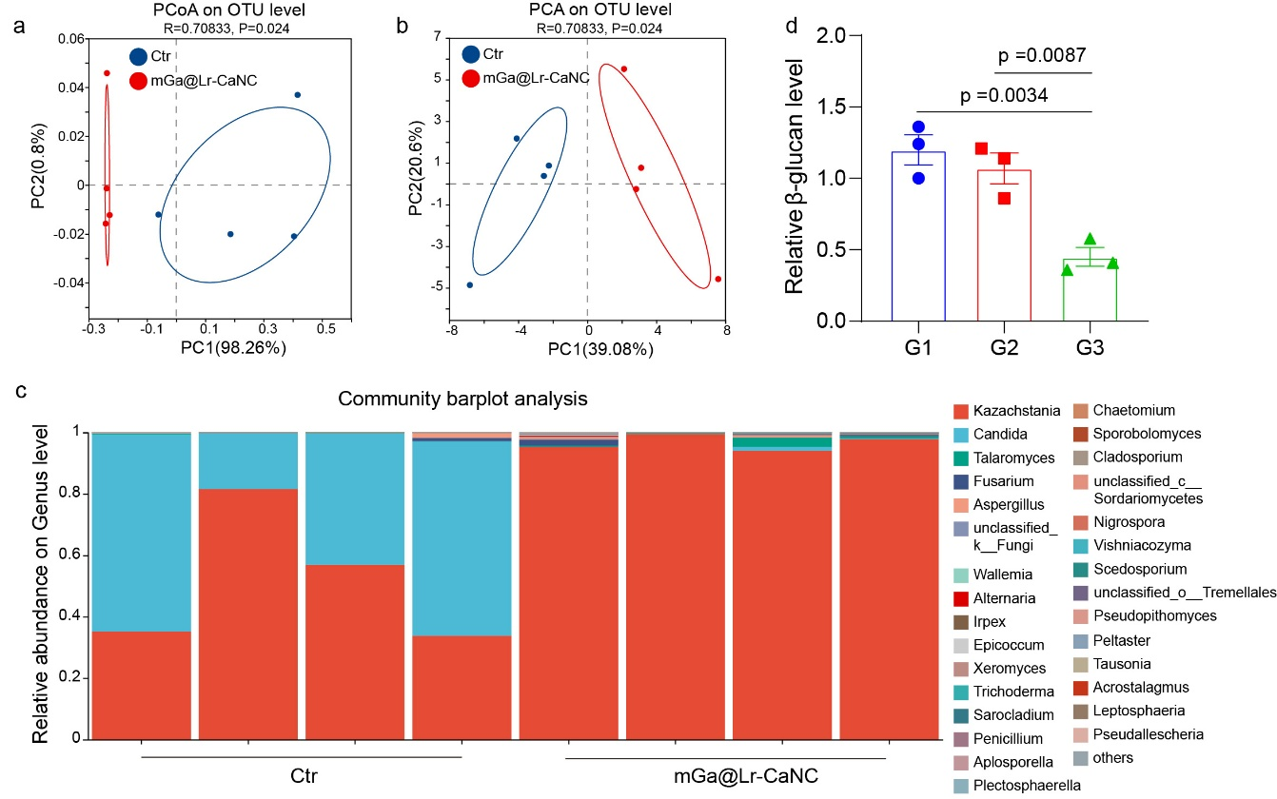
FigureS32. 18S rRNA sequencing of mouse feces after treatment with mGa@Lr-CaNC. (a) PCoA analysis of mouse fecal fungi, representing β-diversity. (b) PCA analysis of mouse fecal fungi, representing β-diversity. (c) Relative abundance of different species in mouse fecal fungal microbiota after different treatments. (d) Relative β-glucan level in the blood after different treatments. Data are presented as the mean ± sem. Statistical significance was determined by one-way ANOVA with Tukey’s post hoc correction (d). G1: Ctr; G2: Lr-CaNC; G3: mGa@Lr-CaNC.

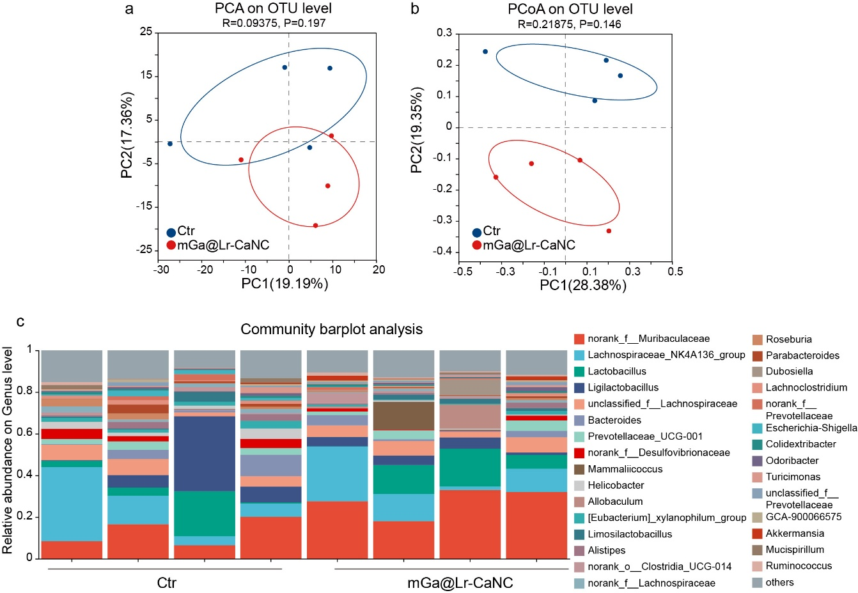
FigureS33. 16S rRNA sequencing of mouse feces after treatment with mGa@Lr-CaNC. (a) PCA analysis of mouse fecal bacteria, representing β-diversity. (b) PCoA analysis of mouse fecal bacteria, representing β-diversity. (c) Relative abundance of different species in mouse fecal bacteria microbiota after different treatments. n = 4 independent samples.

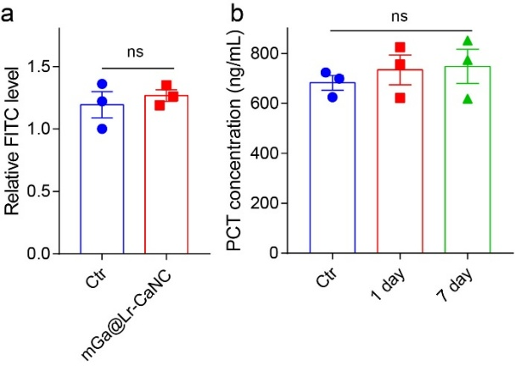
Figure S34. Assessment of biosafety. (a) Relative FITC level in the blood in Ctr group and mGa@Lr-CaNC group. (b) PCT concentration treatment with mGa@Lr-CaNC after 1 day and 7 days compared to the untreated control. n = 3 independent samples. Data are presented as the mean ± sem. Statistical significance was determined by unpaired two-tailed Student’s t-test (a) and one-way ANOVA with Tukey’s post hoc correction (b). ns means no significance.

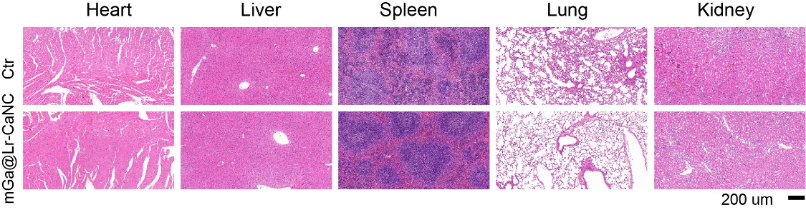
Figure S35. H&E staining of major organs in mice 30 days after oral administration of PBS and mGa@Lr-CaNC.

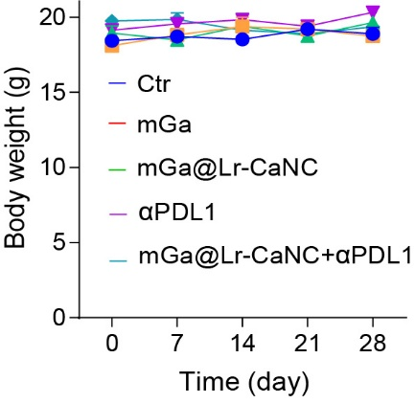
Figure S36. Analysis of mouse body weight after different treatments. n = 5 independent samples.

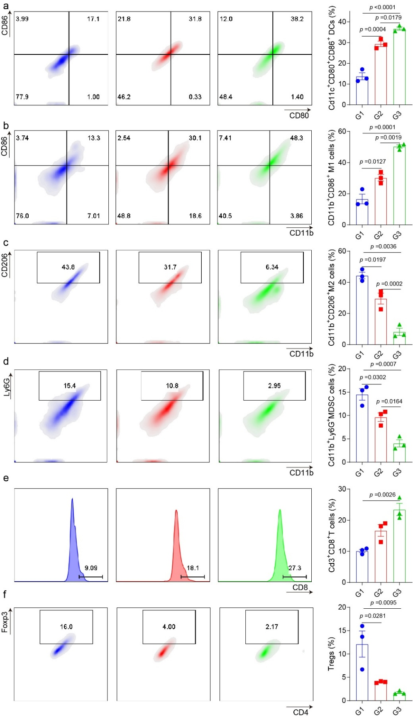
FigureS37. TIME analysis. FCM plots and quantitative analysis of DCs (a), M1 macrophages (b), M2 macrophages (c), MDSCs (d), CD8+ T cells (e), and Tregs (f), in mouse tumors after different treatments. n = 3 independent samples. Data are presented as the mean ± sem. Statistical significance was determined by one-way ANOVA with Tukey’s post hoc correction. G1: Ctr; G2: mGa; G3: mGa@Lr-CaNC.
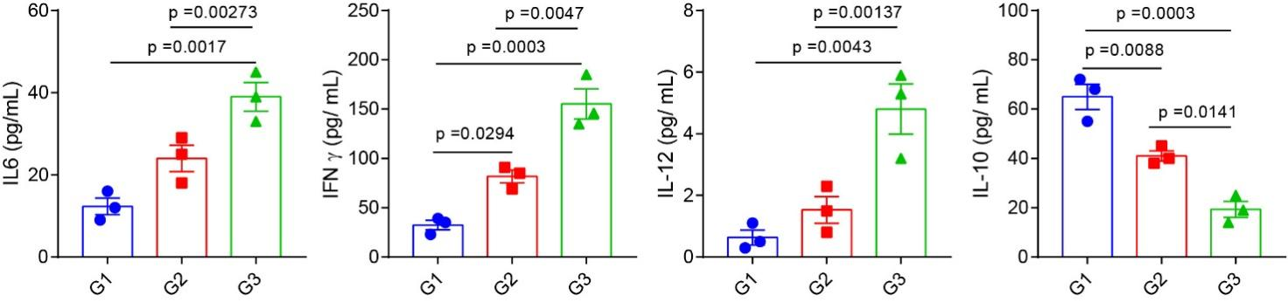
FigureS38. Measurement of cytokine concentrations (including IL-6, IFN-γ, IL-12, and IL-10) in mouse tumors after different treatments. n = 3 independent samples. G1: Ctr; G2: mGa; G3: mGa@Lr-CaNC. Data are presented as the mean ± sem. Statistical significance was determined by one-way ANOVA with Tukey’s post hoc correction.

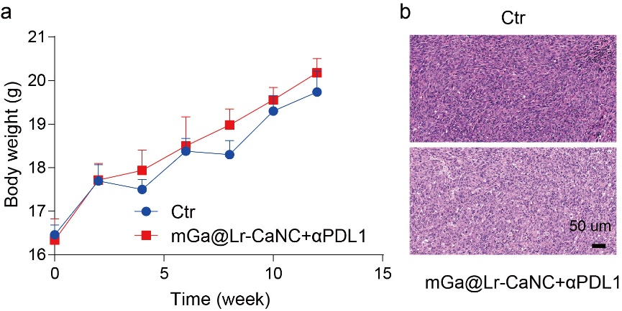
Figure S39. Antitumor efficiency of mGa@Lr-CaNC on the pancreatic tumor-bearing mouse model. (a) Body weight of mice in two groups. (b) H&E staining of major organs in two groups. n = 5 independent samples. Data are presented as the mean ± sem.

Supplementary Tables
Table S1. Cu concentration of ER-Cu₁SAZyme acquired from ICP measurement.
Measurement | Cu Content (Mass %)
ICP (bulk) | 0.11

Table S2. EXAFS data fitting results for samples. Structural parameters of samples obtained by EXAFS fitting. There are the average coordination number (CN), path distance (R), Debye-Waller factor (σ²), and the R-Factor of the fitting. The S₀² used in the EXAFS fitting was estimated to be 0.75.
Sample | Shell | CN | R(Å) | σ² (Å²) | R-Factor
CaO | Ca-O | 6 | 1.90 | 0.0091 | 0.002
Ca-NC | Ca-N | 3.1 | 1.84 | 0.0086 | 0.003

