Supplemental data
Human Serum Albumin Profiling by Top-down Analysis Enables Multi-Class Liver Fibrosis Staging: A Cross-Platform Validation Study

Souleiman El Balkhi^{1,2}, Racym Berrah¹, Léa Le Du³, Mohamad Ali Rahali^{1,2}, Roy Lakis¹, François Ludovic Sauvage¹, Pierre Marquet^{1,2}, Franck Saint-Marcoux^{1,2}, Véronique Loustaud-Ratti^{1,3}, Paul Carrier^{1,3}
¹ P&T, UMR1248, Inserm, Univ. Limoges, France.
² Department of pharmacology, toxicology and pharmacovigilance, CHU Limoges, France.
³ Department of Liver Disease, CHU Limoges, Limoges, France

Address for correspondence: Souleiman El Balkhi, Pharmacology-Toxicology and Pharmacovigilance Department, Centre de Biologie et de Recherche en Santé (CBRS), 2, av. Martin Luther King, 87042 Limoges Cedex, France. Phone: +33555056140.
E-mail: souleiman.elbalkhi@chu-limoges.fr

Between January 2021 and January 2023, 172 patients diagnosed with chronic liver disease (CLD) at various stages and 82 control subjects met the initial eligibility criteria.
The patient group consisted predominantly of males (116/172, 67.4%), with a median age at inclusion of 61 years.
The distribution across fibrosis stages was as follows: 36 (20.9%) patients were classified as F0/F1, 23 (13%) as F2, 30 (17%) as F3, and 83 (48%) as F4 (cirrhosis). Most fibrosis staging assessments relied on transient elastography.
Among the 83 patients with cirrhosis (F4), disease severity was assessed using the Child-Pugh classification. Thirty-seven patients (44.6% of F4; 21.5% of total cohort) were classified as Child-Pugh Class A, 26 (31.3% of F4; 15.1% of total) as Class B, and 20 (24.1% of F4; 11.6% of total) as Class C. The average MELD score progressively increased with Child-Pugh class, reflecting increasing disease severity.
The primary etiologies of CLD in this cohort were nonalcoholic steatohepatitis (NASH; 62 patients, 36.0%) and alcohol-related liver disease (ALD; 40 patients, 23.3%). A combination of ALD and NASH was identified in 11 patients (6.4%). Other etiologies included viral hepatitis B (HBV; 15 patients, 8.7%), viral hepatitis C (HCV; 11 patients, 6.4%), autoimmune hepatitis (AIH; 11 patients, 6.4%), and less common causes such as hemochromatosis, primary biliary cholangitis (PBC), primary sclerosing cholangitis (PSC), cardiac hepatopathy, and cryptogenic cirrhosis. The detailed etiological breakdown is shown in Table 1.
Clinical manifestations of decompensation were frequent among the cirrhotic patients. Ascites was present in 30 of the 83 (36.1%) individuals with cirrhosis. It was graded as moderate in 18 patients (distributed across 7 Child-Pugh B and 11 Child-Pugh C cases) and was tense or refractory to diuretics in 12 patients (7 Child-Pugh B and 5 Child-Pugh C cases). Hepatic encephalopathy (clinically apparent, West Haven grade II or III) was documented in 18 (21.7%) cirrhotic patients. This included one patient classified as Child-Pugh A (stage II), seven patients as Child-Pugh B (4 stage II, 3 stage III), and ten patients as Child-Pugh C (8 stage II, 2 stage III).

Analysis of classical liver disease biomarkers
Among classical laboratory parameters, serum albumin concentration, as determined by routine biochemical methods, exhibited a significant decline with advanced liver disease (Figure S1). While levels in controls (n= 19; mean = 45 g/L) and patients with early fibrosis stages F0/F1 (47.5 g/L), F2 (44.6 g/L), and F3 (42.7 g/L) remained relatively stable, a highly significant (p<0.0001) progressive decrease was observed in patients with cirrhosis. Specifically, albumin levels dropped from 40.7 g/L in F4 Child-Pugh A (F4_A) to significantly lower levels in F4 Child-Pugh B (F4_B; 29.9 g/L; p<0.05 vs F4_A) and further to Child-Pugh C (F4_C; 26.4 g/L; p<0.0001 vs F4_A and F4_B).
The FIB-4 index, demonstrated a clear stepwise increase with disease progression (Figure 6, FIB4). Starting from low values in the F0/F1 group, FIB-4 scores significantly increased through stages F2, F3, and F4_A, reaching markedly higher levels in patients with F4_B and F4_C cirrhosis (p<0.01 for F4_B vs F4_A; p<0.01 for F4_C vs F4_B). The difference between F0/F1 and all F4 stages was highly significant (p<0.0001).
AST levels, indicative of hepatocellular injury, showed a trend towards elevation with increasing disease severity (Figure S1, AST). While AST levels were relatively low and comparable across controls and fibrosis stages F0/F1, F2, and F3, they became significantly higher in patients with F4_A, F4_B, and F4_C cirrhosis compared to the F0/F1 group (p<0.0001). A significant increase was also observed between F4_A and F4_B (p<0.05). ALT was not able to discriminate between any of the groups.
Serum bilirubin concentration, a marker of hepatic excretory function, remained low across controls and fibrosis stages F0/F1, F2, F3, and even in F4_A cirrhosis (Figure S1, Bilirubin). However, bilirubin levels markedly and progressively increased in patients with F4_B and F4_C cirrhosis, with highly significant differences (p<0.0001) observed between these advanced stages and all preceding stages, as well as between F4_B and F4_C.

Figure S1. Classical clinical and biochemical markers across chronic liver disease stages. Dot plots showing values for (A) routine serum albumin (g/L), (B) FIB-4 index, (C) aspartate aminotransferase (AST, U/L), (D) total bilirubin (µmol/L), and (E) alanine aminotransferase (ALT, U/L) stratified by fibrosis stage. Horizontal bars represent mean ± SEM. Statistical significance is indicated (*p < 0.05, **p < 0.01, ***p < 0.001, ****p < 0.0001; one-way ANOVA with Tukey's post-hoc test). FIB-4: Fibrosis-4 index; AST: aspartate aminotransferase; ALT: alanine aminotransferase.
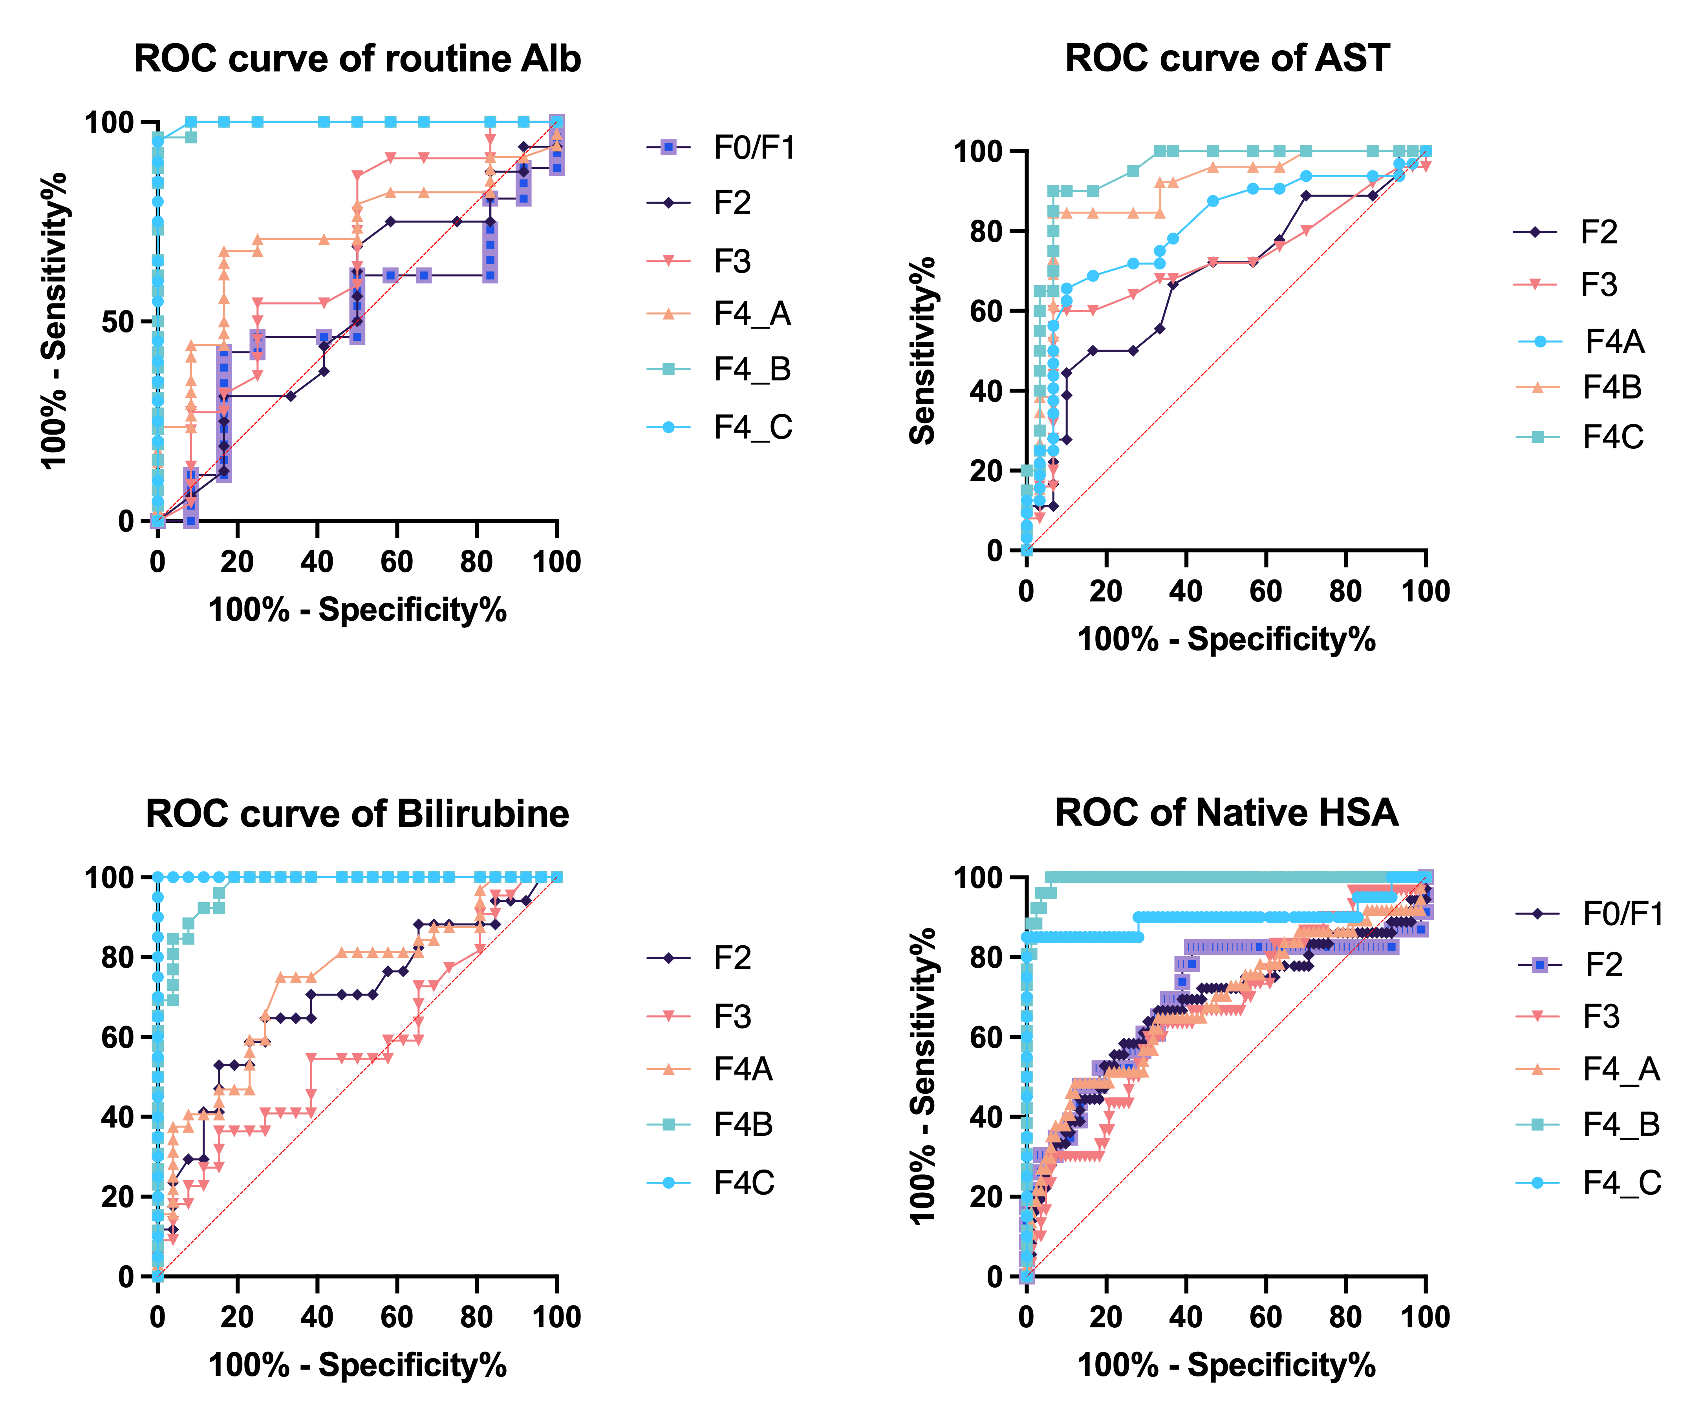
Figure S2. ROC curve analysis of classical clinical markers and native HSA. Receiver operating characteristic curves for (A) routine serum albumin, (B) AST, (C) total bilirubin, and (D) native HSA measured by LC-HR-MS, discriminating each fibrosis stage from healthy controls. Curves are color-coded by fibrosis stage. The diagonal dashed line represents chance-level discrimination. AST: aspartate aminotransferase; HSA: human serum albumin; LC-HR-MS: liquid chromatography high-resolution mass spectrometry.

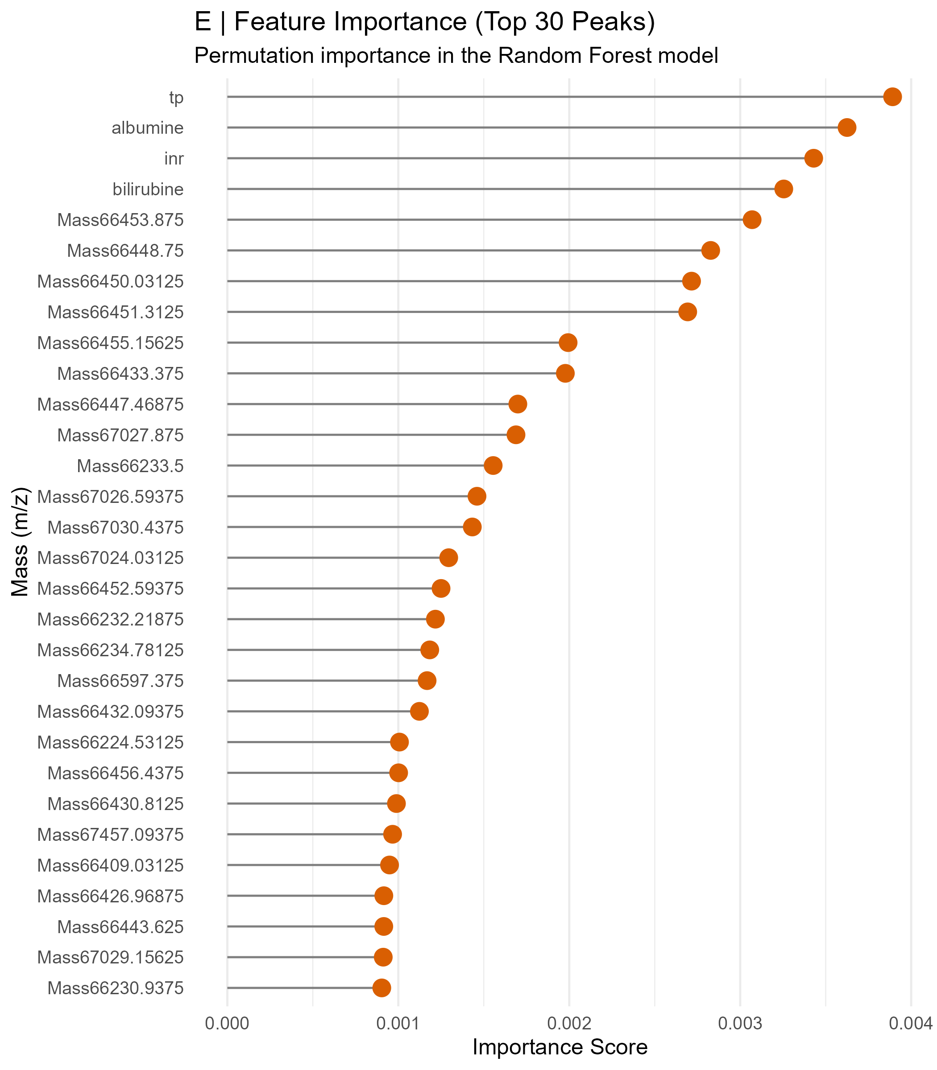
Figure S3. Feature importance of the 75-variable ALBOM classification model. Lollipop chart showing permutation importance scores for the top 30 predictive features in the OrdinalForest model. Features are ranked by decreasing importance. Orange dots indicate spectral albumin peaks (m/z values); the four top-ranked features (tp: total protein; albumine: routine serum albumin; inr: international normalized ratio; bilirubine: total bilirubin) are standard routine clinical variables included in the combined LC-TOF + Clinical model. Spectral peaks cluster in two m/z sub-regions: ~66,230–66,600 Da (native and cysteinylated albumin isoforms) and ~67,024–67,457 Da (poly-glycated albumin adducts).

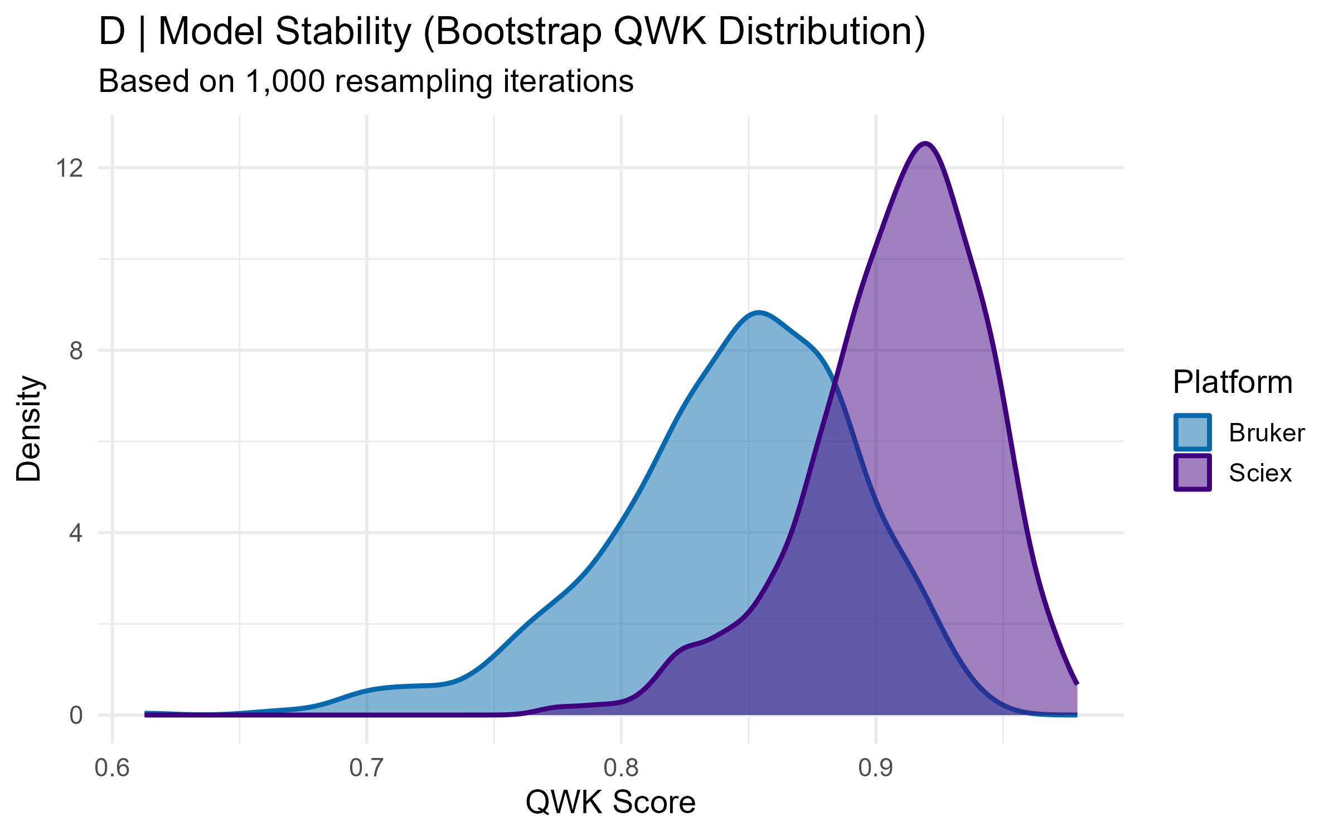
Fig S4. Density plots illustrate the distribution of Quadratic Weighted Kappa (QWK) scores from 1,000 bootstrap resampling iterations. The performance of the hierarchical OrdinalForest classifier is compared across two independent LC-HR-MS platforms: Bruker and Sciex. High mean QWK scores (0.862 and 0.916, respectively) and overlapping distributions demonstrate the robustness and platform independence of the HSA isoform signature for staging chronic liver disease. This statistical equivalence supports the model's readiness for multicenter clinical validation.

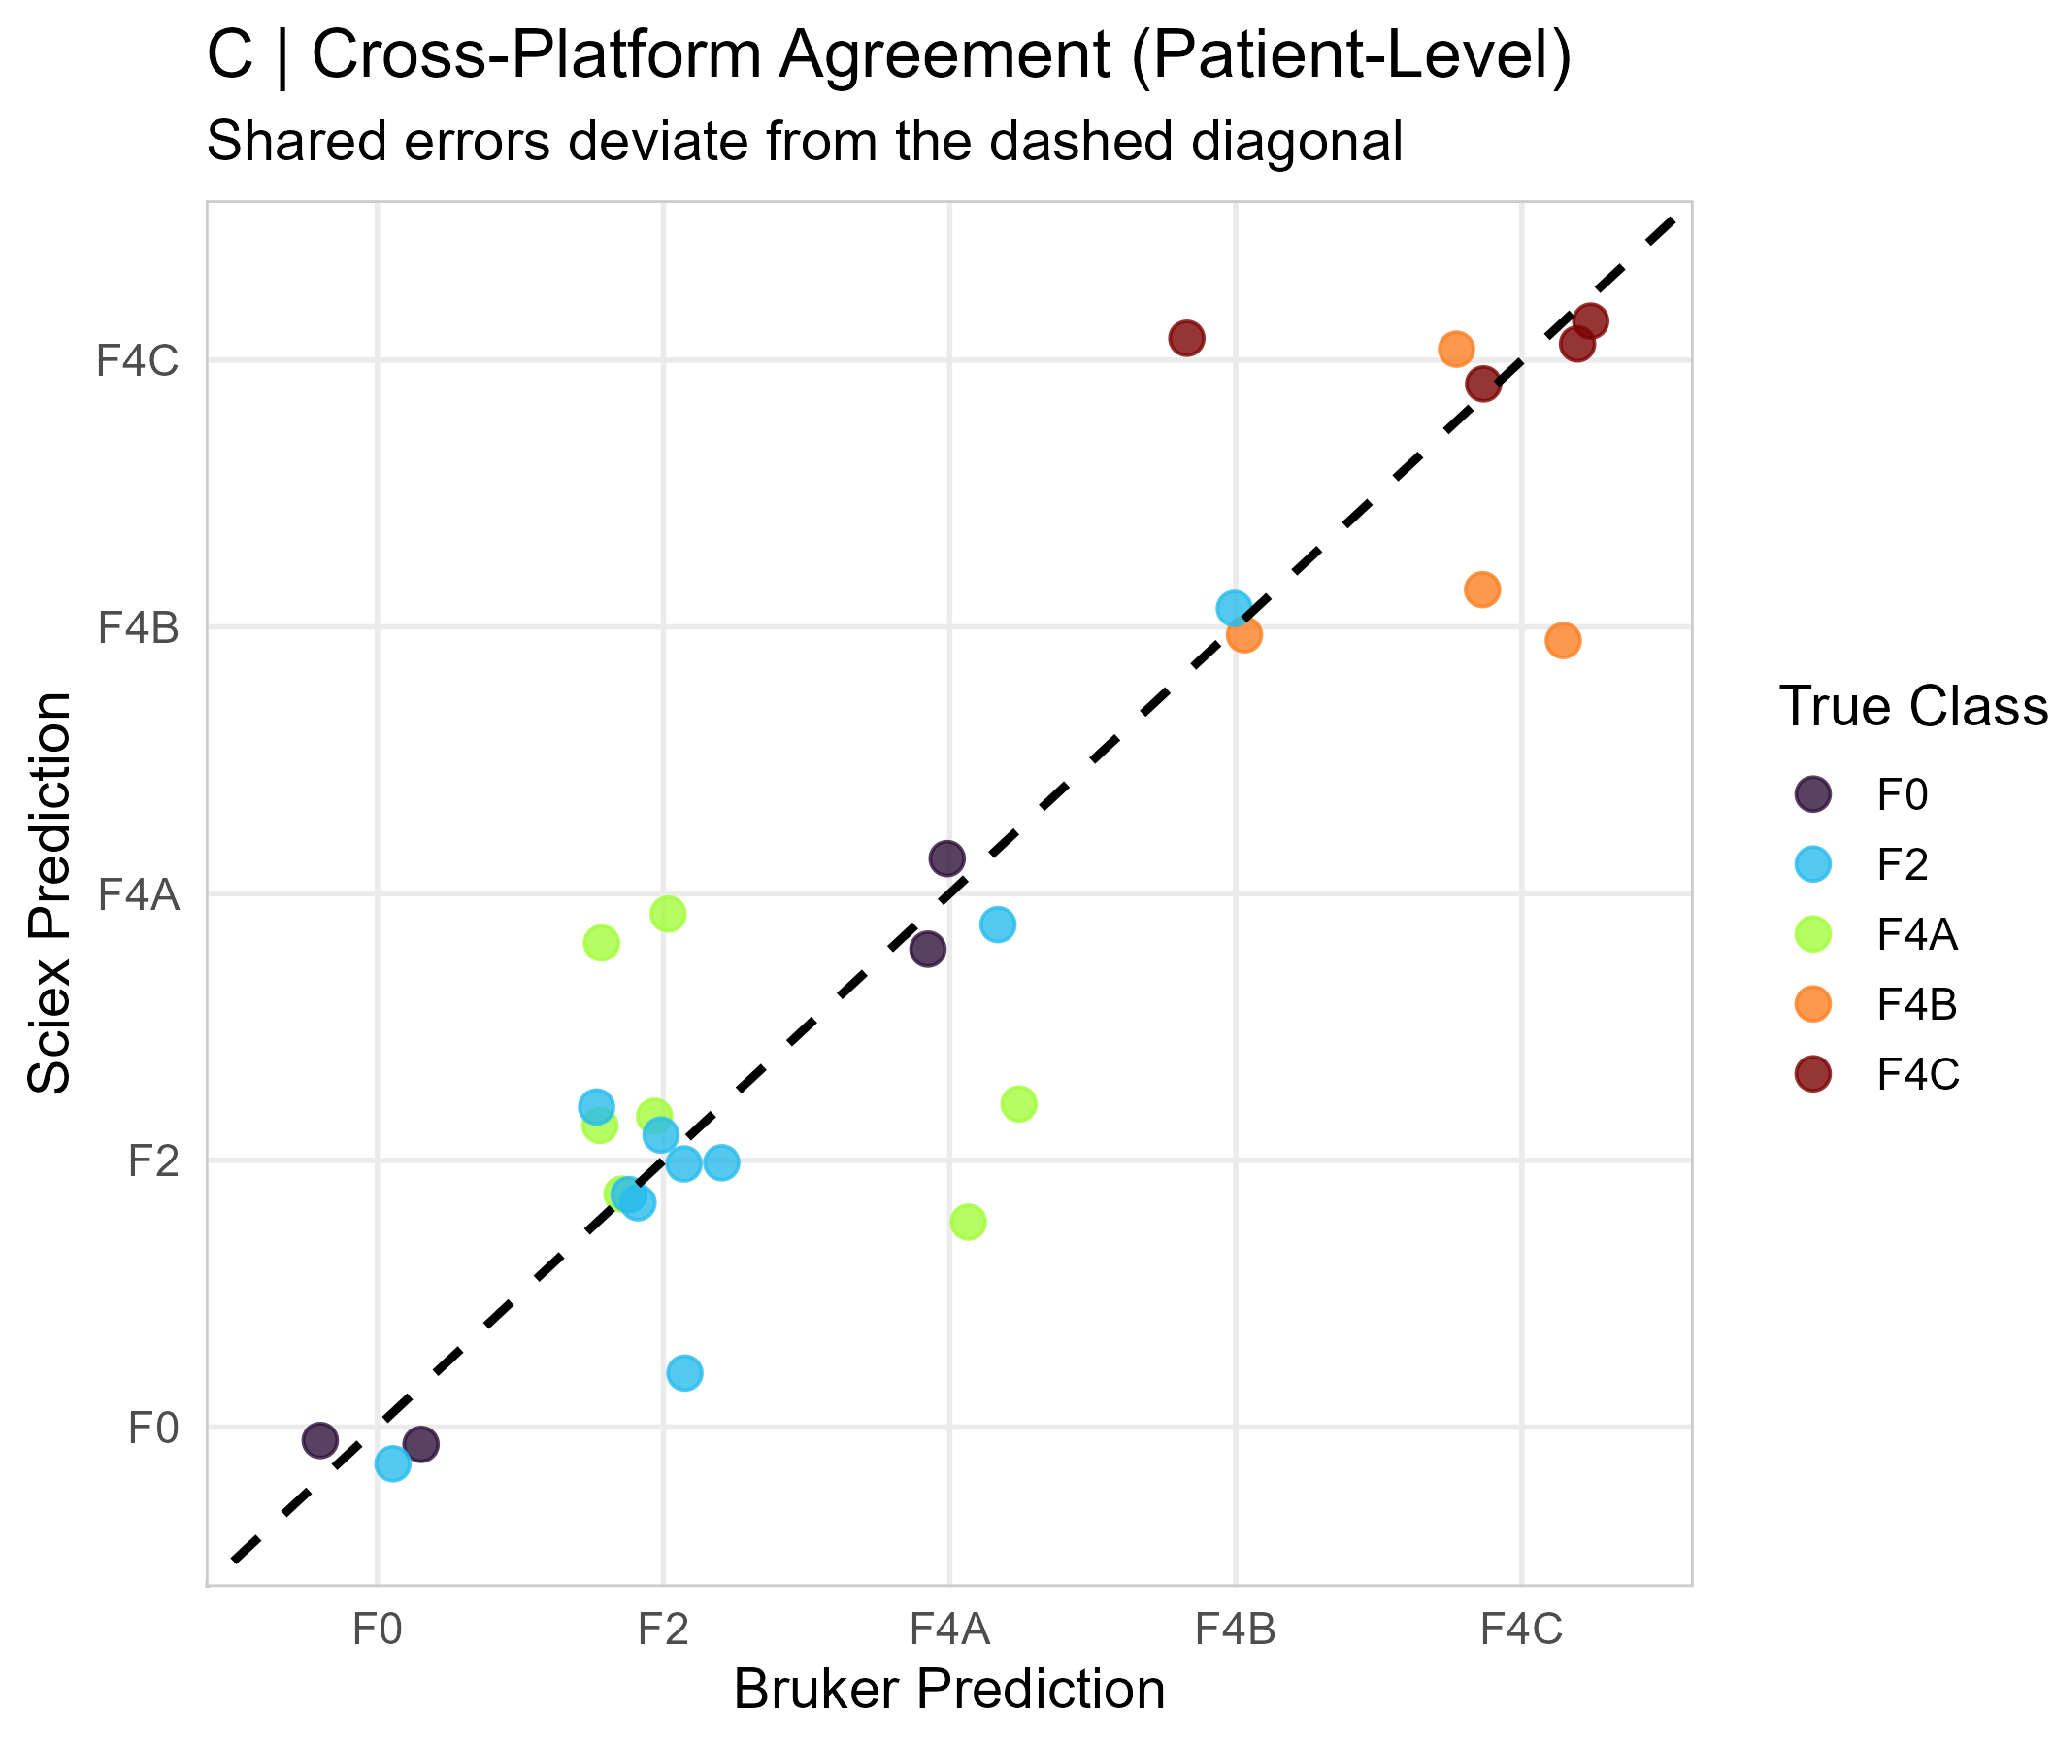

Fig S5. Cross-platform agreement at the patient level. Comparison of fibrosis stage predictions between Bruker and Sciex LC-HR-MS platforms. Points represent individual patients, color-coded by biopsy-confirmed fibrosis stage (F0–F4C). Alignment along the identity line (dashed) indicates high inter-platform consistency. The shared error profile (Jaccard index = 0.696) and statistical equivalence (McNemar p=0.149) underscore the reproducibility of the HSA spectral signature. These results validate the model’s performance stability across different hardware, facilitating its transition to multicenter clinical environments.

