Supplementary Information
Atmospheric pressure and population density as super-factors influencing the transmission of coronavirus disease 2019 (COVID-19)
Wei Yan^{1*}, Muhammad Zohaib Nawaz^{2#}, Wenqian Xu^{3#}, Zheng Jiang^{1#}, Weixiang Sun⁴, Jiayue Lai¹, Yinghui Shao⁴, Wei Zhang¹, Rui Zhang⁵
¹College of Marine Science and Technology, China University of Geosciences, Wuhan 430074, PR China
²Department of Computer Science, University of Agriculture, Faisalabad, 38040 Pakistan
³Department of Statistics, China University of Geosciences, Wuhan 430074, PR China
⁴School of Computer Science, China University of Geosciences, Wuhan 430074, PR China
⁵State Key Laboratory of Marine Environmental Science, Fujian Key Laboratory of Marine Carbon Sequestration, College of Ocean and Earth Sciences, Xiamen University, Xiamen 361102, PR China
# These authors contributed equally to this work.
To whom correspondence should be addressed:
Assistant Prof. Wei Yan, e-mail: yanwei@cug.edu.cn
Wei Yan: A1912, Comprehensive Teaching Building, No. 388 Lumo Road, Wuhan, Hubei, (430074) PR China Tel: 86-027-67886151; Fax: 86-027-67886167

Figure A1 Average (a) effective reproduction number (R_{proxy}), (b) infection rate (IR), and (c) compound growth (CG) of coronavirus disease 2019 (COVID-19) and average (d) temperature (AT) and (e) atmospheric pressure (AAP) at county level for 24 days within the period under investigation. (f) Population density (PD).

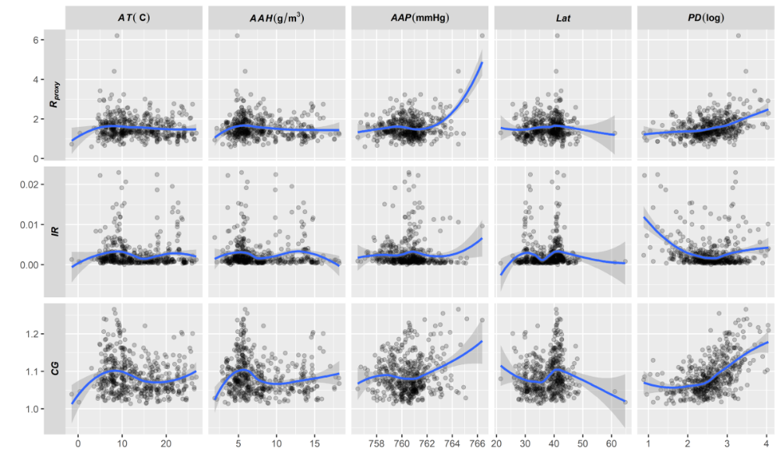
Figure A2 The 24-day average effective reproduction number (R_{proxy}), infection rate (IR), and compound growth (CG) of coronavirus disease 2019 (COVID-19) plotted as a function of average temperature (AT)(a, f, k), average absolute humidity (AAH)(b, j, i), average atmospheric pressure (AAP)(c, h, m), latitude (d, i, n), and population density (PD)(e, j, o) at the county level.

Table A1 Statistics table for univariate linear and quadratic regression models of compound growth rate (CG) of coronavirus disease 2019 (COVID-19) at county level for 17 days within the period under investigation.
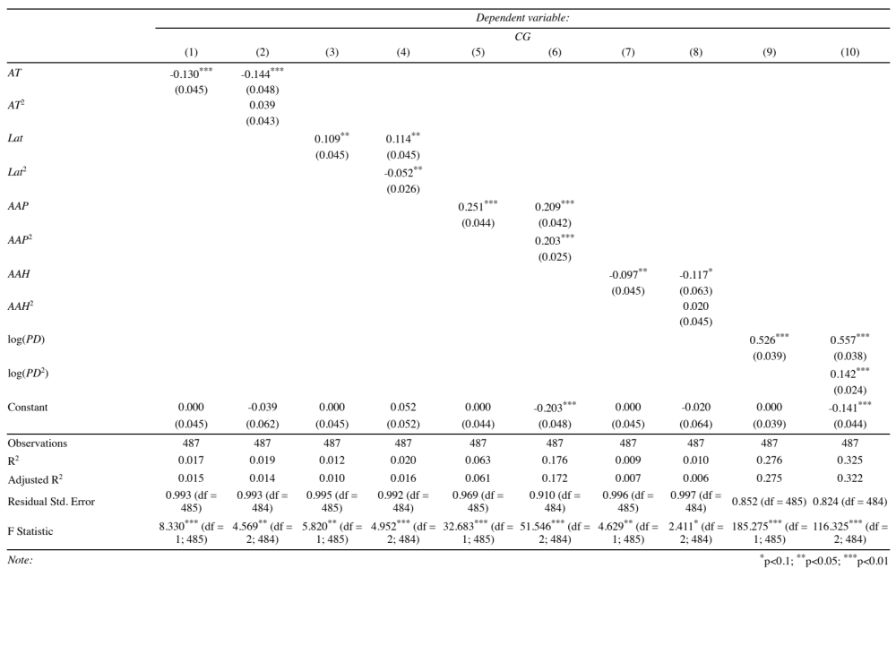
Table A2 Statistics table for univariate linear and quadratic regression models of infection rate (IR) of coronavirus disease 2019 (COVID-19) at county level for 17 days within the period under investigation.
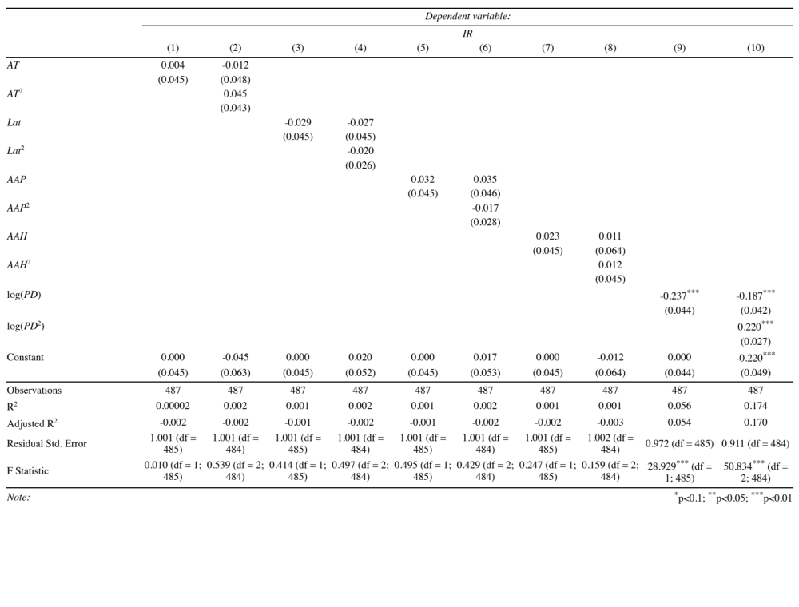
Table A3 Statistics table for univariate linear and quadratic regression models of effective reproduction number (R_{proxy}) of coronavirus disease 2019 (COVID-19) at county level for 24 days within the period under investigation.
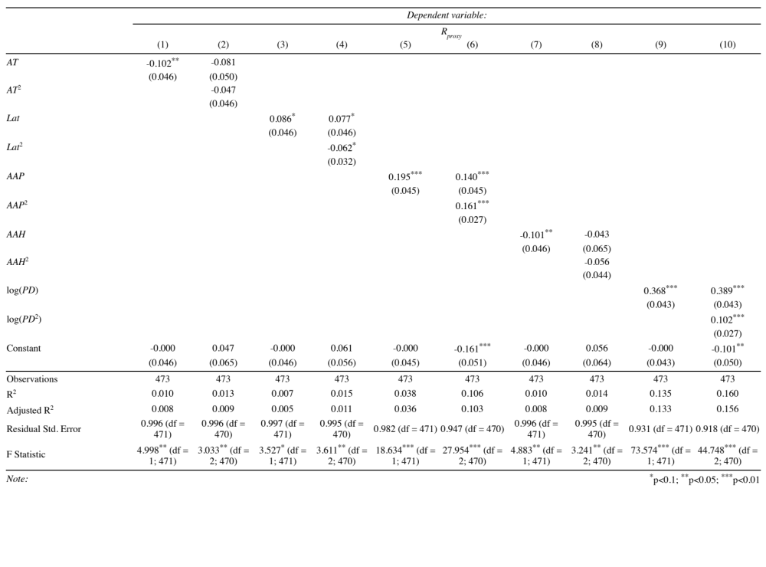
Table A4 24 Statistics table for univariate linear and quadratic regression models of compound growth rate (CG) of coronavirus disease 2019 (COVID-19) at county level for 24 days within the period under investigation.
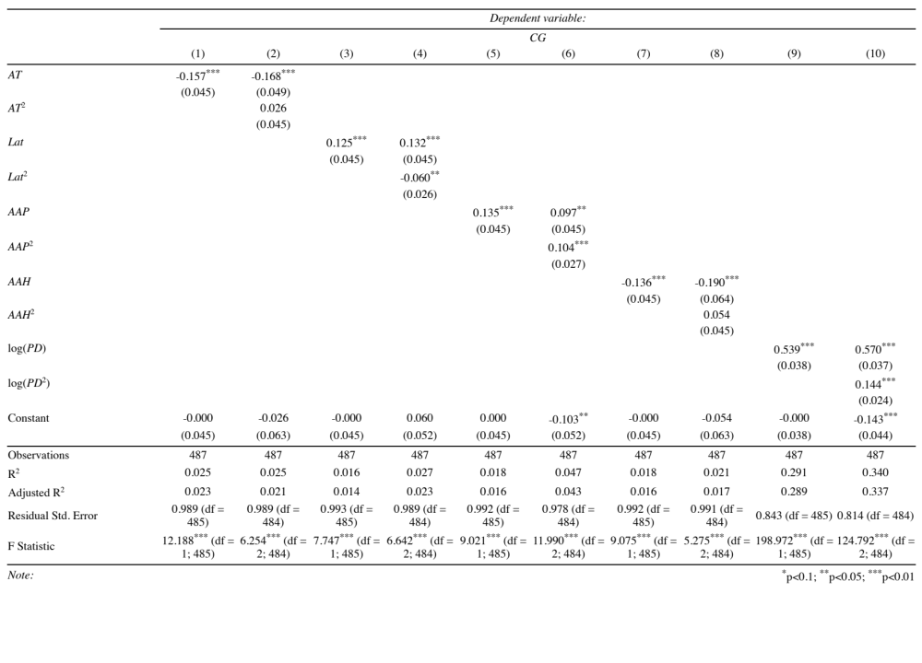
Table A5 Statistics table for univariate linear and quadratic regression models of infection rate (IR) of coronavirus disease 2019 (COVID-19) at county level for 24 days within the period under investigation.
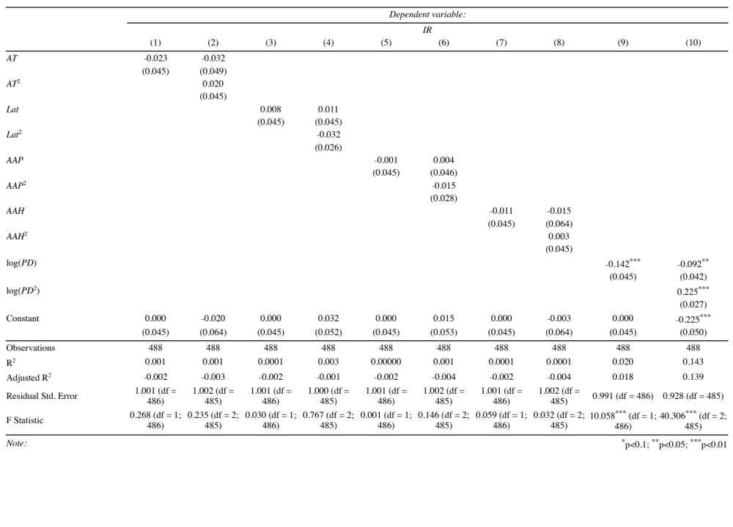
Table A6 Statistics table for univariate linear and quadratic regression models of effective reproduction number (R_{proxy}) of coronavirus disease 2019 (COVID-19) at county level for 31 days within the period under investigation.
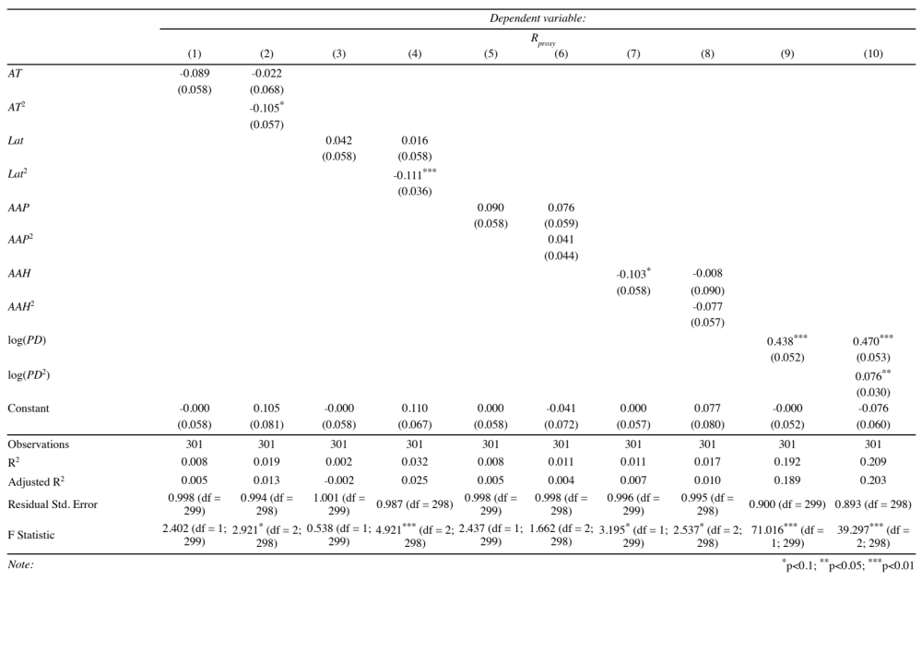

Table A7 Statistics table for univariate linear and quadratic regression models of compound growth rate (CG) of coronavirus disease 2019 (COVID-19) at county level for 31 days within the period under investigation.
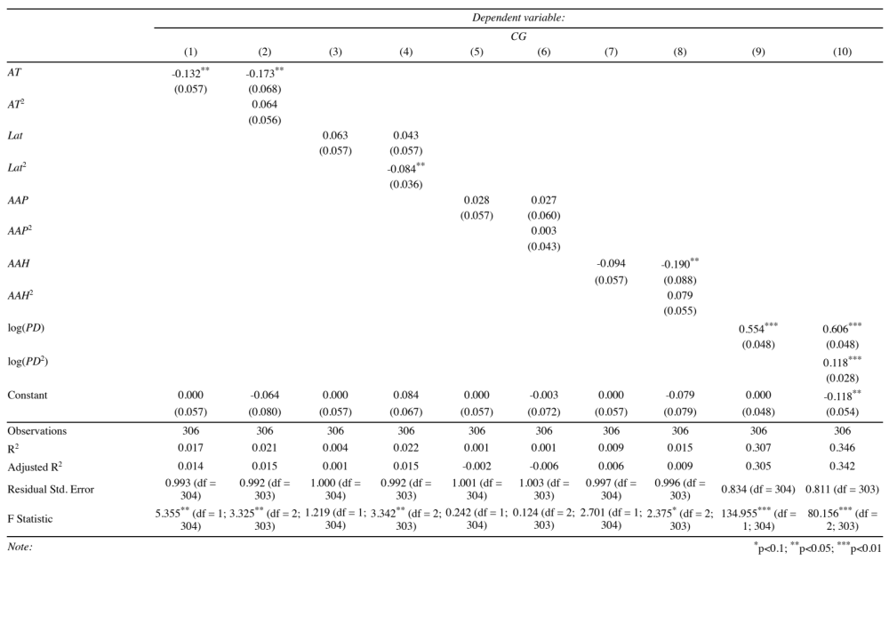
Table A8 Statistics table for univariate linear and quadratic regression models of infection rate (IR) of coronavirus disease 2019 (COVID-19) at county level for 31 days within the period under investigation.
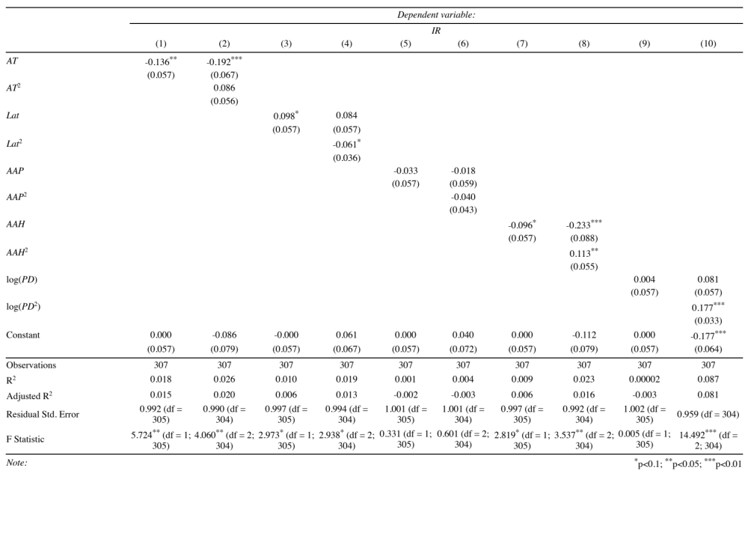

Table A9 Statistics table for stepwise multiple regression models of average (a) effective reproduction number (R_{proxy}), (b) compound growth (CG), and (c) infection rate (IR) of coronavirus disease 2019 (COVID-19) at the county level for 24 days within the period under investigation.
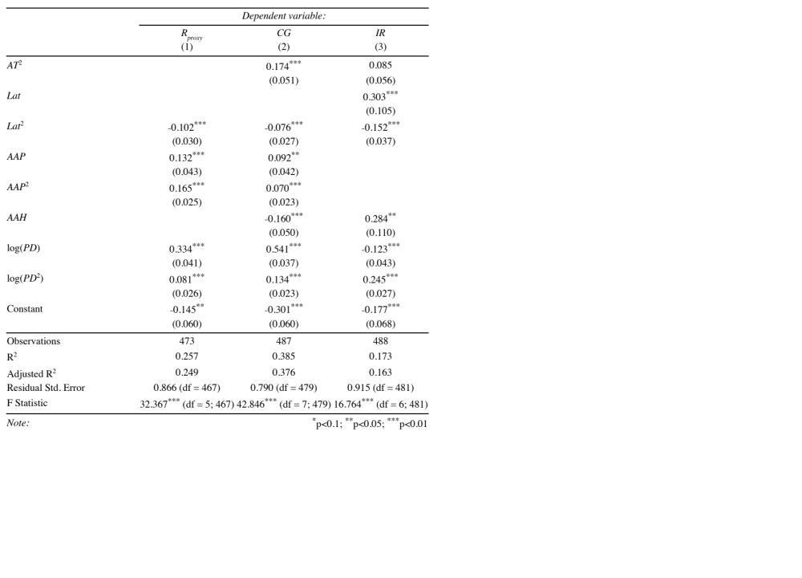
Table A10 Statistics table for stepwise multiple regression models of average (a) effective reproduction number (R_{proxy}), (b) compound growth (CG), and (c) infection rate (IR) of coronavirus disease 2019 (COVID-19) at the county level for 31 days within the period under investigation.
