ELECTRONIC SUPPLEMENT

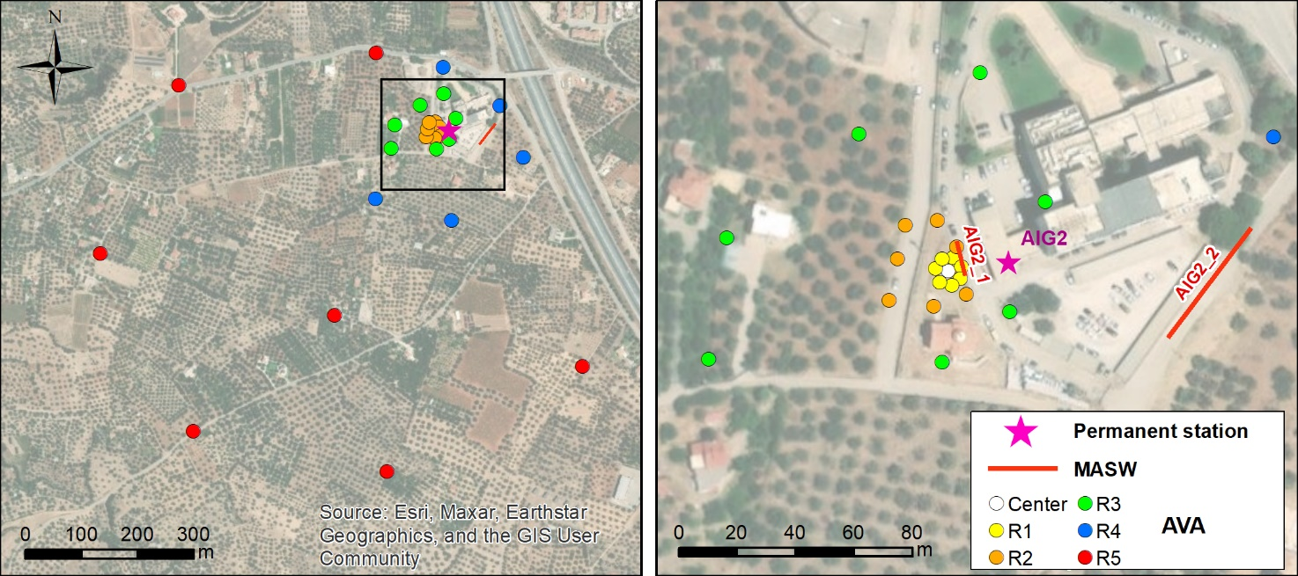
Figure ESM 1: Configuration of MASW (red line) and AVA deployment (colored circles) for the AIG2 station site.

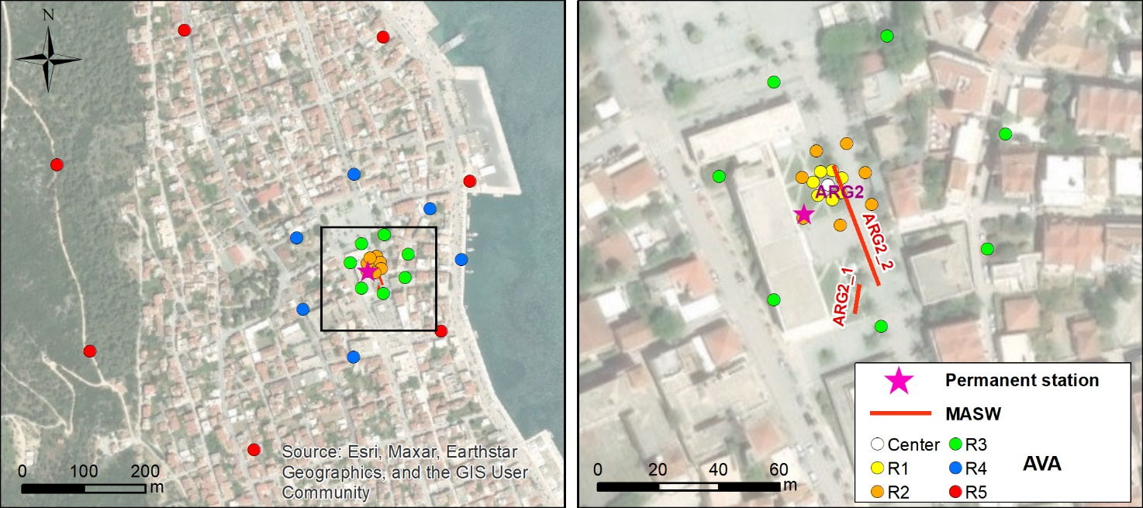
Figure ESM 2: Configuration of MASW (red line) and AVA deployment (colored circles) for the ARG2 station site.

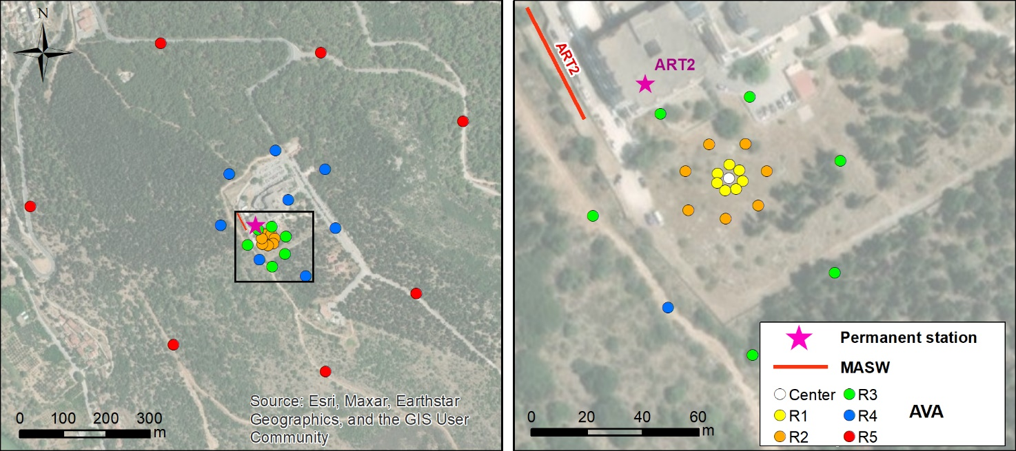
Figure ESM 3: Configuration of MASW (red line) and AVA deployment (colored circles) for the ART2 station site.

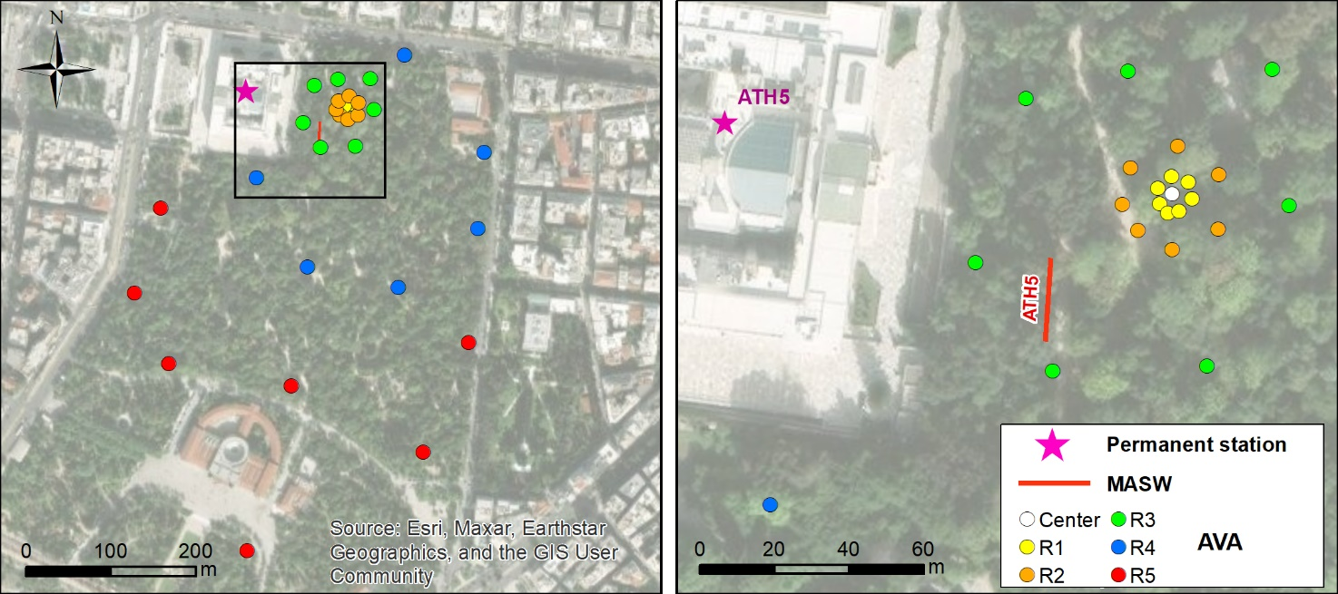
Figure ESM 4: Configuration of MASW (red line) and AVA deployment (colored circles) for the ATH5 station site.

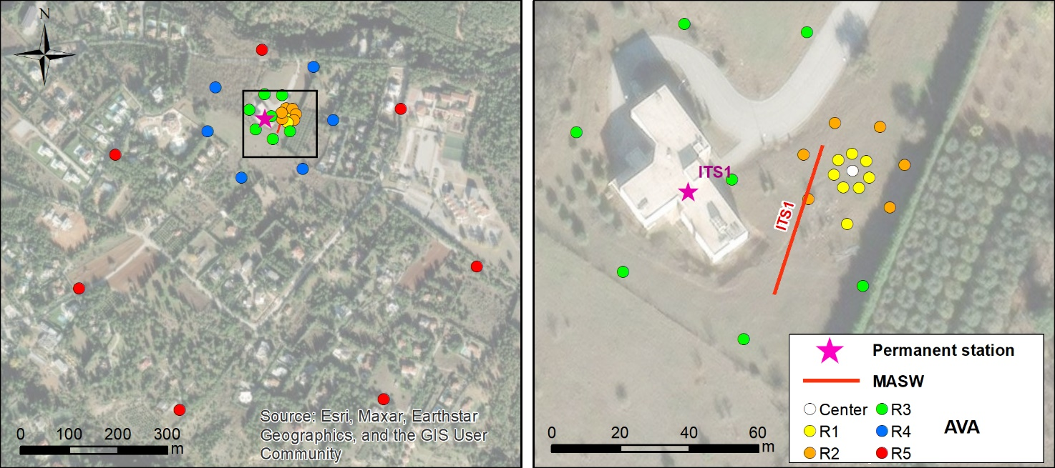
Figure ESM 5: Configuration of MASW (red line) and AVA deployment (colored circles) for the ITS1 station site.

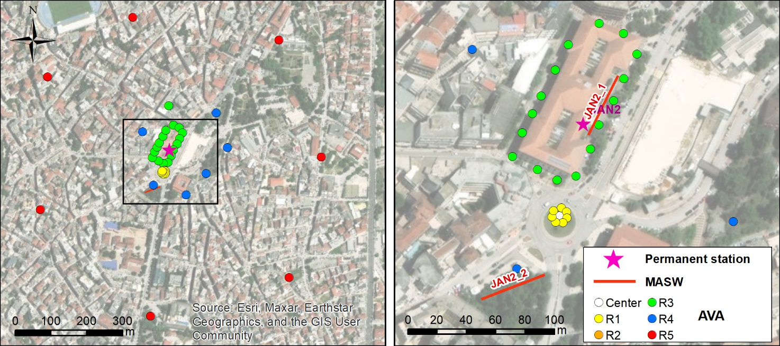
Figure ESM 6: Configuration of MASW (red line) and AVA deployment (colored circles) for the JAN2 station site.

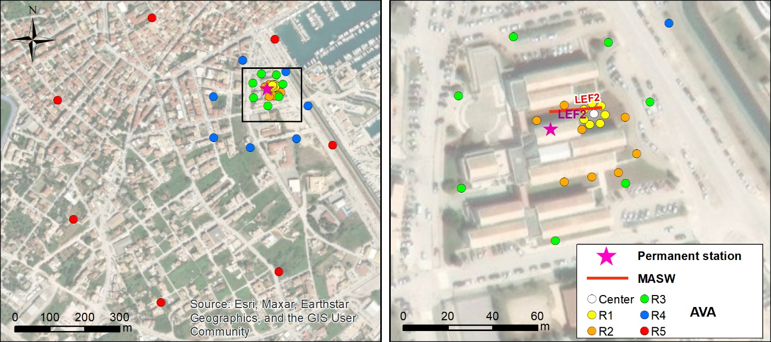
Figure ESM 7: Configuration of MASW (red line) and AVA deployment (colored circles) for the LEF2 station site.

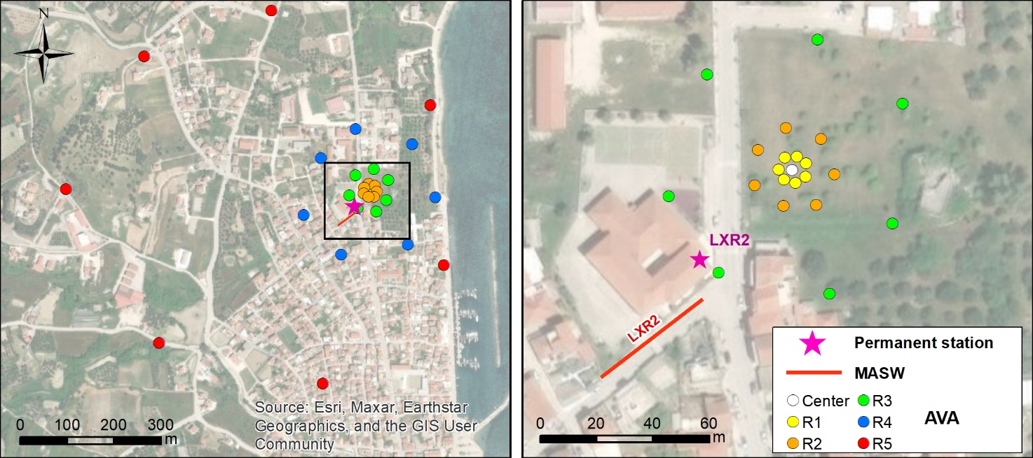
Figure ESM 8: Configuration of MASW (red line) and AVA deployment (colored circles) for the LXR2 station site.

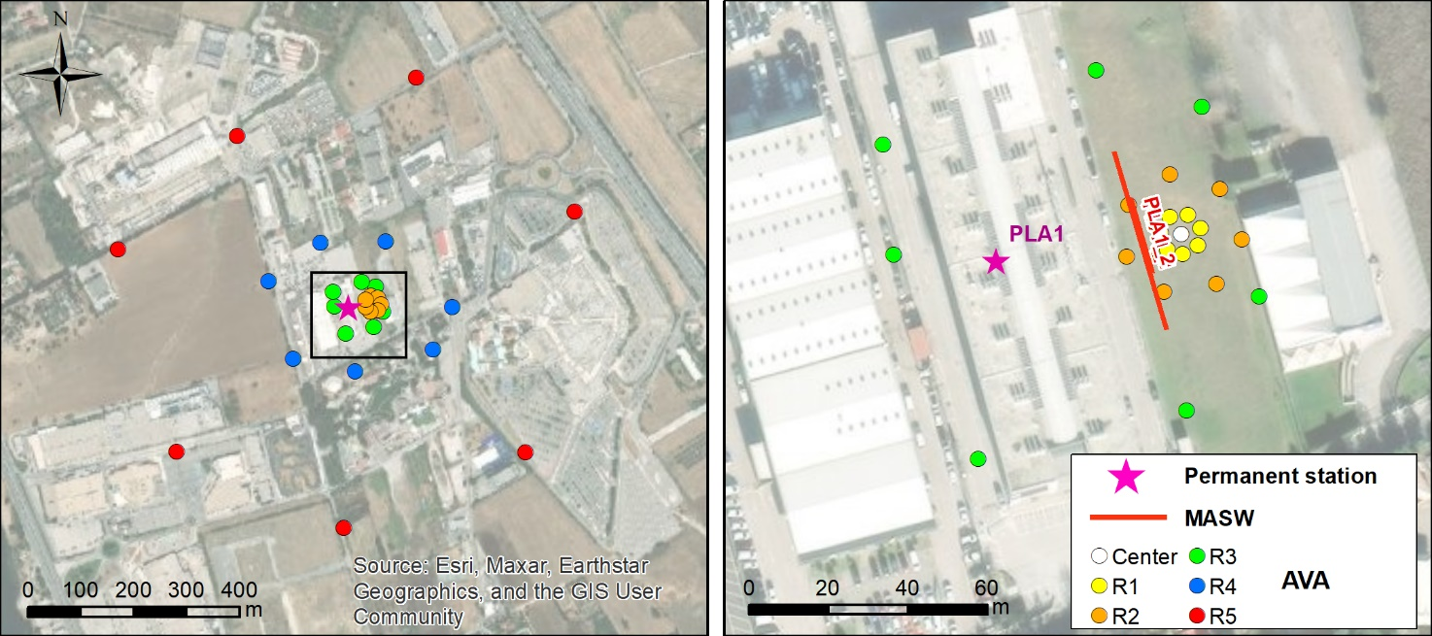
Figure ESM 9: Configuration of MASW (red line) and AVA deployment (colored circles) for the PLA1 station site.

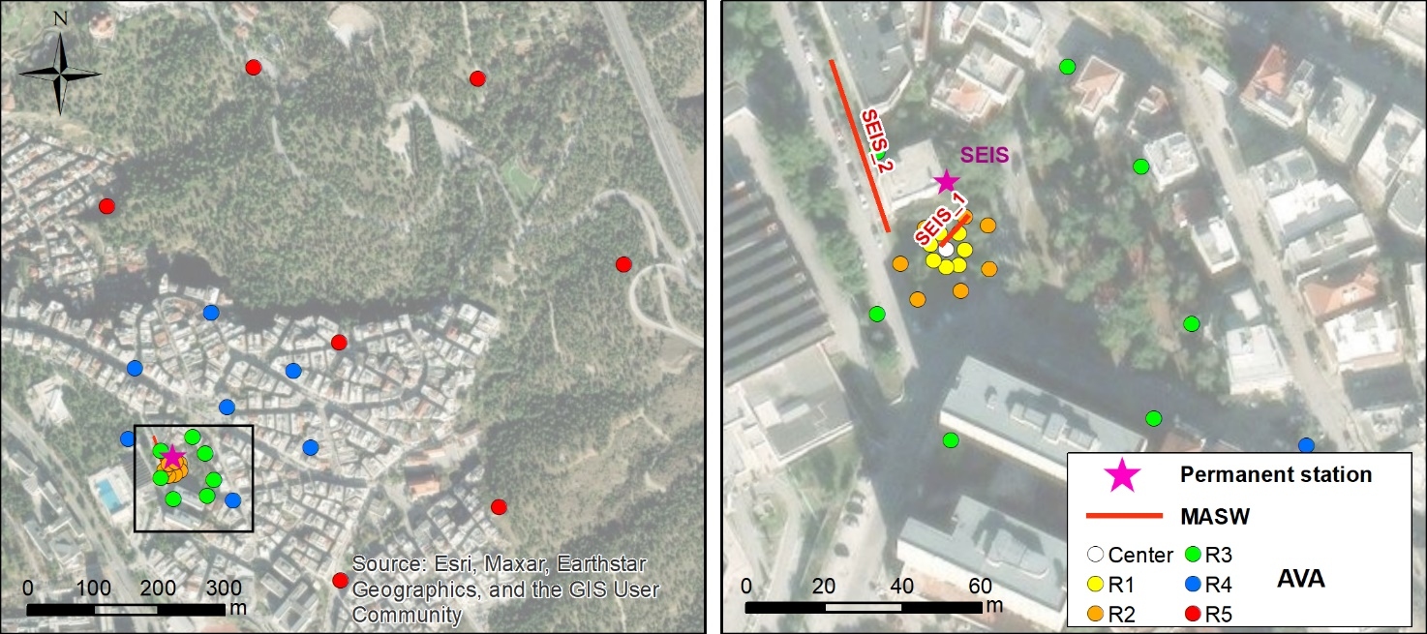
Figure ESM 10: Configuration of MASW (red line) and AVA deployment (colored circles) for the SEIS station site.

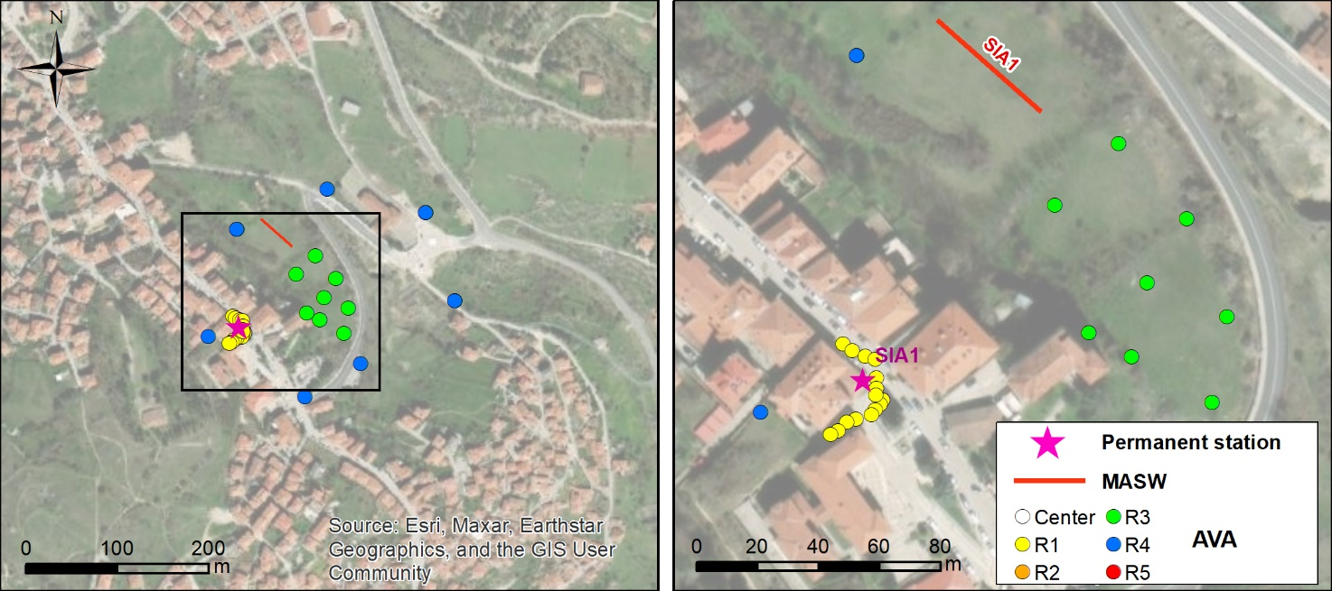
Figure ESM 11: Configuration of MASW (red line) and AVA deployment (colored circles) for the SIA1 station site.

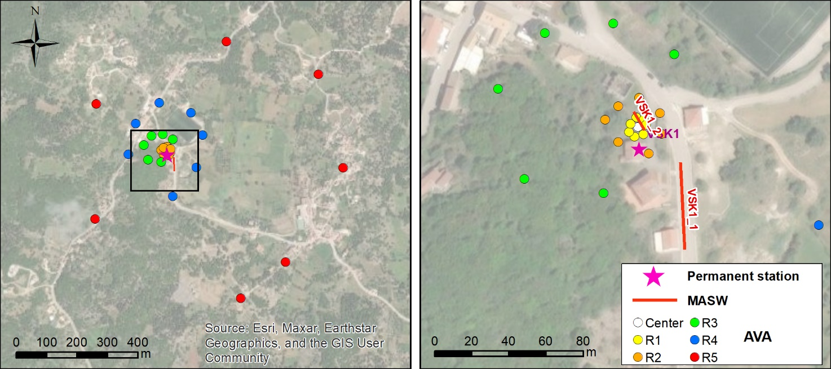
Figure ESM 12: Configuration of MASW (red line) and AVA deployment (colored circles) for the VSK1 station site.

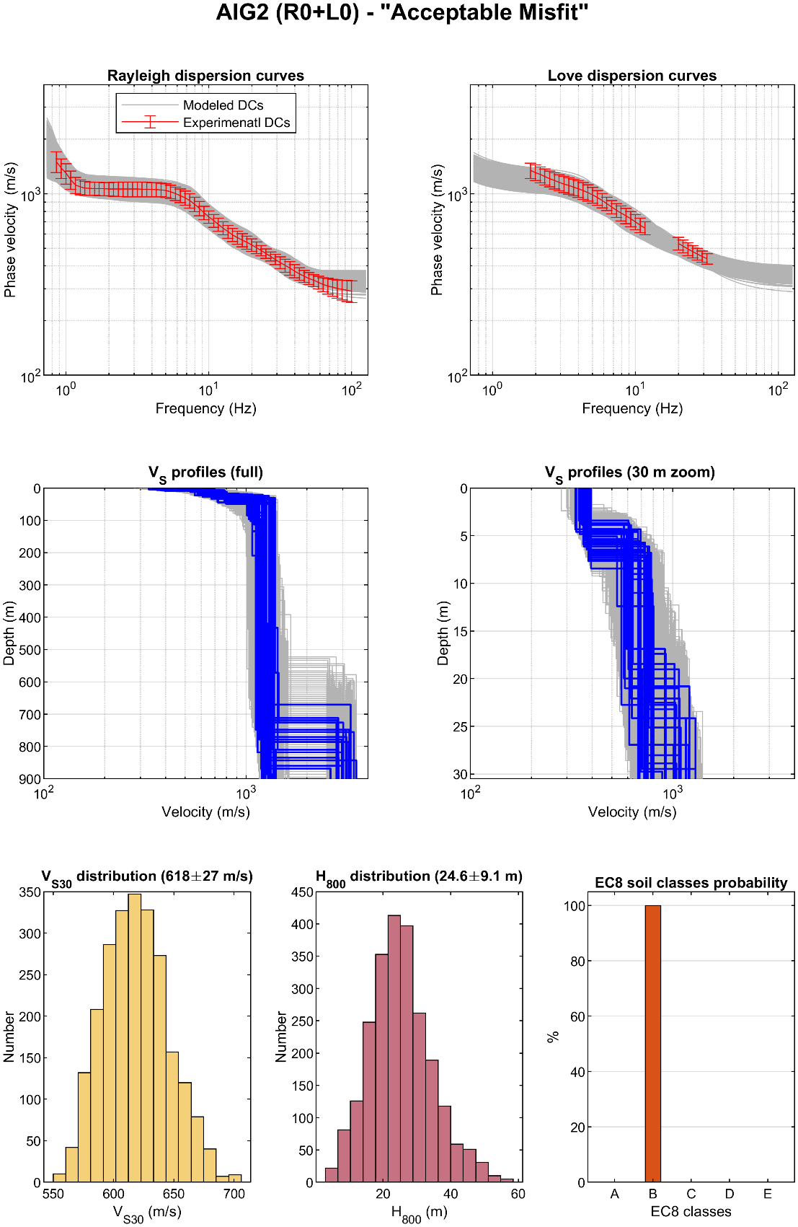
Figure ESM 13: Summary of inversion results for site AIG2. See additional description in the legend of Figure 9.

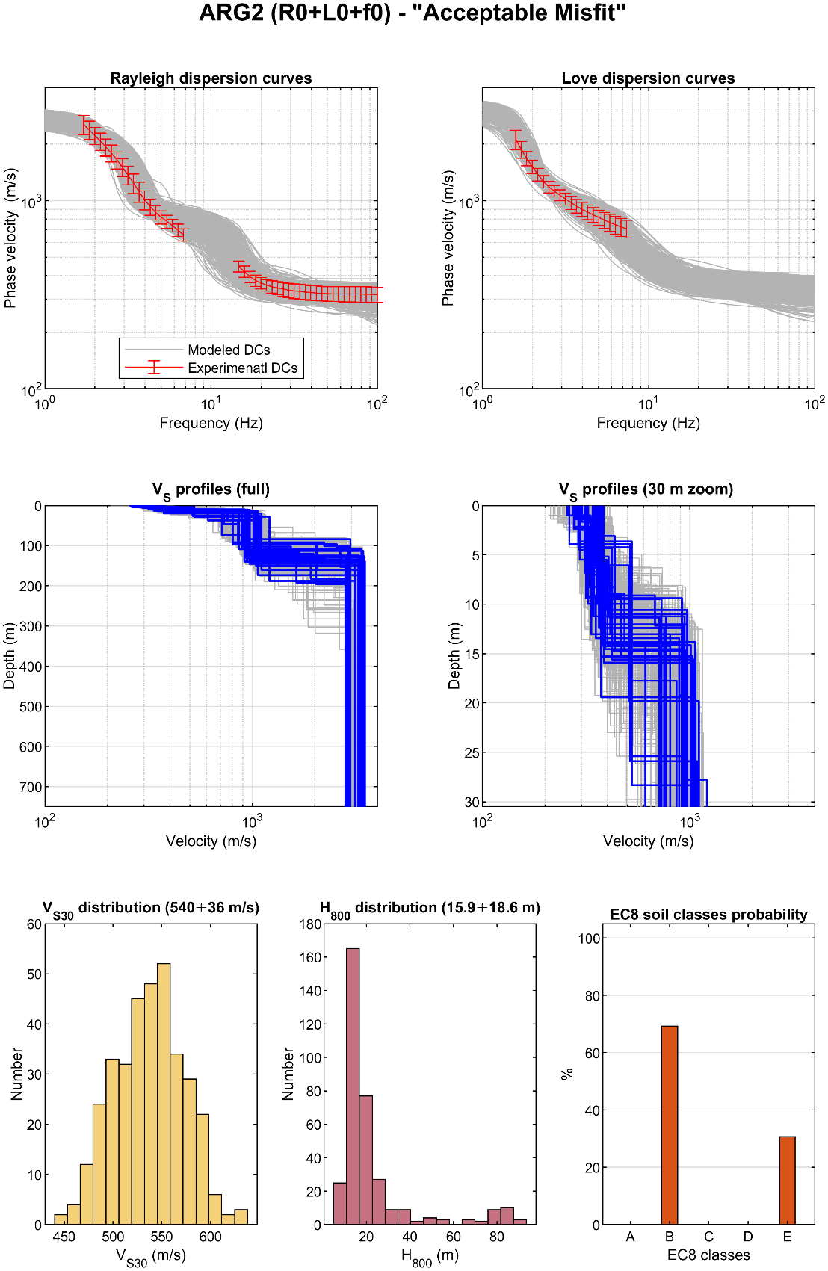
Figure ESM 14: Summary of inversion results for site ARG2. See additional description in the legend of Figure 9.

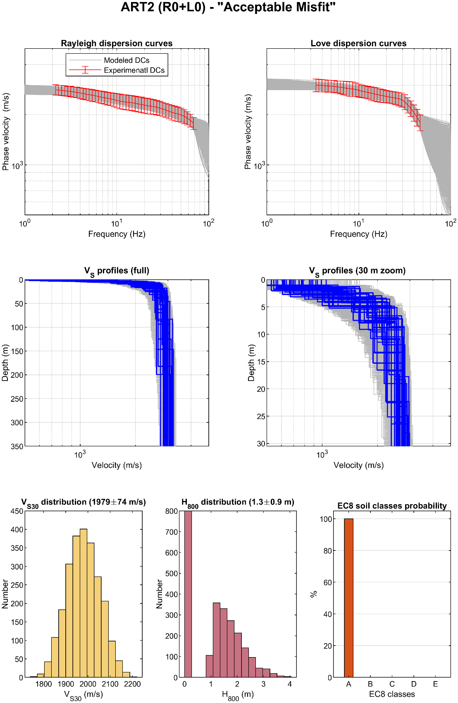
Figure ESM 15: Summary of inversion results for site ART2. See additional description in the legend of Figure 9.

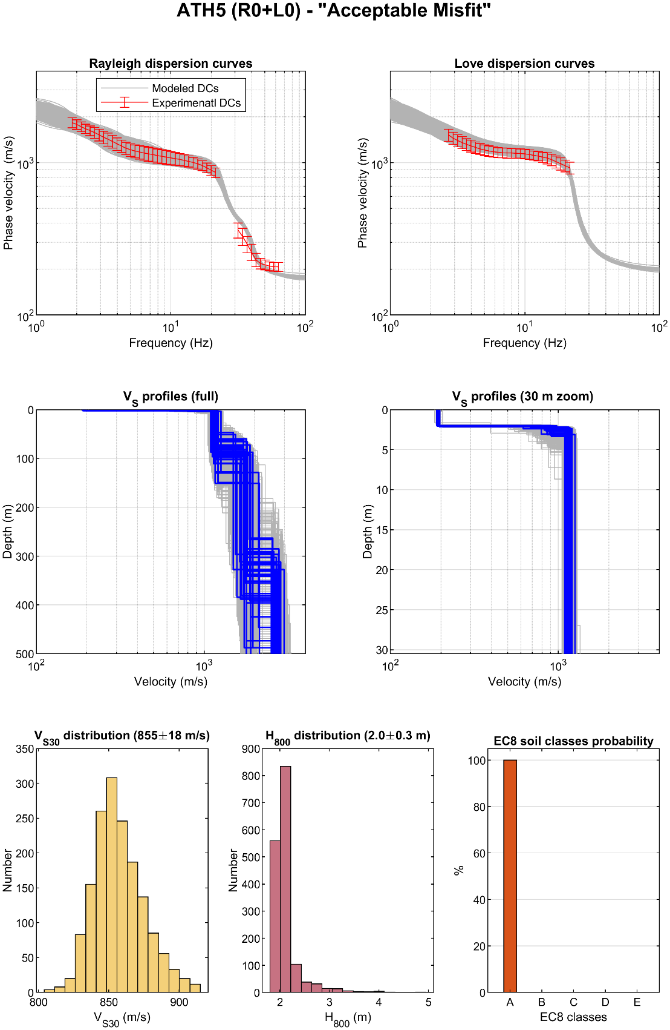
Figure ESM 16: Summary of inversion results for site ATH5. See additional description in the legend of Figure 9.

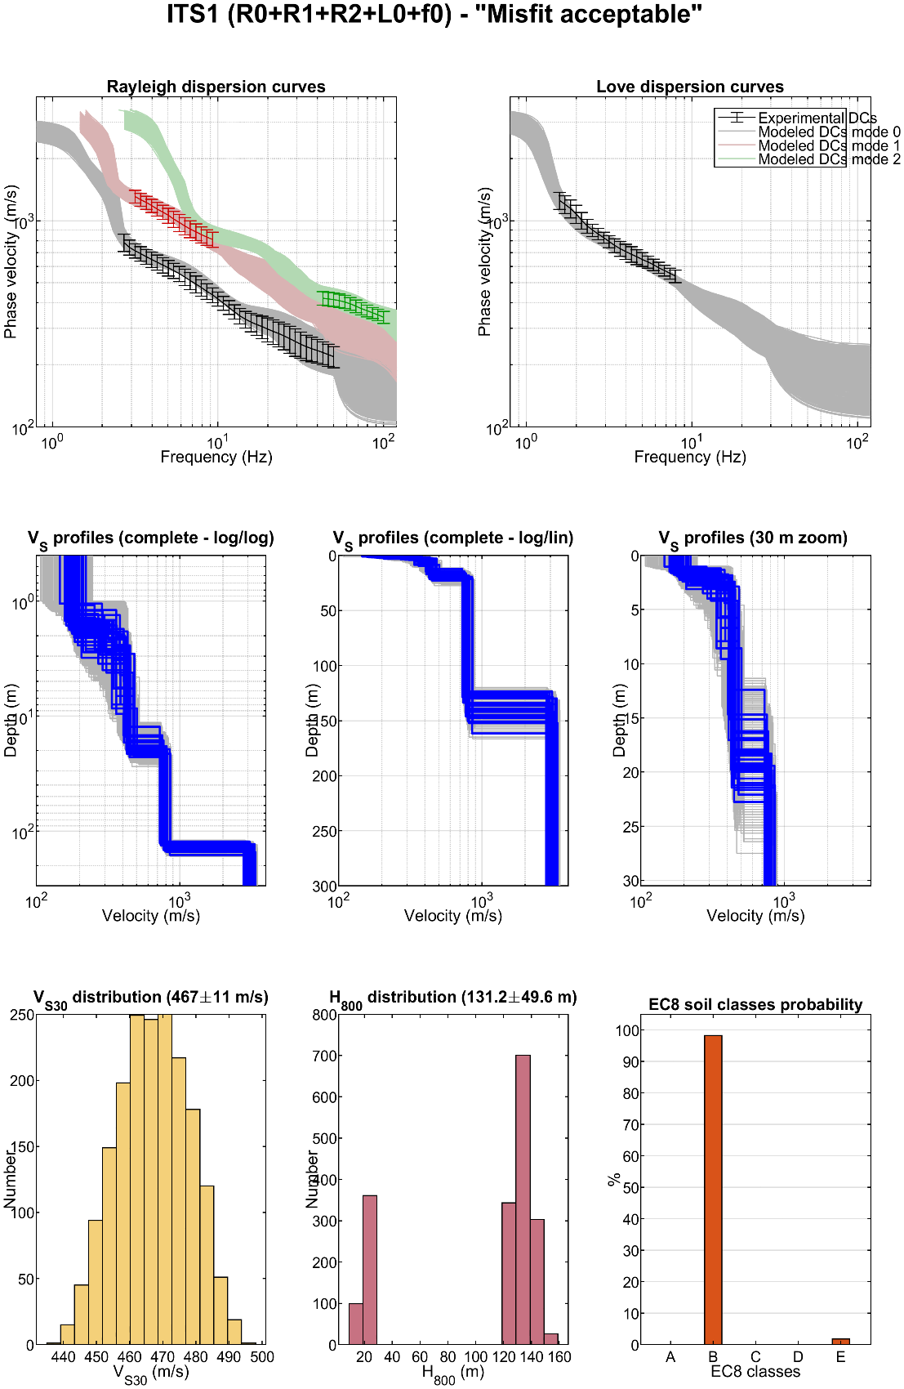
Figure ESM 17: Summary of inversion results for site ITS1. See additional description in the legend of Figure 9.

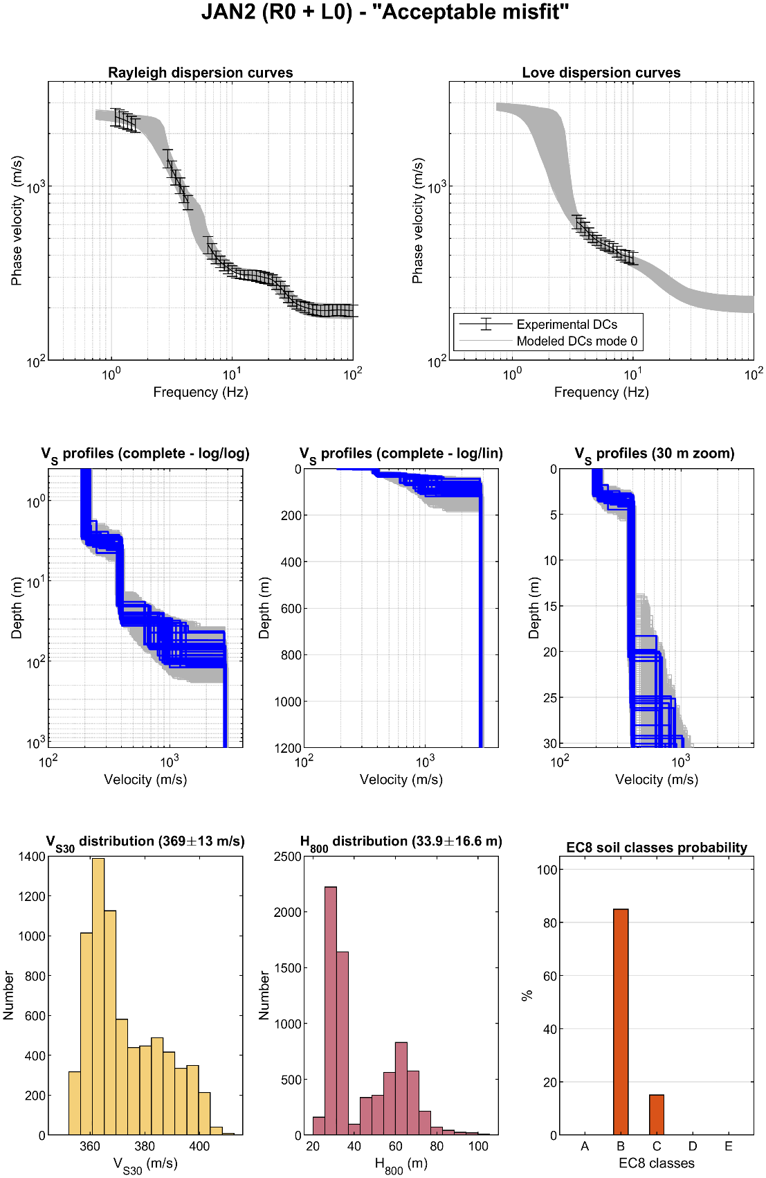
Figure ESM 18: Summary of inversion results for site JAN2. See additional description in the legend of Figure 9.

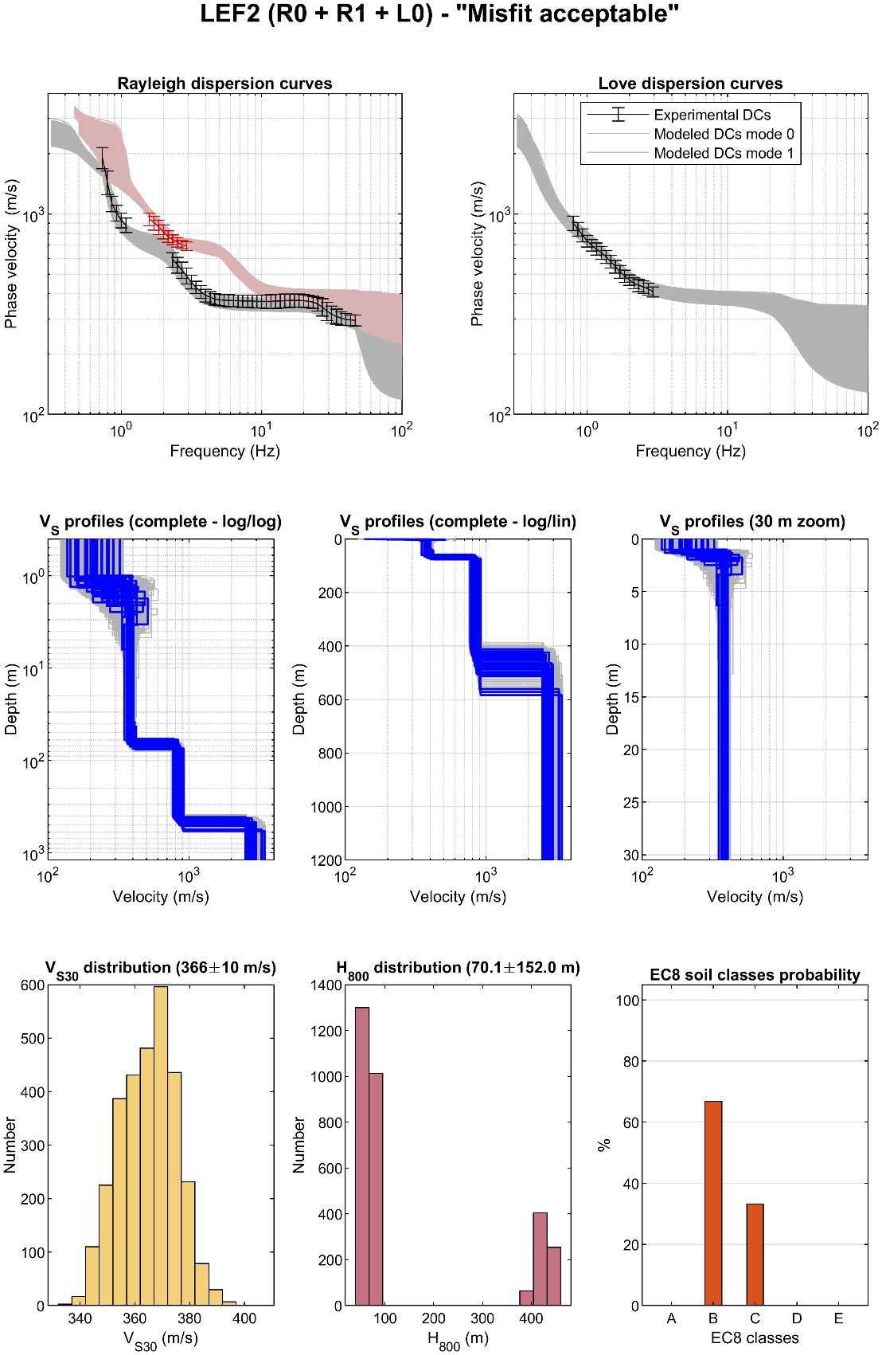
Figure ESM 19: Summary of inversion results for site LEF2. See additional description in the legend of Figure 9.

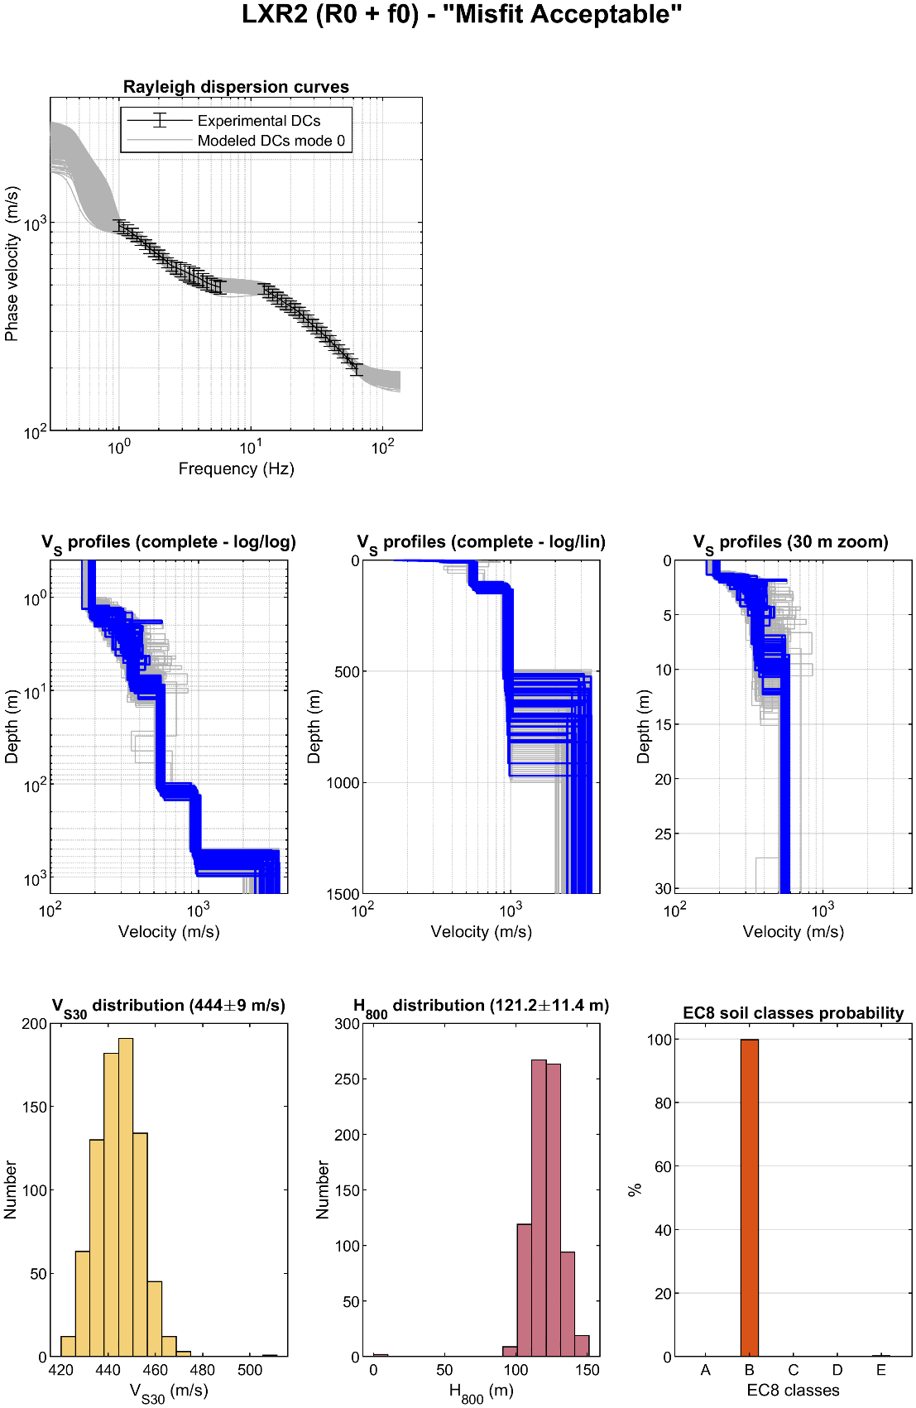
Figure ESM 20: Summary of inversion results for site LXR2. See additional description in the legend of Figure 9.

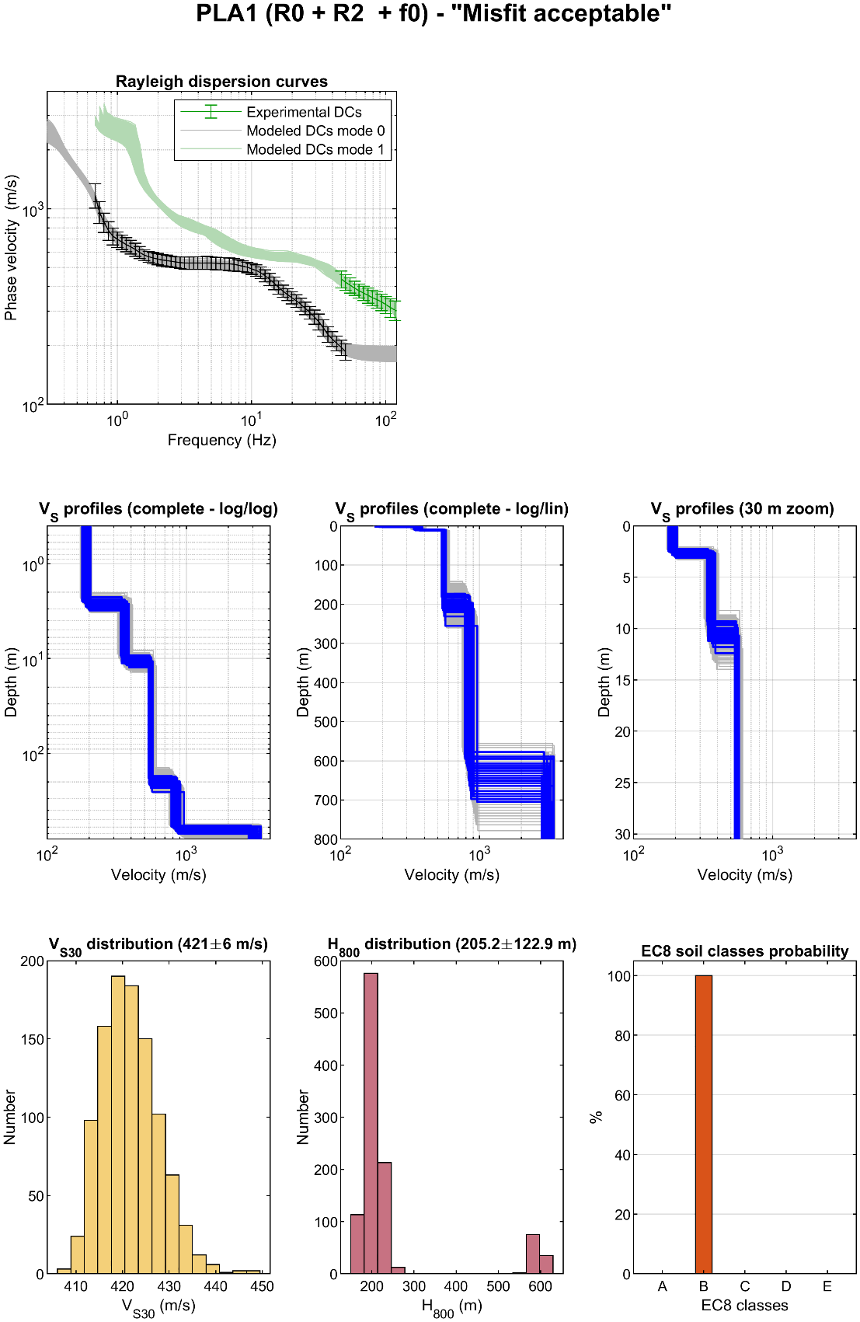
Figure ESM 21: Summary of inversion results for site PLA1. See additional description in the legend of Figure 9.

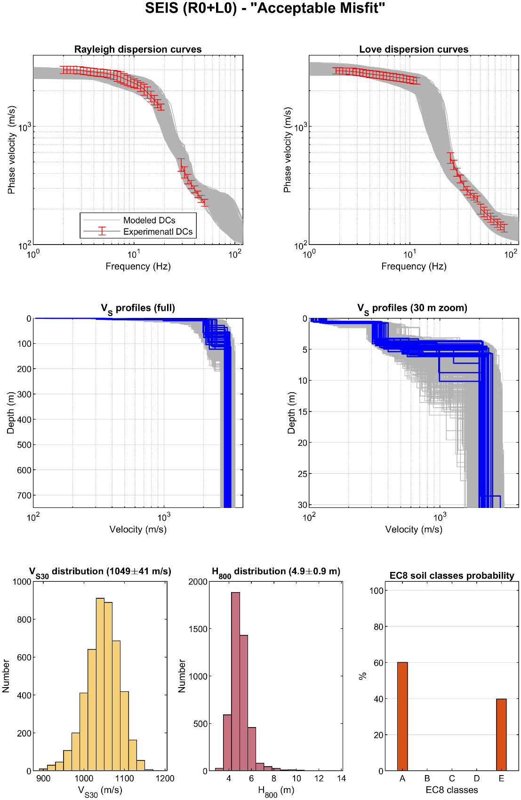
Figure ESM 22: Summary of inversion results for site SEIS. See additional description in the legend of Figure 9.

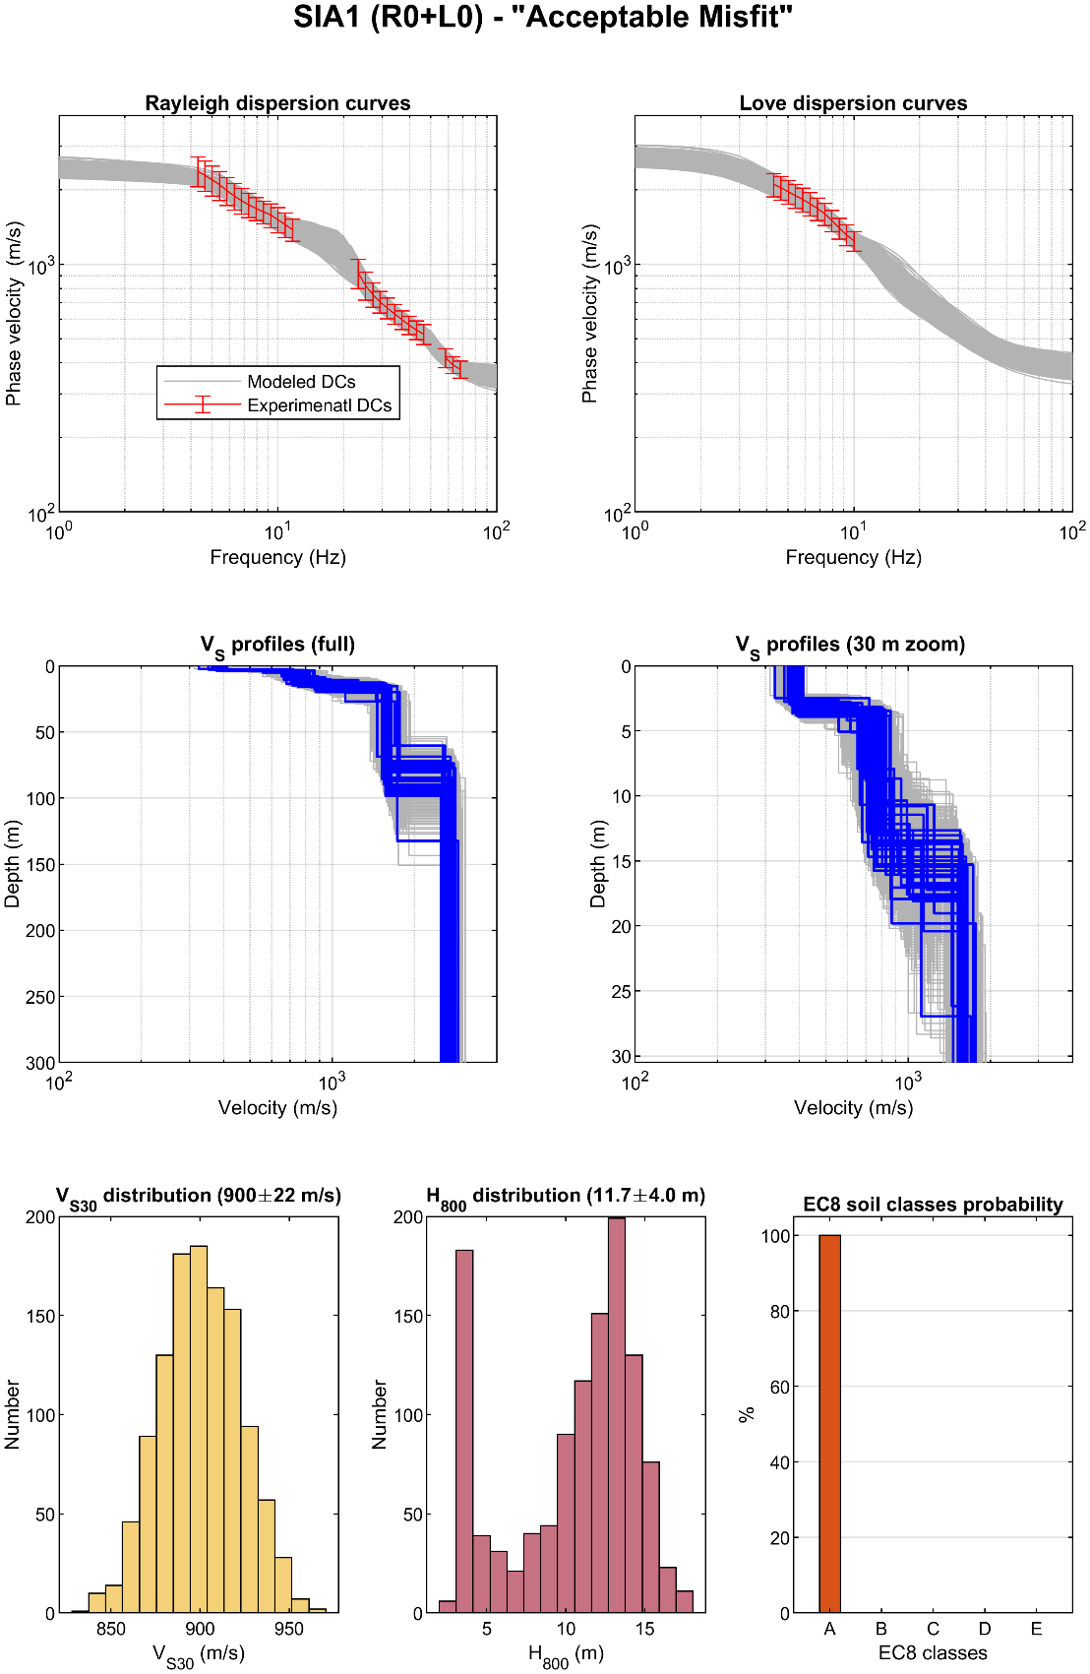
Figure ESM 23: Summary of inversion results for site SIA1. See additional description in the legend of Figure 9.

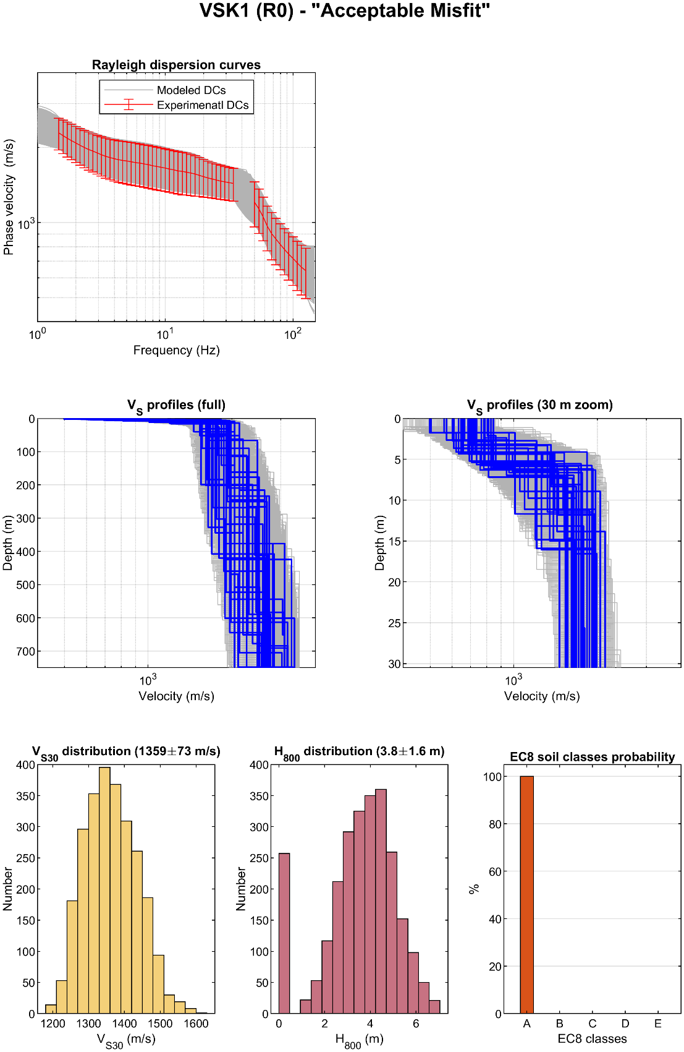
Figure ESM 24: Summary of inversion results for site VSK1. See additional description in the legend of Figure 9.

