Supplementary file 1
Multiple imputation (MICE) analysis

Methods

Missing values in the dataset
We assessed missing data distribution across variables in the dataset Figure 1. Additionally, for the overall missingness in our dataset, we assessed it by calculating the percentage of missing values across all variables. This was computed using this formula {Percentage of Missing Values=Number of Missing Values/Total Number of Values ​×100}. The analysis revealed that 6.8% of values were missing across the entire dataset, indicating a relatively low level of missingness that was suitable for multiple imputation procedures.

Multiple Imputation
To address missing data in our study, we employed multiple imputations using the Multivariate Imputation by Chained Equations (MICE) algorithm. This method was implemented using the ‘mice’ package in R.

Missing Data Mechanism Assessment
Prior to imputation, we conducted Little’s test to evaluate whether the data were Missing Completely At Random (MCAR). This test helps determine if the missingness in the dataset is unrelated to both observed and unobserved variables.

Imputation Process
We first examined the missing data pattern using the ‘md.pattern()’ function to understand the structure of missingness in our dataset. Based on this analysis, we tailored our imputation strategy to the specific characteristics of each variable. For the imputation process, we generated five imputed datasets (m =5) using 40 iterations (maxit =40) for each imputation. A seed value of 123 was set to ensure reproducibility of the results.

Imputation Methods
We customized the imputation methods for different types of variables to ensure appropriate handling of their unique characteristics. For non-ordinal categorical variables such as gender, education, employment, ethnicity, marital status, disability and long-term conditions, we used polytomous regression (polyreg). For ordinal variables such as age group, number of relatives, number of friends and household size were imputed using proportional odds models (polr). Additionally, for binary variables including having pets, having children and the dichotomized social capital score, we employed logistic regression (logreg). This approach allows for the imputation of mixed data types while preserving the relationships between variables and maintaining the uncertainty associated with the missing data.

Diagnostics for the imputation process
Convergence diagnostics for the multiple imputation process were examined across 40 iterations for the variables in Figure 2. The means and standard deviations demonstrated stable patterns without systematic trends. The consistent patterns and absence of extreme deviations between the five imputed datasets indicated successful convergence of the imputation algorithm and plausible imputed values.

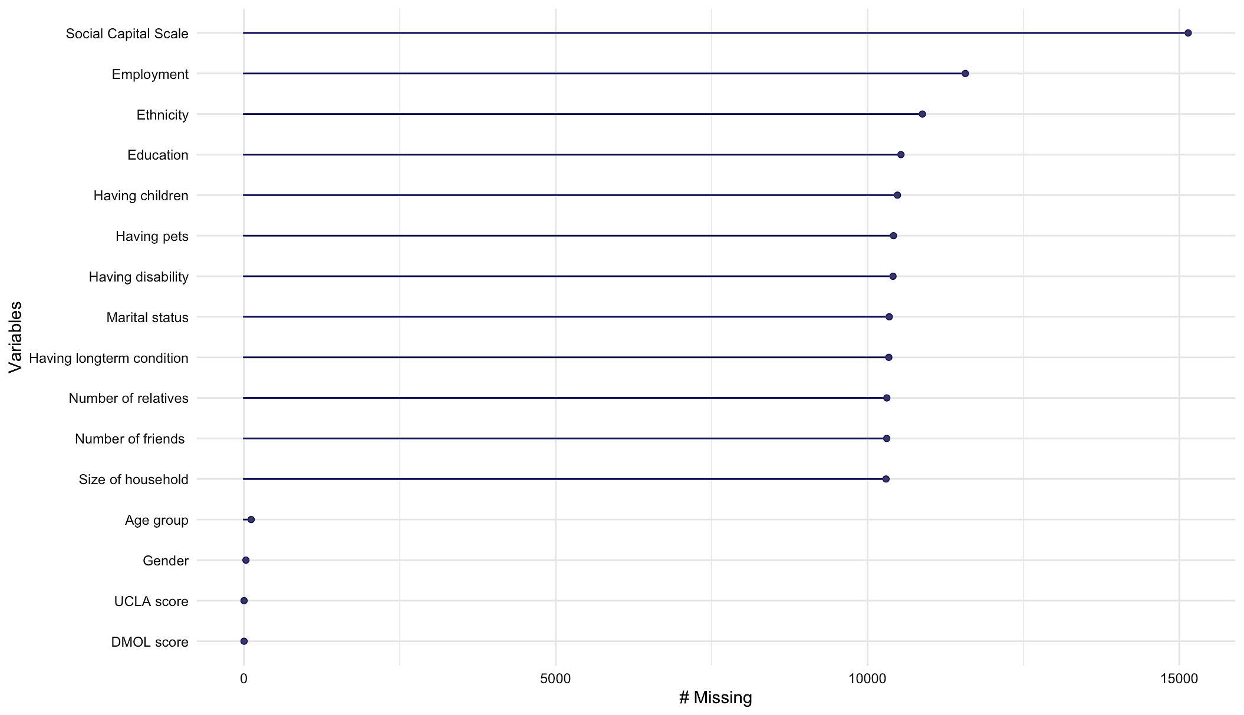
Figure 1: Missing Data Distribution Across Variables in Dataset. This figure displays the number of missing values (#Missing) for various demographic and social variables in a dataset. The variables are arranged vertically, with the Social Capital Scale showing the highest number of missing entries, followed by variables like employment, ethnicity and education.

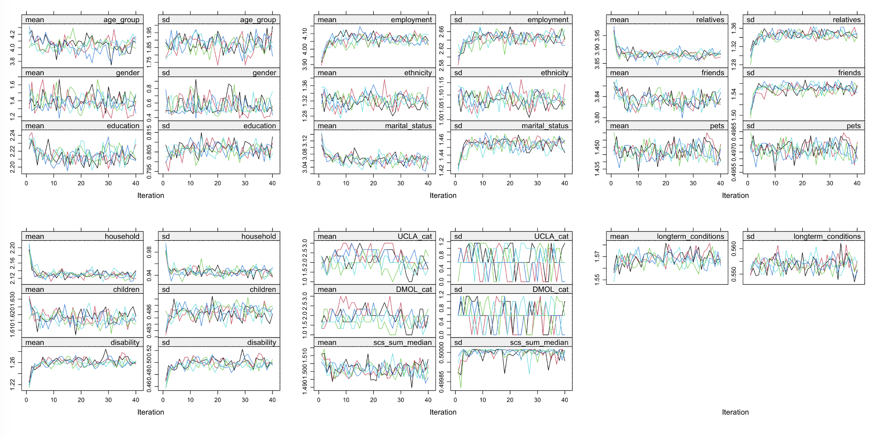
Figure 2: Convergence diagnostics for multiple imputation. Trace plots showing means (left panels) and standard deviations (right panels) across 40 iterations for all imputed variables. Each coloured line represents one of the five imputed datasets. The plots demonstrate the convergence patterns for demographic variables (age group, gender, education), social variables (employment, ethnicity, marital status, relatives, friends), household characteristics (pets, household, children), health-related variables (disability, long-term conditions) and outcome measures (UCLA, DMOL, Social capital scale).

Post-Imputation Analysis
Following the imputation, analyses were conducted on each of the five imputed datasets separately Table 1-3. The results from these analyses were then pooled using Rubin’s rules to obtain final estimates that incorporate both within- and between-imputation variability.

Association between demographic and social factors and loneliness as measured by the UCLA Loneliness Scale
The analysis of demographic and social factors associated with loneliness, as measured by the UCLA Loneliness Scale, reveals significant relationships across various categories Table 1. Age demonstrates a strong inverse relationship with loneliness (p<0.001), with older age groups showing progressively lower odds of experiencing loneliness compared to the 16-25 reference group. The adjusted odds ratio for those over 65 is 0.15 (95% CI: 0.14, 0.16). Gender also plays a role in loneliness, with males showing lower odds compared to females in both unadjusted (OR: 0.79, 95% CI: 0.77, 0.80) and adjusted (OR: 0.81, 95% CI: 0.79, 0.83) analyses (p<0.001). The ‘Other’ gender category initially shows higher odds of loneliness, but this effect is reduced after adjustment.

Education levels present a pattern where, in unadjusted analysis, university degree holders show lower odds of loneliness (OR: 0.79, 95% CI: 0.77, 0.81, p<0.001) compared to those with secondary school education Table 1. However, after adjustment, this relationship reverses, with university degree holders showing higher odds (OR: 1.21, 95% CI: 1.17, 1.24, p<0.001). Employment status is strongly associated with loneliness. Unemployment is linked to higher odds of loneliness in both unadjusted (OR: 4.67, 95% CI: 4.44, 4.92) and adjusted (OR: 1.79, 95% CI: 1.68, 1.91) analyses (p<0.001). Furloughed individuals also show elevated odds of loneliness, with an adjusted OR of 2.28 (95% CI: 1.37, 3.79, p =0.002). Marital status emerges as a significant factor. Being married or in a civil partnership is associated with lower odds of loneliness compared to being single, in both unadjusted (OR: 0.18, 95% CI: 0.18, 0.19) and adjusted (OR: 0.44, 95% CI: 0.42, 0.46) analyses (p<0.001). Widowed individuals show lower unadjusted odds (OR: 0.45, 95% CI: 0.43, 0.47) but higher adjusted odds (OR: 1.34, 95% CI: 1.27, 1.42) of loneliness (p<0.001).

Social connections show a strong association with loneliness Table 1. Having more relatives and friends is consistently associated with lower odds of loneliness (p<0.001). For individuals with 9 or more friends, the adjusted OR is 0.09 (95% CI: 0.09, 0.10, p<0.001) compared to those with no friends. Health factors demonstrate strong associations with loneliness. Having a disability is associated with higher odds of loneliness in both unadjusted (OR: 3.51, 95% CI: 3.41, 3.60) and adjusted (OR: 1.77, 95% CI: 1.71, 1.82) analyses (p<0.001). Similarly, having a long-term condition shows higher odds in both unadjusted (OR: 2.76, 95% CI: 2.70, 2.83) and adjusted (OR: 1.67, 95% CI: 1.62, 1.72) analyses (p<0.001).

Table 1: Association between demographic and social factors and loneliness as measured by UCLA Loneliness Scale
 | Unadjusted OR (CI) ¶ | P value | Adjusted OR (CI) † | P value *
Age
16-25 | Ref. |  | Ref.
26-35 | 0.70 (0.67, 0.74) | <0.001 | 0.66 (0.62, 0.71) | <0.001
36-45 | 0.59 (0.56, 0.62) | <0.001 | 0.50 (0.46, 0.53) | <0.001
46-55 | 0.43 (0.41, 0.45) | <0.001 | 0.33 (0.31, 0.36) | <0.001
56-65 | 0.27 (0.25, 0.28) | <0.001 | 0.23 (0.21, 0.25) | <0.001
>65 | 0.15 (0.15, 0.16) | <0.001 | 0.15 (0.14, 0.16) | <0.001
Gender
Female | Ref. |  | Ref.
Male | 0.79 (0.77, 0.80) | <0.001 | 0.81 (0.79, 0.83) | <0.001
Other | 3.37 (2.93, 3.87) | <0.001 | 1.19 (1.02, 1.40) | 0.03
Would rather not say | 1.98 (1.67, 2.34) | <0.001 | 0.99 (0.81, 1.20) | 0.909
Education
Secondary school | Ref. |  | Ref.
A levels/College | 1.03 (1.00, 1.05) | 0.08 | 1.10 (1.07, 1.14) | <0.001
University Degree or higher | 0.79 (0.77, 0.81) | <0.001 | 1.21 (1.17, 1.24) | <0.001
Employment
Employed full-time | Ref. |  | Ref.
Employed part-time | 0.80 (0.77, 0.83) | <0.001 | 1.06 (1.02, 1.11) | 0.002
Furloughed | 2.35 (1.54, 3.59) | <0.001 | 2.28 (1.37, 3.79) | 0.002
Volunteer (full or part-time) | 0.61 (0.55, 0.67) | <0.001 | 1.09 (0.98, 1.21) | 0.101
Retired | 0.42 (0.41, 0.43) | <0.001 | 0.94 (0.90, 0.98) | 0.003
Self-employed | 0.69 (0.66, 0.72) | <0.001 | 1.11 (1.06, 1.17) | <0.001
Student (full or part-time) | 2.20 (2.07, 2.34) | <0.001 | 1.26 (1.16, 1.36) | <0.001
Unemployed | 4.67 (4.44, 4.92) | <0.001 | 1.79 (1.68, 1.91) | <0.001
Unpaid carer | 2.58 (2.33, 2.85) | <0.001 | 2.05 (1.84, 2.29) | <0.001
Other | 3.31 (3.10, 3.53) | <0.001 | 1.71 (1.59, 1.84) | <0.001
Ethnicity
White | Ref. |  | Ref.
British Black/African/Caribbean | 1.72 (1.59, 1.85) | <0.001 | 1.06 (0.96, 1.16) | 0.24
Mixed/Multiple ethnic groups | 1.83 (1.68, 1.99) | <0.001 | 1.04 (0.95, 1.15) | 0.392
White and Black Caribbean | 2.34 (1.95, 2.81) | <0.001 | 1.16 (0.94, 1.43) | 0.169
Asian/Asian British | 1.76 (1.66, 1.87) | <0.001 | 1.22 (1.14, 1.31) | <0.001
Other ethnic group | 1.60 (1.49, 1.72) | <0.001 | 1.04 (0.96, 1.13) | 0.294
Marital status
single | Ref. |  | Ref.
Divorced | 0.62 (0.59, 0.64) | <0.001 | 1.05 (1.00, 1.10) | 0.057
In a relationship | 0.42 (0.40, 0.44) | <0.001 | 0.51 (0.49, 0.54) | <0.001
Married / Civil partnership | 0.18 (0.18, 0.19) | <0.001 | 0.44 (0.42, 0.46) | <0.001
Widowed | 0.45 (0.43, 0.47) | <0.001 | 1.34 (1.27, 1.42) | <0.001
Other | 0.76 (0.71, 0.81) | <0.001 | 0.98 (0.91, 1.06) | 0.617
Number of relatives
0 [11] relatives | Ref. |  | Ref.
1 relative | 0.91 (0.86, 0.97) | 0.001 | 1.02 (0.96, 1.08) | 0.551
2 relatives | 0.70 (0.66, 0.73) | <0.001 | 0.85 (0.80, 0.90) | <0.001
3 or 4 relatives | 0.36 (0.34, 0.38) | <0.001 | 0.57 (0.54, 0.61) | <0.001
5-8 relatives | 0.16 (0.15, 0.17) | <0.001 | 0.39 (0.37, 0.42) | <0.001
9 or more relatives | 0.09 (0.08, 0.09) | <0.001 | 0.29 (0.27, 0.31) | <0.001
Number of friends
0 [11] friends | Ref. |  | Ref.
1 friend | 0.78 (0.74, 0.82) | <0.001 | 0.79 (0.75, 0.83) | <0.001
2 friends | 0.46 (0.44, 0.48) | <0.001 | 0.51 (0.49, 0.54) | <0.001
3 or 4 friends | 0.22 (0.21, 0.23) | <0.001 | 0.29 (0.27, 0.30) | <0.001
5-8 friends | 0.10 (0.10, 0.11) | <0.001 | 0.16 (0.15, 0.17) | <0.001
9 or more friends | 0.05 (0.05, 0.05) | <0.001 | 0.09 (0.09, 0.10) | <0.001
Having pet
No | Ref. |  | Ref.
Yes | 1.25 (1.22, 1.27) | <0.001 | 1.05 (1.02, 1.07) | <0.001
Number of household members
0 members | Ref. |  | Ref.
1 member | 0.39 (0.38, 0.40) | <0.001 | 0.74 (0.71, 0.78) | <0.001
2-3 members | 0.64 (0.62, 0.66) | <0.001 | 0.70 (0.66, 0.73) | <0.001
4-5 members | 0.73 (0.69, 0.76) | <0.001 | 0.66 (0.62, 0.71) | <0.001
> 5 members | 1.06 (0.96, 1.17) | 0.264 | 0.67 (0.60, 0.76) | <0.001
Children
No | Ref. |  | Ref.
Yes | 0.48 (0.47, 0.49) | <0.001 | 1.06 (1.03, 1.10) | <0.001
Disability
No | Ref. |  | Ref.
Yes | 3.51 (3.41, 3.60) | <0.001 | 1.77 (1.71, 1.82) | <0.001
Would rather not say | 3.48 (3.27, 3.71) | <0.001 | 1.56 (1.45, 1.68) | <0.001
Longterm conditions
No | Ref. |  | Ref.
Yes | 2.76 (2.70, 2.83) | <0.001 | 1.67 (1.62, 1.72) | <0.001
Would rather not say | 3.03 (2.82, 3.26) | <0.001 | 1.66 (1.54, 1.80) | <0.001
¶: Crude ordinal logistic regression model.
†: Ordinal logistic regression model adjusted for age, gender, education, employment, ethnicity, marital status, having relatives, having friends, having pets, household size, having children, having disability and having long-term condition.
*: Significance level, with values <0.05 considered statistically significant.

Number of observations in the adjusted model =135,725 observations

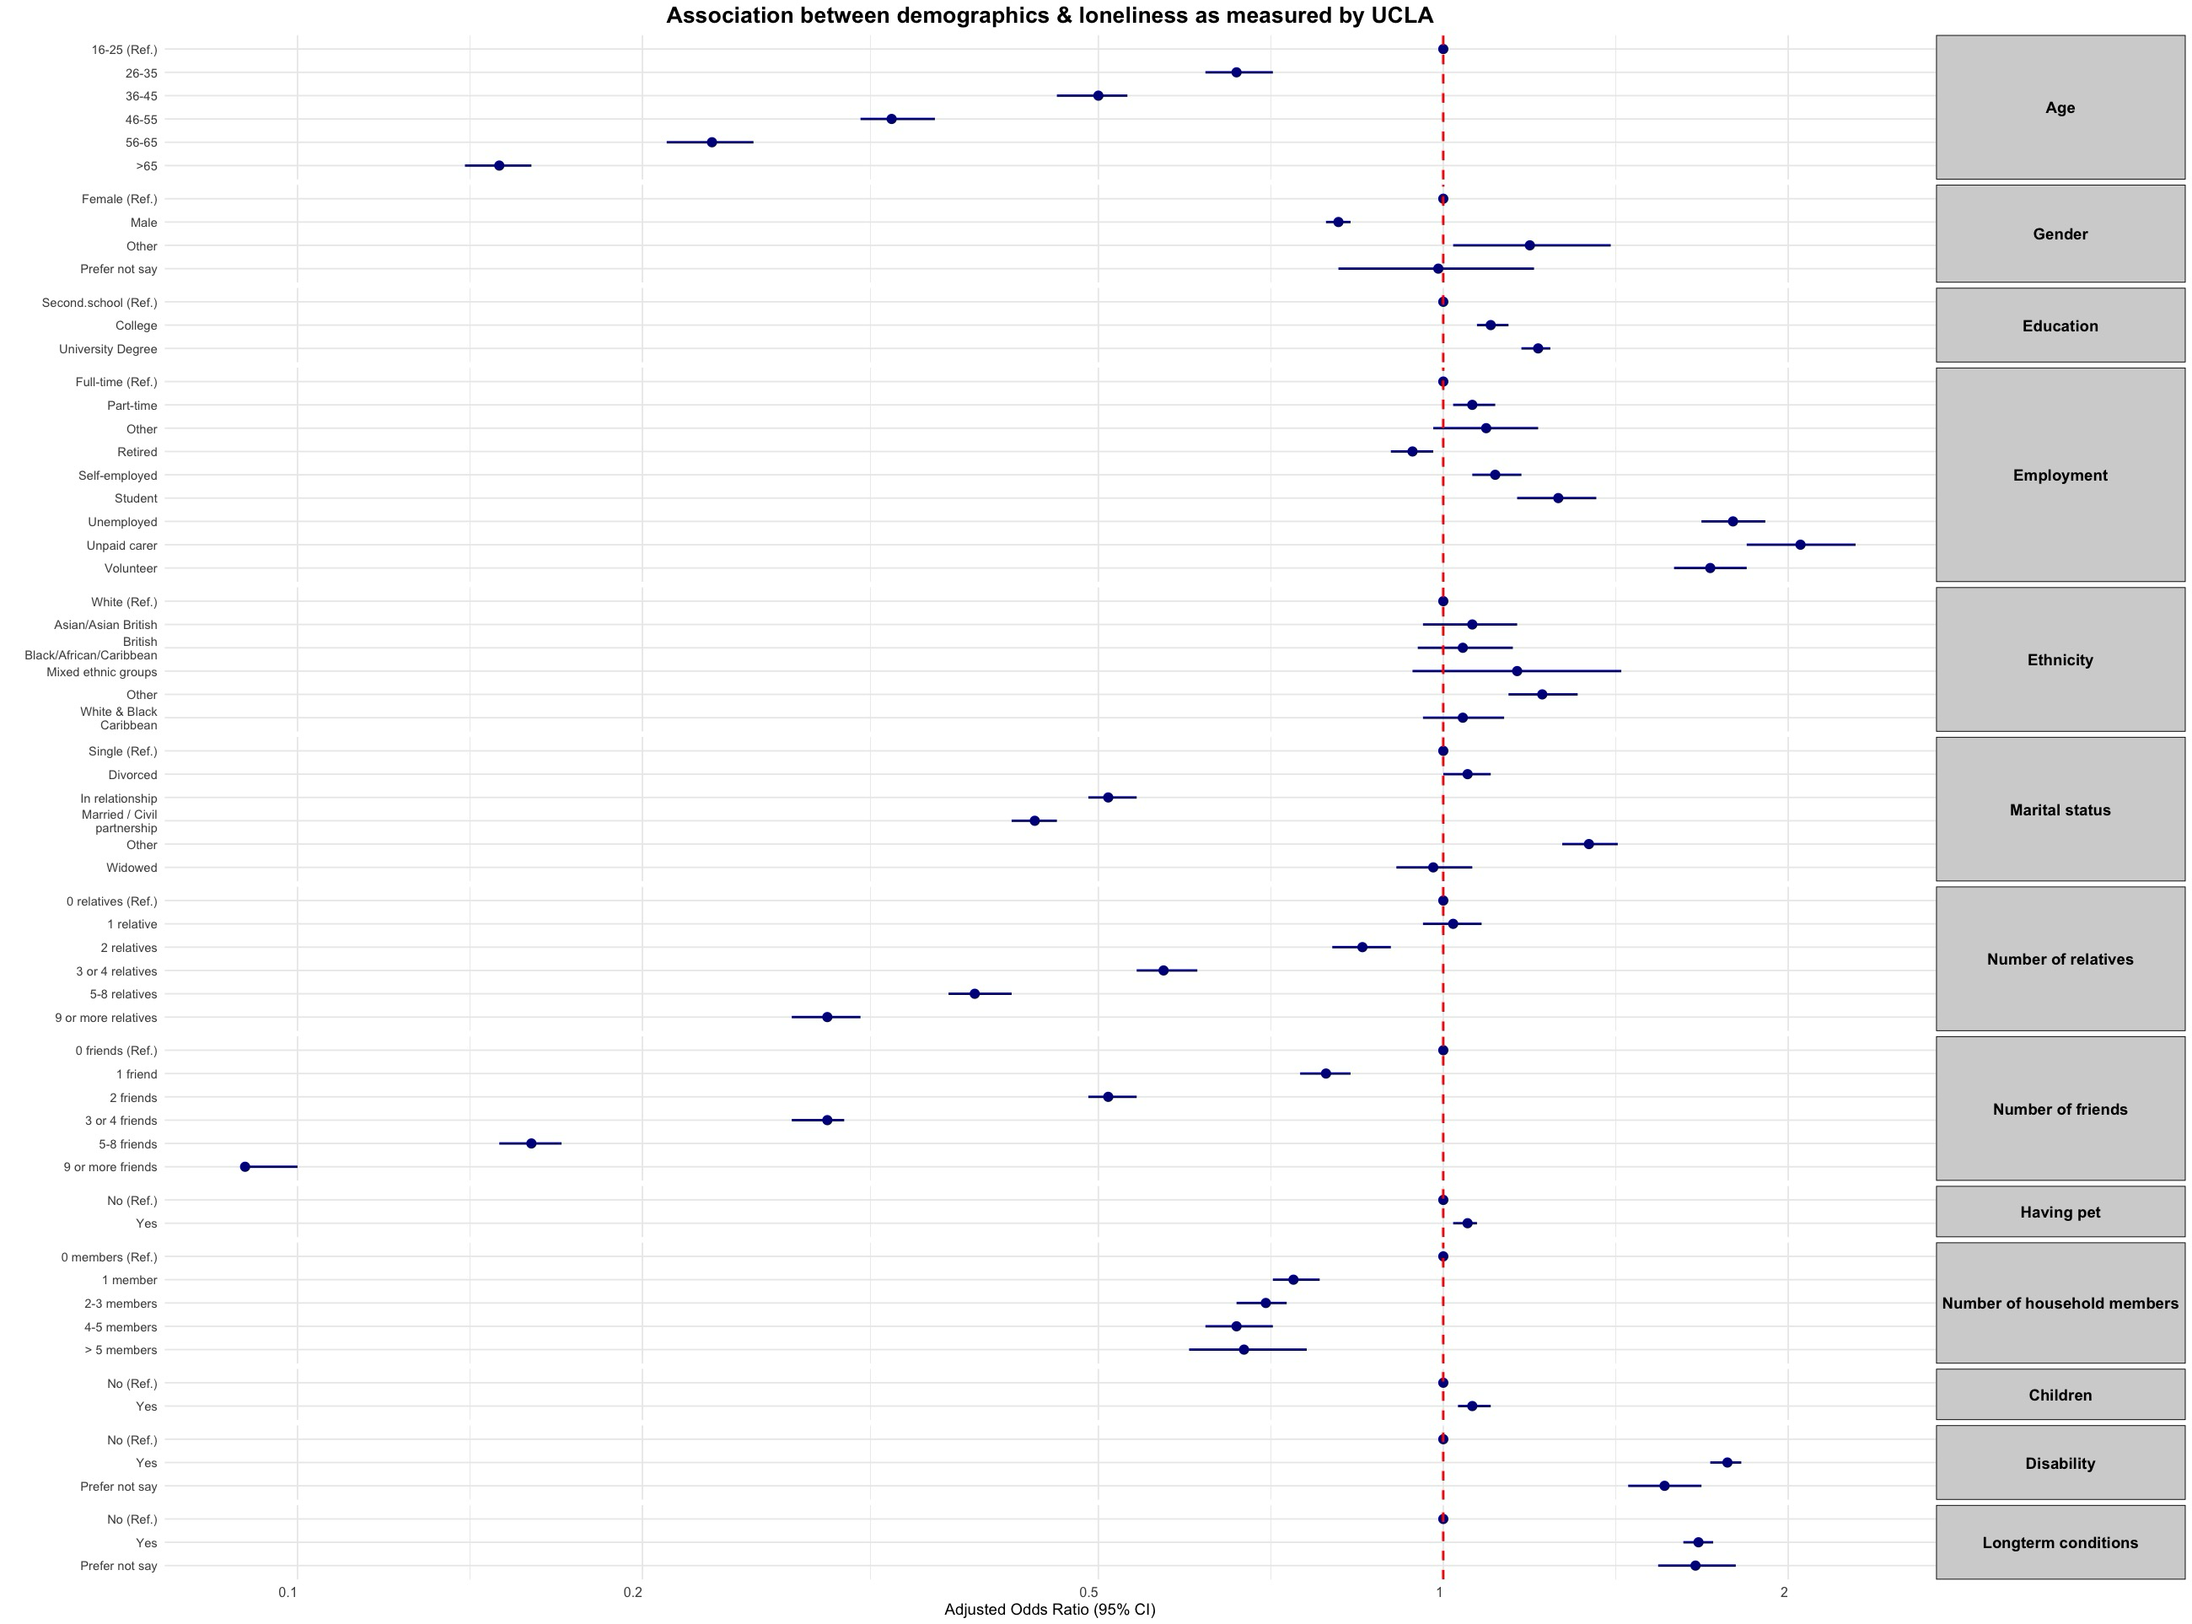
Figure 3: Forest plot of association between demographic & social factors and loneliness as measured by the UCLA Loneliness Scale

Association between demographic and social factors and loneliness as measured by Direct Measure Of Loneliness (DMOL)
The analysis of demographic and social factors associated with loneliness, as measured by DMOL, revealed significant relationships across various categories Table 2. Age demonstrates a strong inverse relationship with loneliness (p<0.001), with older age groups showing progressively lower odds of experiencing loneliness compared to the 16-25 reference group. The adjusted odds ratio for those over 65 is 0.19 (95% CI: 0.18, 0.21). Gender also plays a role in loneliness, with males showing lower odds compared to females in both unadjusted (OR: 0.73, 95% CI: 0.72, 0.75) and adjusted (OR: 0.74, 95% CI: 0.73, 0.76) analyses (p<0.001). The ‘Other’ gender category initially shows higher odds of loneliness, but this effect becomes non-significant after adjustment.

Education levels present a pattern where, in unadjusted analysis, university degree holders show lower odds of loneliness (OR: 0.70, 95% CI: 0.68, 0.72, p<0.001) compared to those with secondary school education Table 2. After adjustment, this relationship remains significant but with a smaller effect size (OR: 0.95, 95% CI: 0.92, 0.98, p =0.002). Employment status is strongly associated with loneliness. Unemployment is linked to higher odds of loneliness in both unadjusted (OR: 4.09, 95% CI: 3.89, 4.31) and adjusted (OR: 1.67, 95% CI: 1.57, 1.78) analyses (p<0.001). Furloughed individuals show elevated odds of loneliness in the unadjusted analysis (OR: 1.96, 95% CI: 1.29, 2.98, p =0.002), but this becomes non-significant after adjustment. Marital status emerges as a significant factor. Being married or in a civil partnership is associated with lower odds of loneliness compared to being single, in both unadjusted (OR: 0.21, 95% CI: 0.20, 0.21) and adjusted (OR: 0.45, 95% CI: 0.43, 0.47) analyses (p<0.001). Widowed individuals show lower unadjusted odds (OR: 0.58, 95% CI: 0.55, 0.60) but higher adjusted odds (OR: 1.48, 95% CI: 1.40, 1.56) of loneliness (p<0.001).

Social connections show a strong association with loneliness Table 2. Having more relatives and friends is consistently associated with lower odds of loneliness (p<0.001). For individuals with 9 or more friends, the adjusted OR is 0.16 (95% CI: 0.15, 0.17, p<0.001) compared to those with no friends. Health factors demonstrate strong associations with loneliness. Having a disability is associated with higher odds of loneliness in both unadjusted (OR: 2.88, 95% CI: 2.80, 2.96) and adjusted (OR: 1.44, 95% CI: 1.39, 1.48) analyses (p<0.001). Similarly, having a long-term condition shows higher odds in both unadjusted (OR: 2.44, 95% CI: 2.38, 2.49) and adjusted (OR: 1.54, 95% CI: 1.50, 1.59) analyses (p<0.001).

Table 2: Association between demographic and social factors and loneliness as measured by Direct Measure Of Loneliness (DMOL)
 | Unadjusted OR (CI) ¶ | P value | Adjusted OR (CI) † | P value *
Age
16-25 | Ref. |  | Ref.
26-35 | 0.76 (0.72, 0.80) | <0.001 | 0.74 (0.69, 0.79) | <0.001
36-45 | 0.64 (0.61, 0.67) | <0.001 | 0.55 (0.52, 0.59) | <0.001
46-55 | 0.49 (0.46, 0.51) | <0.001 | 0.39 (0.36, 0.42) | <0.001
56-65 | 0.31 (0.30, 0.32) | <0.001 | 0.27 (0.26, 0.29) | <0.001
>65 | 0.20 (0.19, 0.21) | <0.001 | 0.19 (0.18, 0.21) | <0.001
Gender
Female | Ref |  | Ref.
Male | 0.73 (0.72, 0.75) | <0.001 | 0.74 (0.73, 0.76) | <0.001
Other | 2.42 (2.12, 2.76) | <0.001 | 0.95 (0.82, 1.10) | 0.524
Would rather not say | 1.73 (1.46, 2.04) | <0.001 | 0.89 (0.74, 1.07) | 0.202
Education
Secondary school | Ref |  | Ref.
A levels/College | 0.93 (0.91, 0.96) | <0.001 | 0.96 (0.93, 0.99) | 0.018
University Degree or higher | 0.70 (0.68, 0.72) | <0.001 | 0.95 (0.92, 0.98) | 0.002
Employment
Employed full-time | Ref |  | Ref.
Employed part-time | 0.87 (0.84, 0.90) | <0.001 | 1.07 (1.03, 1.12) | <0.001
Furloughed | 1.96 (1.29, 2.98) | 0.002 | 1.51 (0.96, 2.38) | 0.072
Volunteer (full or part-time) | 0.64 (0.58, 0.71) | <0.001 | 1.03 (0.91, 1.15) | 0.669
Retired | 0.49 (0.48, 0.50) | <0.001 | 0.95 (0.91, 0.99) | 0.025
Self-employed | 0.72 (0.69, 0.75) | <0.001 | 1.09 (1.04, 1.15) | <0.001
Student (full or part-time) | 1.94 (1.83, 2.06) | <0.001 | 1.08 (1.00, 1.17) | 0.04
Unemployed | 4.09 (3.89, 4.31) | <0.001 | 1.67 (1.57, 1.78) | <0.001
Unpaid carer | 2.15 (1.94, 2.37) | <0.001 | 1.58 (1.42, 1.75) | <0.001
Other | 2.93 (2.74, 3.14) | <0.001 | 1.56 (1.45, 1.68) | <0.001
Ethnicity
White | Ref |  | Ref.
British Black/African/Caribbean | 1.80 (1.67, 1.95) | <0.001 | 1.18 (1.08, 1.29) | <0.001
Mixed/Multiple ethnic groups | 1.67 (1.54, 1.82) | <0.001 | 1.04 (0.94, 1.14) | 0.439
White and Black Caribbean | 2.20 (1.82, 2.67) | <0.001 | 1.11 (0.91, 1.35) | 0.327
Asian/Asian British | 1.85 (1.75, 1.96) | <0.001 | 1.39 (1.31, 1.48) | <0.001
Other ethnic group | 1.73 (1.61, 1.87) | <0.001 | 1.27 (1.17, 1.38) | <0.001
Marital status
single | Ref |  | Ref.
Divorced | 0.65 (0.63, 0.68) | <0.001 | 1.00 (0.95, 1.05) | 0.977
In a relationship | 0.40 (0.38, 0.42) | <0.001 | 0.48 (0.46, 0.51) | <0.001
Married / Civil partnership | 0.21 (0.20, 0.21) | <0.001 | 0.45 (0.43, 0.47) | <0.001
Widowed | 0.58 (0.55, 0.60) | <0.001 | 1.48 (1.40, 1.56) | <0.001
Other | 0.82 (0.77, 0.89) | <0.001 | 1.01 (0.94, 1.10) | 0.759
Number of relatives
0 [11] relatives | Ref |  | Ref.
1 relative | 0.88 (0.83, 0.93) | <0.001 | 0.95 (0.90, 1.01) | 0.114
2 relatives | 0.70 (0.66, 0.73) | <0.001 | 0.82 (0.77, 0.87) | <0.001
3 or 4 relatives | 0.40 (0.38, 0.42) | <0.001 | 0.60 (0.57, 0.63) | <0.001
5-8 relatives | 0.19 (0.18, 0.20) | <0.001 | 0.41 (0.39, 0.44) | <0.001
9 or more relatives | 0.11 (0.10, 0.12) | <0.001 | 0.30 (0.28, 0.32) | <0.001
Number of friends
0 [11] friends | Ref |  | Ref.
1 friend | 0.81 (0.77, 0.85) | <0.001 | 0.83 (0.79, 0.87) | <0.001
2 friends | 0.53 (0.50, 0.55) | <0.001 | 0.61 (0.59, 0.64) | <0.001
3 or 4 friends | 0.29 (0.28, 0.30) | <0.001 | 0.40 (0.39, 0.42) | <0.001
5-8 friends | 0.15 (0.15, 0.16) | <0.001 | 0.26 (0.25, 0.27) | <0.001
9 or more friends | 0.08 (0.08, 0.08) | <0.001 | 0.16 (0.15, 0.17) | <0.001
Having pet
No | Ref |  | Ref.
Yes | 1.16 (1.13, 1.18) | <0.001 | 0.99 (0.97, 1.02) | 0.485
Number of household members
0 members | Ref |  | Ref.
1 member | 0.40 (0.38, 0.41) | <0.001 | 0.78 (0.74, 0.81) | <0.001
2-3 members | 0.62 (0.60, 0.64) | <0.001 | 0.73 (0.70, 0.76) | <0.001
4-5 members | 0.73 (0.70, 0.77) | <0.001 | 0.75 (0.70, 0.80) | <0.001
> 5 members | 1.07 (0.97, 1.18) | 0.184 | 0.80 (0.71, 0.89) | <0.001
Children
No | Ref |  | Ref.
Yes | 0.56 (0.55, 0.57) | <0.001 | 1.20 (1.16, 1.24) | <0.001
Disability
No | Ref |  | Ref.
Yes | 2.88 (2.80, 2.96) | <0.001 | 1.44 (1.39, 1.48) | <0.001
Would rather not say | 2.95 (2.77, 3.14) | <0.001 | 1.33 (1.24, 1.42) | <0.001
Longterm conditions
No | Ref |  | Ref.
Yes | 2.44 (2.38, 2.49) | <0.001 | 1.54 (1.50, 1.59) | <0.001
Would rather not say | 2.7 (2.51, 2.89) | <0.001 | 1.52 (1.41, 1.63) | <0.001
¶: Crude ordinal logistic regression model.
†: Ordinal logistic regression model adjusted for age, gender, education, employment, ethnicity, marital status, having relatives, having friends, having pets, household size, having children, having disability and having long-term condition.
*: Significance level, with values <0.05 considered statistically significant.

Number of observations in the adjusted model =135,725 observations

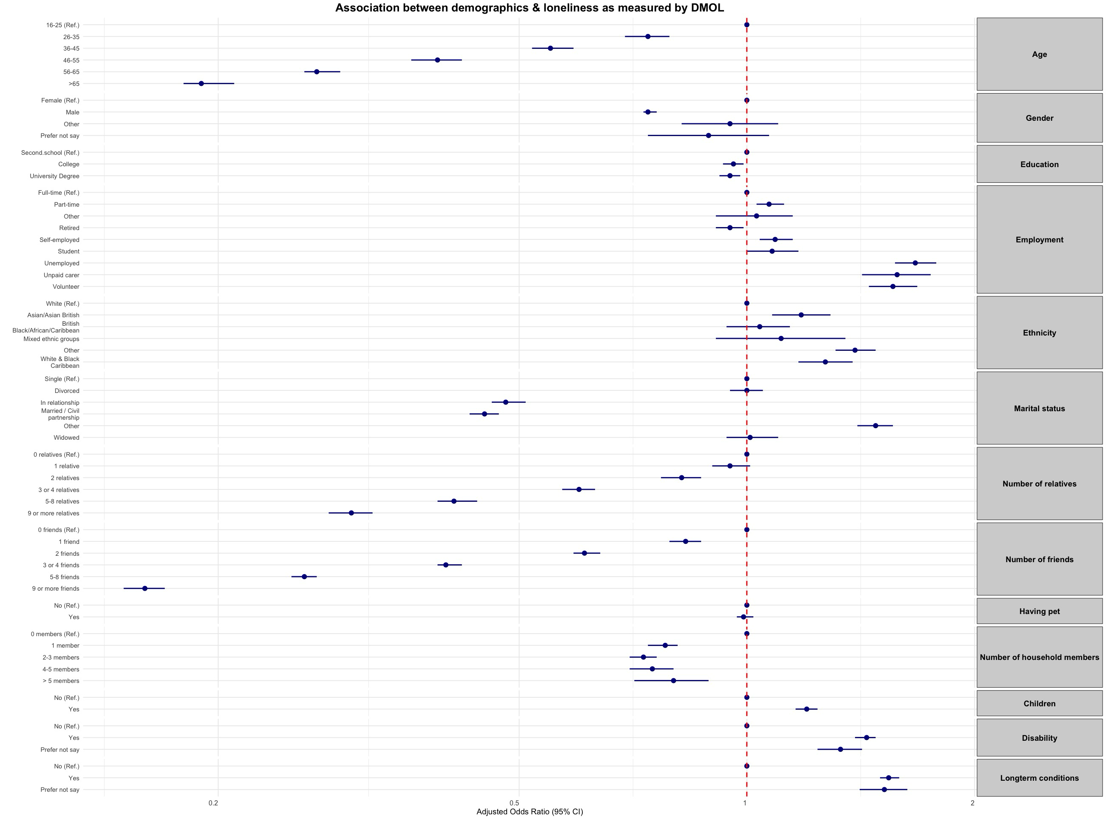
Figure 4: Forest plot of association between demographic & social factors and loneliness as measured by DMOL Loneliness Scale

Association between demographic and social factors and Social Capital Scale
The analysis of demographic and social factors associated with the Social Capital Scale reveals significant relationships across various categories Table 3. Age demonstrates a strong positive relationship with social capital (p<0.001), with older age groups showing progressively higher odds of higher social capital compared to the 16-25 reference group. The adjusted odds ratio for those over 65 is 3.24 (95% CI: 2.97, 3.53). Gender shows a slight association with social capital, with males having marginally higher odds compared to females in both unadjusted (OR: 1.03, 95% CI: 1.01, 1.06, p =0.004) and adjusted (OR: 1.04, 95% CI: 1.01, 1.06, p =0.015) analyses. The ‘Other’ gender category shows lower odds of social capital in both unadjusted and adjusted analyses.

Education levels are positively associated with social capital. University degree holders show higher odds in both unadjusted (OR: 1.29, 95% CI: 1.26, 1.33) and adjusted (OR: 1.15, 95% CI: 1.11, 1.19) analyses (p<0.001) compared to those with secondary school education Table 3. Employment status is significantly associated with social capital. Retired individuals show higher odds in both unadjusted (OR: 2.51, 95% CI: 2.43, 2.60) and adjusted (OR: 1.48, 95% CI: 1.41, 1.56) analyses (p<0.001). Unemployed individuals show lower odds in both unadjusted (OR: 0.42, 95% CI: 0.39, 0.44) and adjusted (OR: 0.90, 95% CI: 0.85, 0.96) analyses (p<0.001 and p =0.002, respectively). Marital status is a significant factor. Being married or in a civil partnership is associated with higher odds of social capital compared to being single, in both unadjusted (OR: 3.28, 95% CI: 3.17, 3.38) and adjusted (OR: 1.59, 95% CI: 1.51, 1.66) analyses (p<0.001).

Social connections show a strong positive association with social capital score Table 3. Having more relatives and friends is consistently associated with higher odds of social capital (p<0.001). For individuals with 9 or more friends, the adjusted OR is 5.20 (95% CI: 4.91, 5.51, p<0.001) compared to those with no friends. Health factors demonstrate negative associations with social capital. Having a disability is associated with lower odds of social capital in both unadjusted (OR: 0.50, 95% CI: 0.49, 0.51) and adjusted (OR: 0.77, 95% CI: 0.74, 0.80) analyses (p<0.001). Similarly, having a long-term condition shows lower odds in both unadjusted (OR: 0.57, 95% CI: 0.55, 0.58) and adjusted (OR: 0.82, 95% CI: 0.80, 0.84) analyses (p<0.001).

Table 3: Association between demographic and social factors and Social Capital Scale
 | Unadjusted OR (CI) ¶ | P value | Adjusted OR (CI) † | P value *
Age
16-25 | Ref. |  | Ref.
26-35 | 1.18 (1.11, 1.26) | <0.001 | 1.16 (1.07, 1.25) | <0.001
36-45 | 1.77 (1.67, 1.88) | <0.001 | 1.81 (1.68, 1.95) | <0.001
46-55 | 2.34 (2.21, 2.47) | <0.001 | 2.39 (2.21, 2.58) | <0.001
56-65 | 3.24 (3.07, 3.42) | <0.001 | 2.72 (2.52, 2.94) | <0.001
>65 | 5.25 (4.97, 5.54) | <0.001 | 3.24 (2.97, 3.53) | <0.001
Gender
Female | Ref. |  | Ref.
Male | 1.03 (1.01, 1.06) | 0.004 | 1.04 (1.01, 1.06) | 0.015
Other | 0.33 (0.28, 0.39) | <0.001 | 0.73 (0.61, 0.88) | 0.002
Would rather not say | 0.57 (0.45, 0.72) | <0.001 | 1.09 (0.82, 1.46) | 0.348
Education
Secondary school | Ref. |  | Ref.
A levels/College | 1.09 (1.05, 1.12) | <0.001 | 1.14 (1.10, 1.18) | <0.001
University Degree or higher | 1.29 (1.26, 1.33) | <0.001 | 1.15 (1.11, 1.19) | <0.001
Employment
Employed full-time | Ref. |  | Ref.
Employed part-time | 1.43 (1.38, 1.49) | <0.001 | 1.18 (1.13, 1.23) | <0.001
Furloughed | 0.78 (0.51, 1.20) | 0.259 | 0.99 (0.61, 1.60) | 0.963
Volunteer (full or part-time) | 1.91 (1.72, 2.12) | <0.001 | 1.27 (1.12, 1.43) | <0.001
Retired | 2.51 (2.43, 2.60) | <0.001 | 1.48 (1.41, 1.56) | <0.001
Self-employed | 1.71 (1.62, 1.81) | <0.001 | 1.26 (1.18, 1.33) | <0.001
Student (full or part-time) | 0.54 (0.51, 0.59) | <0.001 | 0.92 (0.83, 1.01) | 0.086
Unemployed | 0.42 (0.39, 0.44) | <0.001 | 0.90 (0.85, 0.96) | 0.002
Unpaid carer | 0.68 (0.61, 0.77) | <0.001 | 0.88 (0.77, 1.00) | 0.049
Other | 0.66 (0.61, 0.71) | <0.001 | 1.08 (0.99, 1.17) | 0.091
Ethnicity
White | Ref. |  | Ref.
British Black/African/Caribbean | 0.32 (0.29, 0.36) | <0.001 | 0.48 (0.43, 0.53) | <0.001
Mixed/Multiple ethnic groups | 0.50 (0.46, 0.56) | <0.001 | 0.79 (0.71, 0.89) | <0.001
White and Black Caribbean | 0.43 (0.35, 0.53) | <0.001 | 0.76 (0.60, 0.95) | 0.017
Asian/Asian British | 0.54 (0.51, 0.58) | <0.001 | 0.83 (0.77, 0.89) | <0.001
Other ethnic group | 0.51 (0.46, 0.55) | <0.001 | 0.68 (0.62, 0.74) | <0.001
Marital status
single | Ref. |  | Ref.
Divorced | 1.66 (1.59, 1.74) | <0.001 | 1.03 (0.98, 1.09) | 0.242
In a relationship | 1.52 (1.45, 1.59) | <0.001 | 1.21 (1.15, 1.28) | <0.001
Married / Civil partnership | 3.28 (3.17, 3.38) | <0.001 | 1.59 (1.51, 1.66) | <0.001
Widowed | 3.20 (3.05, 3.35) | <0.001 | 1.39 (1.32, 1.48) | <0.001
Other | 1.26 (1.16, 1.37) | <0.001 | 1.00 (0.92, 1.09) | 0.989
Number of relatives
0 [11] relatives | Ref. |  | Ref.
1 relative | 1.25 (1.17, 1.33) | <0.001 | 1.16 (1.08, 1.25) | <0.001
2 relatives | 1.56 (1.46, 1.66) | <0.001 | 1.37 (1.28, 1.47) | <0.001
3 or 4 relatives | 2.33 (2.20, 2.47) | <0.001 | 1.67 (1.56, 1.79) | <0.001
5-8 relatives | 3.96 (3.74, 4.20) | <0.001 | 2.06 (1.93, 2.21) | <0.001
9 or more relatives | 5.57 (5.23, 5.93) | <0.001 | 2.31 (2.14, 2.49) | <0.001
Number of friends
0 [11] friends | Ref. |  | Ref.
1 friend | 1.35 (1.28, 1.43) | <0.001 | 1.33 (1.25, 1.40) | <0.001
2 friends | 1.99 (1.89, 2.09) | <0.001 | 1.78 (1.68, 1.87) | <0.001
3 or 4 friends | 3.35 (3.19, 3.51) | <0.001 | 2.62 (2.49, 2.77) | <0.001
5-8 friends | 5.64 (5.35, 5.94) | <0.001 | 3.82 (3.61, 4.05) | <0.001
9 or more friends | 8.50 (8.08, 8.94) | <0.001 | 5.20 (4.91, 5.51) | <0.001
Having pet
No | Ref. |  | Ref.
Yes | 1.03 (1.01, 1.05) | 0.005 | 1.24 (1.21, 1.27) | <0.001
Number of household members
0 members | Ref. |  | Ref.
1 member | 1.52 (1.48, 1.57) | <0.001 | 1.05 (1.01, 1.10) | 0.031
2-3 members | 1.09 (1.05, 1.12) | <0.001 | 1.13 (1.08, 1.19) | <0.001
4-5 members | 0.91 (0.87, 0.96) | <0.001 | 1.09 (1.02, 1.17) | 0.01
> 5 members | 0.61 (0.55, 0.69) | <0.001 | 0.99 (0.88, 1.13) | 0.923
Children
No | Ref. |  | Ref.
Yes | 1.84 (1.80, 1.89) | <0.001 | 0.93 (0.90, 0.96) | <0.001
Disability
No | Ref. |  | Ref.
Yes | 0.50 (0.49, 0.51) | <0.001 | 0.77 (0.74, 0.80) | <0.001
Would rather not say | 0.39 (0.36, 0.42) | <0.001 | 0.68 (0.63, 0.74) | <0.001
Longterm conditions
No | Ref. |  | Ref.
Yes | 0.57 (0.55, 0.58) | <0.001 | 0.82 (0.80, 0.84) | <0.001
Would rather not say | 0.45 (0.42, 0.49) | <0.001 | 0.74 (0.68, 0.82) | <0.001
¶: Crude ordinal logistic regression model.
†: Ordinal logistic regression model adjusted for age, gender, education, employment, ethnicity, marital status, having relatives, having friends, having pets, household size, having children, having disability and having long-term condition.
*: Significance level, with values <0.05 considered statistically significant.
Number of observations in the adjusted model =135,725 observations

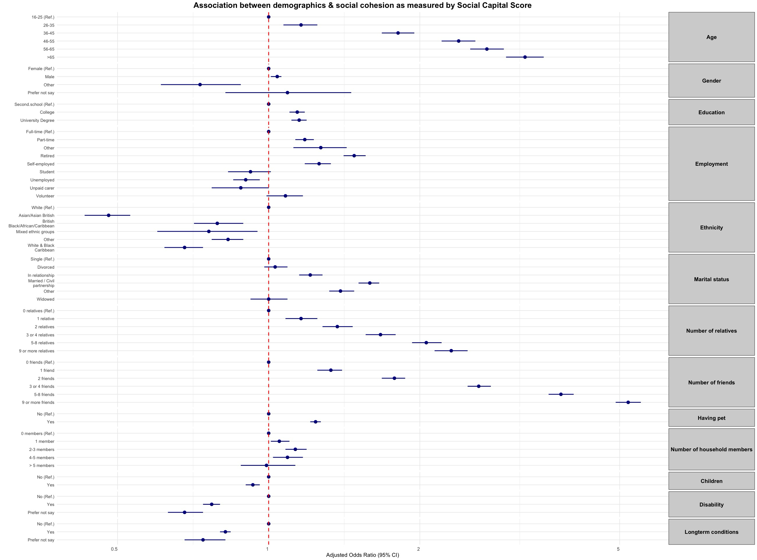
Figure 5: Forest plot of association between demographic & social factors and social cohesion as measured by social capital score

