Supplementary material

Fatty acid | 𝜒² | p value | Cornmeal | O. sulphurea | Potato
C10:0 (Capric acid) | 2.02 | 0.3636 | 0.06ª | 0.03ª | 0.06ª
C12:0 (Lauric acid) | 16.09 | 0.0003 | 4.24^{b} | 2.48ª | 4.23^{b}
C12:1 (Lauroleic acid) | 23.77 | <0.0001 | 0.10^{b} | 0.23ª | 0.08^{b}
C13:0 (Tridecylic acid) | 146.22 | <0.0001 | - | 1.28 | 0.31
C14:0 (Myristic acid) | 59.12 | <0.0001 | 15.71^{b} | 9.35ª | 17.33^{b}
C14:1 (Myristoleic acid) | 22.68 | <0.0001 | 0.63ª | 0.09^{b} | 0.37^{ab}
C16:0 (Palmitic acid) | 189.48 | <0.0001 | 22.61ª | 23.79ª | 28.86^{b}
C16:1 (Palmitoleic acid) | 416.80 | <0.0001 | 21.64ª | 11.22^{b} | 16.52^{c}
C18:0 (Stearic acid) | 335.15 | <0.0001 | 1.47ª | 2.87^{b} | 1.89^{c}
C18:1 (Oleic acid) | 12.92 | 0.0016 | 26.88ª | 23.90^{ab} | 23.12^{b}
C18:2 (Linoleic acid) | 95.26 | <0.0001 | 6.19^{b} | 12.34ª | 5.31^{b}
C18:3 (α-Linolenic acid) | 230.43 | <0.0001 | 0.47^{b} | 12.41ª | 1.92^{b}
MUFAs | 168.55 | <0.0001 | 49.25ª | 35.44^{b} | 40.09^{c}
PUFAs | 94.76 | <0.0001 | 6.66^{b} | 24.75ª | 7.22^{b}
SFAs | 34.28 | <0.0001 | 44.09ª | 39.81ª | 52.68^{b}
UFAs | 34.28 | <0.0001 | 55.91ª | 60.19ª | 47.32^{b}
UFA/SFA ratio | 23.93 | <0.0001 | 1.27^{ab} | 1.54ª | 0.90^{b}
MUFA/PUFA ratio | 243.46 | <0.0001 | 0.13^{b} | 0.70ª | 0.18^{b}
Table S1. Summary of analyses of variance by variable. Mean values calculated for each developmental diet. Superscript letters indicate significant differences in post hoc tests. MUFAs, PUFAs, SFAs and UFAs stand for Monounsaturated, Polyunsaturated, Saturated and Unsaturated fatty acids, respectively. Values represent the average percentage of each fatty acid and fatty acid class over total fatty acid fraction (% FA/FA _{total}), except for the UFA/SFA and MUFA/PUFA ratios, which have no units.
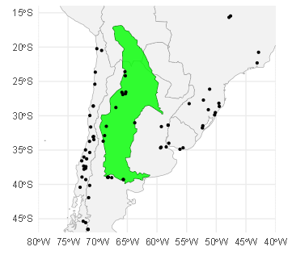
Figure S1. Overlap of Opuntia sulphurea distribution and Drosophila suzukii findings in South America. In green, distribution of Opuntia sulphurea (Thompson et al., 2026). Black dots indicate collection sites of D. suzukii (Bennardo et al., 2021; Gandini et al., 2023; Nair & Peterson, 2023). Occurrence records of Chile were taken from the Agricultural and Livestock Service of Chile webpage (SAG, 2022) and spatially thinned by retaining a single record per 150 × 150 km grid cell to reduce sampling bias while preserving large-scale distribution patterns. The map was created in RStudio (R Core Team, 2024) via ggplot2() (Wickham, 2016).

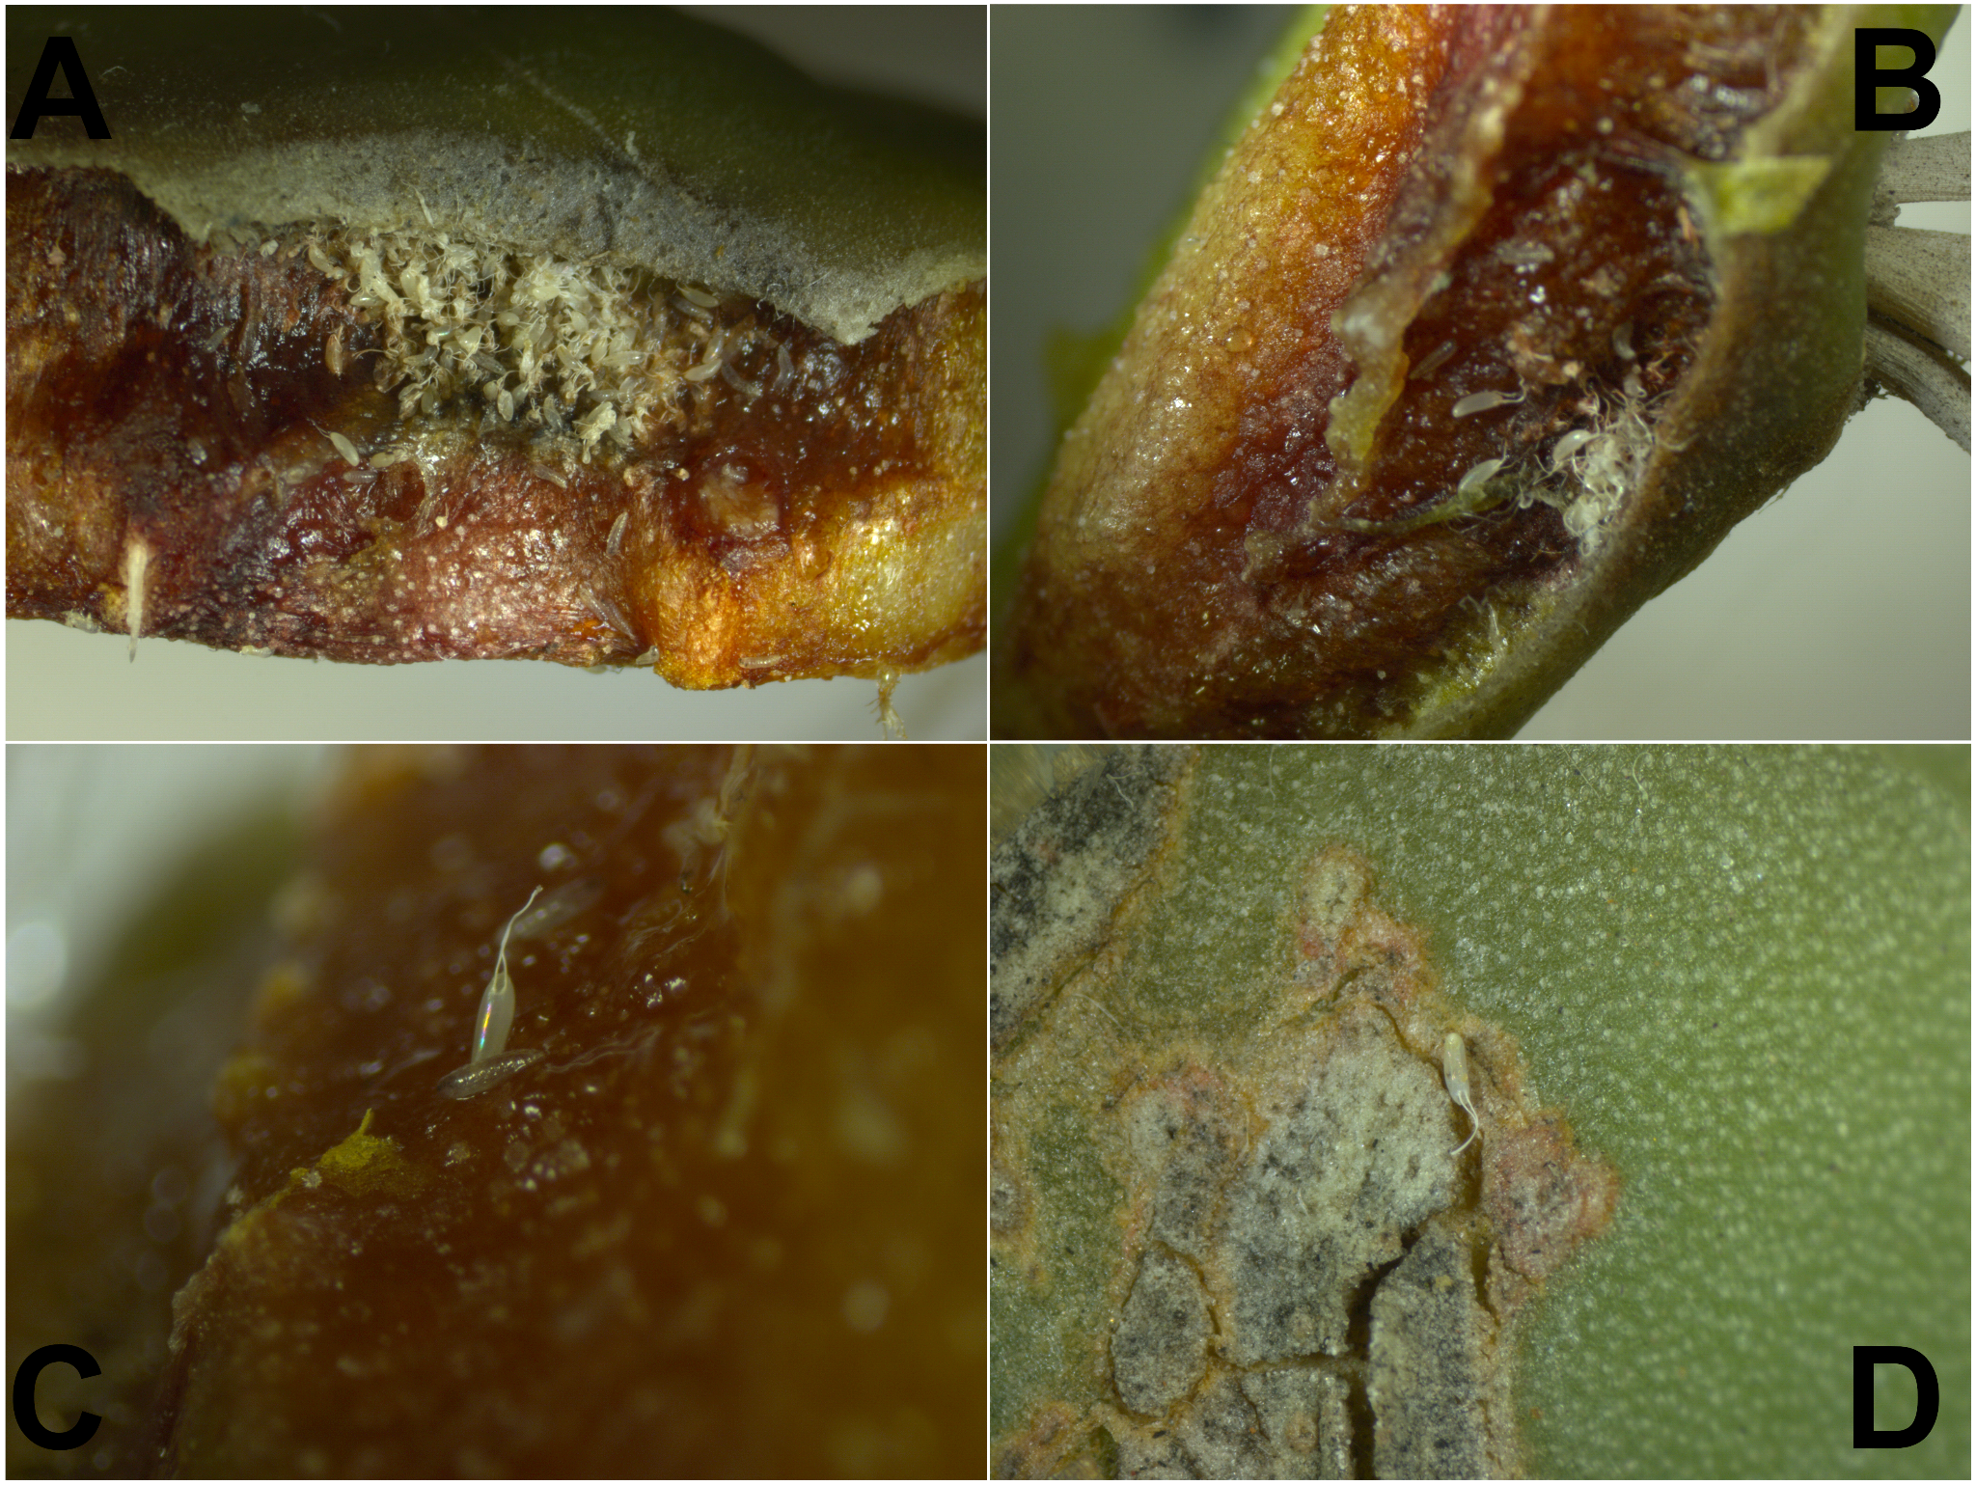
Figure S2. Photographs cactus (O. sulphurea) plates used in the oviposition assay. Figures A-C show larvae and clusters of eggs laid in exposed chlorenchyma, under the cuticle. Figure D shows a single egg laid over a small cut in the cuticle.

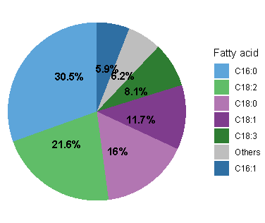
Figure S3. Average fatty acid composition of Opuntia sulphurea. “Other” refers to C10:0, C12:0, C12:1, C14:0, C17:0 and C20:0, which individually represent less than 2% of the fatty acid fraction.
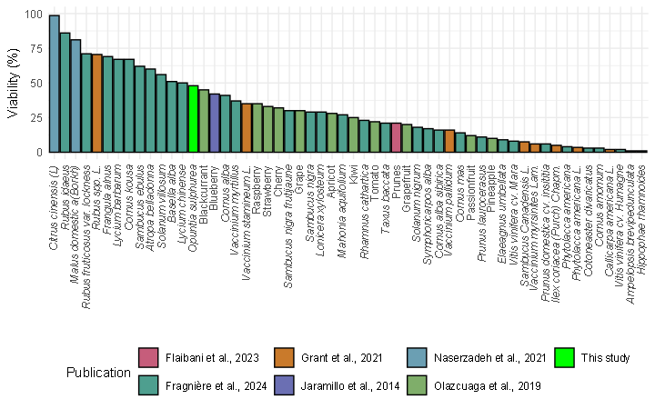
Figure S4. Comparison of egg-to-adult viability across diets in selected literature. Fragnière et al., 2024 reports emergence from fruits collected in nature and public places, Naserzadeh et al., 2021 and Grant & Sial, 2021 assessed emergence from fruits exposed to adult D. suzukii under laboratory conditions while Flaibani et al., 2023 and Olazcuaga et al., 2019 used a semi-natural diet based on fruit purée. In all cases eggs were laid in no-choice preference tests, except for Jaramillo et al., 2015 and Flaibani et al., 2023, who manually placed eggs/larvae in the corresponding medium.
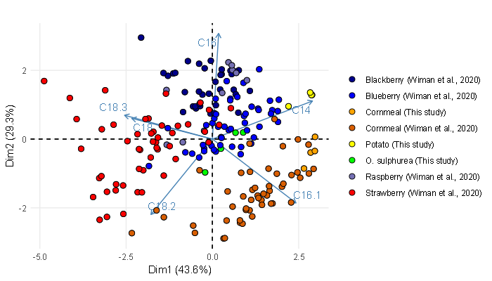
Figure S5. Principal Component Analysis (PCA) of fatty acid profiles of D. suzukii adults reared in several diets, indicated by color. Fatty acid composition of flies reared in O. sulphurea (green) overlaps with blueberry (blue) and cornmeal-reared flies (orange). Data from blackberry, blueberry, raspberry and strawberry taken from Wiman et al. (2020). C10:0, C12:0, C12:1, C13:0, C14:1 and C18:1 were excluded as they are not reported in Wiman et al. (2020). Blue arrows illustrate the contribution of each variable (fatty acid) to the first two principal components, which together explains 72.7% of total variance.

