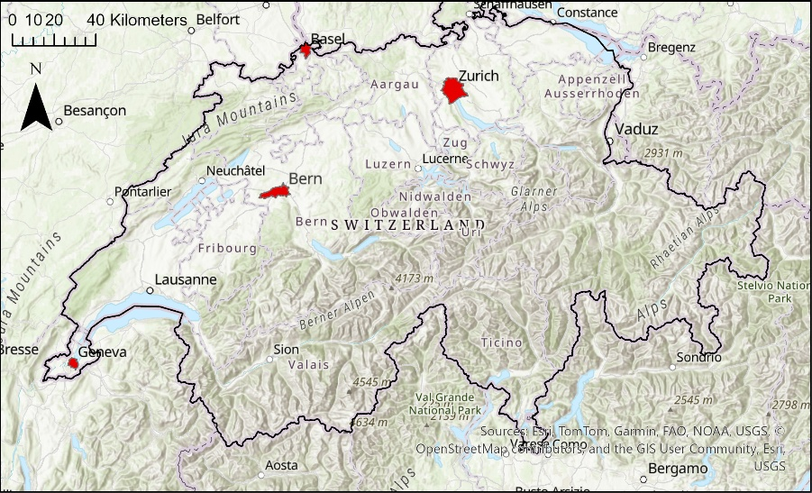
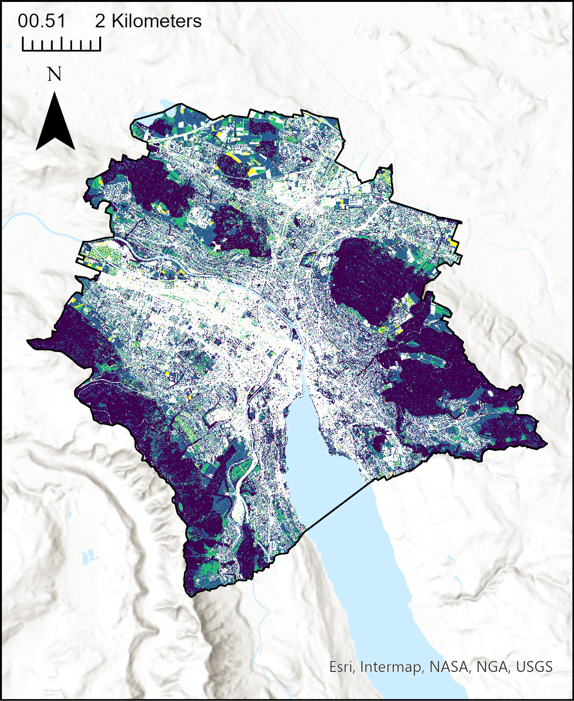
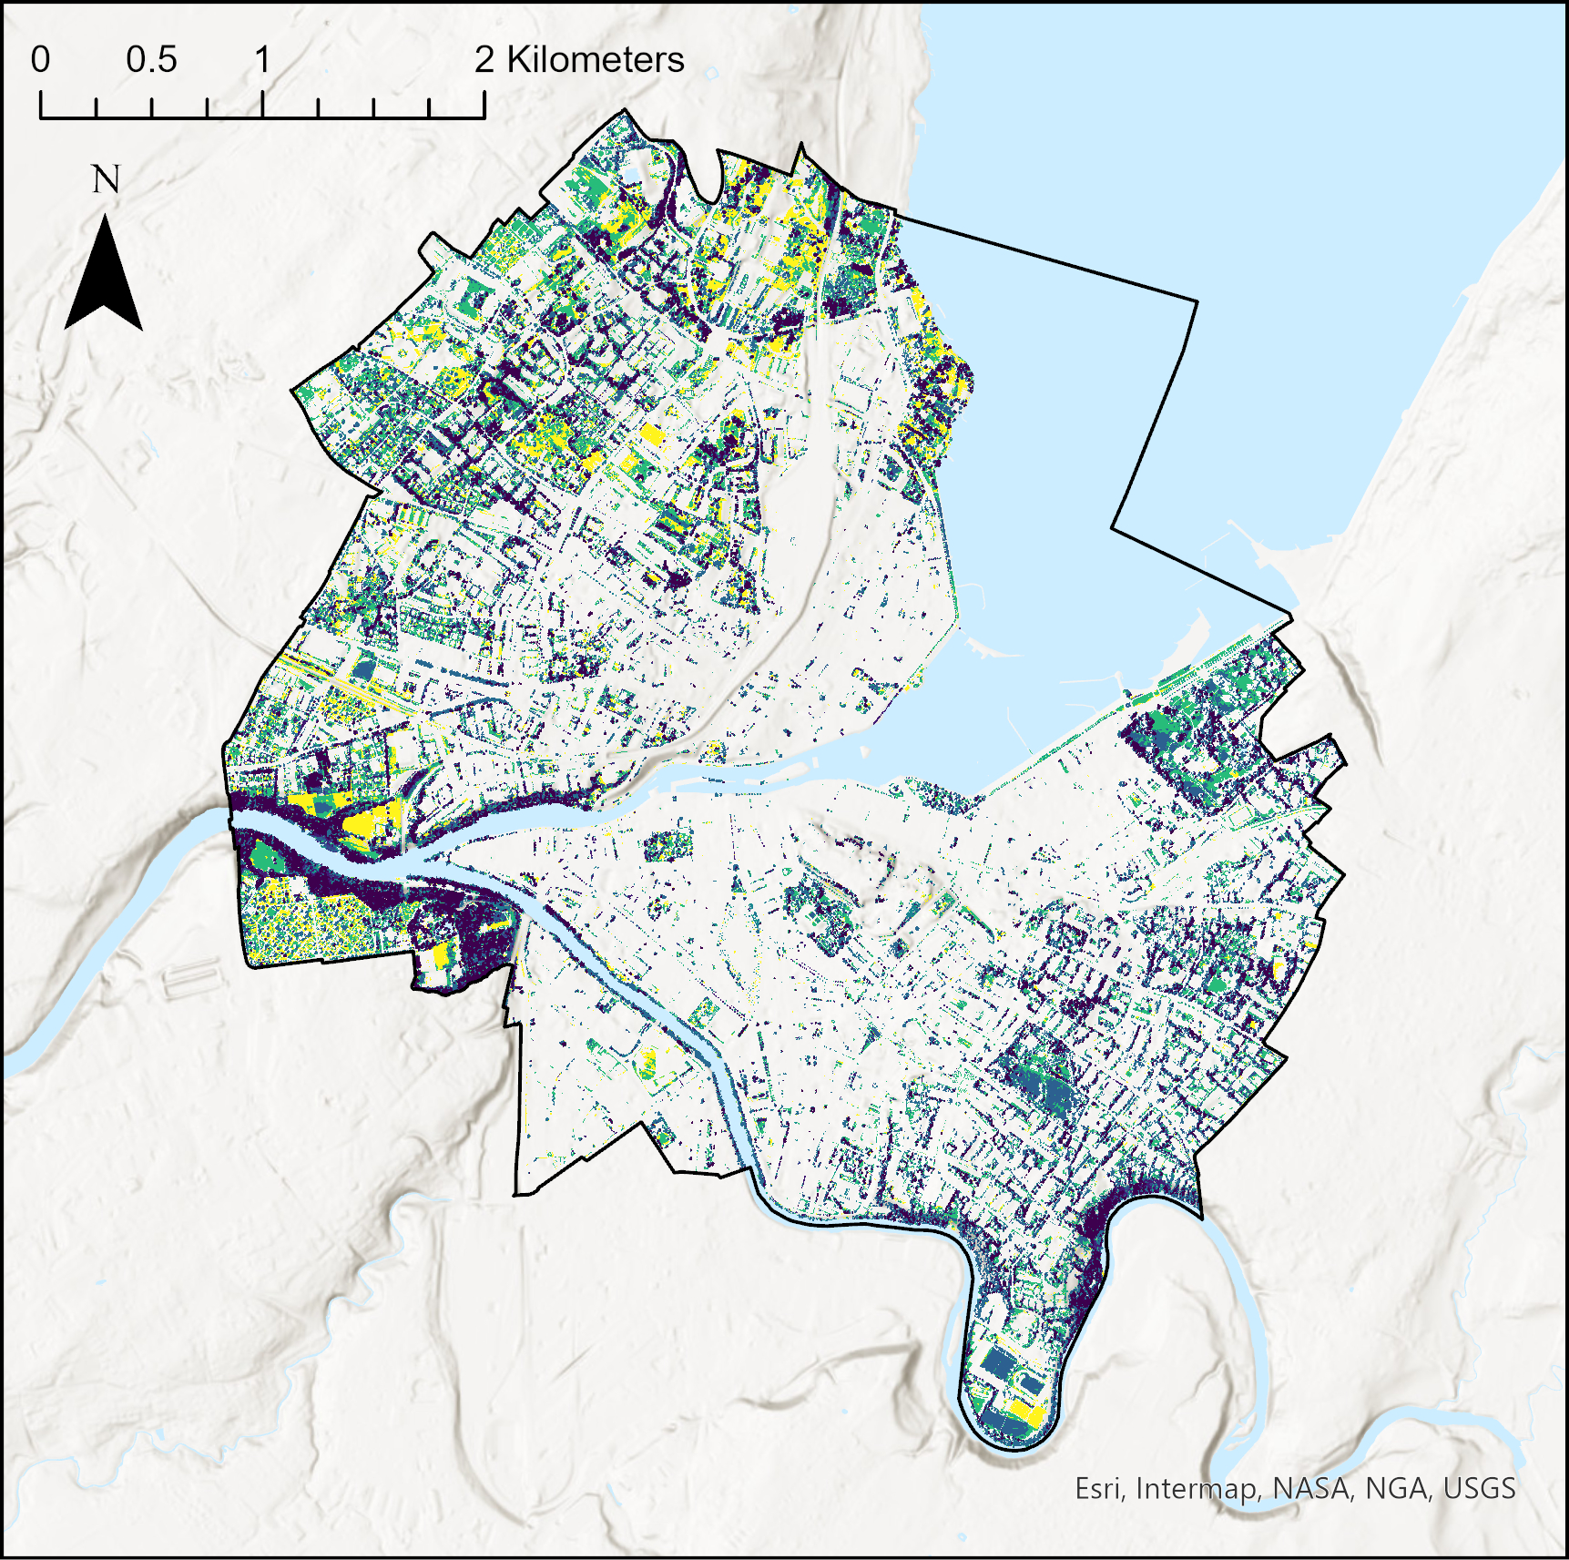
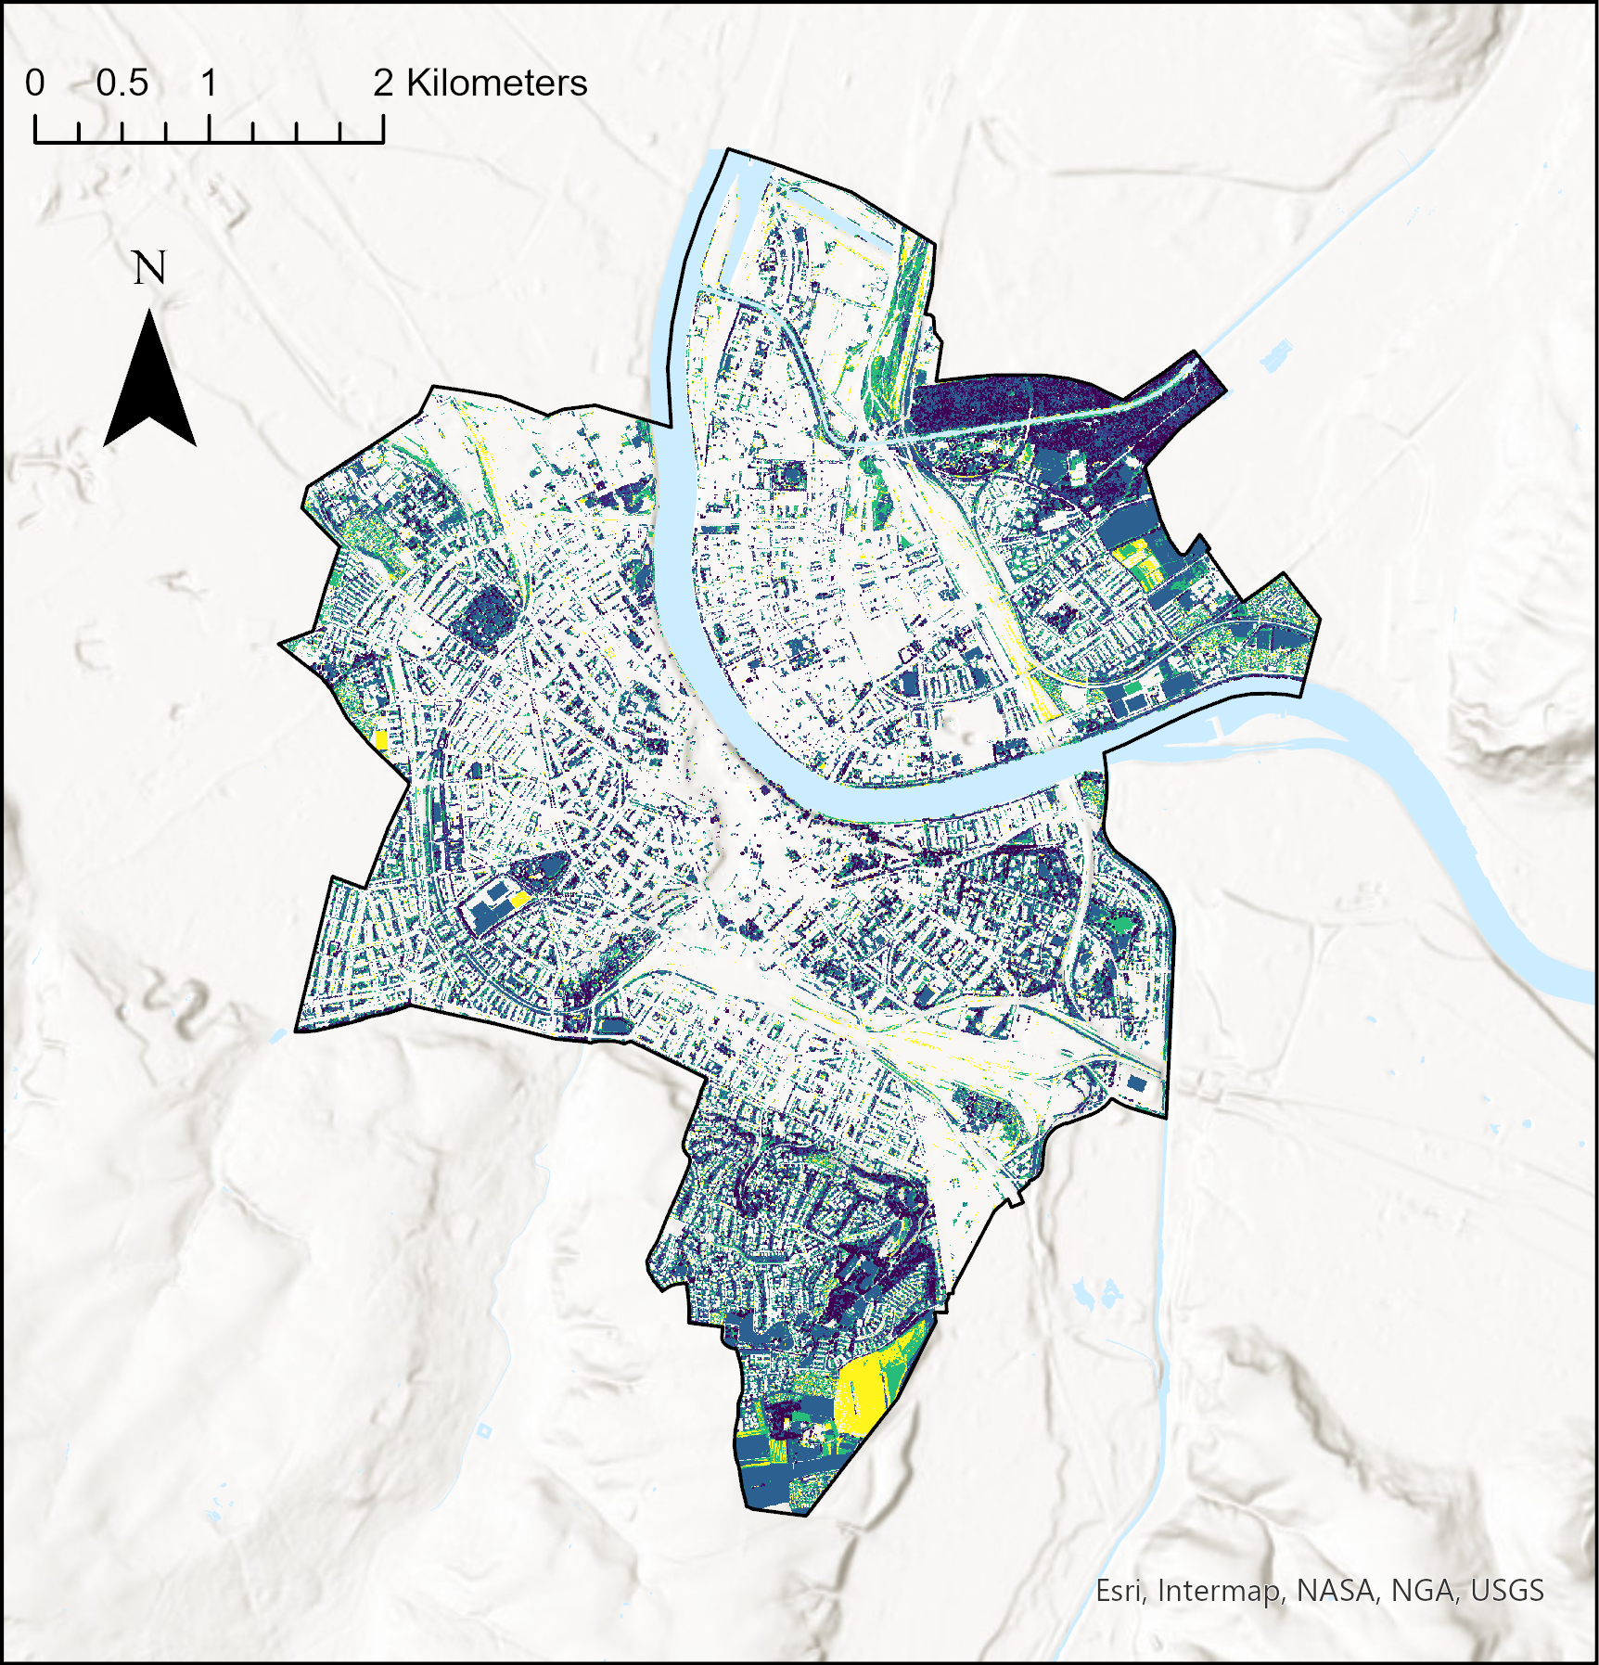
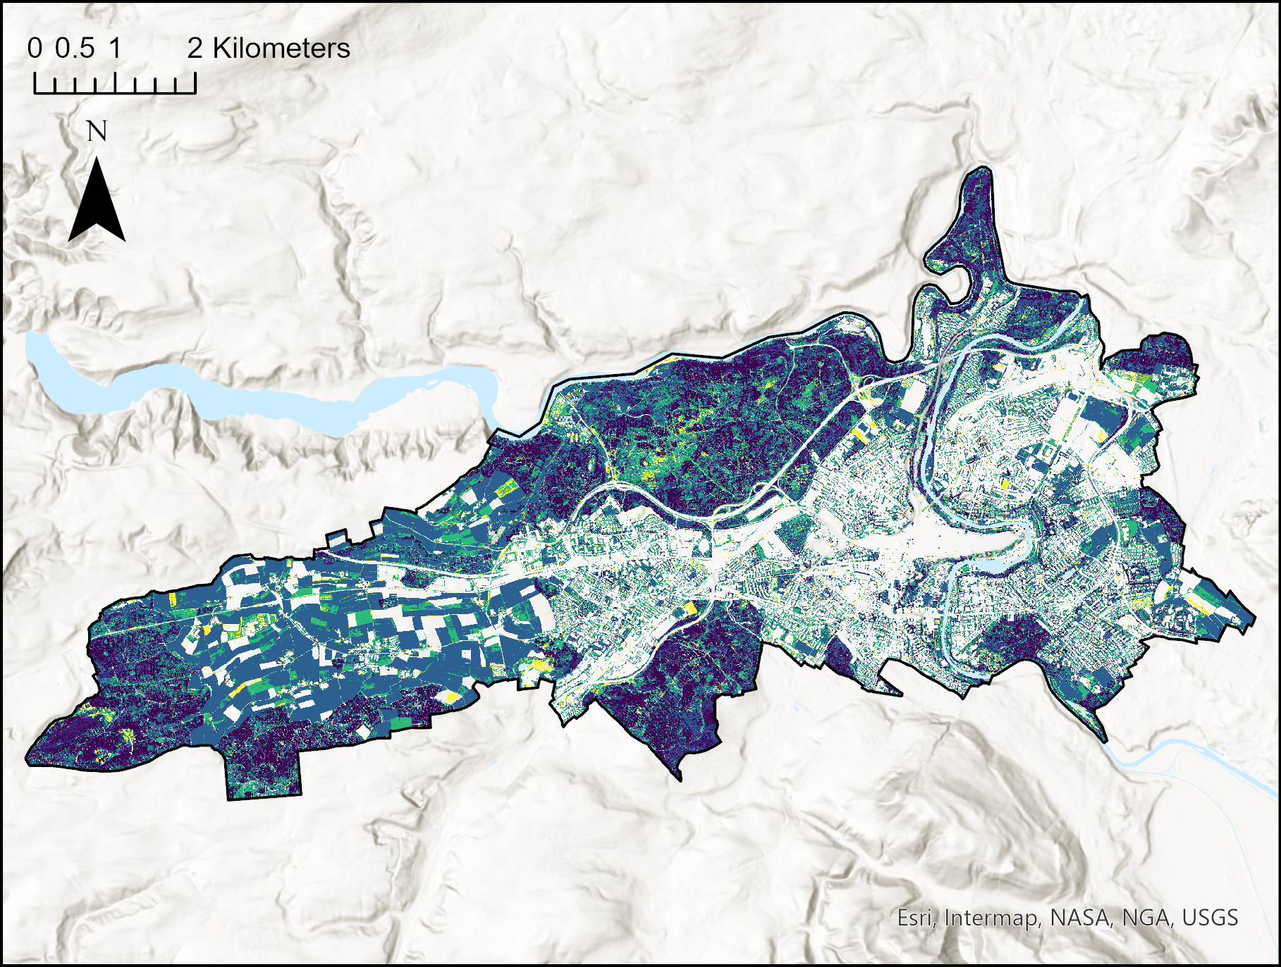
Appendix
A
111
112
121
122
123
131
132
133
141
142
143
211
212
221
222
223
231
232
233
241
242
243
311
312
321
322
323
331
332
333
341
342
343
Legend [NDVI; vegetation height; VCI]
Administrative boundaries
E
D
B
C
Appendix Figure 1: (A) Urban green space typology (UGST) applied to four Swiss cities: Zurich (B), Basel (C), Bern (D), Geneva (E). The typology contains 33 classes based on three remotely sensed parameters (NDVI, VCI, vegetation height). NDVI has three levels of vegetation greenness: 1 = dry; 2 = green; 3 = very green. Vegetation height contains four levels: 1 = grass; 2 = bushes; 3 = tall bushes and small trees; 4 = tall trees. The vertical vegetation complexity (VCI) has three levels 1 = low vertical complexity; 2 = medium vertical complexity; 3 = high vertical complexity.

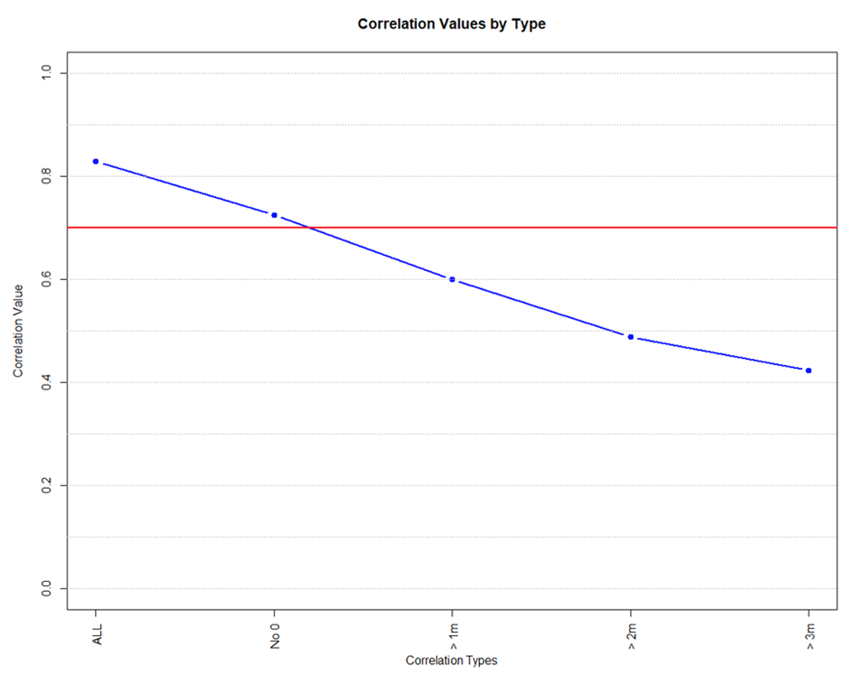
Appendix Figure 2: Pearson correlation coefficient (r) between vegetation height and VCI calculated at different conditions of heights (ALL = all pixels included; No 0 = considered only pixels with vegetation height > 0; > 1 m = considered only pixels with vegetation height > 1 m; > 2 m = considered only pixels with vegetation height > 2 m; > 3 m = considered only pixels with vegetation height > 3 m). The data used for the analysis is derived from Zurich dataset.

Appendix Figure 3: Percent built-up and green land cover for the four cities of Basel (BA), Bern (BE), Geneva (GE) and Zurich (ZH). Shadows of built-up and green represent the pixels were eliminated from the final typology. The percentage of pixels was normalized to the total area of the cities, with borders defined by the administrative boundaries. Water areas were not included in the total surface.

Appendix Figure 4: Percentage of green area pixels for each of the 33 UGST classes. The percentages were based on the four final segmentation layers for each of the cities included in the study: Basel (BA), Bern (BE), Geneva (GE) and Zurich (ZH).

Appendix Table 1: Acquisition year of the remotely sensed datasets used to develop the UGST for the cities.

City | Orthophoto | LiDAR
Zurich | 2022 | 2018
Bern | 2018 | 2023
Basel | 2021 | 2023
Geneva | 2022 | 2019

Appendix Table 2: Number of species and number of observations per city for each of the five taxonomic groups.
City | Animal group | Number of observations
Zurich | 10 reptile species | 1057
 | 16 amphibian species | 1322
 | 594 flying-active insect species | 39025
 | 126 ground-dwelling insect species | 12263
 | 26 spider species | 132
Total | 772 species | 53799
Basel | 6 reptile species | 83
 | 6 amphibian species | 60
 | 241 flying-active insect species | 2297
 | 71 ground-dwelling insect species | 816
 | 5 spider species | 5
Total | 329 species | 3261
Bern | 7 reptile species | 847
 | 16 amphibian species | 811
 | 376 flying-active insect species | 8304
 | 181 ground-dwelling insect species | 1750
 | 31 spider species | 44
Total | 611 species | 11756
Geneva | 5 reptile species | 48
 | 5 amphibian species | 24
 | 215 flying-active insect species | 1510
 | 76 ground-dwelling insect species | 495
 | 44 spider species | 82
Total | 345 species | 2159
Total (across cities) | 1165 | 70975

Appendix Table 3. UGST reclassification to four functional categories.
New class | Original UGST classes Included | Description and Ecological Rationale
UGST_1: Degraded/Low-quality Vegetation | All classes with NDVI = 1: 111, 112, 121, 122, 123, 131, 132, 133, 141, 142, 143 | These sites are characterized by low NDVI values (first digit = 1), indicating poor vegetation vigor and health. Regardless of vegetation height or vertical complexity, these areas are likely to be dry, stressed, or degraded, and therefore offer limited resources and structural complexity. Consequently, they are expected to support lower diversity and abundance.
UGST_2: Intermediate Open Habitat | From NDVI = 2 with minimal vertical complexity (VCI = 1): 211, 221, 231, 241 | With moderate NDVI (first digit = 2) but low vertical complexity (third digit = 1), these habitats are relatively open and homogeneous. The vegetation is typically low in stature (grass or low bushes) and lacks layering. Such sites, often managed lawns or disturbed grasslands, may lack the structural features needed to support a high diversity of species.
UGST_3: High-Quality, Open or Semi-open Habitats | From NDVI = 2 with higher VCI (VCI =2 or 3): 212, 222, 223, 232, 233, 242, 243; and from NDVI = 3 with low to moderate structure (height = 1 - 2 and VCI = 1 – 2): 311, 312, 321, 322 | These sites either have moderate vegetation quality (NDVI = 2) with increased vertical complexity or high vegetation quality (NDVI = 3) while maintaining an open or semi-open structure (lower heights and low-to-intermediate VCI). They represent environments that are lush without being overly dense, still providing some degree of microhabitat variation.
UGST_4: High-Quality, Dense, Multi-layered Forests | From NDVI = 3 with high structure: specifically, NDVI = 3, height = 2 with VCI = 3 (323); all NDVI = 3 classes with height = 3 (331, 332, 333) and height = 4 (341, 342, 343) | These habitats are defined by high NDVI values combined with tall vegetation and high vertical complexity. They represent dense, mature, multi-layered forests with closed canopies. Such areas offer a rich variety of microhabitats, nesting sites, and structural heterogeneity. In less urbanized contexts, these complex habitats are often linked with higher overall biodiversity.

Appendix Table 4: Results of the GAMs model to explain species richness and multidiversity score using the individual parameters (NDVI, vegetation height, VCI) as explanatory variables.

NDVI
 |  | edf |  | F | p-value
multidiversity |  | 3.672 |  | 8.923 | <0.001 ***
amphibians |  | 3.234 |  | 8.412 | <0.001 ***
spiders |  | 2.9 |  | 18.13 | <0.001 ***
insects (flying) |  | 2.782 |  | 7.045 | <0.001 ***
insects (ground-dwelling) |  | 2.87 |  | 4.511 | <0.001 ***
Reptilia |  | 3.824 |  | 30.27 | <0.001 ***
Vegetation height
 | edf |  | F |  | p-value
multidiversity | 3.86 |  | 28.84 |  | <0.001 ***
amphibians | 3.459 |  | 6.811 |  | <0.001 ***
spiders | 3.526 |  | 5.977 |  | <0.001 ***
insects (flying) | 3.844 |  | 13.96 |  | <0.001 ***
insects (ground-dwelling) | 3.756 |  | 31.7 |  | <0.001 ***
Reptilia | 3.86 |  | 20.01 |  | <0.001 ***

VCI
 | edf | F | p-value
multidiversity | 3.837 | 29.78 | <0.001 ***
amphibians | 3.385 | 9.967 | <0.001 ***
spiders | 3.618 | 6.08 | <0.001 ***
insects (flying) | 2.857 | 9.058 | <0.001 ***
insects (ground-dwelling) | 3.673 | 31.85 | <0.001 ***
Reptilia | 3.887 | 22.4 | <0.001 ***

Appendix Table 5: Example results of the GAMs model using the original 33 UGST classes to explain species richness and multidiversity score. Statistical results of the classes 111, 211, 243, 311, 322, 343 are presented.

 |  | UGST classes
 | class | edf | F | p-value
multidiversity | 111 | 2.512 | 2.950 | 0.003 **
multidiversity | 211 | 2.411 | 8.433 | <0.001 ***
multidiversity | 243 | 3.217 | 8.235 | <0.001 ***
multidiversity | 311 | 2.361 | 11.316 | <0.001 ***
multidiversity | 322 | 2.456 | 12.967 | <0.001 ***
multidiversity | 343 | 3.653 | 13.111 | <0.001 ***
amphibians | 111 | 1.836 | 2.328 | 0004 **
amphibians | 211 | 2.707 | 1.317 | 0.106
amphibians | 243 | 2.615 | 2.753 | 0.005 **
amphibians | 311 | 2.657 | 23.182 | <0.001 ***
amphibians | 322 | 3.572 | 27.753 | <0.001 ***
amphibians | 343 | 2.594 | 5.363 | <0.001 ***
spiders | 111 | 2.816 | 4.021 | <0.001 ***
spiders | 211 | 3.154 | 2.761 | 0.009 **
spiders | 243 | 2.811 | 1.809 | 0.05
spiders | 311 | 3.673 | 8.279 | <0.001 ***
spiders | 322 | 3.625 | 1.972 | 0.068
spiders | 343 | 2.764 | 5.74 | <0.001 ***
insects (flying) | 111 | 0.081 | 0.012 | 0.437
insects (flying) | 211 | 2.491 | 9.653 | <0.001 ***
insects (flying) | 243 | 2.804 | 3.119 | 0.002 **
insects (flying) | 311 | 3.166 | 18.875 | <0.001 ***
insects (flying) | 322 | 1.854 | 1.237 | 0.054
insects (flying) | 343 | 3.168 | 3.41 | 0.002 **
insects (ground-dwelling) | 111 | 1.705 | 5.5 | <0.001 ***
insects (ground-dwelling) | 211 | 0.995 | 14.819 | <0.001 ***
insects (ground-dwelling) | 243 | 3.262 | 14.7 | <0.001 ***
insects (ground-dwelling) | 311 | 3.487 | 17.825 | <0.001 ***
insects (ground-dwelling) | 322 | 3.147 | 3.815 | <0.001 ***
insects (ground-dwelling) | 343 | 3.644 | 8.34 | <0.001 ***
reptiles | 111 | 1.816 | 0.797 | 0.158
reptiles | 211 | 2.359 | 3.575 | <0.001 ***
reptiles | 243 | 2.822 | 5.177 | <0.001 ***
reptiles | 311 | 1.421 | 3.301 | <0.001 ***
reptiles | 322 | 2.705 | 8.331 | <0.001 ***
reptiles | 343 | 3.626 | 15.429 | <0.001 ***

Appendix Table 6: Results of the GAMs model to explain species richness and multidiversity score using aggregated habitat types as explanatory variables. UGST_1: degraded/low quality vegetation; UGST_2: Intermediate open habitat; UGST_3: high-quality open or semi-open habitat; UGST_4: high-quality, dense and multilayered forests.

Functional categories
 | New class | edf | F | p-value
multidiversity | UGST_1 | 1.792 | 1.272 | 0.049 *
multidiversity | UGST_2 | 2.791 | 12.734 | <0.001 ***
multidiversity | UGST_3 | 3.756 | 28.069 | <0.001 ***
multidiversity | UGST_4 | 3.689 | 10.644 | <0.001 ***
amphibians | UGST_1 | 1.312 | 0.736 | 0.101
amphibians | UGST_2 | 3.153 | 2.360 | 0.020 *
amphibians | UGST_3 | 2.790 | 37.529 | <0.001 ***
amphibians | UGST_4 | 2.055 | 4.304 | <0.001 ***
spiders | UGST_1 | 2.852 | 4.432 | <0.001 ***
spiders | UGST_2 | 2.673 | 1.974 | 0.03 *
spiders | UGST_3 | 3.794 | 6.125 | <0.001 ***
spiders | UGST_4 | 2.957 | 6.630 | <0.001 ***
insects (flying) | UGST_1 | 0.0007888 | 0.000 | 0.605
insects (flying) | UGST_2 | 2.793 | 13.026 | <0.001 ***
insects (flying) | UGST_3 | 3.347 | 17.431 | <0.001 ***
insects (flying) | UGST_4 | 1.979 | 4.223 | <0.001 ***
insects (ground-dwelling) | UGST_1 | 2.103 | 4.522 | <0.001 ***
insects (ground-dwelling) | UGST_2 | 2.869 | 18.486 | <0.001 ***
insects (ground-dwelling) | UGST_3 | 2.5 | 18.373 | <0.001 ***
insects (ground-dwelling) | UGST_4 | 3.765 | 7.913 | <0.001 ***
Reptilia | UGST_1 | 2.166 | 1.549 | 0.418 *
Reptilia | UGST_2 | 2.645 | 7.865 | <0.001 ***
Reptilia | UGST_3 | 3.875 | 14.814 | <0.001 ***
Reptilia | UGST_4 | 3.668 | 15.054 | <0.001 ***

Appendix Table 7: Results of the GAMs model to explain species richness and multidiversity score using total green area as explanatory variable.

Total vegetation
 | edf | F | p-value
multidiversity | 3.888 | 27.57 | <0.001 ***
amphibians | 2.942 | 23.14 | <0.001 ***
spiders | 3.064 | 8.13 | <0.001 ***
insects (flying) | 3.681 | 21.64 | <0.001 ***
insects (ground-dwelling) | 3.344 | 8.02 | <0.001 ***
Reptilia | 3.869 | 14.13 | <0.001 ***

